Experiment 4: Design and Analysis of FIR and IIR filters

## AIM: To design FIR/IIR filters in MATLAB using various algorithms

*Filter specifications and design methods:*

Max passband ripple: 1dB Min stopband attenuation: 30dB

Lower passband edge: 0.2pi Lower stopband edge: 0.19pi

Upper passband edge: 0.3pi Upper stopband edge: 0.31pi

1. FIR Window (Rectangular, Hanning)

2. FIR LS

3. FIR Park McClellan

4. IIR Butterworth

5. IIR Chebyshev

6. IIR Inverse Chebyshev

7. IIR Elliptic

For the purpose of designing minimum order filters, for the sake of exploration, we have used our own code. However, a more accurate way to do this is to use the MATLAB filter design tool, as we have done in the subsequent parts for seeing the effect of bit precision on filter response, passband ripple, stopband attenuation and stability

## Code:

**Experiment4.m**

%% 1.a FIR-Rectangular window

N=512;

h1 = fir1(N, [0.199 0.301], 'bandpass', rectwin(N+1));

freqz(h1, 1, 10000);

%figure;

%h1_dash = bitprecision(10,1,N+1,h1); %used for finite word length

%fvtool(h1,1,h1_dash,1);

%% 1.b.FIR-Hanning window

N=400;

h1 = fir1(N, [0.198 0.302], 'bandpass', hann(N+1));

figure;

freqz(h1,1,10000);

%% 2.FIR-LS

h1 = firls(155,[0 0.19 0.203 0.297 0.31 1],[0 0 1 1 0 0]);

figure;

freqz(h1,1,10000);

%% 3.FIR-Parks-McClellan

N=175;

h1=firpm(N,[0 0.19 0.205 0.295 0.31 1],[0 0 1 1 0 0]);

figure;

freqz(h1,1,10000);

%% 4.Butterworth IIR

[z,p,k] = butter(52,[0.2 0.3],'bandpass');

sos = zp2sos(z,p,k);

fvtool(sos);

xlim([0.18 0.32]);

ylim([-45 5]);

%% 5.Chebyshev IIR

[z,p,k] = cheby1(18,1,[0.2 0.3],'bandpass');

sos = zp2sos(z,p,k);

fvtool(sos);

xlim([0.18 0.32]);

ylim([-45 5]);

%% 6.Inverse Chebyshev IIR

[z,p,k] = cheby2(18,30,[0.19 0.31],'bandpass');

sos = zp2sos(z,p,k);

fvtool(sos);

xlim([0.18 0.32]);

ylim([-45 5]);

%% 7.Elliptic IIR

[z,p,k] = ellip(10,1,30,[0.2 0.3],'bandpass');

sos = zp2sos(z,p,k);

fvtool(sos);

xlim([0.18 0.32]);

ylim([-45 5]);

**bitprecision.m**

function a_dash = bitprecision(m,n,N,a)

d2b=zeros(floor(N),floor(m+n));

for i=1:N

d2b(i,:) = fix(rem(a(i)*pow2(-(n-1):m),2)); %de2bi with precision of n,m bits in integral and fractional parts

end

a_dash = d2b*pow2(n-1:-1:-m).';

a_dash = a_dash';

end

Here are the obtained filter responses, along with order for the 8 specified designs:

1. FIR – Rectangular Window

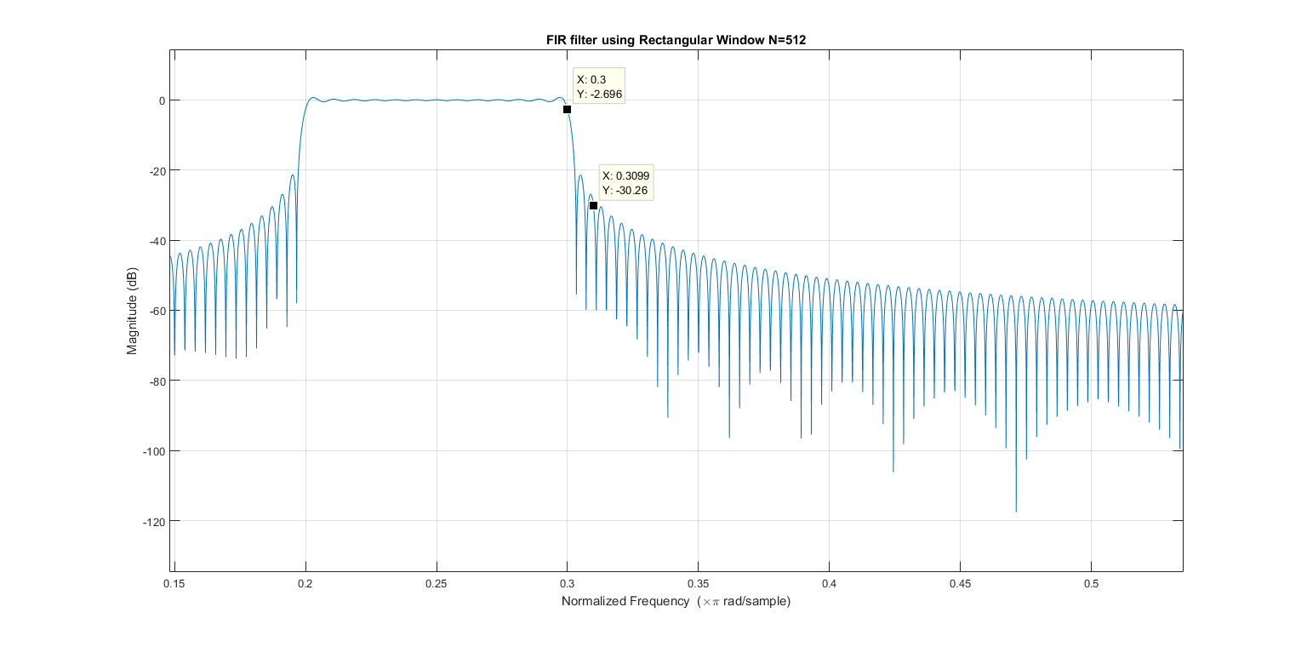

1. FIR – Hanning Window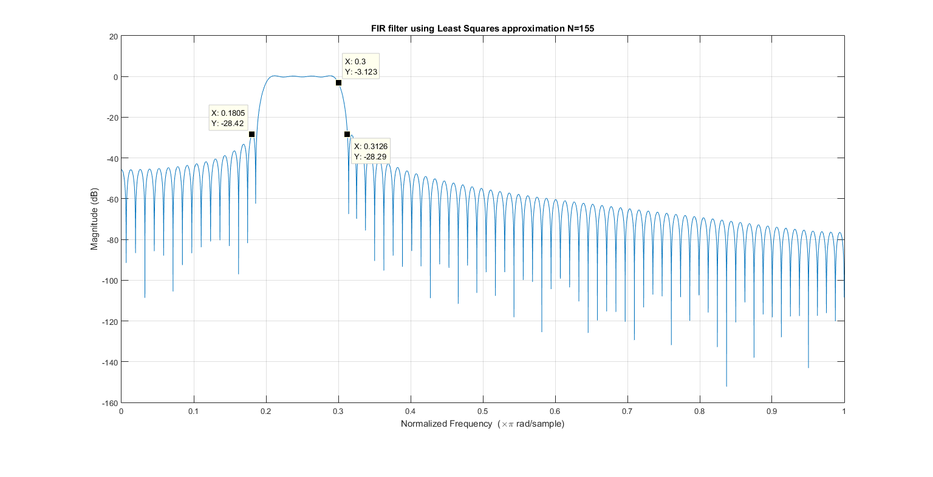
2. FIR – Least Squares approximation

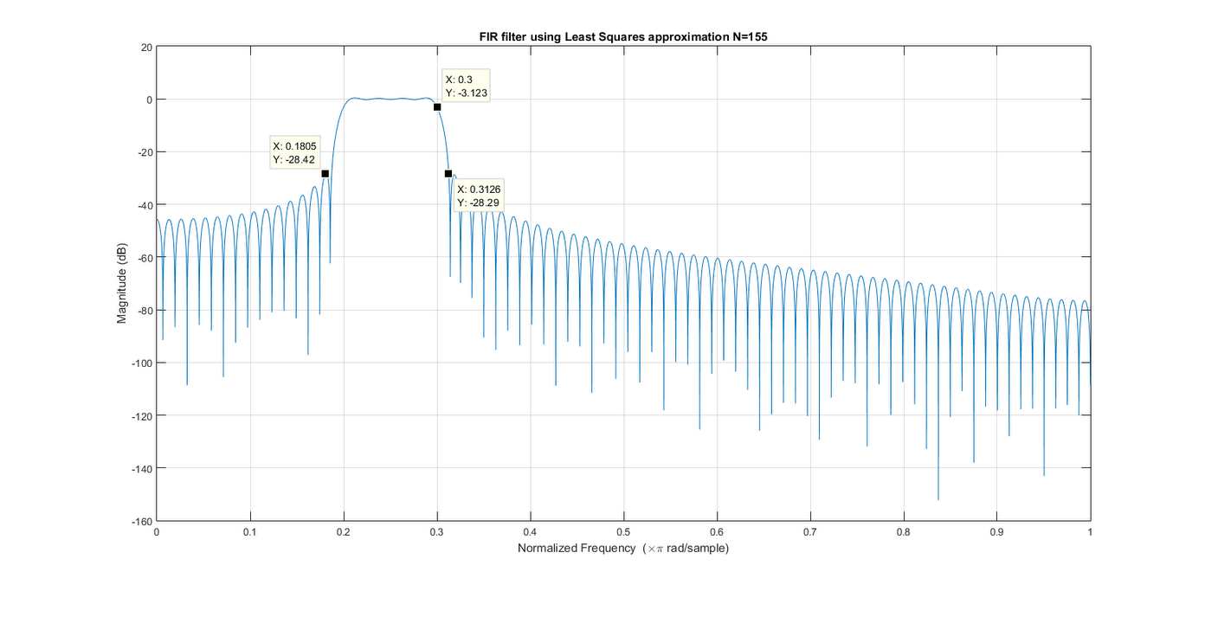

1. FIR – Parks McClellan algorithm

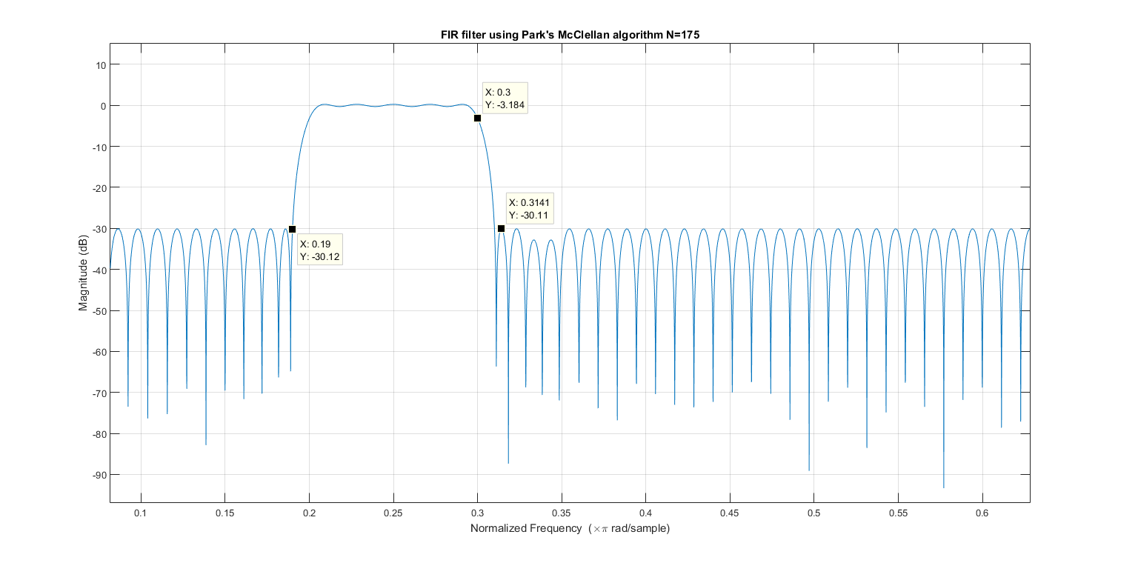

1. IIR – Butterworth

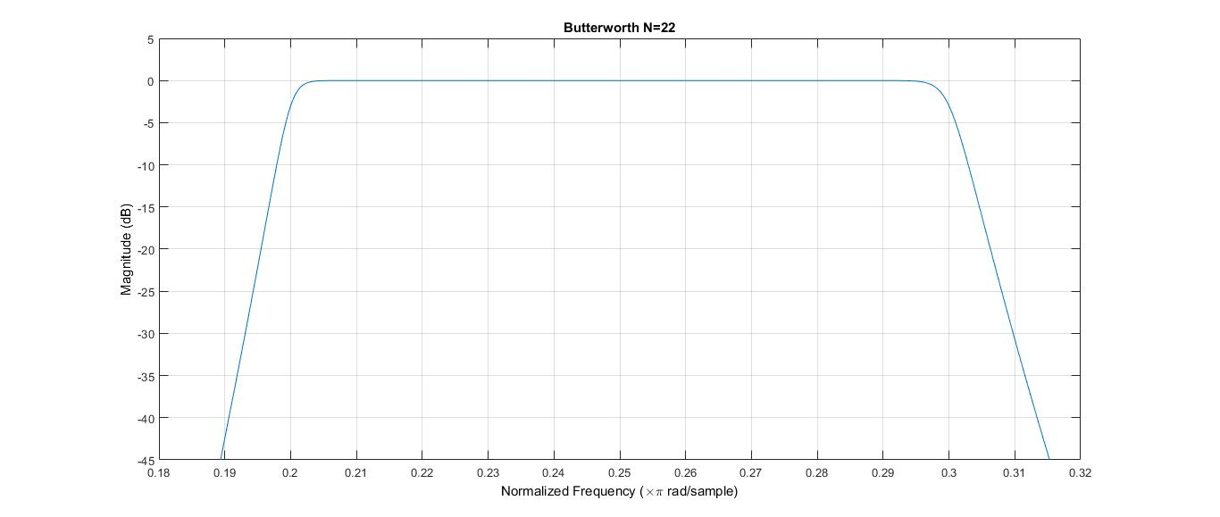

1. IIR – Chebyshev (Chebyshev Type I)

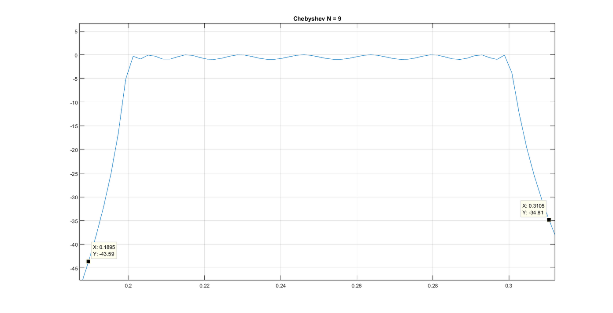

1. IIR – Inverse Chebyshev (Chebyshev Type II)

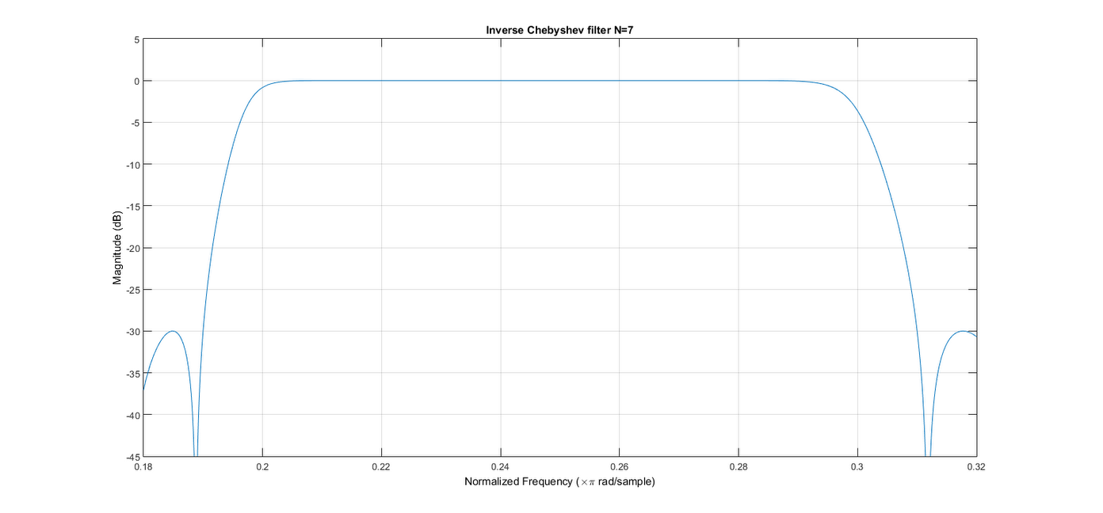

1. IIR – Elliptic

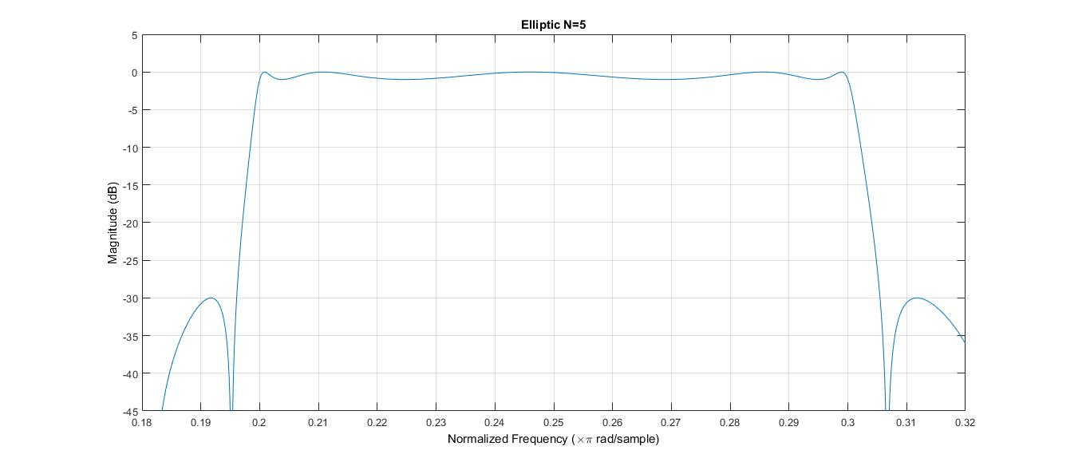

We can use the fvtool filter visualizer window to view the pole zero plots for different filters. FIR filters don’t have stability issues, as there is no feedback. However, for IIR filters, we need to ensure that all the poles are inside the unit circle, for the filter to be stable. As we can see in the following plots, this is indeed true.

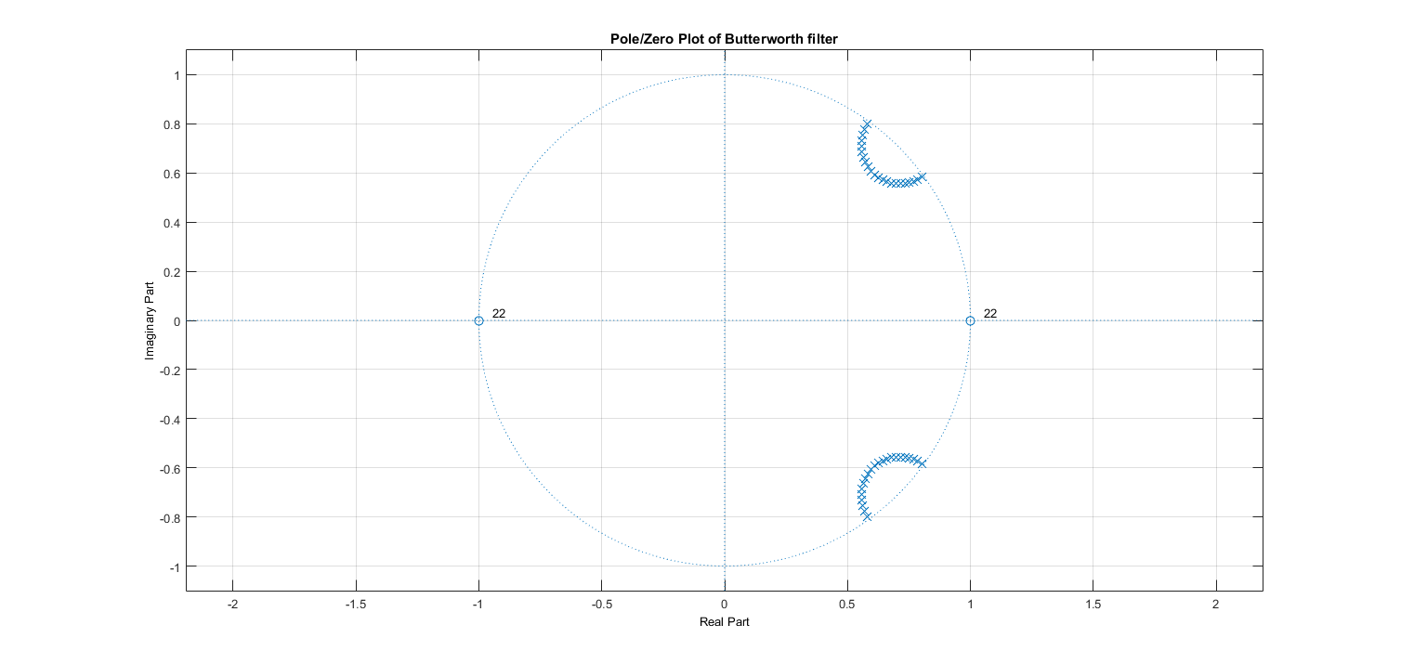

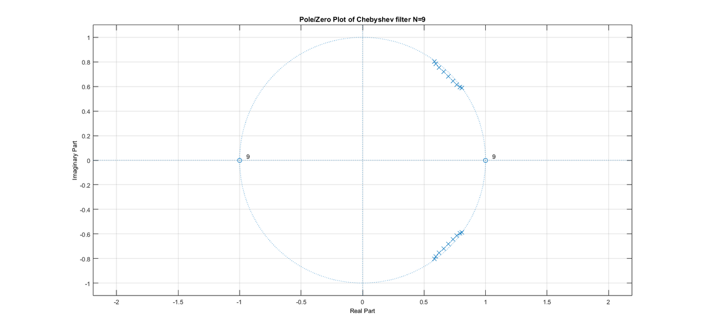

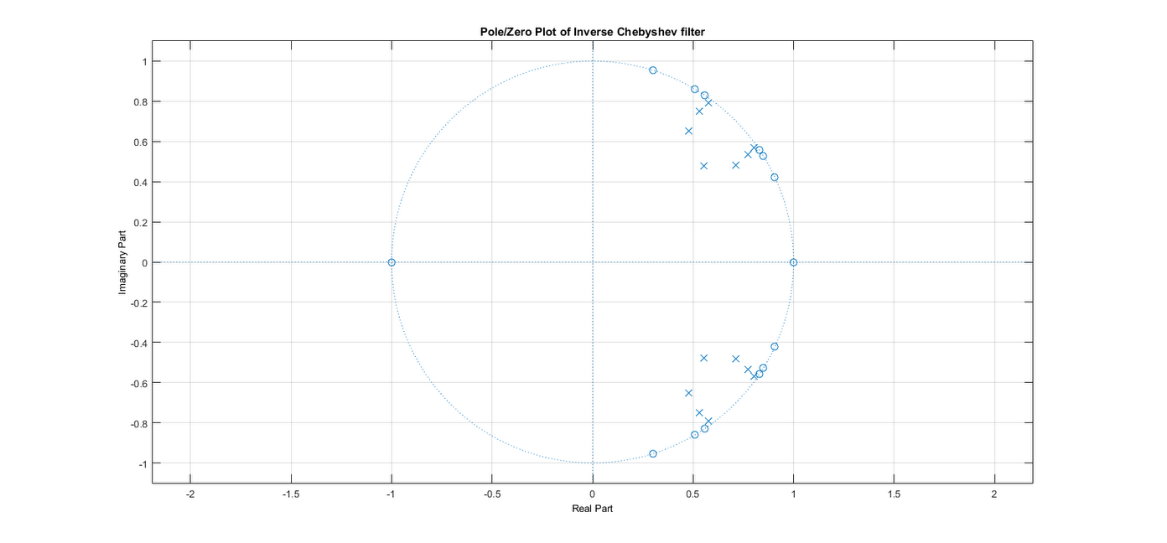

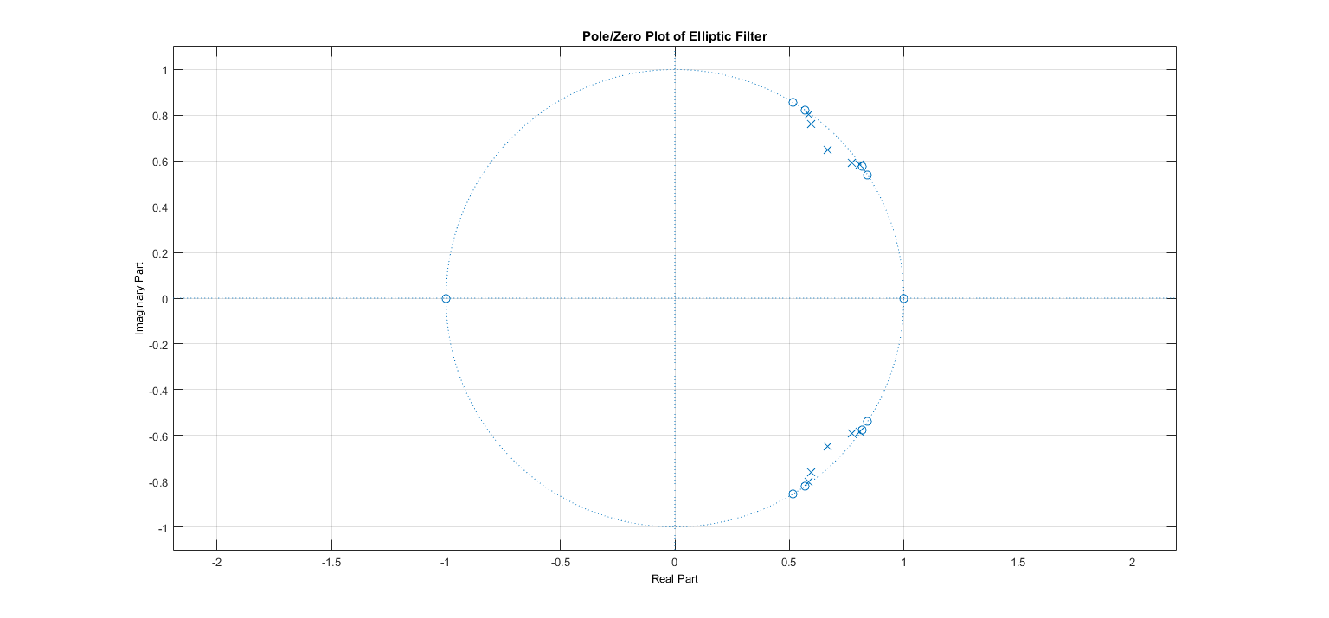

There are a few things worth noting from these plots. Firstly, IIR filter orders are much lesser than FIR filter orders. This is purely due to the fact that IIR filters are acausal. Secondly, in FIR filters, the required specifications are met at the least order for the Parks – McClellan algorithm (N=135), followed by Least Squares method and Hanning window, least effective being Rectangular window.

Next, we try to see the effect of bit precision on the filter response and stability. Note that we’ll only be doing this for IIR filters, as they are the only ones who have stability issues. Also, the values of passband ripple and stop band attenuation have minimal variation in the FIR case.

## Effect of Bit Precision:

Changing the bit precision of the coefficients from the earlier double precision floating point to the now fixed point leads to a degradation in filter response, and after a certain point makes the filter response unstable, leading to drastic change in passband ripple and stop band attenuation.

Here are the plots of the filter response and the variation of passband ripple and stopband attenuation:

1. IIR – Butterworth

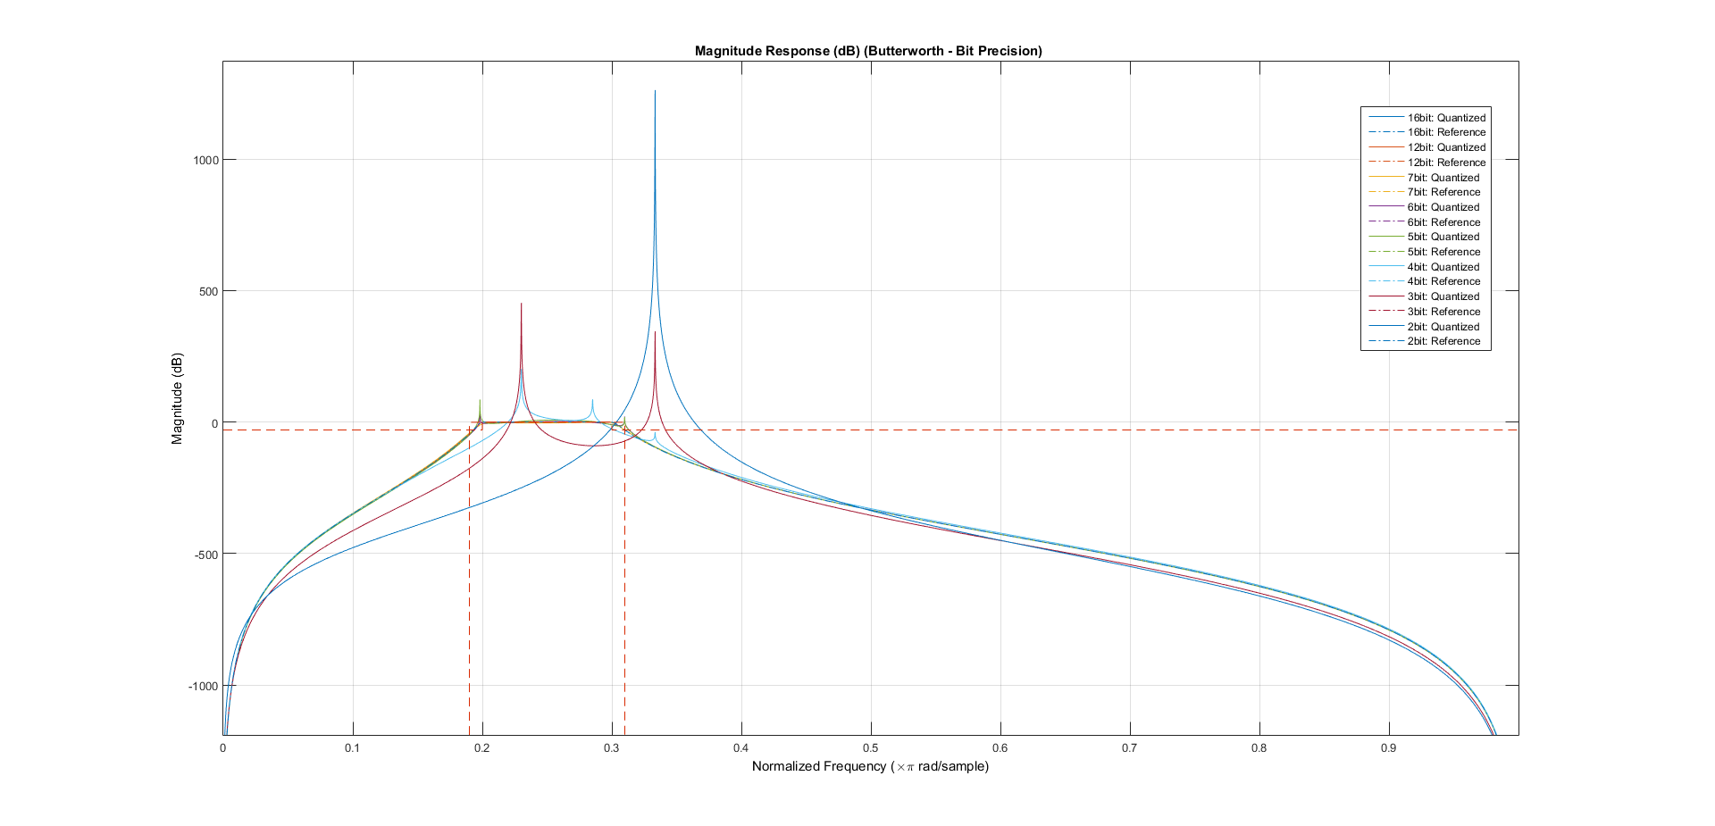

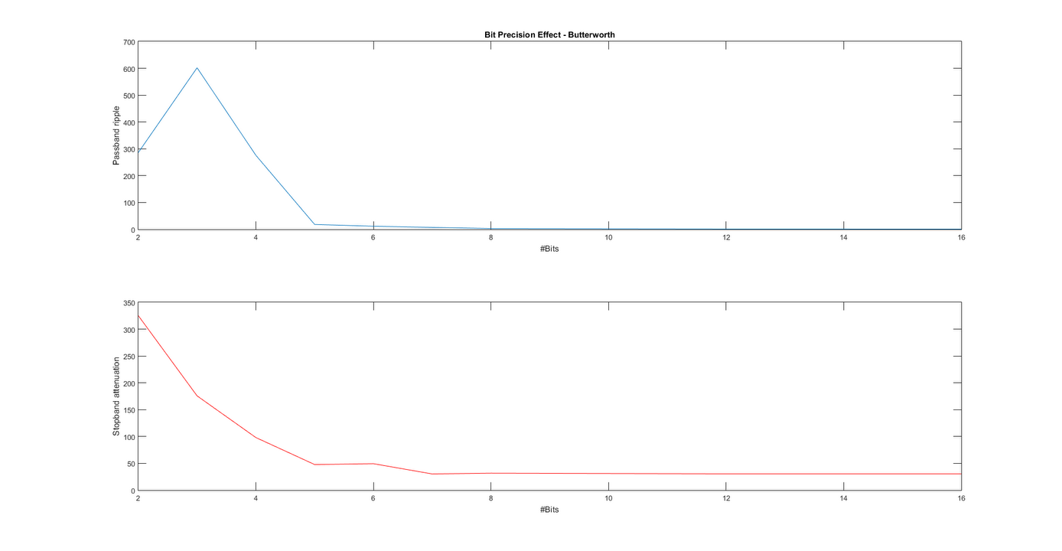

1. IIR – Chebyshev (Chebyshev Type I)

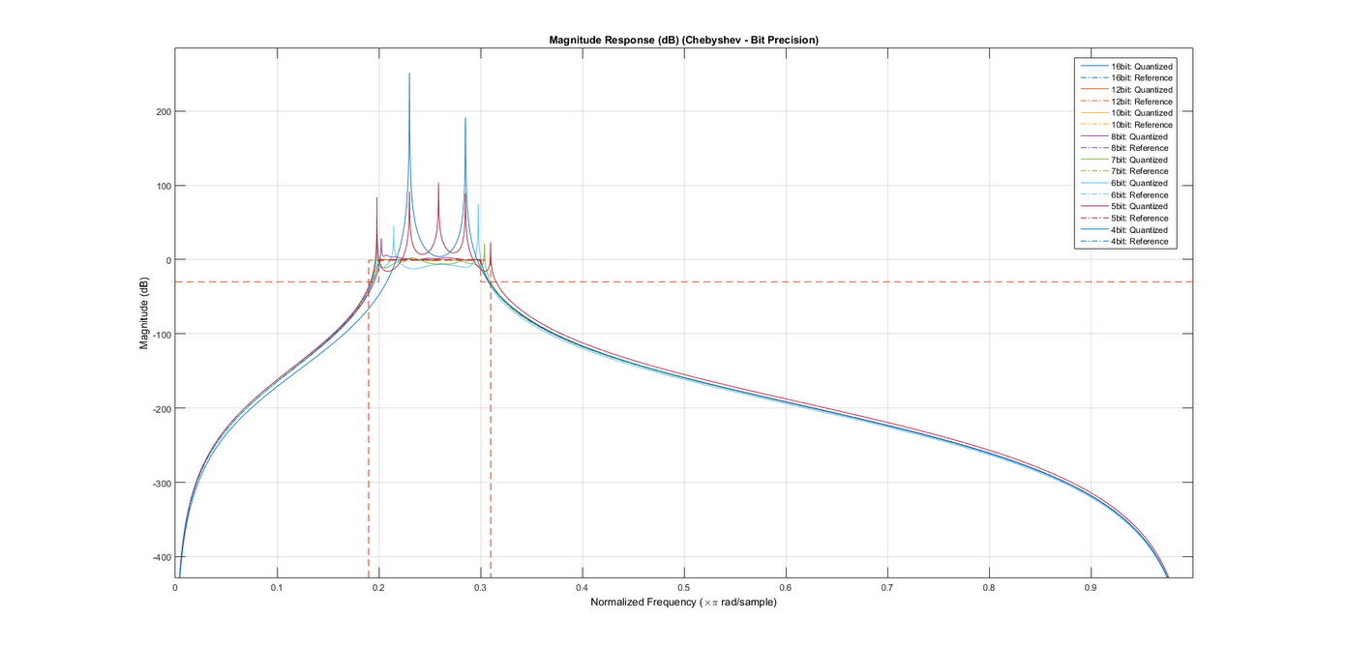

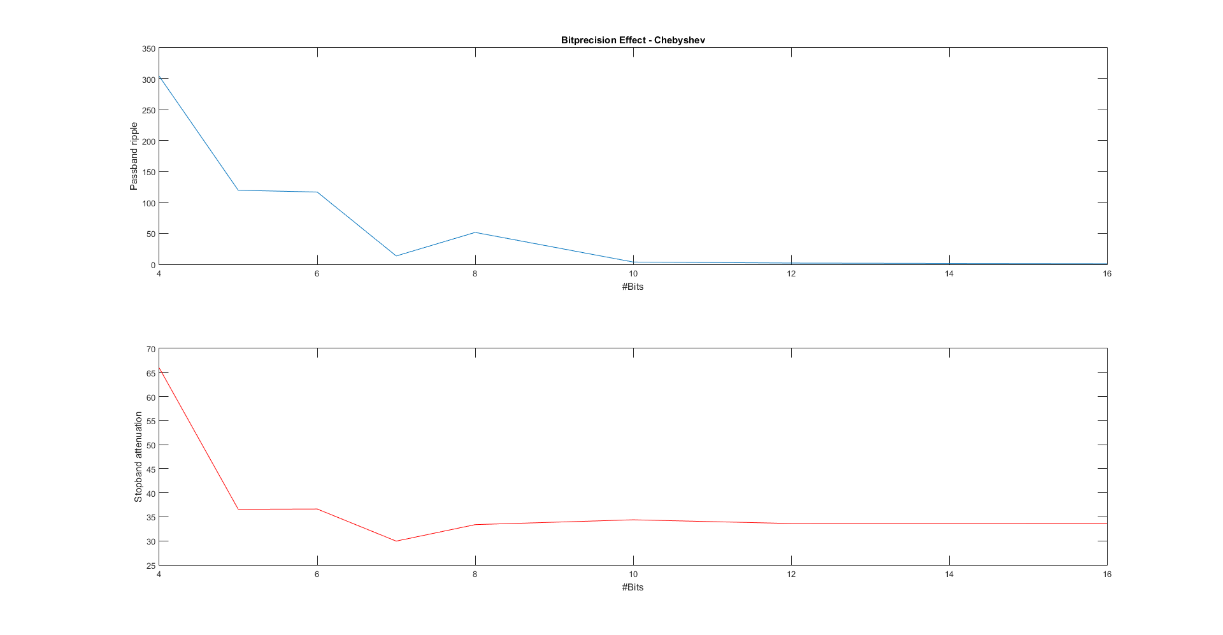

1. IIR – Inverse Chebyshev (Chebyshev Type II)

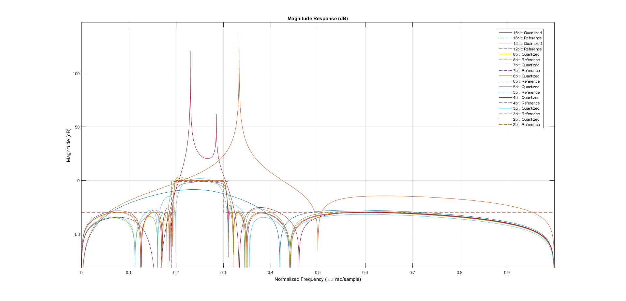

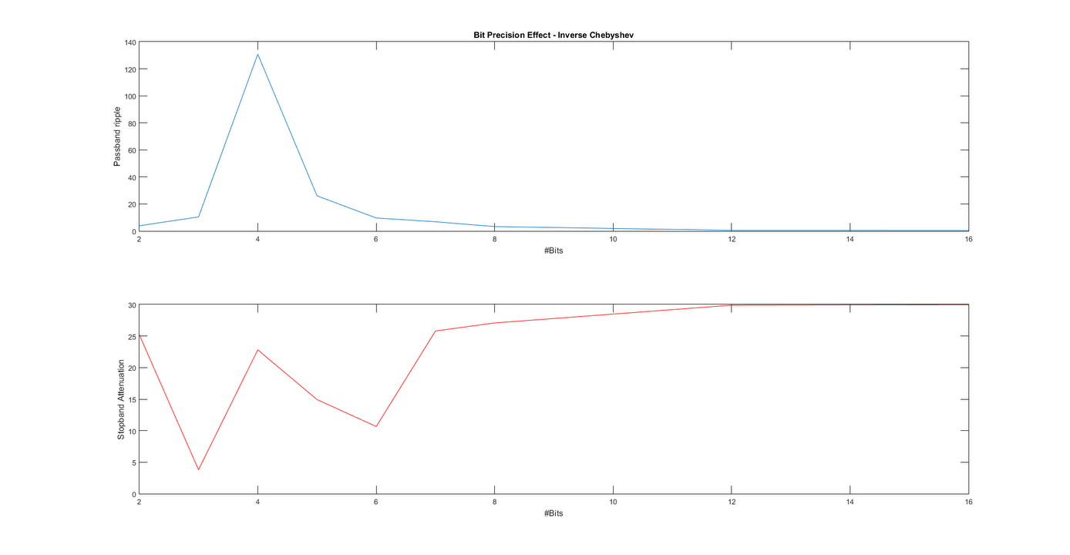

1. IIR – Elliptic

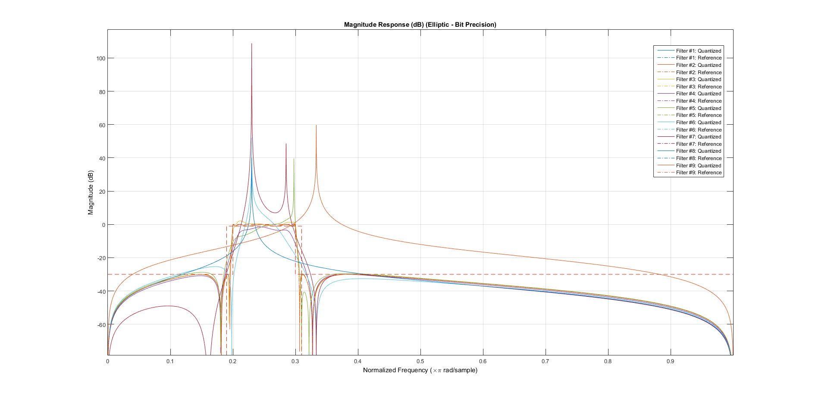

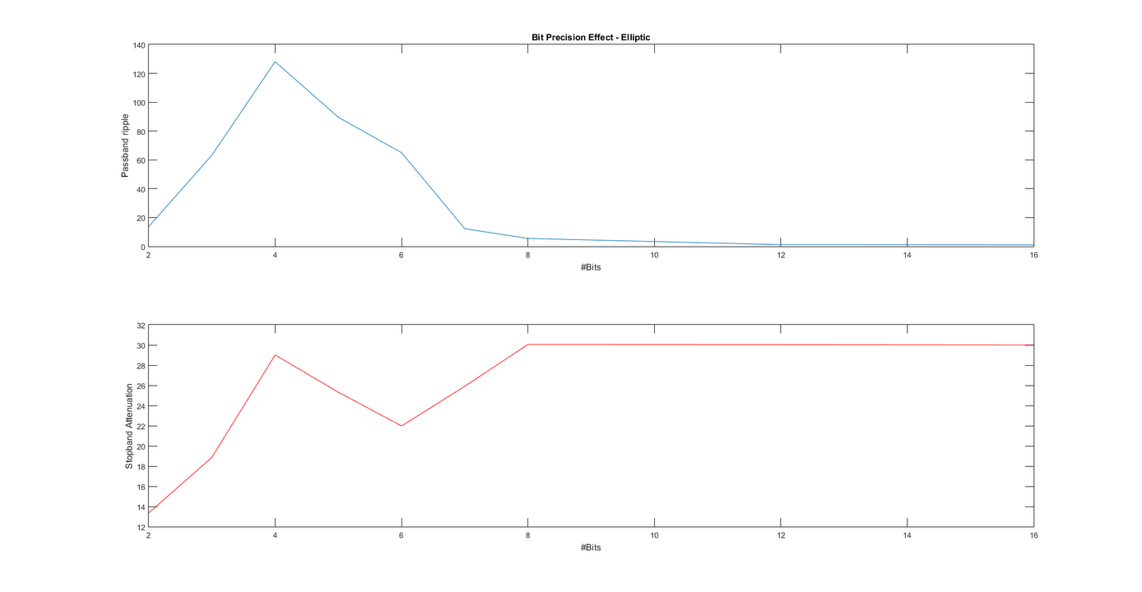

Butterworth: Unstable when #Bits <= 5

Chebyshev-I: Unstable when #Bits <= 7

Chebyshev-II: Unstable when #Bits <= 4

Elliptic: Unstable when #Bits <= 8

# Discussions:

### Aditya Sinha (14EC10002)

1. Although IIR filters have lesser order than FIR filters, they are more difficult to implement, having more complex hardware (need for feedback). Also, there is the added fact that they are acausal, making them unfit for real time applications.
2. Elliptic IIR filter has a sharp cut-off and meets the requirements at the least order. This is the reason why it is so widely used in spacecraft applications for sensing low voltages.
3. While seeing the bit precision effect, we saw that below a certain number of bits, the filter becomes unstable and poles move outside the unit circle. This happens at a higher number of bits for elliptic filter. So, although elliptic filters are the sharpest, they are also the most vulnerable to stability issues and their passband ripple and stop band attenuation quickly degrade with truncation of bits. So, to implement the elliptic filter, we need more complex hardware.
4. In rectangular window, on increasing the filter order, we see very little change in the stop band attenuation. This is as rectangular windowing method is designed to have a sharp cutoff and the stop band attenuation starts saturating after a order of about 100.

### Saurabh Dash (14EC10050)

1. The filter design tool gives us a better result, as it internally uses functions like ellipord() to compute the minimum order filter. Plus, it is indispensable for the purpose of seeing bit precision effect.
2. We see that as the filter response starts becoming unstable, there is a sharp change in the passband ripple and stopband attenuation.
3. Elliptic filter has the most stability concern among the IIR filters. This is a tradeoff that we have to deal with for obtaining a sharp filter. Since elliptic filters normally have a higher ripple in the passband as well as stop band when compared to Butterworth or Chebyshev, so their response also degrades more quickly with change in bit precision.