Experiment 5: Deconvolution using Non-Linear Signal Processing Technique (Cepstrum Analysis)

## AIM: To deconvolve and recreate the original Signal as accurately as possible

*Theory:*

The idea is based on the Non Linear Signal Processing technique of Cepstrum Analysis.

The complex cepstrum of a sequence x is calculated by finding the complex natural logarithm of the Fourier transform of x, then the inverse Fourier transform of the resulting sequence:

https://in.mathworks.com/help/examples/signal/win64/CepstrumAnalysisExample_01.png

The input signal Z-Transform:

$$X\left(Z\right)= \frac{0.98+z^{-1}}{(1-0.9e^{\frac{iπ}{6}}z^{-1})(1-0.9e^{-\frac{iπ}{6}}z^{-1})}$$

And the impulse repsonse of the environment:

$$h\left[n\right]= δ\left[n\right]+0.9δ\left[n-15\right]+0.81δ[n-30]$$

Now upon passing x[n] through the environment h[n] we obtain y[n] which is essentially the original signal and it’s echos.

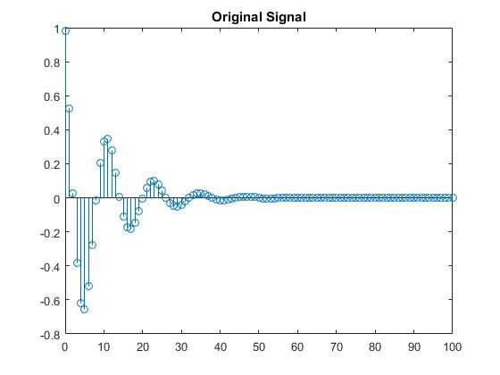

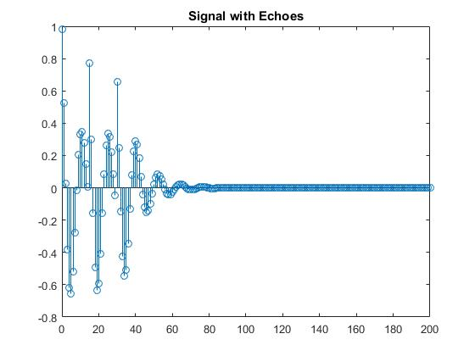

Now the idea of using cepstrum is convert a Multiplicative problem to a additive problem so that the original Signal can be filtered out. It compresses the spectral content of the signal because of the Logarithm operation so that it can be truncated and filtered out.

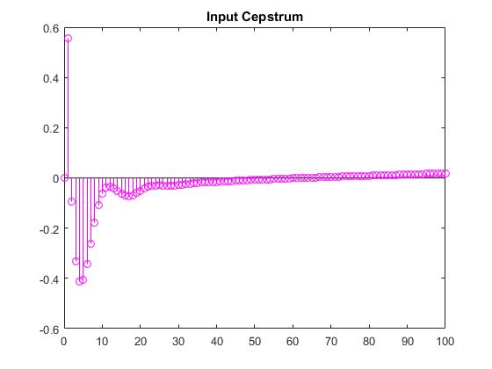

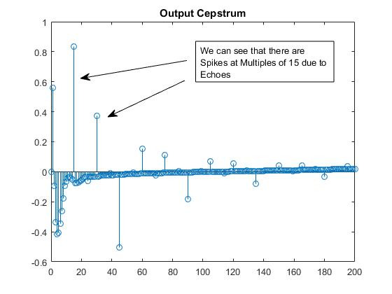

Now to reconstruct the original signal,

* We can truncate this by taking the first 15 samples (before it is corrupted by the echo)
* We can set the values of the cepstrum to 0 at the spikes.
* We can set the values of the cepstrum to the average of the immediate previous and next values at the spikes.

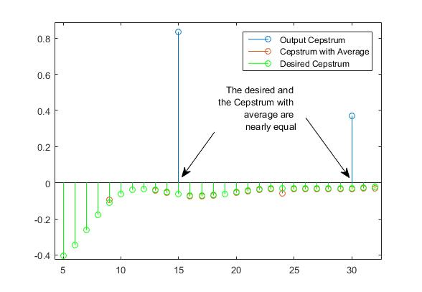

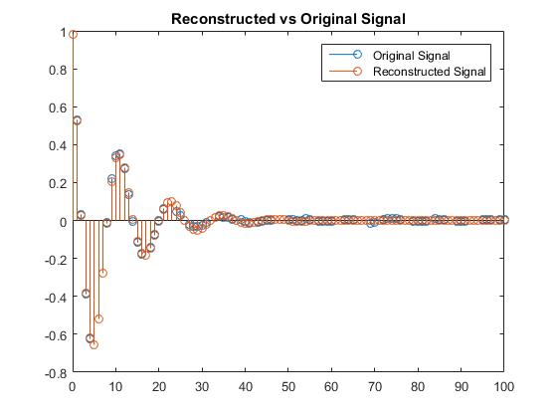

The above reconstructed signal is obtained by using the Averaged Cepstrum.

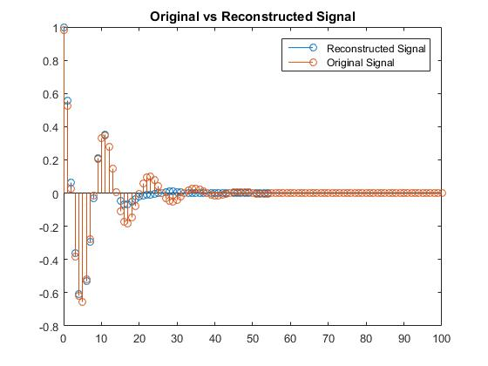

The above reconstructed signal is obtained by using the Truncated Cepstrum.

## Code:

clear;

clc;

close all;

%%

a = -10/(9*1i) + 0.98*exp(1i*pi/6)/1i;

b = 10/(9*1i) - 0.98*exp(-1i*pi/6)/1i;

n = 0:1:100;

x = a*power(0.9*exp(1i*pi/6),n)+b*power(0.9*exp(-1i*pi/6),n);

stem(n,x);

c0 = cceps(x);

%figure;

%stem(0:1:100,c0)

%%

h = zeros(1,101);

h(1) = 1;

h(16) = 0.9;

h(31) = 0.81;

%%

y = conv(x,h);

figure;

stem(0:1:200,y)

%%

c = cceps(y);

figure;

stem(0:1:200,c)

%%

%{

c1 = c;

for i = 1:200

if (mod(i,15) == 0)

c1(1,i+1) = (c1(1,i) + c1(1,i+2))/2;

end

end

%}

%%

c1 = zeros(1,201);

c1(1:15) = c(1:15);

%%

%figure;

hold on;

stem(0:1:200,c1);

stem(0:1:100,c0,'p');

x1 = icceps(c1);

%{

for i = 10:1:100

c1(1:i) = c(1:i);

x1 = icceps(c1);

err(i-9) = sqrt(sum(abs(x-x1)));

end

%}

%plot(10:1:100,err);

figure;

stem(0:1:100,x1(1:101));

hold on;

stem(0:1:100, x);

# Discussions:

### Aditya Sinha (14EC10002)

* Using non-linear transform, we have converted our original multiplication of z-transforms to an addition. Following this, we have used methods like simple truncation and first order interpolation to remove the h’[n] part.
* Deconvolution is helpful in estimating the channel when only the received signal is known, as it deconvolves the received signal to obtain transmitted signal and channel parameters.
* In practice, interpolation is not feasible, as it requires involved hardware.
* If using simple truncation, which is the practically feasible one, we’ll have significant error in frequency content of x after the first observed echo of h (in the cepstral domain). So, it is essential to use a low-frequency transmitting signal to effectively retrieve the channel parameters.

### Saurabh Dash (14EC10050)

* We can see that the reconstructed signal is better in the case of averaged cepstrum instead of the truncated one because it more closely resembles the cepstrum of the input signal.
* The First few samples of the cepstrum contain majority of the spectral information because of a nonlinear operation. Hence even by truncation we get reasonable results at least till a few samples.
* Further H(Z) can be found out by finding the dividing $Y\left(Z\right)$ with $\hat{X}(Z)$
* There is considerable degradation in the reconstructed signal if there are spikes in the cepstrum