Experiment 6: Noise Cancellation using Wiener Filtering

## AIM: To perform Noise Cancellation of a low SNR Signal using the method of optimal Wiener Filtering

*Theory:*

There are two sensors- primary and secondary. The primary sensor receives the signal s[n] corrupted with noise v1[n]. While the secondary sensor receives v2[n], a signal that is correlated with the noise v1[n].

A naïve filtering algorithm can be considered for filtering by subtracting the noise received in the secondary signal from the signal obtained at the primary one to estimate the original signal.

Since the noise obtained at the secondary sensor is not exactly the one at primary but just correlated with it, the above method is not optimal.

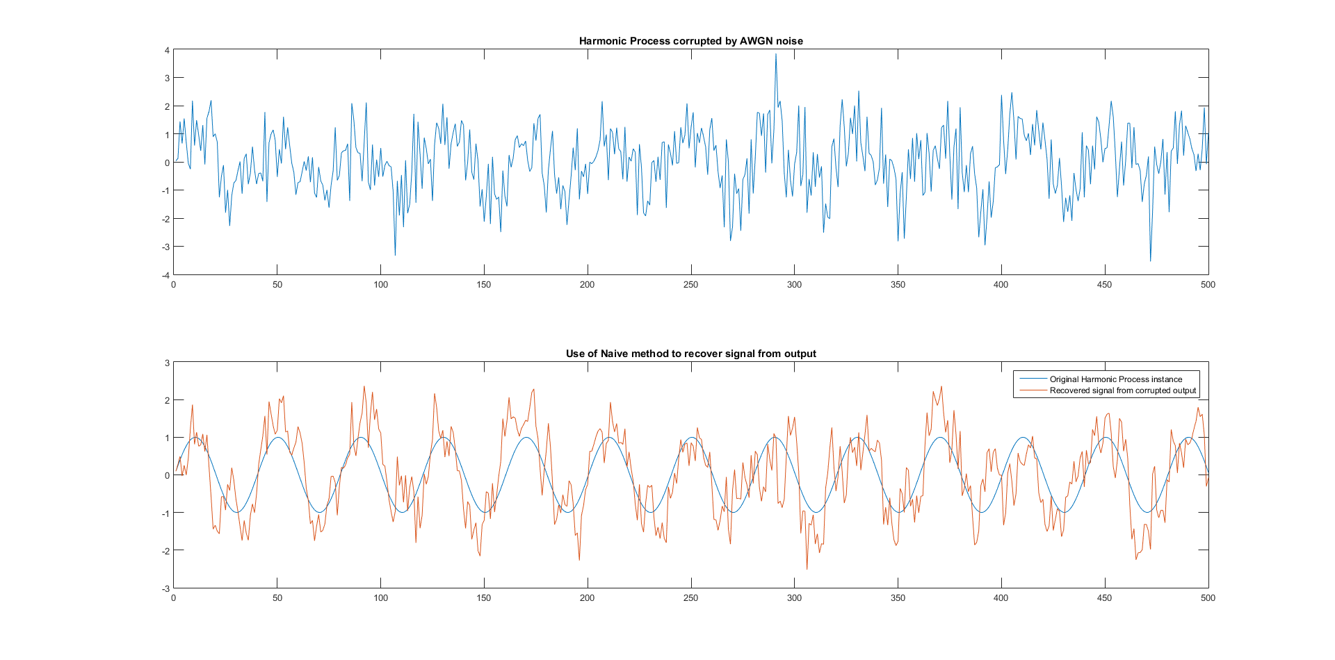

Hence we use a Wiener Filter. Using the wiener filter we can estimate the noise obtained at the primary sensor and thus an estimate of the original signal.

In the context of noise cancellation, we use wiener filtering to get an estimate of v1 noise from the correlated noise obtained at the secondary sensor (v2)

For this, we use the wiener filtering equation and get the optimal filter coefficients. Then, we get an estimate of v1 and subtract it from the primary sensor signal to get the desired signal.

$$\overline{R_{x}} \overline{w}= \overline{r_{dx}}$$

For noise cancellation, the input signal is the secondary sensor input v2 and the desired estimation is of the primary sensor noise v1.

$$\overline{R_{v_{2}}} \overline{w}= \overline{r_{v_{1}v_{2}}}$$

This will further reduce to

$$\overline{R_{v_{2}}} \overline{w}= \overline{r_{xv_{2}}}$$

As desired signal and noise are uncorrelated.

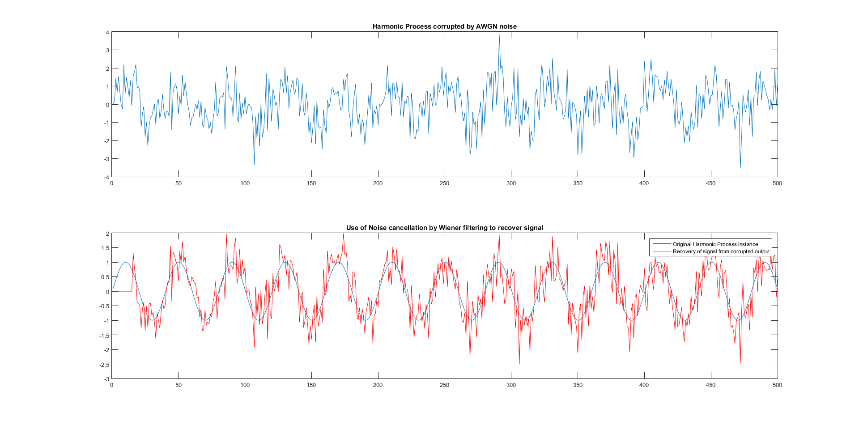

## Code:

clear;

clc;

%%

N = 500;

n = 0:N-1;

w0 = 0.05*pi;

s = sin(w0*n + -pi+ 2*pi*rand);

%plot(s);

w = random('norm', 0,1,1,500);

%plot(w);

v = zeros(1,500);

a = 0.6;

v(1)=w(1);

for i=2:500

v(i)=a*v(i-1)+w(i);

end

%plot(v);

%figure;

x = s + w;

%plot(x);

%% Naive Noise Cancellation

s1 = x - v; %subtract signals at primary and secondary signals

%figure;

%plot(s1);

%% Wiener filtering of secondary signal

p = 15;

r_xv = crosscorr(x, v, p-1);

r_xv = r_xv(p:2*p-1)';

r_v = crosscorr(v, v, p-1);

r_v(1:ceil(length(r_v)/2) - 1)=[];

R_v = toeplitz(r_v,conj(r_v));

wien = R_v\r_xv;

s2=zeros(1,N);

v_n = fliplr(v);

for i=1:N-p+1

s2(N-i+1) = x(N-i+1)-v_n(i:i+p-1)*wien;

end

plot(s2);

# Discussions:

### Aditya Sinha (14EC10002)

* For the purpose of wiener filtering, we require the process to be stationary and ergodic, as we use the values of sample cross-correlation. For this purpose, we have used a harmonic process as the desired signal.
* For noise cancellation, the primary sensor senses the channel output and the secondary sensor senses the ambient surroundings.
* The naïve method still gives us a decent result. This is as the constant ‘a’ is such that there is a strong correlation between v1 and v2. In practical scenario, it might not be so.
* In practical scenario, it is not realistic for the secondary sensor to get only the noise and there will also be some signal component coupled. This will subsequently hamper the estimation and wiener filtering won’t be optimal. We will see an increase in error.
* Since signal coupling can’t be avoided, we can change tracks altogether and use methods like the Adaptive Line Enhancer, where we use the primary signal delayed by a certain amount as the secondary signal. The two sensors are accordingly placed.

### Saurabh Dash (14EC10050)

* The core idea of noise cancellation is getting an estimate of the primary noise from the statistics of the primary and secondary signals (done using optimal wiener filtering) so that it can be removed.
* The order of the wiener filter required depends on the SNR. If the SNR decreases, the order of the filter increases.
* There can be coupling of the desired signal to the secondary signal, which would further result in the degradation of the estimated signal.
* It is important the desired signal and the noise in the secondary sensor must be uncorrelated, so that $\overline{r_{xv_{2}}}$ is equal to $\overline{r_{v_{1}v_{2}}}$