FUNCTIONAL REQUIREMENTS DOCUMENT

Sparecare
Warehouse Management System - Inward Module

Module: WMS - Inward Module
System: Ogys (Deepmindz / Sparecare)
Source: Requirements Discussion - Sessions 01 to 07 - Aug 4 & Aug 12, 2026
Version: 0.11 - Draft
Status: For Review
Prepared by: Saurabh kumar verma

Note on Colour Convention
Text in blue italic throughout this document represents analyst-generated descriptions of screen fields and behaviour, derived by interpreting the session screenshots - not verbatim from the requirements discussion. Text in dark teal marks the Layman Description subsections added in version 0.11. These restate each capability in everyday language with a worked example, for readers who need the substance without the specification detail. They are explanatory only and create no requirement.

Document History
Version | Date | Author | Change Notes
0.1 | Aug 5, 2026 | Saurabh kumar verma | Initial draft - WMS Inward Module - Session 01 (Aug 4, 2026): Gate Entry, Consignment Details, Inward Dashboard
0.2 | Aug 6, 2026 | Saurabh kumar verma | Session 02 (Aug 4, 2026): Receipt Details, Truck Unload - invoice capture, transporter details, box scanning, box condition assessment, unloading status tracker
0.3 | Aug 6, 2026 | Saurabh kumar verma | Session 03 (Aug 4, 2026): unloading without a shipment document, box sticker generation for non-scannable consignments, consignment check initiation, direct-to-bin secondary scanning and product identification, and bin placement with location confirmation. Section 9 extended with save and resume, ship list handling, exception actions, progress tracking and printable summary.
0.4 | Aug 6, 2026 | Saurabh kumar verma | Session 04 (Aug 4, 2026): direct binning Case 1A (primary and secondary cartons the same) and Case 1B (single SKU with primary-product linkage unavailable). Section 14 amended - Confirm Location superseded by Select Location, alternative bin locations, occupancy-aware recommendation as future scope.
0.5 | Aug 6, 2026 | Saurabh kumar verma | Session 05 (Aug 4, 2026): direct binning Case 1C (only the secondary product scannable) and Case 1D (nothing scannable, no supplier data); case selection by supplier-product combination and default OK condition handling; video recording of carton opening; the Case 1 open delivery flow; multi-SKU consignment check and its variance summary; and Case 2A with secondary cartons inside the primary carton. Section 24 records the removal of the box-not-in-uploaded-list prompt at consignment check.
0.6 | Aug 6, 2026 | Saurabh kumar verma | Session 06 (Aug 4, 2026): Case 2B (linkage not available, linkage established by the physical check), Case 2C (only the secondary product scannable) and Case 2D (nothing scannable, no supplier details); open delivery extended with primary carton capture, duplicate scan control and bin location selection; the Binning module - cart assembly and the three binning routes; workflow tracking and system action traceability; and the Location Audit approach. Section 24 amended - Case 2A screens confirmed as 11A to 11C and repeat-scan counting, manual count entry and SKU-level summary added.
0.7 | Aug 12, 2026 | Saurabh kumar verma | Session 07, Part 1 of 4 (Aug 12, 2026) - FRD review against the BRD working through the gap register. New sections: nature of inward transactions including third party purchase and contractor ownership; consignment master data, categories and the Others fallback; mobile and web channel coverage; ship list capture and extraction; and forward-looking location planning and wave picking. Amendments closing gaps in sections 4, 5, 6, 8, 9, 10, 29 and 30.
0.8 | Aug 12, 2026 | Saurabh kumar verma | Session 07, Part 2 of 4 (Aug 12, 2026) - FRD walkthrough and correction. New sections: role hierarchy, access control and audit logging; terminology standardisation. Corrections applied in place: Screen 1 name and contact fields now refer to the truck driver only, GEN selected from a dropdown rather than typed on Screen 2, Courier Type value list aligned to the BRD, and the term Inward Code withdrawn throughout in favour of Gate Entry Number. Section 2 extended with the note that Modules 2 to 5 were described at overview level only; section 29 extended with the rationale for hiding the expected quantity to bin.
0.9 | Aug 12, 2026 | Saurabh kumar verma | Session 07, Part 3 of 4 (Aug 12, 2026) - FRD walkthrough and correction. Corrections in place: FR-004.5 (invoice summary table renders on Screen 4b, not Screen 4a); FR-006.5 and the Screen 6a field reference (photograph mandatory where box condition is other than OK); FR-006.8 (status search returns unloaded or not unloaded only, variance removed, lookup available after session closure); FR-007.6 and FR-007.8 (reconciliation against the expected box count at Receipt Details rather than the gate entry count). Update Box Condition, Mark for Open Delivery and Take Photo removed from the Screen 6b field reference. New correction subsections 4.6, 7.5, 8.6, 9.8 and 10.7 adding FR-001.21, FR-005.10, FR-005.11, FR-006.25 to FR-006.28 and FR-007.15. Open issues OI-066 to OI-073.
0.10 | Aug 12, 2026 | Saurabh kumar verma | Session 07, Part 4 of 4 (Aug 12, 2026) - binning walkthrough. New sections: 40 (FR-037) binning location exception handling across all three routes, Screens 16A to 16F; 41 (FR-038) administrator location exception queue, Screen 17; 42 (FR-039) location recommendation and alternate location rules; 43 (FR-040) forward-looking binning enhancements. Amendment subsections 29.7 (pack size source, direct quantity entry, delete control - closing OI-072) and 30.7 (location sequence, queued next product, actual against expected binned). Exception handling screens renumbered from the source labels 13A/13B, 14A/14B and 15A/15B to 16A to 16F to avoid collision with Case 2D and the binning routes. Open issues OI-074 to OI-082. Session 07 complete.
0.11 | Aug 25, 2026 | Saurabh kumar verma | Layman Description subsections added to all 40 requirement sections, shown in dark teal. Each restates the capabilities of that section in everyday language with a worked example, drawn from the competitor feature comparison workbook. Inserted unnumbered between the Overview and the Functional Requirements of each section, so no existing subsection number or cross-reference changes. Section 39 written new, having no mapped capability in the workbook. Body line spacing set to 1.15 throughout. No requirement added, removed or altered in this version.

Table of Contents
Note: In Microsoft Word, right-click the TOC entries and select Update Field to refresh page numbers.
1. Introduction
1.1 Purpose
1.2 Scope
1.3 Definitions & Abbreviations
2. System Context & Application Vision
2.1 Sparecare Application Overview
2.2 WMS as the Fifth Module
2.3 WMS Module Breakdown
2.4 Note on Module Coverage (Session 07)
3. Inward Module Overview
3.1 Module Purpose & Scope
3.2 Inward Process Steps
3.3 Consignment Source Types
3.4 OEM Document Variability
4. FR-001: Gate Entry (Create GEN) - Screen 1
4.1 Overview
Layman Description
4.2 Functional Requirements
4.3 Screen Field Reference
4.4 Amendments from Session 07
4.5 Corrections from Session 07 (Part 2)
4.6 Corrections from Session 07 (Part 3)
5. FR-002: Consignment Details & Workflow Configuration - Screen 2
5.1 Overview
Layman Description
5.2 Functional Requirements
5.3 Screen Field Reference
5.4 Amendments from Session 07
5.5 Corrections from Session 07 (Part 2)
6. FR-003: Inward Operations Dashboard - Screen 3
6.1 Overview
Layman Description
6.2 Functional Requirements
6.3 Screen Field Reference
6.4 Amendments from Session 07
7. FR-004: Receipt Details - Invoice & Transporter Capture - Screens 4a & 4b
7.1 Overview
Layman Description
7.2 Functional Requirements
7.3 Screen Field Reference - Screen 4a
7.4 Screen Field Reference - Screen 4b
7.5 Corrections from Session 07 (Part 3)
8. FR-005: Truck Unload Initiation & GEN Selection - Screen 5A & 5b
8.1 Overview
Layman Description
8.2 Functional Requirements
8.3 Screen Field Reference - Screen 5A
8.4 Screen Field Reference - Screen 5b
8.5 Amendments from Session 07
8.6 Corrections from Session 07 (Part 3)
9. FR-006: Box Scanning, Condition Assessment & Variance Check - Screens 6a, 6b & 6c
9.1 Overview
Layman Description
9.2 Functional Requirements
9.3 Screen Field Reference - Screen 6a
9.4 Screen Field Reference - Screen 6b
9.5 Screen Field Reference - Screen 6c
9.6 Consolidated Unloading View - Filled State
9.7 Amendments from Session 07
9.8 Corrections from Session 07 (Part 3)
10. FR-007: Unloading Without Shipment Document - Screens 6d, 6e & 6f
10.1 Overview
Layman Description
10.2 Functional Requirements
10.3 Screen Field Reference - Screen 6d
10.4 Screen Field Reference - Screen 6e
10.5 Screen Field Reference - Screen 6f
10.6 Amendments from Session 07
10.7 Corrections from Session 07 (Part 3)
11. FR-008: Box Sticker Generation for Non-Scannable Consignments - Screens 6g & 6h
11.1 Overview
Layman Description
11.2 Functional Requirements
11.3 Screen Field Reference - Screen 6g
11.4 Screen Field Reference - Screen 6h
12. FR-009: Consignment Check Initiation - Screen 7a
12.1 Overview
Layman Description
12.2 Functional Requirements
12.3 Screen Field Reference - Screen 7a
13. FR-010: Direct to Bin - Secondary Scan & Product Identification - Screens 8a & 8b
13.1 Overview
Layman Description
13.2 Functional Requirements
13.3 Screen Field Reference - Screen 8a
13.4 Screen Field Reference - Screen 8b
13.5 Sticker Print Formats
14. FR-011: Bin Placement & Location Confirmation - Screen 8c
14.1 Overview
Layman Description
14.2 Functional Requirements
14.3 Screen Field Reference - Screen 8c
15. FR-012: Direct Binning Case 1A - Primary and Secondary Cartons Are the Same - Screens 8A, 8B, 8C & 8D
15.1 Overview
Layman Description
15.2 Functional Requirements
15.3 Screen Field Reference - Screen 8A
15.4 Screen Field Reference - Screen 8B
15.5 Screen Field Reference - Screen 8C
15.6 Screen Field Reference - Screen 8D
16. FR-013: Direct Binning Case 1B - Single SKU in Primary Carton, Primary-Product Linkage Unavailable - Screens 9a, 9b, 9A, 9B & 9C
16.1 Overview
Layman Description
16.2 Functional Requirements
16.3 Screen Field Reference - Screens 9a & 9b
16.4 Screen Field Reference - Screen 9A (Scan Primary Carton)
16.5 Screen Field Reference - Screen 9B (Scan Product / Secondary Unit)
16.6 Screen Field Reference - Screen 9C (Condition Check & Routing)
16.7 Case 1B Rules, Alerts and Carton Sticker
17. FR-014: Direct Binning Case 1C - Only the Secondary Product Is Scannable - Screens 10A, 10B, 10C & 10D
17.1 Overview
Layman Description
17.2 Functional Requirements
17.3 Screen Field Reference - Screen 10A
17.4 Screen Field Reference - Screen 10B
17.5 Screen Field Reference - Screen 10C
17.6 Screen Field Reference - Screen 10D
18. FR-015: Direct Binning Case 1D - Neither Scannable and No Supplier Data - Screens 10E, 10F, 10G & 10H
18.1 Overview
Layman Description
18.2 Functional Requirements
18.3 Screen Field Reference - Screen 10E
18.4 Screen Field Reference - Screen 10F
18.5 Screen Field Reference - Screen 10G
18.6 Screen Field Reference - Screen 10H
19. FR-016: Case Selection by Supplier-Product Combination and Cross-Cutting Condition Rules
19.1 Overview
Layman Description
19.2 Functional Requirements
20. FR-017: Video Recording of Carton Opening
20.1 Overview
Layman Description
20.2 Functional Requirements
21. FR-018: Open Delivery Flow - Case 1, Same SKU - Piece-to-Piece Inspection
21.1 Overview
Layman Description
21.2 Functional Requirements
21.3 Screen Field Reference - Open Delivery Boxes
21.4 Screen Field Reference - Selected Box & Piece-to-Piece Inspection
21.5 Screen Field Reference - Binning & Location Selection
22. FR-019: Multi-SKU Consignment Check - Screens 11a & 11b
22.1 Overview
Layman Description
22.2 Functional Requirements
22.3 Screen Field Reference - Screen 11a
22.4 Screen Field Reference - Screen 11b
23. FR-020: Consignment Check Variance Summary - Screen 11c
23.1 Overview
Layman Description
23.2 Functional Requirements
23.3 Screen Field Reference - Screen 11c
24. FR-021: Case 2A - Secondary Cartons Inside the Primary Cartons - Screens 11A, 11B & 11C
24.1 Overview
Layman Description
24.2 Functional Requirements
24.3 Screen Field Reference - Screen 11A
24.4 Screen Field Reference - Screen 11B
24.5 Screen Field Reference - Screen 11C
24.6 Amendments from Session 06
25. FR-022: Case 2B - Secondary Cartons Inside the Primary Cartons, Linkage Not Available
25.1 Overview
Layman Description
25.2 Functional Requirements
25.3 Screen Field Reference - Steps 1 & 2
25.4 Screen Field Reference - Steps 3 & 4
25.5 Screen Field Reference - Steps 5 & 6
26. FR-023: Case 2C - Only the Secondary Product Scannable
26.1 Overview
Layman Description
26.2 Functional Requirements
26.3 Screen Field Reference - Steps 1 & 2
26.4 Screen Field Reference - Steps 3 to 6
27. FR-024: Case 2D - Nothing Scannable and No Supplier Details - Screens 13A to 13D
27.1 Overview
Layman Description
27.2 Functional Requirements
27.3 Screen Field Reference - Screen 13A
27.4 Screen Field Reference - Screen 13B
27.5 Screen Field Reference - Screen 13C
27.6 Screen Field Reference - Screen 13D
28. FR-025: Open Delivery - Primary Carton Capture, Duplicate Scan Control and Bin Location Selection
28.1 Overview
Layman Description
28.2 Functional Requirements
28.3 Screen Field Reference - Capture Primary Carton
28.4 Screen Field Reference - Inspect Open Delivery Box
28.5 Screen Field Reference - Binning & Location Selection
29. FR-026: Binning - Cart Assembly - Screens 12a & 12b
29.1 Overview
Layman Description
29.2 Functional Requirements
29.3 Screen Field Reference - Screen 12a
29.4 Screen Field Reference - Screen 12b
29.5 Amendments from Session 07
29.6 Amendments from Session 07 (Part 2)
29.7 Amendments from Session 07 (Part 4)
30. FR-027: Binning Execution - By Product, By Location and Direct - Screens 13a, 13b, 14a, 14b & 15
30.1 Overview
Layman Description
30.2 Functional Requirements
30.3 Screen Field Reference - Screens 13a & 13b
30.4 Screen Field Reference - Screens 14a & 14b
30.5 Screen Field Reference - Screen 15
30.6 Amendments from Session 07
30.7 Amendments from Session 07 (Part 4)
31. FR-028: Consignment Workflow Tracking and System Action Traceability
31.1 Overview
Layman Description
31.2 Functional Requirements
32. FR-029: Location Audit - Approach
32.1 Overview
Layman Description
32.2 Functional Requirements
33. FR-030: Nature of Inward Transactions
33.1 Overview
Layman Description
33.2 Functional Requirements
34. FR-031: Consignment Master Data, Categories and the Others Fallback
34.1 Overview
Layman Description
34.2 Functional Requirements
35. FR-032: Mobile and Web Channel Coverage
35.1 Overview
Layman Description
35.2 Functional Requirements
36. FR-033: Ship List Capture, Upload and Extraction
36.1 Overview
Layman Description
36.2 Functional Requirements
36.3 Screen Field Reference - Ship List Capture and Reconciliation
37. FR-034: Warehouse Location Planning and Wave Picking (Forward-Looking)
37.1 Overview
Layman Description
37.2 Functional Requirements
38. FR-035: Role Hierarchy, Access Control and Audit Logging
38.1 Overview
Layman Description
38.2 Functional Requirements
39. FR-036: Terminology Standardisation and Field Naming
39.1 Overview
Layman Description
39.2 Functional Requirements
40. FR-037: Binning Location Exception Handling - Screens 16A to 16F
40.1 Overview
Layman Description
40.2 Functional Requirements
40.3 Screen Field Reference - Screens 16A & 16B (Binning by Product)
40.4 Screen Field Reference - Screens 16C & 16D (Binning by Location)
40.5 Screen Field Reference - Screens 16E & 16F (Direct Binning)
41. FR-038: Binning Location Exception Queue - Administrator - Screen 17
41.1 Overview
Layman Description
41.2 Functional Requirements
41.3 Screen Field Reference - Screen 17 (Binning Location Exception Queue)
42. FR-039: Location Recommendation and Alternate Location Rules
42.1 Overview
Layman Description
42.2 Functional Requirements
43. FR-040: Forward-Looking Binning Enhancements
43.1 Overview
Layman Description
43.2 Capability Candidates
44. Open Issues & Action Items

1. Introduction

1.1 Purpose
This document defines the functional requirements for the Warehouse Management System (WMS) - Inward Module of the Sparecare integrated platform. It is derived from seven requirements discussion sessions held on August 4 and August 12, 2026, between the Sparecare product team (Naveen Chauhan, Santosh) and Deepmindz. The document translates session discussions and referenced wireframe screens into structured functional specifications for WMS wireframe design and development.

1.2 Scope
This FRD covers the following areas from Sessions 01 to 07:
- System context - Sparecare four existing operating domains and the strategic direction towards a unified integrated cloud platform
- WMS as the fifth module - its position within the Sparecare ecosystem and five broad sub-modules
- Inward Module - end-to-end lifecycle from truck arrival through ERP/DMS synchronisation and finance advice
- Gate Entry (Screen 1) - GEN creation, configurable field capture, document photo upload
- Consignment Details & Workflow Configuration (Screen 2) - product/supplier classification, GEN linkage, per-consignment workflow step applicability
- Inward Operations Dashboard (Screen 3) - real-time pending queue visibility
- Receipt Details - Invoice & Transporter Capture (Screens 4a & 4b) - document number, invoice capture with line-level detail, transporter and driver information, document upload
- Truck Unload Initiation & GEN Selection (Screens 5A & 5b) - GEN search and autofill, invoice selection, transporter verification
- Box Scanning, Condition Assessment & Variance Check (Screens 6a, 6b & 6c) - box-by-box QR scan, condition recording, open delivery workflow, unloading WIP tracker, variance summary
- Extended unloading behaviour (Screens 6a, 6b & 6c) - mid-session save and resume, ship list view and replacement, ship list mismatch handling, unload progress and exception summary, printable unload summary
- Unloading Without Shipment Document (Screens 6d, 6e & 6f) - primary code scan or part number entry, box-number-wise unloading, admin-configured unload approach and manual box counter
- Box Sticker Generation for Non-Scannable Consignments (Screens 6g & 6h) - system-generated temporary box references, sticker printing and scan-back
- Consignment Check Initiation (Screen 7a) - GEN-based retrieval of an unloaded consignment and routing between full consignment check and Direct to Bin
- Direct to Bin - Secondary Scan & Product Identification (Screens 8a & 8b) - secondary box scan, product master lookup, fragile flagging, Issue for Usage, Bin Later batching, D2B and D2W sticker printing
- Bin Placement & Location Confirmation (Screen 8c) - location scan or manual confirmation, part scan, quantity capture and wrong-location handling
- Direct Binning Case 1A (Screens 8A, 8B, 8C & 8D) - primary and secondary cartons the same, unit-by-unit product inspection, damaged-unit set aside for insurance, two-step binning verification, wrong-location override and the bin-later queue
- Direct Binning Case 1B (Screens 9a, 9b and 9A, 9B & 9C) - single SKU in a primary carton where the primary-product linkage is unavailable, manual quantity capture, condition check and routing, and the multiple-SKU and no-location exception paths
- Direct Binning Case 1C (Screens 10A, 10B, 10C & 10D) - primary and secondary cartons the same with only the secondary product scannable, box reference sticker option, secondary scan against master data, unit-by-unit inspection and two-step verified binning
- Direct Binning Case 1D (Screens 10E, 10F, 10G & 10H) - neither carton nor product scannable and no supplier data, manual and predictive product identification, physical count entry, and the exception and next-state panel
- Case selection and cross-cutting condition rules - screen configuration driven by the supplier and product combination, default OK condition on a collapsed panel, and the relabelling of MOQ as quantity per pack size
- Video recording of carton opening - optional toggle at the start of a secondary carton check and a retain-or-delete prompt on completion
- Open Delivery Flow, Case 1 - inspection of cartons flagged during unloading, piece-to-piece condition capture, and binning of good pieces only
- Multi-SKU Consignment Check (Screens 11a & 11b) - a primary carton holding several SKUs, repeated secondary scanning against a constant primary box, and box-level reconciliation against the ship list
- Consignment Check Variance Summary (Screen 11c) - invoiced against received in value, part lines and quantity with short, excess and net, and quality variance by qualitative aspect
- Case 2A (Screens 11A, 11B & 11C) - secondary cartons inside the primary carton with both scannable and linkage available, per-SKU expected against scanned tracking, and carton-wise variance reporting
- Case 2B (six-step flow) - secondary cartons inside the primary carton with both scannable but no linkage, the linkage established by the physical check, actual-scanned work-in-progress counts, and a consignment summary without carton-level variance
- Case 2C (six-step flow) - only the secondary product scannable, the box reference sticker option or the opened cartons counter, and the same summary treatment as Case 2B
- Case 2D (Screens 13A, 13B, 13C & 13D) - nothing scannable and no supplier details, identification by printed barcode stickers or manual and predictive search, condition captured for the selected product only, and the exception and next-state panel
- Open Delivery extension - primary carton capture with smudged-code handling, duplicate scan blocking for unique codes, unique scan code generation for non-unique codes, and bin location selection where several locations are permitted
- Binning - cart assembly (Screens 12a & 12b) - product scanning into a cart, quantity accumulation, the fragile indicator, cart capacity held outside the system, and the cart-then-location-then-parts structure
- Binning execution (Screens 13a, 13b, 14a, 14b & 15) - binning by product, binning by location and direct binning, with location and part verification at the bin, partial placement and relocation
- Consignment workflow tracking and system action traceability - a graphical stepper by consignment or ship list reference, stage durations, and a trace of stickers, generated codes and manual entries
- Location Audit - the two audit approaches introduced at the close of Session 06 for detailing in a subsequent session
- Nature of inward transactions - purchase, branch transfer in, sales return, workshop or in-house return, job work return, and third party purchase with contractor-owned stock held separately from the business's own inventory
- Consignment master data and category management - supplier, carrier, product and document classifications, the mandatory-description Others fallback, auto-generated category codes, PIN code lookup, bulk upload, and inactive categories with the move or don't-move decision
- Mobile and web channel coverage - explicit support for both surfaces and a screen-by-screen assignment of which surface each screen is delivered on
- Ship list capture - soft copy upload, page-by-page camera capture assembled into a PDF, extraction into the master data tables, and view and replace after upload
- Warehouse location planning and wave picking, recorded as forward-looking capability outside the current inward scope
- Amendments closing gaps against the BRD - gate entry date and time of receipt, dashboard aging buckets, document validation at unload selection, auto-finish confirmation with a decline path and partial-unload recording, the third plain-count unload option, permission-gated binning where no location exists, and administrator control over manual entry with scan compliance reporting
- Role hierarchy, access control and audit logging - the Sparecare solution administrator, dealer administrator and dealer user roles, with auditable logs created for every action by every role
- Terminology standardisation - withdrawal of the term Inward Code in favour of the Gate Entry Number throughout the document and the wireframes, and correction of the Courier Type value list
- Corrections to analyst-generated field descriptions on Screen 1 - the truck driver as the sole subject of the name and contact fields, and supplier notification derived from the supplier record rather than the driver's number
- System module context - the five-module breakdown of the warehouse management system with Phase 1 confined to Module 1, Receiving (Inward)
- Corrections to the receipt details specification - the invoice summary table located on Screen 4b as the summary panel, with invoice entry remaining on Screen 4a
- Correction to gate entry selection - the find-by-other-details lookup as a search panel within Screen 5A rather than a separate screen, offering search criteria only
- The Check Unloading Status search as a read-only binary lookup - unloaded or not unloaded, no condition editing, no variance, and available after the unload session has closed
- Photographic evidence made mandatory where a box condition other than OK is recorded, and not required where the condition is OK
- Reconciliation baseline for unloading fixed on the expected box count recorded at Receipt Details, with the gate entry box count treated as indicative only
- Binning location exception handling (Screens 16A to 16F) - the mapped location full, no alternate mapped location available, and no bin location defined, with alternate selection, RBAC-gated manual entry, temporary location and administrator request
- Administrator location exception queue (Screen 17) - the exception backlog by type, request detail, location assignment against the zone hierarchy, temporary manual binning, write-back to the part-location master, and publish-and-notify
- Location recommendation and alternate location rules - the derivation bases put forward, the position that location capacity is not captured, and operator declaration as the sole means of recording a location full
- Forward-looking binning capabilities - schematic site map, voice interaction, cart movement tracking, cart splitting across locations, and system-directed cart composition

Steps 7 (ERP/DMS Sync), 8 (Finance Advice), and sub-modules beyond Inward will be covered in subsequent FRD sessions.

1.3 Definitions & Abbreviations
Term | Definition
WMS | Warehouse Management System - the fifth module being added to the Sparecare integrated platform, covering physical goods receipt, storage, and dispatch operations
GEN | Gate Entry Number - a unique system-generated reference code assigned to every consignment arriving at the warehouse. Serves as the master reference key for the entire inward journey
Inward Module | The first phase of WMS scope; covers the end-to-end process from truck arrival at the gate through to ERP/DMS sync and finance advice
GRN | Goods Receipt Note - a document confirming receipt of goods, one of the accepted primary document types at gate entry
Challan | A delivery note or dispatch document issued by the supplier, accepted as a primary document at gate entry
Ship List | A box-level manifest issued by the OEM detailing each primary box number and its contents; content varies by OEM brand
OEM | Original Equipment Manufacturer - a brand principal that dispatches spare parts to dealer locations
DMS | Dealer Management System - the dealer-side ERP/DMS that receives stock updates after the inward process is complete
ERP | Enterprise Resource Planning system - the backend system that receives stock and financial data post-inward
Primary Box | The outer shipping carton received from the supplier; its quantity and condition are checked at the Truck Unload stage
Secondary Box | The inner product packaging found inside a primary box; checked during the Consignment Check stage
Binning | The process of assigning received stock items to specific warehouse storage locations
VOR Order | Vehicle Off-Road Order - an urgent spare parts order requiring immediate fulfilment; typically single-part, single-box
STO | Stock Transfer Order - an internal transfer of parts from one dealer branch to another
SIMS | Sparecare Inventory Management System - existing cloud-based platform for replenishment order management
Gainer | Existing Sparecare inventory-sharing application for intra/inter-dealer parts sharing and liquidation
AccuStock | Existing Sparecare desktop-based audit services platform for physical inventory audits
LR | Lorry Receipt - a transport document issued by the transporter acknowledging receipt of goods for delivery
SKU | Stock Keeping Unit - a unique identifier for an individual product or part number
WIP | Work In Progress - in the context of truck unload, refers to the real-time unloading status tracker showing progress across all boxes
Open Delivery | A process in which a damaged or suspect box is opened and inspected in front of the transporter/driver, and the condition is recorded for claims purposes
Box Mismatch | A situation during unloading where a scanned box does not match the expected delivery manifest for the GEN - requires confirmation or rejection by the warehouse user
Quality Variance | A summary report of box condition discrepancies per consignment: counts of Damage, Tampered Packaging, Scratch, Broken, and Wrong Delivery boxes
Consignment Check | The secondary verification stage performed after the truck has been unloaded and has left the premises. Primary boxes are opened and their contents verified against the expected quantity.
Direct to Bin (D2B) | A routing decision by which a received part is sent straight to its storage bin without a separate secondary consignment check. Applied where the primary and secondary box are the same physical unit.
Direct to Workshop (D2W) | A routing decision by which a received part is sent straight to the workshop against a vehicle awaiting that part, bypassing storage.
IForU / I4U | Issue for Usage - a flag raised when a scanned part matches an open workshop demand, indicating the part is to be segregated for immediate issue rather than binned.
FR (Fragile) | Fragile indicator held against the product master. Activated on screen when a part defined as fragile is scanned, signalling that it requires careful handling.
MRP Sticker | The secondary box sticker carrying the part identifier and price. It is physically attached to the primary packing, which is why it is lost when the packing is torn off.
Bin Later | An action that defers binning of a scanned part so that several parts can be accumulated and binned together in a single trip.
Binning Zone | The warehouse area allocated to a part in the product master, for example a rack block or aisle group.
Binning Location | The specific rack, shelf or bin position within a binning zone at which a part is to be stored.
MOQ | Minimum Order Quantity - the smallest quantity in which a part is ordered or issued; displayed during binning as a handling reference.
Use Counter | A manual increment control used to count boxes as they are unloaded when neither a ship list nor a scannable box code is available.
Box Reference (Temporary) | A system-generated box number in the format BX-nnnn, issued when no supplier box number exists. Recorded as system-generated so it is not treated as a supplier manifest reference downstream.
Configured Unload Approach | The unloading method selected by the dealer admin for a given scenario - scan-based, counter-based, or sticker-print-and-scan.
Case 1A | The direct binning scenario in which both the primary carton and the secondary unit are scannable, supplier data has been uploaded, and the primary-secondary linkage is available, so the system knows what and how much the carton should contain.
Case 1B | The direct binning scenario in which supplier carton and product data exist but the linkage between them is unavailable. The carton may hold only one SKU, and quantity is established by physical scan or count.
Primary Carton | The outer carton bearing the primary carton barcode. Used interchangeably with primary box in the unloading sections.
Secondary Unit | The individual packaged product inside a primary carton, bearing the product code on the unit or its secondary packing.
Primary-Product Linkage | Supplier-provided data associating a primary carton with the product and quantity it contains. Where unavailable, expected quantity cannot be derived and must be captured by count.
Recommended Location | The bin location the system proposes for a part, drawn from the product master.
Alternative / Other Allowed Locations | Additional bin locations at which a part may legitimately be stored, offered where the recommended location is full or otherwise unavailable.
Set Aside (Insurance) | The outcome applied to a unit found damaged during inspection. The unit is segregated rather than binned so that an insurance claim can be raised against it.
Check Carton | The exception process to which a carton is routed when direct binning cannot proceed, most commonly when multiple product codes are detected inside a single carton.
Capture Status | Indicator on the primary carton record showing how far identification has progressed, for example PRIMARY CAPTURED.
Bin Later Queue | The list of cartons or parts marked for deferred binning, showing the count pending. Deferred binning is completed through the Binning module.
Case 1C | Primary and secondary cartons are the same physical unit and only the secondary product is scannable. Secondary product details are uploaded but the primary-secondary linkage is not available, so the carton is referenced either by a printed box reference sticker or not at all.
Case 1D | Primary and secondary cartons are the same physical unit and nothing is scannable. No supplier details are available and no linkage exists, so the product is identified by manual or predictive search and the quantity is counted physically.
Case 2A | Secondary cartons are contained inside the primary carton. Both are scannable, supplier details are uploaded and the primary-secondary linkage is available, so the check reconciles what is found against what the ship list states for each carton.
Pack Size | The number of units contained in one sale pack, held as master data against the product. This is the value currently displayed on screen as MOQ; the label is to be corrected.
Multi-SKU Primary Carton | A primary carton holding more than one product code. The primary box is scanned once and each secondary product inside it is scanned in turn, with the primary box held constant.
Check Variance | The closing step of a consignment check. Reports invoiced against received in value, part lines and quantity with short, excess and net positions, and reports quality variance by qualitative aspect.
Piece-to-Piece Inspection | Inspection of every individual unit in a carton, used on the open delivery path where the carton was flagged during unloading. Good pieces are binned and damaged pieces are set aside for insurance.
Exception / Next State | The panel presenting the states that arise when a carton cannot be completed normally - the no location alert state and the bin later state - together with the actions available from each.
Case 2B | Secondary cartons inside the primary carton where both are scannable and supplier details are uploaded, but the primary-secondary linkage is not available. The linkage is created by the physical check itself, and no carton-level variance can be reported.
Case 2C | Secondary cartons inside the primary carton where only the secondary product is scannable and no linkage exists. The primary carton is either given a printed box reference sticker or simply counted as opened.
Case 2D | Secondary cartons inside the primary carton where nothing is scannable, no supplier details are available and no linkage exists. Products are identified by manual or predictive search or by printed barcode stickers, and quantities are counted physically.
Cart (Binning Cart) | The physical cart or trolley into which products are collected for binning. Items are scanned as they are added, the same product scanned again increasing the quantity on that line. One cart may serve more than one bin location.
Binning by Product | The binning route that starts from the product: a product is selected from the cart and the system directs the operator to the location recorded against it.
Binning by Location | The binning route that starts from the location: a location is selected and the system shows which product from the cart belongs there.
Direct Binning | Placement of a single product without reference to a cart, capturing product, zone and location and confirming both at the bin.
Unique Scan Code | A code generated and printed by the system for affixing to a secondary pack where the supplier's own code is not unique to the unit, so that individual units can be tracked.
Opened Cartons Counter | A count of how many primary cartons have been opened for checking, used where cartons cannot be identified individually. It advances only when the operator confirms the current carton is complete.
Location Audit | The checking of parts held at a warehouse location, either against a preassigned plan of locations or parts, or generically without planning.
Branch Transfer IN | An inward transaction covering goods transferred from another warehouse within the same business, rather than purchased from an external supplier.
Sales Return | An inward transaction covering goods returned by a customer, whether because the product was not up to standard or for another recorded reason.
Workshop / In-house Return | An inward transaction covering parts previously issued for usage and returned unconsumed - for example where a workshop drew five units and used three.
Job Work Return | An inward transaction covering goods returning from an outward job work transaction, where a process the service centre cannot perform - welding, polishing or milling - was carried out by a third party.
Third Party Purchase | An inward transaction covering goods belonging to a contractor operating within the customer's premises. Ownership rests with the contractor, and the stock is held separately from the business's own inventory.
Others Fallback | The default category held at the end of every classification list, used where an item is not covered by any defined category. Selecting it requires a description, so that recurring entries can later be promoted into categories of their own.
Inactive Category | A category retired from use without being deleted, so that the historical data attached to it is preserved. On deactivation the user nominates a destination category for existing records or chooses Don't Move.
Aging Bucket | A time band applied to the pending queues on the inward dashboard - last 7, 15, 30 and 60-plus days - allowing the operator to see which pending work has been outstanding longest.
Scan Compliance | The proportion of a load binned by scanning against the proportion entered manually, reported so that the exposure created by manual entry is visible.
Sparecare Solution Administrator | The top role in the access hierarchy, administering the platform across dealer organisations.
Dealer Administrator | The role that configures the system for a single dealer organisation - field visibility, category masters, workflow defaults and user permissions.
Dealer User | The role that carries out warehouse operations within the permissions granted by the dealer administrator.
Auditable Log | A record of an action taken in the system, capturing what was done, by whom and when. Created for every action by every role, not only for configuration changes.
Module 1 - Receiving (Inward) | The phase 1 scope of this document: truck arrival, goods receipt note creation, quality and quantity checking, binning, stock movement, ERP and DMS synchronisation, and finance advice.
Check Unloading Status | A read-only lookup on Screen 6b taking a box number or part number and returning whether that item has been unloaded. Returns a binary result only; carries no condition editing and no variance information, and remains available after the unload session has closed.
Expected Box Count | The number of boxes recorded as No. of Boxes in GEN at the Receipt Details stage on Screen 4a. The authoritative baseline against which physical unloading is reconciled. Distinct from the indicative box count that may be taken at gate entry.
Location Exception | A condition at binning in which the location recorded against a part cannot receive the stock: the mapped location is full, no alternate mapped location is available, or no bin location is defined for the part.
Alternate Mapped Location | A location other than the recommended one that is recorded against the part in the master and may receive its stock. Distinct from a location entered manually outside the mapped list, which requires authorisation.
Temporary Location | A holding location recorded against stock that has no defined bin location, used so that binning can proceed while the administrator settles the master.
Part-Location Master | The mapping of parts to bin locations from which recommended and alternate locations are drawn. Updatable by the administrator when resolving a location exception.

2. System Context & Application Vision

2.1 Sparecare Application Overview
Sparecare currently serves automotive dealer customers across four operating domains, each supported by a distinct application:
- Inventory Management (SIMS) - replenishment orders shared with customers to support multi-SKU inventory planning
- Operational Excellence (Power BI) - gap identification, action tracking, and inventory performance dashboards
- Inventory Sharing (Gainer) - intra/inter-dealer parts sharing, slow-mover identification, and liquidation support
- Audit Services (AccuStock) - inventory and process audits at client locations through multiple field approaches

The target state is one integrated cloud application on a common database with modular SaaS architecture, delivered in phases. Currently SIMS and Gainer are cloud-hosted; AccuStock is desktop-based. The new unified platform consolidates workflows and reporting across all domains.
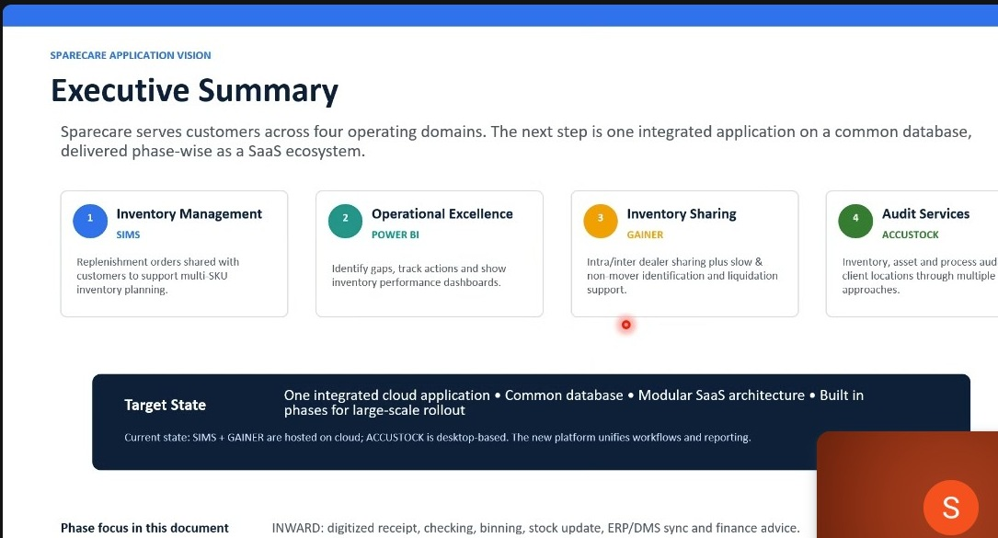
Figure 2.1a - Sparecare Application Vision: four operating domains and target state (one integrated cloud application, common database, modular SaaS architecture)

2.2 WMS as the Fifth Module
The Warehouse Management System (WMS) is the fifth module to be added to the Sparecare integrated platform. It is being built on a new modular architecture to address limitations of the current legacy ASP.NET R12 platform (SCOPE). The WMS will initially focus on the physical goods receipt workflow (Inward Module) and will progressively expand to cover outward, returns, and data analytics.

2.3 WMS Module Breakdown
The WMS comprises five broad modules:
- Module 1 - Receiving (Inward): truck arrival, GRN, quality and quantity check, binning, stock movement, ERP/DMS sync, finance advice
- Module 2 - Operational Excellence: real-time tracking, cycle count / wall-to-wall audit, discrepancy flagging, adjustments, audit trail
- Module 3 - Outward: sales/service order fulfilment, pick list generation, picking via barcode/RFID, packing and labelling, dispatch and gate pass
- Module 4 - Returns: return request handling, goods received, inspection and categorisation, inventory update / disposal
- Module 5 - Data & Analytics: KPI reports, dashboards and analytics, alerts and notifications

Phase 1 scope (this FRD) focuses on Module 1 - Receiving (Inward). The entire WMS will operate on handheld terminals (rugged mobile devices) to enable warehouse staff to scan, record, and update data at the point of physical activity.
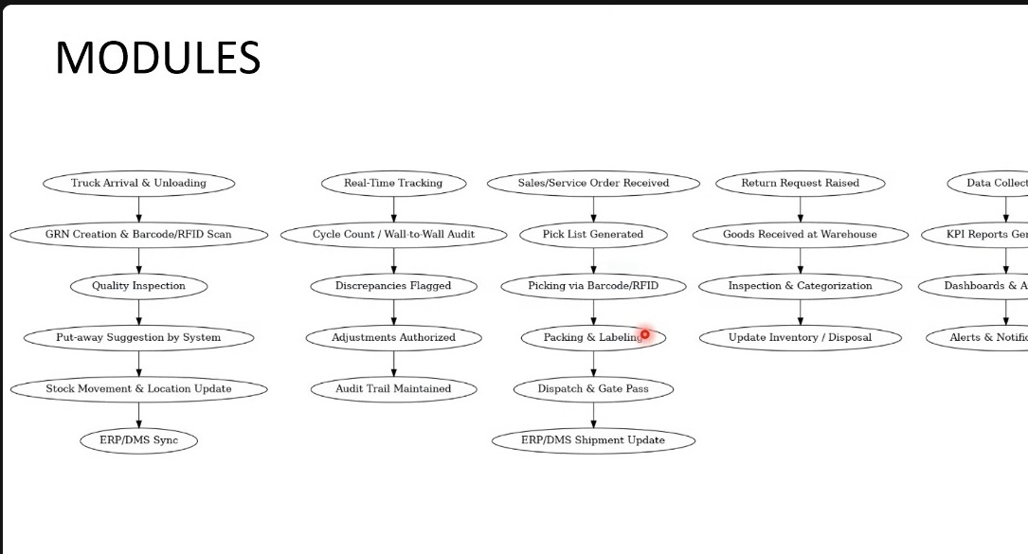
Figure 2.3a - WMS Module Breakdown: five-column flow diagram showing all modules with their constituent steps

2.4 Note on Module Coverage (Session 07)
A caveat was recorded during this session about how much of the wider system has actually been captured. The five-module breakdown at section 2.3 was described in the earlier sessions at overview level only; the detail beneath each of Modules 2 to 5 was not walked through, and individual options within them were mentioned in passing rather than specified.
What was not stated in those sessions is therefore not in this document. The module descriptions for Modules 2 to 5 will need to be gone through in their own right before those phases are specified, and their absence here should not be read as a decision to exclude them.
Note: this matters for reading the rest of the document. Where a capability touches outward movement, returns or analytics, it appears here only to the extent it was raised while discussing inward. Absence from this document is not evidence that a capability is out of scope for the product.

3. Inward Module Overview

3.1 Module Purpose & Scope
The Inward Module covers the complete lifecycle of a consignment from the moment it reaches the warehouse gate until the stock is updated in the system and financial advice is generated. The end result is: controlled physical inward + digital inventory accuracy + downstream system readiness.
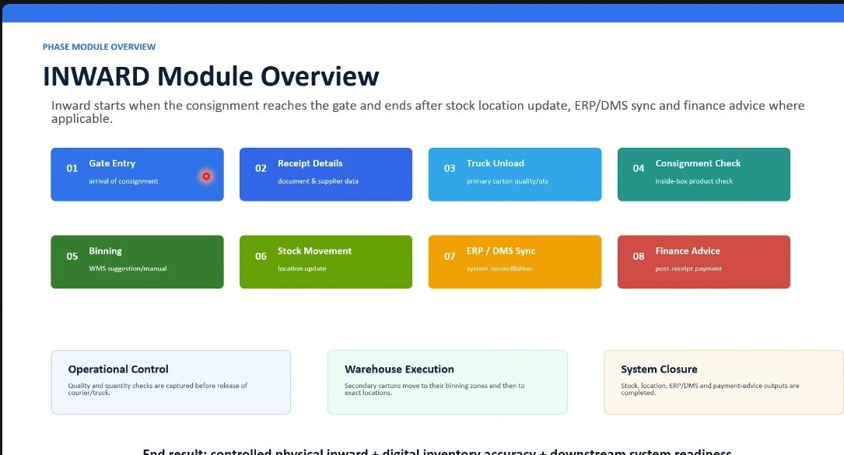
Figure 3.1a - Inward Module Overview: eight-step process with three control phases (Operational Control, Warehouse Execution, System Closure)

3.2 Inward Process Steps
Step | Name | Description
01 | Gate Entry | Arrival of consignment at the warehouse gate. GEN created as master reference.
02 | Receipt Details | Document and supplier data capture. Invoice details, transporter info, and box/invoice counts confirmed.
03 | Truck Unload | Primary carton quality and quantity check. Physical boxes scanned, conditions assessed.
04 | Consignment Check | Inside-box product check. Secondary boxes opened; parts inspected and condition verified.
05 | Binning | Stock items assigned to specific warehouse bin/location. System-suggested or manually overridden.
06 | Stock Movement | Physical movement to assigned locations. Location update recorded.
07 | ERP / DMS Sync | System reconciliation. Stock data synchronised with dealer ERP/DMS.
08 | Finance Advice | Post-receipt payment processing. Financial advice generated where applicable.

3.3 Consignment Source Types
The WMS must handle consignments from four distinct source types:
- OEM Dispatch - material dispatched by a brand principal. May come with ship list, invoice, or GRN depending on OEM brand.
- Branch / STO - material transferred from the dealer own branch. Typically single box; secondary check and binning may be skipped.
- Co-Dealer / Distributor - material from another dealer or authorised distributor. May come on invoice or delivery challan.
- Local / Retail - parts sourced locally from a retail point or vendor.

3.4 OEM Document Variability
A key design consideration is that the document accompanying an OEM consignment varies by brand:
- Some OEMs (e.g., Maruti) provide a ship list - a box-level manifest with each primary box number and its contents, with matching soft copy.
- Other OEMs provide only an invoice stating total box count and an itemised parts list.
- Where OEM ship list or GRN data is available in the back end, the system shall automatically populate invoice numbers in the Screen 4a invoice table (brand-by-brand configuration).
- Document content, format, and delivery channel vary by brand. The system must support configurable document type mapping per OEM brand.

4. FR-001: Gate Entry (Create GEN) - Screen 1

4.1 Overview
The Gate Entry screen is the first step in the inward process. It captures minimum required information and generates the Gate Entry Number (GEN) that serves as the master reference for all subsequent inward stages. Only two fields are mandatory; all others are dealer-configurable.

Layman Description
Gate Entry Creation (FR-001.1 to .11) - Most warehouses already keep a paper register at the gate - vehicle number, driver name, time in. This does the same job, but in the system, and it does not stay at the gate. The moment a vehicle reaches the gate someone creates an entry for it, and the system gives that entry its own number. That number then stays with the load for the rest of its life in the warehouse. Every step afterwards - unloading, checking the boxes, putting them on the shelves - is recorded against it. The value shows up weeks later, when something is queried. Instead of asking three people and hunting through a paper book, you type one number and get the whole history. It also means two loads from the same supplier on the same day never get mixed up, because each one carries its own number.
Example: A truck reaches the gate at 9:40 am. The guard opens the system, enters the vehicle number and the driver name, and saves. The system gives it GE-1042 and prints a slip. The truck goes to bay 3, 48 boxes come off, two are found torn, and all of it is recorded under GE-1042. Three days later accounts find a damaged headlamp and ask which vehicle brought it. The storekeeper types GE-1042 and sees the arrival time, the driver, who unloaded it and that two boxes were torn on arrival - enough to raise the claim with the supplier.
Gate Entry Creation (FR-001.12; FR-001.21) - Recording a load is split into two stages, because the two places have different amounts of time and different information. At the gate the guard has a driver waiting and a queue behind him. He is not going to open cartons or count 200 boxes. He takes the few things he can see - who is driving, a phone number, the vehicle, roughly what has come - and lets the vehicle in. The real detail is captured later at the unloading dock, by the storekeeper who has the paperwork in his hand and the boxes in front of him. That is where invoices are entered and the actual box count is recorded. The distinction matters because it decides which number the warehouse trusts. Anything noted at the gate is a rough glance and should never be used to argue a shortage. The figure recorded at the dock is the one everything else is checked against.
Example: The guard notes driver Ramesh, phone 98xxx, vehicle MH-12-4456 and roughly 50 boxes, then lets the truck in. Twenty minutes later at the dock the storekeeper opens the envelope, enters 3 invoices and records 48 boxes expected. During unloading the men scan 48 and nothing is short. Had the system treated the guard rough figure of 50 as the expected count, it would have reported 2 boxes missing that were never on the truck in the first place.
Gate Entry Creation (FR-001.16 to .20) - Two things are captured here. First, who physically brought the load and how to reach him afterwards - his name and phone number. Second, how it came: your own vehicle, a courier company, a transporter, or a person carrying it by hand. The driver detail matters when something is found wrong after the vehicle has gone. Without a name and a number, a damaged carton becomes an argument with nobody to ask. The transport type matters for a different reason: it tells you which loads arrive by which route, and it is exactly the kind of list that keeps changing as the business changes. So the question is not only whether the field exists, but who controls the list behind it. If your own administrator can add a new courier firm, you do it the same afternoon. If the list is fixed inside the software, you raise a request with the vendor and wait.
Example: A carton is found wet the next morning. The record shows driver Ramesh on 98xxx, arriving by courier, so the storekeeper calls him before the insurance claim goes in and learns it rained during loading. Separately, the branch starts using a new courier firm in March. The administrator adds it to the transport list that same afternoon, and the next arrival is recorded correctly - no ticket raised, nobody waiting.

4.2 Functional Requirements
FR-001.1: The system shall generate a unique Gate Entry Number (GEN) upon submission of the gate entry form. The GEN shall serve as the master reference key for all subsequent inward process steps.
FR-001.2: The gate entry form shall require a minimum of two mandatory fields: Name of the Person and Contact Number. All other fields shall be optional and configurable by the dealer admin.
FR-001.3: The dealer admin shall be able to configure which fields appear on the gate entry screen for their location(s). Fields not required can be hidden entirely.
FR-001.4: The system shall accept any type of incoming consignment through the gate entry - not limited to spare parts. Any goods for which the dealer organisation is making payment shall be eligible for a GEN.
FR-001.5: The gate entry screen shall support capture of a primary document via a camera/upload interface. Document capture at Screen 1 is optional; it may be completed at Screen 2 (Receipt Details).
FR-001.6: All data entered on Screen 1 that is not captured shall be editable and completable at Screen 2. No information shall become permanently locked before Screen 2 is accessed.
FR-001.7: The For Whom / Department Name field, when populated, shall trigger a system notification to the named department informing them of the consignment arrival.
FR-001.8: The GEN shall be displayed prominently on screen after creation (green banner) and shall be printable or shareable as a reference.

4.3 Screen Field Reference
Note: The following table describes Screen 1 (Create GEN) fields as observed in the wireframe. Descriptions in blue italic are analyst-generated.
Field | Control Type | Description
Name of the Person | Text input | Mandatory field. Captures the name of the truck driver only. The gate personnel are a separate role and are not recorded in this field.
Contact Number | Text input | Mandatory field. Mobile or phone number of the truck driver. Not linked to the supplier record and not used to notify the supplier.
Where From (Supplier Name) | Dropdown | Optional. Selects the source supplier from the pre-configured supplier master list. Can be completed at Screen 2 if unknown at gate.
For Whom (Department Name) | Dropdown | Optional. Department or individual for whom the consignment is intended. Triggers internal arrival notification when populated.
Primary Document Type | Dropdown + Camera | Optional at gate. Acceptable types: GRN, Tax Invoice, Challan, Ship List, Delivery Challan, others as configured. Camera enables document photo capture.
Courier Type | Dropdown | Optional. Mode of transport: Transport / Courier / Own Vehicle / Individual (External Person) / Individual (Internal Person), per the BRD. Configurable from master data.
Gate Entry Number (GEN) | System-generated display | Read-only. Auto-generated on Next. Displayed in green banner at bottom of form. Master reference for all subsequent inward steps.

4.4 Amendments from Session 07
The gate entry screen was reviewed against the BRD and two omissions were identified. The first is the date and time of receipt. The BRD requires the gate entry to carry the date and time at which the consignment was received, automatically picked up by the system, and treats it as a mandatory, non-negotiable capture. The FRD as written names only the person's name and contact number as mandatory fields and carries no date or time row at all. The two are different in kind: the name and contact number are dealer-configurable mandatory fields, whereas the date and time of receipt is captured by the system and is not subject to configuration.
The second is the nature of the inward transaction. The gate entry is the point at which a consignment enters the business premises, and the reason it is entering determines much of what follows. The six transaction types are set out in section 33.
Two further points were confirmed about the gate entry number itself. It is created for every consignment received, it signifies that the consignment has entered the business premises, and every subsequent activity on that consignment is conducted by reference to it. It is also the reference against which the business makes payment to the vendor, which connects the gate entry to the payment advice raised to finance for goods received on post-receipt payment terms. The generation logic for the gate entry number has not yet been defined.
Note: the distinction between system-captured and dealer-configurable mandatory fields matters for the screen design. The date and time of receipt should be displayed on Screen 1 as a read-only, system-populated value rather than as an input the user can leave blank or edit.
FR-001.9: The gate entry shall capture the date and time of receipt of the consignment. The value shall be picked up automatically by the system at the moment the gate entry is created.
FR-001.10: The date and time of receipt shall be mandatory and shall not be configurable. It is distinct from the dealer-configurable mandatory fields and shall not be subject to the same configuration.
FR-001.11: The gate entry shall capture the nature of the inward transaction, selected from the six types defined in section 33.
FR-001.12: The administrator shall be able to customise which details are captured at gate entry. The capturable set shall include vendor name, category of products, name of the person carrying the consignment, courier name where applicable, reference document number, document date and number of boxes in the consignment.
FR-001.13: The gate entry number shall serve as the reference against which the business makes payment to the vendor, and shall link to the payment advice raised to finance for goods received under post-receipt payment terms.
FR-001.14: The generation logic for the gate entry number is not yet defined and is recorded as an open item.
FR-001.15: The consignment carrier value set shall be reconciled against the BRD, which defines five values - Transport, Courier, Own Vehicle, Individual (External Person) and Individual (Internal Person). The Courier Type field as currently specified carries four values and shall be aligned so that no value is lost.
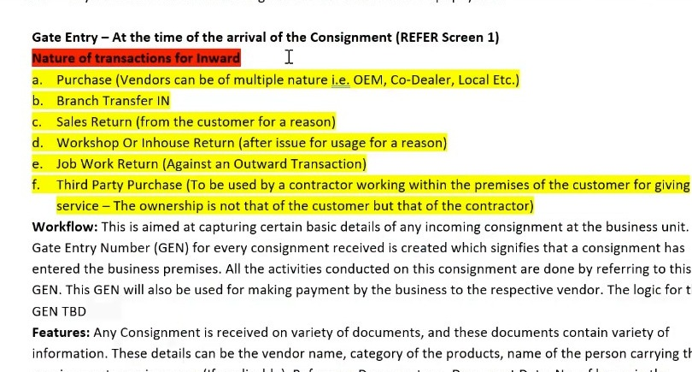
Figure 4.4a - BRD extract shown during the session: the six natures of inward transaction captured at gate entry, the workflow statement establishing the gate entry number as the reference for all subsequent activity and for vendor payment, and the features paragraph listing the details the administrator may configure for capture.

4.5 Corrections from Session 07 (Part 2)
The Screen 1 field descriptions were reviewed line by line and two of them were found to say something other than what was intended. Both descriptions were analyst-generated, and both have been corrected in the field reference table at section 4.3.
The Name of the Person field was described as capturing the name of the gate personnel or the truck driver. It should capture the truck driver only. The person staffing the gate and the driver delivering the consignment have different roles, and recording either one in the same field loses the distinction.
The Contact Number field was described as enabling notification to the responsible party on arrival. It is the truck driver's number and has no connection to the supplier. Drivers change from delivery to delivery, so the number carries no durable relationship to anything. Where the supplier is to be told that their consignment has arrived, that notification derives from the supplier having been selected on the screen - the supplier is already held in the database with their own contact details - and not from the driver's phone number.
The internal arrival notification triggered by the For Whom / Department Name field is correct as written and is unchanged. Where a consignment is intended for a particular department or individual, that party is notified.
The Courier Type value list was found to contain an erroneous value and has been aligned to the five values defined in the BRD.
Note: these were errors of interpretation rather than of transcription. The descriptions were inferred from the wireframe images, and where a field label was ambiguous the inference generalised it - "responsible party" in place of the specific party actually meant. Analyst-generated blue italic text warrants this kind of line-by-line review precisely because it is inference.
FR-001.16: The Name of the Person field on the gate entry screen shall capture the name of the truck driver only. Gate personnel shall not be recorded in this field.
FR-001.17: The Contact Number field shall capture the contact number of the truck driver. It shall carry no linkage to the supplier record.
FR-001.18: Notification to the supplier that a consignment has arrived shall be derived from the supplier selected on the gate entry screen, using the contact details held against that supplier in the master, and shall not use the truck driver's contact number.
FR-001.19: The internal arrival notification triggered by the For Whom / Department Name field shall be retained as specified. Where the consignment is intended for a named department or individual, that party shall be notified on arrival.
FR-001.20: The Courier Type value list shall carry the five values defined in the BRD - Transport, Courier, Own Vehicle, Individual (External Person) and Individual (Internal Person). The value previously recorded as Self-foot is withdrawn as an error.
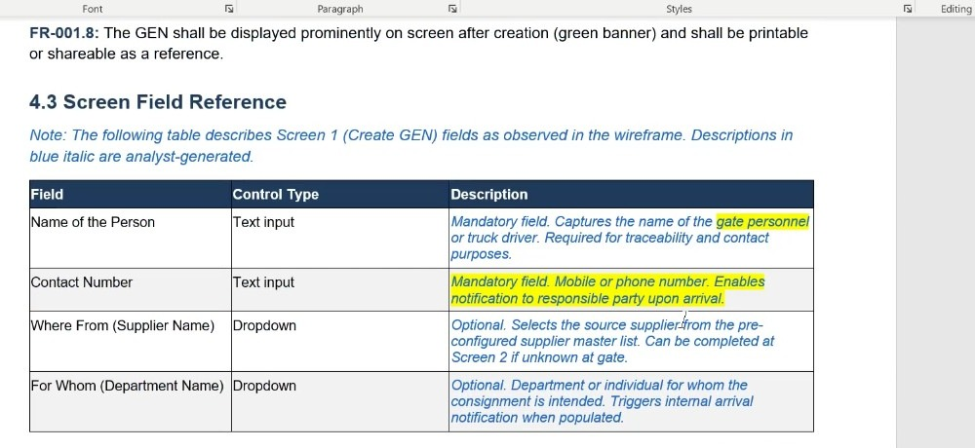
Figure 4.5a - The Screen 1 field reference table as reviewed during the session, with the two descriptions requiring correction highlighted: the conflation of gate personnel with the truck driver, and the generic reference to a responsible party in place of the truck driver.

4.6 Corrections from Session 07 (Part 3)
The box count captured at gate entry cannot serve as the reference value against which unloading is reconciled. At the gate only a minimal set of details is taken - in practice the name of the person carrying the consignment and a contact number - and the primary document presented at that point is frequently a goods receipt carrying no invoice or box-level breakdown. Where a box count is recorded at all it is a glance at the back of a truck, not a verified figure.
The gate entry stage therefore has two distinct parts. The first is the gate entry proper, where the vehicle is admitted against minimal detail. The second is the capture of consignment details as the vehicle reaches the unloading dock, which is where the document, the invoices and the full box detail are recorded and where the reliable expected count originates.
Note: this does not introduce a new count. The expected value is already defined - No. of Boxes in GEN, captured on Screen 4a and established as the reconciliation baseline by FR-004.2. What Part 3 settles is the standing of the gate entry figure relative to it: indicative, not authoritative. The consequential corrections are made in FR-007.6 and FR-007.8.
FR-001.21: The number of boxes captured at gate entry under FR-001.12 shall be treated as indicative only. It shall not serve as the expected value against which unloading is reconciled; that value is the expected box count recorded at Receipt Details (No. of Boxes in GEN, FR-004.2).

5. FR-002: Consignment Details & Workflow Configuration - Screen 2

5.1 Overview
Screen 2 is accessed by the relevant department after gate entry is created. It captures detailed consignment classification, completes any data not entered at Screen 1, and configures which downstream workflow steps apply to this specific consignment.

Layman Description
Not every load goes to the same place. Most of it goes onto the shelves. Some is needed immediately by the workshop, where a vehicle is already on the ramp waiting for the part. Some needs careful handling because it is glass or a windscreen. This tells the system which of those it is, before anyone touches the truck. The system then guides the operator down the right path - it will not offer a shelf location for something going straight to the workshop, and it shows a warning for anything marked fragile. The reason for setting this up front, rather than deciding at the shelf, is that the person unloading at six in the morning is usually not the person who knows why the load was ordered. Marking it at the start means the instruction travels with the load instead of living in somebody head.
Example: A windscreen arrives for a car already on the ramp in bay 2. Before unloading, the load is marked fragile and straight to workshop, with the vehicle number noted against it. When the operator scans the carton the screen shows a handle-with-care warning and tells him to take it to the workshop, not to a rack. He never has to know why, and the car is not held up while somebody works out where the windscreen went.

5.2 Functional Requirements
FR-002.1: Screen 2 shall be pre-linked to the GEN created on Screen 1. Where Screen 2 is accessed independently, the GEN shall be selected from a dropdown of gate entries already created, and shall not be typed in free text.
FR-002.2: Screen 2 shall allow selection of Product Category and Supplier Category. Selecting a product category shall filter the available supplier list.
FR-002.3: The system shall support a configurable Workflow Applicability Confirmation section. The dealer admin shall define, per product-category and supplier combination, which of four downstream steps are applicable by default.
FR-002.4: The workflow applicability defaults shall appear as pre-checked checkboxes on Screen 2. The receiving user shall be able to override any checkbox for the current consignment.
FR-002.5: Only checked workflow steps shall be activated for the consignment. Unchecked steps shall be skipped and the consignment shall proceed to the next active step.
FR-002.6: Any fields left blank on Screen 1 shall be completable on Screen 2.
FR-002.7: The system shall support manual GEN entry on Screen 2 for consignments processed without a prior Screen 1 gate entry.
FR-002.8: Product and supplier category selections shall drive OEM brand-specific document type options, reflecting variability in documentation formats across brands.

5.3 Screen Field Reference
Note: The following table describes Screen 2 (Enter Consignment Details) fields as observed in the wireframe. Descriptions in blue italic are analyst-generated.
Field | Control Type | Description
Product Category | Dropdown | Category of goods in consignment. Drives workflow applicability rules and supplier filtering.
Supplier Category | Dropdown | Type of supplier: OEM / Manufacturer / Local Vendor / Other.
Supplier | Dropdown | Registered supplier from master list, filtered by Supplier Category.
Primary Document Type | Dropdown | If not captured at Screen 1, selected here.
Gate Entry Number | Dropdown / Text input | Auto-linked from Screen 1, or selected from the dropdown of existing gate entries.
Courier Type | Dropdown | If not captured at Screen 1, selected here.
Workflow Confirmation - Unload Truck | Checkbox (default: checked) | Activates Truck Unload step. May be unchecked for single-box VOR orders.
Workflow Confirmation - Check Secondary Boxes | Checkbox (default: checked) | Activates Consignment Check step. May be unchecked for branch transfers.
Workflow Confirmation - Binning | Checkbox (default: checked) | Activates Binning step. May be unchecked when goods are issued directly to workshop.
Workflow Confirmation - Receipt Confirmation | Checkbox (default: checked) | Activates final receipt confirmation step before ERP/DMS sync.

5.4 Amendments from Session 07
Two points were added to the consignment details and workflow configuration screen. The first concerns who defines the workflow. The administrator selects the factors on which default workflows are defined - supplier category, nature of the products, consignment carrier and similar - and defines a default workflow for each combination. The user retains the ability to override the workflow defined for a particular scenario before the receipt process begins.
The second concerns the relationship between the supplier and the categories. Where the user enters the supplier name directly, the supplier category can be derived automatically, because each supplier is tagged to a supplier category during supplier creation. The product categories cannot be derived in the same way and are selected manually from a multi-selection control.
The client is a business entity with multiple recipients of consignments, all of whom use the platform. Where the gate entry already holds the supplier and the product category, the administrator defines which person or persons the consignment is routed to.
Note: the asymmetry between supplier category and product category is worth preserving in the screen design. One field fills itself once the supplier is known; the other cannot, because a single supplier may deliver products spanning several categories in the same consignment.
FR-002.9: The administrator shall select the factors on which default workflows for the receipt of consignments are defined, including supplier category, nature of the products and consignment carrier.
FR-002.10: The user shall be able to override the workflow defined for a particular scenario before the receipt process is started.
FR-002.11: Where the user enters the supplier name directly, the supplier category shall be derived automatically from the supplier record, since each supplier is tagged to a supplier category as part of supplier creation.
FR-002.12: Product categories shall be selected manually through a multi-selection control and shall not be derived from the supplier.
FR-002.13: The system shall support multiple recipients of consignments within the client business entity, and the administrator shall define the person or persons to whom a consignment is routed where the gate entry holds the supplier and product category.
FR-002.14: Irrespective of the nature of the consignment, the first step on opening the inward flow shall be entry of the consignment details, comprising product category, supplier category where not entered at gate entry, supplier name, applicable document, gate entry number and courier type.
FR-002.15: Where the gate entry number was not created on this system, the user shall be able to enter the number that was created manually at the gate.
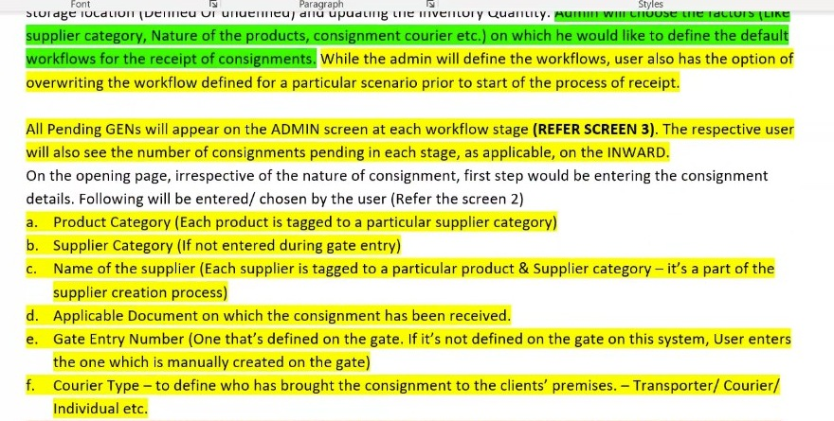
Figure 5.4a - BRD extract: administrator selection of the factors on which default workflows are defined with user override before start of receipt, the pending gate entry list by workflow stage, and the consignment detail fields entered on Screen 2.

5.5 Corrections from Session 07 (Part 2)
The requirement that the gate entry number may be manually entered where Screen 2 is accessed independently was queried and corrected. Manual typing of the number is not intended. Once a gate entry has been created on Screen 1 it becomes available for selection, and where the user comes to Screen 2 directly they choose the gate entry from a dropdown of those already created rather than keying the number by hand.
Note: the distinction is between selecting an existing record and creating one by typing its identifier. Free-text entry of a gate entry number invites transcription errors and could attach a consignment to a number that does not exist. The existing provision for entering a number raised manually at the gate - where the gate is not on this system - is a different case and is unaffected.
FR-002.16: Where Screen 2 is accessed independently of Screen 1, the gate entry number shall be selected from a dropdown of gate entries already created. It shall not be entered as free text.
FR-002.17: A gate entry created on Screen 1 shall become available for selection on Screen 2 immediately on creation.
FR-002.18: The provision for entering a gate entry number raised manually at a gate that is not on this system, as specified in FR-002.15, is unaffected by FR-002.16 and remains available.

6. FR-003: Inward Operations Dashboard - Screen 3

6.1 Overview
Screen 3 provides real-time visibility into the status of all active consignments across the three primary inward workflow stages: Pending for Unload, Pending for Checking, and Pending for Binning. Used by warehouse supervisors to prioritise daily operations.

Layman Description
One screen showing every load currently in the building and what stage each has reached - arrived at the gate, waiting to unload, being unloaded, being checked, being put away. Alongside each one it shows how long it has been sitting at that stage. The stage on its own is not worth much; almost any system can show a status. What makes this screen worth having is the time. A load at waiting to unload is perfectly normal. A load that has been at waiting to unload for six hours is a problem, and it stays invisible unless the screen puts the number in front of you. This is the screen a supervisor keeps open through the day, and the one a manager looks at to find out where the work is piling up.
Example: At 4 pm the screen lists 6 loads. Five have moved on in the last hour. One has been sitting at waiting to unload since 10 am, because the bay was blocked and nobody escalated it. The supervisor sees the six-hour figure, sends two men across, and it is cleared before closing. Without the ageing column the same load would have been found the next morning, still on the truck, with demurrage running against it.

6.2 Functional Requirements
FR-003.1: The dashboard shall display three real-time pending queues: Pending for Unload (trucks awaiting unloading), Pending for Checking (GENs awaiting consignment check), and Pending for Binning (GENs awaiting bin assignment).
FR-003.2: Each queue shall display the count of pending items as a summary tile with a drill-down view showing individual consignment records.
FR-003.3: Pending consignment records shall display: Gate Entry Number (GEN), Date, Supplier, and a quantity/value metric relevant to the stage.
FR-003.4: The dashboard shall reflect only the workflow steps that are active for each consignment as configured in Screen 2.
FR-003.5: The dashboard shall update in real time as consignments are processed through each stage.

6.3 Screen Field Reference
Note: The following table describes Screen 3 (Inward Operations Dashboard) as observed in the wireframe. Descriptions in blue italic are analyst-generated.
Field / Column | Control Type | Description
Pending for Unload | KPI tile + expandable table | Count of consignments awaiting Truck Unload. Drill-down shows: Gate Entry Number, Date, Supplier, Value.
Pending for Checking | KPI tile + expandable table | Count of GENs awaiting Consignment Check. Drill-down shows: Gate Entry Number, Date, Supplier, Number of Boxes.
Pending for Binning | KPI tile + expandable table | Count of GENs awaiting Binning. Drill-down shows: Gate Entry Number, Date, Supplier, Number of Units.
Gate Entry Number (GEN) | Text / link | The GEN reference number. Clickable to drill into consignment detail.
Date | Date display | Date of gate entry creation.
Supplier | Text | Supplier name or code as registered in the master.
Value / Count | Currency / Number | Estimated consignment value (for Unload queue) or box/unit count (for Checking/Binning queues).
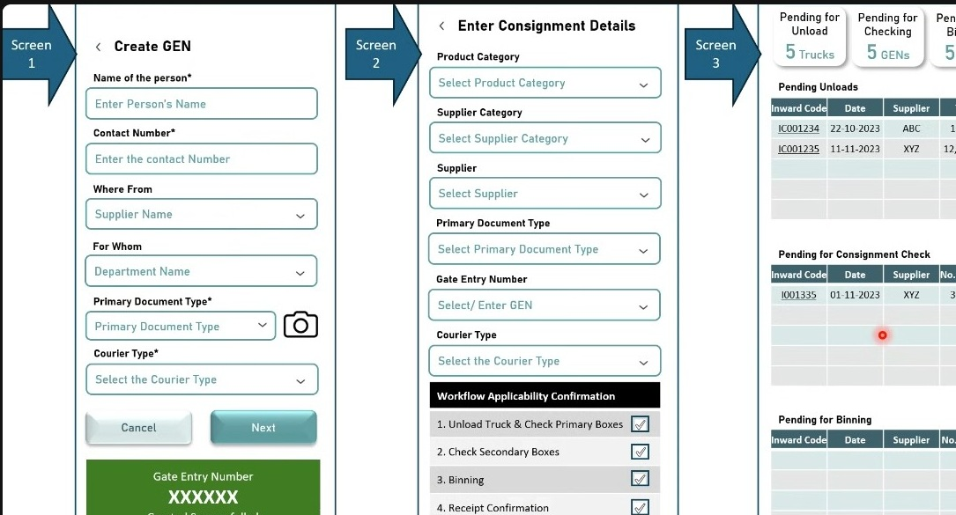
Figure 6.3a - Screens 1-3 composite: Gate Entry (Screen 1), Consignment Details (Screen 2), and Inward Operations Dashboard (Screen 3) showing three pending work queues

6.4 Amendments from Session 07
The dashboard as specified reports pending queue counts with drill-downs but has no time dimension. The BRD requires pending activity to be presented in aging buckets, and the reason is practical: a large warehouse may carry a substantial backlog of consignments on which binning has not been completed, and a flat count gives no indication of which of them has been waiting longest.
Note: the buckets are a filter over the existing pending queues rather than a new queue. The counts already on the dashboard should become filterable by age, so the operator can move from what is pending to what is pending and overdue.
FR-003.6: The inward operations dashboard shall present pending activity in aging buckets and shall allow the pending queues to be filtered by age.
FR-003.7: The aging buckets shall be the last 7 days, the last 15 days, the last 30 days and 60 days and over.
FR-003.8: The aging dimension shall apply to the pending queue counts already specified for the dashboard, so that the operator can establish which pending items have been outstanding longest.
FR-003.9: The dashboard shall present the pending gate entries at each workflow stage, with the respective user seeing the number of consignments pending at each stage.
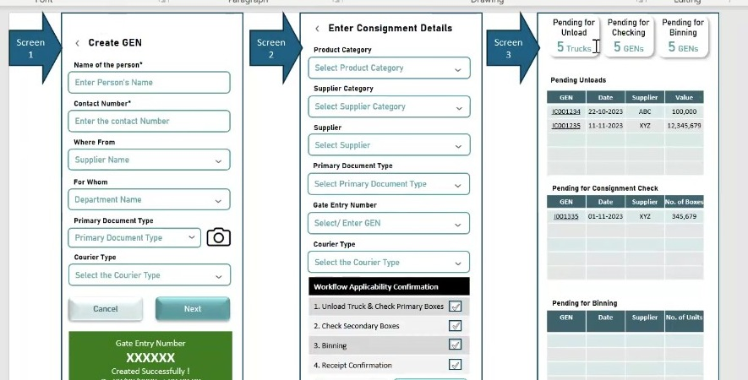
Figure 6.4a - Wireframe reviewed during the session: gate entry creation on Screen 1, consignment detail capture with the workflow applicability confirmation on Screen 2, and the pending-for-unload, pending-for-checking and pending-for-binning queues on Screen 3 which the aging buckets will filter.

7. FR-004: Receipt Details - Invoice & Transporter Capture - Screens 4a & 4b

7.1 Overview
Screens 4a and 4b constitute the Receipt Details stage (Step 2 of the inward process). Screen 4a captures the formal consignment documentation: the primary document reference, total box and invoice counts, and individual invoice-level details. Screen 4b captures transporter and vehicle information and provides an overview of all invoices added, with document upload options. Both screens are accessed via Step 2 after the gate entry (Screen 1) has been created. Data from Screen 1 (GEN, primary document type) is automatically carried forward.
For certain OEM brands where invoice data is available in the back end (e.g., linked to the ship list or GRN reference), invoice details will auto-populate in the invoice summary table without manual entry, based on brand-level configuration.

Layman Description
Invoice Capture (FR-004.3 to .5) - One vehicle very often carries more than one invoice from the same supplier. This lets you enter all of them against that single arrival, instead of forcing you to create a separate arrival for each invoice. As each one is added the screen builds up a list - invoice number, date, amount - with a running total at the bottom, the way a shopping bill adds up as items are scanned. There is usually also a tick against each invoice so you can mark which ones you have physically received, because the papers and the goods do not always travel together. The reason this matters is that one truck is one physical event. If the system makes you split it into three arrivals, then your box counts, your unloading records and your shortage reports are split three ways as well, and nothing reconciles cleanly afterwards.
Example: A truck arrives carrying 3 invoices worth Rs 40,000, Rs 15,000 and Rs 70,000. All three are entered against that one arrival, the screen shows Rs 1,25,000 at the bottom, and the storekeeper ticks two as received because the third invoice copy is missing from the envelope. The 48 boxes on the truck are counted once, against one arrival, not divided arbitrarily between three.
Invoice Capture (FR-004.2; FR-007.15) - Before unloading begins, somebody records how many boxes this load should contain. That number comes off the paperwork - the invoice or the packing list - and it becomes the figure the system checks against. As boxes come off the truck and are scanned, the system counts them and compares. If the count falls short it says so. This sounds obvious, but it is the single thing that decides whether a shortage is ever found at all. Without a number recorded before unloading there is nothing to compare against, and a missing box only comes to light later, when somebody goes looking for that part and cannot find it - by which time the vehicle has gone and the supplier has no reason to accept it. The timing is the whole point: the number has to exist before the boxes come off, not after. This capability also spans Section 10.
Example: The paperwork says 50 boxes, so the expected count is recorded as 50. The men scan 48 and the system shows 2 short while the driver is still in the yard. The storekeeper walks out, checks the truck, finds one box behind the cabin and scans it, then marks the remaining one short on the driver copy. One box is recovered and one is claimed - both on the same day, with the driver present.
Invoice Capture (FR-004.4) - For some suppliers - usually the large vehicle manufacturers - the invoice already exists in the back-office system before the truck arrives. Where that is the case the details are fetched automatically instead of being typed in again by the storekeeper. He sees the invoice number, date and amount already filled in, and his job becomes checking them against the paper in his hand rather than copying them across. Two things come out of this. It is faster, at a moment when a driver is standing and waiting. And it removes typing mistakes on exactly the fields that cause disputes - an invoice number with two digits transposed will not match at payment time, and somebody will spend an afternoon finding out why. Whether it works usually depends on the supplier, so it is worth asking which suppliers it covers, not simply whether the feature exists.
Example: A consignment arrives from a vehicle manufacturer. Instead of the storekeeper typing invoice number MSIL/24/8891, its date and Rs 2,40,000 by hand, the screen shows them already filled in. He compares them against the printed invoice, sees they match, and moves on in seconds. For a small local supplier the same screen comes up blank and he types the details in as usual.

7.2 Functional Requirements
FR-004.1: Screen 4a shall carry forward the GEN and GEN Date from the gate entry record. Both fields shall be read-only and pre-populated.
FR-004.2: The system shall capture the total number of boxes in the GEN and the total number of invoices in the GEN. These counts serve as the expected values against which actual unloading is tracked in Screen 6a.
FR-004.3: Screen 4a shall allow the user to capture individual invoice details via the Capture Invoice Details collapsible accordion. Each invoice record shall include: Invoice Number, Invoice Date, and Total Invoice Amount. The system shall allow multiple invoices to be added sequentially using an Add Next control.
FR-004.4: For OEM brands where invoice data is available from the back end (linked to the primary document reference such as ship list or GRN number), the system shall automatically populate the invoice summary table. This behaviour shall be configurable per OEM brand.
FR-004.5: Screen 4b shall display a summary table of all invoices added on Screen 4a (Details of the Invoices Added) showing: Invoice No., Date, Amount, and a Received checkbox per invoice. The table shall show a Total row aggregating all invoice amounts.
FR-004.6: Screen 4b shall capture transporter and driver details: Name of the Transporter (from registered list or free entry), Vehicle Number as per GR Documents, Name of the Driver, and Contact Number.
FR-004.7: The Capture Transporter Details section on Screen 4b shall be collapsible. If transporter details have been pre-captured at gate entry (Screen 1), they shall be pre-filled and editable.
FR-004.8: Screen 4b shall provide document upload options for: GRN photograph and Invoice photographs. Uploaded documents shall be associated with the GEN record.
FR-004.9: If the user attempts to proceed (Next) without entering invoice details, the system shall display an amber confirmation dialog: You have not added details of the invoices. Are you sure? Pressing Next after confirmation shall allow progression without invoice details.
FR-004.10: Submission state shall be communicated via toast notifications: success (Details Added Successfully), failure (Failed! Please Try Again), or incomplete invoice warning (amber dialog).

7.3 Screen Field Reference - Screen 4a
Note: Screen 4a (Enter Consignment Details - left panel) captures the formal receipt document and invoice-level detail. Field descriptions in blue italic are analyst-generated.
Field | Control Type | Description
GEN | Read-only text | Auto-populated from the gate entry created in Screen 1. Carried forward as the master reference for this consignment detail record.
GEN Date | Read-only date | Auto-populated date of gate entry creation. Not editable on Screen 4a.
Primary Document Type | Dropdown | Pre-filled if captured at gate entry. If blank, selected here. Acceptable types per OEM brand configuration: GR/LR (Goods Receipt/Lorry Receipt), Tax Invoice, Challan, Ship List, and others.
Document Number | Text input | The reference number of the primary document accompanying the consignment (e.g., LR number, Invoice number, GRN number).
Document Date | Date picker (DD/MM/YYYY) | Date shown on the primary document.
No. of Boxes in GEN | Numeric input | Total number of physical boxes included in this consignment. Used as the expected count against which actual unloading is tracked in Screen 6a.
No. of Invoices in GEN | Numeric input | Total count of invoices associated with this GEN. Each invoice may cover multiple boxes or product lines.
Capture Invoice Details (collapsible) | Collapsible accordion | Expandable section. When expanded, displays Invoice Number, Invoice Date, and Total Invoice Amount fields plus an Add Next control to capture multiple invoices sequentially.
Invoice Number | Text input + Add Next | Individual invoice reference number. Each invoice is added in sequence using the Add Next button. All invoices appear in the Details of Invoices Added summary table.
Invoice Date | Date picker | Date of the individual invoice being captured.
Total Invoice Amount | Numeric input | Total value of the individual invoice. The system aggregates all invoice amounts into a grand total shown in the summary table.
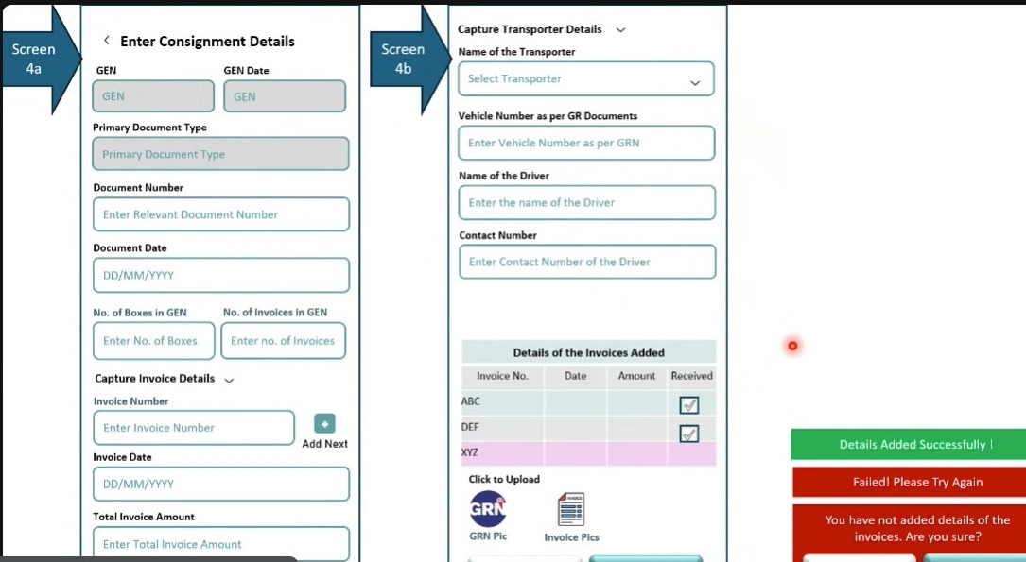
Figure 7.3a - Screen 4a (Enter Consignment Details) and Screen 4b (Capture Transporter Details) - empty state showing all data entry fields

7.4 Screen Field Reference - Screen 4b
Note: Screen 4b (Capture Transporter Details - right panel) captures logistics and vehicle information and provides the invoice summary overview. Field descriptions in blue italic are analyst-generated.
Field | Control Type | Description
Capture Transporter Details (collapsible) | Collapsible accordion | Expandable section. Contains transporter and vehicle identification fields. Can be left blank if transporter details are not available at this stage.
Name of the Transporter | Dropdown | Select from registered transporter list or enter a new transporter name. Pre-registered transporters auto-fill related fields.
Vehicle Number as per GR Documents | Text input | Vehicle registration number as stated in the goods receipt document. May differ from the actual vehicle number if the truck was changed en route.
Name of the Driver | Text input | Name of the driver delivering the consignment.
Contact Number (Driver) | Text input | Mobile number of the driver. Used for communication during unloading.
Details of the Invoices Added (summary table) | Read-only data table | Auto-populated grid showing all invoices captured in Screen 4a. Columns: Invoice No., Date, Amount, Received (checkbox). Includes a Total row summing all invoice amounts. The Received checkbox allows marking each invoice as confirmed received.
Click to Upload - GRN Pic | Image upload | Upload a photograph of the Goods Receipt Note (GRN) document accompanying the consignment.
Click to Upload - Invoice Pics | Image upload | Upload photographs of one or more invoice documents accompanying the consignment.
System validation states | Toast notification | Three possible states: (1) Details Added Successfully (green) - all required data captured; (2) Failed! Please Try Again (red) - submission error; (3) You have not added details of the invoices. Are you sure? (amber confirmation dialog) - displayed when Next is pressed without invoice details.
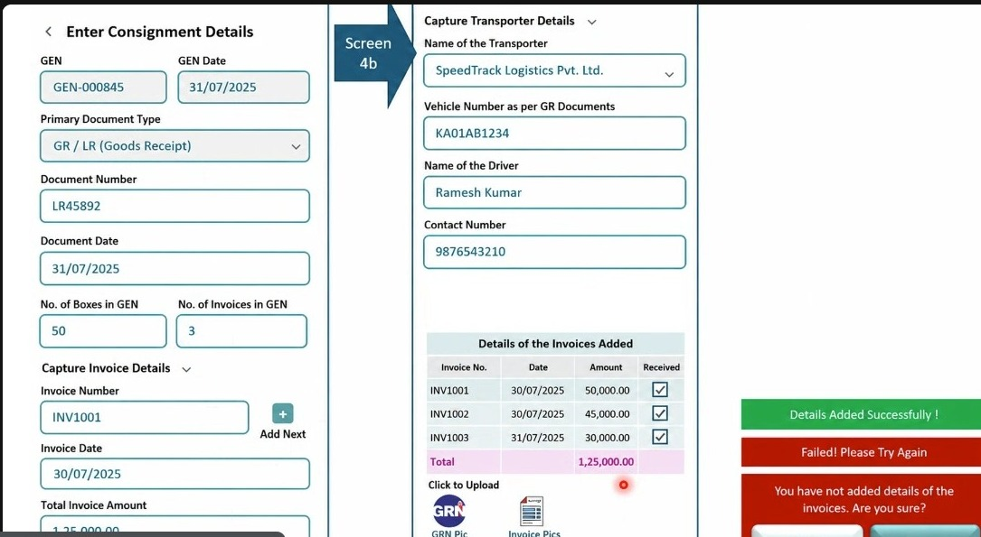
Figure 7.4a - Screen 4a and 4b filled state: GEN-000845, document type GR/LR, 50 boxes, 3 invoices (INV1001/1002/1003 totalling Rs.1,25,000), transporter SpeedTrack Logistics, driver Ramesh Kumar, vehicle KA01AB1234

7.5 Corrections from Session 07 (Part 3)
The invoice summary table was raised during the walkthrough as appearing twice, which risked being read as two tables on two screens rather than one table described in two places. There is one summary table.
Note: the summary table renders on Screen 4b, not Screen 4a. Invoices are keyed one at a time in the Capture Invoice Details accordion on the left-hand entry panel (Screen 4a); the running summary and its Total row render on the right-hand panel alongside transporter capture (Screen 4b). The Screen 4b field reference at section 7.4 and the reviewed board both place the table on 4b. FR-004.5 was the sole inconsistency and has been corrected in place to read Screen 4b; the field reference at 7.4 is unchanged. The 4a/4b split is inferred from the board layout, as the session identified the duplication without resolving which screen owns the table.
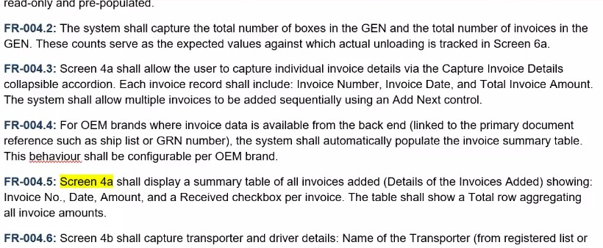
Figure 7.5a - FRD section 7.2 as reviewed in session, with the Screen 4a attribution in FR-004.5 highlighted as the wording to be corrected

8. FR-005: Truck Unload Initiation & GEN Selection - Screens 5A & 5b

8.1 Overview
Screens 5A and 5b are the Truck Unload initiation stage (part of Step 3). Screen 5A allows the warehouse operator to identify and load the GEN associated with the truck to be unloaded. This can be done either by directly entering the GEN or by searching using other known details (supplier, document number, date, status). Once the GEN is selected, all associated consignment data is auto-filled and the operator selects which invoices to unload in this session. Screen 5b allows final verification and editing of transporter and driver details before commencing the physical unloading scan.
The WMS operates on handheld terminals (rugged mobile devices, approximately smartphone-sized) used by warehouse staff at the point of physical activity. All scanning, photo capture, and box-level recording is performed on these devices.

Layman Description
To start unloading you tell the system which arrival you are working on, normally by entering its reference number. But the man standing at the truck often does not have that number - the slip is in the office, or the load came in on the previous shift. So the same screen lets him find it using things he can see or ask: the supplier name, the document number on the paperwork, or simply today date. The results come back on the same screen and he picks the right one. The detail worth checking is whether that search sits inside the screen or is a separate one. If finding the load throws him out to another screen and back, he loses his place, and quite often the system then asks him to re-enter details it already holds.
Example: The operator at bay 3 has no slip. He types the supplier name and today date. Two arrivals come back - one with 12 boxes, one with 48. He knows the truck in front of him is the big one, picks the 48, and the screen fills in the supplier, the document and the invoices on its own. He starts scanning within seconds, without walking back to the office to ask anyone.

8.2 Functional Requirements
FR-005.1: Screen 5A shall allow the warehouse operator to enter or select the GEN associated with the truck to be unloaded. Upon selection, all consignment data associated with that GEN shall be automatically populated on screen.
FR-005.2: If the operator does not know the GEN, Screen 5A shall provide a secondary search panel (Find GEN Using Other Details) that allows lookup by: Supplier Name, Supplier Category, Product Category, Document Number, Document Date, and Status. Search results shall display matching GENs with their document reference, supplier, date, and Pending Docs count.
FR-005.3: Upon GEN selection, Screen 5A shall auto-populate: GEN Date, Supplier Category, Supplier, Product Category, Primary Document Type, Document Number, Document Date, and associated invoices.
FR-005.4: Screen 5A shall allow the operator to select specific invoices within the GEN to unload in the current session. The system shall display the expected box and unit counts for the selected invoices.
FR-005.5: Screen 5b shall display the transporter and driver details pre-filled from Screen 4b. All fields shall be editable to accommodate changes at the time of physical truck arrival (e.g., vehicle number change).
FR-005.6: The Truck / Vehicle No. Reported field on Screen 5b shall support camera capture to photograph the vehicle number plate, providing evidence of the actual vehicle present during unloading.

8.3 Screen Field Reference - Screen 5A
Note: Screen 5A (Unload Truck - GEN selection view) allows the operator to identify the correct consignment before commencing unloading. Field descriptions in blue italic are analyst-generated.
Field / Section | Control Type | Description
Gate Entry Number (GEN) | Search dropdown with clear (x) | Primary search field. Enter or select the GEN (e.g., GEN-000845) to load all consignment details. An x button clears the selection.
Find GEN Using Other Details (link) | Expandable search panel | Alternative search for when the GEN is not known. Opens a right-side panel with filters: Supplier Name, Supplier Category, Product Category, Document Number, Document Date, Status. Search returns a list of matching GENs for selection.
GEN Date | Read-only display | Populated when a GEN is selected. Shows date of gate entry creation.
Supplier Category | Read-only display | Populated when a GEN is selected. Shows supplier category (e.g., OEM).
Supplier | Read-only display | Populated when a GEN is selected. Shows registered supplier name.
Product Category | Read-only display | Populated when a GEN is selected. Shows product category (e.g., Spare Parts).
Primary Document Type | Read-only display | Populated when a GEN is selected. Shows document type (e.g., GR / LR).
Document Number | Read-only display | Populated when a GEN is selected. Shows document reference number.
Document Date | Read-only display | Populated when a GEN is selected. Shows document date.
Select Documents to Unload | Multi-select dropdown | Allows selection of specific invoices within the GEN to unload in this session. Shows selected invoice count, Expected Boxes, and Expected Units summary below the dropdown.
Check / Enter Transporter Details (collapsible) | Collapsible accordion | Pre-fills transporter details from Screen 4b if already captured. Can be edited or completed here if not previously entered.
GEN search results list | Radio-button list | When using Find GEN by Other Details, displays matching GENs: GEN code, supplier, date, document number, and Pending Docs count badge for each result. User selects one and proceeds.
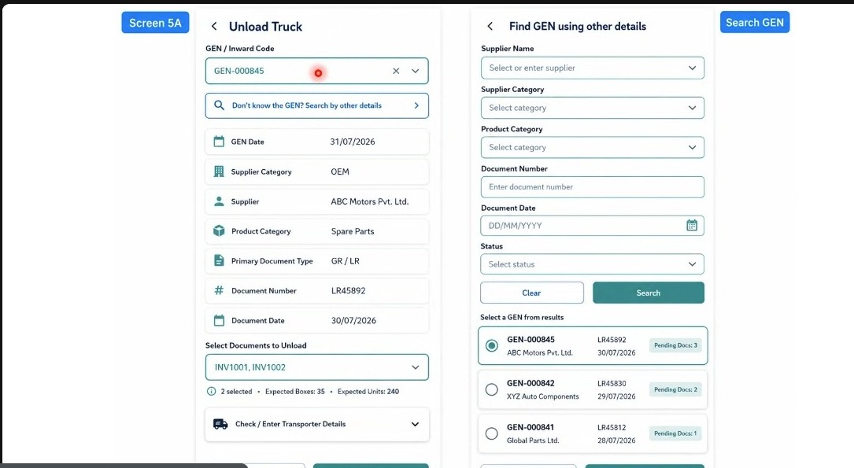
Figure 8.3a - Screen 5A (Unload Truck) with GEN search autofill showing GEN-000845 details and secondary Find GEN panel with Supplier Name, Supplier Category, Product Category, Document Number, Date, and Status filters

8.4 Screen Field Reference - Screen 5b
Note: Screen 5b (Check / Enter Transporter Details) is the final step before commencing box scanning. Field descriptions in blue italic are analyst-generated.
Field | Control Type | Description
Name of the Transporter | Read-only / editable text | Pre-filled from Screen 4b transporter capture. Editable if details need correction at the time of physical truck arrival.
Name of the Driver | Text input | Driver name. Pre-filled if captured earlier; editable.
Driver Contact Number | Text input + phone icon | Driver mobile number. Phone icon allows direct call from the handheld device.
Truck / Vehicle No. Reported | Text input + camera icon | Vehicle registration number as physically observed at the warehouse gate during unloading. Camera icon allows photo capture of the vehicle number plate. This may differ from the vehicle number in GR documents if the truck was changed.
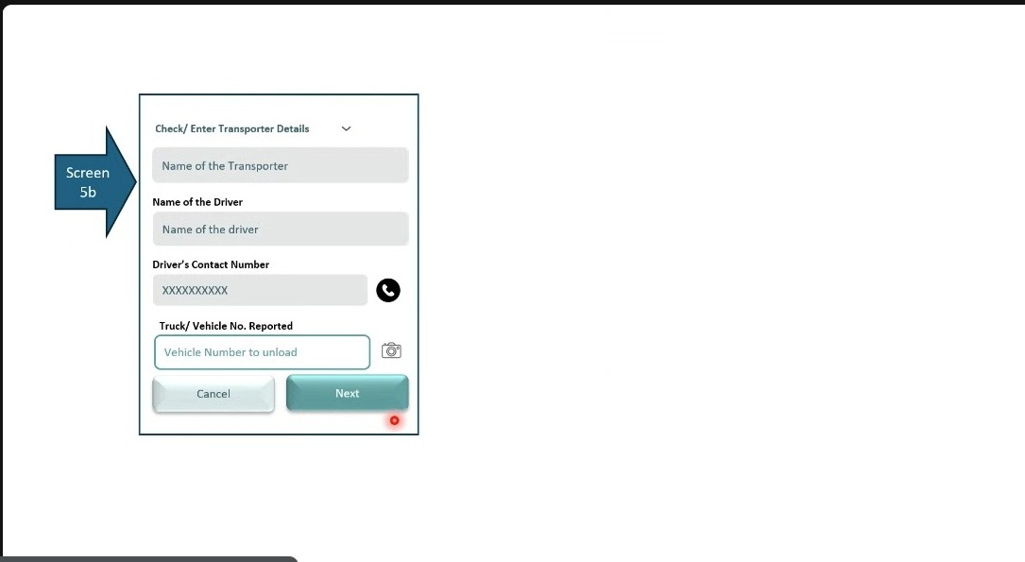
Figure 8.4a - Screen 5b (Check / Enter Transporter Details) showing transporter name, driver name and contact, and truck/vehicle number fields with photo capture option

8.5 Amendments from Session 07
Selecting the gate entry and document to unload against currently carries no validation. The BRD requires that a document number which is not eligible for the selected gate entry is rejected outright rather than accepted and reconciled later, because unloading a truck against the wrong document creates confusion that is difficult to unpick once the goods are on the floor.
FR-005.7: Where a document number that is not eligible for the selected gate entry is entered while choosing the gate entry or document to unload against, the system shall not accept it.
FR-005.8: The system shall display a rejection message and shall require the user to enter or select the correct document number before the unload can proceed.
FR-005.9: The document number entered shall be validated as matching the selected gate entry.

8.6 Corrections from Session 07 (Part 3)
Finding a gate entry by other known details is a search facility within Screen 5A, not a screen in its own right. The operator begins typing in the GEN field, the lookup options appear, the operator searches and selects, and the consignment loads - all without leaving the screen. The board reviewed in session had drawn the lookup as a separate panel reached by leaving Screen 5A, and had additionally drawn a further screen carrying supplier name, receipt date and document capture, none of which belongs to a search.
The list of criteria in section 8.1 - supplier, document number, date, status - is a list of the fields the operator may search on. It is not a list of screens, and was flagged in session as reading that way.
Note: no requirement changes as a result of this. FR-005.2 already specifies the lookup as a secondary search panel on Screen 5A. The correction is to the wireframes, which render it as a separate screen, and the two requirements below state the rule explicitly so the boards can be corrected against it.
FR-005.10: The Find GEN Using Other Details lookup shall be presented within Screen 5A as a search panel or overlay. It shall not be implemented as a separate screen, and the operator shall not be required to navigate away from Screen 5A to use it.
FR-005.11: The lookup shall offer search criteria only. It shall not capture supplier, document or consignment data, all of which are captured at the Receipt Details stage and are auto-populated on Screen 5A once the gate entry is selected.
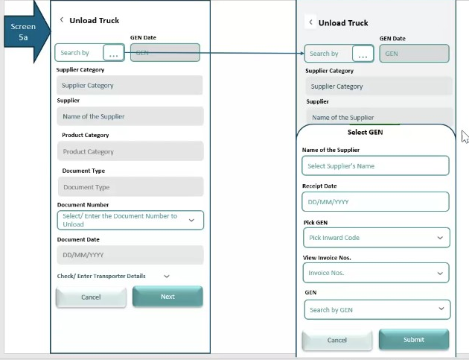
Figure 8.6a - the board reviewed in session: the Select GEN lookup drawn as a separate panel over Screen 5a, carrying supplier name, receipt date and invoice capture fields that do not belong to a search
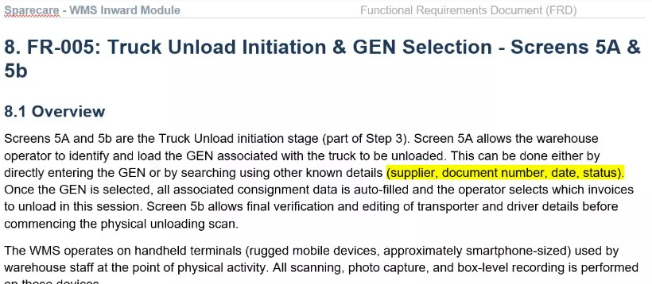
Figure 8.6b - FRD section 8.1 as reviewed in session, with the comma-separated search criteria highlighted as the passage read as a list of separate screens

9. FR-006: Box Scanning, Condition Assessment & Variance Check - Screens 6a, 6b & 6c

9.1 Overview
Screens 6a, 6b, and 6c constitute the core unloading execution stage (Step 3 - Truck Unload). Screen 6a is the primary box scanning screen where each physical box is identified (by QR scan or manual entry), its condition assessed, and a running unloading WIP tracker maintained. Screen 6b provides a search utility to check the unloading status of a specific box or part number. Screen 6c shows the variance between the document-declared quantities and the actual quantities scanned, along with a quality variance summary by condition type.
The unloading stage operates on handheld terminals. Each box has a QR code or barcode on the outer carton. The operator scans each box as it is unloaded from the truck. Box condition is assessed and recorded in the same step. The unloading WIP tracker (at the bottom of Screen 6a) provides a running count: how many boxes have been unloaded, how many remain, and how many are OK vs not OK.

Layman Description
Box Scanning and Condition (FR-006.1 to .4) - Boxes are not counted in a lump. Each one is scanned individually as it comes off the truck, the same way a courier scans parcels at your door. The moment a box is scanned the screen asks a single question - what does this box look like? The operator picks from a short list: fine, packing torn, damaged, wet, crushed. He answers while the box is still in his hands. The timing is the whole point of the feature. If the system waited until the end of unloading, the operator would remember that one box was torn but not which one, and a claim against a specific box could not be raised. Asking at the moment of the scan ties the condition to that particular box permanently. It is also the only moment at which the person who actually saw the box is the one answering the question.
Example: A truck has 48 boxes and box 17 has a torn corner. The operator scans box 17, taps packing torn, and carries straight on to box 18 without stopping. At the end the record shows 47 boxes fine and box 17 torn. The supplier is told box 17 arrived torn and cannot dispute which one it was. Had the question been asked only after all 48 were down, the operator would have known one box was torn but not which - and nothing could have been claimed.
Box Scanning and Condition (FR-006.5; FR-006.28) - A photograph is only demanded when there is something worth photographing. If the operator marks a box as fine, the system does not ask for one and does not slow him down. The moment he marks it as torn, damaged or wet, the camera becomes compulsory and the entry cannot be saved until a photo is taken. The reason for tying it to the condition rather than making it always-on is practical. A man unloading 200 boxes will not photograph every one, and if the system insists he will find a way round it - photographing the floor, or marking everything as fine so it stops asking. Demanding a photograph only for the few boxes that are actually damaged keeps the rule enforceable, and those are the only photographs anyone will ever need. When the supplier disputes the claim, the photograph is what settles it.
Example: Out of 48 boxes, 46 are fine and are scanned through in a couple of minutes with no camera prompt at all. Box 17 is marked packing torn and box 31 wet - for those two the screen will not let the operator continue until he photographs them. Three weeks later the supplier says the boxes left the factory in good order. Two photographs, timestamped and tied to those box numbers, close the argument.
Unloading Status Lookup - A plain lookup that answers one question: has this box or this part come off the truck yet, yes or no. It is used constantly and almost never by the person doing the unloading. Somebody from the workshop needs a part urgently and wants to know whether it has arrived; rather than walking to the bay and interrupting, they type the part number and get an answer. The important word is only. This screen does not let anyone change the condition of a box, or add a photograph, or record damage - it just reports. Keeping it read-only matters, because condition should be recorded once, by the man holding the box, and not later by somebody at a desk who never saw it. The second thing worth checking is whether it still works after the unloading has been closed, since most of the questions come afterwards.
Example: At 11 am the workshop rings: a brake disc is needed for a car on the ramp. The service advisor types the part number and sees unloaded - it came off at 9:50. He sends someone to collect it. The next day he checks a different part and gets not unloaded, so he orders it from another branch instead of waiting. Neither enquiry disturbs the men working the truck.
Unload Session Control - Unloading a large consignment does not always finish in one go. A shift ends, a bay is needed, rain starts. This lets the operator save where he has got to and pick it up later without losing the scans already done, and it records honestly that the load was only partly unloaded rather than quietly treating it as complete. The other half of the feature is what happens at the end. When every box on the list has been scanned, the system offers to close the session - but the operator can decline. That matters more than it sounds. The list is not always right; there is often one more box on the truck that nobody expected. If the system closes automatically the moment the list is satisfied, that extra box has nowhere to go and gets left off the record entirely.
Example: At 6 pm 31 of 48 boxes are down and the shift ends. The operator saves; the next morning another man opens the same session and carries on from box 32. Later, all 48 are scanned and the system asks whether to finish. He can see a further carton still in the truck, so he declines, scans it as box 49, and only then closes - with 49 recorded against a list that said 48.

9.2 Functional Requirements
FR-006.1: Screen 6a shall allow the warehouse operator to scan or manually enter the box number (Unit / Box No.) for each physical box as it is unloaded from the truck. Each scan creates a record in the unloading tracker linked to the GEN.
FR-006.2: Box numbers shall be scannable via QR code or barcode reader on the handheld device. Manual keyboard entry shall also be supported as a fallback.
FR-006.3: If a scanned box number does not match the expected manifest for the GEN, the system shall display a confirmation dialog (Box No. does not match with the uploaded data. Would you like to upload it?). The operator may confirm to add the box as a discrepancy record, or reject to discard the scan.
FR-006.4: For each box scanned, the operator shall be able to record the box condition via the Update Box Condition accordion. Condition options shall include: OK, Packing Tampered, Damaged, Visible Scratch, Without Packing, Wrong Delivery. Multiple conditions may be selected for a single box.
FR-006.5: When a box condition other than OK is selected, the system shall require photo evidence capture (camera) before the box entry can be saved. An audio/video note capture is planned as a future enhancement.
FR-006.6: The Mark for Open Delivery action shall be available for boxes assessed as damaged, tampered, or wrong delivery. Marking a box for open delivery initiates a formal inspection process (in the presence of the transporter/driver) as per the defined open delivery workflow.
FR-006.7: The system shall provide a real-time Unloading WIP Status bar on Screen 6a showing: Unloaded (boxes scanned), Balance (expected minus scanned), OK (condition OK boxes), and Not OK (boxes with any non-OK condition). The WIP status shall be refreshable via a manual refresh button rather than real-time auto-update, to avoid excessive processing load.
FR-006.8: Screen 6b shall provide a search function (Enter Box No. or Part No.) allowing any user to check the unloading status of a specific box or SKU/part number. The box or part number shall be mandatory. The search shall return whether the item is unloaded or not unloaded; it shall not return variance information. The lookup shall remain available after the unload session has been closed, so that the unloading status of a box can be established retrospectively. This feature is subject to the availability of SKU-level box manifest data from the OEM/supplier.
FR-006.9: Screen 6c shall display a variance summary for the consignment: expected vs actual box counts (As Per Document / Actual / Variance) and a quality variance table (No. of boxes/units by condition: Damage / Tampered Packaging / Scratch / Broken / Wrong Delivery / Total).
FR-006.10: The Finish Truck Unload button on Screen 6a shall commit the unloading session. Any remaining unscanned boxes shall be flagged as Balance in the WIP tracker.
FR-006.11: The system shall allow the unloading session to be saved at any point without completing it. All boxes scanned, conditions recorded, photographs captured and remarks entered up to that point shall be persisted, and the operator shall be able to resume from the same state. This supports shift changes and breaks during a long unload.
FR-006.12: Where a ship list has been uploaded against the GEN, Screen 6a shall display it in a Shipment Details (Shiplist) panel showing the file name and upload timestamp, with a View action to open it and a Replace action to upload a corrected or alternative ship list. Replacing the ship list shall re-evaluate the expected box manifest for the consignment.
FR-006.13: Where a scanned box is not present on the uploaded ship list, the system shall raise a Mismatch with Shiplist exception against that box and shall require the operator to choose one of two actions before continuing: Set Aside, which segregates the box for return to the transporter and excludes it from the received count; or Add Document, which attaches supporting documentation to justify acceptance of the box into the consignment.
FR-006.14: The system shall maintain a Recent Box Entries log on the box condition screen, listing the most recently processed boxes with box number, recorded quality, status indicator and timestamp, together with a View All action to open the full log for the session.
FR-006.15: Screen 6a shall display an Unload Progress indicator showing boxes unloaded against total expected boxes and the corresponding completion percentage, updated in real time as each box is scanned.
FR-006.16: Screen 6c shall display an Unload Completion status and an Exception Summary stating the number of boxes marked as exceptions and confirming that the associated open delivery actions have been enabled and handled.
FR-006.17: Screen 6c shall provide a Print Summary action producing a printable record of the unloading session covering quantity variance, document-wise breakdown, quality variance and the exception summary.
FR-006.18: Unloading shall capture variance at primary box level only. Where a Units column is shown for reference, it shall be derived from document data and not from physical counting. Unit-level verification and the resulting quantity reconciliation shall be performed at the Consignment Check stage (see Section 12), because the transport vehicle cannot be held while every carton is opened.

9.3 Screen Field Reference - Screen 6a
Note: Screen 6a (Unload Truck - box scanning view) is the primary unloading execution screen operated on handheld terminals. Field descriptions in blue italic are analyst-generated.
Field / Section | Control Type | Description
Gate Entry Number (GEN) | Dropdown / auto-fill | The GEN associated with this unload session. Auto-filled from Screen 5A selection or selected manually.
Supplier | Read-only display | Auto-filled from GEN record. Supplier name for this consignment.
Document Number | Read-only display | Auto-filled from GEN record. Primary document reference number.
Unit / Box No. | Text input + QR scan icon | Box identifier entry. Either typed manually or scanned via QR/barcode reader on the handheld device. Each box entry creates a record in the unloading tracker. Delete Entry removes a mistaken scan.
Update Box Condition (collapsible) | Collapsible accordion + multi-select | Expandable condition assessment panel per box. Options: OK / Packing Tampered / Damaged / Visible Scratch / Without Packing / Wrong Delivery. Multiple conditions can be selected for a single box.
Mark for Open Delivery | Action button / icon | Flagged when a box condition warrants formal open delivery procedure (inspection in presence of the transporter/driver). Triggers a defined open delivery process and associates any photo/video evidence.
Take Photo | Camera icon | Captures photo evidence of box condition. Mandatory where the recorded condition is anything other than OK; the box entry cannot be saved until the photograph is captured. Not required where the condition is OK. Future enhancement: audio/video note capture also planned.
Save | Button | Saves the current box entry and condition record to the unloading tracker.
Finish Truck Unload | Primary action button | Marks the unloading session as complete. All scanned boxes are committed. Any balance (unscanned) boxes are flagged in the WIP tracker.
Unloading WIP Status | Status bar with refresh | Real-time tracker showing: Unloaded (count of scanned boxes), Balance (expected minus scanned), OK (boxes in good condition), Not OK (boxes with any condition other than OK). Refreshed manually to avoid real-time processing overhead.
Box No. mismatch warning | Confirmation dialog | If a scanned box number does not match the uploaded GEN manifest, the system prompts: Box No. does not match with the uploaded data. Would you like to upload it? with YES / NO options. YES adds the box as a discrepancy record; NO cancels the entry.

9.4 Screen Field Reference - Screen 6b
Note: Screen 6b (Check Unloading Status / Search) allows lookup of a specific box or part number. Field descriptions in blue italic are analyst-generated.
Field / Section | Control Type | Description
Check Unloading Status / Enter Box or Part No. | Search input | Combined search field. Enter a box number or SKU/part number to check its unloading status. The box or part number is mandatory. Returns a binary result only - unloaded or not unloaded. The search is read-only: it does not return variance information and offers no condition-editing action. Remains available after the unload session is closed.
Box mismatch confirmation | Dialog (YES / NO) | Same mismatch confirmation as Screen 6a - triggered when box number does not match GEN manifest.

9.5 Screen Field Reference - Screen 6c
Note: Screen 6c (Check Variance) provides the consignment-level quantity and quality variance summary. Field descriptions in blue italic are analyst-generated.
Field / Column | Control Type | Description
Gate Entry Number (GEN) | Dropdown | Select the GEN for which variance is to be checked.
Supplier | Read-only display | Auto-filled from GEN record.
Check Variance panel | Read-only summary table | Displays side-by-side comparison of expected vs actual quantities. Columns: As Per Document, Actual, Variance.
Quality Variance (No. of Boxes / Units) | Summary table | Tabulates condition issues across all boxes in the consignment. Rows: Damage / Tampered Packaging / Scratch / Broken / Wrong Delivery / Total. Columns: Qualitative Aspect, No. (count of boxes with that condition).
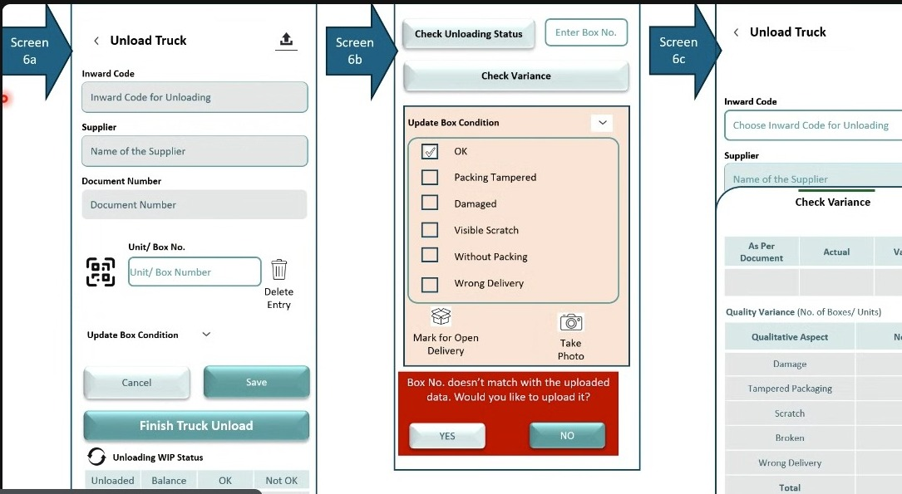
Figure 9.5a - Screens 6a / 6b / 6c composite: Screen 6a (box scanning with QR input, Update Box Condition accordion, Finish Truck Unload, WIP status tracker), Screen 6b (Check Unloading Status search with box condition options and mismatch dialog), Screen 6c (Check Variance with As Per Document / Actual / Variance columns and quality variance table)

9.6 Consolidated Unloading View - Filled State
Note: The composite below shows Screens 6a, 6b and 6c in a populated state and illustrates the behaviours described in FR-006.11 to FR-006.18: the ship list panel with View and Replace, the WIP status and unload progress tracker, the Mismatch with Shiplist exception with its Set Aside and Add Document actions, the Recent Box Entries log, and the variance, exception summary and Print Summary controls on Screen 6c.
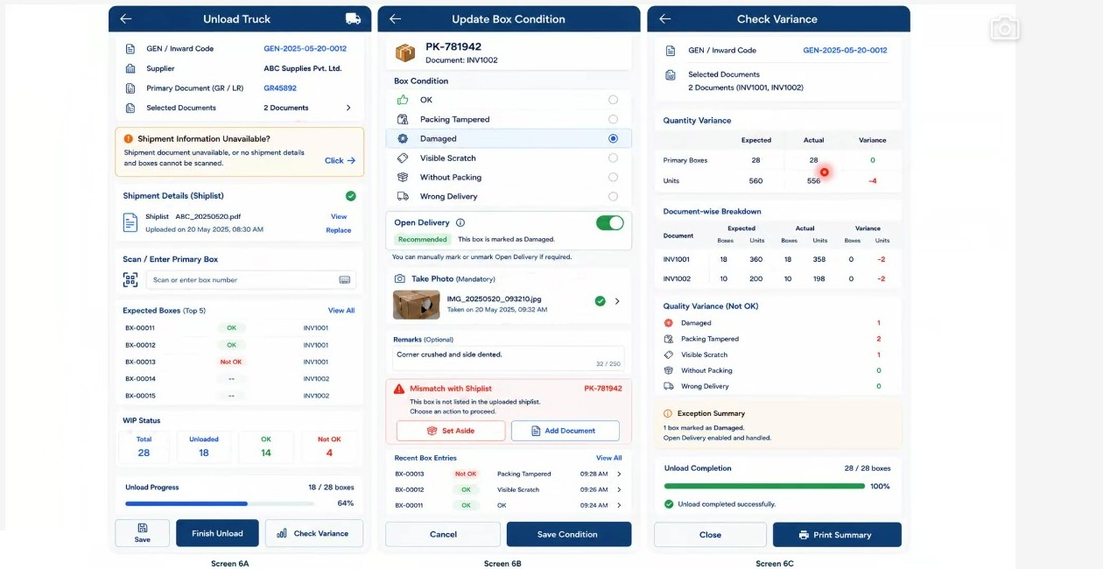
Figure 9.6a - Screens 6a, 6b and 6c in filled state: ship list panel with View and Replace, expected box list, WIP status and unload progress tracker (Screen 6a); box condition with open delivery, mandatory photo, Mismatch with Shiplist exception offering Set Aside and Add Document, and Recent Box Entries (Screen 6b); quantity variance, document-wise breakdown, quality variance, exception summary and Print Summary (Screen 6c).

9.7 Amendments from Session 07
Three points were added to truck unloading, all concerning how an unload session is closed.
The first is the auto-finish confirmation. Where the ship list has been uploaded and every box on it has been scanned, the system should recognise that the unload is complete and offer to finish it rather than waiting for the operator to decide. The confirmation must be declinable: the operator may know that a further box is present which was not on the list, and must be able to refuse the prompt and continue scanning.
The second is partial unloading. A consignment of fifty parts may arrive with only thirty present because the supplier did not hold the remaining stock, with the balance following on a later date. In that situation the operator finishes the unload knowing it is incomplete. The system should state how many cartons remain outstanding, ask for confirmation, and record that the truck was not completely unloaded.
The third is saving and resuming. Where a consignment runs to a large number of cartons, the operator should be able to save the session and return to it rather than being required to complete it in one pass.
Note: the existing Finish Truck Unload button is not replaced by any of this. It remains available at all times; what is added is a system-initiated prompt when the list is satisfied, a declinable path out of that prompt, and an explicit record when the session is closed short.
FR-006.19: Where the ship list has been uploaded and every box on it has been scanned, the system shall trigger a confirmation that the unload appears complete and shall offer to finish the truck unload.
FR-006.20: The auto-finish confirmation shall be declinable. Where the operator observes an additional box that was not on the ship list, the operator shall be able to decline the prompt and continue scanning.
FR-006.21: The Finish Truck Unload action shall remain available to the operator at all times and shall not be conditional on the ship list being satisfied.
FR-006.22: Where Finish Truck Unload is selected while cartons remain outstanding, the system shall state how many cartons are still expected and shall request confirmation before closing the session.
FR-006.23: Where the operator confirms closure with cartons outstanding, the system shall record that the truck was not completely unloaded, so that the incomplete unload is visible subsequently.
FR-006.24: The operator shall be able to save an unload session and resume it later, so that a consignment running to a large number of cartons need not be completed in a single pass.
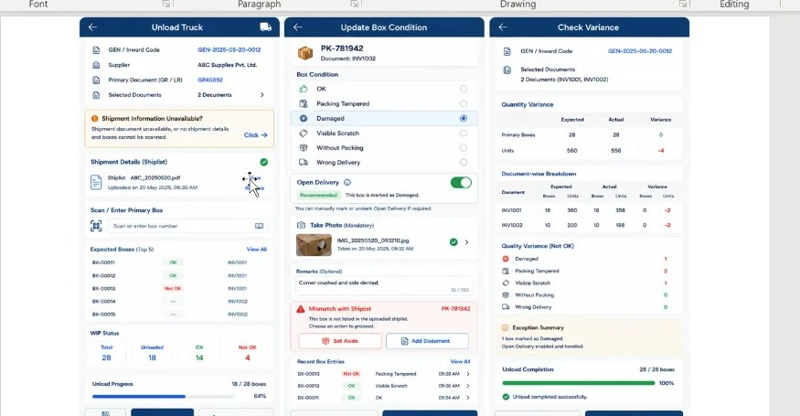
Figure 9.7a - Wireframe reviewed during the session: the unload screen with the ship list uploaded and the expected box list, box condition capture with mandatory photograph and the mismatch-with-shiplist alert, and the check variance summary with quantity and quality variance, exception summary and unload completion progress.

9.8 Corrections from Session 07 (Part 3)
The Check Unloading Status search answers one question and returns one kind of answer: has this box or part come off the truck, yes or no. Its purpose is operational and narrow. A workshop needs a part urgently while a hundred-box consignment is being unloaded; somebody searches the part number and learns whether it is already off the truck. Nothing about box condition is involved.
Screen 6b as drawn carried Update Box Condition, Mark for Open Delivery and Take Photo, and the field reference described the condition panel as reachable without selecting a gate entry. That is the behaviour objected to in session. Box condition is recorded once, on Screen 6a, at the moment the box is scanned during unloading, where the operator is physically holding the box. Offering the same controls from a status lookup creates a second and unwitnessed route to the same record.
Check Variance was similarly misplaced. It is not an immediate step after a status search. Variance is a consignment-level reckoning that becomes meaningful only once every box has been unloaded, every condition recorded and the session closed; running it against a single box mid-unload returns nothing usable.
Note: the rule a developer needs from this is that the status search is read-only. It takes a mandatory box or part number, returns unloaded or not unloaded, and offers no action. Condition is updated on Screen 6a and nowhere else; variance is read on Screen 6c after the unload is finished. The Update Box Condition, Mark for Open Delivery and Take Photo rows have been removed from the section 9.4 field reference accordingly, and FR-006.8 has been corrected in place to drop variance from what the search returns and to state that the lookup survives closure of the session.
FR-006.25: The Check Unloading Status search on Screen 6b shall be read-only. It shall not present Update Box Condition, Mark for Open Delivery, photo capture or any other action that writes to the box record.
FR-006.26: Box condition shall be recorded only on Screen 6a at the point of scanning during unloading. No alternative route to recording or amending box condition shall be offered from a status lookup.
FR-006.27: Check Variance shall not be presented as an action available from the status search. Variance shall become available only once the unload session has been closed, at the consignment level, as specified in FR-006.9 and FR-006.16.
FR-006.28: Photograph capture shall be mandatory where a recorded box condition is anything other than OK, and the box entry shall not be saved until the photograph has been captured. Where the condition is OK no photograph shall be required.
Note: the wireframe control is labelled Take Photo (Mandatory) without qualification. That is the name of the control, not the rule. The rule is conditional on the recorded condition, consistent with FR-006.5, FR-007.5 and FR-008.7.
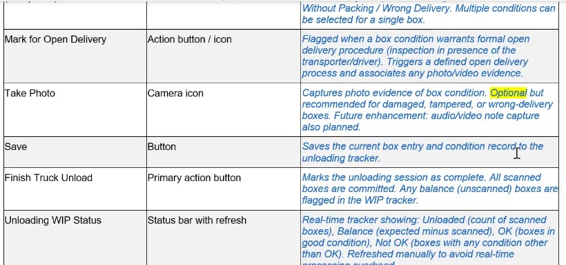
Figure 9.8a - the Screen 6a field reference as reviewed in session, with the optional wording on Take Photo highlighted as the description to be corrected

10. FR-007: Unloading Without Shipment Document - Screens 6d, 6e & 6f

10.1 Overview
A significant proportion of consignments arrive without a ship list. In this situation the system has no box-level manifest to validate against, so the unloading screens operate in a reduced mode: the expected box list and the ship list comparison are suppressed, and the box count captured at gate entry becomes the only expected reference available.
Two sub-scenarios are handled here. In the first, the outer carton still carries a scannable primary code, or at minimum a legible part number, so each box can be identified individually as it comes off the truck (Screens 6d and 6e). In the second, the dealer has configured a counter-based approach in which the operator simply increments a count for each box unloaded and records exceptions separately (Screen 6f).
Everything downstream of identification is unchanged. Box condition assessment, the open delivery recommendation, mandatory photo capture and remarks all behave exactly as defined in Section 9, so that an exception raised in this mode is handled identically to one raised against a ship-list consignment.

Layman Description
Vehicles turn up with no paperwork more often than anyone would like - the invoice is following by courier, or the driver has lost it. The question is whether the system lets you carry on. If it insists on a document before anything can be unloaded, the truck sits in the yard. This provides ways of unloading without one, chosen by an administrator to suit how the business works: counting the boxes on a counter as they come off, scanning them if they happen to carry codes, or recording them against a reference created on the spot. What it deliberately does not do is invent an expected quantity. With no document there is nothing to compare against, so the system records what physically came off and leaves the shortage question until the paperwork arrives, rather than producing a variance figure that means nothing.
Example: A truck arrives at 7 am with no invoice; the supplier says it will be emailed by noon. Rather than holding the vehicle, the storekeeper unloads under the counter method, tapping the counter once per box as it comes off, and finishes with 48. At 1 pm the invoice arrives showing 50. The two figures are compared then, and 2 boxes are raised as short - with the unloading already done and the truck long gone.

10.2 Functional Requirements
FR-007.1: Where no shipment document is available against a GEN, the unloading screen shall open in reduced mode and shall display a persistent banner reading Shipment document not available. Ship-list-dependent controls, including the expected box list and the ship list comparison, shall be suppressed.
FR-007.2: The operator shall scan the primary box code printed on the outer carton to identify each box. Where that code is not legible, is damaged, or is absent, the system shall accept manual entry of the part number printed on the carton as an alternative box identifier.
FR-007.3: Unloading shall be recorded box-number-wise. The system shall maintain a running list showing each box number processed, its recorded quality and its status indicator, with the ability to tap any row to update its condition.
FR-007.4: Each box shall be assessed for condition immediately after it is unloaded, using the same condition set defined in FR-006.4: OK, Packing Tampered, Damaged, Visible Scratch, Without Packing and Wrong Delivery.
FR-007.5: Where a box is assessed as anything other than OK, the open delivery recommendation, mandatory photo capture, optional remarks and the Recent Box Entries log defined in Section 9 shall apply without modification. Every exception shall open the same condition flow irrespective of which unload approach is in use.
FR-007.6: The system shall display a Box Unloading summary showing Unloaded, OK and Not OK counts, and a Variance Summary (Box Number Wise) showing boxes unloaded against the expected box count recorded at Receipt Details (No. of Boxes in GEN, FR-004.2) together with the remaining balance. Document-based quantity variance shall not be attempted in this mode; the expected box count recorded at Receipt Details shall serve as the expected value.
FR-007.7: The unload approach shall be configurable by the dealer admin. The selected approach shall be displayed on screen as Configured Unload Approach with a Set by Admin indicator, and the operator shall not be able to change it at the point of unloading.
FR-007.8: Where the counter approach is configured, Screen 6f shall present a Use Counter control which the operator increments once for each box unloaded. The running count shall be displayed prominently and shall be reconcilable against the expected box count recorded at Receipt Details (No. of Boxes in GEN, FR-004.2).
FR-007.9: Under the counter approach, the system shall provide a Box Quality Update section with an Add Not OK Box action. This shall allow the operator to raise an exception against a temporary box reference without scanning, recording the quality and status of that box while the remaining boxes are counted in bulk.
FR-007.10: The system shall not attempt reconciliation of ordered quantity against received quantity at the unloading stage. Where a consignment arrives without a document, the shortfall between what was ordered and what was received shall be determined at the Consignment Check stage, once boxes are opened and contents are counted.
FR-007.11: Finish Unload shall commit the session. All boxes scanned, counted or raised as exceptions shall be carried forward to the Consignment Check stage as the received population for that GEN.

10.3 Screen Field Reference - Screen 6d
Note: Screen 6d (Unload Truck - no shipment document) is the reduced-mode box scanning screen. Field descriptions in blue italic are analyst-generated.
Field / Section | Control Type | Description
Shipment document not available. | Static banner | Persistent amber/grey notice at the top of the screen confirming that no ship list or manifest exists for this GEN. Its presence explains why expected-box controls are absent.
Gate Entry Number (GEN) | Read-only text | Gate Entry Number carried forward from the gate entry record. Displayed as the master reference for the unloading session.
Supplier | Read-only text | Supplier name resolved from the consignment record.
Scan / Enter Primary Box | Scan field + keyboard toggle | Primary capture control. Helper text reads Scan each box as it is unloaded. Accepts a QR/barcode scan, or manual keyboard entry of the part number where the code is not legible.
Box Unloading (Box Number Wise) | Summary tiles | Three running counters - Unloaded, OK and Not OK - updated as each box is processed.
Box list (Box No. / Quality / Status) | Scrollable table | One row per processed box showing the box number, the quality label recorded against it, and a status icon. Helper text reads Tap a box to update condition, allowing an earlier assessment to be corrected.
Variance Summary (Box Number Wise) | Summary strip | Shows boxes Unloaded against the gate entry count and the Remaining balance. Replaces the document-based variance available when a ship list exists.
Save | Secondary button | Persists the session without closing it, per FR-006.11.
Check Variance | Primary button | Opens the variance view for the session.

10.4 Screen Field Reference - Screen 6e
Note: Screen 6e (Update Box Condition - no shipment document) records the condition of an individual scanned box. Field descriptions in blue italic are analyst-generated.
Field / Section | Control Type | Description
Scanned box header | Read-only text | Displays the scanned box number with a Scanned Box sub-label and a box icon. Identifies which box the condition is being recorded against.
No shipment details available. Quality update is required for each box. | Static notice | Explains that because there is no manifest to validate against, a condition assessment is mandatory for every box rather than only for exceptions.
Box Condition | Radio group (six options) | OK, Packing Tampered, Damaged, Visible Scratch, Without Packing, Wrong Delivery. Single selection per box.
Open Delivery | Toggle with Recommended tag | Automatically recommended when the selected condition indicates damage or tampering. Explanatory text names the condition that triggered the recommendation. The operator may override the toggle.
Take Photo (Mandatory) | Camera capture with thumbnail | Photographic evidence of the box condition. Mandatory when the condition is other than OK. A Retake / Change action allows the image to be replaced.
Remarks (Optional) | Multi-line text, 250 characters | Free-text description of the observed condition, with a live character counter.
Recent Box Entries | Scrollable log | Chronological list of recently processed boxes showing box number, quality, status icon and timestamp, per FR-006.14.
Cancel / Save Condition | Button pair | Cancel discards the assessment for this box; Save Condition commits it and returns to the scanning screen.

10.5 Screen Field Reference - Screen 6f
Note: Screen 6f (Unload Truck - counter approach) is used where boxes are neither listed on a manifest nor individually identifiable. Field descriptions in blue italic are analyst-generated.
Field / Section | Control Type | Description
No shipment details and boxes are not scannable. | Static banner | Confirms the conditions that caused the counter approach to be applied.
Gate Entry Number (GEN), Supplier | Read-only text | Consignment identification carried forward from the gate entry record.
Configured Unload Approach | Read-only panel with Set by Admin tag | Displays the unloading method configured for this scenario by the dealer admin. Not editable at the point of unloading.
Use Counter | Numeric display with increment control | Large running box count with a plus control. Helper text reads Press + after each box is unloaded. Serves as the received box count for the session.
Box Quality Update | Table with Add Not OK Box action | Allows exceptions to be raised without scanning. Each row carries a temporary box reference, the quality recorded and a status icon.
Box Ref. (Temporary) | System-generated reference | Sequential reference issued by the system for an exception box, so that the exception can be tracked even though the box has no supplier identifier.
Each exception opens the same condition flow with Condition, Open Delivery, Photo, and Remarks. | Static helper note | Confirms that exception handling is identical across all three unload approaches.
Save / Finish Unload | Button pair | Save persists the session; Finish Unload commits it and releases the consignment to the Consignment Check stage.
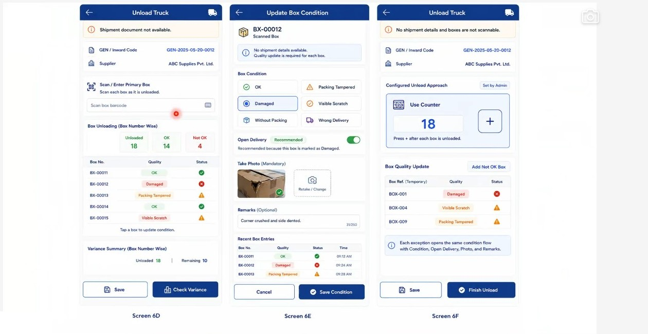
Figure 10.5a - Screens 6d, 6e and 6f: reduced-mode unloading with the Shipment document not available banner, box-number-wise unloading list and variance summary (Screen 6d); mandatory per-box condition capture with open delivery, photo and remarks (Screen 6e); admin-configured Use Counter approach with Box Quality Update and Add Not OK Box (Screen 6f).

10.6 Amendments from Session 07
Where neither the shipment list nor the boxes are scannable, the BRD sets out three distinct options rather than two. The first is to print stickers and scan them back. The second is a tap counter incremented once per box. The third is a plain entry of the total number of boxes unloaded, with no per-box tracking at all - the operator unloads the consignment and records that fifty or sixty boxes were received.
The first two are already specified. The third is not currently represented as a separate configuration, and it is materially different from the other two: it produces a total with no record of the individual boxes, which is the right answer where per-box tracking would cost more than it is worth.
Note: these are three configuration choices, not a sequence. The applicable option should be settled before unloading begins rather than being offered to the operator on the floor.
FR-007.12: Where neither the shipment list nor the boxes are scannable, the system shall support three distinct and separately configurable counting options.
FR-007.13: The third option shall be a plain entry of the total number of boxes unloaded, recorded as a single manual total with no per-box tracking, no scanning and no incrementing.
FR-007.14: The three options - print and scan back stickers, tap counter per box, and plain total count entry - shall each be available as a distinct configuration for a consignment.

10.7 Corrections from Session 07 (Part 3)
Two requirements in this section reconciled the boxes unloaded against the box count recorded at gate entry. That count is not dependable, for the reasons set out in section 4.6: at the gate the consignment may be accompanied by nothing more than a goods receipt, and the box figure, where taken at all, is indicative. Reconciling a physical unload against it invites a variance that reflects only the weakness of the original count.
Note: the baseline is unchanged from what the document already specifies - the expected box count recorded at Receipt Details on Screen 4a, established by FR-004.2. FR-007.6 and FR-007.8 have been corrected in place to reference it rather than the gate entry count. No new baseline is introduced.
FR-007.15: Reconciliation of boxes unloaded shall be against the expected box count recorded at Receipt Details (No. of Boxes in GEN, FR-004.2). The box count captured at gate entry shall not be used as the reconciliation baseline.
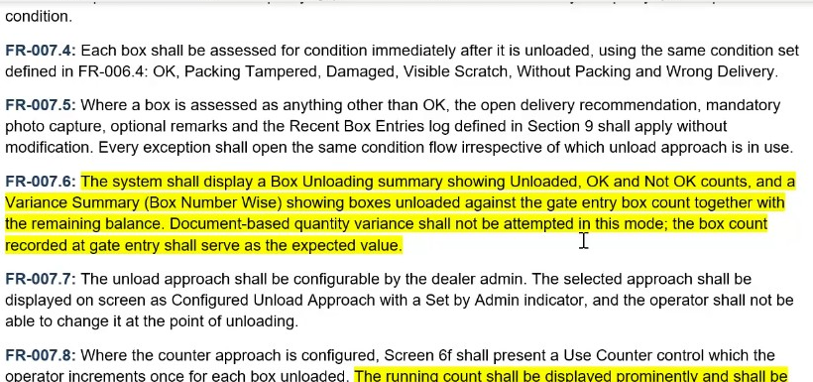
Figure 10.7a - FRD section 10.2 as reviewed in session, with the gate entry box count clauses in FR-007.6 and FR-007.8 highlighted as the passages to be corrected

11. FR-008: Box Sticker Generation for Non-Scannable Consignments - Screens 6g & 6h

11.1 Overview
The most constrained scenario is one in which the consignment arrives with no shipment document and the boxes carry no scannable code at all. Counting alone gives a total but leaves no way to attach a condition, a photograph or a remark to a specific physical box, and no way to trace that box through the remainder of the inward process.
To close that gap the system generates its own box references, prints them as stickers, and has the operator paste one sticker on each box. Once pasted, the boxes become scannable and the standard condition flow resumes unchanged. The references are recorded as system-generated so that downstream processes do not mistake them for supplier manifest numbers.

Layman Description
Plenty of goods arrive with nothing to scan - loose cartons, local suppliers, anything repacked in transit. Without a code on the box there is no way to tell box 12 from box 30, and everything after that becomes guesswork. This lets you print a sticker on the spot and put it on the box, giving it its own code for the rest of its life in the warehouse. Once the sticker is on, that box behaves like any other: it can be scanned when unloading, scanned again when it is checked, and referred to by number in a claim. The practical points to check are whether the printing happens at the bay or only in an office, and whether the code stays tied to that consignment - a sticker that just prints a random number nobody can look up is not much use.
Example: A local supplier delivers 20 plain cartons with no markings at all. The operator prints 20 stickers at the bay and puts one on each carton as it comes off. Carton 6 is crushed, so it is scanned and marked damaged. When the claim goes in, the supplier is told carton 6 - a box that had no identity at all twenty minutes earlier and could otherwise only have been described as one of the twenty.

11.2 Functional Requirements
FR-008.1: Where neither a shipment document nor a scannable box code is available, the system shall support a sticker-based unload approach. The approach shall be selectable by the dealer admin and shall be displayed on screen as Print Box Stickers & Scan under Configured Unload Approach, with helper text reading Use printed stickers to unload and track boxes.
FR-008.2: The system shall accept a Total Boxes to Print value. It shall default to the box count recorded at gate entry and shall remain editable by the operator to accommodate a discrepancy discovered at the dock.
FR-008.3: The system shall generate a unique temporary box reference for each box to be printed, in the format BX-nnnn, sequential within the GEN.
FR-008.4: The system shall render a Sticker Preview of the generated references. Each sticker shall carry the box reference as human-readable text, a QR code and a linear barcode, so that it can be read by either scanner type in use at the dealership.
FR-008.5: The system shall print the full set of stickers in a single action, labelled with the count to be printed. On-screen guidance shall instruct the operator to print and paste one sticker on each unloaded box.
FR-008.6: Once a sticker has been pasted, the box shall be scanned back into the system. The condition screen shall confirm the scan with a Printed Sticker Scanned indicator and shall prompt the operator to update quality before saving.
FR-008.7: Box condition assessment, the open delivery recommendation, mandatory photo capture, optional remarks and the Recent Box Entries log shall behave identically to FR-006 and FR-007. The sticker approach shall change only how a box is identified, never how an exception is handled.
FR-008.8: The system shall flag each temporary box reference as system-generated rather than supplier-issued, so that reconciliation, returns and any subsequent claim against the supplier do not treat it as a manifest reference.
FR-008.9: The system shall record that box ownership is unverified in this scenario. Where there is neither a ship list nor a supplier code, the system cannot establish that a given box belongs to this dealer rather than to another consignee sharing the vehicle. Ownership shall be confirmed at the Consignment Check stage, when the box is opened and its contents identified.

11.3 Screen Field Reference - Screen 6g
Note: Screen 6g (Print Box Stickers) generates and prints temporary box references. Field descriptions in blue italic are analyst-generated.
Field / Section | Control Type | Description
No shipment details and boxes are not scannable. | Static banner | Confirms the conditions that caused the sticker approach to be applied.
Gate Entry Number (GEN), Supplier | Read-only text | Consignment identification carried forward from the gate entry record.
Configured Unload Approach - Print Box Stickers & Scan | Read-only panel with Set by Admin tag | Displays the sticker approach as configured by the dealer admin, with helper text explaining that printed stickers will be used to unload and track boxes.
Total Boxes to Print | Numeric field with generate control | Number of stickers to produce. Defaults to the gate entry box count and remains editable.
Sticker Preview | Preview grid | Shows the generated stickers before printing. Each tile carries the box reference in text, a QR code and a linear barcode.
Print and paste one sticker on each unloaded box. | Static helper note | Operating instruction shown beneath the preview grid.
Back | Secondary button | Returns to the previous screen without printing.
Print n Stickers | Primary button | Sends the full sticker set to the connected label printer in a single action. The button label reflects the count entered.

11.4 Screen Field Reference - Screen 6h
Note: Screen 6h (Update Box Condition - printed sticker) records the condition of a box identified by a system-generated sticker. Field descriptions in blue italic are analyst-generated.
Field / Section | Control Type | Description
Scanned box header | Read-only text | Displays the temporary box reference with a Printed Sticker Scanned sub-label, distinguishing it from a supplier-issued box number.
Update quality before saving. | Static notice | Reminds the operator that a condition assessment is required for every box under this approach.
Box Condition | Radio group (six options) | OK, Packing Tampered, Damaged, Visible Scratch, Without Packing, Wrong Delivery. Single selection per box.
Open Delivery | Toggle with Recommended tag | Recommended automatically where the selected condition indicates damage or tampering; overridable by the operator.
Take Photo (Mandatory) | Camera capture with thumbnail | Mandatory photographic evidence where the condition is other than OK, with a Retake / Change action.
Remarks (Optional) | Multi-line text, 250 characters | Free-text observation with a live character counter.
Recent Box Entries | Scrollable log | Chronological list of processed boxes with reference, quality, status icon and timestamp.
Cancel / Save Condition | Button pair | Cancel discards the assessment; Save Condition commits it and returns to scanning.
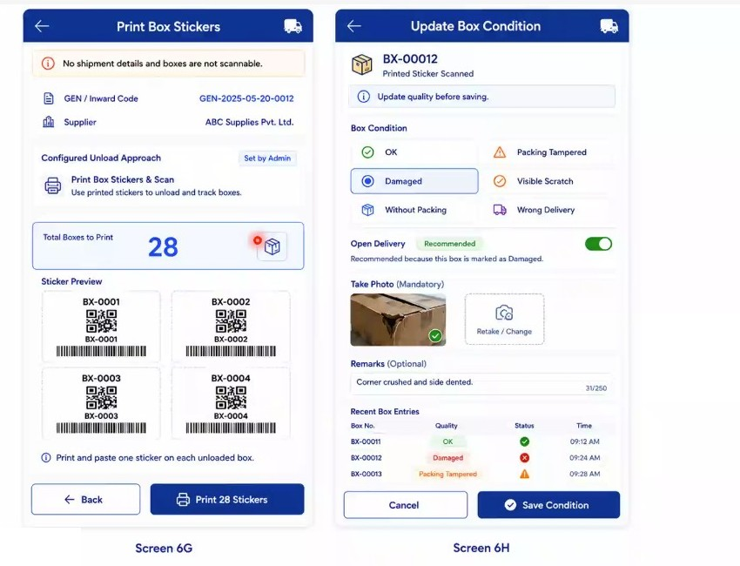
Figure 11.4a - Screens 6g and 6h: Print Box Stickers with Total Boxes to Print, sticker preview showing box reference, QR code and barcode, and the Print n Stickers action (Screen 6g); condition capture against a scanned printed sticker (Screen 6h).

12. FR-009: Consignment Check Initiation - Screen 7a

12.1 Overview
Consignment Check is the second physical stage of the inward process. It begins once the truck has been unloaded and has left the premises, at which point the dealer holds a set of primary boxes whose outer condition has been assessed but whose contents have not been verified. This is the stage at which boxes are opened, secondary packages are scanned and the quantity actually received is established.
Not every consignment requires it. Where the primary box and the secondary box are the same physical unit - a bumper, a windshield glass, a bonnet, a fender, a door or a tail door typically arrives as a single packed item - there is nothing to open and no inner verification to perform. Such consignments are routed straight to binning. Screen 7a is therefore a routing decision point as much as a data capture screen.

Layman Description
Once the truck is empty, there is a decision to make about how thorough to be. Either every carton is opened and checked against the paperwork, item by item, or the goods go straight onto the shelves and are checked later or not at all. Both are legitimate: a sealed consignment from a trusted manufacturer does not need opening, while a load from a supplier with a history of short deliveries does. What matters is that the choice is made deliberately, recorded, and not reversible halfway through - because the two routes produce very different records, and mixing them means nobody can later say whether a discrepancy was missed or never looked for. The system should remember which route was taken, so that when a shortage surfaces two weeks on, you know whether anyone actually checked.
Example: Two loads arrive on the same morning. The manufacturer consignment goes direct to bin - sealed cartons, straight to the racks, no opening. The second, from a supplier who short-shipped twice last quarter, is put through a full check and two items are found missing from a carton. A month later, when a part from the first load cannot be found, the record shows it went direct to bin and was never opened - so the search starts on the shelves rather than with the supplier.

12.2 Functional Requirements
FR-009.1: Screen 7a shall allow an unloaded consignment to be retrieved by GEN, either by selecting from a list of consignments awaiting checking or by entering the GEN directly. GEN Date shall auto-populate on selection.
FR-009.2: Supplier Category, Supplier and Product Category shall auto-populate from the consignment record established at gate entry and Screen 2. These fields shall be read-only at this stage.
FR-009.3: The user shall select or enter the Document Type, Document Number and Document Date applicable to the consignment being checked. Document Type shall be driven by the OEM-brand-specific configuration described in Section 3.4.
FR-009.4: The screen shall present two mutually exclusive routes: Consignment Check, which opens the full secondary verification flow with box opening and item-level scanning; and Direct to BIN, which bypasses secondary verification and proceeds directly to product identification and binning.
FR-009.5: Direct to BIN shall be applicable where the primary and secondary box are the same physical unit, so that no opening or inner verification is possible or required. In this case the consignment proceeds straight towards billing and storage.
FR-009.6: The route selected shall be recorded against the consignment for audit purposes. Where a dealer applies a uniform policy for a given product or supplier category, the route shall be defaultable by configuration, consistent with the workflow applicability mechanism defined in FR-002.3.
FR-009.7: Cancel shall exit the screen without committing a route selection, leaving the consignment in the pending-for-checking queue.

12.3 Screen Field Reference - Screen 7a
Note: Screen 7a (Consignment Check) initiates the post-unload checking stage and selects the route the consignment will follow. Field descriptions in blue italic are analyst-generated.
Field | Control Type | Description
GEN | Search / select field with lookup control | Gate Entry Number of the consignment to be checked. The adjacent lookup control opens a picker listing consignments that have completed unloading and are awaiting check.
GEN Date | Read-only text | Date of the selected gate entry. Auto-populated on GEN selection.
Supplier Category | Read-only text | Supplier classification carried forward from the consignment record.
Supplier | Read-only text | Supplier name carried forward from the consignment record.
Product Category | Read-only text | Product classification carried forward from the consignment record. Together with Supplier Category it determines the document types available below.
Document Type | Dropdown | Type of document accompanying the consignment - for example ship list, invoice, GRN or delivery challan. Options are driven by OEM brand configuration.
Document Number | Dropdown with free entry | Reference number of the selected document. Where document data is available in the back end the number may be selected; otherwise it is entered manually.
Document Date | Date field (DD/MM/YYYY) | Date printed on the accompanying document.
Consignment Check | Primary action button | Routes the consignment into the full secondary check flow, in which primary boxes are opened and their contents verified.
Direct to BIN | Primary action button | Routes the consignment directly to product identification and binning, bypassing secondary verification. Applied where primary and secondary box are the same unit.
Cancel | Secondary button | Exits without committing a route selection.
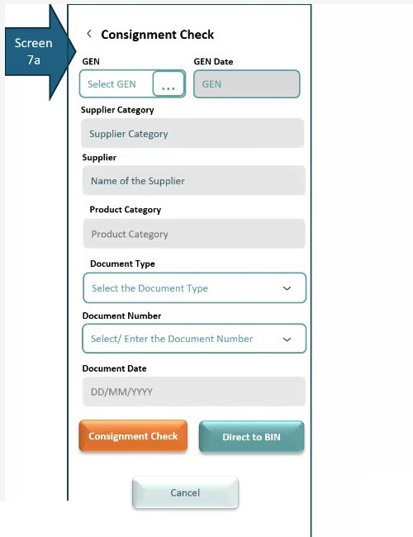
Figure 12.3a - Screen 7a (Consignment Check): GEN and GEN Date, auto-populated supplier and product classification, document type, number and date, and the two routing actions Consignment Check and Direct to BIN.

13. FR-010: Direct to Bin - Secondary Scan & Product Identification - Screens 8a & 8b

13.1 Overview
Screens 8a and 8b handle the identification of an individual part once the routing decision has been taken. The operator scans the unit or box, the system resolves it against the product master, and the part's storage destination is displayed before any physical movement occurs.
Two operational realities shape this design. The first is that a part may be needed immediately by a vehicle already in the workshop, in which case it must be segregated rather than binned. The second is that warehouse staff routinely tear off the primary packing to save space - a packed bonnet occupies roughly one and a half times the space of an unpacked one - and the MRP identifier is attached to that packing. Once the packing is removed the part loses its identity, and staff resort to writing the part number on the item by hand. The system therefore prints a replacement identification sticker that can be attached directly to the part.

Layman Description
Product Identification - Scanning a part should immediately tell the operator everything he needs to deal with it, without him going to look anything up. The description confirms he has the right item - part numbers are long and similar, and the description is how a human checks. The storage location tells him where it goes, which is the next thing he will need. And a fragile indicator warns him before he handles it carelessly. The value is in getting all of it from one scan. If the operator has to check a printed list for the location, or ask somebody whether an item needs careful handling, the system is only doing part of the job and the rest depends on the individual - which is exactly what goes wrong when the experienced man is on leave.
Example: The operator scans a part and the screen shows Front Brake Disc, location B-12-04, not fragile. He walks straight to B-12-04. The next scan comes up as a headlamp assembly with a fragile marker, so he carries it separately rather than stacking it. Neither decision needed anyone else, and a man on his second day makes the same choices as a man with ten years.
Disposition Routing - A part that has just been scanned does not always belong on a shelf. Four things can sensibly happen to it, and the system offers all four at that moment. It can be issued straight for use. It can go to the workshop for a specific vehicle, with the vehicle number recorded so it can be found later. It can be put away on a shelf now. Or it can be set aside to be put away later, when there is time. Offering the choice at the point of scanning is what makes it work, because that is when the operator has the part in his hand and knows what is happening to it. If the decision has to be made later on a different screen, the part gets put on a shelf by default and someone has to go and fetch it again an hour afterwards.
Example: A brake pad set is scanned. The workshop has been waiting for it, so the operator picks deliver to workshop and enters vehicle MH-01-2233. The part never goes to a rack. The next scan is a filter with no urgency, so he picks proceed to bin and puts it away. The third is a slow-moving item at the far end of the warehouse, so he picks bin later and carries on unloading rather than walking the length of the building for one part.
Bin Later Queue - Work on a bay is constantly interrupted. An operator scans a part, then something else arrives and he scans that too before finishing with the first. Rather than losing the first part or forcing him to deal with it before he can move on, the system puts it into a pending list automatically. He carries on, and comes back to the list when there is a gap. This matters because the alternative is worse than it sounds. If the system insists each part is finished before the next can be scanned, the operator starts working round it - putting parts aside physically and scanning them later from memory, which is where errors come in. A queue that fills by itself matches how the work actually happens rather than how it is supposed to happen. This capability also spans Section 14.
Example: The operator scans a radiator, then a pallet arrives at the bay and he scans four more parts while helping unload it. The radiator has gone into the pending list on its own. Twenty minutes later he opens the list, sees five items waiting, and works through them one at a time - putting each away properly. Nothing was left on the floor unrecorded and nothing had to be remembered.

13.2 Functional Requirements
FR-010.1: Screen 8a shall carry forward the GEN, Supplier and Document Number from Screen 7a. These fields shall be read-only, presented under a collapsible Consignment Details section.
FR-010.2: The Initiate Direct Binning section shall accept the Unit / Box No. by QR or barcode scan, or by selection from a list of boxes received against the consignment. A delete control shall allow an incorrectly scanned box to be cleared without leaving the screen.
FR-010.3: On successful scan, the system shall retrieve and display from the product master: Product Code, Product Description, MOQ, Binning Zone and Binning Location. The operator shall therefore know the destination of the part before picking it up.
FR-010.4: Where the product master defines the part as fragile, the FR indicator adjacent to Product Code shall be activated and visually highlighted. Where the part is not fragile the indicator shall remain in a neutral state. This gives the operator an immediate handling signal for items such as headlights and windshield glass.
FR-010.5: The system shall provide print controls against the product identification and the binning destination, producing the stickers defined in Section 13.5. This allows a replacement identifier to be attached directly to a part whose primary packing has been removed.
FR-010.6: Screen 8b shall provide a Deliver to Workshop section capturing the Vehicle Number, for parts routed directly to a vehicle under repair rather than to storage.
FR-010.7: Where the scanned part matches an open workshop demand held in the system, the IForU (Issue for Usage) action shall be activated automatically. This signals to the operator that the part is required by a vehicle currently in the workshop and must be segregated rather than binned.
FR-010.8: The operator shall select one of four dispositions for each scanned part: IForU, which segregates it for immediate issue to the workshop; Proceed to BIN, which opens the binning flow described in Section 14; BIN LATER, which defers binning; or Cancel.
FR-010.9: BIN LATER shall be applied by default where the operator scans a further part without having actioned the previous one. Parts so deferred shall accumulate into a bin-later queue, allowing a trolley load - typically three to four doors, or several windshield glasses - to be carried and binned in a single trip.
FR-010.10: Screen 8b shall provide an Update Product Condition section and an Update Box Condition checklist offering OK, Packing Tampered, Damaged, Visible Scratch, Without Packing and Wrong Delivery, together with a Take Photo action for evidence capture. Condition recorded here relates to the secondary unit and is distinct from the primary box condition recorded during unloading.
FR-010.11: The system shall print two distinct sticker formats as defined in Section 13.5: a D2B sticker for parts going to storage and a D2W sticker for parts going to the workshop.

13.3 Screen Field Reference - Screen 8a
Note: Screen 8a (Direct to BIN - product identification) resolves a scanned unit against the product master and displays its storage destination. Field descriptions in blue italic are analyst-generated.
Field / Section | Control Type | Description
Consignment Details | Collapsible section | Groups the read-only consignment identification carried forward from Screen 7a, collapsed by default to maximise working space on the handheld.
GEN | Read-only text | Gate Entry Number of the consignment being processed, labelled GEN for Consignment Check.
Supplier | Read-only text | Supplier name carried forward from the consignment record.
Document Number | Read-only text | Reference number of the document selected at Screen 7a.
Unit / Box No. | Scan field + dropdown + delete control | Primary capture control under Initiate Direct Binning. Accepts a QR or barcode scan of the secondary unit, or selection from the list of boxes received. The adjacent delete control clears an incorrect entry.
Product Code | Read-only text with edit affordance | Part number resolved from the product master on scan. The pencil affordance allows correction where the resolved code is wrong or the item was entered manually.
FR | Status indicator | Fragile flag held against the product master. Activated and highlighted when the scanned part is defined as fragile; otherwise neutral.
Product Description | Read-only text | Descriptive name of the part, resolved from the product master.
MOQ | Read-only text | Minimum Order Quantity for the part, shown as a handling and packing reference.
Binning Zone | Read-only text with print control | Warehouse area allocated to the part. The adjacent print control produces the destination sticker.
Binning Location | Read-only text | Specific rack or bin position within the binning zone at which the part is to be stored.

13.4 Screen Field Reference - Screen 8b
Note: Screen 8b (disposition and condition) determines what happens to the identified part and records its condition. Field descriptions in blue italic are analyst-generated.
Field / Section | Control Type | Description
Deliver to Workshop - Vehicle Number | Text field with print control | Registration of the vehicle awaiting the part. Completed where the part is to be routed to the workshop rather than to storage. The print control produces the D2W sticker.
Update Product Condition | Collapsible section | Records the condition of the secondary unit, as distinct from the outer carton condition captured during unloading.
IForU | Action button | Issue for Usage. Segregates the part for immediate issue to the workshop. Activated automatically where the scanned part matches an open workshop demand.
Proceed to BIN | Action button | Opens the binning flow (Screen 8c) for immediate placement of the part at its allocated location.
BIN LATER | Action button | Defers binning and adds the part to the bin-later queue so that several parts can be binned in one trip. Applied by default where a further part is scanned without the current one being actioned.
Cancel | Secondary button | Abandons the disposition for this part.
Update Box Condition | Checklist (six options) | OK, Packing Tampered, Damaged, Visible Scratch, Without Packing, Wrong Delivery. Records the observed condition of the unit being binned.
Take Photo | Camera capture | Photographic evidence of the recorded condition, following the same evidence convention used during unloading.

13.5 Sticker Print Formats
Note: The two sticker formats below are as illustrated in the session wireframe. Field descriptions in blue italic are analyst-generated.
Sticker | Fields | Purpose
Sticker for Print - D2B Parts | Part No., Part Description, MOQ, Binning Zone, Binning Location | Attached to a part being sent to storage. Replaces the MRP sticker lost when the primary packing is removed, and additionally carries the destination so the part can be binned without returning to the device.
Sticker for Print - D2W Parts | Repair Order, Vehicle No., Model, Supervisor, Part No., Part Description | Attached to a part being sent to the workshop. Identifies which vehicle and repair order the part belongs to and who is responsible for it, so that a segregated part is not mistaken for free stock.
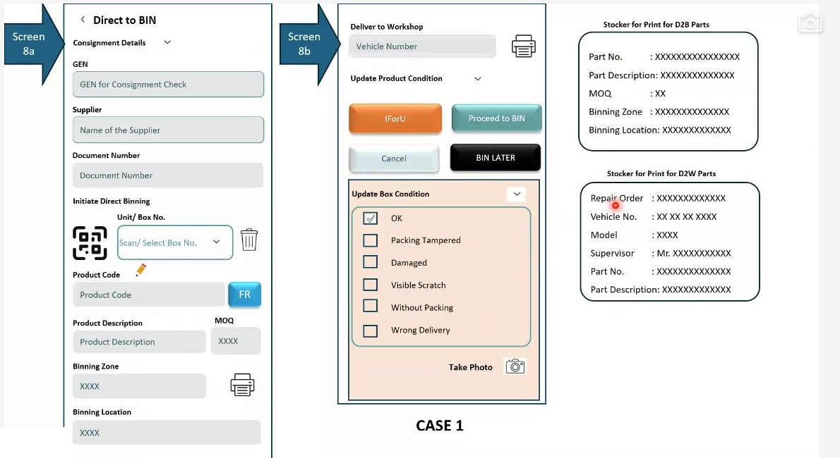
Figure 13.5a - Screens 8a and 8b with the two sticker formats: product identification showing Product Code, FR fragile flag, MOQ, Binning Zone and Binning Location (Screen 8a); disposition via IForU, Proceed to BIN or BIN LATER with Update Box Condition and Take Photo (Screen 8b); D2B and D2W sticker print layouts.

14. FR-011: Bin Placement & Location Confirmation - Screen 8c

14.1 Overview
Screen 8c completes the inward journey by placing the part physically into stock. Two conditions must hold simultaneously for the placement to be correct: the operator must be at the location the system expects, and the part in hand must be the part that belongs there. The screen therefore verifies location and part independently before accepting a quantity.
The design accommodates warehouses where not every bin carries a scannable code, and where space constraints regularly force an operator to place stock somewhere other than the allocated position. Rather than blocking the operator, the system raises a wrong-location alert and records the deviation.

Layman Description
Bin Placement (FR-011.1 to .4; FR-011.13) - Putting a part away requires two scans, not one: the shelf and the part. Scanning the part alone proves the right item was picked up but not where it went. Scanning the shelf alone proves somebody stood at the shelf. Only both together prove that this part went into this location, and that is the record the whole stock system depends on afterwards. It sounds like extra work but it takes a couple of seconds and it prevents the single most expensive mistake in a warehouse, which is stock recorded in a place it is not actually in. Once that happens the part is effectively lost: the system says it exists, somebody goes to fetch it, it is not there, and a replacement is ordered while the original sits three shelves away.
Example: The operator carries a filter to B-12-04. He scans the shelf label, then scans the filter. Only then does the system accept the put-away. On another occasion he scans B-12-04 and then a similar-looking filter with a different part number - the screen stops him and shows the mismatch. Without the two scans that part would have been recorded in B-12-04 and lost the day somebody went to get it.
Bin Placement (FR-011.5 to .8) - Alongside the two scans, the operator records how many pieces he is actually putting into that location. Two ways of doing it are needed, because two situations exist. If there are five items and they are individually barcoded, scanning each one is the most reliable. If there are two hundred small clips, scanning each is absurd and typing the number is the only sensible answer. A system that insists on one method for everything will be worked around. The other half is the check: it should not be possible to record putting away more than was picked up. Without that limit, a mistyped quantity creates stock that does not exist, and the error only surfaces at the next stock count when it is far too late to work out where it came from.
Example: The operator picked up 5 filters and puts 5 into B-12-04, scanning each one. Next he has 200 clips and types 200 rather than scanning them individually. Later he mistypes 50 against a line where only 5 were picked up, and the system refuses it and shows the 5. Fifty phantom clips never enter the stock figures.
Bin Placement (FR-011.9; FR-011.14; FR-011.16) - A part is often permitted in more than one place - a main location and one or two alternates, or a fast-moving item stocked in two zones. The system shows the operator which places are allowed for the part in his hand, rather than leaving him to remember or to ask. The more important half is what happens when he scans somewhere else entirely. Warehouses are busy and shelves look alike; scanning the shelf below the right one is an easy mistake. If the system accepts it silently, the part is lost. If it warns that this location is not one of the permitted ones, the operator either corrects himself or makes a deliberate decision to override - and either way somebody knows about it.
Example: A filter is allowed in B-12-04 and B-12-05; the screen shows both. The operator walks to the rack and scans B-13-04 by mistake, one row over. The screen warns that this is not a permitted location for this part. He looks up, sees he is at the wrong rack, moves one row and scans again. The whole correction takes ten seconds and no stock is misplaced.
Bin Capacity - Whether the system knows how much space a location has and how much of it is currently occupied. If it does, it can avoid sending anyone to a shelf that has no room, and the whole business of arriving at a full location and picking an alternative largely disappears. If it does not, every full shelf is discovered by a person standing in front of it. This is worth establishing carefully, because a system may well show a capacity field without anything using it - the field is filled in at setup, never maintained, and the recommendation ignores it. Ask whether it actually prevents a recommendation, not whether the number can be stored. This capability also spans Section 42.
Example: The system knows C-04-02 holds 40 units and currently has 38. An operator arrives with 5 filters; the system does not send him to C-04-02 at all, because it knows only 2 will fit. He goes straight to C-04-05. Where capacity is stored but unused, he would be sent to C-04-02, discover the problem himself, and go through the exception process instead.
Geolocation - Using the location of the device to confirm the operator is physically at the shelf he says he is at, rather than relying on the barcode scan alone. It closes a specific loophole: an operator can scan a printed sheet of location barcodes from the comfort of the bay and record putaways that never happened. In a warehouse where that is a real risk it is valuable. In most it is over-engineering, and indoor positioning is unreliable enough that false rejections would cost more than the problem is worth. Realistically this is a large-site capability, and worth asking about mainly to establish how sophisticated a competitor is rather than because it is likely to be needed.
Example: In a large multi-floor warehouse the device confirms the operator is on the second floor in aisle C when he scans C-04-02. In a single-room dealership store the same feature would reject valid scans whenever the signal drifted, and would be switched off within a fortnight.

14.2 Functional Requirements
FR-011.1: On Proceed to BIN, the system shall present the binning screen carrying the Binning Zone and Binning Location already determined at Screen 8a, so that the operator knows where to go before leaving the scanning point.
FR-011.2: SCAN Location shall read the QR code or barcode fixed at the bin location, confirming that the operator has physically reached the correct place.
FR-011.3: Where a bin location carries no scannable code, the operator shall be able to assert arrival using Confirm Location. The system shall record that the location was confirmed manually rather than scanned.
FR-011.4: SCAN Part shall read the identifier of the part being placed, so that part and location are verified against each other and not merely in sequence.
FR-011.5: The Quantity control shall record how many units of the part are being placed at the location, with decrement and increment controls and a default of one.
FR-011.6: The system shall not permit the quantity binned at a location to exceed the quantity picked for binning. This check shall apply across all placements made from a single bin-later batch.
FR-011.7: The system shall support two methods of recording multiple identical parts: scanning each unit individually, or scanning once and entering a count. Which method applies shall be configurable at dealer level.
FR-011.8: Where a part is not scannable - for example where the packing has been removed and the part number written on the item by hand - the system shall accept manual entry of the part number in place of a scan.
FR-011.9: Where the scanned location does not correspond to the allocated location, the system shall raise a Wrong Location alert and shall offer two responses: proceed with binning at the scanned location, recording the deviation against the part; or abandon the placement and relocate to the defined location.
FR-011.10: PICK NEXT to Bin shall advance to the next part in the bin-later queue without leaving the binning flow. Finish shall close the binning session. Cancel shall abandon the current placement.
FR-011.11: Future scope - bin capacity awareness. The system is intended to hold the dimensions, volume and permissible weight of each bin in configuration, so that it can advise whether a target bin can physically accept the item and can distinguish a genuine wrong location from a full one. Weight limits matter because heavy items cannot be stacked above light ones without risk of toppling. This capability is outside Phase 1 scope and is expected to form part of a later bin management release.
FR-011.12: Future scope - geolocation confirmation. Where a dealer operates fixed, surveyed bin locations, the geolocation of the handheld device may be captured at the moment of confirmation to verify placement automatically without requiring a scan. This capability is outside Phase 1 scope.
FR-011.13: Session 04 revision - superseding FR-011.3. The Confirm Location action shall be replaced by a Select Location control presenting a dropdown of the bin locations permitted for the part, comprising the recommended location and any alternative locations. The operator selects the location actually used rather than merely asserting arrival. This preserves the wrong-location check, because a selected location can still be compared against the recommended one, whereas a bare confirmation could not be.
FR-011.14: Where a part has more than one permitted bin location, the system shall display the recommended location together with the other allowed locations, and the operator shall choose between them. This accommodates the common situation in which the recommended bin is already full and the part must be placed elsewhere.
FR-011.15: Future scope - occupancy-aware recommendation. Once bin volume and dimension data is held in configuration (see FR-011.11), the system is intended to indicate the occupancy of a target bin and propose an alternative where it is substantially full. This is envisaged as a chargeable additional service rather than base functionality, and is outside Phase 1 scope.
FR-011.16: The system shall present a deliberately small set of options at the point of binning. Pickers operating the handheld may have limited literacy, and an excess of choices at the moment of placement increases error rather than reducing it. Where the system can determine the correct answer it shall do so rather than asking the operator to decide.

14.3 Screen Field Reference - Screen 8c
Note: Screen 8c (bin placement) verifies location and part before committing stock to a storage position. Field descriptions in blue italic are analyst-generated.
Field / Section | Control Type | Description
Deliver to Workshop - Vehicle Number | Text field with print control | Carried forward from Screen 8b. Remains visible so that a part diverted to the workshop mid-flow can still be captured against a vehicle.
Update Product Condition | Collapsible section | Carried forward from Screen 8b, allowing a condition observed while handling the part to be recorded before placement.
IForU / Proceed to BIN | Action buttons | Retained from the previous screen so that a part can still be diverted to the workshop after the binning flow has been opened.
SCAN Location | Scan control | Reads the QR or barcode fixed at the bin location, confirming the operator has reached the allocated position.
SCAN Part | Scan control | Reads the part identifier being placed. Accepts manual entry of the part number where the item is not scannable.
Confirm Location | Button | Manual assertion of arrival, used where the bin location carries no scannable code. The manual confirmation is recorded as such.
Quantity | Numeric stepper | Number of units being placed at this location, with decrement and increment controls. Defaults to one and cannot exceed the quantity picked for binning.
Cancel | Secondary button | Abandons the current placement without committing.
PICK NEXT to Bin | Primary button | Commits the current placement and advances to the next part in the bin-later queue.
Finish | Primary button | Commits the current placement and closes the binning session.
Wrong Location ! - Would you like to proceed with Binning | Alert panel | Raised when the scanned location does not match the allocated location. Offers YES, which proceeds at the scanned location and records the deviation, and Place at the defined location, which abandons the placement and directs the operator to the allocated position.
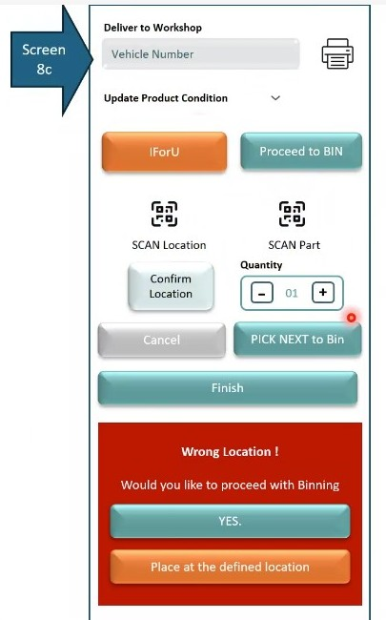
Figure 14.3a - Screen 8c (bin placement): SCAN Location and SCAN Part controls, Confirm Location fallback, quantity stepper, PICK NEXT to Bin and Finish actions, and the Wrong Location alert offering YES or Place at the defined location.

15. FR-012: Direct Binning Case 1A - Primary and Secondary Cartons Are the Same - Screens 8A, 8B, 8C & 8D

15.1 Overview
Case 1A is the most favourable direct binning scenario. Three conditions hold together: both the primary carton and the secondary unit carry scannable codes, the supplier has uploaded its data, and the linkage between primary carton and product is available. The system therefore knows before the carton is opened which part it contains and how many units should be inside.
This section elaborates the flow already defined in FR-010 and FR-011 for that specific condition, and adds two behaviours not previously specified: a unit-by-unit product inspection in which each individual unit receives its own condition and outcome, and a wrong-location override with an explicit bin-later hand-off (Screen 8D).
Case 1A applies only where a carton holds a single SKU packed as identical units - a front bonnet assembly, for example, where the outer carton and the item inside are effectively the same thing. A carton holding several different SKUs falls outside this flow and is handled as described in Section 16.

Layman Description
Case 1A - Same Carton - This covers the simplest kind of goods, where the box you receive and the item inside are effectively the same thing - one carton, one part number - and the carton carries a barcode. There is no opening, no counting of different items inside, no relationship to work out. The consignment is scanned and put away. Even here the system should still require both the shelf and the part to be confirmed at the rack, because the simplicity of the goods does not make misplacing them any less likely. It is worth establishing whether a competitor handles only this straightforward case well and struggles with the more awkward ones, since this is the case that gets demonstrated in sales presentations and the others are where the real difficulty lies.
Example: Fifty cartons of engine oil arrive, one product code, barcode on every carton. The operator scans a carton, the system shows the product and its location, he carries it to the rack, scans the shelf, scans the carton again and it is done. Around fifteen seconds per carton with no opening and no counting - and the same two-scan confirmation as everything else.
Piece Inspection - Where a box has been opened because something is wrong with it, the pieces inside are looked at one at a time rather than judged as a batch. The system walks through them and keeps three running counts: how many were good, how many were damaged, and how many are going onto an insurance claim. The three are kept separate because they go to three different places afterwards. Good pieces go on the shelf and become sellable stock. Damaged pieces do not, and must not be counted as though they were. Claim pieces need to be held aside and photographed rather than put away or thrown out. A single count of pieces received, with no breakdown, means somebody has to sort it out physically later from a pile with no labels on it. This capability also spans Section 17.
Example: A carton of ten headlamp units arrives crushed at one corner. Opened piece by piece: six are perfect, three are cracked, one is smashed beyond any question. The six go to the shelf as normal stock, the three cracked are set aside for the supplier to decide on, and the smashed one goes straight onto the insurance claim with a photograph. Three outcomes from one carton, each recorded separately.
Location Override - The system suggests a location, but the operator is the one standing in the warehouse and sometimes the suggestion is wrong - the shelf is full, blocked, or the part is bulky and will not fit. He is allowed to put it somewhere else, but the system asks him to confirm rather than letting it happen silently, and then records where it actually went. That last part is what makes the feature worthwhile. An override with no record is the same as losing the stock: the system believes it is in one place and it is in another. An override that is confirmed and recorded means the stock figure stays true, and the pattern of overrides tells you something useful - if one location is overridden every week, its allocation is probably wrong.
Example: The system sends the operator to B-12-04 but the shelf is packed with a delivery from yesterday. He selects a different location, B-12-09, and the system asks him to confirm the change before accepting it. The stock record now says B-12-09, which is where the part actually is. Three weeks later the supervisor sees B-12-04 has been overridden eleven times and reallocates the part properly.
Insurance Routing - A damaged carton is not all bad. Most of what is inside is usually fine, and the point of opening it is to separate the two. Good pieces go onto the shelf and become normal sellable stock. Damaged pieces must not - they go to a set-aside area and onto a claim. The system has to keep those two paths genuinely separate, because the temptation is to treat the carton as a single unit and either shelve all of it or write off all of it. Shelving damaged pieces means a customer eventually receives one, which costs far more than the part. Writing off good pieces means throwing away stock you have paid for. The value of the feature is entirely in the splitting. This capability also spans Section 21.
Example: A carton of twelve alternators arrives wet; nine are fine and three are water damaged. The nine are binned normally and appear in stock that afternoon, available to sell. The three go to the set-aside rack against a claim, and the system will not let them be put on a shelf. One carton, two destinations, and neither nine good units written off nor three bad ones sold.

15.2 Functional Requirements
FR-012.1: Case 1A shall be applied where all three preconditions hold: both cartons are scannable, supplier details have been uploaded, and the primary-secondary linkage is available. Where any precondition fails, the system shall fall through to Case 1B.
FR-012.2: The system shall support an optional flag indicating that the primary and secondary carton are the same physical unit for a given item. The flag shall be optional rather than mandatory, and shall serve to identify in advance which items follow this flow. Where a ship list and full configuration are available the linkage is derived automatically; the flag exists for consignments where it is not.
FR-012.3: The Direct to BIN screen shall present two tabs - Current Check and Open Delivery - allowing the operator to switch between the consignment currently being processed and the open delivery queue. The Open Delivery tab shall carry a count badge, and open deliveries shall be viewable and configurable from it.
FR-012.4: Entering the GEN shall auto-populate the consignment details: GEN, Supplier and Document Number.
FR-012.5: Scanning the primary Unit / Box No. shall retrieve and display Product Code, Product Description, MOQ, Binning Zone and Binning Location, together with the fragile (FR) indicator defined in FR-010.4.
FR-012.6: The resolved Product Code shall be overwritable, either by scanning again or through predictive search, so that a misread or mismatched code can be corrected without abandoning the carton.
FR-012.7: Only one product code shall be permitted inside a primary carton under Case 1A. Where different products are found, the operator shall be prevented from proceeding and the carton shall be routed to the check-carton process described in FR-013.13.
FR-012.8: The D2W Vehicle Number field shall appear when a vehicle number is required against an open order, and shall offer sticker printing for the workshop route.
FR-012.9: Where a carton contains more than one unit, the system shall present a Product Inspection - Unit by Unit section requiring a condition and an outcome to be recorded against each unit individually, identified as Unit n of m. Condition shall be OK or Damaged; outcome shall be Proceed to BIN or Set Aside (Insurance). Photographic evidence shall be capturable per unit.
FR-012.10: A unit recorded as damaged shall be routed to Set Aside (Insurance) rather than to a bin, so that an insurance claim can subsequently be raised against the internal part. Good units within the same carton shall continue to binning unaffected. This means a single carton may split between binning and insurance.
FR-012.11: The system shall display running inspection totals for the carton: Good Units, Damaged Units and Insurance Claim counts.
FR-012.12: Binning Action (Screen 8C) shall enforce a two-step verification. Step 1 shall scan the location and confirm Location Verified; Step 2 shall scan the product and confirm Product Verified. Neither step shall be skippable.
FR-012.13: On successful verification the system shall display a Binning Verified Successfully confirmation stating how many good units will be binned and how many units have been moved to Set Aside / Insurance, so that the operator sees the split before committing.
FR-012.14: Confirm BIN shall commit the placement. Cancel Carton shall abandon the carton and reverse the actions recorded against it. The verification sequence - user scans location, user scans product, system confirms binning at the selected location - shall be recorded.
FR-012.15: Where the scanned location differs from the recommended location, Screen 8D shall display both the Recommended Location and the Scanned Location, warn that a wrong location has been selected, and ask whether the operator still wishes to bin at the scanned location. Two responses shall be offered: Cancel and Confirm Override.
FR-012.16: If the override is confirmed, the chosen location shall be recorded against the item as the actual storage location. If cancelled, all actions for that carton shall be cancelled. This shall be stated on screen so the operator understands the consequence before choosing.
FR-012.17: Where a carton is marked for deferred binning, Screen 8D shall confirm the carton reference as marked Bin Later, clear the carton details, present the next-scan control (scan next primary carton or product code), and display a Bin Later Queue with the count of pending cartons.
FR-012.18: Deferred binning shall be completed through the Binning module rather than through the inward flow. The system shall state this on screen so the operator knows where the carton has gone.
FR-012.19: Where the operator scans a second item without having actioned the first, the system shall assume bin-later for the first item, consistent with FR-010.9.
FR-012.20: D2B and D2W stickers shall be printable from this flow in the formats defined in Section 13.5, populated with the live values resolved for the carton.

15.3 Screen Field Reference - Screen 8A
Note: Screen 8A (Direct to BIN - Case 1A) identifies the carton and resolves it against the product master. Field descriptions in blue italic are analyst-generated.
Field / Section | Control Type | Description
Current Check / Open Delivery | Tab pair with count badge | Switches between the consignment currently being processed and the open delivery queue. The badge shows how many open deliveries are outstanding.
Consignment Details | Collapsible section | Groups GEN, Supplier and Document Number, collapsed by default to preserve space on the handheld.
GEN | Search / select field | Gate Entry Number for the consignment check. Selecting it auto-populates supplier and document details.
Supplier | Read-only text | Supplier name resolved from the consignment record.
Document Number | Read-only text | Reference of the document selected at Screen 7a.
Unit / Box No. | Scan field with clear and delete controls | Primary carton identifier under Initiate Direct Binning. Scanned from the carton barcode.
Product Code | Resolved text with edit affordance and FR indicator | Part number retrieved on scan. The pencil affordance allows overwrite; the FR badge activates where the product master defines the part as fragile.
Product Description / MOQ | Read-only text pair | Descriptive name of the part and its minimum order quantity, shown side by side.
Binning Zone | Read-only text with print control | Warehouse zone allocated to the part. The print control produces the destination sticker.
Binning Location | Read-only text marked (Recommended) | The system's recommended bin position. Explicitly labelled as a recommendation because alternatives may be permitted.
You can overwrite product code by scanning or using predictive search. | Informational note | Explains the correction path available where the resolved product code is wrong.
Only one product code is allowed inside one primary carton. If multiple different products are found, user cannot proceed. | Warning note | States the Case 1A constraint and its consequence, so the operator is not surprised when the flow blocks.

15.4 Screen Field Reference - Screen 8B
Note: Screen 8B (Deliver to Workshop and unit inspection) determines disposition and records the condition of each unit in the carton. Field descriptions in blue italic are analyst-generated.
Field / Section | Control Type | Description
D2W Vehicle Number | Text field with print control | Registration of the vehicle awaiting the part. Helper text notes that the vehicle number appears when required against an open order.
IForU / Proceed to BIN | Action button pair | Issue for Usage segregates the part for the workshop; Proceed to BIN opens the binning verification flow.
Cancel / BIN LATER | Action button pair | Cancel abandons the disposition; BIN LATER defers the carton to the bin-later queue.
Update Box Condition | Checklist (six options) | OK, Packing Tampered, Damaged, Visible Scratch, Without Packing, Wrong Delivery. Records the condition of the outer carton.
Take Photo | Camera capture | Photographic evidence of the recorded carton condition.
Product Inspection - Unit by Unit | Repeating section, one block per unit | Presented where the carton holds more than one unit. Each block is headed Unit n of m and requires its own condition, outcome and photograph.
Condition (per unit) | Status selector | OK or Damaged for the individual unit, independent of the outer carton condition.
Outcome (per unit) | Routing selector | Proceed to BIN for a good unit, or Set Aside (Insurance) for a damaged one. Allows a single carton to split between storage and an insurance claim.
Photo (per unit) | Camera capture with thumbnail | Evidence of the individual unit's condition, retained against the insurance claim where applicable.
Good Units / Damaged Units / Insurance Claim | Summary tiles | Running totals for the carton, updated as each unit is inspected.

15.5 Screen Field Reference - Screen 8C
Note: Screen 8C (Binning Action - verification) confirms location and product before committing the carton to stock. Field descriptions in blue italic are analyst-generated.
Field / Section | Control Type | Description
Primary Carton header | Read-only summary block | Carton reference and the resolved product, shown so the operator can confirm they are working on the right carton.
Quantity (MOQ) / Binning Zone / Recommended Location / Other Allowed Locations | Read-only detail list | The full storage instruction for the carton. Other Allowed Locations lists the alternatives available where the recommended bin cannot be used.
Step 1: Scan Location | Scan field with verification badge | Reads the code fixed at the bin location. On success the field shows Location Verified and the message Location scanned successfully.
Step 2: Scan Product | Scan field with verification badge | Reads the product identifier. On success the field shows Product Verified and the message Product scanned successfully. Sequenced after location so both are checked against each other.
Binning Verified Successfully! | Confirmation panel | States how many good units will be binned and how many have been moved to Set Aside / Insurance, giving the operator the split before commitment.
Confirm BIN | Primary button | Commits the placement at the verified location.
Cancel Carton | Secondary button | Abandons the carton and reverses the actions recorded against it.
Sequence note | Informational note | Records the intended order of operations - user scans location, user scans product, system confirms binning at the selected location - as an on-screen aid.

15.6 Screen Field Reference - Screen 8D
Note: Screen 8D (Binning Action - exception states) handles a wrong-location override and the hand-off to deferred binning. Field descriptions in blue italic are analyst-generated.
Field / Section | Control Type | Description
State 1: Wrong Location Override | State header | Identifies the exception being handled, so the operator understands this is not the normal path.
Recommended Location | Read-only text | The location the system expected the part to be placed at.
Scanned Location | Read-only text, highlighted | The location actually scanned. Rendered in a warning treatment to make the divergence obvious.
Wrong location selected. Do you still want to bin at ...? | Warning dialog | States the recommended location and asks for an explicit decision rather than silently accepting or rejecting the placement.
Cancel / Confirm Override | Button pair | Cancel abandons all actions for the carton; Confirm Override accepts the scanned location and records it as the actual storage position.
If user confirms, chosen location is recorded. If cancelled, actions for the carton are cancelled. | Informational note | Makes the consequence of each choice explicit before it is made.
State 2: Bin Later / Next Scan State | State header | The screen state reached when a carton is deferred rather than binned.
Carton marked as Bin Later | Confirmation strip | Names the carton reference that has been deferred, so the operator has a record of what was set aside.
Carton details cleared. Scan next. | Status text with scan control | Confirms the working area has been reset and offers the next-scan control for the following primary carton or product code.
Bin Later Queue | Navigable summary row | Shows the count of cartons pending deferred binning and opens the queue.
Binning later is done using the BINNING module. | Informational note | Tells the operator where the deferred work will be completed, so a bin-later carton is not assumed lost.
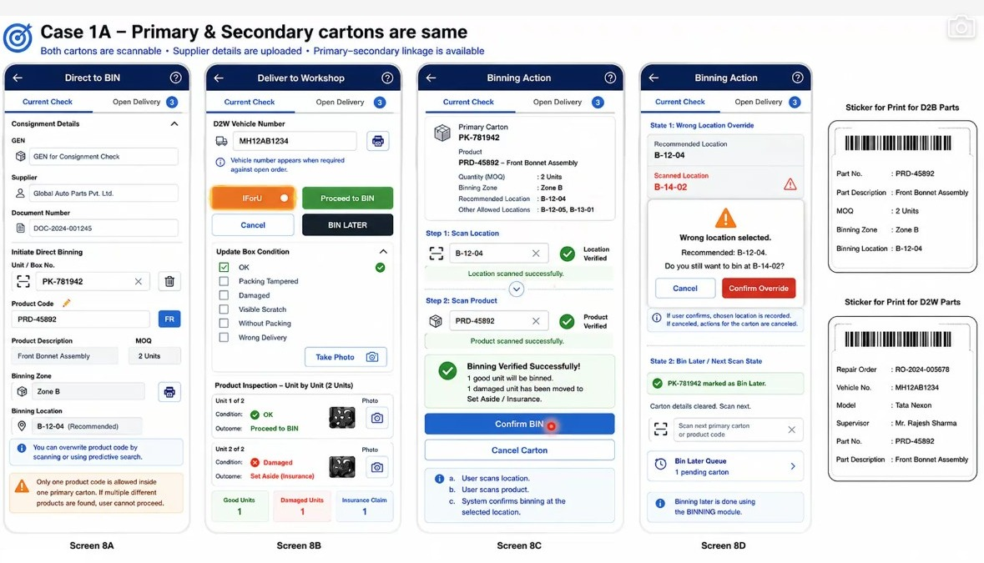
Figure 15.6a - Case 1A composite (Screens 8A, 8B, 8C and 8D): carton identification with product master lookup and the single-product-code constraint (Screen 8A); disposition with unit-by-unit product inspection, per-unit outcome and Good / Damaged / Insurance Claim totals (Screen 8B); two-step location and product verification with the binning confirmation (Screen 8C); wrong-location override and the bin-later / next-scan state with the Bin Later Queue (Screen 8D); D2B and D2W stickers populated with live values.

16. FR-013: Direct Binning Case 1B - Single SKU in Primary Carton, Primary-Product Linkage Unavailable - Screens 9a, 9b, 9A, 9B & 9C

16.1 Overview
Case 1B covers the situation in which the supplier has uploaded both primary carton data and product data, but not the linkage between the two. The system knows the carton exists and knows the part exists, but cannot say which part is inside which carton, or how many units should be there. Expected quantity is therefore unavailable and must be established by physically scanning or counting what comes out of the carton.
The flow runs in three steps: scan the primary carton, scan the product on the secondary unit, then verify product and location and take an action. Because identification depends entirely on the product scan, the carton may hold only one SKU. Finding a second product code inside the same carton invalidates the assumption the flow rests on, and the carton is diverted to the check-carton process.
Screens 9a and 9b give the handheld layout for this case, with separate scan controls for the primary box number and the product code. Screens 9A, 9B and 9C set out the same flow as a three-step sequence with the full field detail, rules and exception alerts.

Layman Description
Sometimes the supplier tells you a carton is on its way but not what is inside it. The carton can be received and scanned, but the system has no expected quantity to check against, because nobody has been told one. What separates a good system here is honesty. It should say plainly on screen that the expected quantity is not known and why - rather than showing a blank that looks like a zero, or worse, quietly treating the number that was found as the number that was expected, which makes every consignment appear to balance perfectly. A warehouse that cannot tell the difference between checked and correct and never checked at all will find out the difference eventually, usually during a stock count.
Example: A carton arrives with a barcode but no contents information. The operator scans it, opens it, and finds 12 pieces. The screen shows expected: not provided by supplier, found: 12. The consignment is not reported as balanced - it is reported as unverifiable, with the reason. When the invoice later shows 15, the 3 missing pieces are still a live question rather than something the system already closed off.

16.2 Functional Requirements
FR-013.1: Case 1B shall be applied where the supplier has uploaded primary carton data and product data but the linkage between primary carton and product is unavailable. The system shall display the linkage status explicitly as LINKAGE UNAVAILABLE against the carton.
FR-013.2: The flow shall run in the sequence: scan primary carton, scan product on the secondary unit, verify product and location, take action. The sequence shall be shown on screen so the operator knows how many steps remain.
FR-013.3: Screen 9A shall display the primary carton record: Primary Carton No., GEN / Consignment, Supplier, Document Reference, Capture Status, Carton Type, Uploaded By Supplier and Linkage Status.
FR-013.4: Screen 9A shall state that the expected product and quantity will be determined only after product verification, and that the carton may contain only one SKU. The operator shall proceed via a Scan Product (Secondary) action.
FR-013.5: Screen 9B shall retrieve verified product information on scanning the product code from the unit or its secondary packing: Product Code, Product Description, MOQ, Binning Zone, Recommended Location, Alternative Locations, D2W Vehicle No. and IForU Eligible.
FR-013.6: Screen 9B shall present Supplier Quantity as not available, annotated with the reason (no linkage), rather than leaving the field blank. Quantity Received / Count shall be captured through a stepper control in units.
FR-013.7: The system shall state on screen that expected quantity is unavailable because the carton-product linkage is unknown, and that quantity will be captured from the actual scan or count. The absence of a variance figure in this mode is therefore explained rather than silently omitted.
FR-013.8: Scan Another Unit (Same Product) shall increment the Quantity Received under the same primary carton. It shall not move the carton to Bin Later automatically.
FR-013.9: Where a different product code is scanned within the same primary carton, the carton shall be treated as a multiple-SKU case: direct binning shall be stopped and the carton routed to the Check Carton process.
FR-013.10: Scan Next Carton (New Primary Carton) shall be permitted at any point. Where the operator scans the next primary carton without selecting an action for the current one, the system shall automatically mark the current carton as Bin Later.
FR-013.11: Screen 9C shall capture two conditions separately: Primary Carton Condition and Unit / Product Condition for each unit. Each shall support photographic evidence capture.
FR-013.12: Screen 9C shall capture two additional checks as explicit yes/no decisions: Insurance Required and IForU Eligible.
FR-013.13: Screen 9C shall offer four next actions: Proceed to Bin (bin now), Bin Later, IForU (issue for use), and Cancel. The permitted actions shall reflect whether direct binning is allowed for the carton.
FR-013.14: The system shall indicate throughout whether direct binning is allowed or not allowed for the carton in its current state, using a consistent visual key.
FR-013.15: All conditions, quantities and actions shall be captured against User ID, date and time to provide a full audit trail. Actions taken on a carton diverted to Check Carton shall be logged in the same way.
FR-013.16: The system shall raise four distinct on-screen alerts, each with its own sticker or pop-up treatment: Match, where the product is verified successfully and the operator may proceed; Mismatch, where the scanned product does not match supplier data and must be verified before proceeding; Multiple SKU, where more than one product code is detected in the carton and direct binning is not allowed; and No Location, where no bin location is mapped for the SKU and a location must be identified before binning.
FR-013.17: The system shall print a carton sticker carrying the carton reference, SKU, product description, location and GEN. The sticker shall be printed and affixed to the carton or pack after verification, so that a carton identified only by scan retains that identification physically.
FR-013.18: Screens 9a and 9b shall provide the handheld layout for this case, presenting separate scan controls for Primary Box Number and Product Code. The two identifiers are captured independently because, in the absence of linkage, neither can be derived from the other.

16.3 Screen Field Reference - Screens 9a & 9b
Note: Screens 9a and 9b are the handheld layout for Case 1B, distinguished from Case 1A by the separate primary and product scan controls. Field descriptions in blue italic are analyst-generated.
Field / Section | Control Type | Description
Direct to BIN / Open Delivery | Tab pair | Switches between the current check and the open delivery queue, as on Screen 8A.
Consignment Details - GEN, Supplier, Document Number | Collapsible read-only section | Consignment identification carried forward from the consignment check.
Primary Box Number | Scan field with dropdown and delete control | First of two independent scan controls. Captures the outer carton identifier.
Product Code | Scan field with dropdown and delete control | Second independent scan control under Initiate Direct Binning. Captures the product on the secondary unit. Separate from the primary scan because no linkage exists between them.
Product Description / MOQ | Read-only text pair | Resolved from the product master once the product code has been scanned.
Binning Zone | Read-only text with print control | Zone allocated to the part, with sticker printing.
Binning Location | Read-only text | Bin position allocated to the part.
Deliver to Workshop - Vehicle Number | Text field with print control | Vehicle registration where the part is routed to the workshop, with D2W sticker printing.
Update Product Condition | Collapsible section | Condition of the secondary unit, distinct from the carton condition.
IForU / Proceed to BIN / Cancel / BIN LATER | Action buttons | The four dispositions available for the scanned part.
Update Box Condition | Checklist (six options) | OK, Packing Tampered, Damaged, Visible Scratch, Without Packing, Wrong Delivery.
Take Photo | Camera capture | Evidence of the recorded condition.
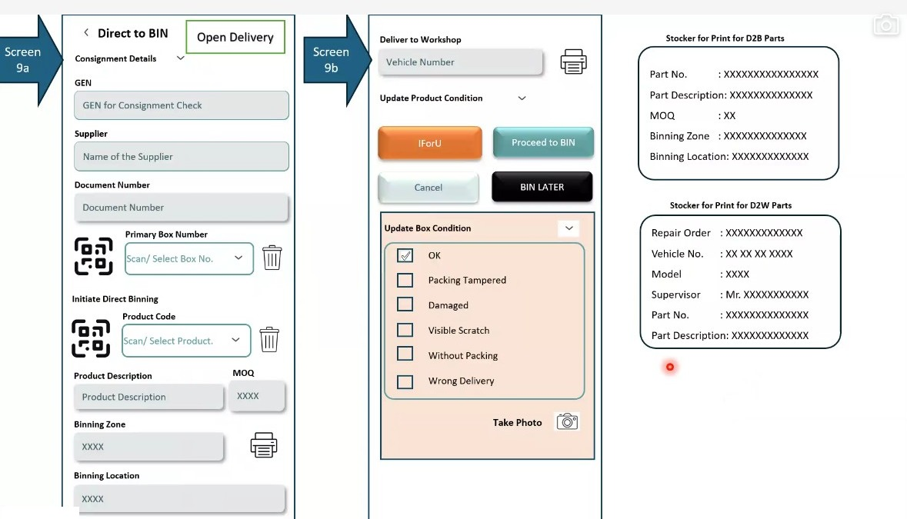
Figure 16.3a - Screens 9a and 9b: the Case 1B handheld layout, with separate scan controls for Primary Box Number and Product Code reflecting the absence of carton-product linkage, and the disposition, box condition and sticker print controls carried over from Screens 8a and 8b.

16.4 Screen Field Reference - Screen 9A (Scan Primary Carton)
Note: Screen 9A is step 1 of the Case 1B sequence and establishes what is known about the carton before it is opened. Field descriptions in blue italic are analyst-generated.
Field | Control Type | Description
Step 1: Scan primary carton barcode | Scan instruction bar | States the action required at this step, keeping the three-step sequence visible to the operator.
Primary Carton No. | Read-only text | Carton identifier resolved from the scanned barcode.
GEN / Consignment | Read-only text | Gate Entry Number the carton belongs to.
Supplier | Read-only text | Supplier that dispatched the carton.
Document Reference | Read-only text | Reference of the advance shipping or dispatch document under which the carton arrived.
Capture Status | Status badge | How far identification has progressed, for example PRIMARY CAPTURED - the carton is known but its contents are not.
Carton Type | Read-only text | Classification of the carton, for example Primary Carton.
Uploaded By Supplier | Read-only text | States what supplier data is held, for example primary and product data, making clear that data exists but linkage does not.
Linkage Status | Status badge | LINKAGE UNAVAILABLE. The field that determines Case 1B applies rather than Case 1A.
Primary-product linkage is not available for this carton. | Informational panel | Explains that the product code on the secondary unit must be scanned to identify the SKU, and that expected product and quantity will be determined after product verification.
SCAN PRODUCT (SECONDARY) | Primary action button | Advances to step 2.
Note: This carton can contain only one SKU. | Constraint note | States the assumption the flow depends on, so the multiple-SKU exception is not a surprise.

16.5 Screen Field Reference - Screen 9B (Scan Product / Secondary Unit)
Note: Screen 9B is step 2 and identifies the SKU and the quantity actually present. Field descriptions in blue italic are analyst-generated.
Field | Control Type | Description
Step 2: Scan product code on the unit / secondary packing | Scan instruction bar | States the action required at this step.
Product Code | Read-only text (verified) | SKU resolved from the product scan. Grouped under a Product Information (Verified) heading to distinguish confirmed data from assumed data.
Product Description | Read-only text | Descriptive name of the identified part.
MOQ | Read-only text | Minimum order quantity for the part.
Binning Zone | Read-only text | Zone allocated to the part in the product master.
Recommended Location | Read-only text | The bin position the system proposes.
Alternative Locations | Read-only list | Other bin positions at which the part may legitimately be stored, offered where the recommended bin is unavailable.
D2W Vehicle No. | Read-only text | Vehicle registration where an open workshop demand exists against this part.
IForU Eligible | Status badge | Whether the part qualifies for immediate issue to the workshop.
Supplier Quantity (if available for this carton) | Read-only field, annotated | Shown as not available with the reason given as no linkage, rather than left blank, so the operator understands why there is no expected figure.
Quantity Received / Count | Numeric stepper with unit label | Physical count of units found in the carton. This becomes the received quantity of record in the absence of an expected figure.
Expected quantity is not available because carton-product linkage is unknown. | Informational note | Explains the absence of a variance calculation at this stage.
SCAN ANOTHER UNIT (Same Product) | Secondary action button | Increments the quantity received under the same carton without deferring the carton.
SCAN NEXT CARTON (New Primary Carton) | Secondary action button | Moves to the next carton. Marks the current carton Bin Later if no action was taken on it.

16.6 Screen Field Reference - Screen 9C (Condition Check & Routing)
Note: Screen 9C is step 3 and determines where the carton and its contents go. Field descriptions in blue italic are analyst-generated.
Field | Control Type | Description
Step 3: Check conditions and choose action | Instruction bar | States the action required at this step.
Primary Carton Condition | Dropdown with photo capture | Condition of the outer carton, with photographic evidence.
Unit / Product Condition (Each Unit) | Dropdown with photo capture | Condition of the product itself, recorded per unit and independent of the carton condition.
Insurance Required | Yes / No selector | Explicit decision on whether the unit is to be set aside for an insurance claim.
IForU Eligible | Yes / No selector | Explicit decision on whether the unit is to be issued to the workshop rather than binned.
PROCEED TO BIN (Bin Now) | Action button | Commits the carton to immediate binning.
BIN LATER (Bin Later) | Action button | Defers the carton to the bin-later queue.
IFORU (Issue for Use) | Action button | Segregates the part for immediate workshop issue.
CANCEL (Cancel) | Action button | Abandons the actions recorded against the carton.
If multiple product codes are found in this carton, Direct Binning will be stopped and carton will be moved to Check Carton process. All actions are audit logged. | Informational panel | States the exception rule and confirms that the audit trail applies to exception paths as well as normal ones.

16.7 Case 1B Rules, Alerts and Carton Sticker
Note: The rules and alerts below are as set out on the session wireframe board. Field descriptions in blue italic are analyst-generated.
Rule / Alert | Trigger | System Behaviour
Same Product - Scan More Units | The same product code is scanned again within the same primary carton | Increments the Quantity Received under that carton. The carton is not moved to Bin Later automatically.
Different Product Scanned | A different product code is scanned within the same primary carton | The carton is treated as a multiple-SKU case. Direct binning stops and the carton is routed to Check Carton.
Next Carton Scanned | The operator scans the next primary carton without selecting an action for the current one | The current carton is automatically marked Bin Later so that no carton is left in an undetermined state.
Match Sticker | Scanned product matches supplier data | Confirms the product is verified, showing SKU, location and quantity, and allows the operator to proceed. A sticker is produced for the carton.
Mismatch Sticker | Scanned product does not match supplier data | Warns that the scanned product does not match, and requires the operator to verify before proceeding.
Multiple SKU Alert | More than one product code detected in the carton | States that direct binning is not allowed and directs the carton to the Check Carton process.
No Location Alert | No bin location is mapped for the scanned SKU | States that no location is mapped and directs the operator to the no-location process to identify a location before binning.
Carton Sticker (Print) | Verification completed | Prints a sticker carrying carton reference, SKU, product description, binning location and GEN, to be affixed to the carton or pack after verification.
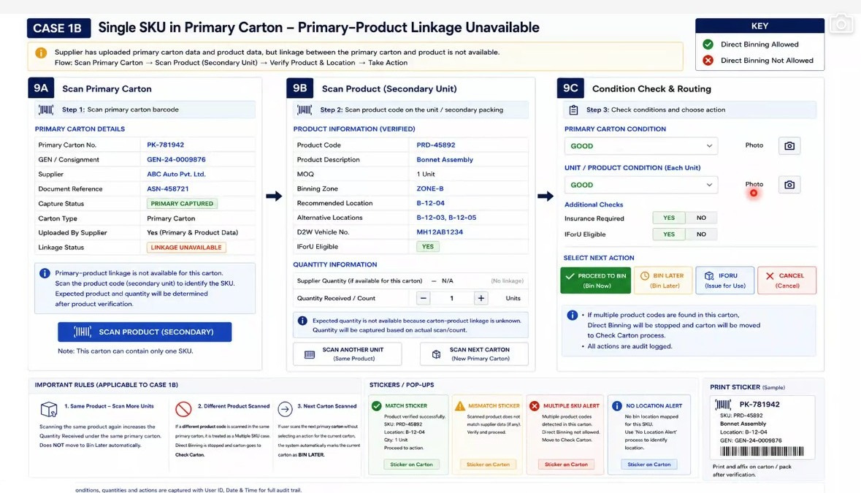
Figure 16.7a - Case 1B board (Screens 9A, 9B and 9C): primary carton details with LINKAGE UNAVAILABLE status (Screen 9A); verified product information with recommended and alternative locations, and manual quantity capture in place of an expected figure (Screen 9B); primary carton and per-unit condition capture, insurance and IForU checks, and the four routing actions (Screen 9C); with the Case 1B rules, the match, mismatch, multiple-SKU and no-location alerts, and the carton print sticker.

17. FR-014: Direct Binning Case 1C - Primary and Secondary Cartons Are the Same, Only the Secondary Product Is Scannable - Screens 10A, 10B, 10C & 10D

17.1 Overview
Case 1C applies where the primary carton and the secondary carton are the same physical unit, but only the secondary product carries a scannable code. The secondary product details have been uploaded and the primary-secondary linkage is not available. The outer box carries no scannable marking at all, so the carton itself cannot be identified by scanning.
The same consignment header data used in the other direct binning cases - gate entry number, supplier details and document details - is captured on entry to the flow. From there the operator has two routes. A box reference sticker can be printed and stuck on the primary box, after which the box becomes scannable and the flow behaves exactly as Case 1B. Alternatively the operator can continue without the primary sticker, in which case the primary box scan field is hidden and the secondary product is scanned directly.
Scanning the secondary product returns the product code, description, quantity per pack, binning zone, binning location and any alternate locations from master data, together with the Issue for Usage flag where the part is reserved against a vehicle or job. Inspection is then performed unit by unit, damaged units are set aside for insurance, and binning is confirmed through a two-step scan of location and product.
Note: Screens 10A to 10D form the Case 1C board. Screen 10A resolves how the primary carton will be referenced, Screen 10B identifies the SKU from the secondary code, Screen 10C carries out the condition and unit inspection, and Screen 10D performs the verified bin placement. The three sticker formats shown alongside the board are those already defined in section 13.5.

Layman Description
The outer box has nothing to scan but the part inside does. The answer is to give the outer box an identity by printing a label for it, so that from then on it can be scanned like anything else. Being able to see the label on screen before it prints matters more than it sounds: labels are printed in bulk on a busy bay, and discovering after forty of them that the part number was wrong means peeling forty labels off forty boxes. A preview costs a second and prevents that. Whether labelling the outer box is compulsory or optional is also worth asking, since some warehouses only want it where the box will be stored intact and not where it is opened immediately.
Example: Twenty unmarked outer boxes arrive, each holding barcoded parts. The operator selects the first, sees the label on screen showing the part and the box reference, confirms and prints. He sticks it on, scans it, then scans the parts inside. Box 7 turns out to be damaged - and because it now carries a reference, the damage is recorded against box 7 specifically rather than against the consignment as a whole.

17.2 Functional Requirements
FR-014.1: Case 1C shall be applied where the primary and secondary cartons are the same physical unit, only the secondary product is scannable, secondary product details have been uploaded and the primary-secondary linkage is not available. The system shall state these conditions on the screen header.
FR-014.2: Screen 10A shall capture the same consignment header data used in the other direct binning cases - gate entry number, supplier details and document number - and shall state explicitly that the primary box itself is not scannable.
FR-014.3: Screen 10A shall offer two mutually exclusive routes: Print Box Reference Sticker, to be affixed to the primary box, and Continue Without Primary Sticker, which hides the primary box scan field and takes the operator directly to secondary product scanning.
FR-014.4: Where Print Box Reference Sticker is selected, the printed sticker shall carry the box reference number, the gate entry number and the supplier. Once the sticker is affixed the carton becomes scannable and the flow shall thereafter behave as Case 1B.
FR-014.5: Screen 10A shall display a preview of the box reference sticker before the print command is issued.
FR-014.6: Screen 10B shall provide secondary product scanning by barcode or QR code, with camera capture, and shall provide a manual or predictive search alternative where the printed code cannot be read.
FR-014.7: On a successful secondary scan the system shall retrieve and display the product code, product description, quantity per pack, binning zone, binning location, alternate locations and the workshop vehicle number. All of these values shall be sourced from master data uploaded from the back end - the product master and the location master - and not from transaction data.
FR-014.8: The field currently labelled MOQ shall be understood and relabelled as quantity per pack size. It states how many units are contained in one sale pack and is master data, not an order quantity.
FR-014.9: Products reserved for a specific vehicle or repair order shall be highlighted for Issue for Usage, and the workshop vehicle number shall be shown against the product.
FR-014.10: Primary Box Reference shall be an optional field on Screen 10B. Where a sticker was printed the reference shall be captured; where the operator continued without a sticker the field shall remain empty and the flow shall proceed on the secondary scan alone.
FR-014.11: Box condition shall default to OK and shall be presented in a collapsed panel. The operator shall only expand the panel and change the condition where a problem is physically observed, since the great majority of products are received in good condition. This behaviour applies wherever condition is captured and is stated as a cross-cutting rule in FR-016.
FR-014.12: Screen 10C shall present product inspection unit by unit for the quantity held in the carton, with a per-unit condition, per-unit photograph capture and a per-unit outcome of either Proceed to BIN or Set Aside (Insurance).
FR-014.13: Where a unit is recorded as damaged the operator shall be able to take a photograph of it, and the unit shall be set aside so that an insurance claim can be raised against it.
FR-014.14: Screen 10C shall maintain running counters for Good Units, Damaged Units and Insurance Claim, and shall allow the product and location detail - including the damaged item list - to be printed.
FR-014.15: Screen 10D shall perform binning in two verified steps: Step 1 scan the location, Step 2 scan the product. Each step shall be confirmed on screen before Confirm BIN is enabled, and the system shall state how many units will be binned and how many are set aside.
FR-014.16: Where no binning location exists for the product the system shall raise a No Location Alert offering Enter Location or Notify Admin, governed by role-based access control. Where the operator is not permitted to enter a location a notification shall be sent to the administrator, who shall either grant the privilege to that user or decide the location themselves. This alert shall be raised wherever a specific mapped location has not been defined.
FR-014.17: Where cartons are processed continuously one after another, deferred cartons shall be placed in the Bin Later queue, and the queue with its pending count shall be reachable from Screen 10D.
FR-014.18: Stickers shall be printable from this flow for the primary box reference, for direct-to-bin parts and for direct-to-workshop parts, in the formats already defined in section 13.5.

17.3 Screen Field Reference - Screen 10A (Primary Box Reference Option)
Note: Screen 10A is the entry point for Case 1C. It confirms the consignment header and forces a decision on how the primary carton will be referenced, since the carton itself carries no scannable code.
Field | Control Type | Description
Current Check / Open Delivery | Tab bar with count badge | Switches between the consignment currently being checked and the open delivery queue; the badge shows how many cartons are pending open delivery inspection.
Consignment Details | Collapsible section | Groups the header data carried in from gate entry so that it can be collapsed once the operator has confirmed it.
GEN | Read-only field | Gate entry number of the consignment being checked.
Supplier | Read-only field | Supplier name resolved from the gate entry number.
Document Number | Read-only field | Shipment document reference captured at receipt.
Primary box not scannable notice | Information banner | States that the primary box itself carries no scannable code and directs the operator to choose one of the two options below.
1) Print Box Reference Sticker | Option card with chevron | Prints a system-generated reference sticker to be stuck on the primary box; the note beneath states that once printed the flow follows Case 1B.
2) Continue Without Primary Sticker | Option card with chevron | Hides the primary box scan field and takes the operator straight to secondary product scanning.
Preview: Box Reference Sticker | Preview panel | Shows the sticker exactly as it will print - barcode, Box Ref No., GEN and Supplier - before the print command is issued.
Print Box Reference Sticker | Action button | Sends the previewed sticker to the label printer.

17.4 Screen Field Reference - Screen 10B (Scan Secondary Product)
Note: Screen 10B identifies the SKU from the secondary product code. Every field below the scan is populated from the product and location masters, not from the consignment document.
Field | Control Type | Description
Primary box not scannable notice | Information banner | Repeats the case condition and instructs the operator to scan the secondary product code in order to identify the SKU.
Scan Secondary Product | Scan field with camera control | Captures the barcode or QR code printed on the secondary product.
Manual / Predictive Search | Alternate action | Used where the code cannot be read; searches the product master by code, description or part number.
Product Details (Confirmed) | Section header with status tick | Confirms that the scanned code has resolved successfully against the product master.
Product Code | Read-only field | Product code returned by the scan.
Product Description | Read-only field | Description held against the product in the master.
MOQ / Qty | Read-only field | Quantity per pack size, from the product master - see FR-014.8 on the relabelling of this field.
Binning Zone | Read-only field | Warehouse zone in which the product is stocked.
Binning Location | Read-only field | Recommended bin location from the location master.
Alternate Locations | Read-only field | Further permitted bin locations for the same product.
D2W Vehicle No. | Read-only field | Vehicle registration where the part is reserved for a workshop job rather than for stock.
Primary Box Ref (Optional) | Editable field | Carries the printed box reference where one was produced; remains blank where the operator continued without a sticker.
Sticker path note | Information banner | States that where a box reference sticker was printed, this path behaves as Case 1B from that point onwards.

17.5 Screen Field Reference - Screen 10C (Review Product & Action)
Note: Screen 10C carries out the carton condition check and then the unit-by-unit product inspection, and determines whether each unit proceeds to binning or is set aside.
Field | Control Type | Description
Product Summary | Read-only panel | Consolidates product code, description, quantity per pack, binning zone, recommended location and alternate locations for confirmation before inspection begins.
Update Box Condition (Primary Carton) | Collapsible checklist | OK, Packing Tampered, Damaged, Visible Scratch, Without Packing and Wrong Delivery. Defaults to OK and remains collapsed unless a problem is observed.
Product Inspection - Unit by Unit | Repeating block | One block per unit in the pack, headed Unit n of N, so that each physical unit is accounted for individually.
Condition (per unit) | Status control | Records the condition of the individual unit as OK or Damaged.
Take Photo (per unit) | Camera control | Captures photographic evidence against the individual unit.
Outcome (per unit) | Derived status | Proceed to BIN for good units, Set Aside (Insurance) for damaged units.
Insurance Claim | Tag | Marks the unit as forming part of an insurance claim.
Good Units / Damaged Units / Insurance Claim | Counter tiles | Running totals across the units inspected in this carton.
Print Product / Location Details | Action with printer icon | Prints the product and location detail slip, including the damaged item list used to support the claim.
iForU | Action button | Routes the product to Issue for Usage where it is reserved against a job.
Proceed to BIN | Primary action | Sends the good units forward to the binning step.
BIN LATER | Secondary action | Adds the carton to the bin later queue for binning in a later pass.
Cancel | Action | Abandons the current carton without recording an outcome.

17.6 Screen Field Reference - Screen 10D (Binning Action)
Note: Screen 10D performs the verified bin placement in two steps and handles the case where no bin location has been mapped for the product.
Field | Control Type | Description
Product panel | Read-only summary | Product code, quantity per pack, binning zone, recommended location and other allowed locations for the carton being binned.
Step 1: Scan Location | Scan field with verification tag | The bin location is scanned and confirmed with a Location Verified indicator and a success message.
Step 2: Scan Product | Scan field with verification tag | The product is scanned and confirmed with a Product Verified indicator and a success message.
Binning verified successfully | Confirmation panel | States how many units will be binned and how many are set aside for insurance.
Confirm BIN | Primary action | Commits the binning transaction for the verified units.
No Location Alert | Warning panel | Raised where no bin location exists for the product; offers Enter Location where role-based access allows, otherwise Notify Admin.
Enter Location | Action button | Allows a permitted user to key the bin location manually.
Notify Admin | Action button | Sends the location request to the administrator, who either grants the privilege to the user or assigns the location directly.
Bin Later Queue | Navigation row with count | Opens the queue of cartons deferred for later binning and shows the number pending.
Sticker print panels | Print panels | Three sticker formats are available alongside this screen - primary carton box reference, D2B part and D2W part - in the formats defined in section 13.5.
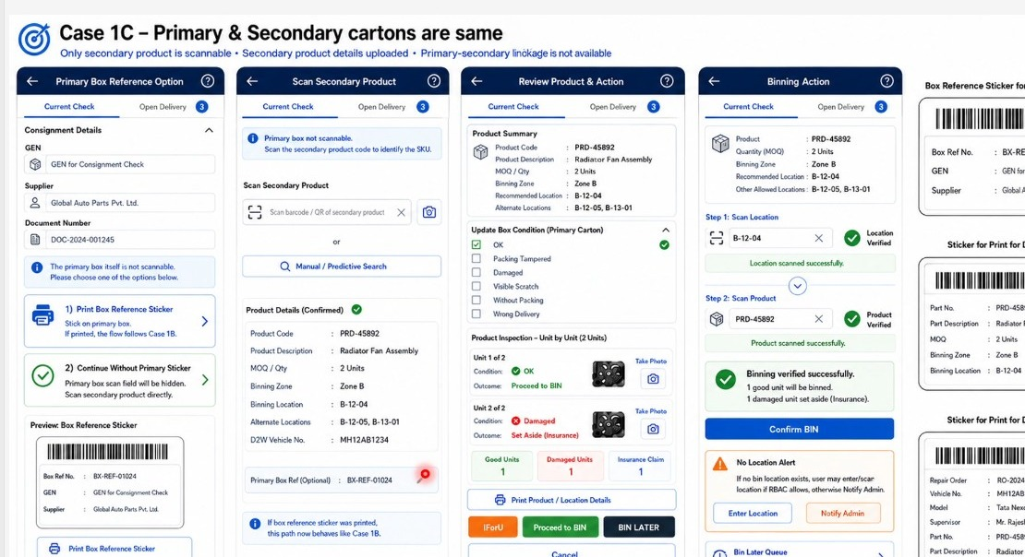
Figure 17.6a - Case 1C board (Screens 10A to 10D): primary box reference option, secondary product scan, unit-by-unit review and action, and the two-step binning action, with the three sticker print formats shown alongside.
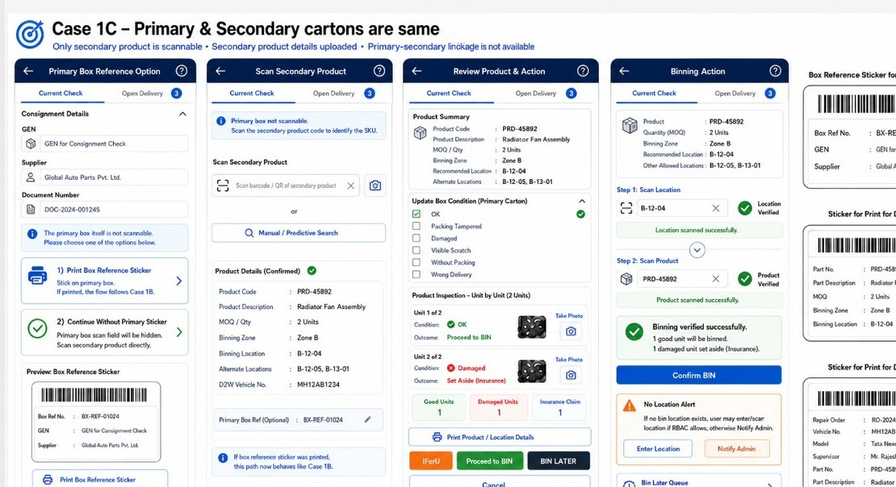
Figure 17.6b - Case 1C detail: the two routes offered on Screen 10A, the master data returned by the secondary scan on Screen 10B, the collapsible box condition panel and unit inspection on Screen 10C, and the No Location Alert and Bin Later queue on Screen 10D.

18. FR-015: Direct Binning Case 1D - Primary and Secondary Cartons Are the Same, Neither Scannable and No Supplier Data - Screens 10E, 10F, 10G & 10H

18.1 Overview
Case 1D applies where the primary and secondary cartons are the same physical unit and nothing at all is scannable - neither the primary carton nor the product inside it. No supplier details have been uploaded and the primary-secondary linkage is not available. Since there is no code to read, identification is entirely manual.
On selecting this case the system disables every scan control on the screen. The operator identifies the product through manual or predictive search on product code, description or part number, and then physically counts the contents and keys the total quantity in the carton. Only one product code is permitted inside one primary carton in this case; where a second product is found the operator cannot proceed on this path.
Everything downstream of identification behaves as in Case 1C. Condition capture defaults to OK, damaged units are photographed and set aside for insurance, and binning is confirmed against the recommended location held in master data. Where no location has been mapped, or where the carton is deferred, the exception panel presents the two resulting states.
Note: the Case 1D board labels its four panels by title only and does not carry screen numbers. For reference within this document they are designated Screens 10E to 10H - Identify Product Manually, Review Product & Action, Binning Action and Exception / Next State. This designation is analyst-assigned and is subject to the screen numbering reconciliation recorded as OI-020.

Layman Description
When nothing at all can be scanned, the system should recognise it and adapt rather than leaving the operator fighting a screen designed for barcodes. Three things make the difference. The scanning controls switch off, so nobody wastes time pointing a scanner at an unmarked carton. Finding the part works by typing a few letters, with matches appearing as you type - the alternative is scrolling a list of several thousand parts on a handheld, which nobody will do. And the quantity is typed in, because there is nothing to scan and count. Handled well, an unlabelled consignment takes a few minutes longer. Handled badly, the operator gives up on the system and writes it on paper, which is where the record disappears.
Example: Forty brackets arrive loose in plain cartons. The scanner greys out on its own. The operator types brac, sees Bracket - Front Bumper LH in the list, taps it, and types 40. Two are bent so he records those separately. The whole consignment is on the system in about four minutes, without a barcode and without a paper note that someone has to key in later.

18.2 Functional Requirements
FR-015.1: Case 1D shall be applied where the primary and secondary cartons are the same physical unit, neither the primary carton nor the product is scannable, no supplier details are available and the primary-secondary linkage is not available. The system shall state these conditions on the screen header.
FR-015.2: On selection of Case 1D the system shall automatically disable all scanning controls, including the primary box scan field and the product code scan field, and shall indicate on screen that scan options are inactive for this case.
FR-015.3: The system shall provide manual and predictive product search, allowing the operator to identify the product by product code, product description or part number where no scannable code exists.
FR-015.4: The operator shall enter the total quantity in the carton manually, having counted the contents physically. The system shall provide a stepper control with a unit label for this entry.
FR-015.5: Only one product code shall be permitted inside one primary carton in Case 1D. Where multiple products are found in the carton the operator shall not be able to proceed on this path and shall be routed to the exception handling.
FR-015.6: Box condition shall be captured against the standard condition set and shall default to OK, in line with FR-016.
FR-015.7: Where a unit is found damaged the operator shall photograph it and set it aside for insurance, exactly as in Case 1C.
FR-015.8: The review screen shall display the manually entered quantity alongside the pack size, the binning zone, the recommended binning location, the alternate locations and the workshop vehicle number, all drawn from master data.
FR-015.9: Binning shall run as a two-step confirmation. Step 1 shall allow the recommended location to be selected as well as scanned, since scanning is unavailable in this case. Step 2 shall confirm the product. Confirm BIN shall only be enabled once both steps report success.
FR-015.10: Where no mapped location exists for the selected product the system shall raise the No Location Alert, offering Enter Location where role-based access allows and Notify Admin otherwise, as defined in FR-014.16.
FR-015.11: The system shall present an exception and next-state panel covering two states: the No Location Alert state, and the Bin Later state which confirms that the carton has been marked for later binning, that product and location details have been cleared, and that the next product in the carton may now be identified.
FR-015.12: The Bin Later queue shall be reachable from this panel with its pending carton count, and the system shall state that binning of deferred cartons is completed through the Binning module.
FR-015.13: All remaining behaviour - Issue for Usage routing, Proceed to BIN, BIN LATER, condition capture and sticker printing - shall be identical to Case 1C and shall not be re-specified for this case.

18.3 Screen Field Reference - Screen 10E (Identify Product Manually)
Note: Screen 10E is the Case 1D entry point. Its defining characteristic is that the scan controls are present but disabled, so the operator can see why manual identification is being required rather than finding the controls simply absent.
Field | Control Type | Description
Consignment Details | Collapsible section | Gate entry number, supplier and document number for the consignment being checked.
Supplier | Read-only field | Displays that supplier details are not available, which is one of the defining conditions of this case.
Neither Primary Carton nor Product Code is Scannable | Option card with chevron | States the case condition and takes the operator into manual or predictive identification.
Primary Box (Scan Inactive) | Disabled field | Greyed out and inoperable; the primary carton cannot be scanned in this case.
Product Code (Scan Inactive) | Disabled field | Greyed out and inoperable; the product code cannot be scanned in this case.
Search Product (Manual / Predictive Search) | Search field with filter control | Searches the product master by product code, description or part number.
Product Code / Description result | Result card with confirmation tick | Confirms the product selected from the master before quantity is entered.
Enter / count total quantity in carton | Stepper with unit label | The operator counts the contents physically and keys the total; there is no scan-derived count in this case.
Scan options inactive in Case 1D | Information note | Confirms to the operator that all scan controls remain disabled for this case.
Confirm Product | Primary action | Commits the manually identified product and the counted quantity.
Single product code rule | Warning banner | States that only one product code is allowed inside one primary carton and that the operator cannot proceed where multiple products are found.

18.4 Screen Field Reference - Screen 10F (Review Product & Action)
Note: Screen 10F mirrors Screen 10C, with the quantity shown as manually entered rather than scan-derived.
Field | Control Type | Description
Product summary | Read-only panel | Product code, description, manual quantity against pack size, binning zone, recommended binning location, alternate locations and workshop vehicle number.
Update Box Condition (Primary Carton) | Collapsible checklist | The standard condition set - OK, Packing Tampered, Damaged, Visible Scratch, Without Packing, Wrong Delivery - defaulting to OK.
Product Inspection - Unit by Unit | Repeating block | Per-unit condition, photograph capture and outcome, identical in behaviour to Screen 10C.
Good Units / Damaged Units / Insurance Claim | Counter tiles | Running totals for the carton being inspected.
Print Product / Location Details | Action with printer icon | Prints the product and location detail slip for the carton.
iForU / Proceed to BIN / BIN LATER | Action buttons | The same routing options offered in Case 1C - issue for usage, bin now, or defer to the bin later queue.
Cancel | Action | Abandons the carton without recording an outcome.
Single product code warning | Warning banner | Repeats the rule that only one product code is allowed inside one primary carton and that the operator cannot proceed otherwise.

18.5 Screen Field Reference - Screen 10G (Binning Action)
Note: Screen 10G differs from Screen 10D in that location and product are selected and confirmed rather than scanned, since no scannable code exists on either.
Field | Control Type | Description
Product summary | Read-only panel | Product code, description, manually entered quantity with its good and damaged split, binning zone and recommended binning location.
Step 1: Select / Scan Location | Selection or scan field | The recommended location is pre-filled from master data and can be selected rather than scanned, since scanning is unavailable in this case.
Location Verified | Status tag | Confirms that the location selection has been accepted.
Step 2: Confirm Product | Confirmation field | The product is confirmed rather than scanned, and a success message is displayed.
Binning verified successfully | Confirmation panel | States how many units will be binned and how many are set aside for insurance.
Confirm BIN | Primary action | Commits the binning transaction.
Cancel Carton | Secondary action | Abandons the carton at the binning step.
No Location Alert | Warning panel | Offers Enter Location where role-based access allows and Notify Admin otherwise.

18.6 Screen Field Reference - Screen 10H (Exception / Next State)
Note: Screen 10H is not a step in the main sequence. It presents the two states the flow can enter when a carton cannot be completed normally, and the actions available from each.
Field | Control Type | Description
State 1: No Location Alert | State panel | Raised where no mapped location exists for the selected product in the zone; presents Enter Location and Notify Admin as the two available responses.
Enter Location / Notify Admin | Action buttons | Enter Location is offered only where role-based access permits manual entry; otherwise the request goes to the administrator.
State 2: Bin Later / Next Selection State | State panel | Confirms that the current carton has been marked Bin Later, that product and location details have been cleared, and that the next product in the carton can now be identified.
Identify Next Product Manually | Action button | Starts manual identification of the next product without leaving the carton.
Bin Later Queue | Navigation row with count | Opens the deferred queue and shows the number of cartons pending.
Binning later note | Information banner | States that binning of deferred cartons is carried out through the Binning module.
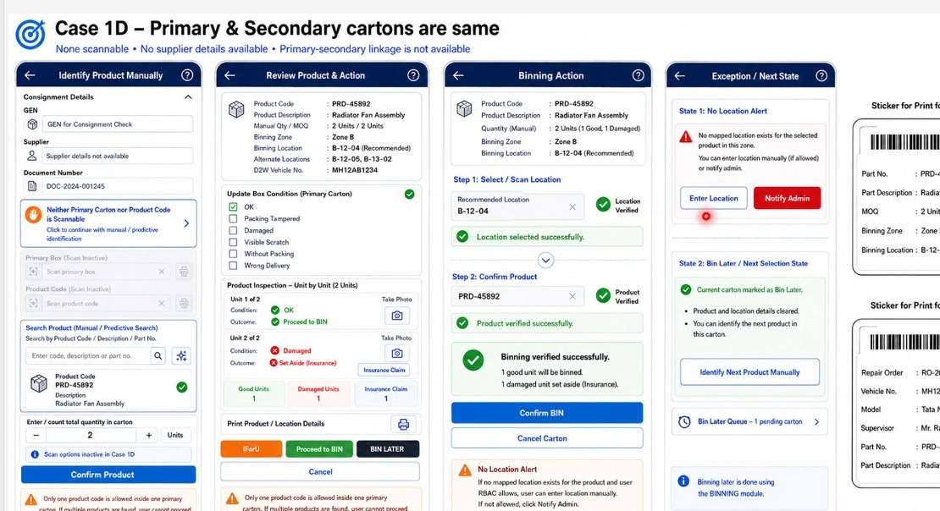
Figure 18.6a - Case 1D board (Screens 10E to 10H): manual product identification with the scan controls visibly disabled, review and action, binning by location selection rather than scan, and the exception and next-state panel.

19. FR-016: Case Selection by Supplier-Product Combination and Cross-Cutting Condition Rules

19.1 Overview
Two rules were confirmed during this session that apply across every case in the direct binning and consignment check flows rather than to any single screen. They are recorded here once so that they are not restated in each case.
The first is that the applicable case is not chosen by the operator at run time. It is defined in advance at supplier and product level, and the moment a supplier and product are selected the system presents only the screens belonging to that case. All other screens are suppressed. The second is that condition capture defaults to OK and is presented collapsed, because in practice the overwhelming majority of products arrive in good condition and asking the operator to select a condition on every unit would slow the check without adding information.

Layman Description
Case Selection - Which of these situations applies - everything scannable, only the inner item scannable, nothing scannable - depends on the supplier and the part, and it does not change from day to day. So the system should work it out itself from what it already knows, rather than asking the operator to choose. This matters because the operator is the worst person to ask. He is standing at a truck, he has forty cartons to move, and the categories mean nothing to him. Ask him to pick one and he will pick the same one every time regardless of what is in front of him, and the whole scheme quietly stops working. Determined automatically it is invisible and reliable; left to the operator it is a source of wrong data that nobody notices for months.
Example: A consignment arrives from a supplier whose cartons are always barcoded but whose inner items never are. The operator scans the first carton. The system recognises the supplier and the part, works out which situation this is, and presents the right screen - sticker printing enabled, inner scanning disabled. He is never asked to categorise anything and could not tell you afterwards that a decision had been made at all.
Condition Capture - Most boxes are fine. If the system asks the operator to state the condition of every single one from a blank field, he has to make forty-eight positive selections to record forty-eight boxes that were all perfectly normal. Starting on OK means he only touches the condition control for the two boxes that actually have something wrong. This is a small design decision with a large effect on whether the data is any good. A field that must be filled for every item, when the answer is nearly always the same, gets filled with whatever is quickest - and after a week that is whatever happens to be first in the list, whether or not it is true. Defaulting to the normal case keeps the exceptions meaningful.
Example: Forty-eight boxes come off the truck. The operator scans each one and does nothing about condition for forty-six of them, because OK is already selected. For box 17 he taps packing torn and for box 31 wet. Two deliberate actions rather than forty-eight, and the two that were recorded are the two that actually mattered.

19.2 Functional Requirements
FR-016.1: Screen configuration shall be driven by the combination of supplier and product. The applicable case shall be defined at supplier-product level in advance, and on selection of that supplier and product the system shall present only the screens belonging to the applicable case and shall suppress all others.
FR-016.2: The operator shall not be required to select the case at run time; the case shall be resolved by the system from the supplier-product configuration.
FR-016.3: Condition capture shall default to OK on every screen on which it appears, and shall be presented in a collapsed panel. The operator shall expand the panel and record a different condition only where a problem is physically observed.
FR-016.4: The field labelled MOQ shall be relabelled as quantity per pack size across all screens on which it appears. It denotes the number of units in one sale pack and is master data.
FR-016.5: Product, location and related reference data shall be uploaded from the back end as master data and shall be available to every case flow on scan or on manual selection.

20. FR-017: Video Recording of Carton Opening

20.1 Overview
A requirement for video evidence of carton opening was raised during this session. The practice it is modelled on is one already followed by dealers, who record the opening, counting and closing of every carton so that a dispute over contents can be settled from the recording. The same practice is used for high-value items and for return consignments, where photographic and video evidence is captured as a matter of routine.
The recording is to be optional and controlled by a toggle available at the point a secondary carton check is started. Because retained video occupies storage, the system is to prompt at the end of the exercise for a decision on whether the recording is kept or discarded.
Note: this requirement is not yet reflected on any wireframe screen. It extends the photographic evidence capture already specified for box and unit condition, and is supplementary to it rather than a replacement. The trigger point, the retention prompt and the storage policy are recorded as an open item.

Layman Description
A video recording of a carton being opened, made when the contents are likely to be disputed. It differs from photographs in showing the sequence - that the carton was sealed when the recording started, that nothing was added or removed, and what was actually inside. That continuity is what a photograph cannot demonstrate. It is optional by design, because recording every carton would produce hours of footage nobody will ever watch and fill the storage on the device. What matters is the decision afterwards: the system should ask whether to keep the recording or discard it, so that the few genuinely needed are retained deliberately and the rest are not left accumulating.
Example: A high-value consignment of ECUs arrives with a broken seal. The storekeeper records the opening on video, showing the seal, the carton being cut, and the six units inside - one of which is missing. At the end the system asks whether to keep it and he keeps it. The next carton is routine, he records nothing, and the day produces one video rather than forty.

20.2 Functional Requirements
FR-017.1: The system shall support video recording of the carton opening and checking activity, triggered from the point at which the operator begins to open the box.
FR-017.2: Video recording shall be optional and shall be controlled by a toggle presented when a secondary carton check is started.
FR-017.3: At the end of the exercise the system shall prompt the operator to decide whether the recording is retained or deleted, since retained recordings consume storage.
FR-017.4: The retain or delete decision shall be capable of being taken per carton or at the end of the entire consignment check, depending on whether the shipment document details are available.
FR-017.5: Retained recordings shall be held against the carton so that they can be produced as evidence of contents in support of a claim against the supplier or the transporter.
FR-017.6: Video recording shall be supplementary to the photographic evidence already captured against box and unit condition and shall not replace it.

21. FR-018: Open Delivery Flow - Case 1, Same SKU - Piece-to-Piece Inspection of Cartons Marked at Unloading

21.1 Overview
Cartons that were flagged during unloading as damaged, tampered or otherwise suspect are marked for Open Delivery at that point and are not binned on the normal path. They are held back and inspected piece by piece before any unit is placed in a bin. This flow covers that inspection for Case 1, where the primary and secondary cartons are the same and the carton holds a single SKU.
The operator picks the carton from the open delivery queue, sees the observation recorded against it at unloading, verifies the product, and then inspects each unit in the pack individually. Good pieces proceed to binning; damaged pieces are set aside for insurance and are excluded from the bin transaction. Where a different product code is found inside the carton the carton is moved to Check Carton, because Case 1 permits only one SKU.
Note: this is the Open Delivery tab that appears alongside Current Check on the consignment check screens. The count badge on the tab is the number of cartons awaiting inspection, so the operator can see the open delivery backlog without leaving the current check.

Layman Description
Open Delivery Queue - Boxes that arrived visibly damaged are not put away with everything else. They go onto a separate list to be opened and examined, usually in front of the driver, so that responsibility is settled before he leaves. The list shows how many are waiting, how many have been dealt with, and - importantly - what was noticed about each one when it came off the truck. Carrying that original observation through is what makes the list usable an hour later, when the man who unloaded it has gone. Without it, somebody is looking at a carton knowing only that something was wrong with it, with no idea whether it was wet, crushed or had a broken seal, and no way to tell whether the damage has got worse since.
Example: Three cartons come off the truck damaged and go onto the open delivery list. At 2 pm the storekeeper opens the list and sees carton 17 marked packing torn, carton 31 wet, carton 40 seal broken. He deals with the seal-broken one first because that is a security matter, and he knows which it is without asking anyone - the man who unloaded it went home at noon.
Piece Inspection - Opening a damaged carton means examining every piece inside it, not glancing at the contents and forming an impression. The system presents them one at a time and counts as it goes: five of twelve checked, and a result recorded against each. Doing it piece by piece is what turns an impression into evidence. A note saying carton damaged, some items affected is worth nothing in a claim. Nine good, three cracked, out of a pack of twelve, with each one recorded, is worth the money. It also stops the two failure modes that happen when there is no structure - condemning a whole carton because the top item was broken, and passing a whole carton because the top item was fine.
Example: Carton 31 should hold twelve alternators and arrived wet. The system presents them one by one. Nine are dry inside their inner packing and pass. Three have water damage. The screen shows 12 of 12 checked, 9 good, 3 damaged. Without the piece-by-piece walk-through the operator would probably have written off all twelve, and nine sellable units would have gone onto a claim.

21.2 Functional Requirements
FR-018.1: The consignment check screens shall carry two tabs, Current Check and Open Delivery, with a badge on the Open Delivery tab showing the number of cartons pending inspection.
FR-018.2: The Open Delivery Boxes screen shall display counters for Total Open Delivery, Pending Inspection, Ready to BIN and Set Aside / Insurance.
FR-018.3: The screen shall present a searchable and filterable list of cartons showing box number, the observation recorded at unloading, the current status and the available action.
FR-018.4: The observation recorded during unloading - damaged, visible scratch, packing tampered or product OK - shall be carried forward and displayed against the carton so that the inspector knows why it was held back.
FR-018.5: On selecting a carton the system shall display the earlier unload observation together with the Open Delivery Marked flag.
FR-018.6: The system shall require the product in the carton to be scanned or verified. Case 1 shall allow only one SKU in the carton; where a different product code is found the carton shall be moved to Check Carton.
FR-018.7: Inspection shall be performed piece by piece. The system shall present each unit in turn with its condition options - OK, Damaged, Packing Tampered, Visible Scratch - together with photograph capture and an insurance claim checkbox.
FR-018.8: The system shall maintain running totals of Total Units against pack size, Inspected and Remaining, and shall allow the operator to move between units.
FR-018.9: Each unit shall carry an outcome of Proceed to BIN or Set Aside / Insurance, and the screen shall maintain counters for Good Units, Damaged Units and Insurance Claim.
FR-018.10: The binning screen shall show the recommended bin location together with the available alternative locations, and shall require a two-step confirmation of location and product before the bin transaction is committed.
FR-018.11: Only good units shall be binned. Damaged pieces shall remain in Set Aside / Insurance and shall be excluded from the bin transaction, and the system shall state this on screen.
FR-018.12: The flow shall provide the actions Inspect Selected Box, Proceed to Inspection, Set Aside Carton, Proceed Good Units to BIN and Set Aside Damaged Units.

21.3 Screen Field Reference - Open Delivery Boxes
Note: this is the queue screen. It exists so that cartons held back at unloading are not lost and can be worked through as a distinct backlog, with the reason each was held visible in the list.
Field | Control Type | Description
Current Check / Open Delivery | Tab bar with count badge | Open Delivery is the active tab in this flow; the badge shows the number of cartons awaiting inspection.
Total Open Delivery | Counter tile | All cartons marked for open delivery during unloading for this consignment.
Pending Inspection | Counter tile | Cartons marked for open delivery that have not yet been inspected.
Ready to BIN | Counter tile | Cartons inspected and cleared for binning.
Set Aside / Insurance | Counter tile | Cartons or units held back for an insurance claim.
Search by Box No. | Search field with filter control | Locates a specific carton in the open delivery list.
Box No. | Table column | The primary box reference of the carton awaiting inspection.
Earlier unload observation | Table column with status chip | The condition recorded when the carton was unloaded - Damaged, Visible Scratch, Packing Tampered or Product OK.
Current Status | Table column with status chip | Pending Inspection or Ready to BIN.
Action | Table column with button | Inspect for cartons not yet inspected, Open for cartons already cleared.
Open delivery note | Information banner | States that these cartons were marked for open delivery during unloading and that the product inside must be inspected before binning.
Inspect Selected Box | Primary action | Opens the selected carton for piece-by-piece inspection.

21.4 Screen Field Reference - Selected Box & Piece-to-Piece Inspection
Note: these two panels run together in practice. The first confirms the carton and the SKU, the second steps through the individual pieces and splits them between binning and the insurance hold.
Field | Control Type | Description
Selected Primary Box | Header panel | Shows the carton reference under inspection together with the earlier unload observation and the Open Delivery Marked flag.
Scan / Verify Product | Scan field | Confirms the product inside the carton; labelled for Case 1, same SKU only.
Product Code / Description / MOQ / Binning Zone / Binning Location | Read-only fields | Product master detail for the SKU expected in this carton.
Single SKU rule | Information banner | States that Case 1 allows only one SKU in the carton and that the carton must be moved to Check Carton where a different product code is found.
Direct Binned Pieces | Counter chip | Shows how many pieces from this carton have already been sent to binning.
Total Units (MOQ) / Inspected / Remaining | Counter row | Progress of the piece-by-piece inspection for this carton.
Units | Unit selector | Selects the unit currently being inspected.
Condition (per unit) | Option set | OK, Damaged, Packing Tampered or Visible Scratch for the individual piece.
Photo / Insurance Claim (per unit) | Camera control and checkbox | Captures evidence and flags the piece for an insurance claim.
Outcome (per unit) | Derived status | Proceed to BIN for acceptable pieces, Set Aside / Insurance for the rest.
Good Units / Damaged Units / Insurance Claim | Counter tiles | Running totals for the carton under inspection.
Proceed to Inspection / Set Aside Carton | Action buttons | Starts the piece-by-piece inspection or holds the whole carton back.
Proceed Good Units to BIN / Set Aside Damaged Units | Action buttons | Splits the carton at the end of inspection between binning and the insurance hold.

21.5 Screen Field Reference - Binning & Location Selection
Note: the binning panel on this path binds only the good pieces. The counts shown at the bottom of the screen are the split established during the piece-by-piece inspection.
Field | Control Type | Description
Product summary | Read-only panel | Product code, description, good units to be binned and the number set aside.
Available Bin Locations | Selection panel | Lists the recommended location together with the alternative locations permitted for the product.
Recommended Location | Highlighted row | The system-recommended bin, marked so the operator can accept it without searching.
Alternative Locations | Selectable rows | Other permitted bins for the same product.
Step 1: Scan Location | Scan field | Captures the bin at which the units are being placed.
Step 2: Scan / Confirm Product | Scan field | Confirms the product being placed into that bin.
Binning verified successfully | Confirmation panel | States how many good units will be direct binned.
No Location Alert | Warning panel | Raised where no recommended location is available; offers Enter Location or Notify Admin.
Set aside note | Information banner | States that damaged pieces remain in Set Aside / Insurance and that only good pieces are direct binned.
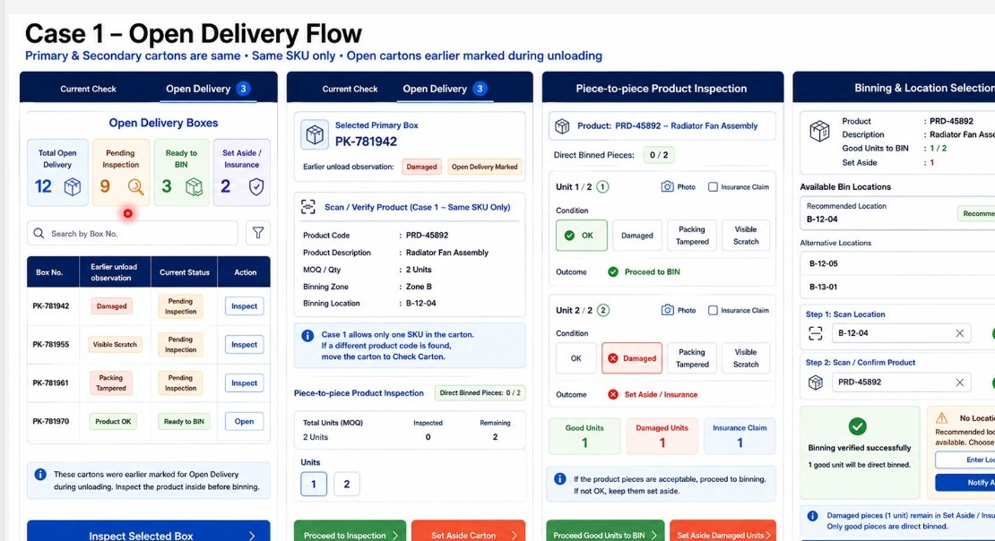
Figure 21.5a - Case 1 Open Delivery Flow: the open delivery queue with unload observations carried forward, the selected carton with its single-SKU rule, piece-to-piece product inspection, and binning with recommended and alternative locations.

22. FR-019: Multi-SKU Consignment Check - Primary Carton Containing Several SKUs - Screens 11a & 11b

22.1 Overview
The direct binning cases covered so far assume a single part in the primary carton, because the primary and secondary cartons were the same. This flow covers the case where a primary carton holds several different SKUs - a carton that may be filled entirely with one part, or may hold a mix of springs, pistons and other items packed together.
The primary box is scanned once and then stays constant while the operator scans each secondary product inside it in turn, entering the quantity found for each. A live status panel tracks how many units have been checked in that box, how many remain, and how the checked units split between acceptable and not acceptable.
The expected quantity for the box comes from the ship list, which is uploaded at gate entry and states which box contains what and in what quantity. The reconciliation performed here is against that ship list for the box currently open - it is not a reconciliation against the purchase order. Purchase order matching is a separate flow: the shortfall against the order is established once the whole consignment has been checked, and the order may subsequently be closed short.
Note: the wireframe board for this flow is headed Direct to BIN, which does not describe what the screens do. The flow is a multi-SKU consignment check, not direct binning. The heading correction is recorded as an open item.

Layman Description
Multi-SKU Check (FR-019.1 to .8) - A large outer carton often holds several different parts rather than a quantity of one. Checking it means opening it and scanning each part inside separately, then comparing what was found against what the paperwork said should be in there. While the operator works through it, the screen keeps a live tally: how many lines have been checked, how many are still to go, how many were fine and how many had a problem. The running count is what makes it usable. Opening a carton with 30 different parts and no on-screen progress means the operator loses his place the moment he is interrupted, and either starts again or skips something. Seeing 18 of 30 done tells him exactly where he is, and tells a supervisor walking past how far the job has got.
Example: Carton 4 holds 30 different parts. The operator scans them one by one; the screen shows 18 checked, 12 to go, 17 fine, 1 not fine. He is called away for ten minutes, comes back, and picks up at part 19 without recounting. At the end the carton shows 29 found against 30 expected, and the missing line is identified by part number rather than as one item short somewhere in the box.
Multi-SKU Check (FR-019.9 to .11) - The expected quantities have to come from somewhere, and there are only two possibilities: the supplier tells you, or somebody in your warehouse types them in. The difference matters enormously. If the supplier sends a packing list and it is loaded into the system, the expected figures are independent of your own staff and can be used to hold the supplier to what he said he sent. If your own storekeeper types them from the invoice, then a typing error becomes a shortage that never existed, and the supplier can reasonably dispute it. So the question to ask is not just whether expected quantities exist on screen, but where they came from - and whether the check is performed against that list rather than against something assembled locally.
Example: The supplier emails a packing list before dispatch; it is loaded and shows 30 lines totalling 214 pieces. The check is run against those figures and comes back 2 pieces short on one line. Because the expected number came from the supplier own document, the claim is straightforward. Where no packing list is provided, the system says so rather than letting the storekeeper type a number that would then look like independent evidence.
Status Lookup - The same lookup that reports unloading status, used during the checking stage and answering a narrower question: has this particular part been checked yet? It exists because checking a large consignment takes hours and people keep asking about individual parts while it is going on. Rather than interrupting the man doing the checking, anyone can search and see for themselves. In practice it is used with a part number far more often than a box number, because the people asking - the workshop, the parts counter - think in parts, not in cartons. They do not know or care which box something arrived in. A system that only accepts a box number here technically has the feature but will not actually be used, which is exactly the sort of thing that separates a genuine yes from a partial one.
Example: The parts counter has a customer waiting for a clutch plate that was on this morning delivery. Rather than walking to the checking bay, the counter staff type the part number and see it has already been checked and is fine. They promise the customer within the hour. Had the search only accepted a carton number, they would have had no way to look - nobody at the counter knows which carton a clutch plate came in.

22.2 Functional Requirements
FR-019.1: Where a primary carton contains more than one SKU the multi-SKU consignment check flow shall be used in place of the direct binning flow.
FR-019.2: Screen 11a shall autofill the consignment header from the gate entry number and shall provide Scan Primary Box and Scan Product Code controls, each with a delete control so that an entry captured in error can be removed.
FR-019.3: Once the primary box has been scanned the operator shall scan each secondary product inside that box in turn. The primary box shall remain constant while products within it are scanned.
FR-019.4: The quantity of each scanned product shall be enterable through a stepper control, and the pack size shall be displayed alongside it from master data.
FR-019.5: The product description shall autofill from the scanned product code, and products flagged as fragile in the master shall be highlighted with a fragile indicator.
FR-019.6: The screen shall display the binning zone and location for the scanned product and shall allow the location label to be printed.
FR-019.7: Where the product is routed to a workshop job rather than to stock, the vehicle number shall be captured and shall be printable.
FR-019.8: Screen 11b shall maintain a live Box / Units Check status showing Checked, Balance, OK and Not OK for the box currently being checked.
FR-019.9: The expected quantity for each box shall be taken from the ship list uploaded at gate entry, which states which primary box contains which items and in what quantity.
FR-019.10: The balance shall be calculated against the ship list quantity for the box currently being checked, box by box, and not across all boxes in the consignment together.
FR-019.11: The reconciliation performed on this screen shall be against the ship list only. Reconciliation against the purchase order is a separate flow, and the check shall not compare the scanned quantity to the ordered quantity at this point.
FR-019.12: The system shall provide a status lookup that accepts either a box number or a part number, so that at any stage the operator can establish whether a given carton has been opened and checked.
FR-019.13: Lookup by part number shall be the primary use of the status check, since the operator most often needs to know the status of a part rather than of a carton.
FR-019.14: The flow shall provide the actions Cancel, Check Next Primary Box and Finish Consignment Check, and shall provide access to the variance summary.

22.3 Screen Field Reference - Screen 11a (Scan Primary Box and Products)
Note: Screen 11a is a capture screen. The delete controls beside each scan field exist because the operator is scanning repeatedly into the same carton and a mis-scan must be removable without abandoning the carton.
Field | Control Type | Description
Consignment Details | Collapsible section | Gate entry number, supplier and document number, autofilled for the consignment being checked.
Scan Primary BOX | Scan or select field with delete control | Captures the primary box; the delete control removes a box captured in error.
Scan Product Code | Scan or select field with delete control | Captures each secondary product found inside that primary box; the primary box stays constant while products are scanned.
Quantity | Stepper control | Number of units of the scanned product found in this box.
MOQ | Read-only field | Quantity per pack size, from the product master.
Product Description | Read-only field | Description resolved from the scanned product code.
FR | Flag button | Highlights the scanned product as fragile.
Update Product Condition | Collapsible checklist | The standard condition set, defaulting to OK and collapsed until a problem is observed.
Location Details - Zone / Location | Read-only fields with print control | Binning zone and location for the scanned product, printable as a label.
Deliver to Workshop - Vehicle Number | Field with print control | Captured where the product is routed to a workshop job rather than to stock.

22.4 Screen Field Reference - Screen 11b (Check Status and Actions)
Note: Screen 11b is the status and control panel for the carton currently open. The counters refer to the open carton only, not to the consignment as a whole.
Field | Control Type | Description
Cancel | Action | Abandons the check of the box currently open.
Check Next Primary Box | Action | Closes the current primary box and opens the next one for checking.
Finish Consignment Check | Primary action | Closes the consignment check and activates the variance summary.
Box / Units Check WIP Status | Live status table | Counters for the box currently being checked.
Checked | Counter | Units scanned so far in this box.
Balance | Counter | Units still to be scanned, derived from the ship list quantity for this box.
OK | Counter | Checked units recorded in acceptable condition.
Not OK | Counter | Checked units recorded as damaged, tampered or otherwise not acceptable.
Check Status / Enter Box / Part No. | Action with input field | Looks up the check status of a carton or a part; the input accepts either reference.
Check Variance | Action | Opens the variance summary for the consignment check.
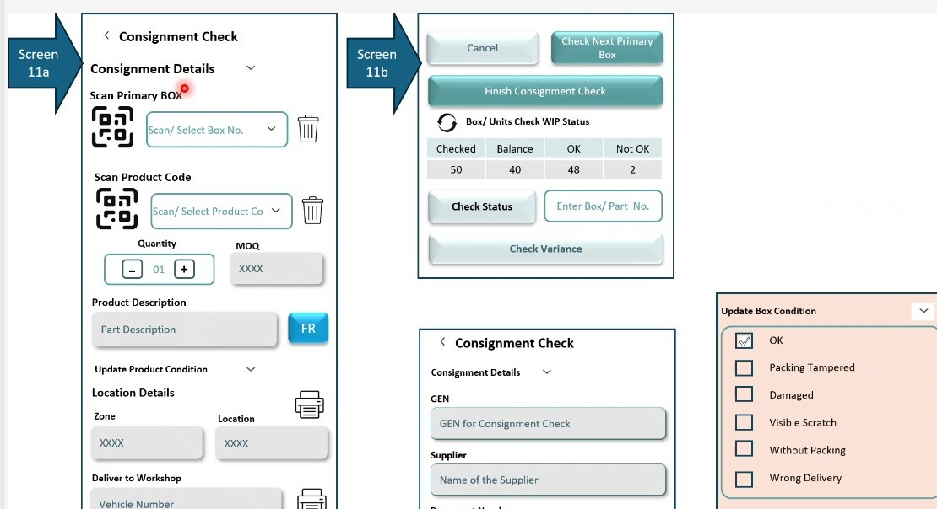
Figure 22.4a - Multi-SKU consignment check (Screens 11a and 11b): primary box and product scanning with delete controls, quantity and pack size capture, the fragile flag, and the box and units check status with the check status and check variance actions.

23. FR-020: Consignment Check Variance Summary - Screen 11c

23.1 Overview
The variance summary closes the consignment check. It reports the position of the whole consignment in value, part lines and quantity, showing what was invoiced, what was received, what is short and what has been received in excess, with a net position. Alongside it a second table reports the qualitative position - how much of what was received is damaged, tampered, scratched, broken or wrongly delivered.
The reference for the variance is the ship list rather than the invoice, since the ship list is what states which carton held which items. Short quantities are not a closure of the matter: the balance is expected to arrive incrementally on subsequent deliveries, and the purchase order remains open until it is either fulfilled or closed short by the supplier.
Note: Screen 11c is reached from Check Variance on Screen 11b and is activated once Finish Consignment Check has been pressed. The two tables are laid out for entry against a fixed set of rows, so the summary structure is the same for every consignment regardless of its size.

Layman Description
Variance Reporting (FR-020.1 to .3; FR-020.5 to .8) - At the end of a check, one summary that says what should have arrived, what did arrive, and the difference - expressed both in money and in quantity, and broken down by part line. Money matters because that is the language of the claim and of the accounts department. Quantity matters because that is what the warehouse actually deals in. A summary that gives only one of the two forces somebody to work out the other by hand. Short and excess are reported separately rather than netted off, since two lines short and two lines over is a very different situation from everything balancing. It should be printable, because the driver or the supplier will want a copy, and correctable before it is finalised - the first pass through a check always contains a miscount or two.
Example: The check finishes showing invoiced Rs 2,40,000 against received Rs 2,31,500, with 3 lines short totalling 6 pieces and 1 line over by 2 pieces. The storekeeper spots that one short line was actually a miscount, corrects it, and finalises. The summary is printed, signed by the driver, and sent with the claim - a single sheet showing both the money and the pieces.
Variance Reporting (FR-020.4; FR-021.17) - Not all problems are the same problem. A carton with a scratch on it is a different matter from a carton whose seal has been tampered with, and both are different from the wrong item having been sent altogether. This reports each kind separately rather than lumping them into a single count of things that were wrong. The reason is that each kind goes to a different place. Transit damage is an insurance matter; tampered packaging is a security matter and may involve the transporter; wrong delivery is a supplier error with no claim attached at all, just a return. If the summary says only 5 problems, somebody has to open every one to find out what to do with them. If it says 3 damaged, 1 tampered, 1 wrong item, the work sorts itself. This capability also spans Section 24.
Example: A consignment finishes with 5 problem lines. The summary splits them: 3 damaged in transit, 1 with the packing seal broken, 1 where a different part number was sent. The 3 go to the insurance claim, the tampered carton is raised with the transporter that afternoon, and the wrong part is set aside for return. Three different actions, three different people, sorted from one screen without opening anything again.

23.2 Functional Requirements
FR-020.1: The system shall provide a variance summary screen, reachable through Check Variance and activated once Finish Consignment Check has been completed.
FR-020.2: The summary shall report value, part lines and quantity against the rows Invoiced, Received, Short, Excess and Net.
FR-020.3: Short shall report the shortfall against the shipment document and Excess shall report quantity received over and above it; the net position shall be reported after both.
FR-020.4: The system shall report quality variance separately by qualitative aspect - Damage, Tampered Packaging, Scratch, Broken and Wrong Delivery - against value, parts and quantity.
FR-020.5: Variance shall be computed with reference to the ship list, which states the number of part line items and the quantity dispatched, rather than against the invoice alone.
FR-020.6: Short quantities shall remain open pending subsequent deliveries. The system shall not treat a shortfall as final, since the balance is commonly delivered incrementally on later dates.
FR-020.7: The variance summary shall be printable and shall be editable before it is finalised.
FR-020.8: Damaged, scratched and broken items shall be reportable by quantity, value and part number so that the claim position is visible from the summary.

23.3 Screen Field Reference - Screen 11c (Check Variance)
Note: the two tables on this screen answer different questions. The first asks how much was received against how much was sent; the second asks what condition it arrived in.
Field | Control Type | Description
Summary (Value) | Table | Reports the consignment position across three columns - Value (Rs.), Part Lines (Nos.) and Quantity (Nos.).
Invoiced | Table row | Value, part lines and quantity as stated on the shipment document.
Received | Table row | Value, part lines and quantity actually checked in during the consignment check.
Short | Table row | The shortfall of the received position against the document.
Excess | Table row | Quantity received over and above the document.
Net | Table row | The net position once short and excess have been applied.
Quality Variance (No. of Boxes / Units) | Table | Reports the qualitative position across Value (Rs.), Parts (Nos.) and Qty (Nos.).
Damage / Tampered Packaging / Scratch / Broken / Wrong Delivery | Table rows | The qualitative aspects against which the received consignment is reported.
Edit control | Action icon | Allows the variance entry to be corrected before it is finalised.
Print control | Action icon | Prints the variance summary.
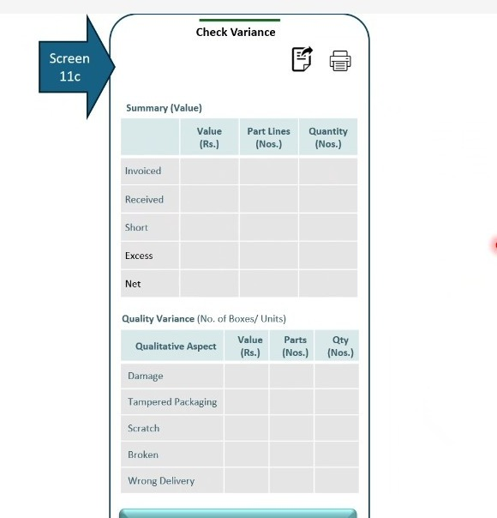
Figure 23.3a - Screen 11c: the variance summary, with the value summary reporting invoiced, received, short, excess and net across value, part lines and quantity, and the quality variance table reporting by qualitative aspect.

24. FR-021: Case 2A - Secondary Cartons Inside the Primary Cartons, Both Scannable and Linkage Available - Screens 11A, 11B & 11C

24.1 Overview
Case 2A covers the arrangement in which secondary cartons sit inside the primary carton. The primary carton is opened and a number of separately packed items are found within it. Both the primary and the secondary cartons are scannable, the supplier details have been uploaded, and the primary-secondary linkage is available - so the system knows in advance which secondary packs belong in which primary carton and in what quantity.
Because the linkage is available, the check is a reconciliation rather than a discovery exercise. The primary box is opened and the system states how many secondary packs are expected in it. Each secondary carton is then scanned, the count for each SKU is tracked against what was expected, and the balance is visible throughout. Once the box is finished the operator moves to the next primary carton, and on completion the variance is reported carton by carton as well as across the consignment.
One control shown on the original board is to be removed. The screen prompted the operator where a scanned primary box was not found in the uploaded list, asking whether to proceed. That situation does not arise at consignment check, because cartons that do not belong to the consignment are already identified and segregated during unloading. By the time the consignment check begins, every carton in front of the operator belongs to this consignment.
Note: the Case 2A board carried no screen numbers when it was first presented. Session 06 re-presented the same board in higher fidelity with the numbering shown on it, confirming the three panels as Screens 11A, 11B and 11C - Consignment Check, Scan Secondary Cartons and Check Variance. The numbering below is therefore taken from the source and is no longer analyst-assigned.

Layman Description
This is the easiest situation to handle. The big outer carton has a barcode, the smaller boxes inside it also have barcodes, and the supplier has already told you which small boxes belong in which big one. Because that relationship is known in advance, the system can be specific: it knows carton A should contain boxes 1 to 6, so when only five are scanned it can say precisely which one is missing, from which carton. That is much stronger than knowing you are one box short somewhere in a load of two hundred. The relationship comes from the supplier, not from anything your warehouse does, so the feature only works where the supplier provides it - which is why the next few rows deal with what happens when he does not.
Example: Outer carton A is scanned and the system shows it should hold 6 boxes. The operator scans 5 and the sixth never appears. The screen names it - box number 4 of carton A - and the shortage is reported against that specific box. The supplier cannot argue about which load or which carton, because the record points at his own packing information.

24.2 Functional Requirements
FR-021.1: Case 2A shall be applied where secondary cartons are contained inside the primary carton, both primary and secondary cartons are scannable, supplier details have been uploaded and the primary-secondary linkage is available.
FR-021.2: The consignment check screen shall carry two tabs, Consignment Check and Direct to BIN, so that the operator can move between the full check and the direct binning path for the same consignment.
FR-021.3: The primary box shall be captured by scan or selection, and the system shall require that the primary carton exists in the uploaded box list for the selected gate entry number.
FR-021.4: The prompt asking whether to proceed where a primary box is not found in the uploaded list shall be removed from this screen. Cartons that do not belong to the consignment are identified and segregated during unloading, so the situation does not arise at consignment check.
FR-021.5: On opening a primary box the system shall record and display the box reference, its active status and the time at which it was opened.
FR-021.6: The system shall display a work-in-progress summary for the open primary box showing Expected Secondary Packs, Scanned and Balance.
FR-021.7: Each secondary carton shall be captured by scanning its product or carton code, with a manual and predictive search alternative for codes that cannot be read because they are smudged or damaged.
FR-021.8: On a successful secondary scan the system shall display the product code, description, pack size, binning zone, binning location and workshop vehicle number, together with the fragile flag and the workshop required flag where they apply.
FR-021.9: The system shall maintain a current count for the SKU being scanned, with manual entry available, and shall show progress in the form of units scanned so far against units expected.
FR-021.10: The system shall maintain a table of all products scanned in the open primary box showing product code, description, expected quantity, scanned quantity, balance and binning zone.
FR-021.11: Where a product not previously seen in this box is scanned the counter shall start at one. Where a product already scanned in this box is scanned again later the counter shall continue from its last recorded count rather than restarting.
FR-021.12: Condition shall be captured per SKU against the standard condition set, with photograph capture and an insurance claim flag.
FR-021.13: The flow shall provide the actions Issue for Usage, Proceed to BIN and Scan Next Product at SKU level, and Check Next Primary Box, Refresh WIP Status, Check Product Status and Finish Consignment Check at box and consignment level.
FR-021.14: The system shall provide a product status lookup which, on entry of a product code, returns the primary box, the scanned quantity, the expected quantity, the balance and the time at which the product was last scanned.
FR-021.15: The variance screen shall be activated once Finish Consignment Check has been completed and shall report Total SKUs Expected, Total Units Expected and Units Scanned.
FR-021.16: Because the primary-secondary linkage is available in this case, variance shall be reported carton by carton, showing for each primary box the product code, description, expected quantity and actual quantity found.
FR-021.17: Quality variance shall be reported across the consignment by qualitative aspect - damaged, packing tampered and visible scratch.
FR-021.18: The system shall confirm on screen that the consignment check has been completed for the primary box, and shall allow the variance to be printed.

24.3 Screen Field Reference - Screen 11A (Consignment Check - Primary Box Capture)
Note: Screen 11A opens one primary carton at a time and states up front how many secondary packs should be found inside it, which is what makes the check a reconciliation rather than a discovery exercise.
Field | Control Type | Description
Consignment Check / Direct to BIN | Tab bar | Switches between the full consignment check and the direct binning path for the same consignment.
Consignment Details | Collapsible section | Gate entry number, supplier and document number for the consignment being checked.
Primary Box Capture | Section | Scan or select the primary box number to open a carton for checking.
Primary box must exist notice | Information banner | States that the primary carton must exist in the uploaded box list for the selected gate entry number.
Primary Box Opened | Status panel | Shows the box reference, an Active status chip and the timestamp at which the carton was opened.
Expected Secondary Packs | Counter tile | Number of secondary packs the ship list states should be inside this primary carton.
Scanned | Counter tile | Secondary packs scanned so far from this carton.
Balance | Counter tile | Secondary packs still to be scanned from this carton.
Start / Continue Scanning Secondary Packs | Primary action | Opens the secondary scanning screen for the selected primary box.

24.4 Screen Field Reference - Screen 11B (Scan Secondary Cartons)
Note: Screen 11B is where the operator spends most of the check. The running table of products scanned in the open carton is what allows the balance for each SKU to stay visible while scanning continues.
Field | Control Type | Description
Primary Box header | Status bar | Shows the carton under check, its Active state and the time at which it was opened.
Scan Secondary Product / Carton Code | Scan field | Captures the code printed on the secondary carton or the product inside it.
Manual / Predictive Search (Smudged Code) | Alternate action | Used where the printed code cannot be read.
Selected Product | Panel | Product code, description, pack size, binning zone, binning location and workshop vehicle number for the scanned SKU.
FR flag / Workshop Required flag | Status chips | Mark the SKU as fragile and as required for a workshop job respectively.
Current Count | Stepper with manual entry | Units counted for the selected SKU, with a scanned-so-far indicator against the expected quantity.
Products Scanned in This Primary Box | Table | Serial number, product code, description, expected, scanned, balance and binning zone for every SKU found in the carton.
Counter behaviour note | Information banner | States that a newly scanned product starts its counter at one and that a previously scanned product resumes from its last count.
Quality Check | Collapsible checklist | The standard condition set for the selected SKU, with Take Photo and Insurance Claim.
iForU / Proceed to BIN / Scan Next Product | Action buttons | Route the SKU to issue for usage or to binning, or move on to the next SKU in the carton.
Check Next Primary Box / Refresh WIP Status / Check Product Status / Finish Consignment Check | Action buttons | Carton-level and consignment-level controls.
Check Product Status | Lookup panel | On entry of a product code, returns the primary box, scanned quantity, expected quantity, balance and the time of the last scan.

24.5 Screen Field Reference - Screen 11C (Check Variance)
Note: Screen 11C reports variance carton by carton as well as in total, which is possible in this case only because the primary-secondary linkage is available.
Field | Control Type | Description
Activation note | Information banner | States that the screen becomes active only after Finish Consignment Check has been pressed.
Total SKUs Expected | Counter tile | Distinct SKUs the ship list states should be present in the consignment.
Total Units Expected | Counter tile | Total units the ship list states should be present.
Units Scanned | Counter tile | Total units actually scanned during the check.
Primary Carton-wise Variance (Linkage Available) | Table | For each primary box, the product code, description, expected quantity and actual quantity found - available because the primary-secondary linkage exists in this case.
Quality Variance (Across This Consignment) | Counter tiles | Counts of damaged, packing tampered and visible scratch items across the whole consignment.
Completion confirmation | Status banner | Confirms that the consignment check has been completed for the primary box.
Close / Print | Action buttons | Closes the variance view or sends it to the printer.
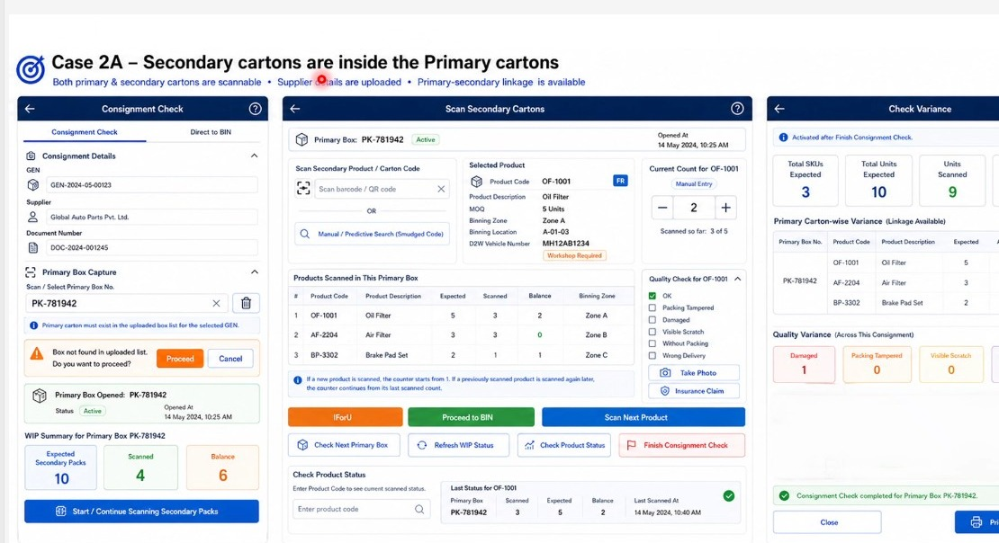
Figure 24.5a - Case 2A board (Screens 11A to 11C): primary box capture with the work-in-progress summary, secondary carton scanning with the per-SKU expected, scanned and balance table, and the carton-wise variance report.

24.6 Amendments from Session 06
Case 2A was re-presented at the start of Session 06 in higher fidelity and the screen numbering was confirmed on the board as Screens 11A, 11B and 11C. The numbering used earlier in this document has been corrected accordingly.
The walkthrough also settled how counting behaves where a supplier does not print a unique code on every unit. In many consignments every unit of a part carries the same code, so scanning the same code repeatedly is the means of counting units rather than an error. Some suppliers do differentiate, adding an extra character or a distinct code to each individual part, but the system cannot rely on it.
Note: this subsection records only what Session 06 added to or changed in Case 2A. The screens, fields and base behaviour remain as set out in sections 24.1 to 24.5.
FR-021.19: The screens for Case 2A shall be numbered 11A, 11B and 11C as confirmed on the Session 06 board. The earlier designations 12a, 12b and 12c are withdrawn, and Screens 12a and 12b are reassigned to the Binning module as set out in section 29.
FR-021.20: Where the same product code is scanned more than once within a primary carton, each scan shall increment the quantity counted for that product. Repeated scanning of an identical code shall be treated as the means of counting units, not as a duplicate error.
FR-021.21: The system shall accommodate both supplier conventions: a single shared code across all units of a part, and a distinct code carrying an additional character for each individual unit. Counting shall not depend on the supplier providing unique per-unit codes.
FR-021.22: The count for a product shall also be enterable manually, so that a quantity can be recorded where scanning is impractical or where the operator is correcting a scanned count.
FR-021.23: Condition shall be capturable per part at the point the part is selected, and a photograph shall be capturable against each part inspected.
FR-021.24: The variance shall express the difference between expected and found units at product level - for example ten units expected against nine found shall be reported as a variance of one unit short.
FR-021.25: The consignment check summary shall be reportable at SKU level, stating how many units of each product were found across the consignment, and shall be printable and exportable.
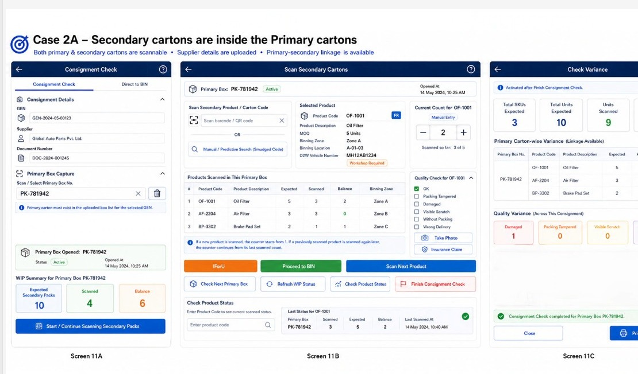
Figure 24.6a - Case 2A re-presented in Session 06 with the screen numbering shown on the board: Screen 11A primary box capture and work-in-progress summary, Screen 11B secondary carton scanning with the per-SKU expected, scanned and balance table, and Screen 11C the carton-wise variance report.

25. FR-022: Case 2B - Secondary Cartons Inside the Primary Cartons, Primary-Secondary Linkage Not Available

25.1 Overview
Case 2B covers the arrangement in which secondary cartons sit inside the primary carton and both are scannable, but the primary-secondary linkage is not available. The supplier has uploaded the list of primary cartons and the list of secondary packs, but not the mapping that says which pack belongs in which carton.
Linkage availability follows ship list availability. Where a ship list has been provided the linkage exists; where it has not, it does not. That both codes are scannable does not imply a linkage: the primary carton is coded for the supplier's own dispatch and logistics purposes, and the secondary pack is coded for product identification. The two codings are independent.
The linkage that the supplier did not provide is created by the physical check itself. The operator scans the primary carton, then scans each secondary pack found inside it, and the system stores that association. The primary carton is therefore still captured even though its expected contents are unknown - it is the only way to know which of the unloaded cartons have been checked and which have been missed, and it allows the warehouse to report back to the supplier which carton was found to hold which products. The supplier's packing department holds this data at their end even when it is not shared, so a discrepancy can be settled against it.
The approach is otherwise identical to Case 2A. The single difference is in reporting: because the expected contents of each carton are unknown, no primary-carton-wise variance can be produced.
Note: the Case 2B board is laid out as a six-step flow rather than as numbered screens - Select Consignment & Start, Scan Primary Carton, Scan Secondary Cartons, Decide Action, Finish Consignment Check, and Consignment Check Summary. The step numbers below follow the board.

Layman Description
The same physical situation as the previous row - small boxes inside a big carton, everything scannable - except that the supplier has not told you which belongs to which. Without that information the system cannot say a box is missing from a particular carton; it can only work with totals. What a good system does here is build the relationship as the work happens: as the operator opens carton A and scans the boxes inside it, the system records that those boxes came out of that carton. By the end of the check you have the linkage the supplier never gave you. Two things follow from that. Future consignments can be checked more precisely, and the record can be sent back to the supplier so his own packing information improves.
Example: Carton B is opened and 5 boxes are scanned out of it. The system had no advance information but now records those 5 against carton B. The same is done for the other 9 cartons. At the end the storekeeper has a complete carton-by-box map that did not exist that morning, and it is sent to the supplier - who from the next consignment starts providing it himself.

25.2 Functional Requirements
FR-022.1: Case 2B shall be applied where secondary cartons are contained inside the primary carton, both primary and secondary cartons are scannable, supplier details have been uploaded, and the primary-secondary linkage is not available.
FR-022.2: The system shall treat the availability of the ship list as determining the availability of linkage. Where a ship list has been provided the linkage shall be taken to be available; where it has not, the linkage shall be taken to be unavailable.
FR-022.3: The system shall not infer a linkage from the fact that both codes are scannable. The primary carton is coded for the supplier's dispatch and logistics purposes and the secondary pack for product identification, and the two are independent.
FR-022.4: The approach shall otherwise be the same as Case 2A, and the behaviour specified for Case 2A shall apply except where this section states otherwise.
FR-022.5: Step 1 shall display the consignment details together with the upload status received from the supplier, listing which of the primary box list, secondary packs list and product list have been uploaded, and stating explicitly that the primary-to-product linkage is not available.
FR-022.6: Step 2 shall capture the active primary carton by scan and shall record the carton number, the time at which it was opened, the user who opened it and its status.
FR-022.7: On opening a primary carton the system shall state that linkage is not available and shall instruct the operator to scan all secondary cartons inside that primary carton.
FR-022.8: The system shall establish the primary-to-secondary association at the point of scanning. Scanning the primary carton and then the secondary products found within it shall create and store the linkage that the supplier did not provide.
FR-022.9: The primary carton shall continue to be captured even though its expected contents are unknown, so that the system can establish which of the unloaded cartons have been checked and which have been missed.
FR-022.10: The association established during the check shall be reportable back to the supplier, stating which primary carton was found to contain which products and in what quantities.
FR-022.11: Steps 2 and 3 shall maintain a work-in-progress count for the active primary carton showing secondary packs scanned, unique products scanned and total units scanned. These shall be actual scanned counts only, since no expected quantity exists for the carton.
FR-022.12: Step 3 shall list every product scanned in the active primary carton with product code, description and quantity in units, and shall provide a search alternative for codes that cannot be read.
FR-022.13: Step 4 shall capture product condition against the standard condition set and shall capture two additional checks - whether insurance is required and whether the product is eligible for issue for usage - each answered yes or no.
FR-022.14: Step 4 shall offer four next actions: Proceed to BIN, Bin Later, Issue for Usage for immediate workshop use, and Scan Next Secondary Carton to continue within the same primary carton.
FR-022.15: Step 5 shall state that all primary cartons have been scanned and shall request confirmation before the consignment check is closed, and shall offer Check Product Status and Refresh Consignment Status.
FR-022.16: An audit trail shall be captured for all scans, conditions and actions once the consignment check is finished.
FR-022.17: Step 6 shall present a summary of actual scanned data covering primary cartons expected, primary cartons checked, secondary packs scanned, unique products scanned and total units scanned.
FR-022.18: The summary shall report actual quantity at SKU level across the consignment and shall report quality issues across the consignment by qualitative aspect - damaged, packing tampered, visible scratch and wrong delivery.
FR-022.19: Primary-carton-wise variance shall not be produced in this case, because the expected contents of each carton are unknown. This is the only difference from Case 2A.
FR-022.20: Where the supplier has uploaded expected product quantities at gate entry level, variance may be reported at consignment level only, on request. Where no expected quantity has been uploaded, variance shall not be applicable.
FR-022.21: The consignment check summary shall be exportable as a report.

25.3 Screen Field Reference - Steps 1 & 2 (Consignment Check and Scan Primary Carton)
Note: the upload status block on Step 1 is what selects this case. It is the only place in the flow where the operator is told, before any scanning begins, that the linkage will have to be built by hand.
Field | Control Type | Description
Gate Entry Number (GEN), GEN Date | Read-only fields | Identify the consignment being checked and the date it entered the warehouse.
Supplier, Supplier Category | Read-only fields | Supplier name and category, for example OEM, carried from gate entry.
Document Type, Document No. | Read-only fields | The shipment document under which the consignment arrived, for example a tax invoice.
No. of Primary Boxes, No. of Invoices | Read-only counters | Establish the size of the consignment before the check begins.
Upload Status (From Supplier) | Status list | States which lists the supplier has uploaded - primary box list, secondary packs list and product list - and flags the primary-to-product linkage as not available.
Linkage not available notice | Information banner | States that the supplier has uploaded the primary cartons and the secondary packs but not the mapping between them.
Start Consignment Check | Primary action | Opens the check for this consignment.
Scan primary carton barcode / QR code | Scan field with camera | Captures the primary carton to be opened.
Primary carton scanned successfully | Confirmation panel | Confirms the scan and displays the captured primary carton number.
Active Primary Carton Details | Panel | Primary carton number, the time it was opened, the user identifier that opened it and its status.
Scan all secondary cartons notice | Information banner | States that linkage is not available and instructs the operator to scan every secondary carton inside this primary carton.
Primary Carton WIP (Actual Scanned) | Counter row | Secondary packs scanned, unique products scanned and total units scanned for the open carton. These are actual counts only, with no expected figure to compare against.
Scan Secondary Carton | Primary action | Moves to secondary scanning for the open primary carton.

25.4 Screen Field Reference - Steps 3 & 4 (Scan Secondary Cartons and Decide Action)
Note: every count on these two steps is an actual count. There is no expected figure to compare against, which is why the panels are labelled Actual Scanned throughout.
Field | Control Type | Description
Active Primary Carton | Status header | Shows the carton currently open, marked Active, so the operator can see which carton the scans are being attributed to.
Scan Secondary Carton / Product | Scan field with camera | Captures each secondary carton or product found inside the open primary carton.
Search Product (Smudged Code) | Alternate action | Used where the printed code cannot be read.
Scanned Products in this Primary Carton (Actual Scanned) | Table | Serial number, product code, product description and quantity in units for every product found in the open carton.
Carton WIP (Actual Scanned) | Counter row | Live secondary packs, unique products and total units scanned for the open carton.
Scan Next Secondary Carton | Action | Continues scanning within the same primary carton.
Update Product Condition | Checklist | OK, Packing Tampered, Damaged, Visible Scratch, Without Packing and Wrong Delivery, defaulting to OK.
Insurance Required | Yes / No control | Records whether the product is to be included in an insurance claim.
IForU Eligible | Yes / No control | Records whether the product is eligible for immediate issue for usage.
Proceed to BIN | Action card | Sends the scanned product to binning.
Bin Later | Action card | Defers binning of the scanned product to a later pass.
IForU (Issue for Use) | Action card | Issues the product immediately for workshop use.
Scan Next Secondary Carton | Action card | Returns to scanning within the current primary carton.
Refresh Carton WIP | Action | Refreshes the work-in-progress counters for the open carton.

25.5 Screen Field Reference - Steps 5 & 6 (Finish Consignment Check and Summary)
Note: the summary is headed to state that no primary-carton variance is produced, so that its absence reads as a consequence of the case rather than as a missing report.
Field | Control Type | Description
Active Consignment | Status panel | Shows the consignment reference and the number of primary cartons it contains.
Finish Scanning | Confirmation panel | States that all primary cartons have been scanned and asks whether the consignment check should be finished.
Finish Consignment Check | Primary action | Closes the check and generates the summary.
Check Product Status | Action | Views all products scanned across the consignment.
Refresh Consignment Status | Action | Refreshes counts and status at consignment level.
Audit trail notice | Information banner | States that once the check is finished an audit trail is captured for all scans, conditions and actions.
Summary (Actual Scanned) | Summary block | Primary cartons expected, primary cartons checked, secondary packs scanned, unique products scanned and total units scanned.
SKU-wise Actual Quantity (Across Consignment) | Table | Product code, product description and total units scanned for each SKU found across the whole consignment.
Quality Issues (Across Consignment) | Counter tiles | Damaged, packing tampered, visible scratch and wrong delivery counts across the consignment.
No primary-carton variance | Summary heading | The summary is headed to make explicit that carton-level variance is not produced in this case.
Export Summary Report | Action | Exports the consignment check summary.
KEY | Legend | Explains the colour coding used across the board - direct binning allowed, conditional or review required, and direct binning not allowed.
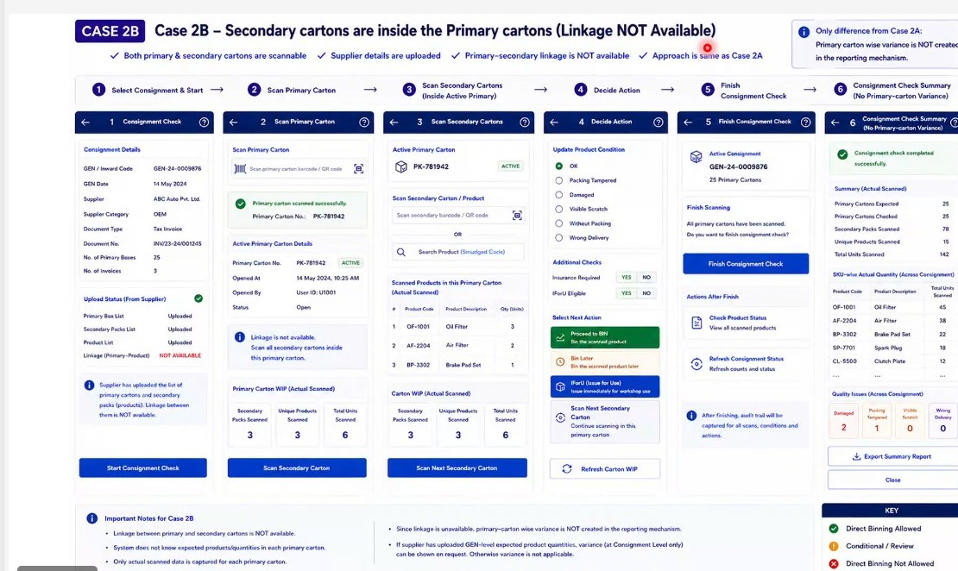
Figure 25.5a - Case 2B board: the six-step flow from consignment selection through primary carton scanning, secondary carton scanning within the active primary, the decide-action step, finish consignment check and the summary, with the case notes and colour key beneath.

26. FR-023: Case 2C - Secondary Cartons Inside the Primary Cartons, Only the Secondary Product Scannable

26.1 Overview
Case 2C covers the arrangement in which secondary cartons sit inside the primary carton, only the secondary product is scannable, and the primary-secondary linkage is not available. The supplier has uploaded the secondary product details but the primary carton carries no readable code.
Because the primary carton cannot be scanned, the operator is offered a choice at the start of each carton: print a box reference barcode sticker and stick it on the carton, in which case the flow proceeds exactly as Case 2B, or continue without a sticker and go straight to scanning the products inside. Where no sticker is used the system cannot identify individual cartons and instead counts how many primary cartons have been opened for checking.
From that point the flow is the same as Case 2B. Each product inside the carton is scanned, its condition recorded, and it is sent to binning, deferred, or issued for usage. On completion the consignment check is finished and the same summary is produced, again without primary-carton-wise variance.
Note: the opened cartons counter only advances when the operator confirms that the current carton is finished and moves to the next one. It is a count of cartons opened, not an identification of them, which is why no carton-level reporting is possible on this path.

Layman Description
Here the big carton has nothing to scan but the items inside it do. The difficulty is that if the outer carton has no identity, there is no way to say which carton something came out of, and no way to report a problem against a specific carton. There are two ways round it. Either print a sticker and give the carton an identity on the spot, which is the better answer because everything afterwards can refer to it, or simply keep a count of how many cartons have been opened, which is weaker but faster. Which of the two a system offers is worth establishing precisely, because both would be described as handling it, and only one leaves you able to point at a particular carton afterwards.
Example: Ten unmarked cartons arrive containing parts that are individually barcoded. The operator prints a sticker for each carton as he opens it, so carton 3 becomes a real reference. He scans 12 parts out of carton 3 and one is damaged. The record says part X, damaged, from carton 3. Where only a counter is used, the same record would say damaged, from one of ten cartons - which is much harder to take to a supplier.

26.2 Functional Requirements
FR-023.1: Case 2C shall be applied where secondary cartons are contained inside the primary carton, only the secondary product is scannable, the secondary product details have been uploaded by the supplier, and the primary-secondary linkage is not available.
FR-023.2: Step 1 shall display the consignment details and the supplier upload status, showing the primary box list as not available, the secondary product list and product details as uploaded, and the primary-to-product linkage as not available.
FR-023.3: Step 2 shall state that the primary carton code is not scannable and shall offer two options: print a box reference barcode sticker and affix it to the primary carton, or continue without printing a sticker.
FR-023.4: Where the operator chooses to print a box reference barcode, the flow shall thereafter behave as Case 2B with a sticker, because the carton has become scannable.
FR-023.5: Where the operator continues without a sticker, the system shall count how many primary cartons have been opened for checking rather than identifying each carton individually.
FR-023.6: The opened cartons counter shall increment only when the operator confirms that the current carton is complete and moves to the next carton.
FR-023.7: Step 3 shall capture each secondary product inside the open carton by scanning its barcode, and shall provide a search alternative for codes that cannot be read.
FR-023.8: Step 3 shall maintain a list of products scanned in the current carton showing product code, description and quantity.
FR-023.9: Step 4 shall capture product condition against the standard condition set, defaulting to OK, together with the insurance required and issue for usage eligibility checks.
FR-023.10: Step 4 shall offer the next actions Proceed to BIN, Bin Later and Issue for Usage, and shall allow the work-in-progress counts for the carton to be refreshed.
FR-023.11: Step 5 shall state that all secondary products have been scanned for all primary cartons and shall request confirmation before the consignment check is closed.
FR-023.12: Step 6 shall present a summary of actual scanned data covering primary cartons opened, secondary products scanned, unique products scanned and total units scanned.
FR-023.13: The summary shall report actual quantity at SKU level across the consignment and quality issues across the consignment, and shall be exportable as a report.
FR-023.14: Primary-carton-wise variance shall not be produced in this case, for the same reason as Case 2B and additionally because individual cartons are not identified.

26.3 Screen Field Reference - Steps 1 & 2 (Start Consignment Check and Primary Carton)
Note: Step 2 is the branch point for this case. Printing a sticker converts the carton into an identifiable one and the flow becomes Case 2B; continuing without one means cartons can only be counted.
Field | Control Type | Description
Consignment Details | Read-only panel | Gate entry code and date, supplier, document type and number, and the number of invoices in the consignment.
Upload Status (From Supplier) | Status list | Shows the primary box list as not available, the secondary product list and product details as uploaded, and the primary-to-product linkage as not available.
Only secondary products scannable notice | Information banner | States that only the secondary products can be scanned and that the primary carton code is not available.
Start Consignment Check | Primary action | Opens the check for this consignment.
Primary carton not scannable warning | Warning banner | States that the primary carton code cannot be scanned and that the operator may either print a box reference barcode sticker or continue without printing.
Print Box Reference Barcode (Optional) | Option card with chevron | Prints a sticker to be affixed to the primary carton so that the carton becomes identifiable.
Continue Without Sticker | Option card with chevron | Proceeds without printing, in which case cartons are counted rather than identified.
Opened carton counting notice | Information banner | States that the system will count how many primary cartons are opened for checking.
Sticker path note | Footnote | States that if the box reference barcode is printed, the flow will be the same as Case 2B with a sticker.
Cancel | Action | Abandons the current carton.

26.4 Screen Field Reference - Steps 3 to 6 (Scan, Decide, Finish and Summary)
Note: from Step 3 onwards this case behaves as Case 2B, so the fields below are stated once and the behaviour specified in section 25 applies.
Field | Control Type | Description
Scan Secondary Product Barcode | Scan field with camera | Captures each secondary product found inside the currently open primary carton.
Search Product (Smudged Code) | Alternate action | Used where the printed barcode cannot be read.
Scanned Products in Current Carton (Actual Scanned) | Table | Serial number, product code, product description and quantity for the products found in the open carton.
Scan Next Product | Action | Continues scanning within the current carton.
Counter behaviour note | Information banner | States that the opened cartons counter increases only when Next Carton is selected after the current carton is finished.
Update Product Condition | Checklist | The standard condition set, defaulting to OK.
Insurance Required / IForU Eligible | Yes / No controls | Record whether the product forms part of an insurance claim and whether it is eligible for immediate issue.
Proceed to BIN / Bin Later / IForU | Action cards | Route the scanned product to binning, to the deferred queue, or to immediate workshop issue.
Refresh Carton WIP | Action | Refreshes the work-in-progress counts for the open carton.
Active Consignment / Primary Cartons Opened | Status panel | Shows the consignment reference and how many primary cartons have been opened so far.
Finish Scanning | Confirmation panel | States that all secondary products have been scanned for all primary cartons and asks whether the check should be finished.
Summary (Actual Scanned) | Summary block | Primary cartons opened, secondary products scanned, unique products scanned and total units scanned.
SKU-wise Actual Quantity / Quality Issues | Tables and counter tiles | Actual units by SKU and the damaged, packing tampered, visible scratch and wrong delivery counts across the consignment.
Export Summary Report / Close | Actions | Exports the summary or closes the consignment check.
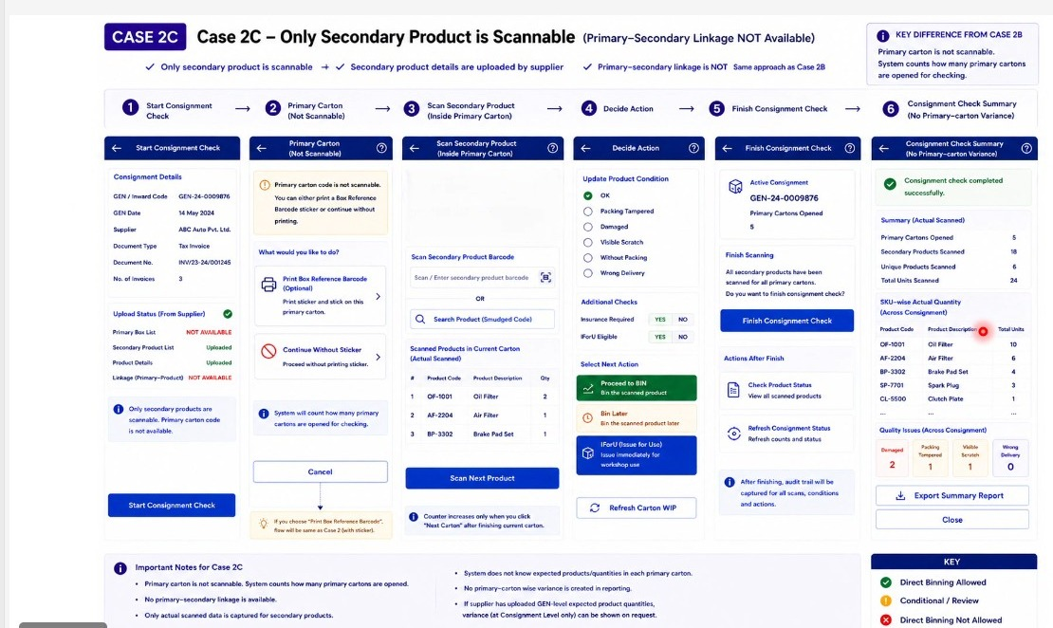
Figure 26.4a - Case 2C board: the six-step flow with the primary carton shown as not scannable, the print-sticker or continue-without choice at Step 2, secondary product scanning inside the carton, and the summary without carton-level variance.

27. FR-024: Case 2D - Secondary Cartons Inside the Primary Cartons, Nothing Scannable and No Supplier Details - Screens 13A, 13B, 13C & 13D

27.1 Overview
Case 2D is the weakest data position in the whole inward flow. Secondary cartons sit inside the primary carton, nothing is scannable, no supplier details are available and no linkage exists. Neither the carton nor the products inside it carry a readable code, and the system holds no expectation of what should be there.
This is not an edge case. A number of the newer original equipment manufacturers do not barcode even their primary products - the tempo traveller segment was cited as an example - and their parts carry no MRP stickers. Dealers also stock items bought locally, such as distilled water, which are not serialised at all but are still held in inventory and must be receivable through the same system.
Identification is therefore manual. The operator either prints product barcode stickers so that products can be identified during inspection, or searches the product master by code, description or part number. Quantity is counted physically. Condition is captured for the selected product only, one item at a time, with damaged units set aside for insurance. Binning then proceeds against the recommended location held in the master, and the exception panel handles the no-location and next-product states.
Note: Screens 13A to 13D are numbered on the board. Their sequence is identify, review and act, bin, and handle the exception - the same shape as Cases 1C and 1D, but with the products discovered rather than expected.

Layman Description
The hardest case: nothing carries a barcode at all - not the outer carton, not the parts inside. Everything has to be identified by a person looking at it and finding it on a list. A system that handles this properly does three things. It switches the scanning controls off rather than leaving them on screen to be poked at pointlessly. It gives a fast way to find a part by typing a few letters of its name or number, since the alternative is scrolling through thousands of entries. And it still lets condition be recorded per part, because the goods are no less likely to be damaged for being unlabelled. This case is more common than people expect - loose items, local fabricators, anything repacked in transit - and a system that quietly assumes everything is scannable becomes useless the moment it happens.
Example: A local fabricator delivers 40 brackets loose in unmarked cartons. The scanner is greyed out. The operator types brac and the part comes up in the list. He records 40 received, 2 bent, and prints stickers so the cartons have references for the rest of their journey. The whole consignment is on record without a single barcode having been read.

27.2 Functional Requirements
FR-024.1: Case 2D shall be applied where secondary cartons are contained inside the primary carton, nothing is scannable, no supplier details are available and the primary-secondary linkage is not available.
FR-024.2: The system shall support consignments from suppliers who do not barcode their primary products at all, and locally purchased non-serialised items which carry no scannable code but are held in stock.
FR-024.3: Screen 13A shall disable the primary box and product code scan controls and shall indicate on screen that they are inactive for this case.
FR-024.4: Screen 13A shall offer two identification methods: print product barcode stickers so that products can be identified manually during inspection, or search the product master by product code, description or part number.
FR-024.5: Where product barcode stickers are printed, the sticker shall carry the product code, description and pack size.
FR-024.6: Screen 13A shall maintain an opened cartons counter and shall list the products identified in the currently opened carton with product code, description and quantity.
FR-024.7: More than one product shall be capable of being added to the same opened carton, since the carton holds several secondary items.
FR-024.8: Screen 13B shall display the selected product with its code, description, manually entered quantity split between good and damaged units, pack size, binning zone, recommended binning location and alternate locations.
FR-024.9: Screen 13B shall list the other products already identified in the current opened carton alongside the selected product, so that the operator retains the context of the carton.
FR-024.10: Condition shall be captured for the selected product only. The system shall state that the condition recorded applies to the selected product and that other products will be captured when they are selected.
FR-024.11: Condition shall be captured item by item within the selected product, with a photograph capturable against each item and an outcome of Proceed to BIN or Set Aside for insurance.
FR-024.12: Screen 13B shall maintain counters for good units, damaged units and insurance claims, and shall offer Issue for Usage, Proceed to BIN, BIN LATER, Continue Identifying Products and Cancel.
FR-024.13: Screen 13C shall bin the selected product in two verified steps - select or scan the recommended location, then confirm the product - and shall state how many units will be binned and how many set aside before Confirm BIN is available.
FR-024.14: Screen 13C shall offer Continue Identifying Next Product and Cancel Current Product so that the operator can move through the carton product by product.
FR-024.15: Screen 13D shall present the no-location alert state with Enter Location and Notify Admin, subject to role-based access control.
FR-024.16: Screen 13D shall present the next product and next opened carton state, confirming that progress has been saved and offering Identify Next Product Manually and Next Opened Carton.
FR-024.17: Screen 13D shall display the opened cartons counter, the number of products identified in the current carton and the bin later queue with its pending count.

27.3 Screen Field Reference - Screen 13A (Identify Products)
Note: the two identification methods are offered side by side because they suit different situations - printing stickers is worthwhile where a carton holds many units of the same part, and searching is faster where it holds a few of several.
Field | Control Type | Description
Consignment Details | Collapsible section | Gate entry number, supplier and document number. The supplier field states that supplier details are not available, which is one of the defining conditions of this case.
Neither Primary Carton nor Product Code is Scannable | Warning card with chevron | States the case condition and takes the operator into manual or predictive identification or sticker printing.
Primary Box (Scan Inactive) | Disabled field | Greyed out and inoperable; the primary carton cannot be scanned.
Product Code (Scan Inactive) | Disabled field | Greyed out and inoperable; the product code cannot be scanned.
Print Product Barcode Stickers | Option card with print control | Prints barcode stickers so that products can be identified manually during inspection.
Search Product (Manual / Predictive Search) | Search field | Searches the product master by product code, description or part number.
Opened Cartons Counter | Counter tile | Number of primary cartons opened for checking so far.
Products identified in current opened carton | Table | Serial number, product code, description and quantity for each product found so far in the open carton.
Continue Identifying Products | Primary action | Adds a further product to the current opened carton.
Multiple products note | Information banner | States that more products can be added to the same carton.

27.4 Screen Field Reference - Screen 13B (Review Product & Action)
Note: the distinguishing feature of this screen is that condition applies to the selected product only. The carton holds several products, so the screen has to make clear which one the operator is currently recording against.
Field | Control Type | Description
Selected Product | Panel | Product code, description, manually entered quantity with its good and damaged split, pack size, binning zone, recommended binning location and alternate locations.
Other products in current opened carton | Table | The products already identified in this carton, with quantity, listed alongside the product currently selected.
Capture Condition for SELECTED PRODUCT ONLY | Section header | Makes explicit that the condition being recorded applies only to the product currently selected.
Condition (per item) | Dropdown | Records the condition of the individual item as OK or Damaged.
Take Photo (per item) | Camera control | Captures photographic evidence against the item.
Outcome (per item) | Derived status | Proceed to BIN for good items, Set Aside (Insurance) for damaged items.
Insurance Claim | Tag | Marks the item as forming part of an insurance claim.
Good Units / Damaged Units / Insurance Claim | Counter tiles | Running totals for the selected product.
iForU / Proceed to BIN / BIN LATER | Action buttons | Route the product to issue for usage, to binning, or to the deferred queue.
Continue Identifying Products | Action | Returns to identification to add another product from the same carton.
Selected product warning | Warning banner | States that the condition captured applies only to the selected product and that other products will be captured when selected.

27.5 Screen Field Reference - Screen 13C (Binning Action)
Note: the location is selected rather than scanned, as in Case 1D, because nothing on the product or the carton can be read by the scanner.
Field | Control Type | Description
Selected Product summary | Read-only panel | Product code, description, manual quantity with its good and damaged split, binning zone and recommended binning location.
Step 1: Select / Scan Location | Selection or scan field | The recommended location is pre-filled from master data and may be selected rather than scanned, since scanning is unavailable in this case.
Location Verified | Status tag | Confirms that the location has been accepted.
Step 2: Confirm Product | Confirmation field | Confirms the product being binned and reports success.
Binning verified successfully | Confirmation panel | States how many units will be binned and how many set aside for insurance.
Confirm BIN | Primary action | Commits the binning transaction for the selected product.
Continue Identifying Next Product | Action | Moves to the next product in the same opened carton.
Cancel Current Product | Action | Abandons the product currently selected without abandoning the carton.
No Location Alert | Warning panel | Raised where no mapped location exists; offers manual entry where role-based access allows, otherwise notification to the administrator.

27.6 Screen Field Reference - Screen 13D (Exception / Next State)
Note: this case needs two counters rather than one - cartons opened and products found in the current carton - because progress is measured in both dimensions at once.
Field | Control Type | Description
State 1: No Location Alert | State panel | Raised where no mapped location exists for the selected product in the zone; presents Enter Location and Notify Admin.
Enter Location / Notify Admin | Action buttons | Manual entry is offered only where role-based access permits it; otherwise the request is routed to the administrator.
State 2: Next Product / Next Opened Carton | State panel | Confirms that progress has been saved, that identification may continue with the next product in this carton, and that the operator may move to the next opened carton once this one is complete.
Identify Next Product Manually | Action button | Starts manual identification of the next product within the same carton.
Next Opened Carton | Action button | Advances to the next opened carton and increments the counter.
Opened Cartons Counter | Counter tile | Number of cartons opened for checking so far.
Products Identified in Current Carton | Counter tile | Number of distinct products found in the carton currently open.
Bin Later Queue | Navigation row with count | Opens the deferred queue and shows the number of products pending.
Printed Product Barcode Stickers | Print panel | Preview of the stickers produced for manual identification, carrying product code, description and pack size.
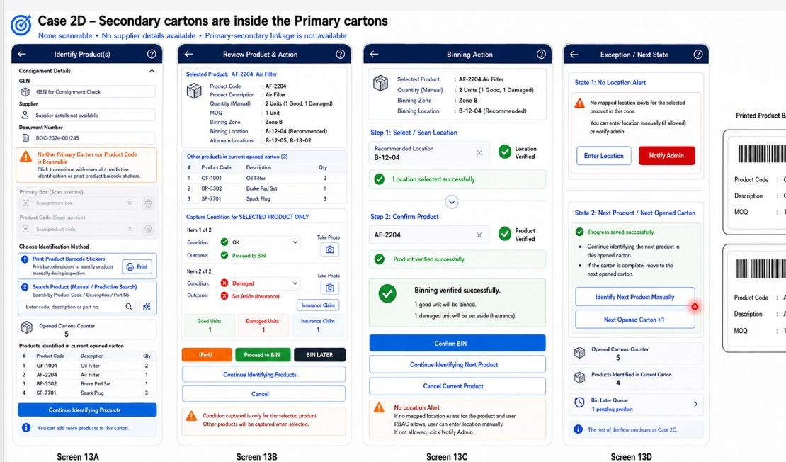
Figure 27.6a - Case 2D board (Screens 13A to 13D): manual product identification with the scan controls disabled and barcode sticker printing offered, review and action for the selected product, binning by location selection, and the exception and next-state panel with the printed sticker formats alongside.

28. FR-025: Open Delivery - Primary Carton Capture, Duplicate Scan Control and Bin Location Selection

28.1 Overview
The open delivery flow introduced in section 21 was extended in this session with a primary carton capture step, controls around duplicate scanning, and an explicit bin location selection where a product may be stocked in more than one place.
The inspection itself is unchanged in principle. Pieces are examined one at a time; a piece damaged because the outer carton was damaged is photographed and recorded as damaged, and it is set aside for insurance while the remaining good pieces proceed to binning. What was added is the handling around it: how the carton is captured when its code cannot be read, what happens when a code that should be unique is scanned twice, and how the operator chooses between several permitted bin locations.
Two distinct code situations are now separated. Where a secondary code is genuinely unique to the unit, scanning it a second time is an error and is blocked. Where a code is not unique - the common case in which every unit of a part carries the same code - the system offers to create and print a unique scan code to be stuck on the secondary pack, so that the unit can be tracked individually.
Note: binning and issue for usage are the two destinations from this flow. Where a piece is routed to a workshop job rather than to stock it does not go to a bin at all, so the phrase proceed to binning should be read as proceed to the appropriate destination.

Layman Description
Duplicate Scan Control - Scanning the same item twice by accident is easy - the scanner beeps, the operator is not sure it registered, he scans again. If the code genuinely identifies that one physical unit, the second scan is a mistake and the system should block it, otherwise one item is counted as two and the stock figure inflates. But not every code is unique to a unit. Many suppliers print the same part number barcode on every box of that part, so ten identical boxes carry ten identical codes and scanning them ten times is entirely correct. A system that blocks all repeats will make those ten boxes impossible to receive. The good answer is to block genuine duplicates and, where codes are shared, offer to generate a separate code per unit.
Example: The operator scans a serial-numbered gearbox, is not sure it took, and scans again - the system blocks the second scan and says already scanned. Later he receives ten identical filter boxes all carrying the same part barcode. Here it does not block him; it offers to print a unique label for each so the ten boxes can be told apart afterwards.
Carton Capture - When a damaged carton is taken for opening, the system records which carton it was and when the examination started. That timestamp does more work than it appears to. Open delivery is usually done in the presence of the driver or the transporter, and the time it happened is what demonstrates the carton was opened on arrival rather than three days later - which is the first thing challenged when a claim is disputed. It also records where the supplier has not provided information linking the carton to its contents, so the reader knows whether the expected contents were independently known or simply what was found. The distinction matters to anyone relying on the record afterwards.
Example: Carton 31 comes off wet at 09:52 and is opened at 10:15 with the driver present. Both times are on the record. When the transporter later argues the carton was fine on delivery and must have got wet in the warehouse, the twenty-three minute gap between arrival and opening, with the driver signature, ends the discussion.
Evidence Capture - A photograph of the outside of a carton shows a crushed corner. It does not show that three of the twelve alternators inside are cracked. Being able to photograph each piece individually is what turns the inspection into evidence, because the claim is about the pieces, not the box. Each photograph attaches to the specific piece it belongs to rather than to the carton generally, so the record shows this unit, damaged, with this image. The other half is that pieces which pass go on to be binned normally from the same screen - the operator should not have to finish the inspection, leave, and start a separate putaway job for the nine good ones.
Example: Three of twelve alternators are cracked. The operator photographs each of the three separately as he works through them. The claim goes to the supplier with three images, each tied to a piece. The remaining nine are sent to bin from the same screen and are on the shelf ten minutes later - no second job, no re-scanning.

28.2 Functional Requirements
FR-025.1: The open delivery flow shall begin with capture of the primary carton, showing the gate entry code, supplier and an optional document number.
FR-025.2: The system shall state where the primary-secondary linkage is not available and shall instruct the operator to capture the primary carton first and then scan the secondary product code.
FR-025.3: The primary box shall be capturable by scan or selection, and where the barcode or QR code is smudged the operator shall be able to enter the box details manually or select the box using predictive search.
FR-025.4: On capture the system shall record and display the box reference, the time at which it was captured and the user who captured it.
FR-025.5: The captured carton screen shall provide navigation to the open delivery queue, described as the cartons marked for open delivery during unloading.
FR-025.6: The inspection screen shall show the selected primary box together with the observation recorded at unloading and the open delivery marked flag.
FR-025.7: Each piece shall be inspected individually, with the selected piece presented separately and its condition recorded against the standard condition set.
FR-025.8: A photograph shall be capturable against the selected piece, and the piece shall be markable for an insurance claim.
FR-025.9: The system shall state that a piece found to be in acceptable condition proceeds to binning and that a piece found otherwise is kept aside.
FR-025.10: Where more than one bin location exists for a product, the system shall present the permitted locations for selection rather than assuming one. Part-to-location combinations shall be uploaded by the administrator.
FR-025.11: Where a code that is unique to the unit is scanned a second time, the system shall block the scan and shall state that duplicate scanning is not allowed for unique SKU codes.
FR-025.12: Where a product code is not unique to the unit, the system shall offer to create and print a unique scan code to be affixed to the secondary pack so that individual units can be tracked.
FR-025.13: The level at which unique scan code generation is configured - by SKU, by product category or by supplier - shall be an administrative setting.
FR-025.14: Where no bin location is found for a product, the system shall raise a no-location alert offering two paths: manual entry of a location where the administrator permits it, and a request routed to the administrator to update the bin location for the product where they do not.
FR-025.15: Binning and issue for usage shall be treated as alternative destinations for an inspected piece. A piece routed to a workshop job shall not be binned.

28.3 Screen Field Reference - Capture Primary Carton
Note: this screen is new to the open delivery path. It exists because the carton has to be identified before its contents can be attributed to it, and because a carton flagged as damaged at unloading may well have a damaged code.
Field | Control Type | Description
Gate Entry Number (GEN) | Read-only field | Identifies the consignment to which the carton belongs.
Supplier | Read-only field | Supplier name resolved from the gate entry.
Document Number (Optional) | Editable field | Captured where a shipment document reference is available; the flow does not require it.
Linkage not available notice | Information banner | States that the primary-secondary linkage is not available and that the primary carton must be captured before the secondary product code is scanned.
Primary Box Capture - Scan / Select Box No. | Scan or select field with delete | Captures the primary carton being inspected; the delete control removes an entry captured in error.
Smudged code note | Information banner | States that where the barcode or QR code is smudged the operator may enter the box details manually or select the box using predictive search.
Primary Box Captured | Confirmation panel | Displays the captured box reference, the date and time of capture and the user who captured it.
Open Delivery Boxes | Navigation row with chevron | Opens the queue of cartons marked for open delivery during unloading.
Next: Scan Secondary | Primary action | Moves to secondary product scanning for the captured carton.

28.4 Screen Field Reference - Inspect Open Delivery Box
Note: the piece list and the selected piece panel work together - the list gives the state of the whole carton at a glance while the panel records against one piece at a time.
Field | Control Type | Description
Selected Primary Box | Header panel | The carton under inspection, with the observation recorded at unloading and the open delivery marked flag.
Secondary Carton / Product Scan | Scan field | Captures the secondary product inside the carton.
Product panel | Read-only fields | Product code, description, pack size, binning zone and binning location for the scanned product.
Direct Binned Pieces | Counter chip | Number of pieces from this carton already sent to binning.
Piece list | Selectable rows | One row per piece in the carton, each showing its inspection state - acceptable, damaged or pending inspection.
Selected Piece / Product Condition | Option set | Condition of the piece currently selected, recorded against OK, Damaged, Packing Tampered, Visible Scratch, Without Packing or Wrong Delivery.
Take Photo | Camera control | Captures photographic evidence against the selected piece.
Mark for Insurance Claim | Checkbox | Flags the selected piece as forming part of an insurance claim.
Inspection guidance | Information banner | States that a piece in acceptable condition proceeds to binning and that a piece found otherwise is kept aside.
Proceed to BIN / Set Aside | Action buttons | Split the carton between the pieces that will be binned and those held for the claim.

28.5 Screen Field Reference - Binning & Location Selection
Note: the three alerts on this screen address three different problems - a code scanned twice, a code that is not unique in the first place, and a product with no location at all.
Field | Control Type | Description
Product header | Panel | The product being binned with its code and description, and the count of pieces to be direct binned.
Available Bin Locations | Selection list with dropdown | The permitted bin locations for the product, from which the operator selects one.
Multiple location note | Information banner | States that where multiple locations exist for a product the operator selects the bin from the dropdown, and that part-to-location combinations are uploaded by the administrator.
Duplicate Scan Blocked | Error alert | Raised where a code unique to the unit is scanned a second time; states that duplicate scanning is not allowed for unique SKU codes.
Print Unique Scan Code | Action alert | Offered where codes are not unique; creates and prints a unique scan code to be stuck on the secondary pack, configurable by SKU, product category or supplier.
No Location Alert | Warning panel | Raised where no bin location is found for the product.
A. Admin allows user entry | Path within the alert | The operator enters or scans a location and bins the product against it.
B. User not allowed | Path within the alert | A request is sent to the administrator to update the bin location for the product.
Continue Binning | Primary action | Commits the placement and returns the operator to the queue.
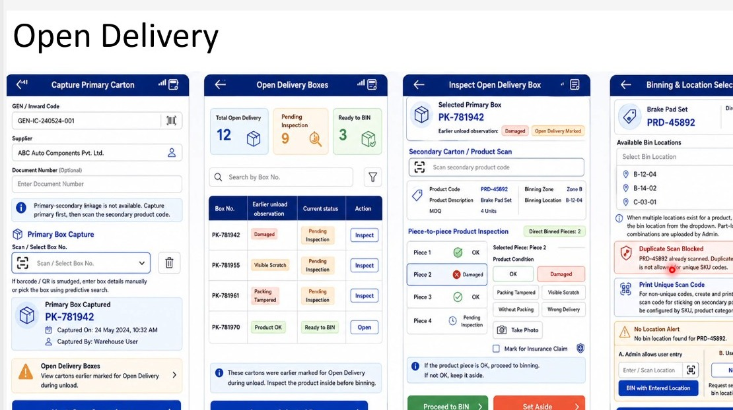
Figure 28.5a - Open Delivery extended: primary carton capture with smudged-code handling, the open delivery queue with unload observations carried forward, piece-by-piece inspection of the selected box, and bin location selection with the duplicate scan, unique scan code and no location alerts.

29. FR-026: Binning - Cart Assembly - Screens 12a & 12b

29.1 Overview
Binning is the stage after the consignment check. By this point the primary and secondary cartons have been scanned, damaged products have been identified and set aside, and every remaining product carries a binning zone, a binning location and any alternate locations from master data.
Physical binning is done with a cart. The operator collects products into a cart or trolley, scanning each one as it goes in, and then takes the loaded cart to the bin locations. Scanning the same product repeatedly increases the quantity on that cart line; scanning a different product adds a new line. When the cart is physically full the operator proceeds to bin it and the next cart becomes active.
How much a cart can hold is a physical matter and is deliberately left outside the system. The operator judges it, taking account of fragility - a heavy item should not be stacked on top of something fragile - which is why the fragile flag is surfaced at the point of adding to the cart rather than only at binning.
One cart can serve more than one bin location. A cart assembled for a single row of the warehouse may have items destined for the start, the middle and the far end of that row. The cart details are therefore to be structured as cart, then location, then the parts and quantities going to that location, rather than as a flat list of parts.
Note: at cart assembly the location is entered rather than scanned. The operator is recording where each item is destined to go. The location scan happens later, at the bin itself, as the confirmation that the right place has been reached. Product scanning at cart assembly is appropriate because the item is physically being picked up and placed into the cart at that moment.

Layman Description
Cart Assembly (FR-026.1 to .9) - Rather than walking a single part to a shelf and coming back, the operator loads several parts onto a trolley and puts them all away in one trip. The system keeps a list of what is on each trolley, so the trolley itself becomes something that can be tracked - what is on it, where each item is going, and how much is left to do. Organising the list by trolley and then by location is what makes the trip efficient: the operator can see that four items on this trolley all go to the same aisle. Fragile items are flagged in the list so they are not stacked underneath something heavy, which is a decision made when loading rather than discovered at the shelf.
Example: The operator loads twelve parts onto trolley 2. The list shows them grouped by location: four for aisle B, five for aisle C, three for aisle D, with one headlamp marked fragile. He walks aisle B, then C, then D, in one loop rather than twelve separate trips, and the fragile item goes on top.
Cart Assembly (FR-026.21 to .23) - Three small things that decide whether cart assembly is quick or painful. First, the standard pack size appears on its own from the part record, so the operator can see that this item normally comes in boxes of five without looking it up. Second, quantity can be typed. Adding ten of the same part by scanning it ten times is the sort of thing that looks fine in a demonstration and is abandoned within a week on a real floor. Third, a line added by mistake can be deleted while the trolley is still being loaded. Without that, the operator either lives with a wrong line or cancels the whole trolley and starts again, and both of those end with somebody adjusting stock later.
Example: The operator adds a filter to the trolley and the screen shows a standard pack of five. He is loading ten, so he types 10 rather than scanning ten times. He then adds a wrong part by scanning the carton next to it, notices immediately, and deletes the line. The trolley leaves the bay with exactly what is on it, and nothing needs correcting afterwards.
No-Location Handling - Sometimes a part has no storage location set up for it at all - a new item, or one that has never been stocked here before. The operator is holding it and has to do something. There are two reasonable answers and the difference between them is a policy decision, not a technical one. Either he is trusted to choose a sensible place himself, with the system recording what he chose, or he is stopped and the item waits until a supervisor defines a proper location. Which applies should depend on who he is, and that is what role-based control means here. Junior staff picking their own locations is how a warehouse ends up with stock nobody can find; senior staff being blocked is how a bay ends up jammed with parts nobody is allowed to move.
Example: A new part arrives with no location defined. A senior storekeeper is allowed to place it, chooses C-04-02, and the system records that he did so and that it was a manual choice. A junior operator with the same part is blocked, and the item goes into a pending list for the supervisor. Both outcomes are deliberate, and neither leaves the part standing on the floor unrecorded.
Expected Quantity Control - An administrator can switch off the display of how many pieces are expected, so the operator has to count what is physically there and enter that number, rather than seeing a figure and confirming it. It exists because of a well-known human problem. If the screen says twelve, a tired man at the end of a shift will type twelve without counting, and eleven pieces will be recorded as twelve. Hiding the expected number forces a genuine count, and the difference between what he enters and what was expected becomes real information rather than a number copied off a screen. It is not always wanted - it slows the work - so it is an option an administrator turns on where accuracy matters more than speed.
Example: For a high-value line the administrator hides expected quantities. The operator opens a carton that should hold twelve alternators, counts eleven, and enters 11. The system flags one short. Had the screen shown twelve with a confirm button, the shortage would almost certainly have been confirmed away and found weeks later at a stock count.

29.2 Functional Requirements
FR-026.1: The system shall support cart-based binning, in which products are collected into a cart, scanned as they are added, and then taken to their bin locations for placement.
FR-026.2: Screen 12a shall capture the consignment details and shall provide a product code scan with a delete control, a quantity stepper, the pack size, the product description, the binning sub-zone and the binning location.
FR-026.3: Products flagged as fragile in the master shall be indicated at the point of adding to the cart, so that the operator can judge how the cart is loaded and avoid stacking heavy items on fragile ones.
FR-026.4: Where the same product is scanned more than once into a cart, the quantity on that cart line shall increase. Where a different product is scanned, a new line shall be added to the cart.
FR-026.5: The active cart number shall be displayed while items are being added.
FR-026.6: The physical capacity of a cart shall not be managed by the system. The operator shall determine when a cart is full.
FR-026.7: When the operator proceeds to bin the active cart, the next cart shall become active for further collection.
FR-026.8: Screen 12b shall present the cart details for each cart, listing part number, quantity and location together with the part description.
FR-026.9: The cart details shall be structured hierarchically as cart, then bin location, then the parts and quantities destined for that location, because one cart may serve more than one bin location.
FR-026.10: At cart assembly the bin location shall be entered or confirmed rather than scanned. Location scanning shall take place at the bin during binning execution, as the confirmation that the correct place has been reached.
FR-026.11: Product scanning shall remain part of cart assembly, since the product is physically being picked and placed into the cart at that point.
FR-026.12: Where no location exists in the master for the part being added to the cart, the system shall raise a no-location alert naming the part number and requesting that a location be added to the master.
FR-026.13: The binning screen shall allow the consignment to be identified by gate entry number, gate entry date, document type and document number.

29.3 Screen Field Reference - Screen 12a (Binning - Add to Cart)
Note: the fragile flag appears on this screen rather than only at binning because the decision it informs - what goes on top of what - is taken while the cart is being loaded.
Field | Control Type | Description
Consignment Details | Collapsible section | The consignment against which the products being binned were received.
Scan Product Code | Scan or select field with delete | Captures each product as it is physically placed into the cart; the delete control removes an item added in error.
Quantity | Stepper control | Number of units of the scanned product being added to the cart; increases as the same product is scanned again.
MOQ | Read-only field | Quantity per pack size for the product, from the master.
Product Description | Read-only field | Description resolved from the scanned product code.
FR | Flag button | Indicates that the product is fragile, so that the operator can load the cart accordingly.
Binning Sub-Zone | Read-only field | The sub-zone within which the product is stocked.
Binning Location | Read-only field | The bin location to which the product is destined. Entered or confirmed here rather than scanned.
Cart No. | Indicator | The cart currently being loaded.
Proceed to Bin | Primary action | Closes the active cart for loading and takes it forward for placement; the next cart then becomes active.
NO LOCATION ALERT | Error panel | States that no location was found and asks for a location to be added to the master for the named part number.

29.4 Screen Field Reference - Screen 12b (Cart Details)
Note: the structure of this screen is the subject of an agreed change. The flat part list shown on the board is to be replaced by a grouping under each bin location within the cart.
Field | Control Type | Description
Cart sections | Collapsible sections | One section per cart, so that the contents of each cart can be reviewed independently.
Part No. | Qty | Location | Row detail | The identifying line for each item on the cart - what it is, how many, and where it is going.
Part Description | Row detail | The description of the part on that cart line.
Proceed To Bin | Action | Sends the selected cart forward to the binning execution screens.
GEN / GEN Date | Select fields | Identify the gate entry against which the binning is being performed.
Document Type / Document Number | Select fields | Identify the document under which the goods were received.
Hierarchical structure | Structural requirement | Cart details are to be grouped by bin location within each cart, with the parts and quantities listed beneath each location, since one cart may serve more than one location. See FR-026.9.
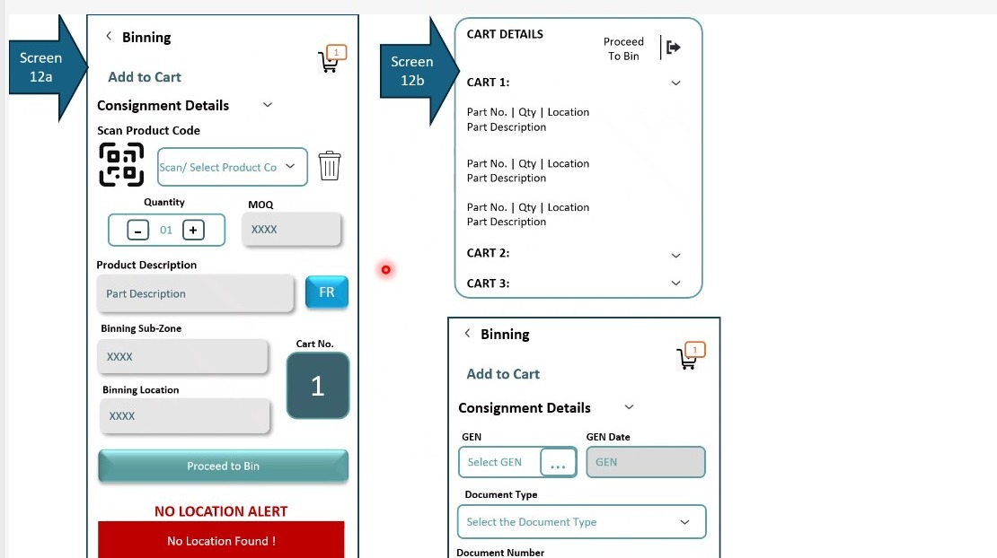
Figure 29.4a - Screens 12a and 12b: product scanning into the active cart with quantity, pack size, fragile indicator and destination location, the no-location alert, and the cart details panel listing part, quantity and location for each cart.

29.5 Amendments from Session 07
The no-location alert is currently specified as raising a request for the master to be updated. The BRD ties the alert to role-based access control and provides for two outcomes rather than one. Where the administrator has permitted it, the user may bin the product to a location of their choice and continue. Where the administrator has not, the user is blocked and a message is routed to the administrator instead.
A second point was raised on the same screen. The BRD gives the administrator the option to hide the expected quantity to bin from the operator, so that the operator counts what is physically present rather than reading the expected figure off the screen and confirming it.
FR-026.14: The no-location alert shall be governed by role-based access control and shall resolve to one of two outcomes according to the permission held by the user.
FR-026.15: Where the administrator has permitted it, the user shall be able to bin the product to a location of their choice and continue.
FR-026.16: Where the administrator has not permitted it, the user shall be blocked from binning and a message shall be routed to the administrator instead.
FR-026.17: The administrator shall have the option to hide the expected quantity to bin from the operator, so that the quantity recorded is the quantity physically counted.

29.6 Amendments from Session 07 (Part 2)
The administrator option to hide the expected quantity to bin, recorded at FR-026.17, was explained in full and the reasoning is worth preserving because it determines how the control must behave.
Where the expected quantity is displayed, an operator who is working at speed can pick a few units, declare the task finished and enter the expected figure - fifty, say - without having counted anything. The recorded quantity then matches the expectation exactly and nothing in the system indicates that a count did not take place.
Where the expected quantity is hidden, that shortcut is closed. The operator does not know what figure would satisfy the system, so the only way to complete the task is to scan each unit as it is placed. The count is built from the scans rather than asserted at the end.
Note: hiding the figure is what makes the scan meaningful, so the option should sit at the same configuration level as the manual entry control at FR-027.14. Hiding the expected quantity while permitting unrestricted manual entry would reopen the same gap by a different route.
FR-026.18: Where the expected quantity to bin is hidden, the quantity recorded shall be derived from the units actually scanned and shall not be enterable as a total.
FR-026.19: The system shall not indicate to the operator what quantity would satisfy the expectation while the expected quantity is hidden.
FR-026.20: The hide-expected-quantity setting and the manual entry permission at FR-027.14 shall be capable of being configured together, so that hiding the quantity is not defeated by unrestricted manual entry.

29.7 Amendments from Session 07 (Part 4)
The cart assembly walkthrough settled three points left open earlier. The pack size displayed beside the quantity is drawn from the master data against the product code, not entered by the operator and not held against the consignment. It is shown for reference so the operator can see the standard pack in which the part is normally handled while deciding what to place in the cart.
Where a product cannot be scanned the operator enters the code, and where several units of the same product are being added the quantity is entered directly rather than by scanning the same item repeatedly. A delete control is available while the cart is being assembled, so that a line added in error can be removed before the cart proceeds to binning.
Note: this closes OI-072, which recorded the quantity entry point truncated at the end of Part 3. The behaviour described there is the behaviour specified here.
FR-026.21: The pack size displayed at cart assembly shall be retrieved from the product master against the product code. It shall be read-only and shall be displayed for reference only.
FR-026.22: Quantity shall be enterable directly on the cart line. The operator shall not be required to scan the same product once per unit in order to build up a quantity.
FR-026.23: A delete control shall be available against each cart line while the cart is being assembled, so that a line entered in error can be removed before the cart proceeds to binning.

30. FR-027: Binning Execution - By Product, By Location and Direct - Screens 13a, 13b, 14a, 14b & 15

30.1 Overview
Once a cart is loaded it is taken to the bin. Three routes are provided. Binning by product starts from the product - the operator scans a product from the cart and the system states which location it is destined for. Binning by location starts from the location - the operator selects the location, goes to it, and the system states which product from the cart belongs there. Direct binning covers a single product placed without a cart at all.
All three end the same way. The operator scans the location and the system compares it against the location recorded on the cart line, raising a wrong location alert if they do not match. The product is then scanned as confirmation that the right part is being placed, with a wrong part alert if it is not. Quantity or number of packs is confirmed, and the placement is saved.
Placement need not be complete. Where there is not enough space at the bin, the operator may place some of the pieces and finish that item, and the remaining pieces are then moved to a different location chosen from the permitted list, scanned there, and updated.
Note: the wrong location and wrong part alerts are the reason the location is scanned here rather than at cart assembly. At the cart the operator states an intention; at the bin the system verifies that the intention was carried out.

Layman Description
Binning Routes - Three different ways of putting stock away, because three different situations exist. Working by part means taking one part and going to its location - sensible when there are a few items in scattered places. Working by location means going to a shelf and dealing with everything on the trolley destined for it - much faster when a trolley has several items for the same aisle. Direct binning is for a single part being put away on its own, with no trolley made up at all, which is what actually happens for the majority of small daily receipts. A system offering only one of the three forces the warehouse to work that way regardless, and the usual result is that operators stop using the trolley function and record things afterwards.
Example: A trolley with twelve parts across three aisles is worked by location - three stops instead of twelve. Later a single urgent filter arrives on its own; the operator uses direct binning and puts it away in under a minute without creating a trolley for one item. Same system, two entirely different jobs.
Scan Verification - The same two-scan discipline as elsewhere, applied at the moment of putting stock on the shelf: the location is scanned, the part is scanned, and only then is the quantity confirmed and the movement committed. What varies between systems is what happens when one of the scans is wrong. A system that simply refuses and gives no reason leaves the operator guessing whether he is at the wrong shelf or holding the wrong part - and after two or three of those he starts typing codes in to get past it. A system that says which of the two was wrong lets him correct it in seconds. It is worth asking to see a deliberate mistake made, because the quality of the error message is the whole difference here.
Example: The operator scans C-05-02 and then a filter. The screen says the part is expected at C-04-02, not here - he is one shelf out. He moves and scans again, and it is accepted. On a different occasion he is at the right shelf with a similar-looking part from the next bin, and the message names the part rather than the location. Two different mistakes, two different messages, both corrected on the spot.
Partial Placement - The intended shelf will not always hold everything being carried to it. Rather than forcing an all-or-nothing decision, the operator can put in what fits and record the remainder against a different location. Both parts of the movement are recorded, so the stock figures stay true to where the goods physically are. The alternative behaviours are both bad. If the system insists the whole quantity goes in one place, the operator either forces the stock in where it does not fit or carries it back to the bay and it sits there. If he can leave part of it unrecorded, the stock figure is wrong from that moment. Splitting properly is the only outcome that leaves the record matching the warehouse.
Example: The operator carries twenty filters to B-12-04 and only twelve will fit. He records 12 there, and the system asks where the remaining 8 are going. He walks to B-12-09 and records those. Stock shows 12 in one location and 8 in the other, which is exactly what a person walking the aisle would find.
Manual Entry Control - Barcodes get smudged, torn and rubbed off. When one will not scan, the operator has to be able to type the code in or the work stops. But typing is also how a system gets quietly bypassed - it is faster than scanning, so given a free choice some operators will type everything and the scanning discipline collapses without anyone noticing. The answer is to allow it under control: permitted by role, with a reason picked from a short list, and counted. The counting is the part supervisors care about. A report showing what proportion of movements were scanned rather than typed tells you whether the process is being followed, and a sudden rise in one shift or one operator is worth asking about.
Example: A carton arrives with the label rubbed away. The operator types the code and picks the reason label damaged from the list. That month the report shows 96 per cent scanned, 4 per cent typed - acceptable. The next month one operator shows 40 per cent typed, all with the reason scanner not working. His scanner is checked, found faulty, and replaced. Nobody would have known otherwise.
Location Sequencing - When working shelf by shelf, the operator needs to know where he is in the round: stop three of eight. Without it, a trolley with parts for eight locations becomes a job with no visible end, and he cannot tell a supervisor how long he will be. The second part is that when several items on the trolley go to the same shelf, the system presents the next one for that shelf before sending him anywhere else - so he deals with everything at that location in one visit rather than walking back later. The third is that if the shelf fills up partway through, he is told at that point rather than arriving with the next item and finding out then.
Example: Trolley 1 has parts for eight locations. At stop three the screen shows 3 of 8 and offers a second part for the same shelf, which he puts away without moving. Halfway through the third item that shelf is full, and the screen tells him immediately rather than after he has walked to stop four and back.
Quantity Reconciliation - Two numbers are kept rather than one: how many pieces were supposed to go into the location, and how many actually did. Where they differ, the difference is visible. Keeping only one number - usually by assuming the intended quantity was achieved - hides every short placement. The operator meant to put twelve in, only ten fitted, and the record says twelve, so the stock figure is two high from that moment and stays that way until a physical count finds it, by which time nobody can say when or where it happened. Two numbers cost nothing to record and mean a discrepancy is visible on the day it occurs, against a specific location and a specific person.
Example: The operator is meant to place twelve filters in B-12-04. Only ten go in; the other two are still on the trolley when he moves on. The record shows expected 12, actual 10, and the two are flagged as still to be placed. Without both figures, stock would show twelve in B-12-04 and a picker would find ten, three weeks later, with no explanation available.

30.2 Functional Requirements
FR-027.1: The system shall provide three binning routes: binning by product, binning by location, and direct binning.
FR-027.2: Binning by product shall allow the operator to select a cart, scan a product from it, and be directed to the location recorded against that product.
FR-027.3: Binning by location shall allow the operator to select a cart, go to a location, and be shown the product from that cart which is destined for it.
FR-027.4: Direct binning shall allow a single product to be placed without a cart, capturing the product code, description, pack size, zone and location.
FR-027.5: In every route the location shall be scanned at the bin and confirmed against the location recorded for the item.
FR-027.6: Where the scanned location does not match the recorded location the system shall raise a wrong location alert and shall require the correct location to be scanned.
FR-027.7: The product shall be scanned at the bin as confirmation that the correct part is being placed.
FR-027.8: Where the scanned product does not match the expected product the system shall raise a wrong part alert and shall require the correct part to be scanned.
FR-027.9: The operator shall confirm the quantity or the number of packs actually placed before the transaction is saved.
FR-027.10: Partial placement shall be permitted. Where there is insufficient space at the bin, the operator shall be able to place only some of the pieces and complete that item.
FR-027.11: Pieces that could not be placed shall be capable of being assigned to a different location selected from the permitted list, scanned at that location and updated.
FR-027.12: Save shall record progress without closing the item, and Finish shall complete it.
FR-027.13: The bin locations associated with a cart shall be presentable as a list, so that the operator can see every location the cart must visit and select between them.

30.3 Screen Field Reference - Screens 13a & 13b (Binning by Product)
Note: this route suits an operator working through a cart item by item. The system supplies the destination once the product is chosen.
Field | Control Type | Description
Select Cart for Binning | Dropdown | Selects which loaded cart is being placed.
Scan Product Code | Scan or select field with delete | Selects the product from the cart that is being placed now.
Part Description / MOQ | Read-only fields | Description and pack size for the selected product.
Go to Location | Read-only field | The location recorded for this product, which the operator now walks to.
SCAN Location / Confirm Location | Scan field and action | The location is scanned at the bin and confirmed against the recorded location.
Scan Product Code to confirm / Confirm Product | Scan field and action | The product is scanned again at the bin as confirmation that the correct part is being placed.
Confirm Quantity | Stepper control | The number of units actually placed at this location.
Save / Finish | Actions | Save records progress without closing the item; Finish completes it.
Wrong Location ! | Error panel | Raised where the scanned location does not match the recorded location; instructs the operator to scan the correct location.
Wrong Part Picked ! | Error panel | Raised where the scanned product does not match the expected product; instructs the operator to scan the correct part.
Cart details | Reference panel | The contents of the selected cart, so that the operator can see what remains to be placed.

30.4 Screen Field Reference - Screens 14a & 14b (Binning by Location)
Note: this route suits an operator walking a row of the warehouse. The location is fixed first and the system supplies the product from the cart that belongs there.
Field | Control Type | Description
Select Cart for Binning | Dropdown | Selects which loaded cart is being placed.
Go to Location | Field | The location the operator is walking to; this route starts from the location rather than the product.
SCAN Location / Confirm Location | Scan field and action | The location is scanned and confirmed before any product is placed.
Product Code to be Binned / MOQ | Read-only fields | The product from the selected cart that belongs at this location, with its pack size.
Product Description | Read-only field | Description of the product to be placed.
Scan Product Code to confirm | Scan field | Confirms that the correct part has been picked from the cart.
Confirm No. of Packs | Stepper control | The number of packs actually placed at this location.
Save / Finish | Actions | Save records progress; Finish completes the placement at this location.
Wrong Location ! / Wrong Part Picked ! | Error panels | The same two verification failures as on the binning by product route.

30.5 Screen Field Reference - Screen 15 (Direct Binning)
Note: direct binning has no cart selection because it handles a single product placed on its own. The verification at the bin is otherwise identical.
Field | Control Type | Description
Product Code | Scan or select field with delete | The single product being placed, captured without reference to a cart.
Product Description / MOQ | Read-only fields | Description and pack size for the product.
Location Details for Binning - Zone / Location | Read-only fields | The zone and location to which the product is destined, from master data.
SCAN Location / Confirm Location | Scan field and action | The location is scanned at the bin and confirmed.
Scan Product Code to confirm / Confirm Product | Scan field and action | The product is scanned as confirmation before placement.
Confirm No. of Packs | Stepper control | The number of packs actually placed.
Save / Finish | Actions | Save records progress; Finish completes the placement.
Wrong Location ! / Wrong Part Picked ! | Error panels | The same verification failures as on the cart-based routes.
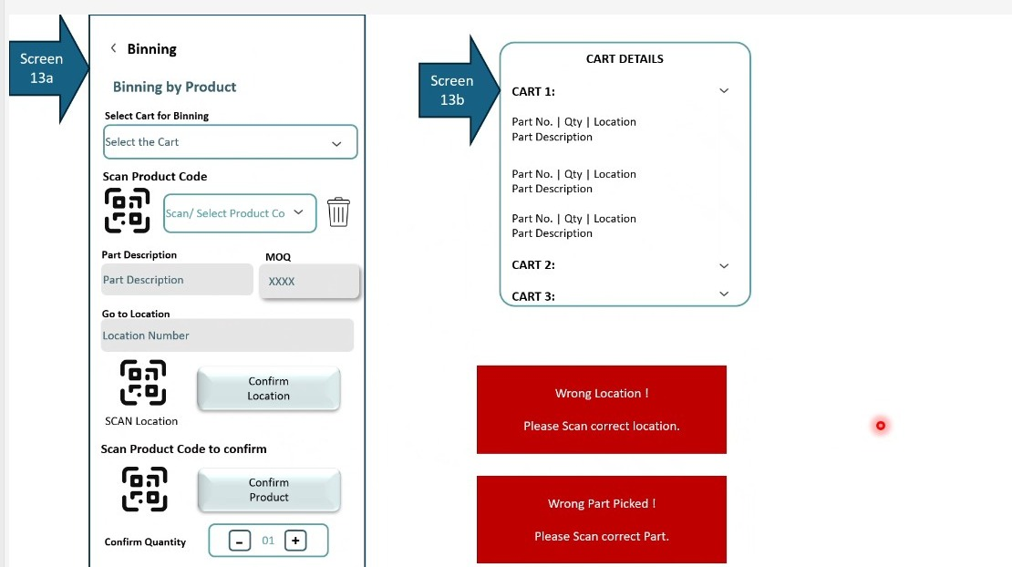
Figure 30.3a - Screens 13a and 13b: binning by product, with cart selection, product scan, the destination location, the scan-and-confirm sequence for location and part, and the wrong location and wrong part alerts.
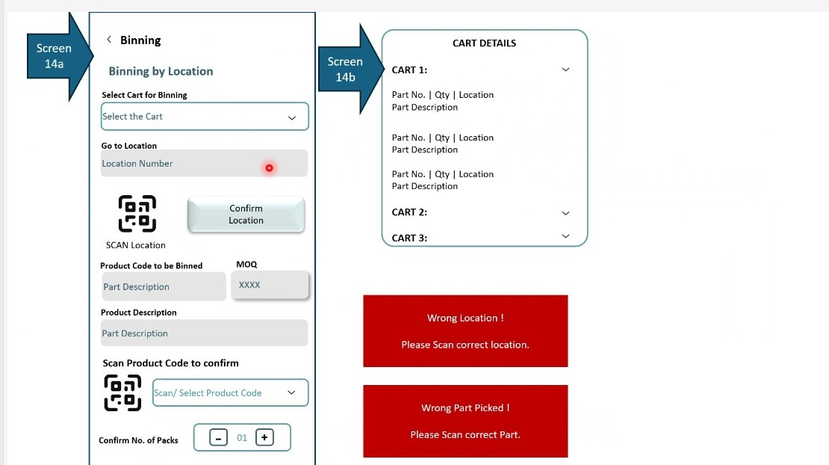
Figure 30.4a - Screens 14a and 14b: binning by location, where the location is confirmed first and the system then presents the product from the cart destined for it.
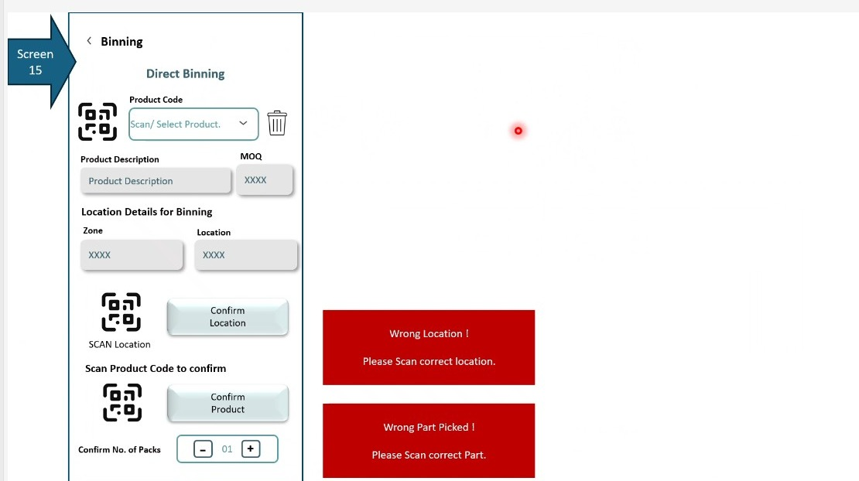
Figure 30.5a - Screen 15: direct binning of a single product without a cart, with the same location and product confirmation and the same two error states.

30.6 Amendments from Session 07
Binning execution is specified as a scan-based process throughout. Two controls around what happens when scanning is not possible were identified as missing.
The first is an administrative toggle. Where a product or location code is smudged or otherwise unscannable, whether the operator may key it manually is a decision for the administrator rather than for the operator. The concern is a practical one: an operator working at speed may scan a single product and then confirm the remainder as matched without actually checking them, and the manual path is where that shortcut becomes available.
The second is reporting on scan compliance. The warehouse needs to see what proportion of a load was actually scanned and what proportion was entered by hand - if ninety per cent scans and ten per cent does not, that ten per cent is where the risk sits. A reason should be captured against each manual entry, because the useful question is not that the operator could not scan but why: whether there was no sticker, or whether the nature of the product is such that it cannot carry one.
A photograph of the item that could not be scanned may also be captured. This was agreed as optional rather than required. The operator is already photographing products at condition capture, and the design intent throughout is to remove steps from the picker's work rather than add them, since a flow with too many steps invites mis-taps and slows the floor.
Note: the reason for manual entry is best offered as a short pick list rather than free text. The operator is working one-handed on a terminal, and a list of two or three causes will be answered where a text box will not.
FR-027.14: The administrator shall be able to define whether manual entry is permitted for smudged or unscannable product codes and location codes at binning.
FR-027.15: Where manual entry is permitted and used, the system shall capture a reason for the manual entry, distinguishing at minimum between the absence of a sticker and a product whose nature prevents scanning.
FR-027.16: The reason shall be captured through a short selection list rather than free text, so that it can be reported on and so that it does not slow the operator.
FR-027.17: The system shall report on products binned using scan and products binned without scan, expressed as a proportion of the load, so that scan compliance is visible.
FR-027.18: The operator may optionally capture a photograph of an item that could not be scanned. This shall not be mandatory.
FR-027.19: Additional steps in the binning flow shall be kept optional wherever possible. The flow shall remain as simple as possible for the operator, since unnecessary steps increase both handling time and the likelihood of a mis-selection.

30.7 Amendments from Session 07 (Part 4)
Binning by location works through the locations a cart must visit in sequence rather than through its parts. The screen shows which location in that sequence the operator is at, and once the products destined for that location are placed it presents the next product queued for the same location before moving on. Where the next queued product cannot be placed because the location has filled, the operator is told so at the point of the attempt rather than on arrival at the next location.
The quantity fields distinguish what was expected from what was placed. Quantity to Bin is the figure carried from the cart; Actual Binned is what physically went into the location. The two are recorded separately so that a short placement is visible rather than absorbed.
FR-027.20: Binning by location shall display the position of the current location within the sequence of locations the selected cart must visit.
FR-027.21: Where more than one product from the cart is destined for the current location, the system shall present the next queued product for that location before directing the operator onwards.
FR-027.22: Where a queued product cannot be placed because the current location has become full, the system shall state this against that product and shall route the operator into the location exception handling defined in Section 40.
FR-027.23: Quantity to Bin and Actual Binned shall be recorded as separate values against each binning transaction.
Note: the wrong location and wrong part alerts at FR-027.6 and FR-027.8 are unchanged. The exception handling introduced in Section 40 concerns a correct location that cannot accept the stock, which is a different condition from the operator being at the wrong place.

31. FR-028: Consignment Workflow Tracking and System Action Traceability

31.1 Overview
Two capabilities were raised in this session that sit above the individual screens. Both were agreed as desirable rather than mandatory for the current phase, and both are recorded here so that they are not lost when the wireframes are built.
The first is a view of where a consignment has reached. The inward process is a workflow, and the path a consignment takes depends on how its information arrived. A search on a consignment number or a ship list reference should return a graphical stepper showing which stage has been reached, in the manner of a parcel tracking view. The operator entering the data is not the audience for this; the person responsible for warehouse operations is, and for them the time spent at each stage is as informative as the stage itself.
The second is traceability of what the system did on the operator's behalf. Across these flows the system generates box reference stickers, prints product barcode stickers, creates unique scan codes and accepts manual entries where scanning was impossible. Each of those is an intervention. Retaining a record of them means that if something is later found to be missing, it is possible to establish where an action was taken and where a gap was filled by hand. For a solution delivered as software as a service this is what allows the system's own contribution to be audited.

Layman Description
Workflow Tracking - A visual indication of how far a consignment has travelled through the process - arrived, unloaded, checked, put away - shown as a progress bar or a set of steps rather than as a status code that means something only to trained staff. The genuinely useful part is the time spent at each step, because that is what turns a status display into a management tool. Knowing a consignment is at the checking stage is mildly interesting. Knowing it has been at the checking stage for eleven hours tells you something is wrong. Over a few weeks the same data shows which step is consistently the slow one, which is usually not the step people assume.
Example: The screen shows a consignment: arrived 08:10, unloaded 09:40 taking 90 minutes, checking started 09:45 and still running at 16:00. Six hours at checking against a normal two. The supervisor investigates and finds one operator was pulled onto another job. Across a month the same view shows checking averages four hours while everyone had assumed unloading was the bottleneck.
Action Traceability - Systems increasingly do things on their own - assigning a location, closing a session, defaulting a value. When one of those automatic decisions turns out to be wrong, somebody has to be able to see what the system did and why, rather than being told the computer did it. This is different from the log of what people did. It is a record of the system's own actions, and it matters most in exactly the situations where trust is lowest - when stock is missing and the staff insist they followed the process. Without it, every automatic behaviour is unarguable, and the usual response is that people stop trusting the automation and start working around it.
Example: Stock appears in a location nobody remembers choosing. The trace shows the system auto-assigned it when the intended shelf was full, following a rule set up eight months earlier that nobody currently working there knew about. The rule is reviewed and changed. Without the trace, the conclusion would have been that an operator put it in the wrong place.
Notifications - An email sent automatically when a consignment reaches a particular point - arrived, checked, variance reported. It matters because the people who need to know are usually not the people watching the screen. The parts manager wants to know a shortage has been found without ringing the warehouse. Accounts want to know goods have been received before they pay. The alternative is somebody remembering to tell them, which works until the day it matters most. The thing to check is whether it can be configured - which stages, and to whom - because a notification on every event to everybody is worse than none at all, and gets filtered into a folder nobody reads within a week.
Example: A variance is finalised showing 6 pieces short. An email goes to the parts manager and to accounts the moment it is confirmed. Accounts hold the payment pending the credit note rather than paying in full and chasing it afterwards. Nobody had to remember to tell them, and the shortage was known about within minutes rather than at month end.

31.2 Functional Requirements
FR-028.1: The system should provide a workflow view showing the stage a consignment has reached, retrievable by searching on a consignment number or a ship list reference.
FR-028.2: The workflow view should be presented graphically as a stepper along a numbered sequence of stages, so that the current position is visible at a glance.
FR-028.3: The workflow view should record the time spent at each stage, for the benefit of the operations function rather than the operator entering the data.
FR-028.4: The system should retain a trace of the actions it has taken on the operator's behalf, including box reference stickers generated, product barcode stickers printed, unique scan codes created and manual entries accepted where scanning was not possible.
FR-028.5: The action trace should be reviewable so that where something is later found to be missing, the point at which an action was taken or a gap was filled manually can be established.
FR-028.6: Notification by email at defined stages of the workflow is acknowledged as a requirement. The stages, triggers and recipients are to be defined in a subsequent session.
FR-028.7: The capabilities in this section are classified as desirable rather than mandatory for the current phase and are to be scoped for a later release.

32. FR-029: Location Audit - Approach

32.1 Overview
Location audit was introduced at the close of the session as the next area of work. Two approaches were stated, and the detailed requirements are to be captured in a subsequent session.

Layman Description
Checking that what the system says is on a shelf is actually on that shelf. Two ways of doing it are needed. A planned audit works through a defined set of locations on a schedule, which is what gets used for a systematic count. A general audit lets someone walk up to any shelf at any time and check it, which is what actually happens when a discrepancy is suspected. Both matter. A system that only supports scheduled counts means an operator who notices something wrong has no way to record it and will simply mention it to someone. One that only supports ad-hoc checking has no way to guarantee every location gets looked at.
Example: A quarterly planned audit covers zone B over three days, shelf by shelf, with the system tracking which have been done. Separately, on a Tuesday, a picker finds four filters where the system says six, and starts a spot check on that location there and then. Both the discrepancy and the systematic count end up in the same records.

32.2 Functional Requirements
FR-029.1: The system shall support a planned location audit, in which the user goes to a preassigned location, or to the location of preassigned parts, and checks the parts lying in that location.
FR-029.2: The system shall support a generic location audit carried out without planning, in which the user goes to any location and checks all or some of the parts held there.
FR-029.3: Detailed requirements for the location audit, including the planning mechanism, the recording of results and the treatment of discrepancies, are to be captured in a subsequent session.
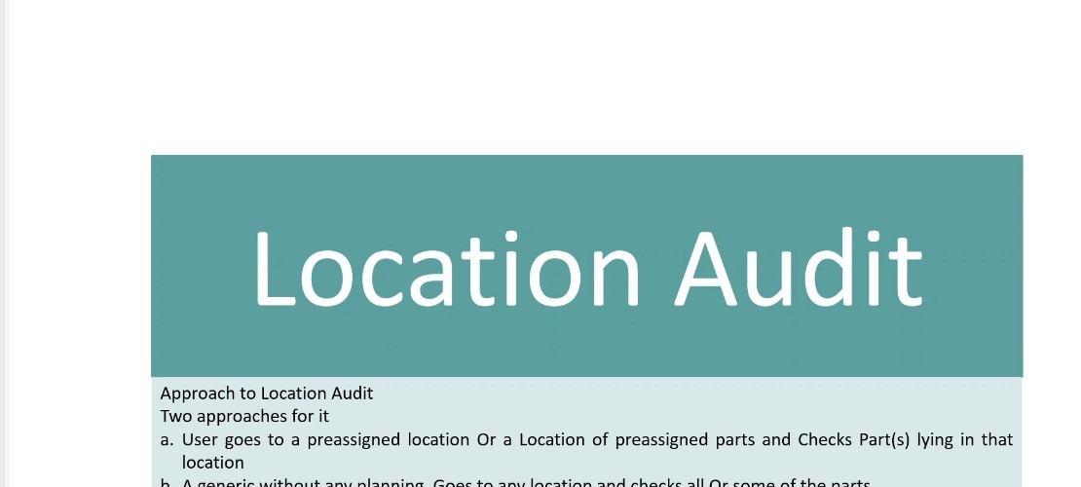
Figure 32.2a - Location Audit: the two approaches stated at the close of Session 06 - a planned audit against a preassigned location or preassigned parts, and a generic audit carried out without planning.

33. FR-030: Nature of Inward Transactions

33.1 Overview
Everything specified so far has assumed that goods arriving at the warehouse have been purchased from a supplier. That is only one of six reasons a consignment may arrive, and the reason matters: it determines who owns the goods, whether a payment is due against them, and what the consignment is reconciled against.
Purchase covers vendors of several natures - original equipment manufacturers, co-dealers, local suppliers and any other purchase. Branch transfer in covers movement between one warehouse and another within the same business. Sales return covers goods coming back from a customer, whether because the product was not up to standard or for any other reason. Workshop or in-house return covers parts issued for usage and not consumed - a workshop that drew five piston springs and used three returns the remaining two to the warehouse to be put back into stock.
Job work return covers goods coming back from an outward job work transaction. Where a repair requires welding, polishing or milling that the service centre is not equipped to perform, a job work identifier is raised, the item is sent out to a third party for the process, and it returns to the warehouse afterwards. The inward transaction exists so that the return leg can be monitored against the outward one.
Third party purchase is the one case in which the goods are not owned by the business at all. A contractor operating within the customer's premises - a painting contractor, for example, whose service the service centre does not perform itself - may store their own materials in space taken within the warehouse, on whatever commercial terms have been agreed. The ownership of that inventory remains entirely with the contractor, who draws on it themselves. It is recorded through the same inward process specifically so that contractor stock is kept separate from the business's own and the two do not mix.
Note: the ownership distinction is the one with the widest consequence. Third-party stock occupies warehouse locations and passes through the same gate entry, unloading and binning flows, but must never be counted as the business's inventory, valued in its stock reports, or included in a claim against a supplier.

Layman Description
Transaction Natures - Goods arrive for more reasons than purchases from suppliers, and each reason has to be treated differently by stock and by accounts. Stock coming from another branch is not a purchase and does not create a liability. A part returned by a customer goes back into stock but may need inspection first. A part coming back unused from the workshop is not new stock at all. Something returned from an outside contractor may have been worked on. If the system only understands purchases, everything else gets recorded as a purchase and the accounts are wrong from the start - or it gets recorded outside the system entirely, which is worse. The type is chosen at the gate, at the start, because it affects everything that follows.
Example: Four vehicles arrive in one morning: a supplier delivery, a transfer from the branch across town, a customer returning an unused alternator, and parts coming back from an outside machining shop. Each is recorded under its own type at the gate. The supplier delivery creates a payable, the branch transfer does not, the customer return is routed for inspection, and the machining return is matched against what was sent out.
Ownership Segregation - Not everything in a warehouse is owned by the business that runs it. Contractor-owned goods and customer property sit on the same racks as your own stock and must not be counted as yours. If the system does not distinguish them, they inflate the stock valuation, they appear in reports as available to sell, and eventually somebody sells one. Recording ownership at the point of receipt is what keeps the two apart, and it has to be at receipt because that is the only moment anyone knows. Once the goods are on a shelf they look identical to everything else, and nobody will be able to tell six weeks later which alternator belonged to whom.
Example: A contractor sends fifteen alternators to be held for a fleet job. They are received and marked as contractor-owned. They occupy rack D-02 alongside your own stock but do not appear in the stock valuation and cannot be picked for a normal sale. When the fleet job runs, they are issued against the contractor - and the month-end valuation is not fifteen alternators too high.
Downstream Integration - Recording the type of receipt is only useful if the rest of the business acts on it. A purchase has to create a payable, a branch transfer has to reduce stock at the sending branch, a customer return has to affect the original sale. If the warehouse records the type but accounts never see it, somebody has to be told separately - by email, or on a list at month end - and that is where things get missed. The question worth asking is not whether the field exists but whether it flows. A system where the storekeeper picks the right type and an accounts clerk then re-keys the same decision from a printout has the feature in name only, and has added a step rather than removing one.
Example: A branch transfer is received and marked as such. Accounts see it appear as a transfer with no payable raised, and the sending branch stock reduces automatically. Nobody sends an email and nobody re-keys anything. Where the flow is missing, the same receipt would sit in the warehouse system correctly typed while accounts, seeing only a goods receipt, raise a payable to a supplier who never sent anything.

33.2 Functional Requirements
FR-030.1: The system shall support six natures of inward transaction, selected at gate entry: purchase, branch transfer in, sales return, workshop or in-house return, job work return, and third party purchase.
FR-030.2: Purchase shall accommodate vendors of multiple natures, including original equipment manufacturers, co-dealers, local suppliers and other purchase sources.
FR-030.3: Branch transfer in shall cover the receipt of goods transferred internally from another warehouse within the same business.
FR-030.4: Sales return shall cover goods returned by a customer, and the system shall capture the reason for the return.
FR-030.5: Workshop or in-house return shall cover parts previously issued for usage and returned unconsumed, and the system shall capture the reason for the return and return the parts to stock.
FR-030.6: Job work return shall cover goods returning from an outward job work transaction, and shall be traceable against the job work identifier raised when the item was sent out.
FR-030.7: Third party purchase shall cover goods belonging to a contractor operating within the premises of the customer for the purpose of providing a service.
FR-030.8: For third party purchase the system shall record that ownership of the goods rests with the contractor and not with the business.
FR-030.9: Goods owned by a contractor shall be held distinctly from the business's own inventory and shall not be commingled with it, either physically in reporting terms or in stock valuation.
FR-030.10: The system shall record the ownership of incoming products as either owned by the business or owned by a contractor operating within the premises of the client.
FR-030.11: The nature of the transaction shall be available to downstream processes, so that reconciliation, payment and stock treatment can differ according to why the consignment arrived.

34. FR-031: Consignment Master Data, Categories and the Others Fallback

34.1 Overview
The master data that classifies an incoming consignment was set out in full during this session. Supplier categories are expected to include original equipment manufacturer, branch, co-dealer, co-distributor and local. Cartons are classified as multi-carton or single-carton consignments and as multi-SKU or single-SKU. Consignment carriers are transport, courier, own vehicle, individual external person and individual internal person. Products are classified as spare parts, accessories, lubricants, tyres, batteries, stationery, grocery and others. Consignments may be received against a goods receipt, an invoice, a challan, no document at all, or something else.
The product list reflects an intention wider than the current scope. The platform starts with automotive as its primary vertical, and once it has been proven there the intention is to extend to other verticals such as retail and e-commerce, which is why the classification already reaches beyond spare parts to stationery and groceries.
Every one of these lists ends in Others, and the reason is operational rather than tidiness. A category that has not been anticipated will eventually arrive, and if the classification is mandatory and offers no way through, the operator is stopped at the gate. Others provides the way through - but selecting it requires a description to be entered, because an Others bucket full of unlabelled entries cannot later be examined to find the categories that should have existed. With a description, recurring entries can be recognised and promoted into categories of their own.
Categories are defined by the administrator at user level, since in a multi-SKU environment the supplier and product categories that matter differ from one client to another. Retiring a category is handled by making it inactive rather than deleting it. An old vehicle model whose parts no longer move is of no further use going forward, but deleting the category would discard the history attached to it; making it inactive preserves the reference.
Note: the inactive-category mechanism has a data consequence that needs handling at the point of deactivation rather than afterwards. The user is asked where the existing records should go, and may either nominate a destination category or choose to leave them where they are, in which case the data stays against the closed category and remains reportable.

Layman Description
Master Data (FR-031.1 to .6) - Behind every dropdown on these screens is a list that has to be maintained - suppliers, transport companies, document types, categories of product. The lists themselves are unremarkable; what matters is who controls them. A warehouse that can add a new supplier or a new courier firm itself does so in five minutes when the need arises. A warehouse that has to raise a request with the software vendor waits days, and in the meantime the staff record the new supplier as Other, or pick the nearest wrong entry from the list, and the data quietly degrades. This is one of the most reliable indicators of whether a system will still be accurate after two years of use.
Example: The branch starts buying from a new supplier on a Monday. The administrator adds it to the supplier list that morning and the first delivery on Wednesday is recorded correctly. In a system where the vendor controls the list, the same delivery is recorded against Other or against a similar supplier name - and six months later nobody can produce an accurate purchase history for either of them.
Others Fallback - However carefully the categories are set up, something will arrive that does not fit any of them. If there is no way to record it, the operator picks the closest wrong answer and the data is corrupted silently. An Other option prevents that, but only if it demands a description. Other on its own is worthless - a year later there are four hundred receipts categorised as Other and no way to tell what any of them were. Other, plus a typed description, is genuinely useful: the receipt is recorded honestly, and reading through the descriptions periodically tells you which new categories actually need creating. It turns a gap in the data into a list of improvements.
Example: A supplier sends a specialist tool that fits none of the product categories. The operator picks Other and types diagnostic equipment. Over three months eleven receipts are recorded as Other, and seven of them are diagnostic equipment. The administrator creates that as a proper category, and the eleven honest Other entries have paid for themselves.
Master Data (FR-031.11; FR-031.12) - Two small conveniences that both reduce typing at the moment a new supplier is created. Entering the PIN code fills in the town and the state automatically, rather than leaving somebody to type them and occasionally get them wrong - which matters because addresses drive delivery and tax treatment. And category codes are generated by the system rather than invented by whoever is creating the record. Hand-typed codes are where duplicate and inconsistent supplier and category records come from: two people create the same category a week apart with slightly different codes, and from then on reports split across both. Neither feature is impressive on its own; together they are a good sign that the underlying records have been thought about.
Example: A clerk creates a new supplier and types PIN 411019. The town and state fill in on their own, correctly spelt. She saves and the system allocates the category code. A colleague creating a similar supplier the following week gets a consistent code rather than inventing a second one - and the supplier report at year end has one line per supplier rather than two.
Master Data (FR-031.13) - At the very start, the entire supplier list, part list and category list has to get into the system, and there are usually thousands of entries. Loading them from a spreadsheet takes an afternoon. Typing them takes weeks, is done under time pressure by whoever is available, and produces exactly the kind of errors that are hardest to find later - transposed part numbers, misspelt supplier names, duplicated entries. This is worth asking about even though it is a one-time activity, because the quality of that initial load determines how much the system can be trusted for its whole life, and because a system without bulk loading suggests the same thinking applies elsewhere.
Example: A dealer going live has 4,000 part numbers and 300 suppliers. With bulk upload, the existing lists are cleaned in a spreadsheet, loaded in one afternoon, and checked. Without it, three staff type for two weeks alongside their normal work - and eighteen months later people are still finding parts entered twice under slightly different numbers.
Lifecycle Control - Categories and master records fall out of use, but deleting them destroys history. If a supplier category is deleted, every past receipt recorded against it either breaks or silently loses its classification, and reports covering last year stop matching what they said at the time. Switching it off instead means it disappears from the dropdowns for new work while everything historic stays intact and readable. The other half is what happens to records still sitting under it: a good system asks where they should move to rather than leaving them orphaned. That question is easy to answer at the moment of the change and almost impossible to answer six months later.
Example: A dealer stops using a supplier category with 40 active parts under it. The administrator deactivates it rather than deleting, and the system asks where the 40 should go; she reassigns them to the correct category. New receipts no longer see the old one in the list. Last year's reports still show it, still add up, and still match the printed copies in the file.

34.2 Functional Requirements
FR-031.1: The system shall maintain a supplier category master, with values including original equipment manufacturer, branch, co-dealer, co-distributor and local.
FR-031.2: The system shall classify cartons as multi-carton or single-carton consignments, and as multi-SKU or single-SKU.
FR-031.3: The system shall maintain a consignment carrier master with the values transport, courier, own vehicle, individual external person and individual internal person.
FR-031.4: The system shall maintain a nature of products master with values including spare parts, accessories, lubricants, tyres, batteries, stationery, grocery and others.
FR-031.5: The system shall maintain a document type master covering goods receipt, invoice, challan, receipt without any document, and others.
FR-031.6: The workflow for consignment inward shall comprise consignment receipt recording, truck unload, consignment check for count and quality of packs inside the primary packing, and binning in the warehouse.
FR-031.7: Every classification list shall carry a default Others category, which shall remain at the end of the list.
FR-031.8: Where a product is received which is not covered by any defined category or by any name held in the master, it shall be classified against Others.
FR-031.9: Where Others is selected the user shall be required to enter a description of what the item is. The description shall be mandatory, so that recurring entries can subsequently be identified and promoted into categories of their own.
FR-031.10: Supplier categories and suppliers shall be defined at user level by the administrator, since the categories that apply differ from one user to another in a multi-SKU environment.
FR-031.11: Category codes shall be generated automatically whenever a new category is created.
FR-031.12: While creating a supplier, the state and city shall be populated from the PIN code using Post Office APIs.
FR-031.13: The system shall provide an option to upload the initial list of suppliers, products and supplier names from an Excel or CSV file, for implementation purposes.
FR-031.14: A category shall be capable of being made inactive rather than deleted, so that the historical data attached to it is preserved and remains available for reference.
FR-031.15: Inactive categories shall appear at the bottom of the list where the option to display all categories is selected.
FR-031.16: Where a category is made inactive, the user shall be required to indicate the category into which the existing data in the database is to be moved, or to choose Don't Move.
FR-031.17: Where Don't Move is chosen, the data shall remain in the database against the closed category and shall remain available for reporting purposes.
FR-031.18: Category and supplier master maintenance shall be provided on the web interface.
FR-031.19: The product classification shall accommodate verticals beyond automotive, since the platform is intended to extend to retail, e-commerce and other verticals after the automotive vertical is established.
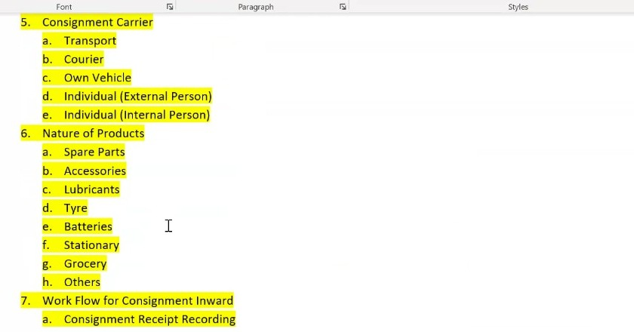
Figure 34.2a - BRD extract: the consignment carrier and nature of products classifications and the consignment inward workflow, each list terminating in an Others value.
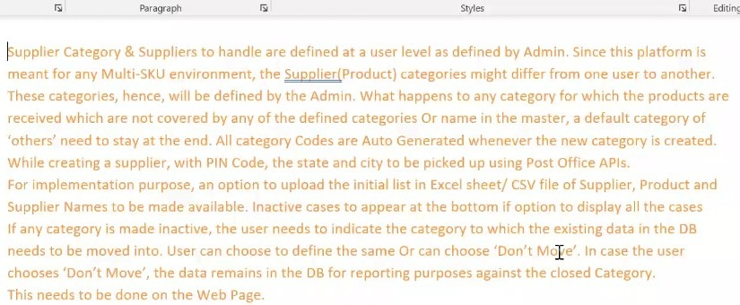
Figure 34.2b - BRD extract: supplier category and supplier handling defined at user level by the administrator, auto-generated category codes, PIN code lookup through Post Office APIs, bulk upload for implementation, and the treatment of inactive categories including the move or don't-move decision.

35. FR-032: Mobile and Web Channel Coverage

35.1 Overview
The BRD states twice that the gate entry module must be both mobile-based and web-based. The FRD as written describes a handheld application throughout, and no web or desktop surface is described anywhere in it. This is an architecture-level difference rather than a field-level one, and it needs resolving before screens are built on a mobile-only assumption.
The practical case is clearest at gate entry. Nothing is scanned at that point - a gate entry number is being raised for a consignment that has just arrived - and the person raising it may well be working at a desk on a laptop rather than on a handheld terminal on the floor. Elsewhere the opposite holds: scanning, condition capture and binning are done by an operator moving around the warehouse and are inherently handheld activities.
What is required is a screen-by-screen determination of which surface each screen is delivered on. Making that determination explicitly, rather than defaulting to one surface, lets each module be built for the way it is actually used.
Note: some screens will need both. The consignment check summary and the variance report are read by warehouse operations as much as by the operator who produced them, and a report that only exists on a handheld is difficult to review.

Layman Description
The work of a warehouse happens in two quite different places. Anything involving physically handling goods - scanning boxes off a truck, confirming a shelf, counting pieces - has to be on a handheld device, because the person doing it has his hands on the stock and cannot walk to a desk. Anything involving reviewing, deciding or configuring - looking at a queue of exceptions, assigning a location, running a report - is far better on a full screen where the whole picture is visible. A system that only exists on desktop forces operators to write things down and key them in later, which is where accuracy is lost. One that only exists on a handheld makes administration painful and reports unreadable.
Example: The unloading operator works entirely on a handheld: scanning, condition, photographs. The administrator works entirely on a desktop: the exception queue, location assignment, reports. The supervisor uses both - the handheld when walking the floor, the desktop when reviewing the day. Nobody is holding a phone to do a job that needs a keyboard, or standing at a desk for a job that needs to be done at the truck.

35.2 Functional Requirements
FR-032.1: The system shall explicitly support both a mobile application and a web-based application.
FR-032.2: The gate entry module shall be available on both the mobile and the web surfaces, in line with the BRD requirement.
FR-032.3: Each screen in the inward module shall be assigned to a delivery surface - mobile, web, or both - and the assignment shall be defined before build.
FR-032.4: The scenarios in which a mobile surface is specifically required and those in which a web surface is specifically required shall be identified, so that each module can be built appropriately.
FR-032.5: Screens which involve no scanning and are typically operated from a desk, such as gate entry, shall be available on the web surface.
FR-032.6: Screens which involve scanning, condition capture or physical handling shall be available on the handheld surface.

36. FR-033: Ship List Capture, Upload and Extraction

36.1 Overview
The ship list is the baseline against which unloading is reconciled - it states how many boxes and which items the truck should be carrying. In practice it arrives as a hard copy, which raises the question of how it reaches the system.
Three routes were discussed. The supplier may provide a soft copy, in which case the file is uploaded directly. Where only a hard copy exists, the operator may photograph each page through the device camera and the pages are assembled into a PDF. Failing both, the details may be keyed manually.
Manual keying is the least preferred of the three. A ship list for a substantial consignment runs to a long list of line items, and the likelihood of error in transcribing it by hand is high. The preference is for a PDF by either route, from which the system reads the document and extracts the line items into the master data tables.
Note: the uploaded ship list should remain viewable and replaceable after upload. A document photographed on the floor may turn out to be illegible, and the operator needs to be able to see what was captured and replace it without restarting the consignment.

Layman Description
Ship List Capture - The supplier packing list has to get into the system somehow, and there are two realities. Sometimes it arrives as a PDF by email before the truck does, in which case it can simply be uploaded. Often it arrives as a sheet of paper in the driver's hand and nothing else exists. Photographing it page by page with the device camera covers the second case, which is far more common than software vendors tend to assume. If only PDF upload is supported, then every paper packing list either gets typed in by somebody or, more likely, gets ignored entirely - and with it goes the independent expected quantity that makes a shortage claim stand up.
Example: One supplier emails a PDF packing list the night before; it is uploaded in seconds. Another sends a three-page printed list with the driver. The storekeeper photographs all three pages at the bay with the handheld. Both consignments now have an expected quantity recorded from the supplier's own document, and both can be checked properly.
Ship List Extraction - Getting the packing list into the system is only half the job; the numbers on it have to become usable data. Extraction reads the document and pulls out the individual lines - part numbers and quantities - so the system can compare them against what is actually found. The alternative is somebody typing thirty or forty lines while a driver waits, which mostly does not happen, and the list ends up stored as an image nobody ever compares anything to. The question worth asking is what happens when extraction gets it wrong, because it sometimes will: whether the operator can correct a misread line, and whether he is shown what was extracted before it becomes the expected quantity.
Example: A three-page list is photographed and the system extracts 34 lines totalling 214 pieces. Two lines are misread because the print was faint; the operator sees the extracted list on screen, corrects them against the paper, and confirms. Those 34 lines become the expected quantities for the check. Where extraction is not offered, the same list would sit on file as three photographs and the consignment would be checked against nothing.

36.2 Functional Requirements
FR-033.1: The system shall provide an option to upload the ship list for a consignment.
FR-033.2: The ship list shall be uploadable in PDF format, since the supplier is expected to be able to provide a soft copy in most cases.
FR-033.3: Where only a hard copy is available, the system shall allow each page to be captured through the device camera and shall assemble the captured pages into a PDF.
FR-033.4: The system shall read the uploaded or captured PDF and extract the line item details into the master data tables.
FR-033.5: Manual entry of the ship list details shall remain available, but shall be treated as the least preferred route because of the high likelihood of transcription error on a long list.
FR-033.6: An uploaded ship list shall remain viewable after upload, and shall be replaceable where the captured document is illegible or incorrect.
FR-033.7: The extracted ship list shall provide the expected box and item counts against which the truck unload is reconciled.

36.3 Screen Field Reference - Ship List Capture and Reconciliation
Note: these controls sit on the unload screen rather than on a screen of their own. The ship list is uploaded at the point it is needed - when the truck is about to be unloaded against it - and the reconciliation is visible in the same place.
Field | Control Type | Description
Shipment Details (Shiplist) | Upload panel | Shows the uploaded ship list file with its name and the date and time it was uploaded.
View / Replace | Actions | Opens the uploaded document for inspection or replaces it where the captured copy is illegible.
Shipment Information Unavailable | Warning banner | Displayed where no shipment document is available, stating that boxes cannot be reconciled against a list.
Expected Boxes | Table with view-all | The box references drawn from the extracted ship list, each shown against the document it belongs to and its current status.
Scan or Enter Primary Box | Scan field | Captures each box as it comes off the truck and matches it against the expected list.
Mismatch with Shiplist | Alert panel | Raised where a scanned box is not listed in the uploaded ship list, offering Set Aside or Add Document as the two ways forward.
WIP Status | Counter row | Total, unloaded, acceptable and not acceptable counts for the session in progress.
Unload Progress | Progress bar | Boxes unloaded against boxes expected, expressed as a percentage of the ship list.

37. FR-034: Warehouse Location Planning and Wave Picking (Forward-Looking)

37.1 Overview
A forward-looking capability was described towards the end of the session and is recorded here so that it is not lost, on the understanding that it sits beyond the current inward scope.
The intention is that the system should inform where products are placed rather than simply recording where they were put. If fast-moving products are known, they can be positioned in the early part of a picking route so that they are quick to reach, and the layout of the warehouse becomes something that is planned rather than inherited.
The same information supports picking. Rather than issuing an order to a single picker to walk the whole warehouse, the system can group work into waves and send several pickers out at once, each covering part of the order, so that the order is completed within its time window.
Note: this depends on movement data the system will only hold once it has been running for some time. It is a later-phase capability, but the location and binning data being captured now is what will make it possible.

Layman Description
Location Planning - Where a part is stored ought to depend on how often it is picked. Fast-moving items near the front and at waist height save a few seconds on every single pick, and across a year that is a substantial amount of walking. Slow-moving items can go to the back or up high. Doing this properly means the system watches how often each part actually moves and suggests relocating those in the wrong place. Most warehouses know this in principle and never act on it, because working out which parts to move requires data nobody has time to assemble. A system that produces the suggestion turns a good idea into something that actually happens.
Example: The system reports that a wiper blade picked forty times a month sits at the back of aisle D, while a part picked twice a year occupies a prime position by the door. It suggests swapping them. The change takes ten minutes and saves the picker a two-hundred-metre round trip forty times a month.
Wave Picking - Rather than picking one order at a time, several are grouped into a batch and collected in a single walk through the warehouse, with the system deciding the sequence so that the route runs in one direction rather than doubling back. On a large site this is the single biggest saving available in picking, because most of the time is spent walking rather than picking. It only makes sense above a certain size: in a small store where everything is within twenty metres, the batching overhead costs more than the walking it saves. Worth establishing not only whether a system offers it but at what size of operation it starts to be worth switching on.
Example: Six orders need eighteen parts between them, scattered across four aisles. Picked individually that is six separate walks. Batched, the system produces one route through the four aisles collecting all eighteen, then sorts them into the six orders at the packing bench. One walk instead of six.

37.2 Functional Requirements
FR-034.1: The system should support location planning informed by product movement, identifying fast-moving products and recommending where they are placed.
FR-034.2: Fast-moving products should be positioned early in the picking route so that they are quick to reach.
FR-034.3: The system should support wave-based picking, in which picking work is grouped and issued to several pickers at once so that an order is completed within its time window.
FR-034.4: The system should determine the direction and sequence in which a picking route is walked.
FR-034.5: The capabilities in this section are forward-looking and sit outside the current inward scope. They are recorded for scoping in a later phase.

38. FR-035: Role Hierarchy, Access Control and Audit Logging

38.1 Overview
The system is delivered to more than one kind of organisation and more than one kind of user within each, and the BRD sets out a role hierarchy accordingly. At the top sits the Sparecare solution administrator, who administers the platform itself. Beneath that sits the dealer administrator, who configures the system for their own organisation - which fields appear, which categories exist, which workflows apply, which permissions users hold. Beneath that sits the dealer user, who carries out the warehouse work.
The principle attaching to this hierarchy is that every action taken by any of these roles creates an auditable log. That was stated as a principle in the BRD but has not until now been set out in this document, even though individual requirements throughout it reference the dealer administrator configuring one thing or another.
The requirement is deliberately broad. Actions are to be logged for every person, not only for administrators and not only for configuration changes - the operational actions matter as much, since it is the operational record that is examined when a discrepancy is investigated.
Note: this section exists because the permissions were being specified one at a time as each screen was discussed - who may bin without a location, who may key a code manually, who may hide an expected quantity. Those are individual expressions of a single access control model, and the model itself needs to be defined before the individual permissions can be assigned coherently.

Layman Description
Access Control - Different people should be able to do different things. A gate guard needs to create arrivals and nothing else. An unloading operator needs to scan and record condition but has no business changing the supplier or category lists. A supervisor can override locations and permit manual entry. An administrator can define locations and change the underlying lists. The important question is not whether roles exist - almost every system claims them - but how finely they can be drawn and who controls them. If there are only two levels, user and administrator, then everybody who needs to do one supervisory task gets full administrative rights, and the control is decorative.
Example: A new operator joins and is given the unloading role: he can scan boxes and record condition, but the option to type in a location is not on his screen at all. His supervisor has that option, plus the ability to approve exceptions. Neither can add a supplier - that sits with the administrator. Three different screens for the same system, and nobody has rights they do not need.
Audit Logging - A record of who did what and when, kept automatically as people work. Which operator scanned a particular box, who changed a condition from OK to damaged, who overrode a location, who deactivated a category. Nobody looks at it most of the time, and that is the point - it is there for the day something has gone wrong and the question is not what happened but how. Without it, a stock discrepancy is a mystery that produces an argument. With it, it is a specific event with a time and a name attached, and the conversation is about fixing a process rather than about who is to blame. Worth asking how far back it goes and whether an administrator can alter it.
Example: A part is recorded in B-12-04 but is not there. The log shows it was scanned into B-12-04 at 11:42 by one operator, and that the record was edited at 16:10 by someone else who changed the quantity. The conversation becomes about why quantities were being edited at four in the afternoon, rather than five people insisting they did not touch it.

38.2 Functional Requirements
FR-035.1: The system shall implement a role hierarchy comprising, at minimum, the Sparecare solution administrator, the dealer administrator and the dealer user.
FR-035.2: The Sparecare solution administrator shall administer the platform across dealer organisations.
FR-035.3: The dealer administrator shall configure the system for their own organisation, including field visibility, category masters, workflow defaults and the permissions held by users at that dealer.
FR-035.4: The dealer user shall carry out warehouse operations within the permissions granted by the dealer administrator.
FR-035.5: All actions taken by any role shall create auditable logs. Logging shall not be confined to administrative or configuration actions.
FR-035.6: Audit logs shall record the action taken, the person who took it, and the time at which it was taken.
FR-035.7: The permission-gated behaviours specified elsewhere in this document shall be expressed as permissions within this access control model, including binning where no location exists (FR-026.15 and FR-026.16), manual entry of unscannable codes at binning (FR-027.14), manual entry of a bin location during unloading (FR-025.14), and hiding the expected quantity to bin (FR-026.17).
FR-035.8: The full role set, and the permissions attaching to each role, are to be defined before build.

39. FR-036: Terminology Standardisation and Field Naming

39.1 Overview
Two terminology corrections were made during the review, both of which apply across the whole document and the wireframes rather than to a single screen.
The first is the term Inward Code. It appears in several screen labels and drill-down descriptions as an alternative name for the gate entry number. There is no such thing as an inward code: there is only the gate entry number. The term is to be removed entirely rather than retained as a synonym, because carrying two names for one identifier means every reader has to work out whether they are the same thing.
The second is the Courier Type value recorded as Self-foot, which is not a mode of transport. It arose as a transcription artefact and has been withdrawn, with the value list aligned to the five values defined in the BRD.
Note: both corrections have been applied throughout this document, including in figure captions and field reference tables. They also need applying to the wireframes, where Inward Code appears as a screen label on several boards - the FRD and the wireframes will otherwise disagree with each other.

Layman Description
Over the life of a project the same thing gets called by different names - one screen says one word, the specification says another, and the wireframes a third. Nobody notices while the project is small, and by the time it is large every conversation starts with working out what the other person means. This settles on one word for each thing and applies it everywhere, so the screen, the specification and the people building it all use the same vocabulary. It is not a feature anyone uses; it is housekeeping that saves an argument a week once the system is live.
Example: The identifier created when a vehicle arrives was being called an inward code on some screens and a gate entry number on others, and new joiners assumed they were two different things. One term was chosen, and every screen, requirement and wireframe now uses it. A developer reading the specification and an operator reading the screen see the same word.

39.2 Functional Requirements
FR-036.1: The term Inward Code shall not be used. The identifier shall be referred to as the Gate Entry Number (GEN) throughout the system, the documentation and the wireframes.
FR-036.2: No synonym or alternative name shall be introduced for the gate entry number.
FR-036.3: Existing screen labels reading GEN / Inward Code shall be changed to Gate Entry Number (GEN).
FR-036.4: The Courier Type value Self-foot is withdrawn. The value list shall carry the five values defined in the BRD, per FR-001.20.
FR-036.5: Terminology corrections agreed in review shall be applied to the wireframes as well as to this document, so that the two do not diverge.

40. FR-037: Binning Location Exception Handling - Screens 16A to 16F

40.1 Overview
Binning assumes that the location recorded against a part can accept the stock being placed. In practice it often cannot. The location may have filled since it was last looked at, because stock moves in and out continuously and the operator has no view of what has happened there in the interim. The part may have no location defined in the master at all. Or the location may be full and the alternates recorded against the part may themselves be full.
The same three conditions arise in all three binning routes, and the same resolution applies in each: offer the alternate locations already mapped against the part, permit a location outside that list only where the user is authorised to enter one, and where neither is possible raise a request to the administrator so that the location is defined or corrected. The operator is never left holding stock with no route forward.
Whether a location is full is established by the operator at the location. The system does not hold the capacity of a location or how much of it is occupied, so it cannot determine this itself. The operator arrives, sees there is no space, and says so.
Note: these screens carry the labels Screen 13A/13B, 14A/14B and 15A/15B on the source boards. Screens 13A to 13D are already assigned to Case 2D in Section 27, and 14a, 14b and 15 to the binning routes in Section 30, so the source labels cannot be carried into this document without colliding. The exception handling screens are therefore numbered 16A to 16F here, and the boards are to be relabelled to match. See OI-076.

Layman Description
Location Exception Handling (FR-037.1 to .6) - The shelf the system sends you to is sometimes already full - stock moves in and out all day and the system does not know what has happened there since this morning. Rather than leaving the operator standing there, it offers the other shelves already approved for that part, and marks which of them have room. He picks one, scans it to confirm he is really there, and carries on. The two details that matter are whether the alternatives are shown immediately - as against him having to go back to a menu and start again - and whether the availability is shown, since a list of five alternatives with no indication of which are usable just means visiting them until one works.
Example: The operator arrives at B-12-04 with two brake discs and it is packed solid. The screen offers B-12-05, marked available, and B-13-01, marked full. He walks to B-12-05, scans it, and the system confirms binning will continue there. Total delay, about ninety seconds - against a walk back to the office to ask somebody.
Location Exception Handling (FR-037.7 to .9) - When none of the approved shelves will work, the last resort is to put the stock somewhere else entirely and type that location in. This is deliberately restricted, because it is the one action that puts stock in a place the system was never told about. Whether an operator can do it should depend on his role: an experienced storekeeper choosing a sensible overflow shelf is reasonable, a new man picking somewhere at random is not. Whoever does it, the location chosen is recorded, and recorded specifically as a manual choice rather than a normal placement. That flag is what lets a supervisor review it afterwards and either approve the location properly or move the stock before it is forgotten.
Example: Every approved shelf for a bulky bumper is full. A senior storekeeper is permitted to enter another location, types D-01-07, and the stock is recorded there and flagged as manually chosen. The next morning the supervisor reviews the flagged entries, agrees D-01-07 is sensible for bumpers, and adds it to the approved list - so the next one is not an exception at all.
Location Exception Handling (FR-037.10 to .12) - A part with no shelf defined anywhere cannot simply be put down and forgotten. The operator puts it in a temporary place, records where, and raises the question with an administrator. The important half is what happens to the rest of his work: he sets that one item aside and carries on with everything else on the trolley. A system that blocks the whole trolley until the question is answered turns one unknown part into an operator standing idle and eleven other parts still unstored. The temporary location is recorded rather than left informal, so when the administrator answers an hour later the stock can be found and moved rather than hunted for on the floor.
Example: A new part arrives with no location in the system. The operator puts it on the overflow rack, records that as temporary, and sends a request to the administrator. He then finishes the other eleven items on his trolley normally. At 3 pm the administrator assigns C-04-05, the operator is notified, and he moves the one part across. Nothing waited except the item that genuinely had to.
Location Exception Handling (FR-037.13; FR-037.14) - Every one of these exceptions - a full shelf, a typed-in location, an alternative chosen, a request raised - is written to a record that can be looked at afterwards. Individually each is trivial and nobody would review them. In aggregate they are the most useful diagnostic a warehouse manager has, because they show where the system's picture of the warehouse has drifted away from the warehouse itself. A location that is full every week is under-allocated. A part that raises a request every time it arrives has never been set up properly. An operator typing locations far more than his colleagues either has a broken scanner or a habit worth asking about. None of that is visible from the individual events.
Example: Over a month the log shows 62 exceptions. Nineteen are the same location being full, twelve are the same three parts having no location defined, and eight are one operator entering locations manually. Three specific fixes come out of that: reallocate one rack, set up three parts properly, and check one scanner - and the following month the count falls to eleven.

40.2 Functional Requirements
FR-037.1: The system shall provide location exception handling at the point of binning in all three binning routes: binning by product (Screens 16A and 16B), binning by location (Screens 16C and 16D) and direct binning (Screens 16E and 16F).
FR-037.2: The system shall recognise three exception conditions: the mapped location is full; no alternate mapped location is available; and no bin location is defined for the part.
FR-037.3: A location shall be treated as full when the operator declares it full at the location. The system shall not infer fullness, since the capacity of a location and the space remaining in it are not held (see Section 42).
FR-037.4: Where the mapped location is full, the system shall display the alternate locations recorded against the part, each marked as available or full, and shall allow the operator to select an available one.
FR-037.5: The selected alternate location shall be scanned and confirmed at the bin in the same way as a primary location, as required by FR-027.5, before the placement is recorded.
FR-037.6: On confirmation the system shall state that binning will continue at the alternate location, so that the operator has positive confirmation before placing the stock.
FR-037.7: Where no alternate mapped location is available, the system shall offer entry of a location outside the mapped list and notification of the administrator.
FR-037.8: Entry of a location outside the mapped list shall be permitted only where the user holds the corresponding permission, consistent with the role-based control at FR-026.14 to FR-026.16 and the manual entry permission at FR-027.14.
FR-037.9: Where a location outside the mapped list is used, the system shall record the location chosen so that the master can be corrected against it.
FR-037.10: Where no bin location is defined for the part, the system shall offer entry of a temporary location and the raising of a request to the administrator.
FR-037.11: A request raised to the administrator shall carry a request identifier, the part, the reason for the exception, the user raising it and its status, and the operator shall be shown this summary at the point of raising it.
FR-037.12: The operator shall be able to set the item aside and continue binning the remainder of the cart while a request is outstanding. Binning shall not be blocked at the cart level by a single unresolved item.
FR-037.13: All exceptions, manual entries, alternate locations chosen and administrator requests shall be captured in the audit trail.
FR-037.14: Direct binning shall follow the same exception handling as the cart-based routes, without cart formation.

40.3 Screen Field Reference - Screens 16A & 16B (Binning by Product)
Note: Screen 16A is the binning by product screen in its exception state, and Screen 16B the exception handling panel it opens. Field descriptions in blue italic are analyst-generated.
Field / Section | Control Type | Description
Select Cart for Binning | Dropdown | The cart being binned. Carries through from cart assembly.
Part No. / Product Description / Pack Size | Read-only display | The part currently being placed, retrieved from the product master.
Fragile / Binning Zone | Read-only display | Fragile indicator and the zone the part belongs to, so the operator knows how to handle it and roughly where it goes.
Recommended Location | Read-only display | The location mapped against the part. Shown with a full indicator when it cannot accept the stock.
Alternate Locations | Read-only list | Other locations mapped against the part, offered when the recommended location is full.
Location full warning | Inline alert | States that the recommended location is full and that another action must be chosen before binning.
Quantity to Bin | Stepper | The quantity being placed. Carried from the cart line.
Verify Location / Confirm Product | Scan actions | The location and product scans required at the bin by FR-027.5 and FR-027.7.
Use Alternate Location | Action button | Accepts an available alternate location and continues binning there.
Enter Other Location | Action button | Entry of a location outside the mapped list. Available only where the user is authorised.
Notify Admin | Action button | Raises the condition to the administrator without stopping the operator.
Enter Temporary Location | Action button | Records a holding location where the part has no location defined in the master.
Send Request to Admin | Action button | Raises a request for the location to be defined or corrected.
Request Summary | Read-only panel | Request identifier, reason, requester and status, shown at the point the request is raised.
Save / Finish | Buttons | Save records progress without closing the item; Finish completes it, per FR-027.12.
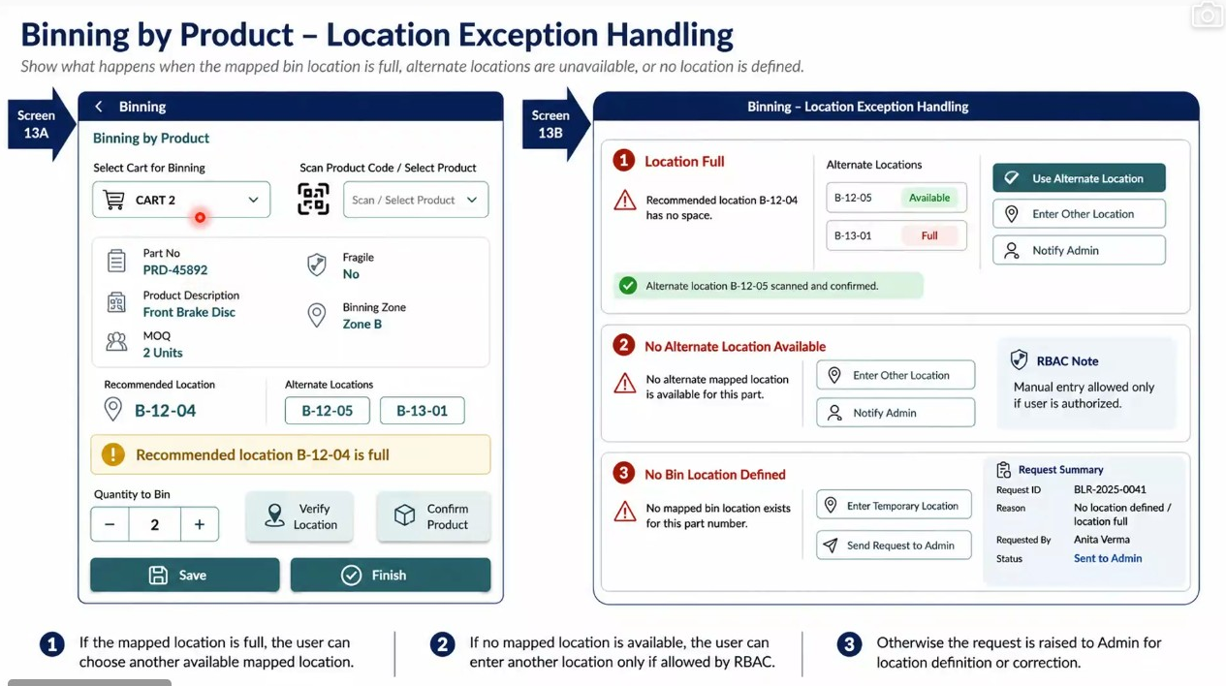
Figure 40.3a - Screens 16A and 16B: binning by product with the recommended location full, the mapped alternates marked available and full, and the three exception states with their permitted actions

40.4 Screen Field Reference - Screens 16C & 16D (Binning by Location)
Note: the location-wise route reaches the same three conditions from the opposite direction - the operator is already at the location when it fills. Only the fields that differ from Screens 16A and 16B are listed.
Field / Section | Control Type | Description
Current Location Sequence | Read-only display | Position of the current location within the sequence of locations the cart must visit, per FR-027.20.
Go to Location / Scan Confirm Location | Text and scan | The location the operator is directed to and the scan confirming arrival.
Location verified | Confirmation state | Positive confirmation that the scanned location matches the expected one.
Quantity to Bin / Actual Binned | Read-only and entry | Expected against placed, recorded separately per FR-027.23.
Next Product (Queued for Current Location) | Read-only panel | The next product from the cart destined for this same location, per FR-027.21.
Next product blocked warning | Inline alert | States that the queued product cannot be binned at the current location because it is full, per FR-027.22.
Current Location / Alternate Mapped Locations | Read-only lists | The full location and the mapped alternates with availability, offered in State 1.
Manual relocation note | Inline note | States that where manual relocation is used the chosen location is recorded for correction, per FR-037.9.
Audit trail note | Inline note | States that exceptions, manual entries, chosen alternates and admin requests are captured in the audit trail, per FR-037.13.
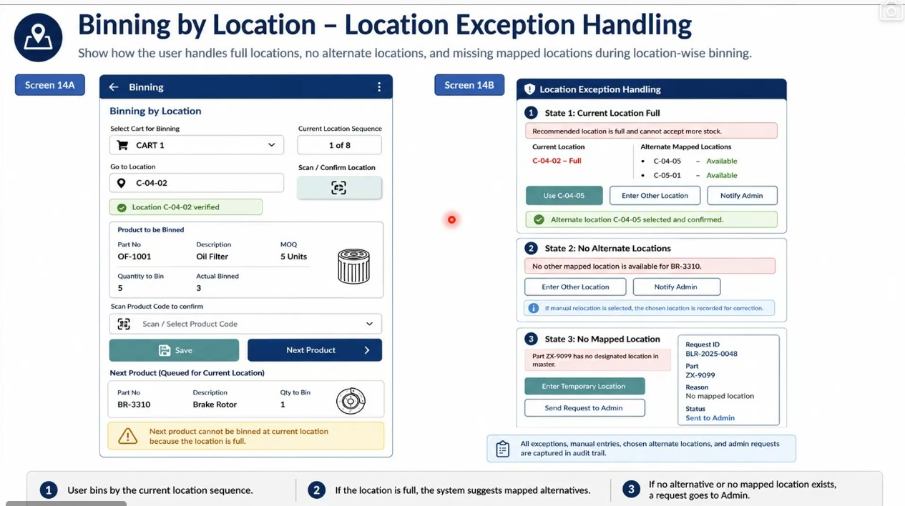
Figure 40.4a - Screens 16C and 16D: binning by location with the current location sequence, the queued next product blocked by a full location, and the three exception states

40.5 Screen Field Reference - Screens 16E & 16F (Direct Binning)
Note: direct binning reaches the same three conditions without a cart. Only the fields that differ are listed.
Field / Section | Control Type | Description
Product Code | Scan or select with delete | The single product being placed. No cart selection precedes it.
Location full warning | Inline alert | States that the recommended location is full and that another action must be chosen before binning.
Binning Zone / Recommended Location / Alternate Locations | Read-only display | Zone and locations mapped against the product, with the recommended location marked full where it cannot accept stock.
Scan / Confirm Location and Scan / Confirm Product | Scan actions | The same two confirmations required in the cart-based routes.
Confirm No. of Packs | Stepper | Number of packs placed, in place of the cart quantity.
Location scanned confirmation | Confirmation state | States that direct binning will continue at the alternate location.
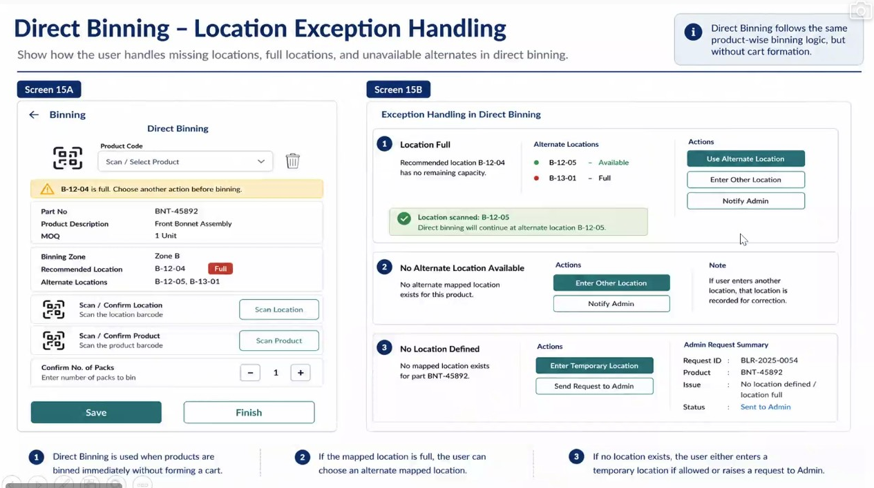
Figure 40.5a - Screens 16E and 16F: direct binning of a single product without a cart, with the same three exception states and the same permitted actions

41. FR-038: Binning Location Exception Queue - Administrator - Screen 17

41.1 Overview
Every request raised under Section 40 arrives in a single administrator queue. The administrator sees what could not be binned and why, defines or corrects the location, and releases the operator to continue. Until that happens the stock is standing somewhere unrecorded, so the queue exists to keep that period short and visible rather than to file the exceptions.
The administrator can do more than answer the immediate request. Where the part has no location in the master, the location decided here can be written back to the master so that the next consignment of the same part does not raise the same exception. Where the answer is provisional, the request can be marked as pending a master update and the operator allowed to bin temporarily in the meantime.

Layman Description
Administrator Exception Queue (FR-038.1 to .6) - Every request an operator raises arrives on one screen for an administrator to deal with. It shows the total waiting and breaks it down by type - no location defined, location full, no alternatives available - because those three need different responses and it helps to see the shape of the backlog before opening anything. Filters by zone, supplier, priority and status let one person work a particular area or clear the urgent ones first, and a search by part number or request reference handles the case where somebody rings up about a specific item. The reason this screen matters is that every request on it represents stock standing somewhere temporary. The queue exists to keep that period short and visible, not to file the problems away.
Example: The administrator opens the screen at 9 am: 18 open requests - 7 no location defined, 6 location full, 5 no alternatives. She filters to zone B, clears the four there in ten minutes, then works the high-priority ones across the other zones. By 10 am the count is down to six, and four operators who were blocked have been released.
Administrator Exception Queue (FR-038.7 to .11) - From the same screen the administrator gives the part a proper home, specifying it down through the warehouse structure - zone, then sub-zone, then rack, then the position on the rack - rather than typing a free-text location that may or may not exist. The second and more valuable part is saving that decision back into the part records permanently. Answering the immediate request unblocks one operator today. Writing it back means the next consignment of that part goes straight to the shelf with no exception at all. Without the write-back the same request is raised every time the part arrives, and the administrator answers the same question every month for years.
Example: A part has raised the same no-location request on three consecutive deliveries. The administrator assigns Zone B, sub-zone 2, rack 12, position 04, and ticks update the part records. The operator is released immediately, and when the part arrives again six weeks later it shows B-12-04 on the screen at cart assembly. The request is never raised again.
Administrator Exception Queue (FR-038.12 to .15) - When the administrator has decided, the operator who raised the request is told automatically - he does not have to keep checking, and he is not left waiting for a phone call. That closes the loop properly: raised, answered, resumed. There is also a middle option for when the answer is provisional. The administrator can permit the stock to be put away temporarily while the permanent location is still being worked out, and mark the request as awaiting a proper decision. Without that middle path, everything has to be either fully resolved or left blocked, and in practice somebody will make an unrecorded decision on the floor to keep the work moving.
Example: At 3 pm the administrator assigns a location and clicks notify. The operator gets a message saying the part now has a home and he can put it away. For a second request she is not yet sure where the part belongs long term, so she permits temporary binning on the overflow rack and marks it pending a proper decision - the stock is off the floor and recorded, and the question stays open on her list rather than being quietly dropped.

41.2 Functional Requirements
FR-038.1: The system shall provide an administrator screen presenting all location exceptions raised during binning.
FR-038.2: The queue shall show counts of open requests and of requests by exception type: no location defined, location full, and no alternatives available.
FR-038.3: The queue shall be filterable by exception type, zone, supplier, priority and status, and searchable by part number and request identifier.
FR-038.4: Each request in the queue shall show the request identifier, part number, description, quantity, recommended location, exception type, the cart it was raised from, the user who raised it, the time it was raised and its status.
FR-038.5: Request status shall distinguish at minimum open, pending review and resolved.
FR-038.6: Requests shall carry a priority, so that the administrator can work the queue in order of urgency rather than in order of arrival.
FR-038.7: Selecting a request shall present its detail: part, product description, pack size and quantity to bin, binning zone, the currently suggested location, the exception, the binning route and cart it was raised from, and the user and time it was raised.
FR-038.8: The administrator shall be able to define a primary location and alternate locations for the part, specifying zone, sub-zone, rack and location.
FR-038.9: The administrator shall be able to record a reason or remark against the decision.
FR-038.10: The administrator shall be able to permit temporary manual binning for the request, so that the operator can place the stock before the master is settled.
FR-038.11: The administrator shall be able to write the decided location back to the part-location master, so that the exception does not recur for the same part.
FR-038.12: The administrator shall be able to publish the location and notify the user, and the user shall be notified that the part now has a defined location and that binning can proceed.
FR-038.13: The administrator shall be able to mark a request as pending a master update where the location given is provisional.
FR-038.14: The queue shall record the resolution, the resolving user and the date and time against each request.
FR-038.15: The exception workflow shall be presented as three stages: the exception is raised during binning, the administrator defines or updates the location, and the user resumes binning.

41.3 Screen Field Reference - Screen 17 (Binning Location Exception Queue)
Note: Screen 17 is the administrator view. It is a web screen rather than a handheld one, consistent with the channel assignment in Section 35. Field descriptions in blue italic are analyst-generated.
Field / Section | Control Type | Description
Exception Type / Zone / Supplier / Priority / Status | Dropdown filters | Narrow the queue to a subset of requests. All default to All.
Search Part No. / Request ID | Search field | Direct retrieval of a known request or of every request against a part.
Open Requests / No Location Defined / Location Full / No Alternatives | Summary counters | Volume by exception type, giving the administrator the shape of the backlog before opening anything.
Location Exception Requests | Table | The queue itself. Columns: Request ID, Part No., Description, Qty, Recommended Location, Exception Type, Current Cart, Raised By, Time, Status.
Recent / WIP Requests | Side list | Recently raised or in-progress requests with their priority, for direct access without filtering.
Request Details | Read-only panel | Full detail of the selected request, including the binning route it was raised from and the cart number.
Primary Location / Alternative Locations | Selection controls | The location the administrator assigns to the part and any alternates to be mapped alongside it.
Zone / Sub-Zone / Rack / Location | Selection and entry | The location hierarchy through which the assignment is specified.
Capacity / Available Space | Numeric entry | Space available at the location. Present on the board but not yet agreed as in scope - see Section 42 and OI-075.
Reason / Remarks | Text entry | The administrator’s note against the decision, retained with the request.
Allow temporary manual binning | Checkbox | Permits the operator to place the stock before the master is settled, per FR-038.10.
Update part-location master | Checkbox | Writes the decided location back to the master so the exception does not recur, per FR-038.11.
Save & Publish Location | Primary action | Commits the assignment and makes it available to the operator.
Notify User | Action button | Tells the user who raised the request that binning can proceed.
Mark Pending Master Update | Action button | Flags the request as answered provisionally, pending a master change.
Exception Workflow | Process indicator | The three stages defined at FR-038.15, shown so the administrator can see where the request stands.
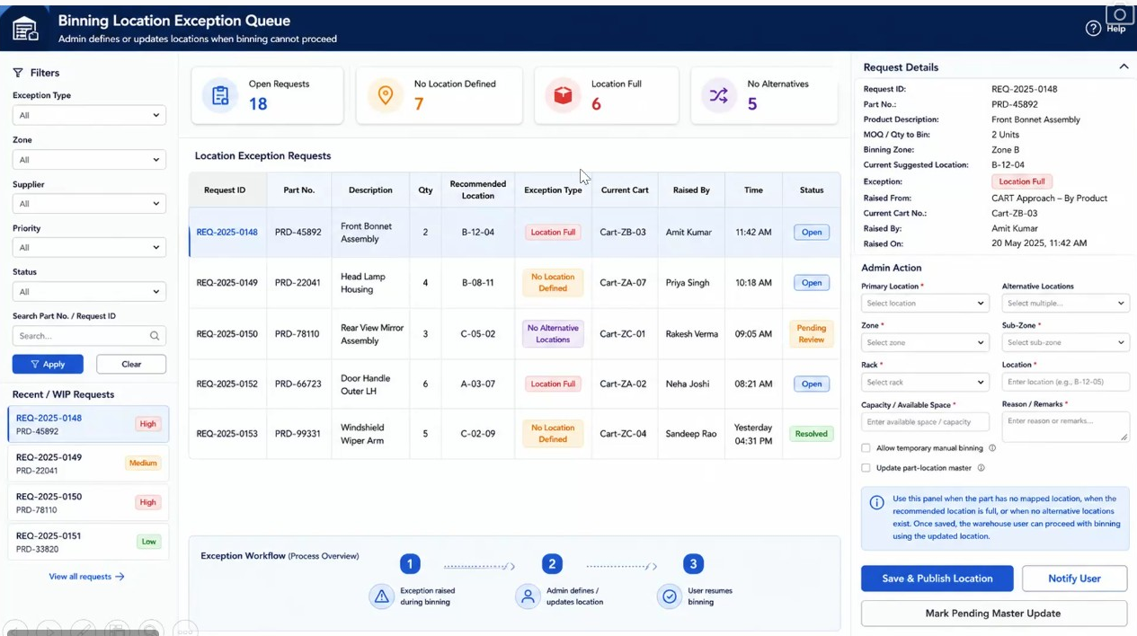
Figure 41.3a - Screen 17: the administrator exception queue with counts by exception type, the request table, the request detail and admin action panel, and the three-stage exception workflow

42. FR-039: Location Recommendation and Alternate Location Rules

42.1 Overview
The binning screens present a recommended location and a set of alternates. The basis on which those are derived has not been defined, and the session established that it must be before the screens can be built.
Two bases were discussed. The first is history: where parts of this kind have been placed before, so that the next consignment goes where the last one went and the alternate follows the same pattern. The second is proximity: recommending the location nearest to where the operator already is, so that a cart carrying several parts is worked in a route that moves forward rather than doubling back. The second matters because the operator is walking a cart around a warehouse, and a recommendation that sends them five rows back costs real time.
Both depend on knowing whether a location can take the stock, and the system does not hold that. Location capacity and the space remaining in a location are not captured today. If they were, a full location would never be recommended and the exception handling in Section 40 would arise far less often. Capturing them was described as an added-value capability a dealer might ask for rather than as part of the current scope.
Current practice fills the gap informally. Warehouse staff place stock where they can see space, and an experienced operator carries a working knowledge of the racking that the system has no access to. It varies between dealers and it changes over time.
Note: no rule is specified here because none was agreed. What is recorded is the requirement that the rules be defined, the two candidate bases put forward, and the position on capacity. OI-074 tracks the derivation rules and OI-075 the capacity question, including the Capacity / Available Space field that appears on the Screen 17 board ahead of any agreement that capacity is in scope.

Layman Description
Location Fullness - Whether a shelf is full is decided by the person standing in front of it, not by the system. The system does not know how much space a location has or how much of it is used, so it cannot work this out - and pretending otherwise would produce confident wrong answers. The operator sees there is no room and says so. What matters is how he says it. It should be a single tap, not a form: these are people working quickly with gloves on and often with limited literacy, and anything requiring typing will be skipped in favour of squeezing the stock in somewhere it does not belong. The moment he declares it full, the alternatives should appear immediately rather than sending him back to a menu.
Example: The operator arrives at C-04-02 with five oil filters and there is no room at all. He taps the full marker once - no typing, no explanation required. The alternatives appear on the same screen straight away, he picks C-04-05, and he is putting stock away within fifteen seconds of arriving at a shelf he could not use.
Recommendation Rules - The system suggests where a part should go, but the basis for that suggestion is a design decision with real consequences, and it is worth asking directly rather than accepting that a recommendation appears. There are two sensible approaches. History-based means sending the part where parts like it have gone before, which keeps the warehouse consistent and predictable. Proximity-based means sending the operator to the nearest suitable shelf, which matters because he is walking a trolley and a suggestion that sends him five rows back costs real time on every trip. Neither is obviously right and many systems do neither, simply showing a location that was typed in once and never reviewed.
Example: An operator with a trolley of twelve parts is in aisle B. A proximity-based system finishes aisle B first, then C, then D - one loop. A history-based system might send him B, D, B, C in the order the parts were loaded, adding several minutes per trolley and a good deal of walking across a shift. Ask which it does, and ask to watch a trolley being worked.

42.2 Functional Requirements
FR-039.1: The rules by which a recommended location is derived shall be defined before the binning screens are implemented.
FR-039.2: The rules by which alternate locations are derived and ordered shall be defined on the same basis.
FR-039.3: Location capacity and remaining space are not captured by the system in the current scope. The recommendation shall not depend on them unless and until they are.
FR-039.4: A location shall be recorded as full only on the declaration of the operator at the location, as established at FR-037.3.
FR-039.5: Where the operator declares a location full, the system shall present the alternate locations for the part immediately, without requiring the operator to navigate away and return.
FR-039.6: The means by which the operator declares a location full shall be a single control requiring no typing, so that it remains usable by staff working at speed and by staff with limited literacy.

43. FR-040: Forward-Looking Binning Enhancements

43.1 Overview
Four capabilities were discussed at length and none was agreed. They are recorded here because the reasoning against them is as useful as the ideas themselves, and because the same suggestions will otherwise be made again.
The first is a site map view: a schematic of the warehouse showing where the operator is, where the recommended location lies and where the alternates lie. Not satellite navigation and not a dynamic route, but a plan view the operator can read. Its value depends entirely on the size of the site. In a warehouse of several floors and long corridors an operator can genuinely lose their way; at a dealer with open ground and a single storeroom it would be an overkill.
The second is voice interaction. On the floor, instruction passes verbally between a supervisor and the operator, and none of it reaches the system. The proposal was to capture that exchange - the operator states where stock has been placed, or asks where to place it, and the system records it. The objections were practical. Warehouse staff speak many languages and accents, and a system that mishears is worse than no system. The counter-example offered was parcel delivery, where the courier completes three or four simple actions and voice plays no part. The conclusion reached was that usability decides it: a capability that is not used has no value, whatever its sophistication.
The third is cart tracking: the operator starts a cart, and its movement becomes visible to a supervisor in the way a ride in progress is visible to a dispatcher. The fourth is cart splitting, where the stock on one cart is placed across two locations because no single location can take it all.
Note: none of these is specified as a requirement. They are recorded as capability candidates with the reasoning attached, following the treatment of location planning and wave picking in Section 37. The session closed with these to be reviewed with a senior stakeholder before the location audit work begins.

Layman Description
Navigation Aids - A plan of the warehouse on the device showing where the operator is, where the shelf he needs is, and where the alternatives are. Not turn-by-turn navigation and not a live moving map - just a readable layout, the way a shopping centre directory shows you where you are standing. Its value depends almost entirely on the size of the site. In a warehouse with several floors and long corridors, a new operator genuinely does get lost and this saves real time. In a dealer's store with one room and open ground, it is an overkill that nobody would open twice. Worth asking whether a competitor offers it and, more usefully, which of their customers actually switch it on.
Example: A new operator on his third day is sent to F-02-14 in a warehouse covering three floors. The plan shows him he is on the wrong floor and where the stairs are. He gets there in two minutes instead of ten minutes and asking two people. In a single-room store the same operator can see every shelf from where he is standing.
Voice Interaction - Speaking to the system rather than typing - telling it where stock has been placed, or asking where something should go, with the answer coming back by voice. The attraction is obvious: the operator has his hands full and a device in his pocket. The difficulty is language. Warehouse staff speak many languages and many accents, and a system that mishears is worse than no system, because a wrong location entered confidently is harder to find than no entry at all. The comparison worth making is with parcel delivery, where the courier completes three or four simple taps and voice plays no part - simplicity beat sophistication. If a competitor offers this, the question is whether it is genuinely used.
Example: An operator with an armful of parts says he has put a bracket in C-04-05 and the system records it. It works well for him. A colleague with a different regional accent is misheard twice in a morning, records stock in the wrong location once, and reverts to typing. The feature exists and half the shift has stopped using it - which is a Partial, not a Yes.
Cart Tracking - A supervisor being able to see, on a screen, which trolleys are out on the floor and what stage each has reached - in the way a dispatcher watches vehicles on a map. On a large site this answers questions that are otherwise answered by walking around: is anyone free, has that urgent putaway been done, why has trolley 3 not moved for forty minutes. It becomes worth having roughly at the point where the supervisor can no longer see the whole floor from where he stands. Below that size it is a screen showing him what he can already see out of the window, and it will not be looked at.
Example: At 11 am the supervisor sees five trolleys active. Four are moving through their locations normally. Trolley 3 has not moved since 10:20 - the operator hit a full shelf and is waiting on an exception. The supervisor resolves it from his desk without anyone having walked over to find him.
Cart Splitting - Where a trolley carries more stock of one part than any single location can take, the operator splits it across two places and the system keeps track of both. Without it he faces three bad options: force the stock in where it does not fit, carry the remainder back to the bay, or put it somewhere else and not record it. The last is the most likely and the most damaging. This is closely related to the exception handling for full locations, and the two are worth asking about together - a system that handles a full shelf but cannot split a quantity has only solved half the problem.
Example: An operator carries thirty brake discs for B-12-04, which will take eighteen. He records 18 there and the system asks where the remaining 12 are going; he takes them to B-12-09 and records those. Stock shows 18 and 12 in two locations, which is what a person walking the aisle would count.
Cart Composition - At present the operator decides what goes on a trolley - usually whatever came off the truck together. The system could instead decide, grouping parts so that one trolley serves one area of the warehouse rather than sending the operator to six aisles. The saving is in walking, and on a large site it is considerable. It also changes who needs to know the warehouse: at the moment an experienced operator loads a sensible trolley because he knows the layout, and a new one loads a poor trolley and walks twice as far. Having the system group them makes the new operator as efficient as the experienced one on his first day.
Example: Twenty parts come off a truck for eight different aisles. Loaded by hand they go onto two trolleys in the order they were unloaded, and each trolley visits six or seven aisles. Grouped by the system, the same twenty parts go onto three trolleys covering two or three adjacent aisles each - more trolleys, but far less walking, and no knowledge of the layout required.

43.2 Capability Candidates
FR-040.1: A schematic site map showing the operator position, the recommended location and the alternate locations is recorded as a candidate capability. It shall be scoped by site size rather than offered universally.
FR-040.2: Voice capture of instruction and confirmation on the warehouse floor is recorded as a candidate capability, subject to demonstrated usability across the languages and accents in actual use.
FR-040.3: Cart movement tracking, giving a supervisor visibility of carts in progress, is recorded as a candidate capability.
FR-040.4: Splitting the contents of a cart across more than one location where no single location can accept it is recorded as a candidate capability.
FR-040.5: System-directed cart composition, in which the system determines which parts are grouped onto which cart so that a cart serves a single area, is recorded as a candidate capability. Cart composition is currently determined by the operator.
FR-040.6: None of the capabilities in this section is in scope for the current phase. Each shall be assessed against the operating reality of the site before it is committed.

44. Open Issues & Action Items
The following open issues and action items were identified across Sessions 01 to 07:

From Session 01:
ID | Priority | Description | Owner
OI-001 | Medium | Field-level mandatory vs optional configuration mechanism to be confirmed - whether set at dealer-admin level via settings screen or per OEM brand profile | Sparecare Product Team
OI-002 | Medium | Full list of OEM-specific document types (ship list variants, GRN formats) to be compiled for brand-level configuration mapping | Naveen / Santosh
OI-003 | Low | Finance Advice step (Step 8) scope to be confirmed in a subsequent session | Sparecare Product Team
OI-004 | Low | Confirmation required on whether WMS will integrate with all DMS platforms or only specific DMS vendors | Naveen / Santosh
OI-005 | Low | Operational Excellence and Perpetual Audit sub-modules to be presented in a subsequent session | Santosh

From Session 02:
ID | Priority | Description | Owner
OI-006 | High | Invoice auto-population from OEM ship list / GRN backend data (per brand configuration) - exact brands and data feed formats to be confirmed | Naveen / Santosh
OI-007 | Medium | Open Delivery process definition - specific steps, documentation requirements, and system recording obligations to be documented in a subsequent session | Sparecare Product Team
OI-008 | Medium | Audio / video note capture for box condition evidence - feasibility on handheld terminals to be confirmed (planned feature, not in current wireframe) | Santosh
OI-009 | Medium | SKU-level search within unloading status check (box-to-part mapping) - depends on availability of box manifest data at item level per brand | Naveen / Santosh
OI-010 | Low | Handheld terminal device specifications (supplier, model, screen size, ruggedness standard) to be shared by Sparecare for UI sizing and interaction design | Naveen
OI-011 | Low | Unloading WIP Status refresh strategy - confirm whether manual refresh is acceptable long-term or whether a push-update mechanism should be planned | Sparecare Product Team
From Session 03:
ID | Priority | Description | Owner
OI-012 | High | Reconciliation of ordered quantity against quantity actually received is not captured during unloading. Confirm that the delta is established at Consignment Check when boxes are opened, and define where the shortfall is reported and to whom. | Naveen / Santosh
OI-013 | High | Box ownership cannot be verified where no ship list and no supplier code exist - a part consignment may carry boxes belonging to another consignee. Confirm the process for identifying and returning a box found not to belong to the dealer. | Naveen / Santosh
OI-014 | Medium | Manual part number entry is required on the binning screen where the part is not scannable, for example where packing has been removed and the number written by hand. To be added to the Screen 8c design. | Santosh
OI-015 | Medium | Wrong Location handling conflates two distinct situations - the operator is at the wrong place, and the allocated bin is full. Confirm whether a separate space-not-available response with relocation guidance is required. | Naveen / Sparecare Product Team
OI-016 | Medium | Scan-per-unit versus scan-once-with-count during binning is to be configurable at dealer level. Confirm the default and whether it varies by product category. | Sparecare Product Team
OI-017 | Medium | Update Product Condition and Update Box Condition appear as separate controls on Screen 8b. Confirm whether both are required at the secondary stage and, if so, how their outputs differ. | Santosh
OI-018 | Low | Bin capacity management - capture of bin dimensions, volume and permissible weight to support placement guidance and stacking rules. Confirmed as a later release, outside Phase 1 scope. | Sparecare Product Team
OI-019 | Low | Geolocation confirmation of bin placement for dealers with fixed surveyed locations. Confirmed as a longer-term capability, outside Phase 1 scope. | Sparecare Product Team
From Session 04:
ID | Priority | Description | Owner
OI-020 | High | Screen numbering requires reconciliation before wireframe build. Session 04 re-presented the direct-to-bin family as Screens 8A to 8D, having been introduced in Session 03 as Screens 8a to 8c, and introduced Screens 9a and 9b alongside Screens 9A, 9B and 9C for the same Case 1B flow. A single numbering convention is to be agreed. | Santosh
OI-021 | Medium | Where the primary-and-secondary-are-the-same flag is captured - gate entry, consignment details or product master - is to be confirmed. Agreed in session that it must be optional rather than mandatory. | Naveen / Santosh
OI-022 | Medium | Wrong location versus relocation for lack of space. Agreed in Session 04 to retain a single wrong-location treatment for now and revisit once the distinction can be determined reliably. Refines OI-015. | Sparecare Product Team
OI-023 | Medium | Insurance claim workflow. The process for raising, evidencing and tracking a claim against a unit set aside as damaged is not yet defined beyond the point of segregation. | Sparecare Product Team
OI-024 | Medium | Confirm Location is to be replaced by a Select Location dropdown per FR-011.13. The source of the location list, and whether it is restricted to the recommended and alternative locations or open to any bin, is to be confirmed. | Naveen / Santosh
OI-025 | Low | Efficient binning route. Sequencing of the bin-later queue so that a picker is not sent from one end of the warehouse to the other was raised as a factor beyond location correctness. Acknowledged as a later optimisation. | Santosh
OI-026 | Low | Bin occupancy-based location recommendation confirmed as a chargeable additional service dependent on capture of bin volume and dimension data. Reinforces OI-018. | Sparecare Product Team
OI-027 | Low | Check Carton process is referenced as the destination for cartons that fail direct binning but has not yet been specified. To be covered in a subsequent session. | Santosh

From Session 05:
ID | Priority | Description | Owner
OI-028 | High | The multi-SKU consignment check board is headed Direct to BIN, which does not describe the flow. The heading is to be corrected before the wireframes are built, as this flow is a consignment check and not direct binning. | Santosh
OI-029 | Medium | Whether the Box / Units Check status table is required on Screen 11b. It reports quantity counts only and does not identify which SKU was short or which was found acceptable, and that is knowable only once the whole carton has been finished. | Naveen / Santosh
OI-030 | Medium | A sample ship list is to be shared as a soft copy, with the customer name redacted, so that the structure of the uploaded data and the field mapping into the system can be understood. | Naveen Chauhan
OI-031 | Medium | A consolidated case matrix is to be prepared across the three defining dimensions - scanning availability, location availability, and the primary to secondary relationship - so that every combination can be reviewed for completeness and any missing scenario identified before build. | Santosh
OI-032 | Medium | Video recording of carton opening. The trigger point, the retain-or-delete prompt, the storage policy and the retention period are to be confirmed, together with the device capability required on the handheld terminal. | Naveen / Santosh
OI-033 | Medium | Case 2D, covering open delivery where secondary cartons sit inside the primary cartons, was deferred at the end of this session and is to be walked through in the next session. | Santosh
OI-034 | Low | The field labelled MOQ is to be relabelled across all screens as quantity per pack size, since it denotes the number of units in one sale pack and not a minimum order quantity. | Santosh
OI-035 | Low | Screens 10E to 10H (Case 1D) are referred to by analyst-assigned numbers in this document because the source board labels those panels by title only. The Case 2A screens, previously numbered 12a to 12c here, were confirmed as Screens 11A to 11C in Session 06 and have been corrected. To be reconciled under OI-020. | Santosh

From Session 06:
ID | Priority | Description | Owner
OI-036 | High | Cart details are presented as a flat list of part, quantity and location. It was agreed that the structure must be cart, then bin location, then the parts and quantities going to that location, since one cart can serve more than one bin location. To be reflected in the final mockups. | Santosh
OI-037 | Medium | Location scanning at cart assembly is to be removed. At the cart the operator defines where an item is going; the location scan belongs at the bin as the confirmation that the correct place has been reached. Screens 12a and 12b to be amended, retaining product scanning at the cart. | Santosh
OI-038 | Medium | Cart capacity is a physical constraint held outside the system. Confirm whether any guidance or warning is required - for example around fragile items and stacking - or whether the judgement remains entirely with the operator. | Naveen / Santosh
OI-039 | Medium | Unique scan code generation for non-unique secondary codes. The level at which this is configured - by SKU, by product category or by supplier - is to be confirmed, together with who is permitted to configure it. | Sparecare Product Team
OI-040 | Medium | Expected product quantities uploaded at gate entry level would allow consignment-level variance to be reported in Cases 2B and 2C. Confirm whether this is in scope for phase 1 and how such a report would be requested. | Naveen / Santosh
OI-041 | Medium | Workflow stepper showing the stage a consignment has reached, with time spent at each stage. Agreed as desirable rather than mandatory; to be scoped for a later release. | Sparecare Product Team
OI-042 | Medium | Traceability of system-assisted actions - stickers generated, unique scan codes created and manual entries accepted. Agreed as good to have; to be scoped for a later release. | Santosh
OI-043 | Medium | Email notification at defined workflow stages was acknowledged and deferred. The stages, triggers and recipients are to be defined. | Naveen / Santosh
OI-044 | Medium | Location Audit. Two approaches were stated at the close of the session - a planned audit against preassigned locations or parts, and a generic audit without planning. Detailed requirements are to be captured in a subsequent session. | Santosh
OI-045 | Medium | Session 06 was presented with Naveen Chauhan present for the first part only. A repeat walkthrough of the remaining content was requested, with any corrections to be communicated back afterwards. | Santosh
OI-046 | Low | Screen numbering. Session 06 confirms Case 2A as Screens 11A to 11C and introduces Screens 12a, 12b, 13a, 13b, 14a, 14b and 15 for the Binning module. Sections 22 and 24 describe the same screen numbers at different fidelity and are to be reconciled under OI-020. | Santosh

From Session 07 (Part 1 of 4):
ID | Priority | Description | Owner
OI-047 | High | Mobile and web surface assignment. Each screen in the inward module is to be assigned to a delivery surface before build. The FRD currently describes a handheld application only, against a BRD that mandates both for gate entry. (GAP-02) | Naveen / Santosh
OI-048 | High | Gate Entry Number generation logic is not yet defined. The format, the sequence and whether it is unique per business unit or across the business are to be confirmed. | Sparecare Product Team
OI-049 | Medium | Third party purchase. How contractor-owned stock is segregated in reporting, stock valuation and physical location, and whether storage charges levied on the contractor are to be handled in this system, are to be confirmed. | Naveen / Santosh
OI-050 | Medium | Ship list extraction. The accuracy expected from PDF extraction, the handling of extraction failures, and whether a manual review step is required before the extracted list becomes the reconciliation baseline, are to be defined. | Sparecare Product Team
OI-051 | Medium | Reason codes for manual entry at binning. The list of permitted reasons is to be agreed - at minimum no sticker present and product nature prevents scanning - together with who maintains it. (GAP-09) | Santosh
OI-052 | Medium | Scan compliance reporting. The level at which the scan against manual split is reported - by consignment, by operator, by supplier or by period - is to be defined. (GAP-09) | Naveen / Santosh
OI-053 | Medium | Consignment carrier value reconciliation. The BRD lists five carrier values and the FRD's Courier Type field carries four. The mapping is to be confirmed so that no value is lost. (GAP-13) | Santosh
OI-054 | Medium | Role hierarchy and RBAC. The BRD's role hierarchy was being reviewed when the extract was cut off. The full role set and the permissions attaching to each are to be captured. (GAP-14) | Naveen / Santosh
OI-055 | Medium | GAP-01 of the gap register was not reached during this session and is to be walked through in a subsequent part. | Santosh
OI-056 | Medium | Payment advice to finance for goods received on post-receipt payment terms was listed in the BRD but not discussed in detail. The trigger, the content and the interface to finance are to be defined. | Naveen / Santosh
OI-057 | Low | Hiding the expected quantity to bin from the operator is an administrator option in the BRD. Whether it is set globally, per supplier or per product is to be confirmed. (GAP-12) | Santosh
OI-058 | Low | Warehouse location planning and wave picking were described as later-phase capabilities. They are to be scoped separately once movement data is available. | Sparecare Product Team

From Session 07 (Part 2 of 4):
ID | Priority | Description | Owner
OI-059 | High | Wireframes carry the label 'GEN / Inward Code' on several boards. The term is withdrawn and the boards are to be updated to read 'Gate Entry Number (GEN)' so that the wireframes and the FRD agree. | Santosh
OI-060 | High | Full role set and permission matrix. The three roles identified - Sparecare solution administrator, dealer administrator, dealer user - are to be extended to the complete set, and every permission-gated behaviour in this document mapped to a role. (GAP-14) | Naveen / Santosh
OI-061 | Medium | Audit log scope and retention. What is logged, at what granularity, how long logs are retained and who may view them are to be defined. | Sparecare Product Team
OI-062 | Medium | Modules 2 to 5 were described at overview level only in the earlier sessions, and the detail beneath each was not walked through. Each module is to be gone through in its own right before those phases are specified. | Santosh
OI-063 | Medium | The BRD document circulated earlier is believed to be incomplete - further features were added after it was sent. The current version is to be shared so that the gap analysis is run against the correct baseline. | Santosh
OI-064 | Medium | A further function was requested in the transport section of the consignment carrier definition but was not specified during the session. The requirement is to be stated. (GAP-13) | Santosh
OI-065 | Low | Review process. Analyst-generated blue italic descriptions are to receive an initial filtering pass before review, so that the review meeting concentrates on substantive requirements rather than on correcting inferred field descriptions. | Saurabh / Santosh
From Session 07 (Part 3 of 4):
ID | Priority | Description | Owner
OI-066 | High | Precedence between the three box counts is unstated. The document now carries an indicative count at gate entry (FR-001.12, FR-001.21), an expected count at Receipt Details (No. of Boxes in GEN, FR-004.2) and an extracted ship list count (FR-033.7). Where two or three are present and disagree, which governs reconciliation, and what is recorded against the others, is to be decided. | Sparecare Product Team
OI-067 | Medium | Retention and visibility of the retrospective unloading status lookup. FR-006.8 now keeps the lookup available after the unload session closes. How far back the history is queryable, and which roles may query it, are to be settled. | Sparecare Product Team
OI-068 | Medium | Retrospective retrieval of box-level condition. Raised as the case where a workshop reports a damaged box after unloading has closed and asks whether the damage was recorded. Described in session as a rare scenario and deferred; the status search deliberately does not carry it. Whether a separate condition-history lookup is warranted is to be decided. | Santosh
OI-069 | High | Wireframe correction - Screen 6b. The board still renders Update Box Condition, Mark for Open Delivery and Take Photo on the Check Unloading Status search. These have been removed from the section 9.4 field reference per FR-006.25 and the board is to be redrawn as a read-only search. | Santosh
OI-070 | Medium | Wireframe correction - Screen 5A. The Select GEN lookup is drawn as a separate panel carrying supplier name, receipt date and invoice capture fields. Per FR-005.10 and FR-005.11 it is to be redrawn as a search panel or overlay within Screen 5A offering search criteria only. The same board also carries the withdrawn label Pick Inward Code, which falls under OI-059. | Santosh
OI-071 | Medium | Provenance marking of highlighted text. Passages highlighted during review as BRD-derived were observed to originate in some cases from the session transcripts rather than the BRD. These are to be cross-checked against the transcripts and re-marked so the source of each requirement is distinguishable. | Santosh
OI-072 | Medium | Binning quantity entry - truncated. At 32:05 the session turned to the binning cart and the extract ends mid-point: scanning the product or entering the product code, and in place of scanning the same item repeatedly, adding it or entering a value directly. The requirement is not reconstructed here and is to be completed from Part 4. Relates to Section 29 (FR-026). | Santosh
OI-073 | Low | Representation of the two gate entry stages. Section 4.6 records that gate entry comprises admission against minimal detail followed by consignment detail capture at the unloading dock. Whether the Inward Process Steps list at section 3.2 should show these as distinct sub-stages is to be decided. | Sparecare Product Team
From Session 07 (Part 4 of 4):
ID | Priority | Description | Owner
OI-074 | High | Derivation rules for recommended and alternate locations are undefined. Two bases were put forward - past placement history for the part, and proximity to the operator so that a cart is worked without doubling back. Neither was adopted. Required before the binning screens can be implemented (FR-039.1, FR-039.2). | Sparecare Product Team
OI-075 | High | Location capacity is not captured, but the administrator board carries a Capacity / Available Space field. The session stated capacity and remaining space are not held today and would be added value if a dealer asked for them; it was also agreed that if they were held, a full location would never be recommended. Whether the field is in scope for the administrator screen only, or out of scope entirely, is to be decided. | Sparecare Product Team
OI-076 | High | Screen numbering for exception handling. The source boards label these screens 13A/13B, 14A/14B and 15A/15B, colliding with Case 2D (Screens 13A to 13D, Section 27) and with the binning routes (Screens 13a, 13b, 14a, 14b and 15, Section 30). They are numbered 16A to 16F in this document and the administrator queue is numbered Screen 17. The boards are to be relabelled to match. Extends OI-046. | Santosh
OI-077 | Medium | Means of declaring a location full. Agreed that the operator declares it rather than the system inferring it. A single no-typing control was discussed, including a pictorial indicator for staff with limited literacy. The control has not been designed (FR-039.6). | Santosh
OI-078 | Medium | Voice and NLP interaction on the warehouse floor. Discussed at length and not adopted. The deciding objection was usability across the languages and accents actually spoken by warehouse staff. To be reviewed with a senior stakeholder before any commitment (FR-040.2). | Santosh
OI-079 | Medium | Schematic site map view. Recorded as a candidate scoped by site size - of value in large multi-floor warehouses, an overkill at a dealer with open ground and a single storeroom. Whether it is offered, and to which customers, is to be decided (FR-040.1). | Sparecare Product Team
OI-080 | Low | Cart splitting across locations and cart movement tracking. Both raised as candidates and neither assessed. Cart splitting has a bearing on the exception handling in Section 40, since splitting is one response to a location that cannot take the whole quantity (FR-040.3, FR-040.4). | Sparecare Product Team
OI-081 | Medium | System-directed cart composition. Currently the operator decides what goes on a cart. Grouping parts so that a cart serves a single area was raised as a future capability and would change how cart assembly in Section 29 works (FR-040.5). | Sparecare Product Team
OI-082 | Medium | Session close: the binning exception handling and the forward-looking capabilities are to be reviewed with a senior stakeholder before the location audit work in Section 32 is taken forward, on the grounds that the exception handling adds considerable complexity. | Santosh

