RESEARCH PAPER
Factory-to-Customer Shipping Route Efficiency Analysis
Nassau Candy Distributor
Prepared as part of a 15-day logistics analytics project. Dataset: 10,194 shipment records across 5 factories, 4 ship modes, 4 regions, and 59 states/provinces.

1. Executive Overview
Nassau Candy Distributor operates as a national distributor, shipping candy products from five factories to customers across the United States. This research paper analyzes 10,194 shipment records spanning 15 products, four shipping modes, and customer locations across 59 states and provinces, to answer a single operating question: which factory-to-customer shipping routes are efficient, and which are not?
The analysis defines a route as a Factory-to-Region or Factory-to-State pairing, builds route-level performance metrics, benchmarks routes against each other, and identifies geographic and ship-mode patterns in delivery performance. A significant data quality issue was discovered during cleaning and is reported transparently in Section 5, with its implications carried through every subsequent finding.

2. Background and Problem Statement
In distribution operations, shipping efficiency directly affects customer satisfaction, operational cost, and the company's ability to scale. Despite holding rich order and shipment data, Nassau Candy Distributor lacked route-level efficiency intelligence: there was no clear visibility into which factory-to-customer routes were consistently efficient, which experienced frequent delays, how shipping performance varied by region, state, and ship mode, or where operational bottlenecks existed geographically. Without this visibility, logistics optimization decisions were necessarily reactive rather than data-driven. This project builds that visibility from the ground up.

3. Data Overview
The dataset contains 10,194 shipment-level records across 18 original fields, covering Order Dates from January 2024 through December 2025. Each record represents one product line within one customer order, including order/ship dates, ship mode, customer location, product details, and financial figures (sales, cost, gross profit).

3.1 Reference Data
Two small reference tables, provided separately from the transactional data, were used to enrich every shipment record with its originating factory: a Factory coordinate table (5 factories, each with latitude/longitude) and a Product-to-Factory mapping (all 15 products map cleanly to exactly one of the 5 factories, with zero unmapped records).
Factory | Products Made | Shipments in Dataset
Lot's O' Nuts | 3 Chocolate products | 5,692
Wicked Choccy's | 2 Chocolate products | 4,152
Secret Factory | 3 products (Sugar/Other) | 217
The Other Factory | 2 products (Sugar/Other) | 100
Sugar Shack | 5 Sugar/Other products | 33

Note the heavy concentration of shipment volume in two factories (Lot's O' Nuts and Wicked Choccy's account for over 96% of all shipments) — this imbalance is itself relevant context for interpreting later route comparisons, since routes from smaller factories naturally have far less data to benchmark against.

4. Methodology
The analysis followed five sequential stages: (1) data cleaning and validation, (2) feature engineering to derive Shipping Lead Time and route categories, (3) route-level aggregation by Factory-to-Region and Factory-to-State, (4) efficiency benchmarking and ranking, and (5) ship-mode and geographic bottleneck analysis. All route-level metrics were built using groupby aggregation in pandas, with a normalized 0-100 Route Efficiency Score calculated by rescaling average lead time between the fastest and slowest route in each grouping.

5. Data Quality Findings
Data cleaning surfaced one major, dataset-wide issue and one secondary geographic labeling issue. Both are reported here in full because they directly affect how subsequent results should be interpreted.

5.1 Ship Date / Order Date Inconsistency (Major Finding)
Calculating Shipping Lead Time as Ship Date minus Order Date produced an average of 1,321 days, with a minimum of 904 days and a maximum of 1,642 days. These figures are not operationally plausible for a candy distributor. Investigation showed that Order Date values cluster entirely within 2024–2025, while Ship Date values cluster entirely within 2026–2030 — a clean five-year-plus separation between the two fields, affecting 100% of the 10,194 records, not a small subset of bad rows.
Because the issue is systemic rather than isolated, rows could not simply be filtered out — there is no unaffected subset to fall back on. The analytical decision made was to flag Lead Time as directionally reliable but not reliable in absolute terms: the data remains useful for comparing routes against one another (relative ranking), but individual day-counts should not be quoted as literal shipping durations. This judgment is supported by the fact that the spread in average lead time across all 20 Factory-to-Region routes (approximately 425 days, from 1,091 to 1,517) is substantially smaller than the absolute magnitude of the values (approximately 1,300 days) — consistent with a roughly uniform date-corruption pattern rather than one concentrated in specific routes. Every table in this report and the accompanying dashboard carries this caveat.

5.2 Country / Province Mismatch (Secondary Finding)
184 of 10,194 records (1.8%) list a Canadian province (e.g. Ontario, Alberta, British Columbia) in the State/Province field while Country/Region is recorded as "United States" for every row in the dataset. These records were flagged rather than removed, and are excluded specifically from the US-states geographic map in the dashboard while remaining included in all other route, state, and ship-mode tables.

5.3 Other Validation Checks (Clean Results)
The dataset showed zero missing values across all 18 original fields, zero fully duplicated rows, zero records with non-positive Sales, Units, or Cost values, and zero mismatches between the Gross Profit field and its expected formula (Sales minus Cost). This indicates the order-capture and financial-recording systems are reliable, even though the shipment-date logging system is not — a useful and specific finding for any technical follow-up.

6. Exploratory Data Analysis
Grouping all 10,194 shipments by Factory and Region produced 20 distinct routes; grouping by Factory and State produced 196 distinct routes, reflecting the full breadth of Nassau Candy's customer geography relative to its five factories.
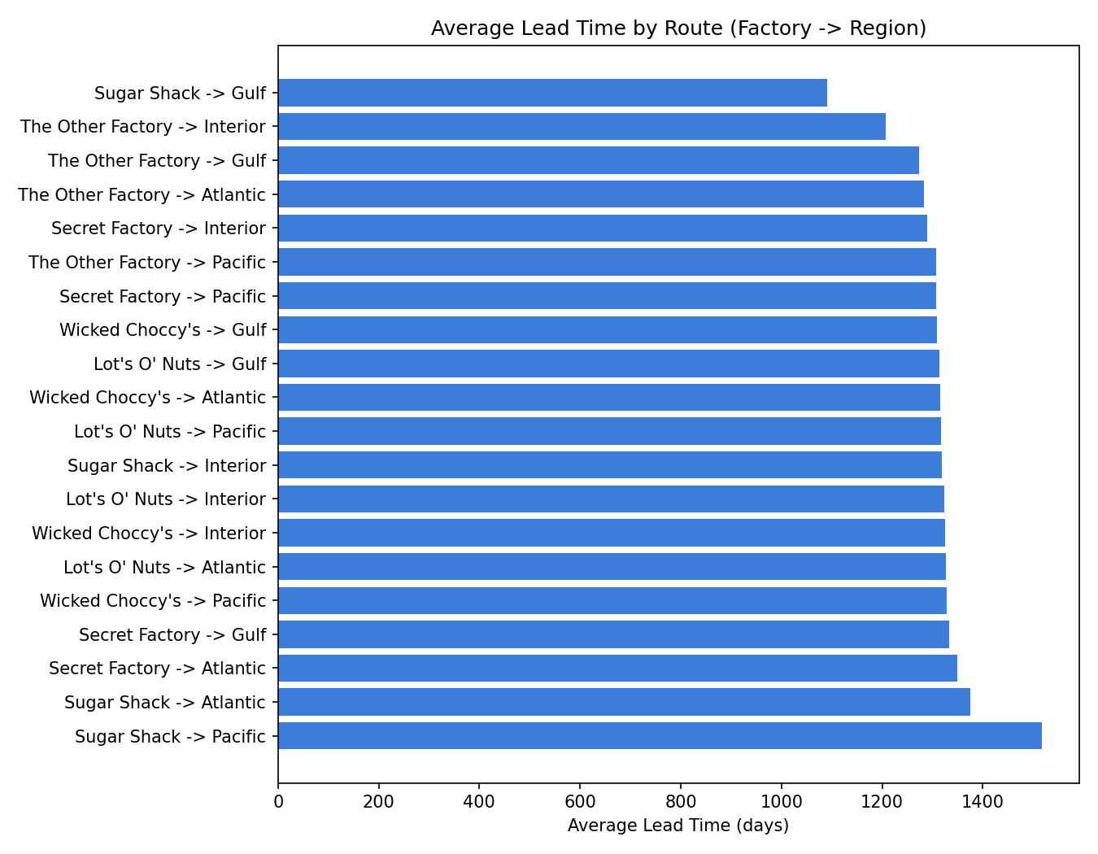
Figure 1. Average Lead Time by Route, all 20 Factory→Region routes, sorted fastest to slowest.
Even accounting for the Section 5 data quality caveat, a clear relative pattern emerges: routes originating from the two largest, highest-volume factories (Lot's O' Nuts and Wicked Choccy's) cluster tightly in the middle of the distribution, while the smaller factories (Sugar Shack, The Other Factory, Secret Factory) show more spread — both the fastest and slowest individual routes belong to lower-volume factories, which is consistent with smaller sample sizes producing more variable averages.

7. Route Efficiency Benchmarking
Ranking all 20 Factory→Region routes by average lead time and rescaling to a 0–100 Route Efficiency Score (100 = fastest route, 0 = slowest route) produced the following top and bottom performers.
Rank | Route | Shipments | Avg Lead Time (days) | Efficiency Score
1 | Sugar Shack -> Gulf | 4 | 1,091 | 100.0
2 | The Other Factory -> Interior | 11 | 1,207 | 72.9
3 | The Other Factory -> Gulf | 19 | 1,273 | 57.4
4 | The Other Factory -> Atlantic | 38 | 1,283 | 55.0
5 | Secret Factory -> Interior | 45 | 1,289 | 53.5

Rank | Route | Shipments | Avg Lead Time (days) | Efficiency Score
16 | Wicked Choccy's -> Pacific | 1,342 | 1,329 | 44.1
17 | Secret Factory -> Gulf | 37 | 1,333 | 43.3
18 | Secret Factory -> Atlantic | 72 | 1,349 | 39.4
19 | Sugar Shack -> Atlantic | 18 | 1,375 | 33.2
20 | Sugar Shack -> Pacific | 3 | 1,517 | 0.0

Caution is warranted on the extremes of this ranking: the #1 (Sugar Shack -> Gulf) and #20 (Sugar Shack -> Pacific) routes are based on only 4 and 3 shipments respectively. These rankings are directionally informative but statistically fragile. Among routes with substantive shipment volume (100+ shipments), the high-volume Lot's O' Nuts and Wicked Choccy's routes to all four regions cluster closely together (ranks 8–16), suggesting consistent, if unremarkable, performance across the company's main shipping lanes.

8. Ship Mode Analysis
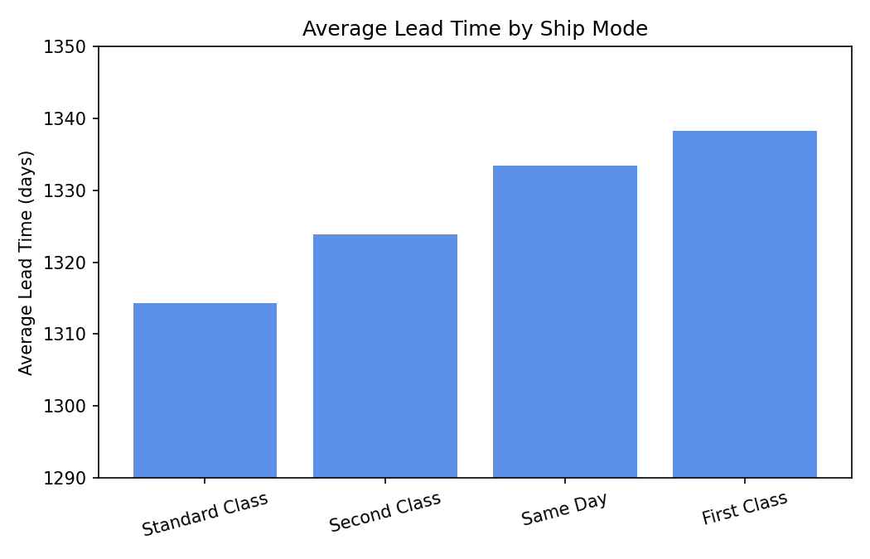
Figure 2. Average Lead Time by Ship Mode (y-axis truncated to show relative differences clearly).
Ship Mode | Avg Lead Time (days) | Shipment Count | Avg Sales
Standard Class | 1,314 | 6,120 | $13.97
Second Class | 1,324 | 1,979 | $14.08
Same Day | 1,333 | 547 | $13.00
First Class | 1,338 | 1,548 | $13.77

Counter to typical assumptions about premium shipping tiers, Standard Class shipments showed the lowest average lead time among all four modes, while First Class showed the highest. Grouped into Standard (6,120 shipments) versus Expedited — Second Class, First Class, and Same Day combined (4,074 shipments) — Expedited shipments averaged 1,331 days versus 1,314 days for Standard, a difference of roughly 17 days in the direction opposite to what "expedited" implies.
Given the Section 5 data quality finding, this should not be read as proof that expedited shipping is literally slower. It should be read as: no reliable speed advantage for premium shipping tiers was found in this dataset, and the Ship Date field would need to be corrected at the source before a stronger claim could be made either way. This is itself an actionable finding — see Section 11.

9. Geographic Bottleneck Analysis
A state was classified as a bottleneck if its total shipment volume AND its average lead time both exceeded the median value across all states — meaning it combines high customer impact (many shipments) with comparatively poor delivery performance. Using this definition, 17 of 59 states/provinces were flagged as bottlenecks.
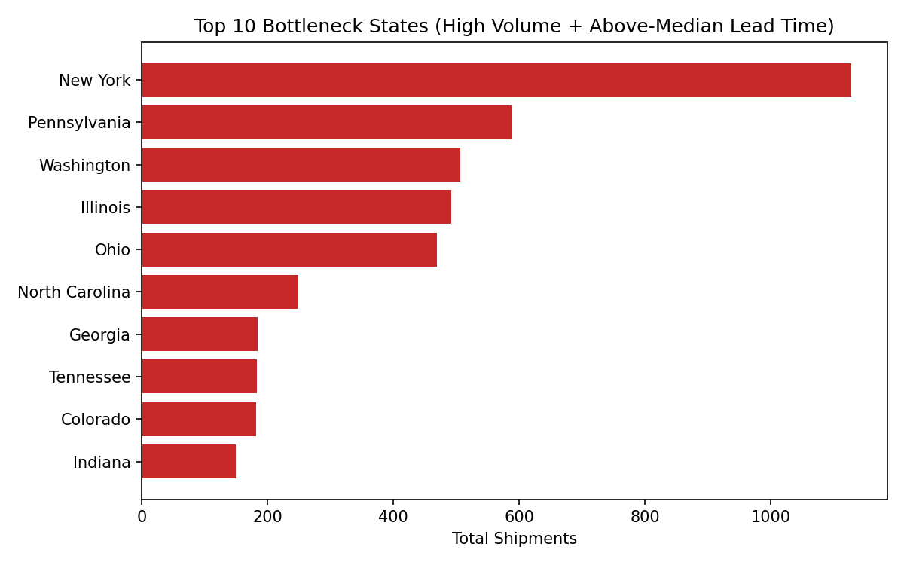
Figure 3. Top 10 bottleneck states by shipment volume.
State | Total Shipments | Avg Lead Time (days)
New York | 1,128 | 1,324
Pennsylvania | 587 | 1,324
Washington | 506 | 1,361
Illinois | 492 | 1,323
Ohio | 469 | 1,326
North Carolina | 249 | 1,335
Georgia | 184 | 1,339
Tennessee | 183 | 1,391

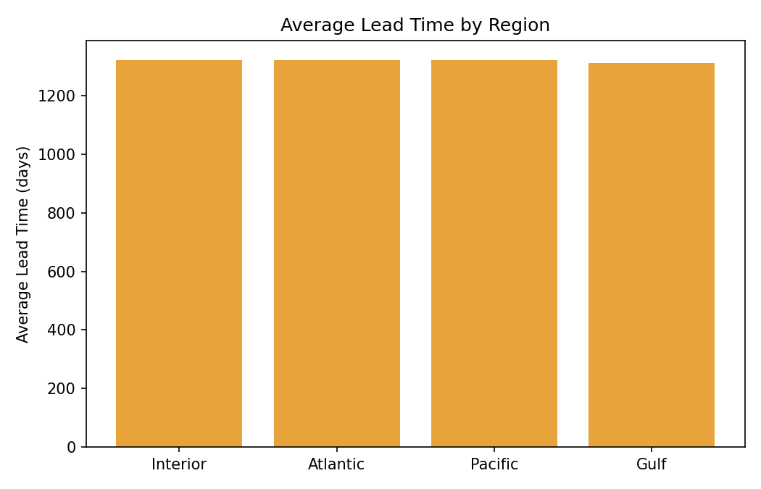
Figure 4. Average Lead Time by Region.
At the region level, the Atlantic region carries both the highest shipment volume of any region and a slightly elevated average lead time relative to Interior and Pacific, making it the single largest area of operational exposure if shipping performance were to be improved — more customers are affected by any inefficiency there than in any other region.

10. Key Insights Summary
- Two factories (Lot's O' Nuts and Wicked Choccy's) account for over 96% of all shipment volume; the remaining three factories serve a long tail of lower-volume routes with more volatile performance metrics.
- Among high-volume routes (100+ shipments), relative performance is fairly consistent — no single major route stands out as a severe outlier once low-sample routes are excluded.
- No shipping mode showed a reliable lead-time advantage over Standard Class; Standard Class was, if anything, marginally faster on average than the three faster-sounding tiers.
- 17 of 59 states meet the combined high-volume + high-lead-time bottleneck definition, with New York, Pennsylvania, Washington, Illinois, and Ohio representing the largest-volume bottlenecks.
- The Atlantic region carries the largest combination of shipment volume and elevated lead time among the four regions tracked.
- A systemic Ship Date data quality issue affects 100% of records and limits how literally absolute lead-time figures can be interpreted throughout this analysis.

11. Recommendations
- Correct Ship Date data capture at the source before drawing firm conclusions about absolute shipping duration or ship-mode speed; until then, treat all lead-time comparisons in this report as relative, not literal.
- Investigate why Sugar Shack -> Gulf and The Other Factory -> Interior rank fastest, but validate findings against a larger sample before generalizing, since both routes currently have fewer than 12 shipments on record.
- Prioritize any route-improvement initiative on the Atlantic region and the New York / Pennsylvania / Illinois / Ohio corridor, since these combine the largest shipment volumes with above-median lead times — improvements here reach the most customers.
- Before paying a premium for expedited shipping tiers, validate whether they deliver a measurable speed benefit once the Ship Date data issue is resolved; current data does not support that assumption.
- Resolve or document the Country/Region vs. State/Province mismatch for the 184 Canadian-province records, since this affects geographic reporting accuracy company-wide, not just this analysis.

12. Limitations
- Lead Time figures throughout this report are affected by a systemic Ship Date data quality issue (Section 5.1); absolute day-counts should not be quoted as literal shipping durations.
- Route-level statistics for low-volume State-level routes (fewer than 5 shipments, a substantial share of the 196 Factory→State combinations) carry high statistical uncertainty and should be treated as indicative only.
- 184 records include a Canadian province in the State/Province field despite a United States Country/Region label, and are excluded from US-only geographic visualizations.
- The bottleneck and delay-frequency definitions used in this report (median-split and 75th-percentile thresholds, respectively) are reasonable, defensible choices but not the only valid ones; a different threshold would shift which specific states or routes are flagged.

13. Appendix

13.1 Factory Coordinates
Factory | Latitude | Longitude
Lot's O' Nuts | 32.881893 | -111.768036
Wicked Choccy's | 32.076176 | -81.088371
Sugar Shack | 48.11914 | -96.18115
Secret Factory | 41.446333 | -90.565487
The Other Factory | 35.1175 | -89.971107

13.2 KPI Definitions Used in This Report
KPI | Definition
Shipping Lead Time | Ship Date minus Order Date, in days (see Section 5.1 caveat)
Average Lead Time | Mean shipping lead time per route
Route Volume | Number of shipments per route
Delay Frequency | % of shipments exceeding the 75th-percentile lead time threshold
Route Efficiency Score | Average lead time rescaled 0-100 (100 = fastest route, 0 = slowest route)

