**SIESCOMS Events Portal**

**Submitted in partial fulfilment of requirement for the**

**degree of**

**MASTER OF COMPUTER APPLICATIONS**

**OF**

**UNIVERSITY OF MUMBAI**

**Submitted by**

**Akshay Devendra Madrikar**

**Roll No: 19**

**M.C.A (2018-2021)**

**Department of M.C.A**

**SIES COLLEGE OF MANAGEMENT STUDIES**

**NERUL, NAVI MUMBAI**

**PROJECT REPORT INDEX**

|  |  |  |
| --- | --- | --- |
| **SR.NO.** | **PARTICULARS** | |
| 1 |  | INTRODUCTION |
| 2 |  | CURRENT & PROPOSED SYSTEM |
| 3 |  | PROJECT SCOPE |
| 4 |  | SYSTEM Models (FLOWCHART/ERD/DFD etc) |
| 5 |  | TECHNICAL REQUIREMENTS |
| 5.1 | HARDWARE |
| 5.2 | SOFTWARE |
| 6 |  | SYSTEM INPUT SCREENS |
| 7 |  | SYSTEM OUTPUT SCREENS (REPORTS) |
| 8 |  | CONCLUSION |
| 9 |  | REFERENCES |

1. **INTRODUCTION**

* Here my organisation is a portal/webpage that will provide a platform for the students to view the events that are to be held by various committees of SIESCOMS.
* Here the students will be able to view the information about the events and its respected committee.
* Various details would be displayed regarding the events like event name, event date from and to, event description and which committee is hosting that particular event.
* There is a column regarding the committee members where each committee member name would be displayed.
* The tools used for the development are:
  + PHP
  + HTML & CSS

1. **CURRENT & PROPOSED SYSTEM**

* Currently there is no such platform where the students of SIESCOMS can view the events that are held by the different committees in the premises.
* The students of SIESCOMS get to know about the events either through the notice on notice boards or through the broadcast messages on social media.
* This proposed system will help the students to view the events as per their need.
* They can view the events easily as the events are segregated as per the committees.
* There is no need of logging in as this portal will be open for everyone.
* Also, there are various options for certain users who are eligible to manage events and members of that particular committee.

1. **PROJECT SCOPE**

* Now here the scope of the system is that I want to provide a platform on one click where the students can easily get know about the events that are going to be held in SIESCOMS by various committees.
* They would get to know everything about the events in the event description section of the webpage.
* As mentioned above in the 6th point of ‘current & proposed system’ the users who are eligible can be either the committee head of a particular committee or the admin.
* There is only one committee head for each committee who would be needed to sign up to the webpage while accessing for the first time and the admin can be anyone who has the highest order of authority.
* The admin would verify the credibility of the tasks done by the committee head on webpage, while the committee head would be able to perform tasks like to add/delete members/events of the committee that he/she belongs to.

1. **SYSTEM Models (USE CASE/ERD)**

* Use Case Diagram

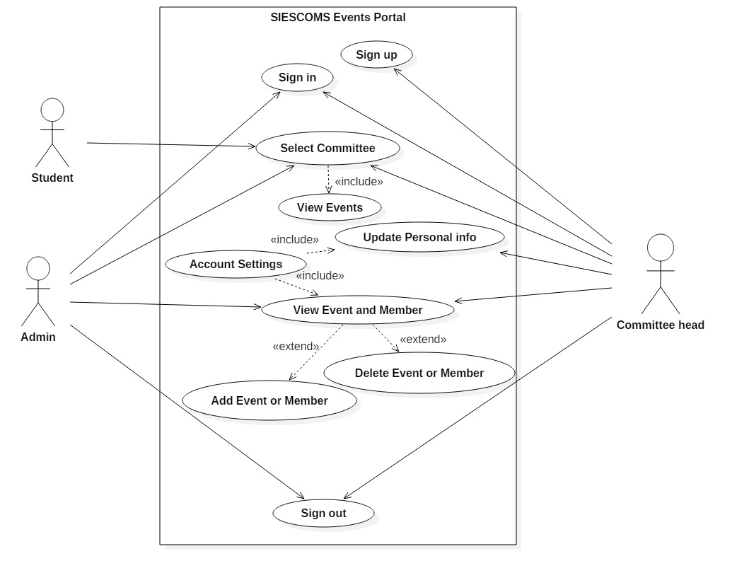

* Entity Relationship Diagram

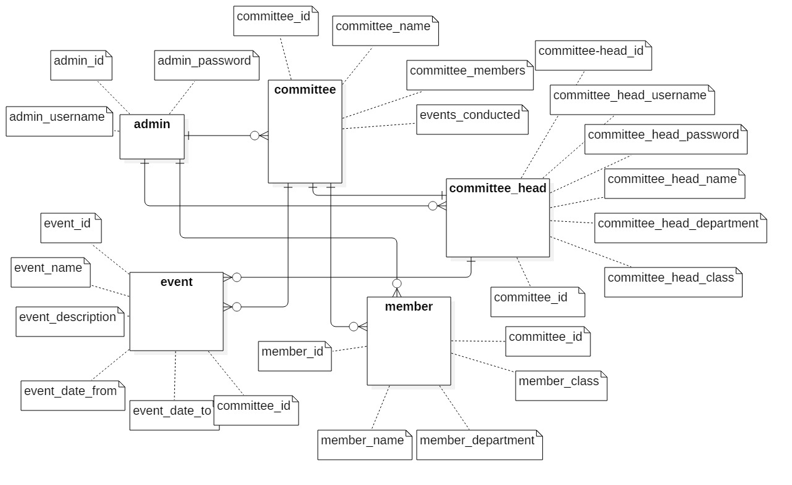

1. **TECHNICAL REQUIREMENTS**

* Before implementing the software, the organization’s system must be updated as per the requirement of the system.
* The system has been designed keeping basic system requirements into consideration related to hardware and software. The system experts from the user and input in frame windows which can be subjected to speeding up the process and is stored in database. The system currently is employing DOS/WINDOWS based environment with a small amount of memory and disk space requirement.
* The hardware configuration of the organization’s system must constitute of:
  1. **HARDWARE**
* Requirement of Computer with moderate speed processor.
* Trained person as Admin to handle the working of Web Application.
  1. **SOFTWARE**
* Google Chrome or any other web browser.
* Supported Architecture

32-Bit(x86)

OR

64-Bit(x64)

1. **SYSTEM INPUT SCREENS**

*login_index.php*

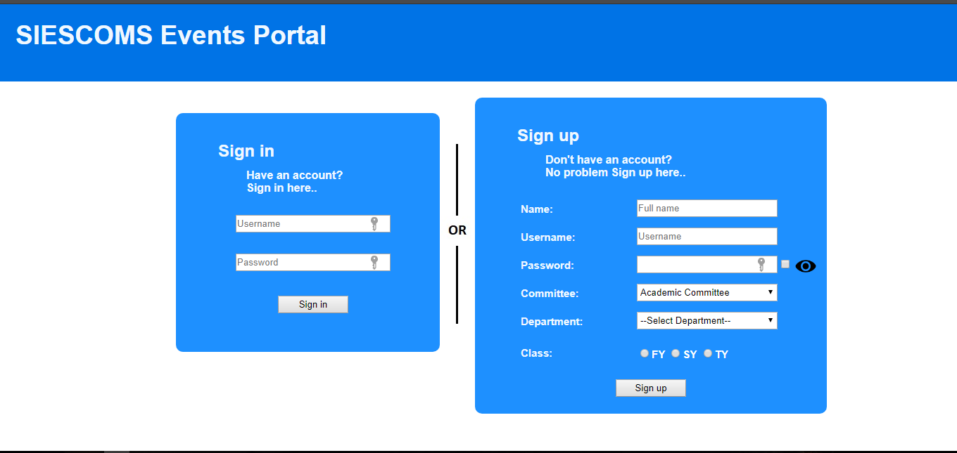

*settings.php*

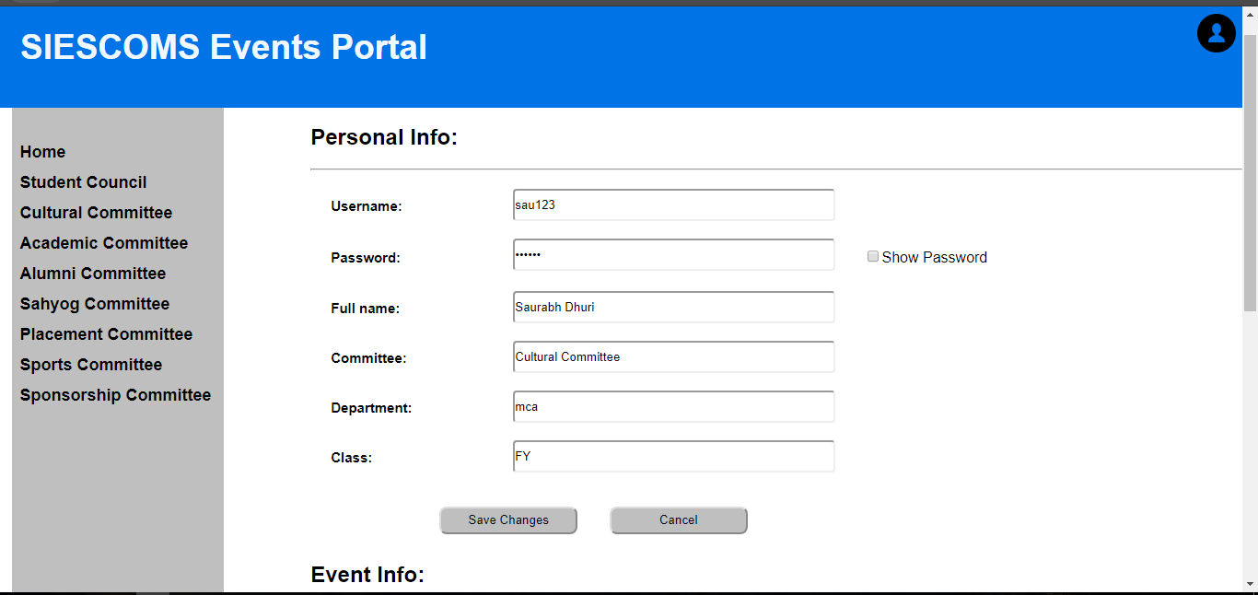

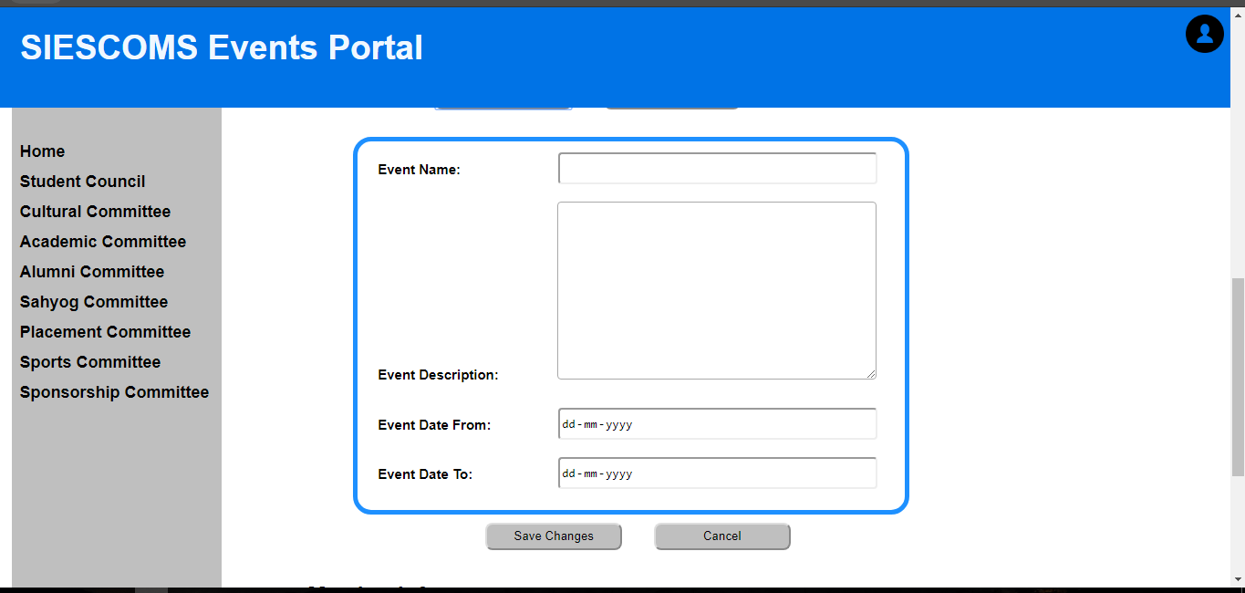

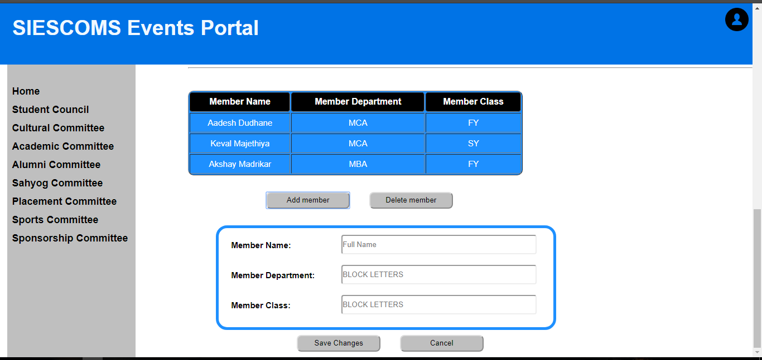

1. **SYSTEM OUTPUT SCREENS (REPORTS)**

*cultural_committee_index.php*

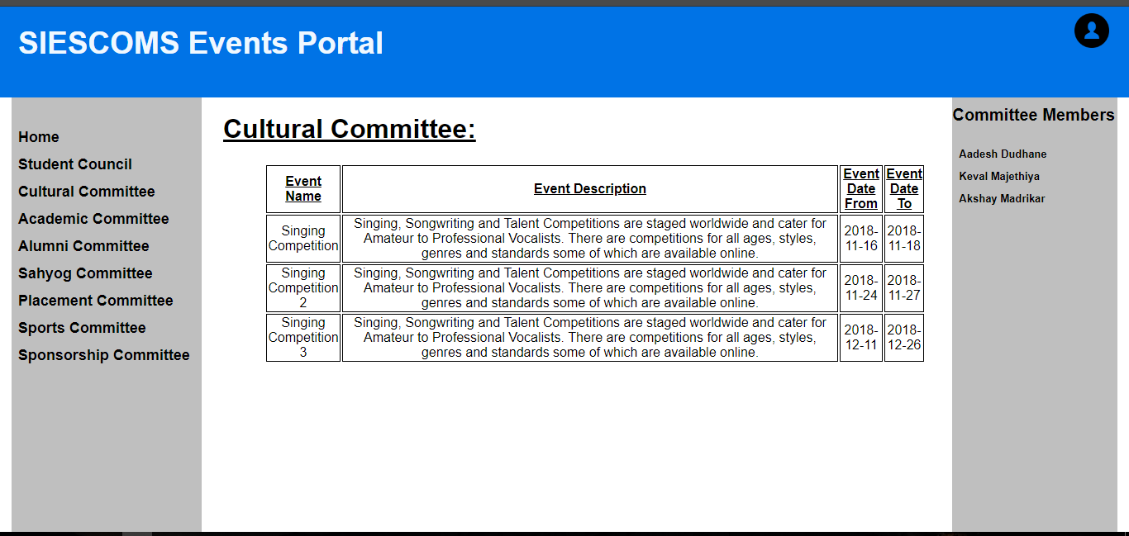

*academic_committee_index.php*

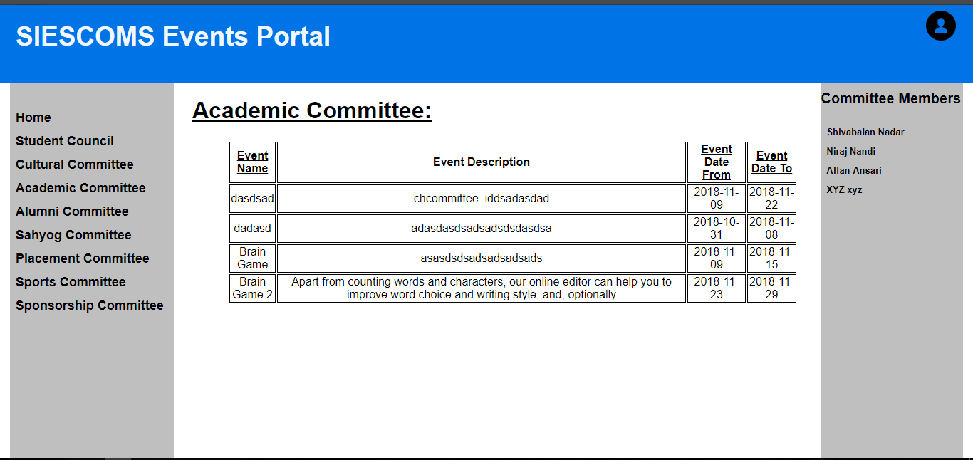

*settings.php*

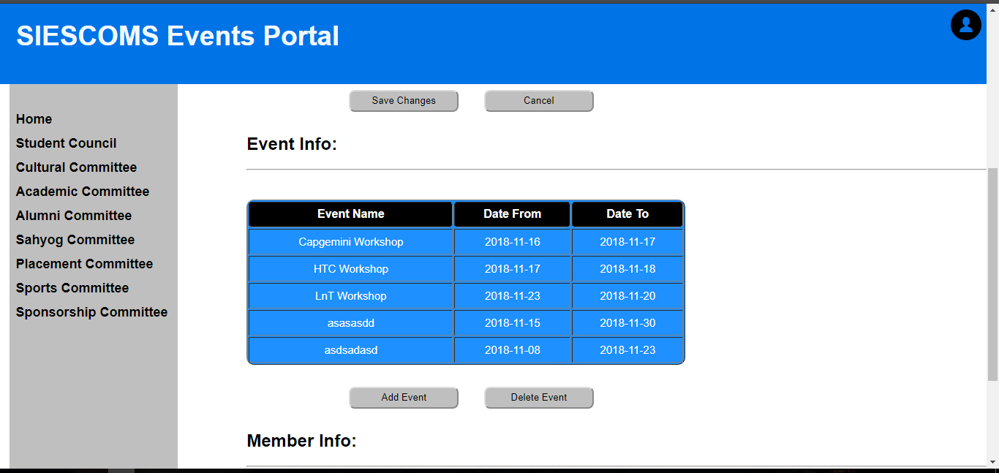

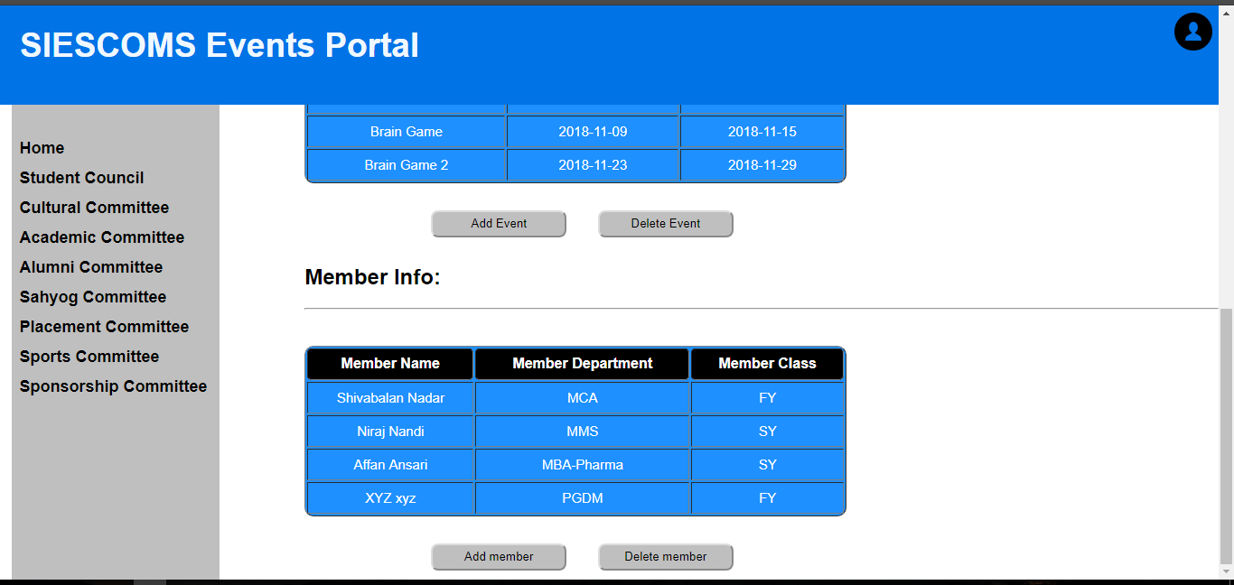

1. **CONCLUSION**

* Overall this project is user friendly and hassle-free.
* The student will be able to easily access the webpage without any ambiguity as the GUI is very much user friendly.
* All the committee names are segregated which makes the job of viewing the events easy.
* Future enhancements are possible and can be added easily for improving the user experience and future updates.

1. **REFERENCES**

**Internet References:**

* [https://material.io/guidelines/#](https://material.io/guidelines/)
* <https://fontawesome.com/icons>
* <https://stackoverflow.com/>
* <https://icons8.com/material-icons/>