AI Solutioning Agent: Business Requirements Document
Version 1.0, final for build
13 October 2026 · Mindmap Digital presales and solutioning team · Internal
Contents
1. Document control
2. Executive summary
3. Business context and problem statement
4. Scope, users and deliverable catalogue
5. Intake and routing: how the agent decides what to build
6. Shared foundation
7. W1 Exploratory intro deck
8. W2 Demo and video showcase
9. W3 Transcript-based proposal
10. W4 RFP-based proposal (RFP response)
11. W5 RFI clarification questions
12. S1 Effort and commercials
13. S2 QC engine
14. W6 Demo build
15. W7 Demo video
16. W8 Email drafts
17. House rules
18. Integrations and configuration
19. Non-functional requirements and human gates
20. Success metrics
21. Risks, assumptions and open questions
Appendix A: Requirement coverage
Appendix B: Formats, templates and pending inputs

1. Document control
This BRD defines, deliverable by deliverable, what the Mindmap Digital Solutioning Agent must do, so it can be built and tested against the way the presales team works today.
Item | Detail
Document | Business Requirements Document, v1.0 (final for build)
Owner | Mindmap Digital presales and solutioning team
Audience | Internal: leadership, presales, solution architects, the build team
Status | Final for build. Every requirement in the brief is mapped and specified; the remaining tender sub-agents (14.4) await the code upload. Three inputs still to be uploaded (B.5) slot into the places marked for them without changing any requirement; Section 21 lists the points for the team to confirm
Formats and templates | Attached in Appendix B: solution and technical architecture formats (B.1, B.2), five slide templates (B.3), the process-flow reference deck (B.4), whose slides also serve as templates (B.6). 00_READ_ME_FIRST, which travels with this BRD, explains in depth how to use the BRD and each template
Review record | Coverage checked against all 272 requirements in the brief, split clause by clause (Appendix A.1); every diagram, table and image checked against the text
How to read it: Sections 2 to 4 set the context and list the deliverables. Section 5 explains how the agent decides which deliverable to build. Section 6 covers what all workflows share. Sections 7 to 16 specify each workflow step by step. Sections 17 to 21 cover house rules, integrations and configuration, non-functional needs, metrics and open points. Appendix A.1 maps each of the 272 requirements in the brief to where this BRD covers it; A.2 lists what this BRD adds beyond the brief, for the team to keep or strike. Appendix B holds the formats and templates the agent must follow.
ID conventions
Prefix | Meaning | Example
RT1 to RT8 | Routing steps (Section 5) | RT7 confirmation card
W1 to W8 | Deliverable workflows; their steps are numbered within each | W4-14
S1, S2 | Shared sub-workflows: effort and commercials; QC engine | S1-6
-G | A human gate inside a workflow | W4-G3
D1 to D8 | QC checkers (Section 13) | D2 contradiction agent
ESC-1 to ESC-4 | Escalation protocol steps (Section 13.4) | ESC-3 trust reset
HR-01 to HR-17 | House rules (Section 17) | HR-01
F1 to F11 | Failure modes (Section 3) | F3
N-01 to N-09 | Non-functional requirements (Section 19) | N-01
Priority (Must or Should) is given for integrations (Section 18) and non-functional requirements (Section 19). Which workflows form release 1 is an open question (Section 21).

2. Executive summary
The Solutioning Agent is not one general agent; it is eight separate deliverable workflows and two shared sub-workflows, with an intake router that decides which workflow a request belongs to before any drafting starts.
Code | Workflow | What it produces
W1 | Exploratory intro deck | Cold or warm approach deck: periodic table of use cases, the top 5 real pain points with their sources, 5 solutions each followed by its architecture; every slide edited from a template slide
W2 | Demo and video showcase | The right existing demos and videos when a client says “show me what you have”
W3 | Transcript-based proposal | Proposal from client calls: a PPT for small deals or a detailed technical document for enterprise deals, pitched complex (technical stakeholders) or simple (higher-level and business stakeholders, such as finance)
W4 | RFP-based proposal (RFP response) | Fully compliant proposal built from the RFP, call updates and RFI answers: the second proposal type beside W3, with the same contents (both architectures with named data sources, process flows, Gantt, RACI, ROI where data exists, one commercials table), placed in the buyer’s format and order
W5 | RFI clarification questions | A short list of unanswered, needed questions with a simple English column and a complex column, for an RFP or any other pursuit
W6 | Demo build | Impressive, functional demo of 10 to 12 sub-agents built on the real domain process
W7 | Demo video | AI-voiced, edited walkthrough with the build platform never visible
W8 | Email draft | Outreach, follow-up and cover emails with no free demo or free POC offers
S1 | Effort and commercials | Inside W3 and W4, after QC: man hours checked by QC-1 and QC-2, internal cost, indicative infrastructure cost, revenue share where it applies, recommended client price, the one client commercials table
S2 | QC engine | Eight checkers (compliance, contradiction, consistency, scope and promises, visuals and tables, proofread, commercials, source check) run as a profile per deliverable (inside every workflow)
Each workflow has its own inputs, step sequence, output structure, human gates and QC profile. The router picks the workflow from what the request names, then from the documents supplied and the pursuit stage, sets the parameters that change the output (audience, deal and client size, commercial model, ROI data), and asks the consultant when the request is unclear or names two deliverables.
The value is not faster first drafts. It is fewer errors reaching a human: generic pain points, missed requirements, contradictions, invented promises, wrong man hours and leaked costs. Every check runs in a fresh context that rebuilds its understanding from the source material and must prove it read every line, word, table and image. When the contradiction agent finds a contradiction, the drafting agent must explain how it got in, its earlier output is no longer trusted, and it re-evaluates the whole document in depth before a first draft exists.

3. Business context and problem statement
Solutioning today is AI-assisted but human-policed. Proofreading is one of the most important parts of the work and takes a lot of time. There are two things to it: the checks done through AI, and the team’s own proofreading. The AI checks run first to fifth. The first is a compliance check that must cover every line, word, image and table; the second is the same compliance check again so nothing is missed; the third is where the team’s own proofreading always finds a contradiction, which a contradiction agent now automates; the fourth and fifth are the check for contradiction and consistency within the document itself, which is done two times (10.4; this mapping of checks three, four and five is this BRD’s reading of the brief, to confirm in Section 21). RFI question sets also take a lot of time.
The recurring failure modes the team has seen are the requirements this agent must design out.
# | Failure mode | Where it shows up | Example from the team | Countered by
F1 | One basic item among specific ones | W1 pain points | Four in-depth pain points (for example the founder saying AI spend is running very heavy and the models are not optimised, which an orchestrator agent can solve), then a fifth such as invoice processing with no explanation | W1-6 specificity checker, D8
F2 | Use cases mapped to the industry, not the company | W1 | High-level industry use cases instead of the company’s own problems | W1-1 to W1-6
F3 | Self-contradiction | W3, W4 | SMS used for a flow, then “secure because we do not use SMS” | D2, D3, ESC protocol
F4 | Invented scope or offers | W3, W4, W8 | A mobile app nobody asked for; a free demo or free POC promised to every client | D4, HR-01, HR-02
F5 | Checks skip tables and images | All QC | Text checked, tables and images not | Coverage rule (13.1)
F6 | Same answer on re-review | QC, requirement reviews | The same input gives the same answer and the same blind spots | Fresh instances (6.3), ESC-3
F7 | Man hours wrong on first pass | S1 | Effort needs correcting | QC-1 and QC-2 (S1-3, S1-4)
F8 | Costs outside the commercials table | W3, W4 | Prices in the executive summary | D7, HR-04, HR-05
F9 | Too many, already-answered RFI questions | W5 | 100 to 200 questions, many already answered, some inconsistent | W5-3 to W5-9
F10 | Generic domain understanding | W6 | A tender agent that only takes a tender and sends a proposal | W6-1, W6-G1
F11 | Visuals not cohesive | W3, W4 | Diagrams that do not match each other or the text | W3-15, W4-11, D5
F11 is derived from the instruction that all visuals must be cohesive rather than from a described incident.

4. Scope, users and deliverable catalogue
Each deliverable is defined by its trigger, its blocking inputs and its output; the router uses this catalogue to decide what to build and does not start a workflow whose blocking inputs are missing.
Deliverable catalogue
Code | Trigger in the pursuit | Blocking inputs | Useful inputs | Output | Accountable
W1 | First approach to a company, cold or warm | Company name; a template slide for every slide type in the deck (B.3, B.6) | Approach type (set at RT6), website, contact names, consultant notes, earlier-contact notes for a warm approach | PowerPoint built by duplicating and editing the provided template slides | Presales consultant
W2 | Client asks “show me what you have” | Topic or industry | Approved pain points from W1 | Shortlist with talking points | Presales consultant
W3 | Discovery call held, no RFP | Call recording or transcript (the transcript is the most important input); client name | Earlier calls, emails, client documents, FTE or KPI baselines | PPT proposal (edited template slides) or detailed technical document, by the format bands (5.4) | Presales consultant; solution architect
W4 | RFP received | RFP and annexures; submission deadline | Call recordings or transcripts, published RFI answers, corrigenda, buyer templates | RFP-based proposal in the buyer’s format; where none is prescribed, a PPT proposal or detailed document by the format bands (5.4) | Bid owner
W5 | Clarification questions are needed: an RFP’s clarification window is open, or a pursuit without an RFP needs answers before a proposal can be built | Everything the client has sent: in an RFP pursuit, the RFP and annexures; otherwise the client’s documents and call transcripts. The question deadline where there is one | Earlier answers, buyer question template | Question sheet plus internal tracker | Bid owner (RFP); presales consultant (other pursuits)
W6 | A new demo is needed | Target process; the team’s domain input | Client documents for testing; approved pain points | Working demo, test log, run sheet | Demo builder; domain owner
W7 | An edited walkthrough video is needed | Working demo | Run sheet from W6-10 (W7-1 writes one if missing); client region for the voice | Single video file | Demo builder
W8 | Any outreach, follow-up or cover note | Purpose; recipient | Case File context; attachment | Email draft | Presales consultant
S1 | Called inside W3 and W4 after QC and the human proofread (W3-19, W4-22) | Proofread proposal; approved technical design | Comparable past deals; budget signals from calls; hosting option and volumes | Reviewed man hours; internal cost; indicative infrastructure cost; revenue share model where it applies; recommended price; commercials table | Solution architect, delivery lead, pricing owner
S2 | Called inside every workflow | The draft and its sources | Earlier QC reports (orchestrator and fix verification only) | QC report with findings and coverage log | Owner of the calling workflow
Out of scope (this release)
- Sending emails, submitting bids or uploading to portals without a human action
- Contract negotiation and legal review
- CRM pipeline management
Users and approvers
Role | Who | Approves
Presales consultant | Runs pursuits and confirms routing | Pain points, the final deck, parameters, the W3 baseline, every word of W3 proposals, W3 release, demo picks, W5 questions outside RFPs, demo outputs (with the domain owner and demo builder), the final video (with the demo builder), emails
Bid owner | The presales consultant leading an RFP | The W4 routing and parameters (RT7), the W4 baseline, each proposed deviation (W4-10), every word of the RFP-based proposal, W4 release, W5 questions for an RFP
Solution architect | Owns architecture and technical design | Technical design; man hours (with the delivery lead)
Delivery lead | Owns delivery effort | Drafts the provisional phase plan; approves man hours; proposes the overhead percentage
Pricing owner | Leadership | Client price, AI reduction, overhead, infrastructure amount shown, revenue share
Domain owner | The team member who studied the domain | Domain process map; demo outputs
Demo builder | Builds demos and videos | Demo readiness; the final video (with the consultant)
The brief names no approvers; these roles are additions (A.2).

5. Intake and routing: how the agent decides what to build
The router (RT1 to RT8) assigns every request to exactly one deliverable workflow: first by what the request names, then by the documents supplied and the pursuit stage. Anything unclear goes to the consultant. Every outcome passes an input check, parameter setting and a confirmation card; W1 and W3 to W7 wait for confirmation before drafting, while W2 and W8 show the card and proceed. The orchestrator then runs the workflow’s steps in order and holds the work at each human gate until it is approved; together they form the top layer of the architecture (Section 6).

5.1 Routing steps
# | Agent | Does | Output
RT1 | Intake agent | Captures the request text, client name, attached files and any deadline mentioned | Intake record
RT2 | Document classifier | Labels every file by type from its content, not its file name (5.2) | File labels with confidence
RT3 | Case File lookup | Finds or creates the Pursuit Case File; reads the pursuit stage and what has already been produced | Pursuit stage, earlier deliverables
RT4 | Workflow classifier | Applies the routing rules in 5.3 in order; records which rule fired and why | One workflow, with reasons
RT5 | Blocking-input check | Checks the catalogue’s blocking inputs for that workflow (Section 4) | Pass, or a list of what is missing
RT6 | Parameter resolver | Sets the parameters that change the output (5.4), each with the evidence used | Parameter set
RT7 | Confirmation card | Shows the consultant the workflow, parameters and evidence. W1, W3, W4, W5, W6 and W7 wait for confirmation. W2 and W8 proceed and show the card, because both are quick and nothing reaches a client without a human gate (added; see A.2) | Confirmed run
RT8 | Launcher | Hands the workflow to the orchestrator | Running workflow
Example confirmation card: “Building W3 Transcript-based proposal for [client]. Format: detailed document (Indian enterprise client; estimated deal inside the detailed-document band). Audience: business, so a simple proposal (attendees were the CFO and the finance controller). Commercial model: standard build. ROI waterfall: included, DSO baseline stated on the call. Follow-on after release: W8 cover email (5.5). Confirm or change.”

5.2 Document classifier (RT2)
Label | Signals the classifier looks for
RFP | Submission instructions, evaluation criteria, numbered requirement clauses, eligibility, deadlines, commercial bid formats
RFP annexure | Referenced by an RFP clause; technical specification, compliance matrix, price schedule, draft contract
RFI or pre-bid answers | Buyer-issued question and answer pairs, corrigenda, addenda
Call transcript | Speaker-labelled turns, timestamps
Call recording or tl;dv meeting link | Audio or video file, or a tl;dv link. Transcribed once, at intake, by the Transcription service (6.4; steps W3-1 to W3-3) for every workflow, so routing and parameters read the transcript
Client brief or requirement note | Problem statement without formal bid structure
Supporting data | Financials, process documents, sample invoices, drawings, BOQs
Earlier Mindmap output | An earlier deck, proposal or question list for this client
Domain notes | The team’s notes on how the work flows in a domain: stages, decisions, branches (W6)
Demo build | A link to or export of a working demo (W7)
Run sheet | A demo path with talking points (W7)
Any file below the confidence threshold is shown to the consultant to label. A misread RFP is the most expensive error in the system, so an RFP is never labelled on weak signals.

5.3 Routing rules (RT4; applied in order, first match wins)
Rule | Condition | Workflow | Notes
1 | The request names one deliverable or action: intro deck, show existing demos, proposal, RFP-based proposal (RFP response), RFI questions, demo build, demo video, email | That workflow | If the inputs point to a different workflow (for example “make a proposal” with an RFP attached), ask: W3 or W4. W2, W6, W7 and W8 start only from this rule or as an accepted follow-on (5.5)
2 | Nothing named; RFP present and its clarification window open | W5, then W4 | W4 starts when the buyer publishes answers or the bid owner releases it
3 | Nothing named; RFP present, window closed or none | W4 | Call transcripts and RFI answers become sources
4 | Nothing named; call transcript or recording, no RFP | W3 | A recording is transcribed first
5 | Nothing named; only a company name is supplied (no transcript, RFP or client brief) | W1 | Cold or warm is a parameter set at RT6
6 | Anything else: no rule matched (for example a client brief without a call), or the request names two deliverables | Ask | One question listing the plausible workflows; the rules then run again

5.4 Parameter resolution (RT6)
RT6 sets provisional values from what is available at intake. In W3 they are re-resolved once the transcript is prepared (W3-4, W3-5) and locked at W3-G1. The deal-size estimate comes from budget signals in the call or from the consultant.
Workflow | Parameter | Values | How it is resolved
W1 | Approach type | Cold / warm | Consultant states it; warm if the Case File shows earlier contact. What each changes is set out in 7.2
W3 | Proposal complexity (audience) | Complex for technical stakeholders / simple for higher-level and business stakeholders, such as finance / mixed | Attendee roles in the transcript and who asked which questions; consultant confirms
W3 | Output format | PPT proposal / detailed technical document | From the format bands in configuration (Section 18), on the two inputs the brief names: how big the client is (smaller client or enterprise, by the configured threshold) and how big the deal is (estimated deal size against the band for the client’s market). Defaults from the brief: a smaller international deal up to 25 lakhs (the brief’s examples are 15 or 25 lakhs) gets just a PPT, with no detailed technical document; an Indian enterprise deal of 15 lakhs or more (15 to 20 lakhs is big for an Indian enterprise) gets a detailed document. Any other case, for example an international deal above 25 lakhs or an Indian deal below 15 lakhs, goes to the consultant at RT7 with the agent’s recommendation and reason
W3, W4 | Commercial model | Standard build / platform or SaaS build | From the transcript or RFP scope; consultant confirms. Platform builds add a revenue share line (S1-8)
W3, W4 | ROI section | Include / exclude | Include only if FTE counts or KPI baselines (for example DSO) are stated in a source
W4 | Audience profile for narrative sections | As for W3 | From the evaluators and stakeholders the RFP names; bid owner confirms
W4 | Response format | Buyer-mandated / else PPT proposal or detailed document | The buyer’s format whenever the RFP prescribes one; otherwise the same format bands as W3
W5 | Pursuit type | RFP / other pursuit | An RFP among the documents means the RFP path (the W4 Stage A agents build the provisional register); otherwise the W3 extractor and consolidator do (W3-5, W3-6)
W5 | Anonymised Q&A | Yes / no | From the RFP’s clarification process; yes means the company is never named in question text
W6 | Domain | Industry and process | From the pursuit and the domain owner
W8 | Email type | Cold outreach / follow-up / cover / submission note | From the pursuit stage and the request
W3 | Understanding reviewers | 2 / 3 | Default 2; the consultant may set 3 at RT7
W4 | Understanding reviewers | 3 / 2 | Default 3; the bid owner may set 2 at RT7
W1, W3, W4 (PPT) | Optional slides | W1 slides 14 and 15; proposal slides 3, 7 and 39 | Proposed by the agent from the pursuit; the consultant, or the bid owner in W4, confirms at RT7
All | Output language | English by default; another language when the RFP or the consultant requires it | Set at RT6, confirmed at RT7
Audience profiles (W3; also used for W4 narrative sections)
Element | Complex proposal (technical stakeholders) | Simple proposal (higher-level and business stakeholders, such as finance)
Lead with | The business logic in depth: how it works, data flow, integration | The value they get and how it will work, in plain terms
Technical architecture | Full depth in the body | Kept, but summarised in the body; full depth in an appendix
Process flows | As-is and to-be, as detailed swimlanes with system steps | As-is and to-be, showing the user effort removed
Language | Precise technical terms, each explained once | Plain language, no unexplained terms
Mixed audience (added; see A.2): a simple-proposal body with a technical appendix.
Format and audience combine as follows. In a PPT proposal the technical architecture is a one-slide summary whatever the audience; complexity sets how much business logic the slides carry. In a detailed document, a complex proposal carries full technical depth in the body and a simple one moves it to an appendix.

5.5 Follow-on workflows across a pursuit
S1 and S2 are not chained after a workflow; they run inside it at the steps named in each workflow. When a workflow is released, the orchestrator proposes the follow-ons below; an accepted follow-on enters routing at RT5.
Situation | Follow-on
New target company | W1, then a W8 email (cold outreach, or a follow-up after earlier contact); W2 when the client asks to see existing work; W6 if no library demo fits; W7 if an edited video is needed
After a discovery call | W3, then a W8 cover email
RFP received | W5 while the clarification window is open, then a W8 note to submit the questions; W4 once answers are out; then a W8 submission note
A new source arrives mid-flight (recording, transcript, RFI answer, corrigendum) | RT3 runs an impact check (added; see A.2): which requirements, drafts or questions it changes. The affected steps re-run, the consultant or bid owner is told what changed, and a changed baseline is re-locked at W3-G1 or W4-G1
A demo video is released (W7-G1) | A W8 cover note to send the video
The decision tree below is the same logic as 5.3, drawn.
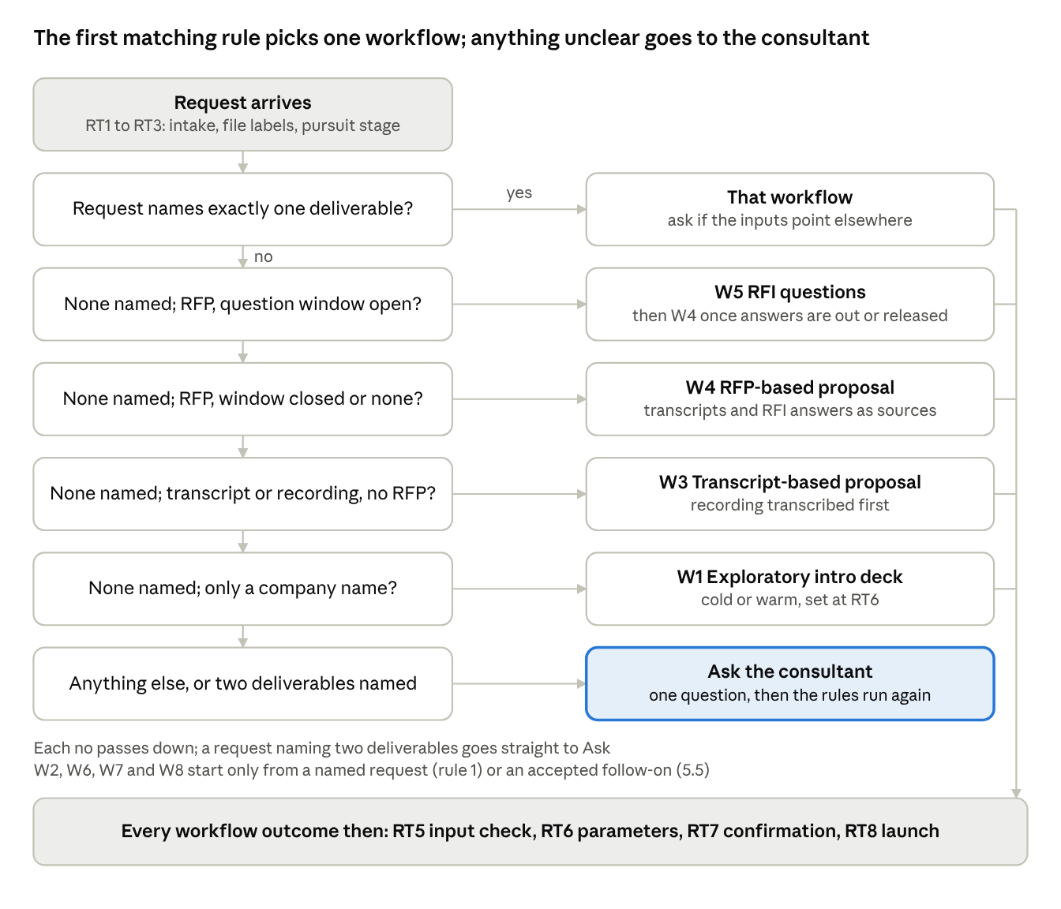
Figure: Routing decision tree, the six rules of 5.3 in order

6. Shared foundation
All workflows share one Pursuit Case File per client, a fixed set of data objects that agents pass to each other, one independent review pattern and a common set of services; nothing passes between agents as free text alone.

6.1 Pursuit Case File
One per client pursuit. It holds source documents and their labels, transcripts, research evidence, the requirement register and its locked baseline, approved pain points, every deliverable version with its parameters, QC reports, findings and how they were resolved, approvals, and the routing history. Every agent reads from it and writes to it; no agent keeps private state.

6.2 Data objects passed between agents
Object | Key fields | Produced by | Used by
Evidence record | Source type, URL or document, page or timestamp, speaker, date, exact passage, retrieval date | W1-2, transcription, document parsing | W1 pain points; W3 and W4 requirements; D8 source check
Pain point | Statement, evidence record IDs, score on each rubric factor (7.1) and total, specificity result and reason, mapped solution | W1-4 to W1-6 | W1 deck, W2, W6, W8
Requirement | ID, text, source references (document, clause, page, timestamp), class (core, supporting, mandatory compliance), what it supersedes, evaluation weight, status | W3-5 and W3-6; W4-1 to W4-4; W5-1 (provisional) | Drafting, S1, D1, D2, D4, W5
Requirement baseline | The locked set of requirements, with version and approver | W3-G1, W4-G1 | D1, D2, D4 in W3 and W4; S1
Provisional register | Requirements consolidated for W5 before any baseline is locked | W5-1 | W5-3 to W5-8
Claim | Subject, statement, location (section, paragraph, table cell, diagram label) | D3 (its first step) | D3 (D5 builds its own list)
Finding | Checker, severity, location, quoted text, conflicting source, proposed fix, how it got in, status | Every checker; human gates | Drafting agent, ESC protocol, consultant
Coverage log | Run ID, element IDs checked, element count of the document | Every checker | Orchestrator, which fails a run with incomplete coverage
Phase plan | Phases, durations, dependencies, milestones; marked provisional | W3-10, W4-9 (delivery lead, with agent support) | Gantt (W3-12, W4-11); reconciled with the reviewed man hours in the deep QC (W3-20, W4-23)
Work package | Description, role, estimated hours, QC-1 and QC-2 comments, reviewed hours, AI reduction and its reason (added at S1-6), assumptions | S1-1 to S1-5 | S1-6; deep QC reconciliation with the Gantt
Commercial inputs | Indicative infrastructure cost with its assumptions; revenue share proposal (model, basis, rate, term) | S1-7, S1-8 | S1-9, S1-G2, S1-10, D7
Question | Simple English text, complex text with document reference, decision it unblocks, sections searched, cited passage, priority, status | W5 | W5 checks, consultant or bid owner
Deliverable version | Workflow, parameters, version, QC report IDs, approvals | Every workflow | Router, audit
Parameter set | Workflow, each parameter value and its source (5.4), who confirmed it at RT7 and when | RT6, RT7 | Every workflow step; D1
Compliance matrix | Requirement ID, buyer clause, response location, status (complies, partial, deviation), reason, bid owner decision | W4-7, W4-10 | D1, W4-G3, W4-G4
Re-evaluation note | Trigger finding, ESC-2 explanation (missed or added), sections re-checked, changes made | ESC-2, ESC-3 | The next QC loop, the human gate, ESC-4
Impact-check result | New source, requirements, drafts or questions affected, baseline change proposed, re-lock decision | RT3 (5.5) | Consultant or bid owner; the affected steps
Demo shortlist and talk track | Demo or video ID, why it fits (pain point, industry), screens to show, talking points, branding and data check result | W1-10, W2-1 to W2-4 | W1 deck, W2-G1
Domain process map | Stages, sequence, decision points, branches, source of each (team or research, flagged) | W6-1 | W6-G1, W6-2, W6-3
Sub-agent spec | The fields in 14.2 | W6-3 | W6-6, W6-7, W6-8, W6-9
Test log | Test case, in or out of sample, expected output, actual output, pass or fail | W6-7, W6-8 | W6-G2, W6-6
Run sheet | Demo path, data to load, talking points per screen | W6-10 | W7-1, live demo
Video script and cut | Script, recorded footage, voiceover, frame check result | W7-1 to W7-5 | W7-6, W7-G1, W8
Email draft | Type, recipient, purpose, sourced facts, draft text, QC report | W8-1 to W8-3 | W8-G1

6.3 Independent review pattern (every checker, every workflow)
- A reviewer starts in a fresh context with only the source documents, the reference it checks against (the locked baseline in W3 and W4 once W3-G1 or W4-G1 has locked it (before that, for the understanding reviews W3-7 and W4-5, the register or the preliminary requirement statement), the provisional register in W5, the approved Case File items elsewhere), the draft, and its checklist. It never sees the drafter’s reasoning or earlier reviews.
- Each pass is a new reviewer instance. The number of passes per checker is set by the deliverable’s QC profile (13.3). Requirement-understanding reviews (W3-7, W4-5) each use a different method, so they do not converge on the same answer: source by source (clause by clause, or call by call); the decision maker’s or evaluator’s view of what is really being bought; and, in W4, delivery feasibility, read as the team that must build it.
- Each reviewer returns a coverage log of every paragraph, word, table cell, diagram, image and caption by ID. Incomplete coverage fails the pass automatically.
- Findings are merged and de-duplicated. Disagreements between reviewers go to a human; there is no vote.
- A fix is verified by a new reviewer instance, never the one that raised the finding.

6.4 Shared services
Service | What it is
Research | Web search and page retrieval: investor relations pages, earnings-call and investor transcripts, annual reports, press, job posts, LinkedIn posts of founders and key personnel; each source named as in Section 18 (Company research)
Transcription | Pulls the recording, and tl;dv’s own transcript where one exists, by tl;dv meeting link or ID, or takes an upload from any other recorder (for example a Zoom, Microsoft Teams or Google Meet recording); converts video to MP3; converts MP3 to text with speaker labels and timestamps. Runs once at intake for every workflow that receives a recording (steps W3-1 to W3-3)
Knowledge base | Accelerator catalogue (the source of periodic table tiles), case studies, past proposals, the demo and video library, the template library (one template slide per slide type), architecture formats, the approved company profile
Visual engine | Generates every diagram in Mindmap formats from the same component and role names used in the text
House rules engine | The rules in Section 17, as checkable patterns and instructions
Config store | Rates, percentages, counts, bands, thresholds, caps and pass counts (Section 18); nothing is hardcoded
The diagram shows how the router, the workflows, S1, S2, the shared services and the named data sources sit together. Every source the agent reads is named and lands in the Case File as a cited evidence record (6.2).
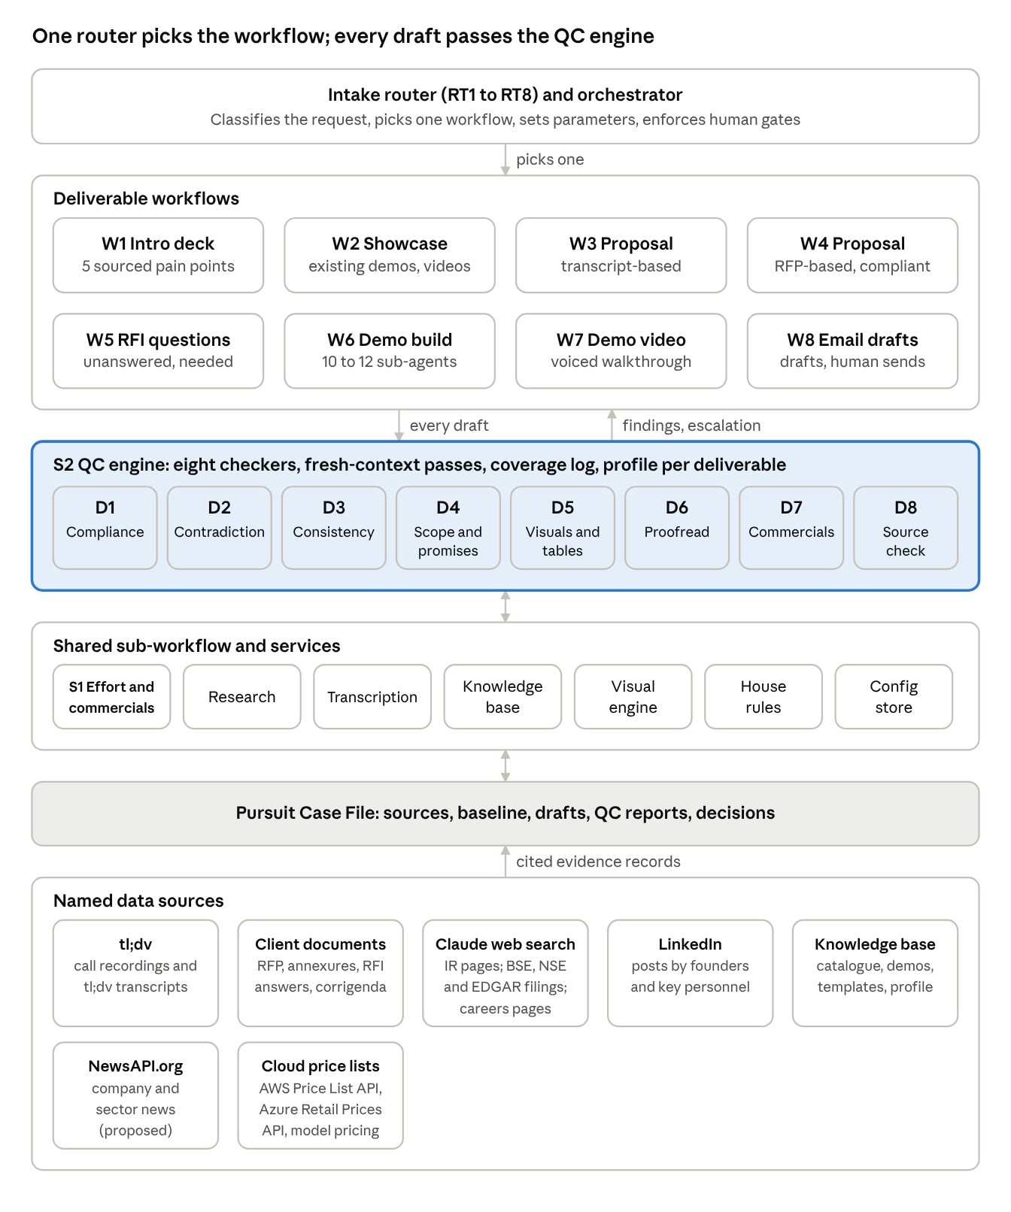
Figure: Solutioning Agent architecture: router, 8 workflows, the QC engine with 8 checkers, S1, 6 shared services and the named data sources
The diagram shows the layers, not every call: workflows also call S1 and the shared services directly and read and write the Case File. The return arrow carries findings to fix and, for contradictions, the escalation protocol (13.4).

7. W1 Exploratory intro deck
W1 turns a company name into an outreach deck that shows the use cases that can be done and the top five that are really useful to them. Each of the five answers a problem the company itself has stated, with the source shown. No pain point may be basic or generic, the fifth included.
Item | Detail
Router picks it when | The request names an intro or exploratory deck (rule 1), or only a company name is supplied (rule 5)
Inputs | Company name and a template slide for every slide type in the deck (blocking; B.3, B.6); approach type, cold or warm, set at RT6; website, contact names, consultant notes (useful)
Output | PowerPoint built by duplicating and editing the provided template slides

7.1 Step-by-step flow
# | Agent | Does | Output | Rule or guard
W1-1 | Research planner | Plans where to look. For every company: founders’ and key personnel’s LinkedIn posts and interviews, press, job posts. For a publicly listed company, also: public transcripts (earnings calls, investor calls), investor presentations, annual reports. For a warm approach, also the notes, emails and transcripts of the earlier contact in the Case File | Research plan | Names the people to cover (founders, CEO, CFO, CTO, function heads)
W1-2 | Research agent | Collects passages where the company or its leaders describe problems, priorities, spend, failures and targets | Evidence records | Each record keeps URL, date, speaker and exact passage
W1-3 | Evidence verifier | Re-opens every source and confirms the passage exists, is attributed correctly and is within the recency window | Verified evidence | Unverifiable evidence is dropped, never paraphrased into a claim
W1-4 | Pain point extractor | Turns evidence into candidate pain points in the company’s own terms | Candidate pool (more than 5) | No candidate without at least one verified evidence record
W1-5 | Pain point ranker | Scores every candidate on the rubric below and picks the five biggest; fit to Mindmap only breaks ties | Top 5, with scores per factor and reasons | The count of five and the weights are configuration values (Section 18)
W1-6 | Specificity checker (fresh context) | Tests all five on the same bar: stated by this company? would it read the same for any company in the industry? how strong is the evidence? | Pass or fail per item, with an explanation of why it is a real problem the company itself has listed, citing the evidence | A passing example: the founder says AI spend is running heavy and the models are not optimised, which an orchestrator agent can address. A failing example: a fifth item such as invoice processing with no evidence or explanation. A failed item is replaced from the pool; if the pool runs out, the consultant decides whether to show fewer than five (added; see A.2)
W1-G1 | Consultant gate | Approves the five pain points and their sources | Approved pain points | Nothing downstream starts before this gate
W1-7 | Periodic table builder | Builds the periodic table of the many use cases that can be employed at this company. Candidate tiles come from the accelerator catalogue in the knowledge base, filtered to the functions and processes the research shows this company runs; the tile count fills the periodic table template’s grid (read from the template, not fixed). Tiles are grouped by function. If fewer applicable tiles remain than the grid holds, the grid is filled from applicable catalogue items for adjacent functions, never with generic tiles; if none remain, the consultant decides at W1-G2 | Periodic table | A fresh-context check removes any tile that does not apply to this company’s business (for example a function it does not have) and any generic AI item; each tile carries a one-line description written for this company
W1-8 | Solution designer | For each pain point: the solution, how it works in three to five steps, the accelerator it uses, the value it brings. Then stars and numbers the five priority tiles on the periodic table to match slide 3, adding and starring a tile for any priority solution that is a new build with no catalogue accelerator | Five solution specs; priority tiles starred | Each spec opens by restating its pain point and source; new builds are flagged where no accelerator fits
W1-9 | Solution architect agent | Draws one solution architecture per solution in the Mindmap format | Five architectures | In the solution architecture format (Appendix B.1); component names identical to the solution spec; every data source named, web sources included: the system or file the W1 research shows the company runs or, where the research does not show it, the most likely one, proposed and flagged for W1-G2; never a generic tile (HR-17, B.1)
W1-10 | Demo shortlister | Uses the W2 matching logic to pick one to three demos or videos for the next-steps slide | Demo shortlist | No step-specific rule
W1-11 | Deck assembler | Builds each slide by duplicating its template slide from the template library and editing it (7.2, Appendix B.3). Never creates a new slide. If a slide type has no template in the library, the deck holds here and the consultant is asked for the template | Draft deck | Text and images change; font sizes and formatting untouched (HR-12)
W1-12 | S2 QC, W1 profile | Runs the W1 checks (13.3) until two consecutive clean loops | QC report | No step-specific rule
W1-G2 | Consultant gate | Final review | Release | No step-specific rule
W1-13 | Follow-on | Proposes a W8 email as a follow-on (5.5): cold outreach for a cold approach, follow-up for a warm one | Follow-on proposal | The email is drafted only once the consultant accepts the follow-on; it then runs through W8 with its own QC and gate
Pain point scoring rubric (W1-5)
Factor | What scores high | Default weight
Stated impact | The company states a cost, loss, delay or risk, ideally with a number | High
Speaker seniority | Said by a founder, CEO, CFO or function head, or in an earnings call or annual report | High
Repetition | Raised in more than one source, or more than once | Medium
Recency | Inside the evidence recency window; the latest scores highest | Medium
Specificity | Names this company’s own process, system or market, not an industry trend | Gate: a candidate below the bar is not ranked at all
Weights are configuration values; the team sets the numbers before go-live. One more gate applies before ranking: the pain point must be addressable by an AI solution Mindmap can deliver, as an accelerator or a new build; a candidate no AI solution addresses is not ranked. Fit to Mindmap’s accelerators is used only to break ties, so a pain point is never picked because Mindmap happens to have a solution for it.

7.2 Slide specification
# | Slide | Template slide to duplicate and edit (never create a new slide) | Content
1 | Title | Reference deck slide 1, title (B.6) | Company name, Mindmap Digital and the deck date
2 | Use case periodic table | Periodic table template (B.3) | Tiles grouped by function, each with code, two-letter symbol, agent name and a one-line description of what it does for this company; the five priority tiles starred and numbered to match slide 3 (the number written in the tile’s star text box, for example “★1”; the star removed from every other tile; the “Featured” count in the counts strip set to 5); the counts strip at the foot updated; the title, category legend and section banners rewritten for this company; no em dashes (HR-09)
3 | The five real problems | Problems template (B.3) | Five columns, one per problem: number, title, why it is a real problem for them, the evidence figure or quote, and its source (who said it, where, when) in place of the industry statistic, written “Source: [speaker], [where], [date]” with no em dash (the template’s dashes are removed, HR-09). The template’s first column (Pain 01) has no description box: until the team adds one to 2_Problems.pptx (B.3, Section 21), problem 1’s explanation goes in the quote strip, and the problem with the shortest explanation is placed in column 1; the quote strip at the foot rewritten
4 to 13 | Solution, then its architecture, five times | Solution: agents slide template (B.3), duplicated once per solution. Architecture: reference deck slide 8, the full-visual slide (B.6), duplicated once per solution, with the architecture drawn in the B.1 format as its visual | Solution slide: headline, one-line summary, three value figures in the stat panel, six icon items (item 1, the problem and its source; items 2 to 4, how it works, with a fourth or fifth step joining item 4’s text; item 5, the accelerator; item 6, the value), and a product screen in the template’s product screen area (the laptop screen on the right; the .pptx holds a “UI SCREEN NEEDED” marker behind the screen image, which is replaced). The green title line at the top (which in the template runs past the slide’s left edge, so the new title is fitted inside the slide) and the “Strategic Rationale” pill are rewritten for this solution, so no template text survives (D4 and D6 check). Each value figure comes from the cited evidence for that pain point or from a named Mindmap case study in the knowledge base, or is marked approximate with its basis recorded internally; D8 checks each. The screen is taken from the matching library demo (W1-10); if none exists, the consultant supplies one, and a screen is never mocked up. Architecture slide: breadcrumb title naming the solution, and the architecture in the B.1 format, laid out landscape to fit the slide’s visual area with the same layers, groups, labelled connectors and legend, and every data source named (HR-17)
14 | How we engage (when used) | Engagement methodology template (B.3) | Four phases with their activities and outputs for this solution; no POC content or POC timings; the phase timing labels removed (W1 has no delivery plan); the quote strip rewritten
15 | Offering overview (when used) | Offerings template (B.3) | A central offering with the eight surrounding items the template holds (four components, three phases, scale and impact); no POC content or POC timings, and phase timings removed (HR-07); no template text survives, including the earlier client’s programme name and figures (D4 and D6 check)
16 | Next steps | Reference deck slide 40, closing (B.6) | A conversation, with the demos from W1-10 named in the call-to-action text. No free demo or free POC is offered
Every slide type in the intro deck has a template. Slides 2, 3, 4, 6, 8, 10, 12, 14 and 15 use the five templates in B.3; the title, architecture and closing slides use slides 1, 8 and 40 of the reference deck (B.6). Which template serves slides 1 and 4 to 16 is proposed for the team to confirm (Section 21). If a template is ever missing from the library, W1 holds at W1-11 and asks for it; it never creates a slide in its place.
Every slide is a duplicate of a provided template slide, edited: text and images change, font sizes and formatting stay as they are (HR-12). Use case slides carry no POC content or POC timings (HR-07) and present each use case directly, not labelled illustrative or hypothetical (HR-08). Slide content has no em dashes (HR-09). Cold and warm decks share the structure above and differ as follows (proposed; see A.2).
Element | Cold approach | Warm approach
Research (W1-1) | Public sources only | Public sources, plus the notes, emails and transcripts of the earlier contact in the Case File
Evidence for pain points | Public statements, cited with who said it, where and when | Public statements, plus what the client said in the earlier conversation, cited with the meeting and date
Slide 3 opening | The problems as the company has stated them publicly | Opens by referring to the earlier conversation
Next steps slide | Asks for a first conversation | Confirms the next step agreed in the earlier contact
Follow-on email (W8) | Cold outreach | Follow-up

7.3 QC profile for W1
W1 runs D8 (every pain point and quote traces to verified evidence), a second specificity check by a new instance, the periodic table relevance check (W1-7), D3, D4 (POC content, free demo or POC offers, commitments), D5 (architecture components match the solution slide; every data source named, HR-17) and D6 (no em dashes, tone, no illustrative labels, template formatting unchanged). Counts are in 13.3.

8. W2 Demo and video showcase
W2 answers a client who asks “show me what you have” with the one to three existing demos or videos that best fit the topic and the client’s stated problems, plus what to say while showing them.
Item | Detail
Router picks it when | The request names it (rule 1), usually after W1, or as an accepted follow-on (5.5)
Inputs | Topic or industry (blocking); approved pain points from the Case File (useful)
Output | Shortlist with reasons and talking points, with links or files; or a proposal to build a new demo in W6 when nothing fits

# | Agent | Does | Output | Rule or guard
W2-1 | Library matcher | Searches the demo and video library by industry, function, process and the client’s pain points | Ranked candidates with match scores | Library entries are tagged by industry, process, sub-agents and the client each was built for
W2-2 | Fit reviewer | Checks each candidate against the client: does it show the topic or problem they raised? would anything in it confuse or contradict the W1 story? | One to three picks, or none | Below the match threshold nothing is shown and W6 is proposed (added; see A.2)
W2-3 | Talk track writer | Per pick: which problem it answers, which screens to show, what result to point to | Talk track | No step-specific rule
W2-4 | Branding and data check | Confirms the build platform is not visible and no other client’s data appears in the chosen demo or video | Pass or fail | No step-specific rule
W2-5 | S2 QC, W2 profile | D8 on every claim in the talk track; D4 for free demo or POC offers and price or timeline promises | QC report | No step-specific rule
W2-G1 | Consultant gate | Approves the picks and the talk track | Release | No step-specific rule

9. W3 Transcript-based proposal
W3 turns client calls into a proposal. Four things are fixed before anything is drafted: the format (PPT or detailed technical document), the complexity (complex for technical stakeholders, simple for higher-level and business stakeholders), and whether the proposal carries an ROI section and a revenue share line. QC runs before and after the first draft, then the human proofread, then commercials (man hours checked by QC-1 and QC-2, then cost, then price), then a deep consistency QC.
Item | Detail
Router picks it when | A call transcript or recording is present and there is no RFP (rule 4), or a proposal is requested without an RFP (rule 1)
Inputs | Call recording or transcript and client name (blocking; the transcript is the most important input); earlier calls, emails, client documents, FTE and KPI baselines (useful)
Parameters (5.4) | Complexity, format, commercial model, ROI section
Output | PPT proposal (small deals) or detailed technical document (enterprise deals)

9.1 Step-by-step flow
# | Agent | Does | Output | Rule or guard
W3-1 | Recording intake (Transcription service) | Pulls the recording, and tl;dv’s own transcript where one exists, by tl;dv meeting link, or takes an upload. W3-1 to W3-3 run once, at intake (RT2), for every workflow that receives a recording; they are listed here because W3 depends on them most | Recording in the Case File | No step-specific rule
W3-2 | Media converter (Transcription service) | Converts the video to MP3 | Audio file | Done as a separate step today; the agent automates it
W3-3 | Transcriber (Transcription service) | Converts the MP3 to a transcript with speaker labels and timestamps | Raw transcript | Also a separate step today. When tl;dv supplies a usable transcript, W3-2 and W3-3 are both skipped (added; see A.2)
W3-4 | Transcript preparer | Maps speakers to attendees and their titles; segments by topic (added; see A.2) | Clean transcript | Titles feed the complexity parameter
W3-5 | Requirement extractor | Pulls requirements, pain points, user roles, current process cues, volumes, FTEs, KPIs (for example DSO), constraints, budget and timeline signals, decision makers | Requirement records with timestamps | Nothing extracted without a timestamp
W3-6 | Consolidator | Merges all calls, emails and documents; later statements supersede earlier ones and conflicts are flagged (added; see A.2) | Requirement register | Both statements kept and cited where they conflict
W3-7 | Understanding reviewers (2 by default, 3 if the consultant sets it; fresh context) | Each rebuilds the requirement summary from the sources alone by a different method (6.3): one call by call; one as the client’s decision maker deciding what they are buying; when a third runs, one for delivery feasibility, read as the team that must build it. Each then compares its summary with the register | Gaps and misreads | Differences go to the consultant
W3-G1 | Consultant gate | Confirms the requirement summary and re-confirms the parameters | Locked baseline and parameters | No step-specific rule
W3-8 | Solution designer | Designs the solution per requirement, reusing accelerators | Solution spec | Every element maps to a baseline requirement; nothing unrequested
W3-9 | Architects | High-level solution architecture and technical architecture in the Mindmap formats | Architectures | Formats in Appendix B.1 and B.2. Depth set by complexity. Team standing preferences: where no source tech stack exists, the real production technology is specified; each named technology is explained; each use case is its own standalone flow (data origin, steps, technology); every data source in both architectures is named, the system or file and the data taken from it, never a generic tile (HR-17, B.1)
W3-G2 | Architect gate | Approves the technical design | Approved design | No step-specific rule
W3-10 | Provisional phase plan (delivery lead, with agent support) | Phases, durations, dependencies and milestones for the Gantt, from the approved design and comparable past projects | Provisional phase plan | Not man hours. Man hours are estimated in the commercials step (W3-19), in the order the brief gives; the deep QC (W3-20) reconciles the two
W3-11 | Process flow builder | As-is and to-be flows per process in the B.4 format: one swimlane per sub-process; as-is cards tagged with the user role or system that does the step; to-be cards tagged with the platform component, as in the reference deck, and with the user role that acts on or receives the step’s output, so each user’s value is visible; a process summary per process; a solution heat map when the solution spans several areas (B.4) | Flow diagrams | Format in Appendix B.4. As-is is usually estimated, by the method in 9.4
W3-12 | Plan and governance builder | Gantt chart for the timeline from the provisional phase plan; RACI matrix in the governance section | Gantt, RACI | Roles match the delivery team; durations are reconciled with the reviewed man hours at W3-20
W3-13 | ROI builder | Waterfall from today’s cost to the future state, one bar per lever. Baseline bars come from client-stated FTE counts, costs and KPIs (for example DSO), each cited; FTEs become cost only with a client-stated or consultant-confirmed cost per FTE. Each lever’s improvement is estimated from the approved solution design and comparable past deployments in the knowledge base, recorded internally with its basis, and shown to the client as approximate | ROI waterfall | Only if FTE or KPI baselines exist; every number cites its source or its recorded basis; shows the client’s own cost levers only, never Mindmap’s price, fees or a payback on them (HR-05)
W3-14 | Drafting agent | Writes the proposal in the variant structure (9.2) and the audience profile (5.4): a detailed document in the Mindmap proposal template (until that template is uploaded, B.5, a detailed document holds at this step and the consultant is asked for it; the agent never invents a layout), or a PPT proposal by duplicating and editing the provided template slides | Preliminary proposal | Never creates a slide (HR-12); a slide type with no template holds the draft and the consultant is asked for one; the Word template for detailed documents is pending (B.5)
W3-15 | Visual planner and cohesion pass | Incorporates the diagrams from W3-9 to W3-13; scans every section for further diagram opportunities and adds them (9.3) without dropping any content; then checks one style and one set of component and role names across every diagram and the text | Proposal with diagrams; cohesion report | No step-specific rule
W3-16 | QC before the first draft | D1 twice; D2, then D3 twice, where any contradiction triggers the escalation protocol (13.4); then D4, D5 and D8, whose findings are fixed without escalation | First draft after two consecutive clean loops | No step-specific rule
W3-17 | QC on the first draft | D1 2 to 3 passes (a third pass runs whenever pass 2 raises a finding); D2, then D3 twice, with any contradiction revised and the loop re-run; D4 and D5 | Two consecutive clean loops | Mirrors W4 Stage E (added; see A.2)
W3-18 | D6 proofread | Every word, by AI; minor findings fixed | Clean text | No step-specific rule
W3-G3 | Human proofread | The consultant reads every word. A critical or major issue, or any issue QC did not log, triggers the escalation protocol and the work returns to W3-17 | Proofread proposal | No step-specific rule
W3-19 | S1: effort, cost, price, commercials table | Man hours estimated and checked by the QC-1 and QC-2 agents (12.1, S1-G1); then cost, indicative infrastructure cost, revenue share where it applies, recommended price and its approval (12.2, S1-G2); then the one commercials table (12.4) | Commercials section | No step-specific rule
W3-20 | Deep QC | D7, D3 and D6 on the whole document, checking the commercials section and every change since W3-G3 first: all commercial terms in place; prices only in the one commercials table, none in the executive summary or anywhere else; numbers consistent everywhere; the Gantt reconciled with the reviewed man hours (a mismatch updates the Gantt); the approved price checked against the format bands, with a band change sent to the consultant before release | QC report | Revise and re-run until clean
W3-G4 | Release gate | The consultant reads the commercials section and every change since W3-G3, then releases. A critical or major issue, or any issue QC did not log: escalation protocol (13.4), back to W3-20, or to W3-17 if it lies outside the commercials | Release | A W8 cover email is proposed as a follow-on (5.5)

9.2 Output variants
Section | PPT proposal (small deals, by the format bands) | Detailed technical document (enterprise deals, by the format bands)
Executive summary | One slide, no prices | One to two pages, no prices
Understanding of the need | One slide | Full section, each point traced to the call
Solution overview | One overview slide, then one agents slide per solution (B.3) | Full section
High-level solution architecture | One slide, Mindmap format, every data source named (HR-17) | Mindmap format with explanation; every data source named (HR-17)
Technical architecture | One-slide summary | Deep: components, data contracts and schemas, model and inference choices, database schema, API endpoints, failure handling, security and access control, observability metrics; every integration and data source named (HR-17)
Process flows | As-is and to-be per process, lanes per sub-process; as-is steps tagged by user role or system, to-be steps by platform component and the user role served (B.4) | As-is and to-be per process, lanes per sub-process; as-is steps tagged by user role or system, to-be steps by platform component and the user role served (B.4), with the step descriptions
Timeline | Gantt slide | Gantt with phases, milestones and dependencies
Governance | RACI slide | RACI with governance cadence
ROI (if data exists) | Waterfall slide | Waterfall with the lever breakdown
Commercials | One table | One table
Compliance matrix (W4 only) | Reference deck slide 8 duplicates, the matrix as a native table (B.6) | A section or annex in the buyer’s order
Assumptions and exclusions | One slide | Section
Engagement approach | Engagement methodology slide (B.3) | Section: phases with their activities and outputs
Title, about Mindmap and close | Reference deck slides 1, 2 and 40 (B.6) | Cover page, company section and close
Optional: leadership, agent landscape, capabilities | Reference deck slides 3, 7 and 39 (B.6), when chosen at RT7 | Not used

9.3 Visual set
The client will look at diagrams more than read the text, so the proposal carries as many diagrams as possible without losing any of the content the text must carry, and all visuals are cohesive. Six visuals are always considered; the visual planner (W3-15) and the visual engine (W4-11) then add a diagram wherever a section’s content takes one of the shapes in the second table.
Visual | Used when | Source of truth
High-level solution architecture | Always | Solution spec
Technical architecture | Always | Approved technical design
As-is and to-be process flows | Always, per process, lanes per sub-process; as-is steps tagged by user role or system, to-be steps by platform component and the user role served (B.4) | Requirement register, transcript, the as-is estimate (9.4)
Gantt chart | Always | Provisional phase plan (W3-10, W4-9), reconciled with the reviewed man hours
RACI matrix | Always, in governance | Delivery team model
ROI waterfall | Only with FTE or KPI baselines | Client-stated baselines; lever estimates with their recorded basis
Diagram opportunities in any section
Content in a section | Diagram added
A sequence of steps, or a hand-off between people or systems | Flow or swimlane
A comparison of options, phases, or before and after | Comparison table or side-by-side panel
Layers, modules or components and how they connect | Architecture or component view in the B.1 or B.2 format
Dates, phases or milestones | Timeline or Gantt
Numbers that add up, change over time or compare | Chart: waterfall, bar or line
Who does what | RACI or responsibility matrix
Data entities and how they relate | Data model diagram
Systems the solution connects to | Integration map, each system and feed named (HR-17)
Risks, priorities or automation potential across areas | Heat map
No content is lost to a diagram. A diagram is added beside the text, never in its place: every requirement answer, commitment and number stays in the text, and the diagram shows it. D5 checks every diagram against the text and flags any requirement answer that exists only inside a diagram.
Formats: architectures follow Appendix B.1 and B.2. Process flows follow the reference deck in Appendix B.4: per process, a “today” summary slide and a current-process swimlane, then an “on the platform” summary slide and a target-process swimlane. A PPT proposal is built by duplicating and editing the provided template slides (B.3) and the reference deck slides mapped in B.6, never by creating new slides.

9.4 Estimating the as-is process
The as-is flow is usually estimated, because the client rarely documents it. The process flow builder (W3-11), or the visual engine (W4-11) in an RFP-based proposal, estimates it in five steps.
Step | What it does
1 | Takes every current-process cue from the transcripts and client documents (W3-5): steps, hand-offs, systems, volumes, time taken, people involved
2 | Fills the gaps from the knowledge base: the same process at past clients, and the current-process patterns in the reference deck (B.4)
3 | Marks each step and figure in the internal record as stated (with its timestamp or document reference) or estimated (with its basis)
4 | Shows the client the flow as the current process as understood from the discussions; estimated figures are shown as approximate, never as the client’s own numbers
5 | The consultant confirms the as-is flow at W3-G3; in W4 the bid owner does so at W4-G3

10. W4 RFP-based proposal (RFP response)
W4 builds the RFP-based proposal, the second proposal type beside W3’s transcript-based proposal. It differs from W3 because the requirements are strict and scored. Agent 1 consolidates the RFP, call updates and RFI answers into a core preliminary requirement, and Agent 2 re-establishes that understanding from scratch two to three times before any drafting. The draft then passes the five AI checks: compliance, the same compliance check again, the contradiction agent, and the internal contradiction and consistency check run two times. A contradiction triggers the escalation protocol before a first draft exists. QC runs again on the first draft, a human proofreads every word, and commercials (man hours, cost, price) come last, followed by a deep consistency QC.
Item | Detail
Router picks it when | An RFP is present and the clarification window is closed or there is none (rule 3), after W5 once answers are out (rule 2), or on request (rule 1)
Inputs | RFP and annexures, submission deadline (blocking); call recordings or transcripts, published RFI answers, corrigenda, buyer templates (useful)
Parameters | Response format, commercial model, ROI section, audience profile for narrative sections, number of understanding reviewers at W4-5 (3 by default)
Output | Proposal in the buyer’s format and order, with a compliance matrix and one commercials table; where the buyer prescribes no format, a PPT proposal or detailed document by the format bands (5.4). It carries the same contents as a W3 proposal (9.2), each mapped into the buyer’s sections: executive summary, understanding of the need, solution overview, high-level solution architecture and technical architecture (both with named data sources, HR-17), as-is and to-be process flows, Gantt, RACI, ROI where data exists, commercials, assumptions and exclusions, engagement approach

10.1 Stage A: Consolidate (Agent 1)
# | Agent | Does | Output | Rule or guard
W4-1 | RFP parser | Splits the RFP and annexures into clauses, including tables, forms and scoring grids | Clause set | Clause count reconciled against the RFP’s own numbering; gaps shown
W4-2 | Source collector | Gathers call transcripts with updates (recordings go through the Transcription service, 6.4), the buyer’s answers to the questions we asked (RFI answers), corrigenda and addenda | Source set | No step-specific rule
W4-3 | Consolidation agent | Consolidates the three together into one structured requirement register | Register | Where a later source changes a clause, both are kept, the prevailing one marked, both cited
W4-4 | Core requirement analyst | Separates the core benefit the RFP is buying from supporting features, mandatory compliance and evaluation weights; writes the core preliminary requirement | Preliminary requirement statement | An RFP for a platform that does X, with AI features on top, is a platform bid: the focus is the core platform; the AI features are answered but not emphasised

10.2 Stage B: Verify the understanding (Agent 2)
# | Agent | Does | Output | Rule or guard
W4-5 | Unbiased reviewers (3 by default; 2 if the bid owner sets it at RT7) | Each starts from blank, takes all the information into consideration, writes its own detailed understanding first, then compares it with the preliminary statement | Independent understanding and gap list each | Different methods (clause by clause; the evaluator’s scoring view; the requirements as read by the delivery team that must build them, the method dropped when only two run) so the same input does not produce the same answer; no access to Agent 1’s reasoning; each returns a coverage log of every clause, transcript and RFI answer it read (6.3 item 3)
W4-6 | Reconciler | Sets the reviews side by side: agreements, disagreements, misreads, emphasis errors | Reconciliation table | No averaging; every disagreement goes to the bid owner
W4-G1 | Bid owner gate | Resolves disagreements and locks the requirement baseline | Locked baseline | Every later check measures against it

10.3 Stage C: Preliminary proposal and diagrams
# | Agent | Does | Output | Rule or guard
W4-7 | Response planner | Outline in the buyer’s order, compliance matrix skeleton, page budget weighted to the core requirement and the scoring | Outline | Buyer section order, page limits and forms followed exactly
W4-8 | Solution designer and architects | Solution, high-level solution architecture, technical architecture | Design | Same guards as W3-9: Mindmap formats, real production technology where no source stack exists, each technology explained, each use case its own standalone flow; every element maps to a baseline requirement; every data source named, as in W3-9 (HR-17, B.1)
W4-G2 | Architect gate | Approves the technical design | Approved design | No step-specific rule
W4-9 | Provisional phase plan (delivery lead, with agent support) | Phases, durations, dependencies and milestones for the Gantt | Provisional phase plan | Not man hours. Man hours come in the commercials step (W4-22), in the order the brief gives; the deep QC (W4-23) reconciles the two
W4-10 | Drafting agent | Builds the preliminary proposal in the buyer’s format; where none is prescribed, in the format the bands select (5.4): the Mindmap detailed document template (pending, B.5; until it is uploaded, a detailed document holds here and the bid owner is asked for it, and the agent never invents a layout), or a PPT built by duplicating and editing the provided template slides. Fills the compliance matrix (added; see A.2) | Preliminary proposal | Full compliance is the default and the target: every requirement is answered as complies wherever it can be met; where one cannot be met, the drafting agent records a proposed partial compliance or deviation with its reason; the bid owner decides it as soon as it is raised (a decision on that requirement, which does not hold the stage), and only approved ones appear, each stated once; never creates a slide (HR-12)
W4-11 | Visual engine | Incorporates all diagrams: architectures, as-is and to-be flows (as-is estimated by the method in 9.4), Gantt from the provisional phase plan, RACI, ROI waterfall if data exists; then adds a diagram wherever a section’s content calls for one (9.3) | Proposal with diagrams | Same rules as W3-11 to W3-13 and W3-15: as-is and to-be tagging (B.4); Gantt and RACI reconciled with the reviewed man hours at W4-23; ROI only from cited baselines, shown as approximate; same component and role names as the text; every data source named (HR-17); no content dropped

10.4 Stage D: AI proofreading before the first draft
Proofreading has two things to it: the checks done through AI, and the team’s own proofreading. The brief numbers the AI checks first to fifth, and this stage runs them in that order. The first is compliance against every line, word, image and table. The second is the same compliance check again, to make sure nothing is missed. The third is the check where the team’s own proofreading always finds a contradiction; the contradiction agent now does it. The fourth and fifth are the check for contradiction and consistency within the document itself, which the brief says is done two times. The team’s own proofreading stays at W4-G3, where the bid owner reads every word. Reading check three as the contradiction agent, and checks four and five as the two runs of the internal consistency check, is this BRD’s interpretation of the brief; the team confirms it (Section 21).
# | Check | What it does
W4-12 | Check 1: D1 compliance, pass 1 | Checks every line, word, image and table for compliance with the requirements, against the RFP, transcripts, RFI answers and the baseline
W4-13 | Check 2: D1 compliance, pass 2 | The same compliance check by a new instance, briefed to make sure nothing is missed
W4-14 | Check 3: D2 contradiction agent | Takes the requirement understanding and reads the document for any sort of contradiction, flagging each one
W4-15 | Checks 4 and 5: D3 internal contradiction and consistency, run two times | Contradiction within the document itself and consistency, for example SMS used for a flow, then “secure because we do not use SMS”; each run by a new instance
W4-16 | D4, D5 and D8 | Unrequested scope such as a mobile app; diagrams and tables against the text; sources of claims about the client. These findings are fixed without escalation; the loop re-runs until two consecutive clean loops (13.2, 13.5)
W4-17 | First draft | Reached after two consecutive clean loops of W4-12 to W4-16
Any contradiction found at W4-14 or W4-15 triggers the escalation protocol (13.4). It runs once W4-15 completes, so all contradictions from checks 3 to 5 go into one escalation. The drafting agent explains why it landed after all the checks; its output is no longer trusted; it re-evaluates everything in depth with a fresh approach. Stage D then restarts from W4-12 with new instances (the restart is an addition, A.2).

10.5 Stage E: QC of the first draft and human proofreading
# | Check | What it does
W4-18 | D1 compliance, 2 to 3 passes (a third pass runs whenever pass 2 raises a finding) | New instances check that everything complies with the requirements
W4-19 | D2, then D3 twice | Looks for contradictions again; any found is revised and the stage restarts at W4-18
W4-20 | D4 and D5 | Findings fixed without escalation; the stage repeats until two consecutive clean loops
W4-21 | D6 proofread | Every word, by AI; minor findings fixed
W4-G3 | Human proofread | The bid owner proofreads every word. A critical or major issue, or any issue QC did not log, is a QC escape: the escalation protocol runs and the work returns to W4-18

10.6 Stage F: Commercials, deep QC and release
# | Step | What it does
W4-22 | S1: effort, cost, price, commercials table | Man hours estimated and checked by the QC-1 and QC-2 agents (12.1, S1-G1); then cost, indicative infrastructure cost, revenue share where it applies, recommended price and its approval (12.2, S1-G2); then the one commercials table (12.4). Where the buyer mandates a price schedule, it is filled instead
W4-23 | Deep QC | D7, D3 and D6 on the whole document, checking the commercials section and every change since W4-G3 first: all commercial terms in place, prices only in the commercials table and nowhere else (including the executive summary), numbers consistent across the document, the Gantt reconciled with the reviewed man hours; where the buyer set no format, the approved price checked against the format bands, with a band change sent to the bid owner; revise and re-run until clean
W4-24 | Submission check | Buyer submission instructions: forms, declarations, signatures, file naming, page limits, number of copies (added; see A.2). Any change it makes goes back through the deep QC (W4-23) for the changed parts before sign-off
W4-G4 | Bid owner sign-off | Reads the commercials section and every change since W4-G3, then releases. A critical or major issue, or any issue QC did not log: escalation protocol (13.4), back to W4-23, or to W4-18 if it lies outside the commercials. A W8 submission note is proposed as a follow-on (5.5)
The diagram shows Stages D to F.
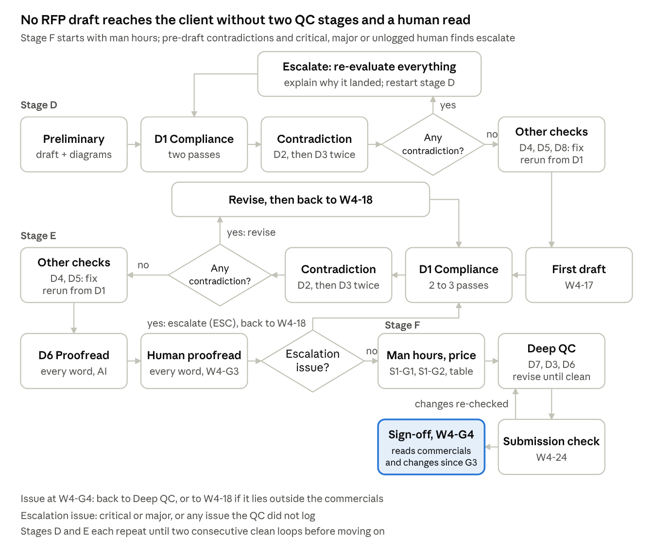
Figure: W4 stages D to F, with the human gates W4-G3, S1-G1, S1-G2 and W4-G4

11. W5 RFI clarification questions
W5 produces a short list of questions that are genuinely unanswered and genuinely needed, for an RFP or for any other pursuit where the client’s documents and calls leave the solution blocked. Claude on its own tends to produce a hundred or two hundred questions, many already answered and some inconsistent; W5 is built to prevent that. Three agents run in turn: the first removes what is already answered, the second removes what is not needed, and the third simulates building the proposal to find where it really gets stuck. W5 runs before any baseline is locked, so it checks against the sources and a provisional requirement register.
Item | Detail
Router picks it when | An RFP is present and its clarification window is open (rule 2), or on request for any pursuit, with or without an RFP (rule 1)
Inputs | Everything the client has sent (blocking): in an RFP pursuit, the RFP and annexures; otherwise the client’s documents and call transcripts. The question deadline where there is one; earlier answers and the buyer’s question template (useful)
Parameters | Pursuit type; anonymised Q&A (yes or no); question cap from config
Output | A question sheet for the buyer or client, and an internal tracker (11.2)

11.1 Step-by-step flow
# | Agent | Does | Output | Rule or guard
W5-1 | Context study | Studies the details of every document, transcript and earlier answer the client has sent; builds a provisional requirement register, using the W4 Stage A agents (W4-1 to W4-4) for an RFP, or the W3 extractor and consolidator (W3-5, W3-6) otherwise; recordings go through the Transcription service (6.4) | Indexed sources, provisional register | No question is written before this completes
W5-2 | Question drafter | Drafts candidate questions from the documents | Candidate questions | Each tied to a clause or passage; no target to produce many
W5-3 | Agent 1: already-answered check | For each question, searches all sources for the answer. Found: the question is dropped, citing where. Not found: the sections searched are recorded | Kept and dropped lists with evidence | No step-specific rule
W5-4 | Agent 2: relevance check | Keeps a question only if it is really needed: its answer changes design, effort, price, compliance or risk; states which | Relevant set | No step-specific rule
W5-5 | Agent 3: solution simulation | Simulates building the proposal (architecture, effort, plan, commercials) and records where it gets stuck; those stuck points become questions, and questions that unblock nothing are dropped (added; see A.2) | Simulation-backed set | Questions added here also pass W5-3 and W5-4
W5-6 | Section verifier | Re-opens the section each question cites and confirms the problem is really there, as described | Verified set | Misattributed questions fixed or dropped
W5-7 | Simplifier | Writes each question in simple English beside the complex version | Two-column set | The complex column keeps the document reference so people can trace where each question comes from
W5-8 | Duplicate and contradiction check | Merges questions asking the same thing; removes questions that contradict each other or the provisional register | Clean set | The same question is never asked twice
W5-9 | Ranker | Ranks by impact and trims to the configured cap (added; see A.2); questions cut by the cap are listed for the approver at W5-G1 | Final set | Never exceeds the cap
W5-10 | S2 QC, W5 profile | W5-3, W5-4, W5-6 and W5-8 repeated 2 to 3 times by new instances; D6 proofread; the anonymised Q&A rule (HR-11) and the build platform rule (HR-03) | QC report | No step-specific rule
W5-11 | Manual cross-check assist | For each question, shows side by side: the question, the section it cites with the passage quoted, the closest answering passage found anywhere in the sources, and the sections searched. It is briefed to prove the question unnecessary, not to confirm it | Review sheet | Pass rule: a question reaches W5-G1 only with either its cited passage quoted word for word and located, or, for a gap found by the W5-5 simulation, the stuck point described and the list of sections searched showing the information is absent; a question with neither is dropped. Fallback: if, over the first pursuits, the approver still finds already-answered or irrelevant questions above the configured rate, the consultant or bid owner switches the cross-check at W5-G1 to human-led, with the agent supplying search hits only; each escape is added to the W5-3 and W5-4 checklists (ESC-4). The pass rule is tested on two past RFPs with their RFI question sets and final responses (pending, B.5)
W5-G1 | Approver gate (bid owner for an RFP; presales consultant otherwise) | Manually reviews every question: already answered? relevant? is the problem really in the cited section? | Approved list | No step-specific rule

11.2 Outputs
Buyer question sheet (mapped to the buyer’s template when one is given)
Column | Content
Q ID | Sequential
Question (simple English) | Plain and short, one sentence where possible
Question (complex) | Full wording, with the document, section, page or clause it comes from
Internal tracker (never sent to the buyer)
Column | Content
Q ID | Same as the buyer sheet
Why we need it | The decision it unblocks: design, effort, price, compliance, risk
Searched, not answered in | Sections W5-3 checked
Priority | High / Medium / Low
Where the buyer runs an anonymised Q&A, the question text never names Mindmap Digital; it uses “we” and “our”.

12. S1 Effort and commercials
S1 runs inside W3 and W4 after QC and the human proofread (W3-19, W4-22), in the order the brief describes: man hours first, checked by the QC-1 and QC-2 agents; then cost (human cost at the blended rate, less the reduction from using AI in development, plus overhead); then the price the client is likely to pay and move ahead with; then the one commercials table; then the deep QC. The Gantt is drafted earlier from a provisional phase plan (W3-10, W4-9) and reconciled with the reviewed man hours in the deep QC. The internal build-up never leaves Mindmap; the client sees one commercials table.

12.1 Part 1: Effort (W3-19, W4-22)
# | Agent | Does | Output | Rule or guard
S1-1 | Work breakdown agent | Breaks the approved solution into work packages: each module and sub-agent, integrations, data work, testing, deployment, project management | Work packages | Every package maps to a baseline requirement
S1-2 | Estimator | Estimates the man hours needed per package and role | Effort estimate | Assumptions recorded per package
S1-3 | QC-1 agent (fresh context) | Reviews the estimate package by package: missing packages, wrong roles, hours too high or too low, weak assumptions | Findings and a corrected estimate | No step-specific rule
S1-4 | QC-2 agent (fresh context) | Reviews the corrected estimate independently to make sure the man hours are correct | Findings | Never sees QC-1’s reasoning
S1-5 | Reconciler | Applies agreed changes; differences above the configured tolerance go to the solution architect and the delivery lead with reasons; compares the total effort with the provisional phase plan and flags any gap for the Gantt | Reviewed man hours | No step-specific rule
S1-G1 | Architect and delivery lead | Approve the man hours | Locked effort | No step-specific rule

12.2 Part 2: Cost and price (W3-19, W4-22)
# | Agent | Does | Output | Rule or guard
S1-6 | Cost calculator | Human cost = reviewed man hours × blended hourly rate. Then estimates the reduction from using AI in development, per work package: which tasks AI speeds up (for example code generation, test writing, documentation, data mapping), by how much, and why, checked by a fresh-context reviewer. Then overhead | Internal cost | All values from config; nothing hardcoded. The overhead within the 20% to 30% range is proposed by the delivery lead from the engagement’s load (travel and onsite time, project management and governance, compliance and documentation, number of client stakeholders), with the reason recorded. The overhead and the AI reduction are approved at S1-G2; reduction ranges per task type come from config
S1-7 | Infrastructure estimator | Estimates the indicative infrastructure cost from the approved technical architecture: hosting option (cloud, client data centre or on-premise), compute and GPU, storage, model or API usage at the expected volumes, third-party licences | Indicative infrastructure cost with its assumptions | Given most of the time; charged to the client at actuals with no Mindmap margin; the assumptions stay internal and a one-line basis appears in the table; a licence or paid data feed billed directly by its provider is shown on its own row instead (12.4)
S1-8 | Revenue share modeller | Platform or SaaS builds only: proposes a revenue share from the models in config (for example a percentage of platform revenue, a fee per transaction, or a fee per active user), with the basis, the rate, the term, and any floor, cap or reduced implementation fee it trades against | Revenue share proposal | Not run for a standard build
S1-9 | Price recommender | Recommends the client price from the internal cost, client size, deal size, budget signals from calls and comparable past deals, with its reasoning on what the client is likely to pay and move ahead with | Recommended price and reasoning | No step-specific rule
S1-G2 | Pricing owner | Approves or sets the client price, the AI reduction, the overhead, whether the infrastructure line shows the indicative amount from S1-7 or reads “At actuals” (reason recorded) and, for platform builds, the revenue share (added; see A.2) | Approved price | No step-specific rule
S1-10 | Commercials table builder | Builds the single client commercials table (12.4) | Commercials section | The calling workflow then runs the deep QC (W3-20, W4-23)
Internal cost = (H × R) × (1 − a) × (1 + o)
H = reviewed man hours; R = blended hourly rate, 750 (in config; currency to confirm); a = reduction from using AI in development, the hours-weighted average of the per-package reductions estimated in S1-6 and checked by a fresh-context reviewer; o = overhead, 20% to 30%. The order follows the brief: human cost, then the AI reduction, then overhead. The client price is then set on what the client is likely to pay (S1-9), not on cost plus a fixed margin.

12.3 Standard commercial structure
Line | Rule
One-time implementation fee | Almost always (the default)
Annual maintenance (AMC) | Compulsory; 20% of the implementation fee
Revenue share | Platform or SaaS builds only, modelled by S1-8; a standard build uses the implementation fee, the compulsory AMC and infrastructure at actuals, with no revenue share
Infrastructure | Most of the time an indicative cost is given (S1-7); where the pricing owner decides at S1-G2 not to give one, the amount reads “At actuals” (HR-06). It is charged as actuals, directly to the client, not by Mindmap Digital, with no Mindmap margin

12.4 Commercials table rules and layout
- One simple table, in the commercials section only, so the client is not confused.
- No prices anywhere else: not in the executive summary, solution sections or appendices.
- No internal basis in any client output: man hours, rates, overhead, AI reduction, margin, notes on where the team is stretched.
- Mindmap’s charges and the charges billed by others are separated by two to three blank rows.
- The infrastructure line, billed by others, sits below the blank rows, highlighted (shaded) and bold, and says inside the table: “Charged as actuals. Billed directly to you, not by us (Mindmap Digital).” The infrastructure line always appears (HR-06).
- Any other charge billed to the client directly by a third party (for example a software licence or a paid data feed, each named by provider, HR-17) gets its own row under the infrastructure line, in the same shaded, bold style and with the same wording.
Item | Basis | Amount
One-time implementation fee | Fixed | [amount]
Annual maintenance (AMC) | 20% of the implementation fee, per year | [amount]
Revenue share | [basis] | [share]
Infrastructure | Charged as actuals. Billed directly to you, not by us (Mindmap Digital). [one-line basis, for example hosting option and volumes] | [indicative amount, or “At actuals”]
The revenue share row appears only for platform or SaaS builds. Where no indicative amount is given, the infrastructure amount reads “At actuals”. The infrastructure row is shaded as well as bold.
Where the buyer mandates a price schedule (W4), it takes precedence; the rules above apply wherever the buyer’s format allows, and D7 checks against the buyer’s schedule. Where the buyer’s schedule requires effort or rates (for example man-days or a rate card), the pricing owner decides at S1-G2 what is shown, and D7 checks against that decision.

13. S2 QC engine
S2 is one pool of eight checkers, run as a different profile for each deliverable. A contradiction before the first draft, or a critical, major or unlogged issue a human finds at a document gate, triggers the escalation protocol, so the drafting agent re-evaluates the whole document rather than patching one line; other findings are simply fixed.

13.1 Checker catalogue
Checker | Checks | Against
D1 Compliance | Every requirement answered, in the right place, to the stated depth; reads every line, word, table and image; flags any partial or deviation answer the bid owner has not approved, for the bid owner to decide | Baseline, compliance matrix, RFP, transcripts, RFI answers; in W6, the sub-agent specs and the demo code (hardcoded values)
D2 Contradiction (the contradiction agent) | Takes the requirement understanding and reads the document for any sort of contradiction; always runs in W3 and W4, never skipped | The requirement understanding (baseline) and the sources
D3 Consistency | Contradiction within the document itself and consistency of technology choices, channels, security claims, numbers, durations, roles and names. Its first step extracts every claim into a claims ledger and flags any subject where claims conflict | The document’s own claims; in W7, the script against the screens
D4 Scope and promises | Anything not agreed: a mobile app, extra integrations, SLAs, free demo or free POC offers, POC content in use case slides, price or timeline promises outside the Gantt and the commercials table, internal cost basis, the build platform’s name | The baseline in W3 and W4; approved pain points and agreed scope in the Case File elsewhere; house rules
D5 Visuals and tables | Every diagram label, table cell, caption and screen against the text and the other visuals; builds its own list of claims; checks that every data source in an architecture is named and matches the text and the other architecture, web sources included (HR-17) | The text; the UI checklist in W6; recorded frames in W7
D6 Proofread | Every word: grammar, terminology, names, numbering, cross-references, style rules, tone | House rules
D7 Commercials | Commercial terms in place, price placement, table structure, AMC arithmetic, infrastructure wording, internal cost leakage | Section 12 rules; the buyer’s price schedule where one is mandated
D8 Source check | Every claim about the client or about Mindmap traces to a verified evidence record or the approved company profile | Evidence records, company profile
Coverage rule. Every pass returns a coverage log of every paragraph, word, table cell, diagram, image and caption by ID. The orchestrator counts the document’s elements itself and compares; incomplete coverage fails the pass (F5).

13.2 Terms
Term | Meaning
Pass | One run of one checker by one new reviewer instance
Loop | One run of the checkers listed for a step or stage (for example W3-16, or W4-12 to W4-16)
Clean loop | A loop with no critical or major findings and no contradiction of any severity from D2 or D3, before or on the first draft; other minor findings are fixed before the next human gate
Deep QC | One run of D7, D3 and D6 after pricing, repeated until a run finds nothing critical or major and no contradiction (a clean deep QC)
Stage | A named part of W4 (A to F)

13.3 QC profile per deliverable
Numbers are passes; a dash means the checker does not run. For W3, “then” separates the loop before the first draft from the loop on it; D6 runs once before the human proofread; the after-pricing entries form the deep QC, repeated until clean.
Checker | W1 | W2 | W3 | W4 stage D | W4 stage E | W4 stage F | W5 | W6 | W7 | W8
D1 | - | - | 2, then 2 to 3 | 2 | 2 to 3 | - | - | 1 (spec against build, hardcoded values) | - | -
D2 | - | - | 1, then 1 | 1 | 1 | - | - | - | - | -
D3 | 1 | - | 2, then 2; plus 1 after pricing | 2 | 2 | 1 | - | - | 1 (script against screens) | -
D4 | 1 | 1 | 1, then 1 | 1 | 1 | - | - | 1 | 1 | 1
D5 | 1 | - | 1, then 1 | 1 | 1 | - | - | 1 (UI checklist) | 1 (frames) | -
D6 | 1 | - | 1; plus 1 after pricing | - | 1 | 1 | 1 | - | 1 (captions) | 1
D7 | - | - | 1 after pricing | - | - | 1 | - | - | - | -
D8 | 1 | 1 | 1 | 1 | - | - | - | - | - | 1
Workflow-specific | Periodic table relevance check (W1-7); second specificity check (W1-12) | Branding and data check (W2-4) | Visual cohesion and diagram opportunities (W3-15) | - | - | Submission check (W4-24) | W5-3, W5-4, W5-6, W5-8 repeated 2 to 3 times; HR-11; HR-03; W5-11 pass rule | Tests (W6-8); acceptance criteria (14.3) | Frame check (W7-5) | Weird-email patterns (Section 16)

13.4 Escalation protocol
Triggers: (1) any contradiction, of any severity, found by D2 or D3 before the first draft (W3-16, W4 stage D); (2) at a document gate (W3-G3, W3-G4, W4-G3, W4-G4), any critical or major issue, or any issue the QC did not log (a QC escape). Contradictions found on the first draft (W3-17, W4 stage E) or in the deep QC are revised and the loop re-run, without the trust reset, as the brief describes for that point. Other gates are ordinary approvals: a rejected item is revised or replaced without escalation.
Step | What happens
ESC-1 Log | The finding is logged with its location; a human-found issue is logged as a QC escape
ESC-2 Explain | The drafting agent must explain why this landed in the document after all the earlier checks: whether it missed something or added something
ESC-3 Trust reset | Because something got through, the earlier output is not trusted. The drafting agent re-evaluates everything in depth, from scratch: the whole document, against the requirement understanding and every source, and is told not to reuse the thought process it followed before. It is done by a new drafting instance given only the sources, the locked baseline, the findings and the ESC-2 explanation, never the earlier reasoning; it returns a re-evaluation note listing every section it re-checked and what it changed, kept in the Case File and read at the next human gate
ESC-4 Re-run and learn | The loop re-runs with new reviewer instances from its return point; the root cause is added to the relevant checklist (added; see A.2)

Finding or issue | Returns to
Contradiction before the first draft (W3-16, W4 stage D): escalation | W3-16, W4-12
Contradiction on the first draft (W3-17, W4 stage E): revised, no trust reset | W3-17, W4-18
Issue at W3-G3 or W4-G3: escalation | W3-17, W4-18
Issue at W3-G4 or W4-G4: escalation | W3-20 or W4-23 if it is in the commercials; otherwise W3-17 or W4-18
The drawn W4 flow is in Section 10.

13.5 Exit rule and severity
A loop repeats until two consecutive loops are clean (proposed rule; see A.2); the deep QC repeats until clean. No stage loops without end: if a stage reaches the configured maximum number of loops (Section 18) without meeting its exit rule, it stops, and the consultant or bid owner receives the open findings and decides whether to continue, accept with notes, or rework (added; see A.2). Then the workflow moves to its next step or human gate.
Severity | Meaning | Examples
Critical | Would lose the bid or create commercial or legal exposure | Missing mandatory requirement, unrequested commitment, price outside the table, internal rate visible
Major | Would be noticed and hurt credibility | Self-contradiction, a diagram that does not match the text, wrong client name
Minor | Polish | Grammar, capitalisation

14. W6 Demo build
A demo must impress the client, not just work. W6 starts from the team’s own understanding of how the work is really done, breaks the process into 10 to 12 sub-agents each built to the depth it deserves, puts them behind a UI that looks very good, and tests them on real documents before anyone sees the demo.
Item | Detail
Router picks it when | The request names it (rule 1), or as an accepted follow-on when W2 finds no good library match (5.5)
Inputs | Target process and the team’s domain input (blocking); client documents for testing, approved pain points (useful)
Output | Working demo, test log per sub-agent, run sheet (feeds a live demo or W7)

14.1 Step-by-step flow
# | Agent | Does | Output | Rule or guard
W6-1 | Domain capture, with research support | The domain owner, the team member who studied the domain, records how the work really flows: sequence, decision points, branches. A research agent supports with sources and fills gaps, each flagged for review | Domain process map | The team’s understanding is the primary input, because Claude alone gives a generic process that will not impress a client
W6-G1 | Domain owner gate | Approves the process map before anything is built | Approved map | No step-specific rule
W6-2 | Business problem selector | Picks the real business problems in that domain that the demo must solve | Problem list with reasons | Tied to the client’s pain points where known
W6-3 | Process decomposer | Breaks the process into 10 to 12 sub-agents and specifies each to the depth it deserves (14.2) | Sub-agent specs | The count range comes from config. Each spec covers its sub-flows and branching, not a single step
W6-4 | Impact feature designer | Proposes features that impress this audience because they are rarely seen in applications, such as a 3D view; a feature counts only if this audience does not already see it in its own tools (the brief’s exception: drawing applications already show 3D) | Feature list | No step-specific rule
W6-5 | UI designer | Designs an interface that looks very good and passes the UI checklist (14.3) | UI design | UI checklist (14.3)
W6-6 | Builder | Builds every sub-agent as functional, inside the platform | Working demo | Nothing hardcoded; values come from uploaded documents and configuration (HR-13)
W6-7 | Test data preparer | Assembles in-sample and out-of-sample documents, with expected outputs for each sub-agent | Test set | Document parsing gets the widest test set
W6-8 | Test agent | Runs every sub-agent end to end through the browser (Playwright and Claude in Chrome) and compares outputs with expected; document parsing is tested on every document type | Test log per sub-agent | Empty, wrong or generic outputs fail; a failed sub-agent returns to W6-6 with its test log. Automated testing only serves to a certain extent
W6-9 | S2 QC, W6 profile | D1 (spec against build, including a check for hardcoded values), D4 (no build platform name, no unagreed claims), D5 (UI checklist) | QC report | No step-specific rule
W6-G2 | Output review | The domain owner, consultant and demo builder review the outputs themselves, confirm they are what they expect, and check the demo against the acceptance criteria in 14.3 | Demo ready | Automated tests never replace this review
W6-10 | Run sheet writer | The demo path, the data to load, talking points tied to the pain points | Run sheet | Used for a live demo or by W7

14.2 Sub-agent specification
Field | Content
Purpose | The business task it performs
Inputs | Documents or data it reads, and from which earlier sub-agent
Sub-flows | The steps inside it
Branching | User choices or data conditions that change the downstream path
Outputs | What it produces and which sub-agent uses it
Test cases | In-sample and out-of-sample inputs with expected outputs

14.3 UI checklist
A consistent design system; real data on every screen, no placeholder text; a clear flow from one sub-agent to the next; outputs shown the way the domain expects them (schedules as Gantt charts, quantities as BOQ tables, structures in 3D where used); no build platform name in the URL, footer, page title or loading screens.
Acceptance at W6-G2: impressive, not just functional
Criterion | Test
Looks very good | Passes the UI checklist above; the domain owner would show it to a senior client as it stands
Real business value | Each screen solves one of the problems from W6-2 and shows the result in the client’s terms: time, cost, margin or risk
Depth | 10 to 12 sub-agents, each with its sub-flows and branches working, not a single step
Something rarely seen | At least one feature the audience rarely sees in applications, such as a 3D view, where it fits the domain
Functional | Every sub-agent passes its in-sample and out-of-sample tests (W6-8)
True to the domain | The domain owner confirms the flow matches how the work is really done

14.4 Worked example: construction tender bidding agent
A tender bidding agent for a construction company is not “take a tender and send out a proposal”. Documentation is a huge problem, and the biggest problem in construction is the planning itself: the plan decides the pricing and the margins, margins are very thin, so there is little room for error.
The domain sequence: soil investigation, then excavation, then dewatering or shoring, then flooring (the flooring is decided by the soil investigation), then substructure, then superstructure. Uploading a tender does not tell you how the construction will flow: the soil investigation decides the path through everything after it, which is why the scheduling sub-agent branches.
Soil branching in the scheduling sub-agent
Element | Requirement
Branch point | The soil type, selected by the user: the soil they expect, or the soil they want to calculate with
Options | The soil classes in the domain owner’s process map (W6-1), not a generic list; the user can run more than one to compare
What changes downstream | The excavation method, whether dewatering or shoring is needed, the flooring decision, the substructure, and the durations, quantities and costs of each
Propagation | Each branch produces its own schedule, BOQ quantities and price, so the pricing sub-agent can show the cost and margin under each soil scenario
Sub-flows | Each stage (excavation, dewatering or shoring, flooring, substructure, superstructure) is its own sub-flow with its own inputs and outputs
View | Schedules as Gantt charts per branch, side by side; the 3D view follows the selected branch

Sub-agent | Purpose | Inputs | Sub-flows and branching | Outputs | Tests
Document compliance | Answers the documentation problem: checks the tender documents are complete and the bidder is eligible | Tender documents; company profile | List the required documents and forms; check each is present and filled; check eligibility criteria against the company profile; flag gaps | Compliance checklist with gaps and where each requirement sits in the tender | A complete tender and tenders with known gaps
Drawings | Reads the tender drawings | Drawing files (PDF or CAD exports) | Identify elements, dimensions, levels and annotations per sheet | Structured drawing data | Drawings from this tender (in-sample) and from other tenders (out-of-sample)
Drawings to specifications | Turns the drawings into specifications | Drawing data; the tender’s specification text | Per element: material, grade, dimensions, finish; conflicts with the written specification flagged | Specification list | Compared with the tender’s own specifications
BOQ estimation | Bill of quantities | Drawing data; specifications; the selected soil branch | Quantities per element and per stage, recomputed for each soil branch | BOQ table per branch | Against a BOQ prepared by the team; tolerance set by the domain owner
Construction scheduling | The plan, which decides pricing and margin | BOQ; specifications; soil branch | The soil branching above, with a sub-flow per stage | Schedule per branch, as a Gantt chart | Each soil branch gives the sequence the domain owner expects
Construction pricing | Prices the plan; margins are thin, so there is little room for error | BOQ and schedule per branch; rates from the uploaded rate library (never hardcoded) | Cost per stage and branch; margin and risk buffer shown per branch | Price and margin per soil scenario | Against a past priced tender; tolerance set by the domain owner
3D agent | Turns the tender into a 3D representation alongside the plan | Drawing data; schedule | Build the model; link each element to its schedule stage; follow the selected branch | 3D view, stage by stage | Model dimensions match the drawings
Remaining sub-agents (to reach 10 to 12) | [INSERT: from the code review, B.5] | [INSERT: from the code review, B.5] | [INSERT: from the code review, B.5] | [INSERT: from the code review, B.5] | [INSERT: from the code review, B.5]

15. W7 Demo video
W7 turns a working demo into an AI-voiced, edited video when the requirement calls for a video instead of a live demo. The build platform (Base44) must never be visible in any frame. This BRD is internal; client-facing outputs never name the platform (HR-03).
Item | Detail
Router picks it when | The request names it (rule 1), or as an accepted follow-on (5.5)
Inputs | Working demo (blocking); run sheet from W6-10 (W7-1 writes one if it is missing); client region for the voice (useful)
Output | Single video file, not zipped (HR-14). A live demo uses the W6-10 run sheet and does not need W7

# | Agent | Does | Output | Rule or guard
W7-1 | Script writer | Writes a run sheet first if W6-10 has none; then the script, scene by scene: the client problem, what the sub-agent does, the result | Script | Each scene tied to a pain point
W7-2 | Recorder | Records the scripted path, driven by browser automation so takes repeat | Raw footage | No step-specific rule
W7-3 | Voiceover | AI voiceover from the script; voice, accent and pace set per client region | Audio track | No step-specific rule
W7-4 | Editor | Cuts, zooms on key outputs, captions, Mindmap title and end cards | Edited video | No step-specific rule
W7-5 | Build platform frame check | Checks every frame: the platform name in the URL bar, at the bottom of the page (where it sometimes appears), in the tab title, on loading screens | Pass, or frames to crop or mask | Mandatory
W7-6 | S2 QC, W7 profile | D3 (script against screens), D4, D5 (frames), D6 (captions) | QC report | No step-specific rule
W7-G1 | Consultant gate | The consultant and the demo builder watch the final cut | Release; the video is sent with a W8 cover note as a follow-on (5.5), or the demo is shown live from the W6-10 run sheet | No step-specific rule

16. W8 Email drafts
Emails are mostly drafted by AI but must be proofread. AI drafts tend to read oddly and to promise a free demo or a free POC to every client. W8 never offers either, never commits to prices or timelines, and always goes to a human before sending.
Item | Detail
Router picks it when | The request names it (rule 1), or as an accepted follow-on (5.5)
Inputs | Purpose and recipient (blocking); Case File context and any attachment (useful)
Output | Email draft

Email type | Set by | Content
Cold outreach | After W1 | One sourced pain point, one relevant capability, a request for a conversation
Follow-up | After a call, or after a warm-approach deck | What was discussed and the agreed next step
Deck or proposal cover | After W3 (proposal cover) or W7 (video cover note) release; a W1 deck goes with the cold outreach or follow-up above | What is attached, the two or three points that matter, the next step
RFI or bid submission note | After W5 or W4 | In the buyer’s required form
The email-type table is an addition beyond the brief (see A.2).
# | Agent | Does | Rule or guard
W8-1 | Context reader | Pulls only the facts the email may use from the Case File | Sourced facts only
W8-2 | Drafter | Writes the email, short by default | Calm, measured, consultant tone; no hype (HR-10)
W8-3 | S2 QC, W8 profile | D8 on every claim; D4 removes any free demo, free POC, price or timeline commitment; D6 proofreads every word and the tone; every pattern in the table below is checked | No exceptions (HR-01)
W8-G1 | Consultant gate | Proofreads every word, edits and sends | Sending is always a human action
What makes an AI email read oddly, and how W8 checks it
Pattern | Example | Checked by | Source
Free demo or free POC offered | “We would be happy to set up a free demo” or “a free POC” | D4; removed, no exceptions | Brief
Tone off | Over-eager, salesy, hype words, exclamation marks | D6, against HR-10 and the configured hype-word list | Brief (tone)
Commitments not agreed | Prices, discounts, timelines, guaranteed results | D4 | Added
Unverified claims | Client names, numbers or results not in the approved company profile or the Case File | D8 | Added
Generic opener | Nothing about this company; could be sent to anyone | D6, against the sourced facts from W8-1 | Added
Too long, or too many asks | Longer than the configured length; more than one request | D6 | Added
Leftovers | Placeholders such as [Name], internal notes, a wrong company name, the build platform’s name | D6 and D4 | Added

17. House rules
These rules live in configuration so the team can add to them, and are checked by the checker or step named. The Source column shows whether a rule comes from the brief, from the team’s standing preferences, or is an addition.
ID | Rule | Applies to | Checked by | Source
HR-01 | Never offer a free demo or a free POC | W1, W2, W3, W4, W7, W8 | D4 | Brief
HR-02 | No deliverable outside the baseline or agreed scope (for example a mobile app, extra integrations, SLAs) | W3, W4 | D4 | Brief (mobile app); rest added
HR-03 | The build platform (Base44), its functions and integrations are never named or visible in client content | W1 to W8 | D4, W2-4, W5-10, W7-5 | Brief (video); team preference
HR-04 | No internal cost basis in client outputs: man hours, hourly rates, overhead, AI reduction, margin, notes on where the team is stretched. Where a buyer-mandated price schedule (W4) requires effort or rates, the pricing owner decides at S1-G2 what is shown, and D7 checks against that decision | W1, W2, W3, W4, W8 | D7 in W3 and W4; D4 elsewhere | Team preference
HR-05 | Prices only in the one commercials table; never in the executive summary or anywhere else. In W4, where the buyer mandates a price schedule, that schedule replaces the commercials table and this rule applies wherever its format allows (12.4) | W3, W4 | D7 | Brief
HR-06 | The infrastructure line always appears, highlighted and bold, stating that it is charged as actuals and billed directly to the client, not by Mindmap. Most of the time it carries an indicative amount; where none is given (the pricing owner decides at S1-G2, with the reason recorded), the amount reads “At actuals”. In W4, where the buyer mandates a price schedule, the infrastructure line follows that schedule wherever its format allows (12.4) | W3, W4 | D7 | Brief
HR-07 | No POC content or POC timings in use case slides | W1; W3 and W4 when delivered as a PPT | D4 | Team preference
HR-08 | Use cases presented directly; never labelled illustrative, hypothetical or “not a client case” | W1; W3 and W4 when delivered as a PPT | D6 | Team preference
HR-09 | No em dashes in slide content | W1; W3 and W4 when delivered as a PPT | D6 | Team preference
HR-10 | Calm, measured, consultant tone; logic-first; no hype | W1, W3, W4, W5, W7, W8 | D6 | Brief (email tone); team preference
HR-11 | In anonymised bidder Q&A, never name the company; “we” and “our” only | W5 | W5-10 | Team preference
HR-12 | Never create a new slide. Every slide is a duplicate of a provided template slide (Appendix B.3 and B.6, held in the template library), edited by changing or removing text and images only; font sizes and formatting stay as they are. A slide type with no template in the library holds the deck until the consultant supplies one | W1; W3 and W4 when delivered as a PPT | W1-11, W3-14, W4-10 (template library lookup); D6 (formatting unchanged) | Brief (templates); team preference
HR-13 | Nothing hardcoded: every value comes from source documents or configuration | All workflows, demos, S1, router thresholds | D1 in W6 for demo code; for S1 and the router, a design rule reviewed at S1-G1, S1-G2 and RT7 | Team preference
HR-14 | Files delivered individually, never zipped | All deliverables | Orchestrator | Team preference
HR-15 | Decks delivered as PowerPoint files built from the provided templates | W1; W3 and W4 when delivered as a PPT | Orchestrator | Team preference; brief (templates)
HR-16 | Company facts, badges and certifications (offices, client count, accelerator count, awards) only from the approved company profile; an expired badge or certification on a template slide is removed | W1, W3, W4, W8 | D8 | Added
HR-17 | Every solution architecture names its data sources: the system or file and the data taken from it; no generic source tile (“ERP”, “Data sources”, “Enterprise systems”, “Web data”, “Price catalogue”, “News API”, “Third-party APIs”); sources from the web are named too, by provider and feed (each price catalogue, market or price feed and news API); the technical architecture uses the same names | W1, W3, W4 | D5; consultant gate W1-G2; architect gates W3-G2, W4-G2 | Brief (Messages 6 and 7)
New rules come mainly from QC escapes: when a human catches something, the team decides whether it becomes a standing rule (ESC-4).

18. Integrations and configuration
The agent connects to the tools named below and keeps every business value, band, threshold and rule in one configuration store. Tools the brief does not name are proposals to confirm.
Integrations
Need | Integration | Used by | Priority
Call recordings and transcripts | tl;dv: the recording and tl;dv’s own transcript pulled by meeting link or ID at intake; matched to the client’s Case File by the consultant at RT7 if the meeting title does not name the client; connects through the team’s tl;dv account, with its key held in a secrets store; if a pull fails or the recording is still processing, the agent retries, then asks the consultant to upload the recording or transcript | Every workflow that receives a recording (at intake) | Should
Video to MP3 | Media conversion inside the agent (a separate manual step today) | Every workflow that receives a recording | Must
MP3 to transcript | Speech to text with speaker labels and timestamps, used when no usable tl;dv transcript exists | Every workflow that receives a recording | Must
Company research | Claude web search and web fetch (proposed), over named sources: the company’s investor relations pages; stock exchange filings and call transcripts (BSE and NSE for Indian listed companies, SEC EDGAR for US listed ones); news through a news API (NewsAPI.org proposed); job posts on the company’s careers page and LinkedIn Jobs | W1, W6 | Must
Leadership posts | LinkedIn content via search results or links the consultant supplies (subject to LinkedIn’s terms) | W1 | Should
Knowledge base | Store for the accelerator catalogue, case studies, past proposals, the template library, the demo and video library (location to confirm) | All | Must
Diagrams | Diagram tool for architectures and flows in the Mindmap formats (tool to confirm) | W1, W3, W4 | Must
Decks and documents | PowerPoint editing of template slides; Word and PDF generation from Mindmap templates | W1, W3, W4 | Must
Demo build and test | The build platform; Playwright and Claude in Chrome for testing | W6 | Must
Voiceover and editing | AI voiceover and video editing tools (to confirm) | W7 | Should
Email | Draft creation in the team’s email system (to confirm) | W8 | Should
Agent workspace | Where consultants make requests and see the RT7 card, gates, findings and QC reports, and approve (tool to confirm) | All | Must
Identity and roles | Single sign-on with the roles in Section 4; internal cost data restricted per N-04 (tool to confirm) | All | Must
Model and orchestration runtime | Claude models per agent and reviewer, through the Claude API (proposed), and a workflow orchestrator with resumable state (N-07); to confirm | All | Must
Configuration store
Parameter | Current value | Used by
Blended hourly rate | 750 (currency to confirm) | S1-6
AMC | 20% of the implementation fee | S1-10
Overhead range | 20% to 30%; the value per deal proposed by the delivery lead and approved at S1-G2 | S1-6
AI reduction ranges per task type | To set from the team’s experience (for example code generation, test writing, documentation) | S1-6
Effort reconciliation tolerance | To set | S1-5
Revenue share models | The models the team offers, with default ranges (to set) | S1-8
Infrastructure cost inputs | Unit rates per hosting option, compute, storage and model usage (to set; refreshed from each provider’s published pricing, named per provider, for example the AWS Price List API, the Azure Retail Prices API and the model vendor’s API pricing page) | S1-7
Proposal format bands | International, smaller client: up to 25 lakhs gets a PPT. Indian enterprise: 15 lakhs and above gets a detailed document. Any other case: the consultant decides at RT7. Client-size threshold (smaller client or enterprise): to set | RT6, W3-20, W4-23
Number of pain points | 5 | W1-5, W1-6
Pain point scoring weights | Defaults to set (7.1) | W1-5
Periodic table tile count | Read from the periodic table template’s grid | W1-7
Demos or videos per pick | 1 to 3 | W1-10, W2-2
Sub-agents per demo | 10 to 12 | W6-3
Blank rows before charges billed by others | 2 to 3 | S1-10, D7
Man-hour QC agents | 2 (QC-1, QC-2) | S1-3, S1-4
Requirement-understanding reviews | 3 in W4-5 (2 if the bid owner sets it); 2 in W3-7 (3 if the consultant sets it) | W3, W4
AI proofreading checks before the first draft | 5: compliance twice, the contradiction agent, the consistency check twice | W3-16, W4 stage D
Classifier confidence threshold | To set | RT2
Library match threshold | To set | W2-2
Evidence recency window | To set | W1-3
RFI question cap | To set | W5-9
RFI cross-check fallback rate | To set | W5-11
Email length and hype-word list | To set | W8-3
Passes per checker | Per the QC profile (13.3) | S2
QC exit rule | Two consecutive clean loops (proposed) | S2
House rules | Section 17 | S2
RFI QC repeats | 2 to 3 | W5-10
Steps per solution on a solution slide | 3 to 5 | W1-8
Demo test tolerances (BOQ, pricing) | Set by the domain owner for each demo | W6-7, W6-8, 14.4
Maximum loops per stage | To set (5 proposed); when reached, the stage stops and a human decides (13.5) | S2, every workflow
Specificity bar | To set: the pass mark for the specificity test (7.1) | W1-5, W1-6
Data handling: client documents stay in that client’s Case File, with no cross-client content in client text; evidence is stored with URL, retrieval date and passage; every draft, QC report, routing decision and approval is versioned.

19. Non-functional requirements and human gates
The agent must be traceable and safe to trust: every claim sourced, every check logged, and nothing reaching a client without a named person approving it.
ID | Area | Requirement | Priority
N-01 | Traceability | Every requirement, pain point, number and claim links to its source | Must
N-02 | Auditability | Versions of drafts, QC reports, findings, routing decisions and approvals kept per pursuit | Must
N-03 | Independence | Checkers isolated from the drafting context (6.3) | Must
N-04 | Confidentiality | Client data isolated per pursuit; internal cost and effort data visible only to the pricing owner, solution architect and delivery lead | Must
N-05 | Data residency | Option to run on Mindmap or client-approved infrastructure for sensitive bids (added; see A.2) | Should
N-06 | Configurability | All values and house rules editable without code changes; nothing hardcoded | Must
N-07 | Resumability | Long workflows resume from the last completed step | Should
N-08 | Transparency | Each step shows what it did, what it used, and what it is unsure of | Must
N-09 | Deadline awareness | RFP and question deadlines drive a back-planned schedule with alerts | Should
Human gates
Gate | Approver | Approves
RT7 | Presales consultant (the bid owner for W4, and for W5 in an RFP pursuit) | Workflow and parameters (W1, W3, W4, W5, W6, W7 wait; W2 and W8 proceed and show the card)
W1-G1 | Presales consultant | The five pain points and their sources
W1-G2 | Presales consultant | Final deck
W2-G1 | Presales consultant | Demo shortlist and talk track
W3-G1 | Presales consultant | Requirement summary and parameters (baseline)
W3-G2 | Solution architect | Technical design
W3-G3 | Presales consultant | Every word of the proposal, including the as-is flows
W3-G4 | Presales consultant | Release, after reading the commercials and every change since W3-G3
W4-G1 | Bid owner | Locked requirement baseline
W4-G2 | Solution architect | Technical design
W4-10 (deviation decision) | Bid owner | Each proposed partial compliance or deviation, with its reason; undecided items are listed at W4-G3 and block W4-G4
W4-G3 | Bid owner | Every word of the RFP-based proposal, including the as-is flows
W4-G4 | Bid owner | Release and submission, after reading the commercials and every change since W4-G3
W5-G1 | Bid owner for an RFP; presales consultant otherwise | Every question
S1-G1 | Solution architect and delivery lead | Reviewed man hours
S1-G2 | Pricing owner | Client price, AI reduction, overhead, infrastructure amount shown, revenue share
W6-G1 | Domain owner | Domain process map
W6-G2 | Domain owner, consultant, demo builder | Demo outputs, readiness and the acceptance criteria (14.3)
W7-G1 | Presales consultant and demo builder | Final video
W8-G1 | Presales consultant | Email; sending is a human action

20. Success metrics
Success is measured by how much less the team catches by hand, not by how fast drafts appear. Zero-tolerance metrics carry fixed targets now; the rest get targets once baselines are measured on the next three to five pursuits.
Metric | Definition | Target
Unrequested commitments | Free demo, free POC, mobile app or similar in any released output | Zero
Cost leaks | Prices outside the one commercials table, or any internal cost basis (man hours, rates, overhead, AI reduction, margin) anywhere in a client output | Zero
Requirement coverage | Share of baseline requirements answered as complies (the compliance matrix in W4; the baseline mapping in W3); approved deviations are reported separately, per bid, with their reasons | 100%
Contradictions at the human proofread | Contradictions of any severity, and any critical issue, found at W3-G3 or W4-G3 | Zero
QC escapes per document | Issues of any severity found by humans after S2 | Baseline first
Routing accuracy | Share of requests not corrected at RT7 | Baseline first
Effort accuracy | Reviewed estimate against actual delivery effort | Tolerance to set
Pain point acceptance | Share of the W1 top five accepted at W1-G1 without replacement | Baseline first
RFI question yield | Share of submitted questions not already answered in the sources | Baseline first
Turnaround | RFP receipt to W4-G4 sign-off | Baseline first
Senior review time | Hours of senior proofreading per document | Baseline first
Slides created outside a template | Slides in any released deck that are not an edited duplicate of a template slide | Zero
Already-answered RFI questions | Questions approved at W5-G1 whose answer was already in the sources | Zero
Unnamed data sources | Generic source tiles (“ERP”, “Data sources”, “Enterprise systems”, “Web data”, “Price catalogue”, “News API”, “Third-party APIs”) in any released solution or technical architecture | Zero
Approved deviations | Partial compliance or deviations the bid owner approved in a W4 bid, each with its reason | Reported per bid; baseline first

21. Risks, assumptions and open questions
The two biggest risks are routing an expensive request to the wrong workflow and independent reviewers still sharing blind spots. Confirmation at RT7, varied review methods, coverage logs and the escalation protocol counter both, but they need testing on real past bids.
Risks
Risk | Effect | Mitigation
Request routed to the wrong workflow | Hours spent on the wrong deliverable | RT7 confirmation for W1, W3, W4, W5, W6, W7; rule 1 asks when the inputs point elsewhere; rule 6 asks when nothing matches or two deliverables are named
RFP misclassified or partly parsed | Requirements missed at source | No RFP label on weak signals (RT2); clause count reconciled against the RFP’s numbering (W4-1)
Reviewers share blind spots | Contradictions still reach humans | Varied review methods; option of a different model per reviewer; escapes feed checklists (ESC-4)
Thin public sources for private companies | Fewer than five sourced pain points | The consultant decides whether to show fewer (W1-6) and can add call or network insight
LinkedIn access limits | Missed leadership statements | The consultant supplies links; search-indexed posts
QC loops run long on large RFPs | Deadline pressure | Deadline-aware scheduling (N-09); parallel passes
Over-reliance on automated demo tests | A demo that looks functional but gives wrong outputs | Mandatory human output review (W6-G2)
Assumptions
- The architecture formats, slide templates and process-flow reference in Appendix B are stable; a change to them is a configuration change, not a rebuild.
- The knowledge base and demo library can be indexed and tagged.
- The approver roles in Section 4 exist as described; they are additions (A.2).
- Small-deal PPT proposals go through the same QC as detailed documents.
Open questions
- ☐ Proposal types: the brief names two, the transcript-based proposal (W3) and the RFP-based proposal (W4). Are there more? Each would become a W3 variant
- ☐ Confirm the reading of the proofreading checks: the two things are the AI checks and the team’s own proofreading; check three is the contradiction agent automating what the team’s own proofreading finds; checks four and five are the internal contradiction and consistency check run two times (Section 3, 10.4). If the team wants its own read at check three as well, a human gate is added after W4-14. D3 also runs again after the first draft (W4-19) and in the deep QC (W4-23), beyond the brief’s two times (an addition, A.2)
- ☐ Format bands for deals outside the ones stated (international above 25 lakhs; an international enterprise deal at any size; Indian below 15 lakhs; a smaller Indian client at any size) and the client-size threshold; today these go to the consultant
- ☐ Currency of the 750 blended rate, and whether it varies by geography
- ☐ Values to set before go-live: AI reduction ranges per task type, pain point scoring weights, revenue share models, infrastructure unit rates, and every other “To set” row in Section 18, plus the effort accuracy tolerance (Section 20)
- ☐ Tools to confirm: knowledge base location, diagram tool, voiceover and editing tools, email system, and the web search, news and pricing providers proposed in Section 18
- ☐ The QC exit rule (two consecutive clean loops is proposed) and the RFI question cap
- ☐ Template mapping for the intro deck (7.2) and the PPT proposal slide map (B.6); the cold and warm differences (7.2)
- ☐ Keep or strike each addition beyond the brief (A.2), including the slide counts in 9.2
- ☐ Upload the pending inputs (B.5): the tender bidding agent code; the Word proposal template; two past RFPs with their RFI question sets and final responses
- ☐ Which workflows form release 1; and confirm the word “flooring” in the construction domain sequence (14.4), kept as written in the brief (if it means footing, the foundation type, the soil branching applies unchanged)
- ☐ Problems template: add a description box to column 1 (Pain 01) of 2_Problems.pptx; until then, problem 1’s explanation goes in the quote strip (7.2)
- ☐ The maximum number of loops per stage before a human decides (Section 18; 5 proposed)

Appendix A: Requirement coverage
Appendix A.1 maps every requirement in the brief to where this BRD covers it: 272 requirements, taken from Message 1 clause by clause (with every failure mode, example and number as its own row), Messages 2 to 8, the attached formats, templates and reference deck, and the team’s standing preferences. Every row is covered; ten carry a reading for the team to confirm (rows 32, 85, 87, 92, 112, 113, 159, 160, 256 and 258) and one waits on an upload (row 185). Quotes are the brief’s own words with filler words (“uh”) and repeated words left out; “…” marks a longer cut.

A.1 Requirement mapping matrix (272 requirements)
Message 1, part 1: intro deck, showcase, proposals and the RFP process (rows 1 to 113)
# | From the brief | Requirement | Where the BRD covers it | Status
1 | “build an AI agent which will do the solutioning work” | An agent that does the team’s solutioning work | Section 1; Section 2 | Covered
2 | “create a proper detailed BRD” | The output is a detailed BRD | Section 1 (document control); whole document | Covered
3 | “break down the processes that we usually do” | Each process is broken down step by step | Section 1 (how to read it); Sections 7 to 16 | Covered
4 | “there is an introductory deck” … “that is on the exploratory side of things when it comes to a deck creation” | Intro (exploratory) deck deliverable | Section 2 (W1 row); Section 7 | Covered
5 | “cold approaching or warm approaching” | Cold or warm approach handled | 5.4 (W1 row); 7.2 cold and warm table; W1-1; W1-13 | Covered
6 | “these are the use cases that can be done” | Show the use cases that can be done | Section 7 intro; W1-7; 7.2 slide 2 | Covered
7 | “top five use cases that are really, really useful to you” | Top five most useful highlighted | W1-5; W1-8 (stars the five priority tiles); 7.2 slides 2 and 3 | Covered
8 | “first study the company’s problems in depth” | Research company problems before mapping | W1-1 to W1-4; W1-G1 | Covered
9 | “cannot just overall give some high level use cases … applicable to that industry” | No generic industry use cases | W1-6; W1-7 guard; 7.1 rubric (specificity gate); F2 | Covered
10 | “really be mapped to that company’s problems” | Use cases mapped to the company’s own problems | W1-6; W1-8 | Covered
11 | “public transcripts if it’s a publicly listed company” | Listed company: public transcripts as source | W1-1; 6.4 Research | Covered
12 | “founders or the key personnel’s LinkedIn’s” | LinkedIn of founders and key personnel as source | W1-1; 6.4 Research; Section 18 (Leadership posts row) | Covered
13 | “there are few ways to actually find this” | Multiple research routes | W1-1 | Covered
14 | “Claude can do with the research agent” | A research agent does it | W1-2; 6.4 Research | Covered
15 | “map the top five biggest pain points” | Rank and select the five biggest | W1-5; 7.1 rubric; Section 18 | Covered
16 | “Claude usually messes up with one of the pain points … very basic thing” | Failure mode: one basic pain point | Section 3 (F1); W1-6 | Covered
17 | “four of the pain points it will give in depth” | All five held to the same depth bar | Section 7 intro; W1-6 | Covered
18 | “AI spend is going very heavy … models are not optimized” | Example of a specific, sourced pain point | W1-6 (passing example); F1 | Covered
19 | “solve through some sort of orchestrator agent” | Example of pain point to solution mapping | W1-6 (passing example); F1 | Covered
20 | “randomly come to some fifth use case … invoice processing” | Example of a failing generic item | W1-6 (failing example); F1 | Covered
21 | “give no explanation … this is a real pain point that they’ve listed” | Every pain point explained as one the company itself listed | W1-6 output; 7.2 slide 3 | Covered
22 | “we create one periodic table” | Periodic table slide | W1-7; 7.2 slide 2; B.3 | Covered
23 | “displays a lot of use cases which can be employed to them” | Many company-applicable use cases | W1-7; 7.2 slide 2 | Covered
24 | “five of the real pain points … list them out as the real problems” | Slide listing the five real problems | 7.2 slide 3 (Problems template, B.3) | Covered
25 | “along with the sources where the problems came from” | Source per problem | 7.2 slide 3; W1-2; W1-3; D8 | Covered
26 | “expand on the solutions in the next five slides” | Five solution slides | W1-8; 7.2 slides 4 to 13; B.3 (agents slide) | Covered
27 | “after each solution, we give a solution architecture in a very specific format” | Architecture slide after each solution, in the house format | W1-9; 7.2 slides 4 to 13; B.1; B.6 | Covered
28 | “that format I will attach … just put it as insert” | Format inserted | Appendix B intro; B.1 | Covered
29 | “a lot of the times the client even asks ki you show me what you have” | Showcase trigger | Section 8 (W2); 5.3 rule 1; 5.5 | Covered
30 | “few videos … few demos … relevant to whatever the topic is” | Pick relevant demos and videos | W2-1; W2-2 | Covered
31 | “we also create some detailed proposals” | Proposal deliverable | Section 2 (W3 row); Section 9 | Covered
32 | “proposals are actually fragmented into different parts” | Proposals come in several types or parts | Section 2 (W3, W4); 5.4; 9.2; Section 21 (open question) | Covered; confirm there are no other types (Section 21)
33 | “One can be a simple transcript based proposal” | Transcript-based proposal (“simple” read as built from the call transcript alone; W3 itself can be complex or simple, 5.4) | Section 9 (W3) | Covered
34 | “transcript is the most important thing” | Transcript is the primary input | Section 4 (W3 row); W3 inputs | Covered
35 | “integrate with TLDV or … the recording part” | tl;dv or recording integration | 6.4 Transcription; 5.2; W3-1; Section 18 (tl;dv row) | Covered
36 | “generate the transcript from a video” | Video to transcript | 6.4 Transcription; W3-1 to W3-3 | Covered
37 | “video needs to be converted to MP3, which we do separately” | Video to MP3 step | W3-2; Section 18 (Video to MP3 row) | Covered
38 | “take that MP3 and we convert it into transcript separately” | MP3 to transcript step | W3-3; Section 18 (MP3 to transcript row) | Covered
39 | “take the transcript and then we create a proposal” | Proposal built from the transcript | W3-5 to W3-14 | Covered
40 | “there are a few metrics that need to be considered … is the proposal supposed to be complex or … simple” | Proposal parameters set before drafting, complexity first | 5.4 (W3 rows: complexity, output format, ROI, revenue share); RT6; Section 9 opening | Covered
41 | “that depends on which stakeholders we’re talking to” | Complexity set by stakeholders | 5.4; W3-4 | Covered
42 | “technical people … really care about the business logic in depth” | Complex variant leads with business logic in depth | 5.4 audience profiles | Covered
43 | “higher level people, like let’s say finance … don’t understand anything about technicals” | Simple variant for higher-level and business stakeholders | 5.4 (W3 complexity row and audience profiles); Section 2 | Covered
44 | “purely be focused on what here is the value that you’re getting” | Simple variant leads with value | 5.4 audience profiles | Covered
45 | “This is how it will work” | Simple variant explains how it works | 5.4 audience profiles | Covered
46 | “We do keep the technicals, but we don’t emphasize” | Technicals kept but de-emphasised | 5.4 audience profiles and the format note below it | Covered
47 | “a high level solution architecture” | HLSA in every proposal | W3-9; 9.2; 9.3 | Covered
48 | “a technical architecture” | Technical architecture in every proposal | W3-9; 9.2; 9.3 | Covered
49 | “a few process flows that show how each user gets value” | Process flows per user showing value | W3-11; 9.2; 9.3; B.4 | Covered
50 | “the process flow should be as is and to be” | As-is and to-be | W3-11; 9.2; B.4 | Covered
51 | “as is obviously will be estimated most of the times” | As-is is usually estimated | 9.4; W3-11; W4-11 | Covered
52 | “Gantt chart for the timeline” | Gantt | W3-12; W4-11; 9.2; 9.3 | Covered
53 | “We also have a RACI matrix” | RACI | W3-12; W4-11; 9.2; 9.3 | Covered
54 | “how many FTEs … DSO … Some KPI metrics” | ROI inputs: FTEs, DSO, KPIs | 5.4 (ROI row, RT6); W3-5; W3-13 | Covered
55 | “create a waterfall chart to show the ROI” | ROI waterfall when data exists | W3-13; W4-11; 9.2; 9.3 | Covered
56 | “all the visuals are cohesive” | Cohesive visuals | W3-15; W4-11; D5; F11 | Covered
57 | “RACI matrix also … there in the governance” | RACI sits in governance | W3-12; 9.2; 9.3 | Covered
58 | “the client will look at diagrams more than reading the text” | Diagram-first design | 9.3 intro | Covered
59 | “incorporate as many diagrams as possible without losing the actual content” | Maximise diagrams, keep all content | 9.3 (both tables and the no-content-lost rule); W3-15; W4-11; D5 | Covered
60 | “solution architecture and technical architecture … comes in a format that we have” | Both architectures in house formats | W3-9; W4-8; B.1; B.2 | Covered
61 | “that format I will again upload in that insert part” | Formats inserted | Appendix B intro; B.1; B.2 | Covered
62 | “that is there on the non-RFP side” | Non-RFP vs RFP distinction | 5.3 rules 1, 3, 4 | Covered
63 | “When we have an RFP … strict set of technical requirements … process changes” | Separate RFP workflow | Section 10 intro (W4) | Covered
64 | “we have to really, really think about and comply with all of the requirements” | Full compliance | W4-4 and W4-5 (the requirement understood in depth); W4-10 (full compliance the default; a deviation only with the bid owner’s approval, Section 19); D1 (13.1); Section 20 (Requirement coverage, 100%; approved deviations reported per bid) | Covered
65 | “everything is cohesively gelling together” | Everything consistent | D3; D5; W4-11 | Covered
66 | “First is the RFP itself” | Consolidate input 1: RFP | W4-1; W4-3 | Covered
67 | “Second is any updates based on any transcripts or calls” | Consolidate input 2: call updates | W4-2 | Covered
68 | “third is the RFI … answers … to the questions that we’ve asked” | Consolidate input 3: RFI answers | W4-2 | Covered
69 | “After consolidating all three together” | Merge the three | W4-3 | Covered
70 | “understanding what is the core, core benefit of the RFP” | Identify core benefit | W4-4 | Covered
71 | “a platform which does X, but they also want AI features on top … focus on the core platform” | Platform-vs-AI-features rule | W4-4 guard; W4-7 | Covered
72 | “we should have probably two agents” | Two agents | 10.1 (Agent 1); 10.2 (Agent 2) | Covered
73 | “consolidate all the information together, structure it” | Agent 1 consolidates and structures | W4-3 | Covered
74 | “give a preliminary requirement … core, core preliminary requirement” | Agent 1 outputs the core preliminary requirement | W4-4 | Covered
75 | “double, triple quality check” | Agent 2 multi-pass check | W4-5 | Covered
76 | “properly understood the requirements based on all of the information” | Understanding checked against all sources | W4-5 | Covered
77 | “on an unbiased basis” | Unbiased reviews | W4-5; 6.3 | Covered
78 | “taking all the information into consideration” | All information used | W4-5 | Covered
79 | “from blank, right? From scratch … every time” | Fresh context every review | W4-5; 6.3 items 1 and 2 | Covered
80 | “otherwise it keeps giving the same answer to the same input” | Avoid convergent reviews | W4-5; W3-7; 6.3 item 2; F6 | Covered
81 | “two to three different unbiased and detailed reviews” | 2 to 3 reviews | W4-5; Section 18 | Covered
82 | “once the requirement is understood, after that we build out the preliminary proposal” | Preliminary proposal after understanding is locked | W4-G1; W4-7 to W4-10 | Covered
83 | “then … incorporate all the diagrams” | Diagrams after preliminary proposal | W4-11 | Covered
84 | “and actually proofread things” | Proofreading stage | 10.4; 10.5 | Covered
85 | “there are two things when it comes to proofreading” | Two components of proofreading | Section 3; 10.4; Section 21 | Covered; confirm this reading (Section 21)
86 | “proofreading is one of the most important parts … takes a lot and lot of time” | Context: proofreading is costly | Section 3; Section 20 (Senior review time) | Covered
87 | “first, second, third, fourth, fifth checks usually are done through AI” | Five AI checks | 10.4; W4-12 to W4-15; W3-16; Section 18; Section 21 | Covered; confirm this reading (Section 21)
88 | “check every line, check every word, check every image, check every table” | Every element checked | 6.3 item 3; 13.1 coverage rule; W4-12 | Covered
89 | “Otherwise it doesn’t check tables or it doesn’t check images” | Failure mode: tables and images skipped | F5; 6.3 item 3; 13.1 coverage rule | Covered
90 | “check everything for first compliance of requirements based on all of the RFP transcript” | Check 1: compliance | W4-12; W3-16 | Covered
91 | “second is again, a same compliance check … nothing is missed out” | Check 2: same compliance check again | W4-13; W3-16 | Covered
92 | “third is when we actually start proofreading on our own and we find some sort of contradiction” | Check 3: the team’s own proofreading finds a contradiction; the contradiction agent now does this check (a human read can be added after W4-14, Section 21) | 10.4 intro; W4-14; Section 3; Section 21 | Covered; confirm this reading (Section 21)
93 | “This always happens. I’ve never seen it actually not happen” | Design assumes contradictions | Section 3; D2 (13.1), which runs in every W3 and W4 QC loop; 13.4 (trigger 1) | Covered
94 | “we create a contradiction agent” | Contradiction agent | D2 (13.1); W4-14; W3-16 | Covered
95 | “which takes the requirements understanding” | D2 input: requirement understanding | D2 (13.1); W4-14 | Covered
96 | “reads the document for any sort of contradictions” | D2 reads whole document | D2 (13.1); 13.1 coverage rule | Covered
97 | “brings that up and says, this is a contradiction” | Finding raised | W4-14; Finding object (6.2) | Covered
98 | “explain why this even landed in the document after you did all the proofreading” | Drafter explains how it landed | ESC-2 (13.4); 10.4 | Covered
99 | “reevaluates everything … I missed this or … I added this” | Explanation names missed vs added | ESC-2; 6.2 Finding (how it got in) | Covered
100 | “since you missed this, I cannot trust what you’ve given” | Trust reset | ESC-3 | Covered
101 | “Again, reevaluate everything in depth” | Full re-evaluation | ESC-3 | Covered
102 | “Don’t just give me … the same thought process” | No reuse of earlier reasoning | ESC-3 | Covered
103 | “after that, we usually get a first draft” | First draft after re-evaluation | W4-17; W3-16; 10.4 escalation paragraph | Covered
104 | “two to three QCs … complying with the requirements” | 2 to 3 compliance QCs on first draft | W4-18; W3-17 | Covered
105 | “again look for any contradictions” | Contradiction check again | W4-19; W3-17 | Covered
106 | “if we find any, then we’ll ask it again to revise” | Revise on contradiction | W4-19; W3-17; 13.4 | Covered
107 | “finally, we proofread every word” | Final every-word proofread | W4-21; W4-G3; W3-18; W3-G3 | Covered
108 | “it’ll randomly promise a mobile app” | Block unrequested scope | D4 (13.1); HR-02; W4-16; F4 | Covered
109 | “or it’ll randomly contradict itself” | Block self-contradiction | D3 (13.1); F3 | Covered
110 | “contradiction, consistency across the document” | Document-wide consistency | D3 (13.1) | Covered
111 | “SMS service for XYZ … secure because we are not following SMS” | SMS example | W4-15; F3 | Covered
112 | “an agent to check for contradiction within the document itself … and consistency” | Internal consistency agent | D3 (13.1) | Covered; confirm this reading (Section 21)
113 | “This check is done two times” | Consistency check run twice | W4-15; W4-19; W3-16; W3-17; 13.3 | Covered; confirm this reading (Section 21)
Message 1, part 2: commercials, demos, video, emails and RFI questions (rows 114 to 224)
# | From the brief | Requirement | Where the BRD covers it | Status
114 | “ensure that all of our … commercial terms are in place” | Commercial terms check | D7 (13.1); W3-20; W4-23 | Covered
115 | “one time implementation fee” | Implementation fee line | 12.3; 12.4 | Covered
116 | “compulsory AMC of 20% on the implementation fee” | AMC 20%, compulsory | 12.3; 12.4; Section 18 | Covered
117 | “infra costs, which will be charged to the client as actuals” | Infra at actuals | 12.3; 12.4 | Covered
118 | “platform build like a SaaS … some sort of revenue share” | Revenue share for platform builds | S1-8; 12.3; 12.4; S1-G2; 5.4 | Covered
119 | “if it’s a standard build, then this is the usual” | Standard build uses standard structure | 12.3 | Covered
120 | “most of the times we actually give a indicative cost” | Indicative infra cost given | S1-7; 12.3; 12.4; HR-06; S1-G2 (12.2, Sections 4 and 19) decides whether the indicative amount is shown | Covered
121 | “highlighted and it is bold that this is charged as actuals” | Infra line highlighted and bold | 12.4 rules and table; HR-06 | Covered
122 | “this is not given to us” | Infra not paid to Mindmap | 12.4 table wording | Covered
123 | “we don’t have any margins on it” | No margin on infra | 12.3; S1-7 | Covered
124 | “how big is the deal and how big is the client” | Format by deal and client size | 5.4 (W3 output format row, RT6); Section 18 (format bands) | Covered
125 | “15 lakhs or 25 lakhs, from an international standpoint … just make a PPT” | Small international deal: PPT | 5.4 format bands; Section 18 | Covered
126 | “we don’t really need … a detailed technical document” | No detailed document for small deals | 5.4; 9.2 | Covered
127 | “fifteen to twenty lakhs is big for an Indian enterprise … detailed document” | Indian enterprise 15 to 20 lakhs: detailed document | 5.4 format bands; Section 18 (15 lakhs and above; the range above 20 lakhs is an extension, A.2) | Covered
128 | “after we have the PPT or the technical document and the QC is done and the commercials are checked” | Order: document, QC, then commercials | Section 12 intro; W3-16 to W3-20; W4 stages D to F | Covered
129 | “how do we usually calculate commercials? … incorporate that agent” | Commercials agent | Section 12 (S1) | Covered
130 | “understanding the man hours needed” | Man hours estimated | S1-1; S1-2 (inside W3-19 and W4-22) | Covered
131 | “after we have the PPT or the technical document and the QC is done and the commercials are checked” and “how do we usually calculate commercials? … One is … understanding the man hours needed” | Commercials, starting with man hours, come after the document and its QC | 12.1 (S1-1 to S1-G1) run at W3-19 and W4-22; provisional phase plan W3-10, W4-9; reconciled at W3-20, W4-23 | Covered
132 | “usually the Claude does not give correctly the first time” | Failure mode: first-pass man hours wrong | Section 3, F7; S1-3, S1-4 | Covered
133 | “QC one agent, QC two agent to ensure that the man hours are correct” | QC-1 and QC-2 on man hours | S1-3, S1-4, S1-5, S1-G1; Section 18 | Covered
134 | “multiply it into a seven fifty blended hourly rate” | Rate 750 | 12.2 formula legend; S1-6; Section 18 | Covered
135 | “That will give us the cost of humans” | Human cost = hours x rate | S1-6; 12.2 formula | Covered
136 | “estimate a cost based on AI … use AI in development” | Estimate the AI-in-development saving | S1-6; S1-G2; Section 18 (AI reduction ranges per task type) | Covered
137 | “how much will it bring us in terms of ROI … cost will reduce” | Cost reduced by the AI saving | 12.2 formula and legend | Covered
138 | “incorporate some overhead … 20 to 30%” | Overhead 20% to 30% | S1-6; 12.2 legend; Section 18 | Covered
139 | “how much will the client actually pay for” | Price set by what the client will pay | S1-9; S1-G2 | Covered
140 | “How much … might the client be willing to move ahead with” | Price set by willingness to proceed | S1-9; 12.2 | Covered
141 | “once the costs … are ready … deep QC to ensure consistency” | Deep QC after costs | W3-20, W4-23; 13.2 Deep QC | Covered
142 | “costs are not there anywhere in the executive summary” | No prices in executive summary | HR-05; 12.4; 9.2 executive summary row; B.6 slide 6 | Covered
143 | “in the table of the commercials and not anywhere else” | Prices only in commercials table | HR-05; 13.1 D7; W3-20, W4-23 | Covered
144 | “keep one simple table … otherwise it confuses the customer” | One simple table | 12.4 | Covered
145 | “between the cost that we charge and the cost that is charged by all these different things … two to three blank rows” | Gap of 2 to 3 blank rows between our charges and every third-party charge | 12.4 (rule and layout); Section 18 | Covered
146 | “very clear within the table itself that this is not charged to us … actuals directly to you” | Wording inside the table | 12.4 bullet and table; HR-06 | Covered
147 | “billed directly to you, not by us” | Exact message | 12.4 table, infrastructure row | Covered
148 | “That thing needs to be very ensured … clients get confused” | Checked every time | 13.1 D7; D7 runs in every deep QC (13.3, W3 and W4 stage F) | Covered
149 | “demo is impressive to a client, not just functional” | Demo must impress | Section 14 intro; W6-4; 14.3 acceptance; W6-G2 | Covered
150 | “UI is very important. It needs to look very good” | UI quality | W6-5; 14.3 checklist and acceptance; 13.3 W6 D5 | Covered
151 | “It needs to be functional” | Functional demo | W6-6; W6-8; 14.3 Functional | Covered
152 | “needs to bring real business value” | Real business value | W6-2; 14.3 acceptance criteria (real business value) | Covered
153 | “show real depth in terms of the process” | Process depth | W6-3; 14.2 | Covered
154 | “broken down into 10 or 12 different sub agents” | 10 to 12 sub-agents | W6-3; Section 18 | Covered
155 | “all of those sub agents need to actually be built into the platform” | Every sub-agent built | W6-6 | Covered
156 | “solving some real business problems” | Real problems solved | W6-2 | Covered
157 | “not just take a tender and send out a proposal” | Tender agent is not a one-step flow | 14.4 opening; F10 | Covered
158 | “we first need to study the domain” | Domain study first | W6-1; W6-G1 | Covered
159 | “first is soil investigation, then … excavation, then … dewatering or shoring, then … flooring” | Domain sequence | 14.4 domain sequence; Section 21 (the word “flooring” to confirm) | Covered; confirm the word “flooring” (Section 21)
160 | “the flooring is decided on the basis of the soil investigation” | Soil decides flooring | 14.4 domain sequence; soil branching table; Section 21 (the word “flooring” to confirm) | Covered; confirm the word “flooring” (Section 21)
161 | “then … substructure, superstructure” | Sequence end | 14.4 domain sequence | Covered
162 | “you need to understand how it works because Claude will not do that” | Team’s domain knowledge is primary | W6-1 guard | Covered
163 | “It will give you some very generic solution … floor the client like what is this” | Failure mode: generic demo | F10; W6-1 guard; W6-8 guard | Covered
164 | “focus on real business problems in that domain” | Problem selection | W6-2 | Covered
165 | “documentation is a huge problem” | Documentation pain | 14.4 opening; document compliance sub-agent | Covered
166 | “Biggest problem … planning … margins get decided, the actual pricing gets decided” | Planning drives pricing and margin | 14.4 opening; construction scheduling and pricing sub-agents | Covered
167 | “the margins are very thin … less room for error” | Accuracy matters | 14.4 opening; pricing and BOQ sub-agents (tolerances) | Covered
168 | “document compliance” | Sub-agent: document compliance | 14.4 sub-agent table | Covered
169 | “the construction scheduling” | Sub-agent: scheduling | 14.4 sub-agent table; soil branching table | Covered
170 | “the construction pricing” | Sub-agent: pricing | 14.4 sub-agent table | Covered
171 | “the BOQ estimation” | Sub-agent: BOQ | 14.4 sub-agent table | Covered
172 | “the drawings” | Sub-agent: drawings | 14.4 sub-agent table | Covered
173 | “turning the drawings into specifications” | Sub-agent: drawings to specifications | 14.4 sub-agent table | Covered
174 | “each sub agent also needs to be broken down into the … depth that it deserves” | Per-sub-agent depth | 14.2 template; W6-3; 14.4 sub-agent table | Covered
175 | “even if you upload a tender you don’t know how the construction will flow” | Flow not derivable from tender alone | 14.4 domain paragraph | Covered
176 | “multiple branching paths depending on the soil investigation” | Soil-dependent branching | 14.4 domain paragraph; soil branching table; scheduling sub-agent | Covered
177 | “which sort of soil are we expecting? Or … want to calculate with?” | User selects soil type | 14.4 soil branching table, Branch point | Covered
178 | “it allows us to create the branching paths for all the rest of the flow” | Downstream re-plans per branch | 14.4 soil branching table (What changes downstream, Propagation) | Covered
179 | “there are multiple subflows … just this sub agent” | Sub-flows within scheduling | 14.4 soil branching table, Sub-flows | Covered
180 | “walk through all of these things in depth” | In-depth walkthrough | W6-3; W6-10 run sheet; 14.3 Depth | Covered
181 | “very important to impress the client also” | Impress | W6-4 | Covered
182 | “anything that is 3D is very impressive … not seen in a lot of applications” | 3D as impact feature | W6-4; 14.3 Something rarely seen | Covered
183 | “seeing their tender turn into a 3D representation along with the plan” | Tender to 3D with plan | 14.4 sub-agent table, 3D agent | Covered
184 | “3D agent is something that is added” | 3D agent | 14.4 sub-agent table | Covered
185 | “I’ll actually upload the whole code itself so that you can review” | Code review of reference build | 14.4 last row (insert); B.5; Appendix B insert placeholder | Covered; code upload pending (B.5)
186 | “that kind of depth needs to go” | Reference depth applied | W6-3; 14.2 | Covered
187 | “Especially document parsing” | Parsing must work | W6-7 guard; W6-8 | Covered
188 | “test it with some out of samples, some in sample data” | In-sample and out-of-sample tests | W6-7; 14.2 Test cases | Covered
189 | “outputs … of all of the different agents are actually what we’re looking for” | Expected outputs per sub-agent | W6-7; W6-8 | Covered
190 | “Playwright plus Claude and Chrome MCP” | Test tooling | W6-8; Section 18 | Covered
191 | “only serves to a certain extent … it is us who can actually review” | Human output review | W6-8 guard; W6-G2 | Covered
192 | “depending on the requirement … make the video” | Video when required | Section 15 opening; W7 router row | Covered
193 | “put an AI voiceover” | AI voiceover | W7-3 | Covered
194 | “edit it” | Editing | W7-4 | Covered
195 | “base 44 is not seen in the URL” | Platform hidden in URL | W7-5; 14.3; HR-03 | Covered
196 | “At the bottom, if it is sometimes it is shown at the bottom” | Platform hidden at page bottom | W7-5; 14.3 (footer) | Covered
197 | “either we send the video or we do the demo live” | Send video or live demo | W7-G1; W6-10; 5.5 | Covered
198 | “email drafts are mostly done by AI only” | AI drafts emails | Section 16 opening | Covered
199 | “But they do need to be proofread” | Email proofread | W8-3 (D6); W8-G1 (human proofreads every word); HR-01 | Covered
200 | “AI definitely sends out some very weird emails” | Prevent odd emails | Section 16 opening and pattern table; W8-3 | Covered
201 | “It always promises a free demo … for every client, right? So that cannot be trusted” | No free demo | HR-01; 13.1 D4; W8-3; pattern table | Covered
202 | “a free POC … it always promises … We need to remove that” | No free POC | HR-01; D4; pattern table | Covered
203 | “Tone can be better … in the emails” | Better tone | W8-2; HR-10; pattern table (Tone off) | Covered
204 | “RFIs also we spend a lot of time in” | RFI question workflow | Section 11 (W5); Section 3; Section 4; 5.4 Pursuit type | Covered
205 | “study the details of all of the documents, all the transcripts, everything … first” | Study all sources first | W5-1 | Covered
206 | “then we need to actually check the questions” | Check questions | W5-3 to W5-8; Section 11 opening | Covered
207 | “horribly stupid and … inconsistent questions, which are already answered” | Failure mode: poor, answered questions | F9; W5-3; W5-4; W5-8 | Covered
208 | “gives thousands of questions … some hundred or 200” | Failure mode: too many questions | Section 11 opening; W5-2; W5-9; F9 | Covered
209 | “first agent needs to actually check whether those questions are already answered” | Agent 1: answered check | W5-3 | Covered
210 | “second agent … check … if the questions are really relevant and which ones are actually needed” | Agent 2: relevance | W5-4 | Covered
211 | “Third agent needs to … simulate building the proposal and see where it’s getting stuck” | Agent 3: simulation | W5-5 | Covered
212 | “we actually get into the solution itself … then we take out those questions” | Stuck points become questions | W5-5 | Covered
213 | “the agents need to simplify the English … very complex English” | Simplify wording | W5-7 | Covered
214 | “there needs to be simple English column” | Simple English column | 11.2 buyer question sheet | Covered
215 | “complex column so that people can actually track … where the question is coming from” | Complex column with source reference | W5-7 guard; 11.2 | Covered
216 | “the same question is not asked twice” | No duplicates | W5-8 | Covered
217 | “It’s not contradictory” | No contradictory questions | W5-8 | Covered
218 | “do some two to three QC checks” | 2 to 3 QC rounds | W5-10; 13.3 W5 column; Section 18 (RFI QC repeats) | Covered
219 | “manually review the questions and see if they’re already answered and … relevant” | Human review | W5-G1 | Covered
220 | “a manual cross-check agent … doesn’t just parse and check. Or even if it does parse and check, it does that very properly” | Cross-check that is not a shallow parse-and-check | W5-11 (briefed to prove the question unnecessary; pass rule); W5-6 | Covered
221 | “the problems are really there in the sections that it has brought out” | Cited section verified | W5-6; W5-11 pass rule | Covered
222 | “the questions are not answered already” | Not-answered verified | W5-11; W5-3 | Covered
223 | “even after doing a lot of QC checks, these questions still remain” | Residual bad questions caught | W5-11 (brief and fallback); ESC-4 | Covered
224 | “I don’t know if a parsing agent will work” | Doubt about parsing | W5-11 pass rule and fallback; Section 18 (fallback rate) | Covered
Messages 2 to 8, the attachments, the team’s standing preferences and the order of steps (rows 225 to 272)
# | From the brief | Requirement | Where the BRD covers it | Status
225 | Msg 2 “it looks too basic” | Depth | Whole BRD (Sections 5 to 21) | Covered
226 | Msg 2 “properly broken down each and every flow” | Every flow broken down | Sections 7 to 16 | Covered
227 | Msg 2 “different types … exploratory decks, proposals and all” | Separate deliverables | Section 2 table; Section 4 catalogue | Covered
228 | Msg 2 “a general solutioning agent which can do everything at once” | Not one general agent | Section 2, first sentence; architecture diagram (Section 6) | Covered
229 | Msg 2 “how will it distinguish … what it’s supposed to make?” | Routing logic | Section 5 (5.1 to 5.5); routing diagram (5.5) | Covered
230 | Msg 2 “reevaluate if this BRD … is actually … fully covering all the requirements” | Full coverage | Whole BRD; Appendix A.1 | Covered
231 | Msg 3 “really do a coverage matrix check … every single word, every single line” | Coverage matrix | Appendix A.1 | Covered
232 | Msg 3 “check all your diagrams, your tables, your lines, your words” | Self-check of all elements | Section 1 review record; Appendix A.1 | Covered
233 | Msg 4 “100% sure you’re complying with all requirements? Check every line, word, table, image” | Full compliance | Whole BRD; Appendix A.1 | Covered
234 | Msg 5 “These are solution/technical architecture diagram format” | Architecture formats used | B.1 and B.2 (both format images attached); W1-9; W3-9; W4-8 | Covered
235 | Msg 5 “I’ve also attached the slide templates” | Five templates included | B.3 table (File column: package path and the name each was supplied under) and the five template previews | Covered
236 | Msg 5 “we ask claude to edit these slides and not make new slides” | Edit templates, never create slides | HR-12; W1-11; W3-14; W4-10; 7.2; 9.3; B.3; B.6; Section 20 metric | Covered
237 | Msg 5 “make sure to also attach these things” | Attachments in the BRD | Appendix B (image previews); B.3 (the five template .pptx files, the reference deck .pptx and the two architecture .png files travel as separate files) | Covered
238 | Msg 5 “give me the final BRD” | Final BRD | Section 1 Document and Status rows | Covered
239 | Msg 5 “here is a deck which shows how process flows look” | Process flow format followed | B.4; B.6 (slides 8 to 12 previews); 9.3; W3-11 | Covered
240 | Attachment: process summary slide per process | Summary slide | B.4 Process summary row; B.6 slides 9 and 11 | Covered
241 | Attachment: current-process swimlane slide | As-is swimlane | B.4 Current process row; B.6 slide 10 | Covered
242 | Attachment: target-process swimlane slide | To-be swimlane | B.4 Target process row; B.6 slide 12 | Covered
243 | Attachment: solution heat map | Heat map | B.4 heat map row; W3-11; B.6 slide 8 | Covered
244 | Pref: calm, measured, consultant tone | Tone rule | HR-10; W8-2 | Covered
245 | Pref: nothing hardcoded | All values in config | HR-13; N-06; 6.4 Config store; Section 18 | Covered
246 | Pref: Base44 never named in client outputs | Platform name hidden | HR-03; 13.1 D4; W2-4; W7-5; 14.3 | Covered
247 | Pref: no POC content or timings in use case slides | No POC in use case slides | HR-07; 7.2 slide 14 and paragraph below the slide table; 13.1 D4 | Covered
248 | Pref: use cases not labelled illustrative or hypothetical | Direct use cases | HR-08; 7.2 paragraph below the slide table | Covered
249 | Pref: no em dashes in slide content | No em dashes | HR-09; 7.2; the BRD itself contains no em dash | Covered
250 | Pref: technical architecture documents go deep | Deep tech architecture | 9.2 Technical architecture row; W3-9; W4-8; 5.4 audience profiles | Covered
251 | Pref: each use case its own standalone flow; explain each technology | Standalone flows, technologies explained | W3-9 guard; W4-8 guard; B.2 note | Covered
252 | Pref: no internal cost basis or stretch notes in proposals | No internal basis | HR-04; 12.4; 13.1 D7; N-04 | Covered
253 | Pref: anonymised Q&A, never name the company | “we”/“our” only | HR-11; 5.4 W5 Anonymised Q&A; 11.2; W5-10 | Covered
254 | Pref: files individually, never zipped | No zips | HR-14; W7 output | Covered
255 | Pref: decks as PowerPoint files | PowerPoint decks | HR-15; W1 output | Covered
256 | Order: RFP checks 1 compliance, 2 compliance again, 3 contradiction agent, 4 and 5 internal consistency, escalation, first draft | Stage D order | 10.4 (W4-12 to W4-17 and the escalation paragraph); W4 flow diagram (10.6) | Covered; confirm this reading (Section 21)
257 | Order: first draft, then 2 to 3 QCs, contradictions again, revise, proofread every word | Stage E order | 10.5 (W4-18 to W4-G3); W4 flow diagram (10.6) | Covered
258 | Order: consistency/contradiction agent run two times | D3 twice | W4-15; W4-19; 13.3 | Covered; confirm this reading (Section 21)
259 | Order: commercials after QC | Cost and price after QC and proofread | W3-19 after W3-G3; W4-22 after W4-G3; Section 12 opening | Covered
260 | Order: deep QC after costs | Deep QC after commercials | W3-20; W4-23; S1-10 guard | Covered
261 | Order: RFI agents 1 answered, 2 relevant, 3 simulate | Agent order | W5-3, W5-4, W5-5, then W5-7 and W5-8; Section 11 opening | Covered
262 | Msg 6 “What about RFP based proposals” | RFP-based proposal as the second proposal type, with the full proposal contents | Section 2 (W4 row); Section 4 (W4 output); Section 5.3 rule 1; Section 10 (opening and Output row); Section 21 (proposal types) | Covered
263 | Msg 6 “all solution architecture diagrams should have named data sources” | Every solution architecture names its data sources | HR-17; B.1 (Data sources row and note); B.2 (Integrations row); W1-9; 7.2 (architecture slides); 7.3; W3-9; 9.2; 9.3; W4-8; W4-11; D5 (13.1); Section 20 (Unnamed data sources); Section 6 diagram (named data sources band) | Covered
264 | Msg 7 “data sources from the web such as price catalogues and news apis should be explicitly named” | Web data sources named by provider and feed | B.1 (Data sources row); B.2 (Integrations row); HR-17; D5 (13.1); Section 20 (Unnamed data sources); 12.4 (paid data feeds on their own row); Section 18 (Company research and Infrastructure cost inputs: named providers); 6.4 Research; Section 6 diagram (named data sources band: Claude web search, NewsAPI.org and cloud price list tiles) | Covered
265 | Msg 8 “GO INTO DEPTH ABOUT USAGE OF BRD AND TEMPLATES VIA A READ ME” | An in-depth READ ME on how to use the BRD and the templates | 00_READ_ME_FIRST (travels with this BRD); Section 1 (Formats and templates row); B.3 | Covered
266 | “unless that is like one, some of the drawing applications” | A feature impresses only if this audience does not already see it in its own tools | W6-4; 14.3 (something rarely seen) | Covered
267 | “when we actually consider these things together at once” | The sub-agents are designed as one connected flow, not separate tools | 14.2 (Inputs from the earlier sub-agent, Outputs to the next, Branching); 14.4 sub-agent table; W6-3 | Covered
268 | Order: study the company’s problems, then the periodic table, then the five real problems with sources, then five solutions each followed by its architecture | Intro deck order | W1-1 to W1-9; 7.2 slide order | Covered
269 | Order: video to MP3, MP3 to transcript, transcript to proposal | Transcript pipeline order | W3-1 to W3-3, then W3-4 onward; 6.4 Transcription | Covered
270 | Order: solution and technical architectures, process flows, then the Gantt, RACI and ROI waterfall | Proposal contents order | 9.2 section order; W3-9 to W3-13; W4-8, W4-11 | Covered
271 | Order: man hours, QC-1 and QC-2, times the 750 blended rate, the AI reduction, overhead, the client price, then the deep QC | Commercials calculation order | S1-1 to S1-10; 12.2 formula; W3-20, W4-23 | Covered
272 | Order: study the domain, pick the real problems, break the process into sub-agents in depth, build, test in and out of sample, human output review, then the video or a live demo | Demo order | W6-1 to W6-10 with W6-G1 and W6-G2; Section 15 (W7) | Covered

A.2 Added beyond the brief (keep or strike)
Item | Where | Why it was added
Router mechanics: document classifier, six ordered rules, confirmation card; W2 and W8 proceed without waiting | Section 5 | Needed to answer how the agent decides what to make
Orchestrator and follow-on proposals; mid-flight impact check by RT3 with baseline re-lock | Sections 5, 5.5 | Workflows must hand over and react to new sources
W5 runs before W4 while an RFP’s clarification window is open | Rule 2 | RFI answers are a consolidation input to the RFP-based proposal (W4)
Mixed audience profile | 5.4 | A meeting often has both technical and business stakeholders
Approver roles: presales consultant, bid owner, solution architect, delivery lead, pricing owner, domain owner, demo builder | Section 4 | The brief names no approvers
Evidence verifier and recency window; named people to cover in research | W1-1, W1-3 | Stops misquoted or stale sources reaching slide 3
Pain point scoring rubric and weights | 7.1 | Makes “the five biggest” testable
Periodic table tiles from the accelerator catalogue, count from the template grid, relevance check | W1-7 | The brief does not say where the tiles come from
Showing fewer than five pain points when the pool runs out (consultant decides) | W1-6 | The brief does not say what to do then
What changes between a cold and a warm deck | 7.2 | The brief names both without saying what differs
Template mapping for solution, engagement methodology and offerings slides; demo shortlist; title and closing slides | 7.2 | The brief attached the templates without assigning each to a slide
Template library; a deck holds when a slide type has no template | HR-12, W1-11, W3-14, W4-10, B.3, B.6 | Enforces “edit these slides, not make new slides” even if a template is ever missing from the library
W2 talk track, fit reviewer, branding and data check; proposing a new demo build when nothing fits | Section 8 | Avoids showing a weak or another client’s demo
Speaker mapping; later statements supersede earlier ones | W3-4, W3-6 | Needed to set complexity and resolve conflicting calls
Baseline-lock and architect gates | W3-G1, W3-G2, W4-G1, W4-G2 | Every later check needs a fixed reference
Two understanding reviews for transcript-based proposals (W3); W3 runs the same two QC rounds as W4 | W3-7, W3-17 | Mirrors the RFP process
Different methods for each understanding review | W3-7, W4-5, 6.3 | Makes “not the same answer twice” enforceable
Provisional phase plan for the Gantt, reconciled with the reviewed man hours in the deep QC | W3-10, W4-9, W3-20, W4-23 | The Gantt is drafted before the commercials step, while man hours stay where the brief puts them
Diagram opportunities table and the no-content-lost rule | 9.3 | Makes “as many diagrams as possible without losing the content” checkable
As-is estimation method | 9.4 | The brief says the as-is is usually estimated, without saying how
Clause-count reconciliation, page budget, compliance matrix | W4-1, W4-7, W4-10 | Makes full compliance checkable
Partial compliance and deviation path, each decided by the bid owner as soon as it is raised | W4-10, D1, Section 20 | A requirement that cannot be met needs a stated, approved answer rather than a false “complies”
Third-party charges other than infrastructure on their own rows; named web sources for the agent’s own research and pricing inputs | 12.4, S1-7, Section 18 | Applies the brief’s “all these different things” and Messages 6 and 7 to the commercials table and to the agent itself; the providers named in Section 18 are proposals to confirm
Reading of the two things in proofreading and of AI checks three, four and five | Section 3, 10.4 | The brief does not name them; confirm (Section 21)
Stage D restart after an escalation; a new drafting instance and a re-evaluation note; root cause added to checklists | 10.4, ESC-4 | Makes “re-evaluate everything” checkable: a fresh drafter, a written note of what was re-checked, and a full re-run of the checks
AI reduction estimated per work package; overhead proposed from the engagement’s load | S1-6 | The brief names both values without saying how each is set
Infrastructure estimator; revenue share modeller with configured models | S1-7, S1-8 | The brief asks for an indicative infra cost and a revenue share without saying how they are produced
Price recommended by the agent and approved by a pricing owner | S1-9, S1-G2 | The brief names no approver
Structured data objects; coverage log on every pass; D8 source check | 6.2, 6.3, 13.1 | Makes “check every line, table and image” enforceable
Exit rule (two consecutive clean loops), severity levels, gate-specific escalation triggers and return points | 13.2, 13.4, 13.5 | A loop needs a stopping rule and a bar for release
Provisional register; W5-5 drops questions that unblock nothing; question cap with cut questions shown to the approver | W5-1, W5-5, W5-9 | No baseline exists yet; stops hundreds of questions
Section verifier; cross-check pass rule and fallback | W5-6, W5-11 | A proposed answer to the doubt that a parsing agent will work
Buyer question sheet split from the internal tracker | 11.2 | Internal columns must not be published to every bidder
Buyer submission check, with changes sent back through the deep QC | W4-24 | Forms, signatures and page limits often decide eligibility
Ban on price or timeline promises in W2 and W8; weird-email patterns beyond free demo, free POC and tone | D4, Section 16 | Same risk as free demo and POC offers; makes “weird emails” checkable
Domain owner role, domain map gate, run sheet | W6-1, W6-G1, W6-10 | Puts the team’s domain study first, as the brief asks
Demo acceptance criteria | 14.3 | Makes “impressive, not just functional” checkable at W6-G2
Soil branching mechanism; sub-agent specs with inputs, outputs and tests | 14.4 | Applies the 14.2 depth template to the brief’s example
Browser-automated recording, voice per client region, captions and title cards | W7-2 to W7-4 | Repeatable, client-appropriate videos
Email-type table | Section 16 | Sets the email’s content from the pursuit stage
Format band defaults (including Indian enterprise deals above 20 lakhs as detailed-document deals) and the rule for deals outside them | 5.4, Section 18 | The brief gives examples, not bands
F11 failure mode; HR-16 company facts rule; N-05 data residency; priorities | Sections 3, 17, 18, 19 | Cohesive visuals; accurate company claims; sensitive bids
House rules from the team’s standing preferences | Section 17 (Source column) | Applied to every output
Statements of judgement: “a misread RFP is the most expensive error”; slide counts in 9.2 | 5.2, 9.2 | Design assumptions to confirm
Thresholds for classification, library match, recency, the question cap and the cross-check fallback | Section 18 | Keeps every decision configurable, not hardcoded
Out-of-scope list; non-functional requirements; success metrics, including zero slides outside templates and zero already-answered RFI questions | Sections 4, 19, 20 | Standard BRD content
Reference deck slides used as templates, and the PPT proposal slide map | B.6, 7.2 | The brief sent the deck for process flows; its other slides cover the slide types the five templates do not, so no slide is ever created
Showcase limited to one to three picks | W2-2, Section 18 | The brief says “a few”; a number makes the step testable
MP3 conversion and transcription skipped when tl;dv supplies a usable transcript | W3-3 | Avoids transcribing twice
Addressable gate for pain points; sources for slide value figures and screens; ROI lever estimates | 7.1, 7.2, W3-13 | Stops the agent inventing solutions, figures or screens
User role served added beside the component tag on to-be process cards | B.4, W3-11 | Shows how each user gets value, as the brief asks, within the reference deck format
Contradictions found by checks 3 to 5 escalate together, once W4-15 completes | 10.4 | One re-evaluation covers every contradiction found in the loop
Maximum loops per stage, with a human decision when it is reached | 13.5, Section 18 | Every loop must end
A detailed document holds while the Word template is pending | W3-14, W4-10 | The agent never invents a layout
Also added beyond the brief: research sources other than public transcripts and LinkedIn (interviews, press, job posts, investor presentations, annual reports) and fit to Mindmap as a tie-breaker (W1-1, W1-5); full technical depth in an appendix for simple proposals (5.4); escalation on critical, major or unlogged issues at document gates (13.4); D3 run twice in each QC stage and the deep QC run over the whole document; a buyer’s price schedule taking precedence (12.4); tl;dv account and failure handling (Section 18); and wording or details such as “a separate manual step today”, “strict and scored”, the UI checklist (14.3), the extra places W7-5 checks, short emails by default (W8-2) and the AMC per-year basis (12.4).

Appendix B: Formats, templates and pending inputs
The architecture formats, slide templates and process-flow reference supplied by the team are attached here. The agent follows these formats and edits these templates; it never invents its own layout.

B.1 Solution architecture format
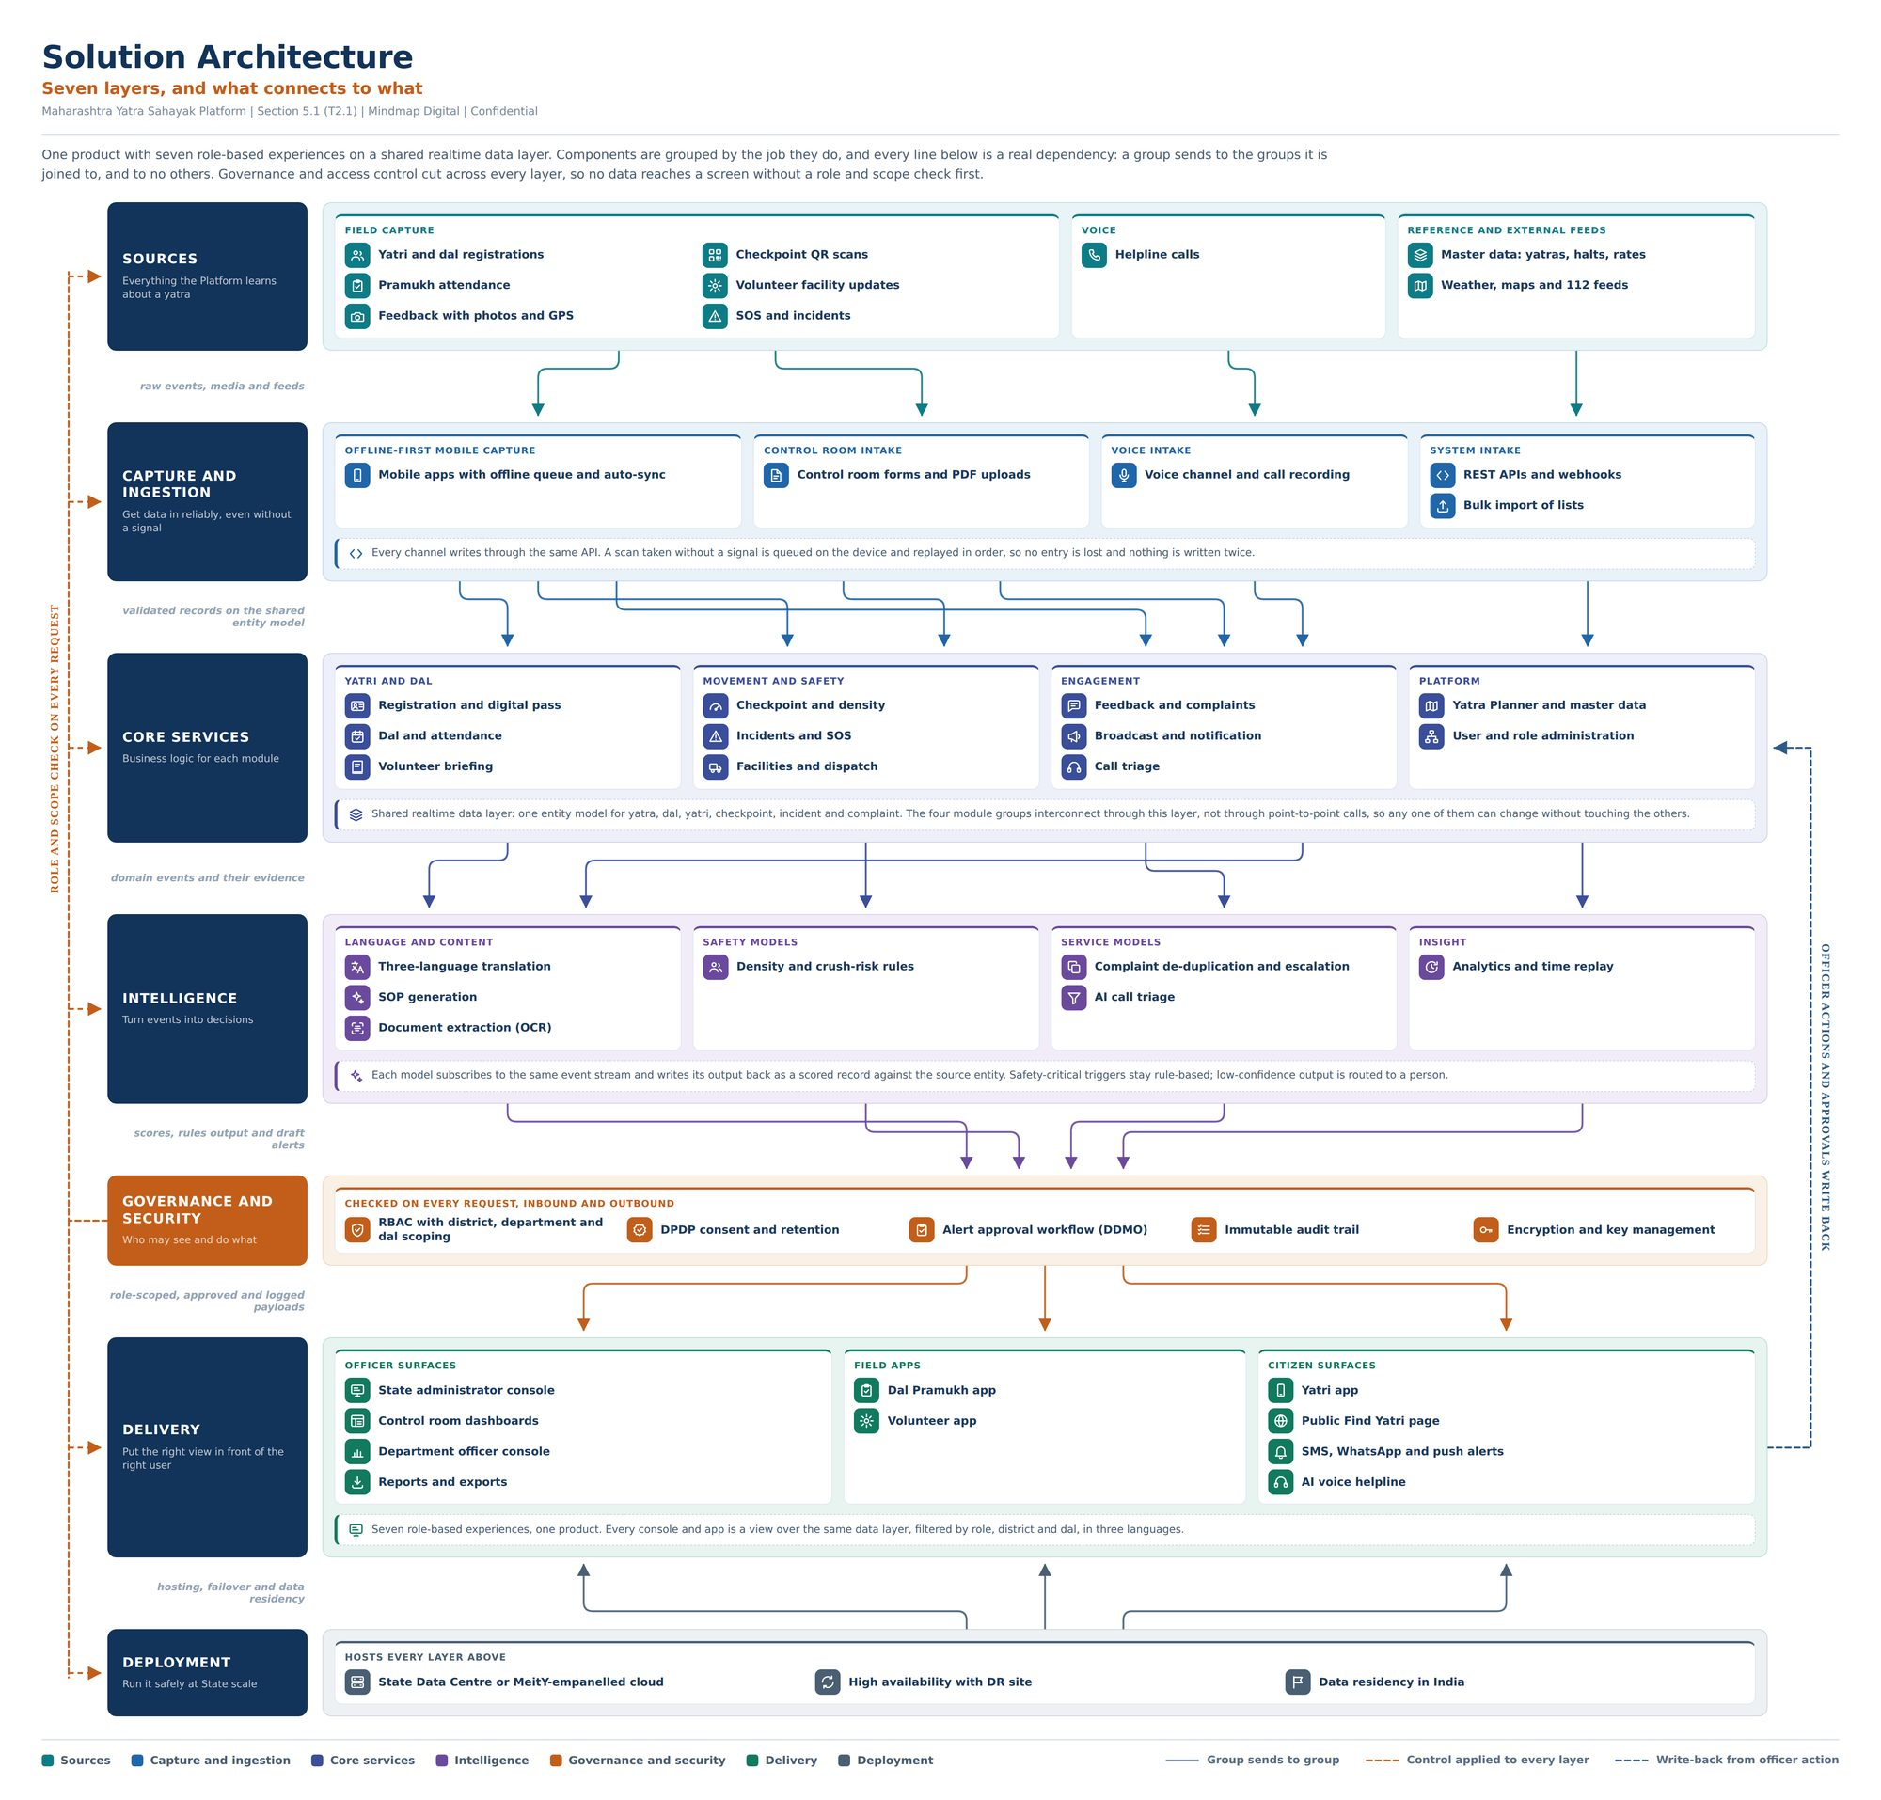
Solution architecture format (B.1)
Element | Rule
Header | Title “Solution Architecture”; an orange subtitle that states the point (for example “Seven layers, and what connects to what”); a meta line with platform, section, Mindmap Digital, Confidential
Lead | One paragraph on what the product is and how the layers depend on each other
Layers | A left column of navy tiles, top to bottom, each with a layer name and a one-line role: Sources, Capture and ingestion, Core services, Intelligence, Governance and security (orange, applied to every request), Delivery, Deployment. The set adapts to the solution
Data sources | Every data source is named: the system or file and the data taken from it (for example “SAP S/4HANA: vendor master, open purchase orders” or “tender PDFs from the buyer’s e-procurement portal”), never a generic tile such as “ERP”, “Data sources”, “Enterprise systems”, “Web data”, “Price catalogue”, “News API” or “Third-party APIs”. Names come from the client’s own sources (transcripts, RFP, RFI answers, research) and are cited in the Case File. Where no source names a system, the architect proposes the most likely one from the evidence and flags it; the gate (W1-G2, W3-G2, W4-G2) confirms or replaces it. If nobody at the gate can name it, in W3 and W4 it is put to the client: added to the W5 question sheet while a clarification window is open, otherwise asked directly by the consultant or bid owner; in W1 the consultant names the most likely system. Sources from the web are named the same way, by provider and feed: a price catalogue by its publisher, format and refresh (for example “distributor price catalogue, Excel, monthly upload” or “LME: copper and aluminium prices, daily”), a news feed by its API (for example “NewsAPI.org: company and sector news”), and so on for every market, weather or reference feed. Where the provider is not yet chosen, the architect proposes a named one, flagged for the gate like any other source. The technical architecture’s Integrations layer uses the same names (HR-17)
Groups | Each layer is a tinted panel of groups (small-caps label) holding items, each an icon and a short name
Note strip | One line under a layer where its groups need explaining
Connectors | Arrows only where one group really sends to another; each gap is labelled on the left with what flows (for example “validated records on the shared entity model”)
Cross-cutting lines | Dashed lines for controls applied to every layer and for write-backs
Legend | Layer colours and line types at the foot
The format image shows layout only. Its header, layer contents and feeds (including the unnamed “Weather, maps and 112 feeds” tile) come from an earlier pursuit and are never copied: every architecture is written fresh for its client, with every data source named (HR-17).

B.2 Technical architecture format
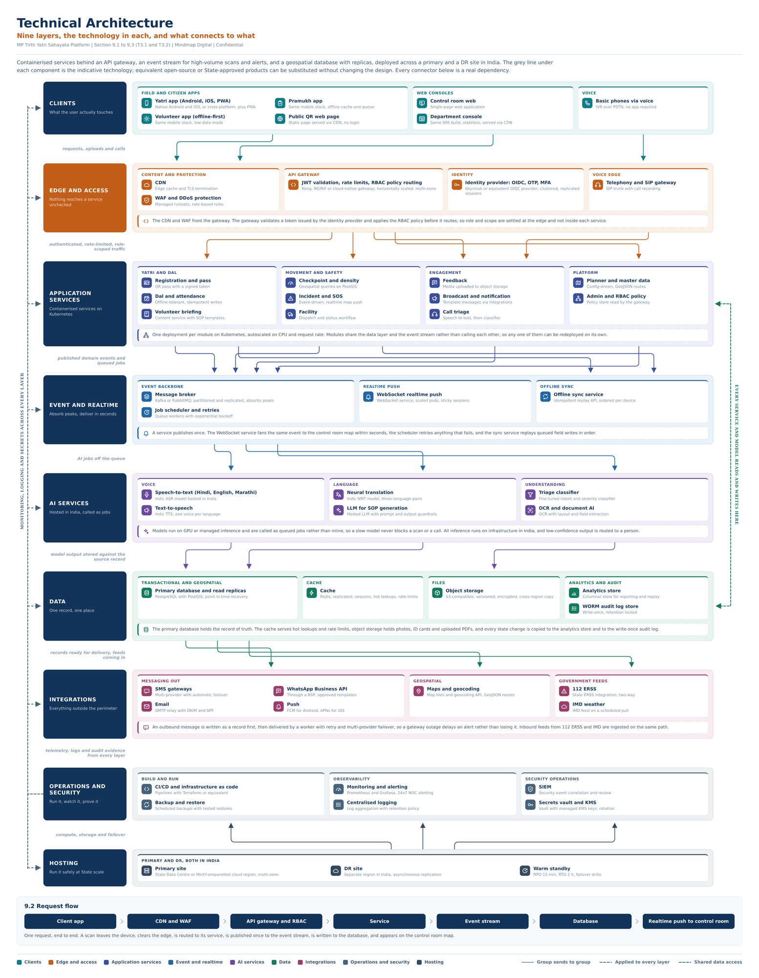
Technical architecture format (B.2)
Element | Rule
Header | Title “Technical Architecture”; an orange subtitle stating the layers and what connects; the same meta line
Lead | One paragraph on the deployment approach, saying the grey line under each component is the indicative technology and equivalents can be substituted without changing the design
Layers | Clients, Edge and access, Application services, Event and realtime, AI services, Data, Integrations, Operations and security, Hosting; adapted per solution
Items | An icon, the component name, and a grey line naming the indicative technology
Integrations | Every external system, data source and web feed is named by its provider and the data or service taken from it, with the same names as the solution architecture (HR-17); never a generic label such as “SMS gateway” or “Maps and geocoding API” alone
Note strip | One line under a layer where its parts need explaining
Connectors | Real dependencies only, labelled on the left (for example “authenticated, rate-limited, role-scoped traffic”)
Cross-cutting lines | Dashed lines for monitoring, logging and secrets across every layer, and for shared data access
Request flow | A strip of chevrons showing one request end to end, with one sentence under it
Legend | Layer colours and line types at the foot
The accompanying text documents each use case as its own standalone flow and explains what each named technology is (team standing preference). Like B.1, the format image shows layout only: its header, components and integrations come from an earlier pursuit and are never copied.

B.3 Slide templates (edit, never create)
Every deck slide is a duplicate of one of these template slides, edited by changing text and images only (HR-12). No slide is ever created from scratch. The five template .pptx files, the 40-slide reference deck (.pptx) and the two architecture format images (.png) travel with this BRD as separate files, in the folder 02_Templates with the sub-folders Slide templates, Reference deck and Architecture formats (file names in the table below). 00_READ_ME_FIRST explains how each one is used.
Template | Used for | Status | File in 02_Templates (name as supplied)
Periodic table | W1 slide 2 | Attached | Slide templates/1_Periodic_Table.pptx (periodic_table_small_detailed)
Problems | W1 slide 3 | Attached | Slide templates/2_Problems.pptx (Problems)
Agents slide | W1 solution slides 4, 6, 8, 10 and 12, duplicated once per solution; solution slides in PPT proposals | Attached | Slide templates/3_Agents_Slide.pptx (agents_slide)
Engagement methodology | W1 slide 14; engagement approach in PPT proposals | Attached | Slide templates/4_Engagement_Methodology.pptx (Engagement_Methodology)
Offerings | W1 slide 15 | Attached | Slide templates/5_Offerings.pptx (Offerings)
Title, architecture (full-visual) and closing slides | W1 slides 1, 5, 7, 9, 11, 13 and 16 | Attached: reference deck slides 1, 8 and 40 (B.6) | Reference deck/Reference_Deck_Slides.pptx
PPT proposal slides | W3 and W4 when delivered as a PPT | Attached: the reference deck slides mapped in B.6, with these five templates | Reference deck/Reference_Deck_Slides.pptx and the five files above
Previews follow.
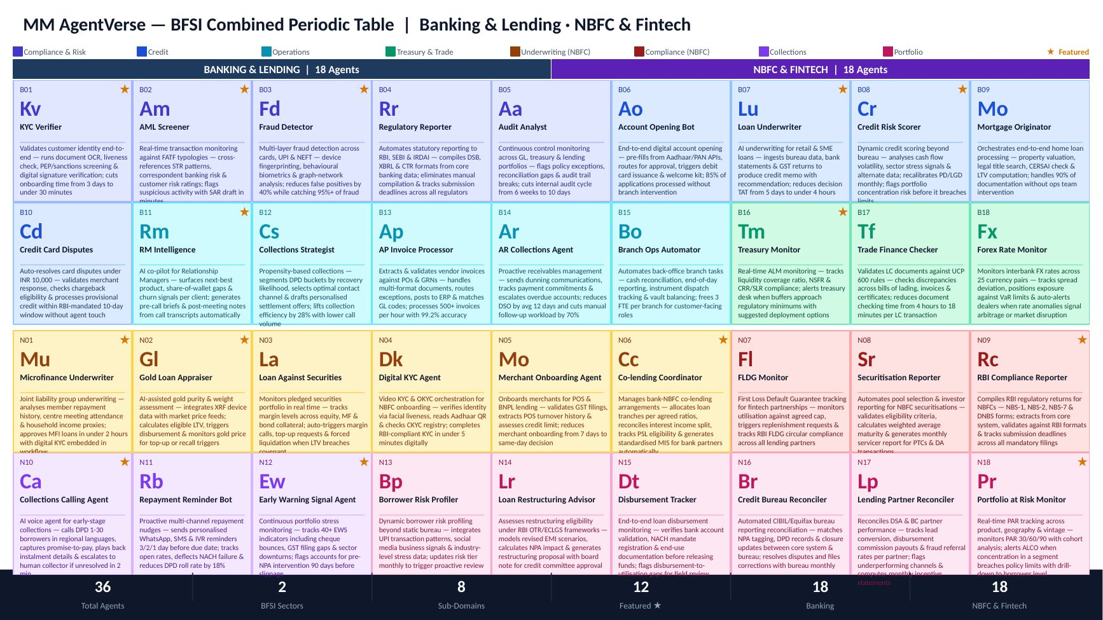
Template 1: periodic table
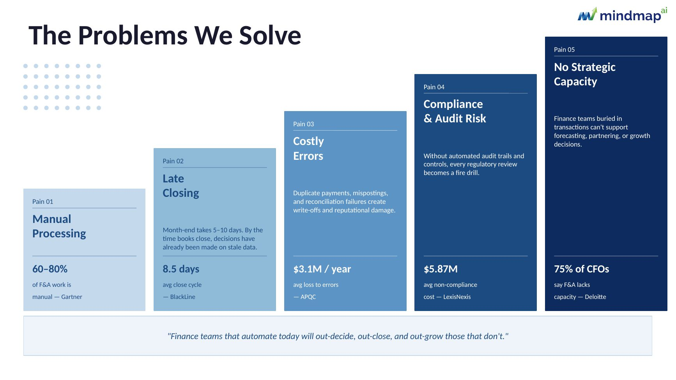
Template 2: problems
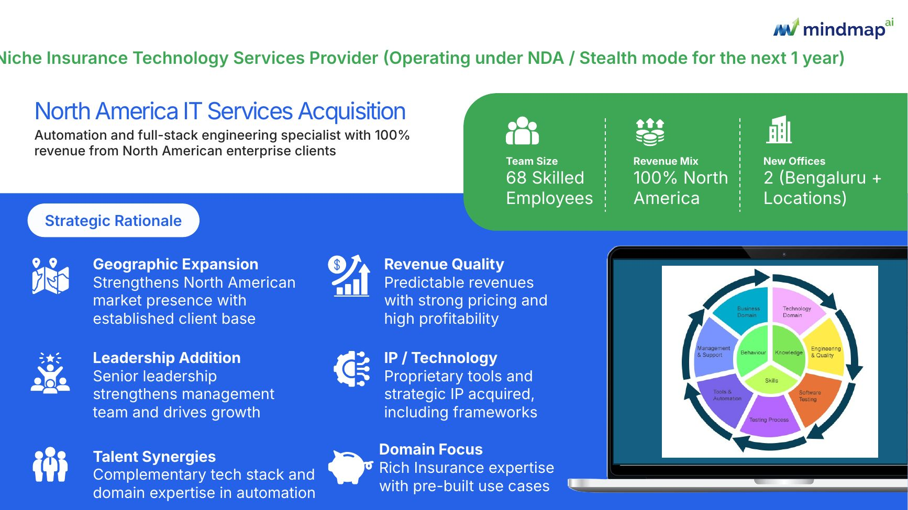
Template 3: agents slide
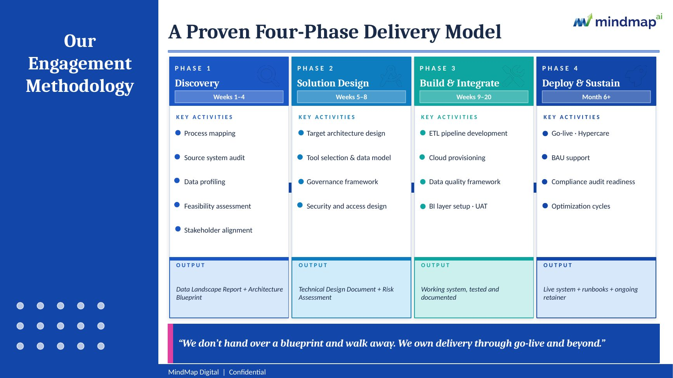
Template 4: engagement methodology
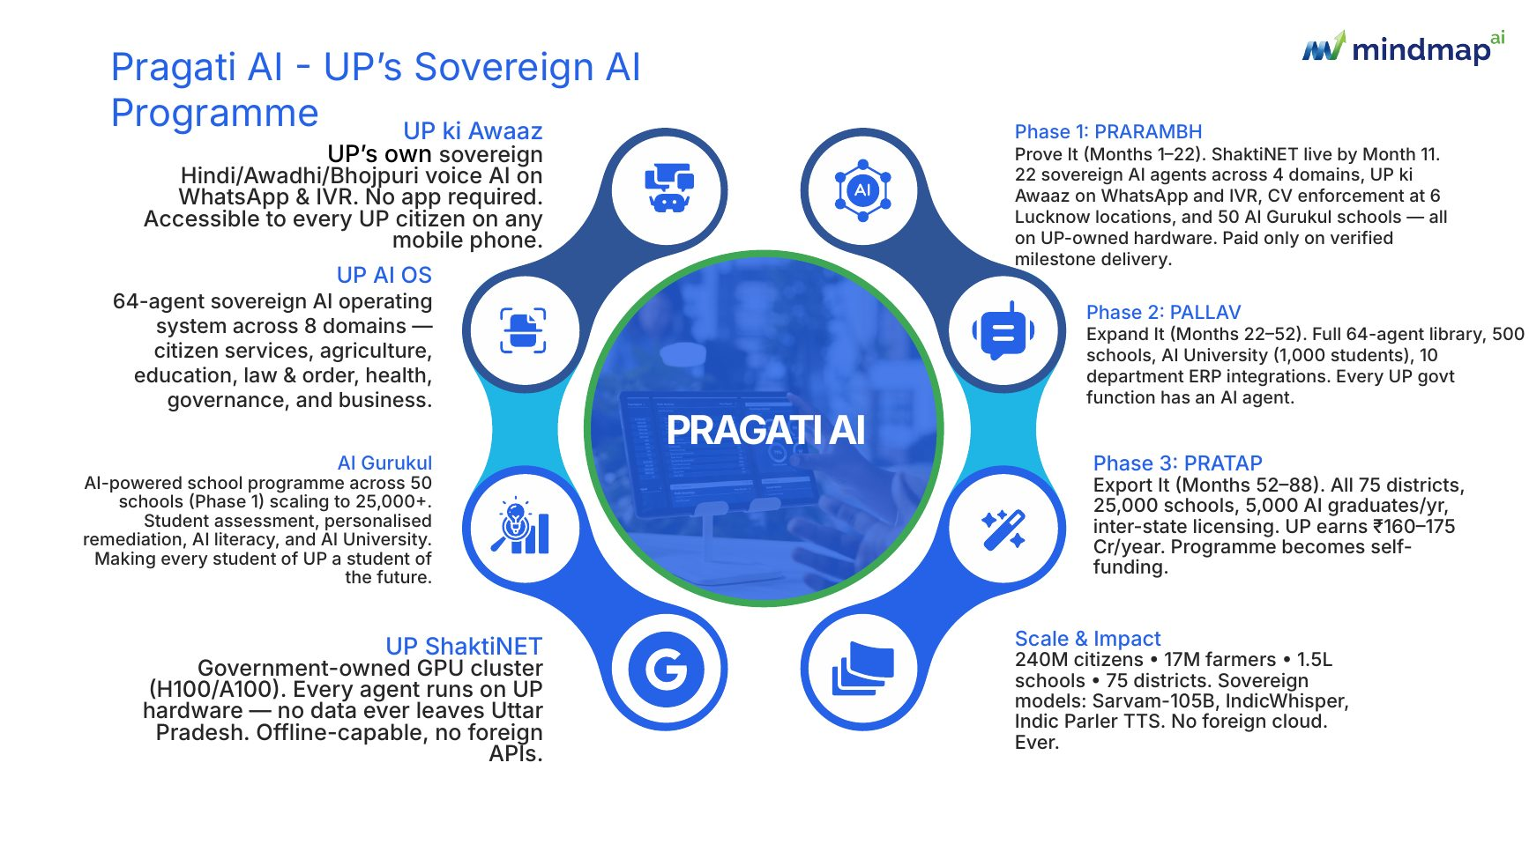
Template 5: offerings

B.4 Process flow format
The reference deck (previews in B.6, slides 8 to 12) shows the format. Each process gets a “today” summary slide and a current-process swimlane, then an “on the platform” summary slide and a target-process swimlane.
Slide | Format
Process summary | “Process N, name”; a two-line summary; KPI tiles; a “today” panel of six icon items (each step and what it costs), or on the second summary an “on the platform” panel; a numbered step list on the right
Current process | One swimlane per sub-process: a navy lane header with the lane name and step references; numbered cards left to right, each with an actor tag (for example BRANCH, ACCOUNTS, CUSTOMER), a title in capitals and a one-line description; the step where it breaks tinted red; a “Where the effort goes” box at the foot
Target process | The same lanes with green headers; each card tagged by platform component (for example CONNECTOR, LANDING, CANONICAL, ENGINE, AGENT, EXCEPTION) or by the acting role (for example BRANCH, FINANCE); in proposals the user role served is added beside the component tag (added; see A.2); agent steps tinted amber; a “What changes” box at the foot
Solution heat map (when a solution spans several areas) | Areas as columns and capabilities as tiles, coloured by automation potential: high (deterministic, runs without a person), medium (an agent proposes, a person approves), low (judgement retained by the client); a star marks what is delivered in the first phase
In a proposal, each process gets these slides (or the same panels as figures in a detailed document), with the as-is actor tags set to the client’s own user roles or systems, and each to-be card showing, beside its platform component tag, the user role that acts on or receives its output, so each user’s value is visible.

B.5 Still pending
Item | Referenced in | Status
Tender bidding agent code (full sub-agent list and depth review) | 14.4 | Awaiting upload
Detailed proposal document template (Word) | W3-14, W4-10 | Awaiting upload
Two past RFPs with their RFI question sets and final responses, for testing | W5-11; Section 21 (testing W4 and W5 before go-live) | Awaiting upload
Insert: Tender bidding agent code review
Insert here: the tender bidding agent code review, once the code is uploaded (B.5).

B.6 Reference deck slides used as templates
The reference deck sent with the templates (40 slides) is also a set of Mindmap slides the agent duplicates and edits. It supplies the slide types the five templates in B.3 do not: the title and closing slides, the company and team slides, the problem and current-state slides, the heat map, the process slides, and a full-visual slide that carries one diagram. That full-visual slide (slide 8, shown below carrying the solution heat map) is how architectures, the Gantt, the RACI, the ROI waterfall and the commercials table reach a deck without a slide being created. The slide numbers below are the deck’s own.
Slide in the reference deck | Layout | Used for
1 Title | Logo, title, date, confidentiality footer; any expired badge removed (HR-16) | W1 slide 1; the first slide of a PPT proposal
2 About us | Company text, presence map, key figures | “About Mindmap” in a PPT proposal; figures, badges and certifications only from the approved company profile (HR-16)
3 Founding team | Three leadership profiles | PPT proposal, when the client asks who leads the work (optional)
4 Our solution | Central platform with surrounding capabilities | Solution overview in a PPT proposal
5 Where it breaks | A statement and three numbered problem panels | Understanding of the need in a PPT proposal
6 Current state | A statement, “where the effort goes” and “what the platform changes” | Executive summary in a PPT proposal (no prices, HR-05); assumptions and exclusions
7 Agent portfolio | Agents in a periodic-table grid, grouped by domain | Agent landscape, when the solution spans several areas
8 Full-visual slide | Breadcrumb title, logo, one full-width visual | The solution heat map; with the visual replaced, every architecture slide (B.1 or B.2 format), the Gantt, the RACI, the ROI waterfall and the commercials table
9 and 11 Process summary | KPI tiles, the “today” or “on the platform” panel, a step list | Process summaries, today and on the platform
10 and 12 Swimlanes | Full-visual current and target swimlanes | As-is and to-be process flows
39 Capabilities | Technology pillars | Optional capability slide
40 Closing | Call to action, offices and contacts from the approved company profile; any expired badge removed (HR-16) | W1 slide 16; the last slide of a PPT proposal
PPT proposal slide map (W3 and W4 when delivered as a PPT)
Proposal slide | Slide to duplicate and edit
Title | Reference deck slide 1
About Mindmap | Reference deck slide 2 (figures from the approved company profile, HR-16)
Leadership (optional, when the client asks who leads the work) | Reference deck slide 3
Executive summary | Reference deck slide 6
Understanding of the need | Reference deck slide 5
Solution overview | Reference deck slide 4, and the agents slide template (B.3) once per solution
Agent landscape (when the solution spans several areas) | Reference deck slide 7
High-level solution architecture | Reference deck slide 8, with the architecture in the B.1 format
Technical architecture | Reference deck slide 8, with the architecture in the B.2 format
Process flows | Reference deck slides 9 to 12, repeated per process; the heat map on slide 8 when the solution spans several areas
Timeline | Reference deck slide 8, with the Gantt as the visual
Governance | Reference deck slide 8, with the RACI as the visual
ROI (if data exists) | Reference deck slide 8, with the waterfall as the visual
Commercials | Reference deck slide 8, with the one commercials table in the visual area (12.4)
Compliance matrix (W4) | Reference deck slide 8, with the matrix as a native table in the visual area, continued over as many duplicates as it needs
Assumptions and exclusions | Reference deck slide 6
Engagement approach | Engagement methodology template (B.3); phase timing labels set from the approved Gantt and reconciled at the deep QC
Capabilities (optional) | Reference deck slide 39
Close | Reference deck slide 40
Slides 13 to 38 of the reference deck repeat the process slides for the earlier pursuit’s processes 2 to 10 (summaries and swimlanes for processes 2 to 5; summaries only for processes 6 to 10). They show the format at scale and are not separate templates: process slides are always duplicated from slides 9 to 12, and none of that pursuit’s content is carried over. Optional slides (3, 7 and 39 in a proposal; slides 14 and 15 in W1) are included when the consultant, or the bid owner in W4, chooses them at RT7, and are confirmed at the release gate.
Slides 8, 10 and 12 hold their visual as a single picture (13.33 by 4.68 inches) under the title. The visual engine renders each new architecture, swimlane, heat map, Gantt, RACI or ROI waterfall as an image in the B.1, B.2 or B.4 style at that size and replaces the picture; the title text is edited. A diagram that does not fit legibly, such as a nine-layer technical architecture, is re-laid landscape or continued on a second duplicate of slide 8. The commercials table and the W4 compliance matrix are placed as native PowerPoint tables in the same area, not as images, so the checkers and the client can read them. The source data of every rendered image is kept in the Case File, so D5 checks the data, not the pixels.
The mapping is proposed for the team to confirm (Section 21). In every case text and images change; fonts, sizes and formatting stay as they are (HR-12). Previews of the slides used follow.
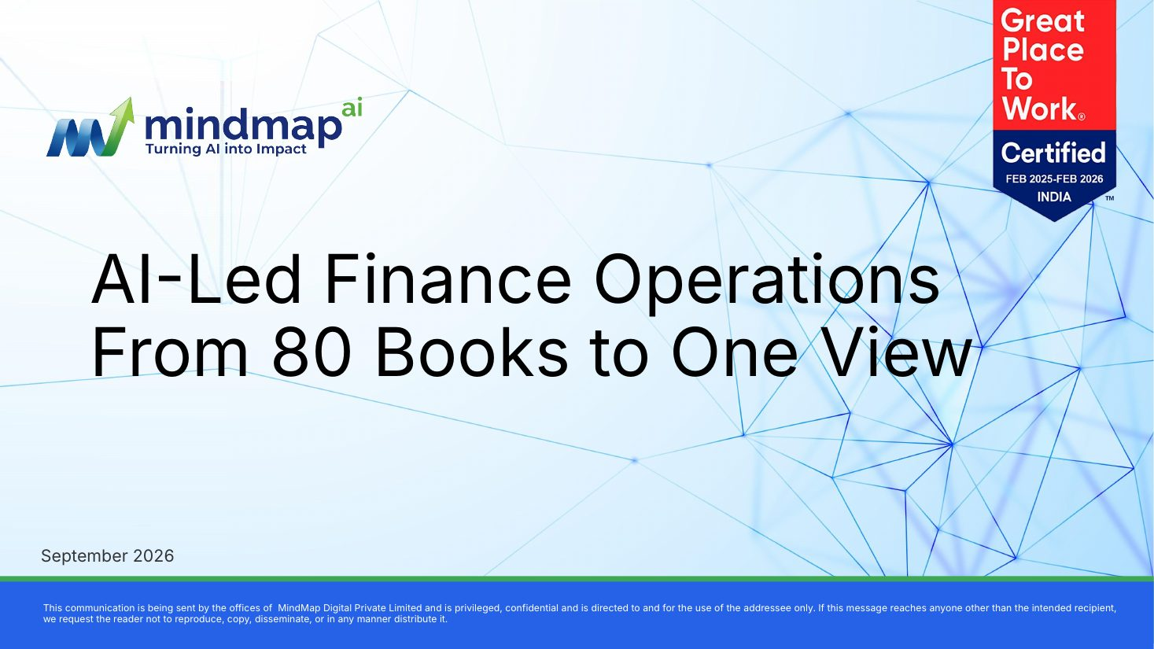
Reference deck slide 1: title
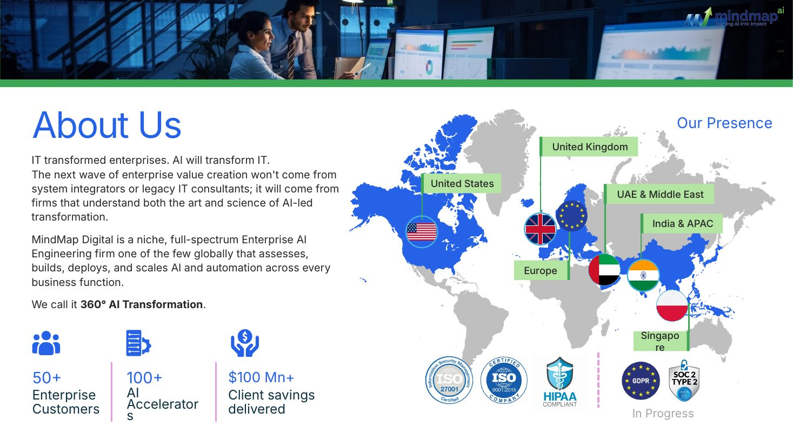
Reference deck slide 2: about us
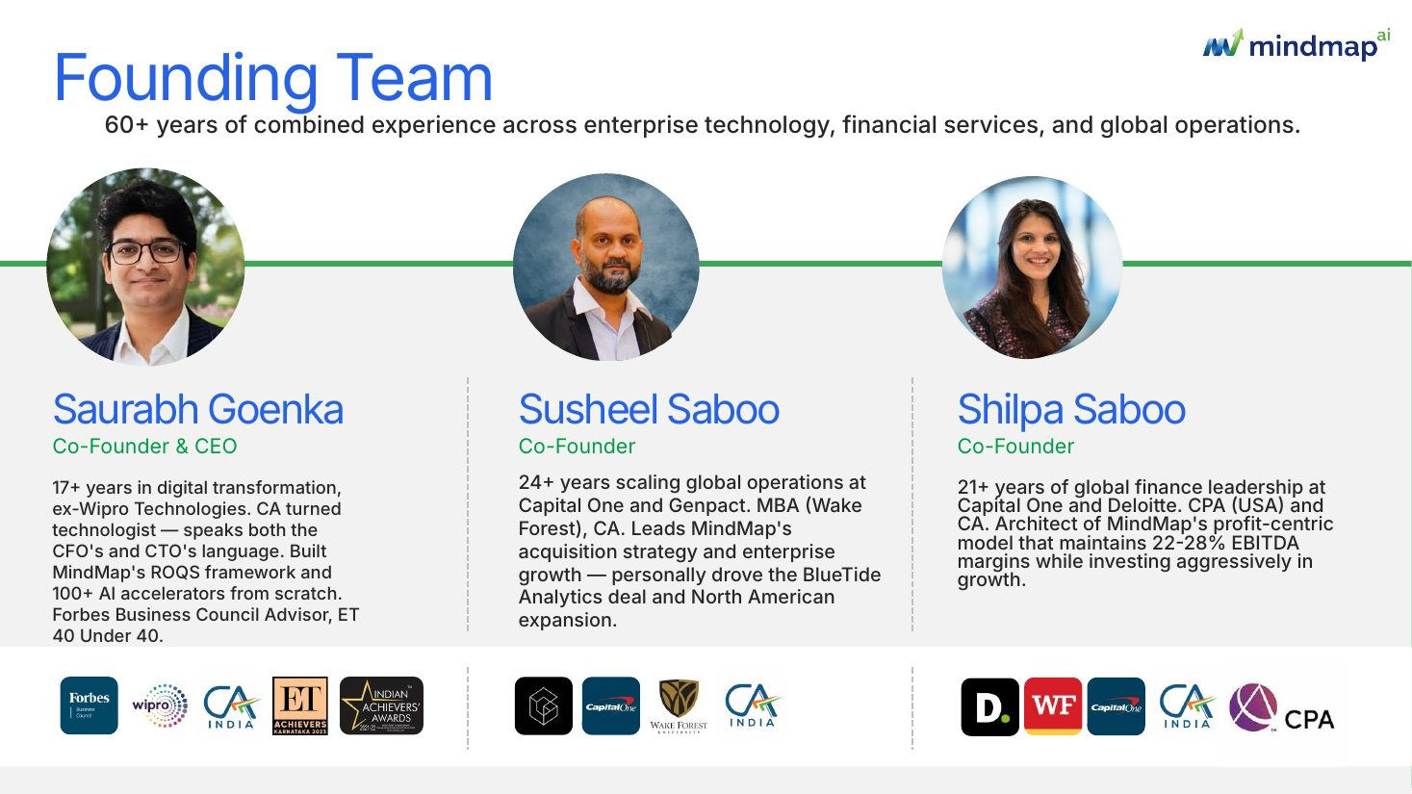
Reference deck slide 3: founding team
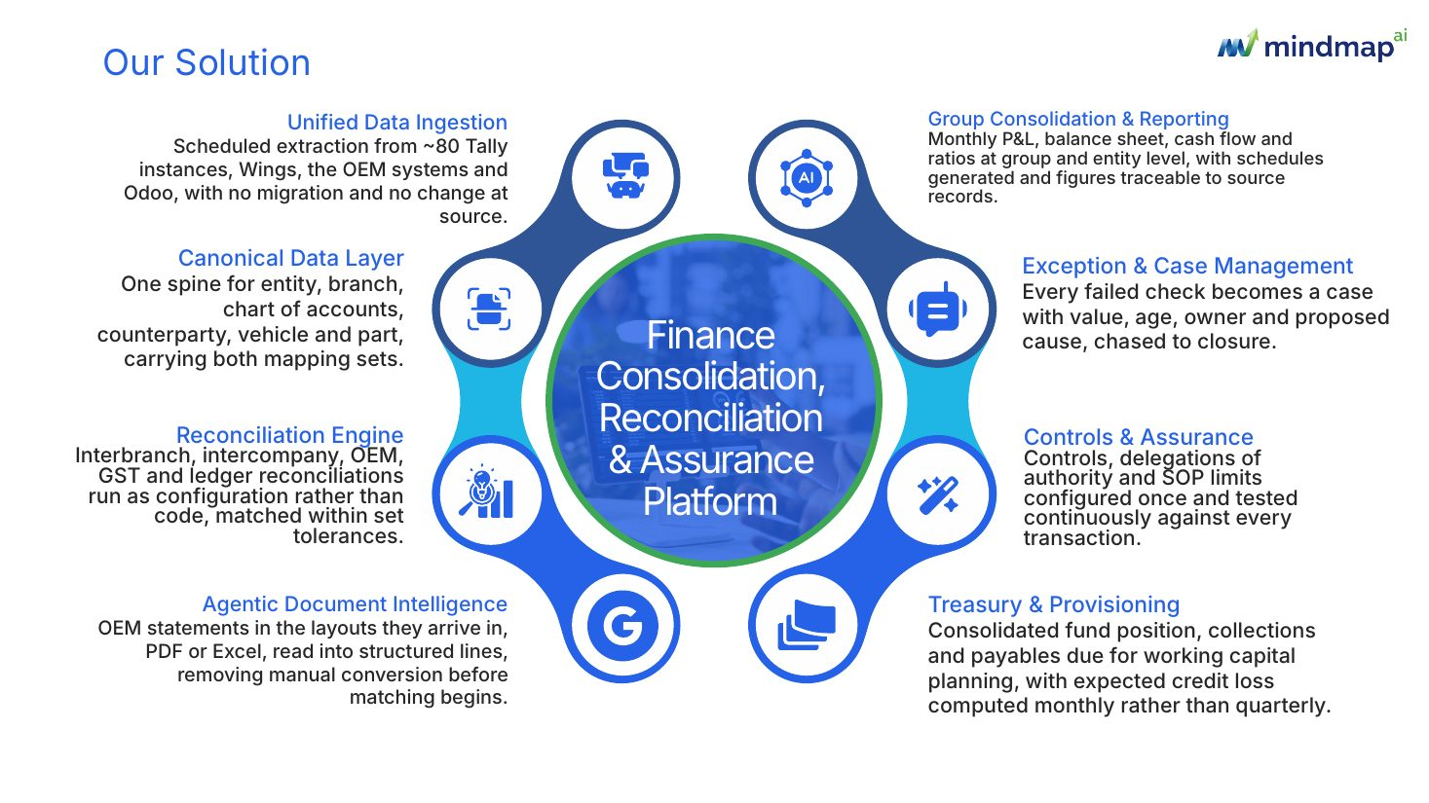
Reference deck slide 4: our solution
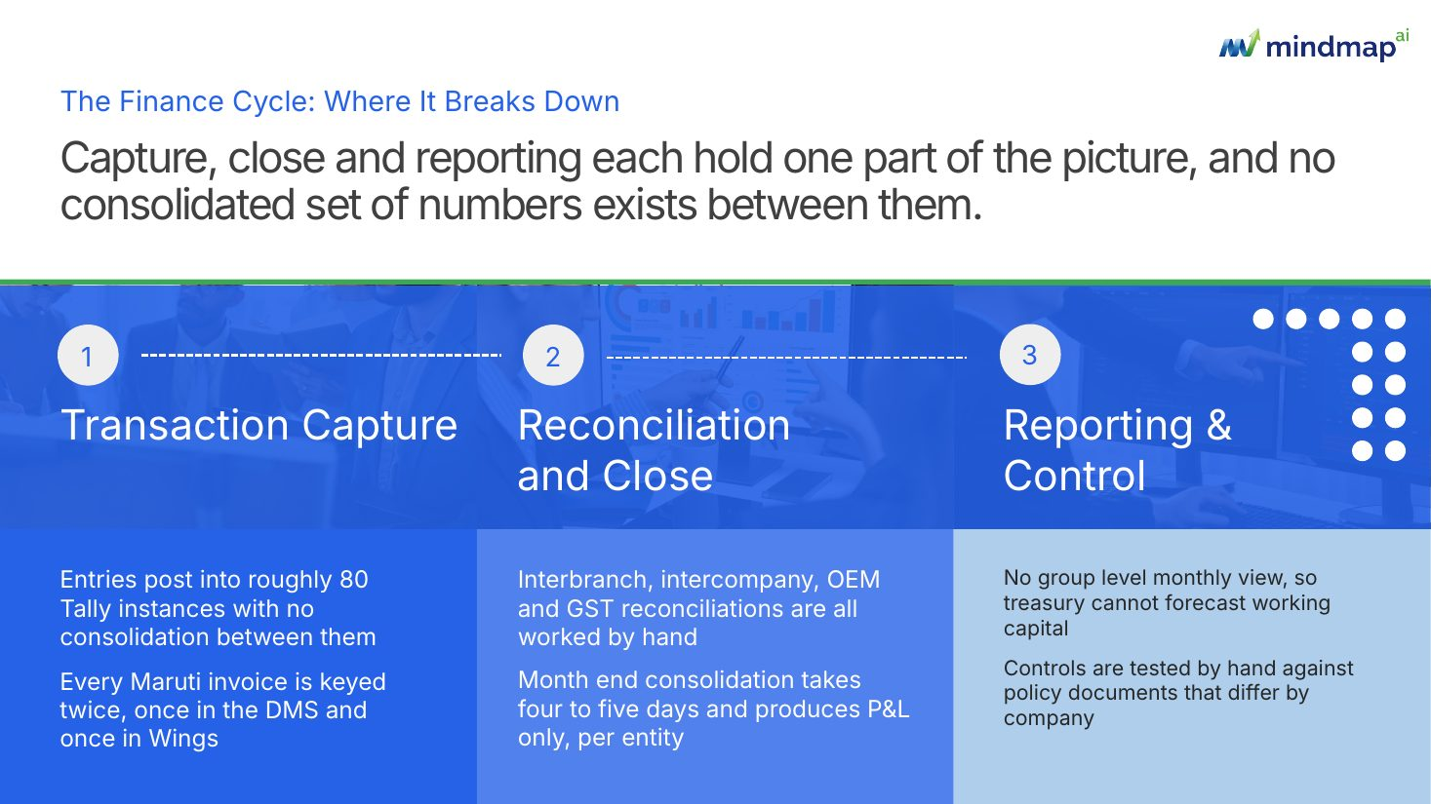
Reference deck slide 5: where it breaks
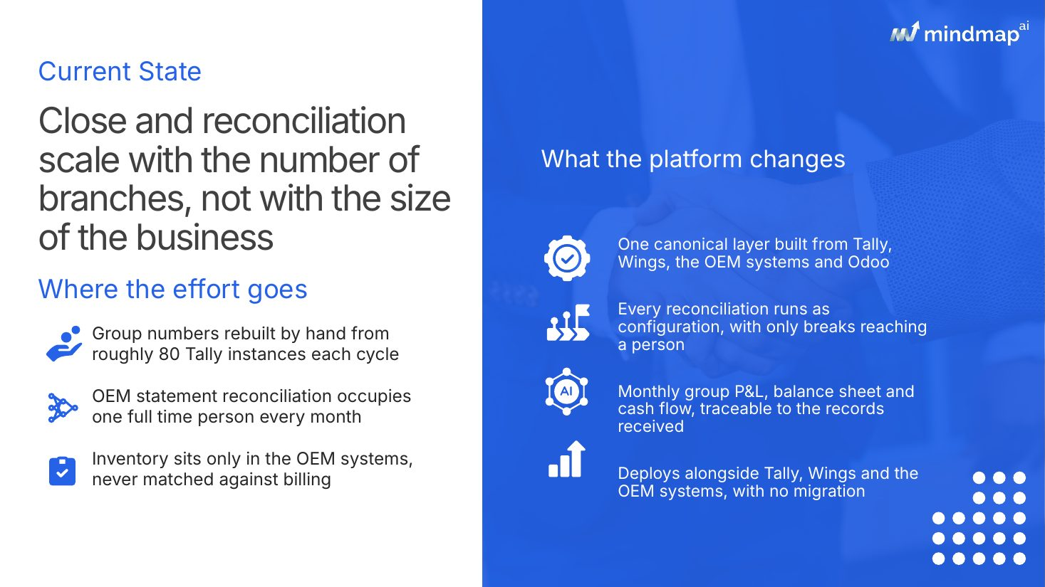
Reference deck slide 6: current state
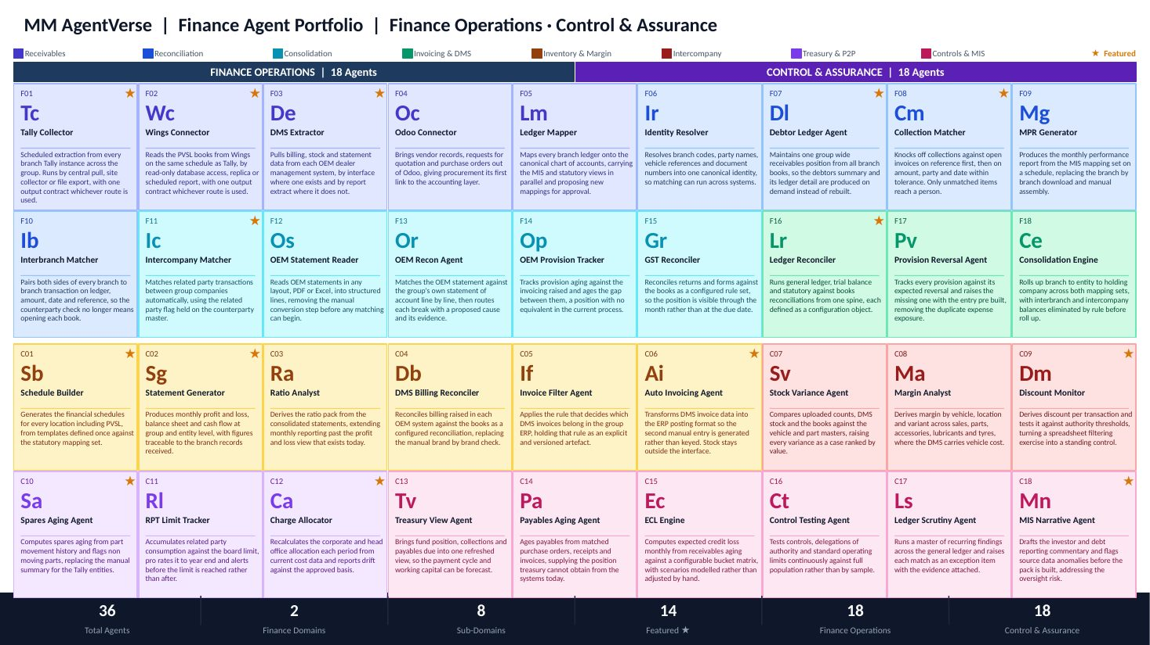
Reference deck slide 7: agent portfolio
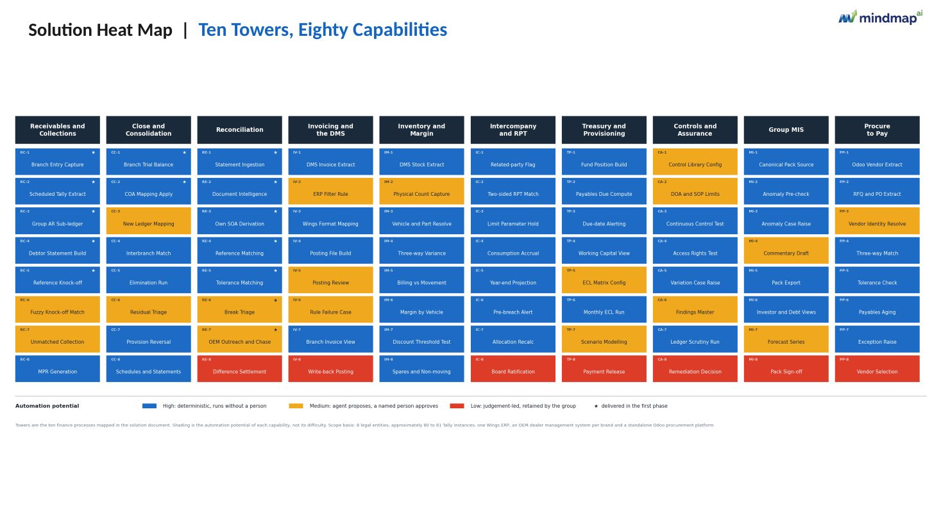
Reference deck slide 8: full-visual slide (shown with the solution heat map)
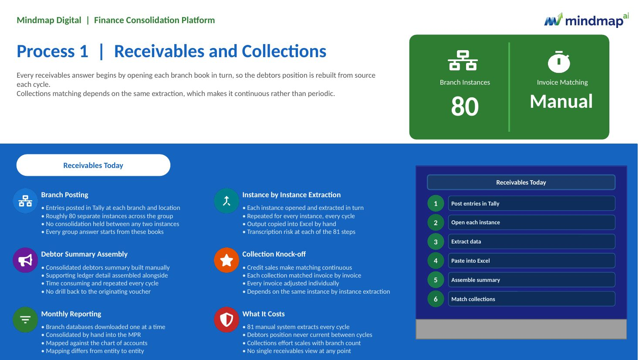
Reference deck slide 9: process summary today
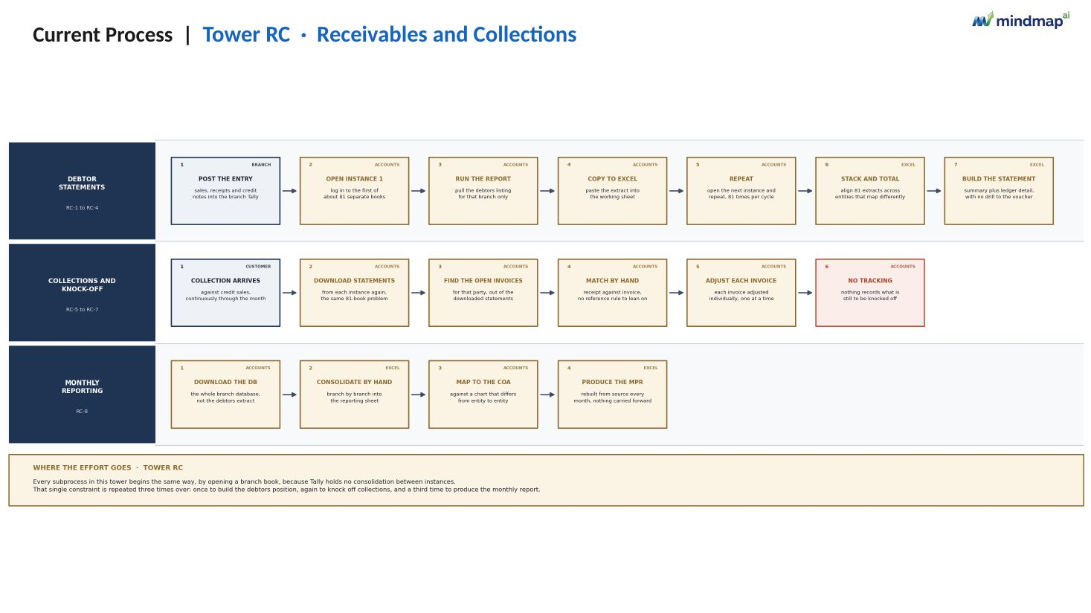
Reference deck slide 10: current process swimlane
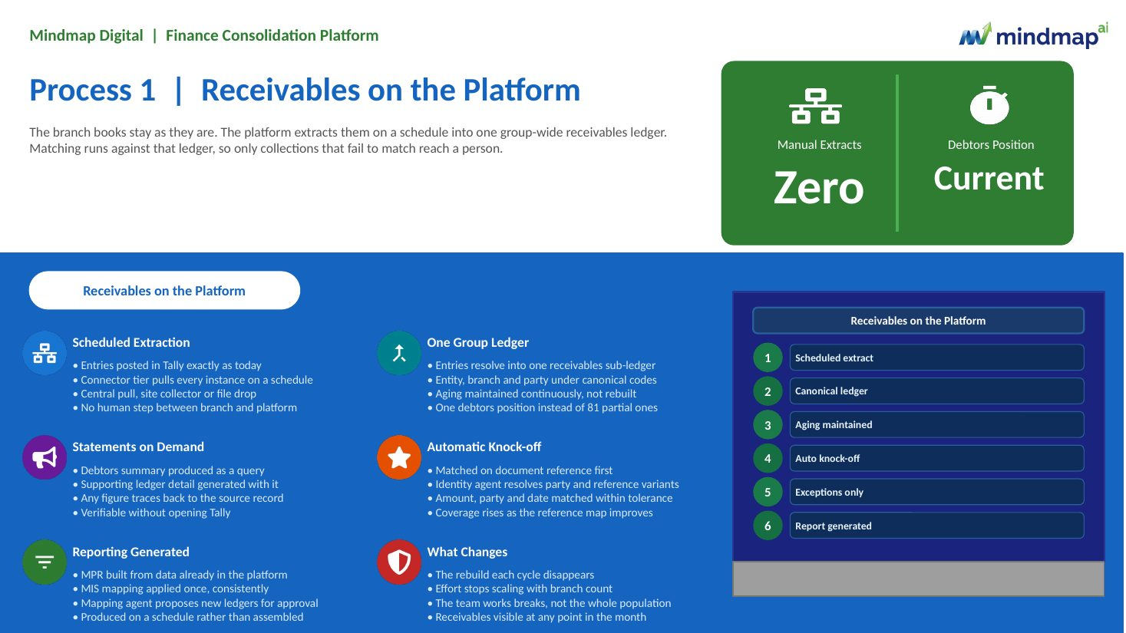
Reference deck slide 11: process summary on the platform
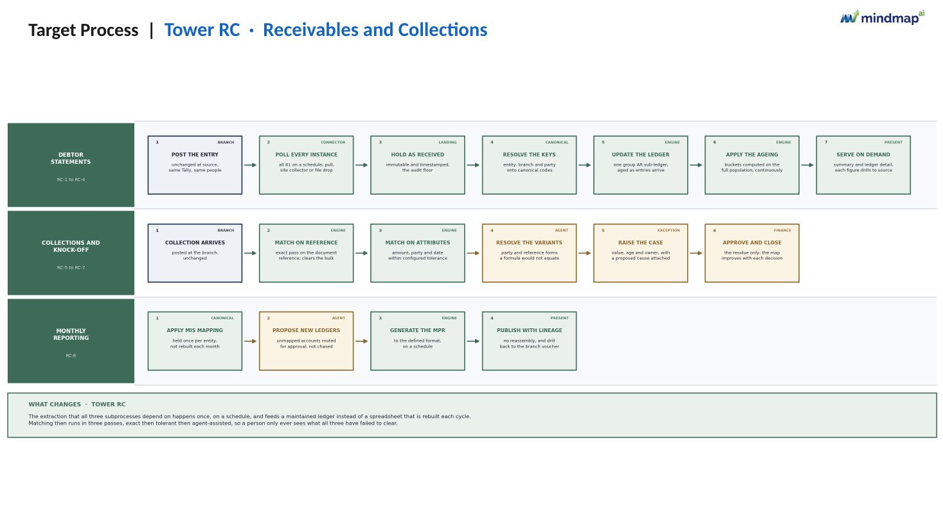
Reference deck slide 12: target process swimlane
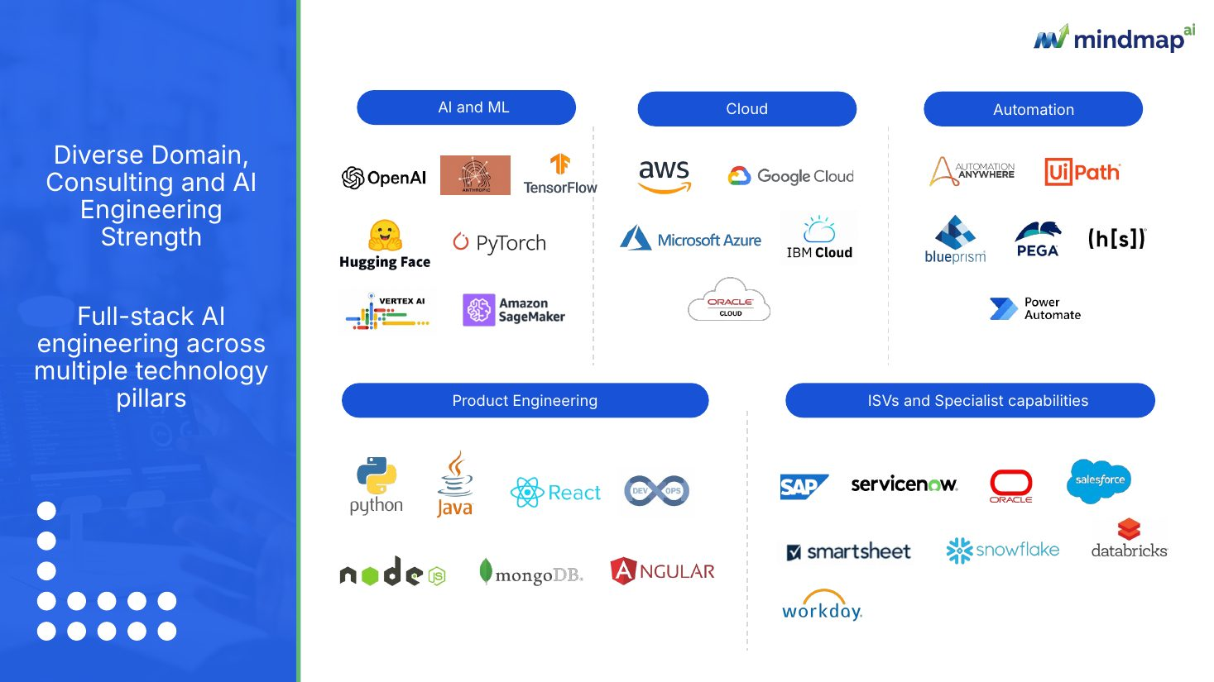
Reference deck slide 39: capabilities

Reference deck slide 40: closing

