**Wire-Frame Design**

**Thyroid Disease Detection**

|  |  |
| --- | --- |
| Developed by | Saurabh Gupta |
| Version | 1.0 |
| Date | 12-06-2023 |

**Table of Contents**

1 Document Change/History Control 3

2 Reviews: 3

3 Approval Status 3

4 Home Page 4

5 Prediction Page 5

|  |  |  |  |  |
| --- | --- | --- | --- | --- |
| **Version** | **Date** | **Done By** | **Review By** | **Remarks** |
| 1.0 | 12-06-2023 | Saurabh Gupta |  |  |
|  |  |  |  |  |
|  |  |  |  |  |
|  |  |  |  |  |
|  |  |  |  |  |
|  |  |  |  |  |
|  |  |  |  |  |
|  |  |  |  |  |
|  |  |  |  |  |
|  |  |  |  |  |
|  |  |  |  |  |
|  |  |  |  |  |
|  |  |  |  |  |

# Document Change/History Control

# Reviews:

|  |  |  |  |
| --- | --- | --- | --- |
| **Version** | **Date** | **Reviewed By** | **Remarks** |
|  |  |  |  |
|  |  |  |  |
|  |  |  |  |
|  |  |  |  |

# Approval Status

|  |  |  |  |  |
| --- | --- | --- | --- | --- |
| **Version** | **Review Date** | **Reviewed By** | **Approved By** | **Remarks** |
|  |  |  |  |  |
|  |  |  |  |  |
|  |  |  |  |  |
|  |  |  |  |  |

# Home Page

On the homepage the user will be able to see the heading of the project name and data input form to predict the Thyroid Disease. 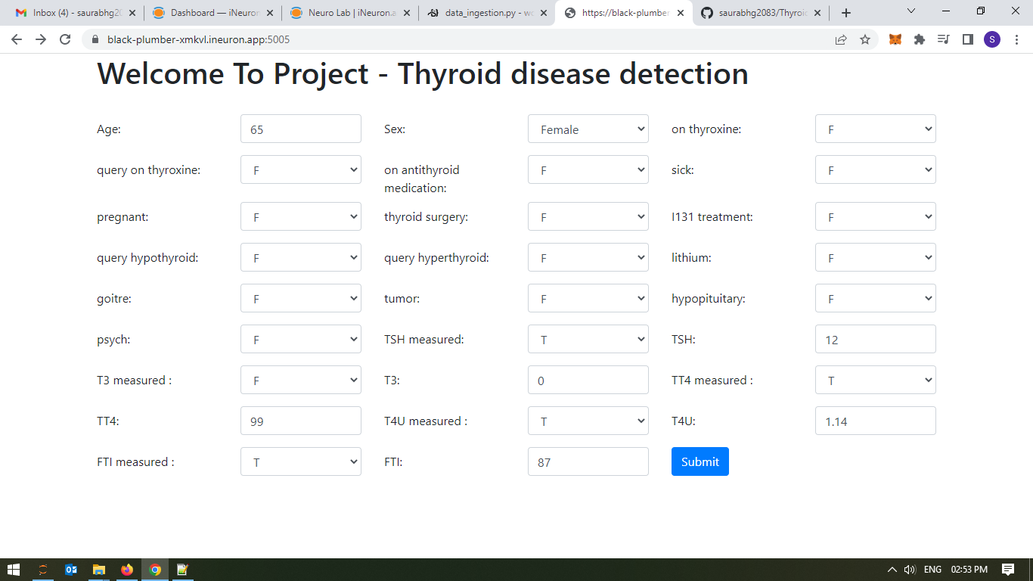

# Prediction Page

After the user will give inputs there will be “Submit” button, on clicking predict button the next page will open which will be the result page where the prediction will be shown for the given inputs. Below is the image how the result page will look like:

