**Assignment 3 Cloud Computing**

Q1. Create your own image which can run a basic Node.js web server as following:

- Use Image: mhart/alpine-node:4.4

- Use your favourite text editor to add app.js:

`Code Snippet Start`

var http = require('http');

http.createServer(function (req, res) {

console.log(new Date().toUTCString() + " - " + req.url);

res.writeHead(200, {'Content-Type': 'text/plain'});

res.end('Hello, Docker.\n');

}).listen(3000);

console.log('Server running at http://0.0.0.0:3000/');

`Code Snippet End`

- Create an entrypoint with the command:

/usr/bin/node app.js

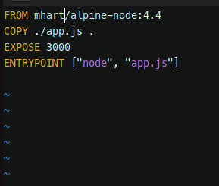

To build the image:

**docker build . -t node2**

To run the container using created image:

**docker run -d -p 30001:3000 node2**

Q2. Deploy an app using python Flask server & create Dockerfile to build image as follwing:

- Install all required dependencies

- Install Flask

pip install flask

- The code "app.py":

import os

from flask import Flask

app = Flask(_name_)

@app.route("/")

def main():

return "Welcome!"

@app.route('/hackers')

def hello():

return 'Hey buddy, how are you?'

if _name_ == "_main_":

app.run(host="0.0.0.0", port=8080)

- Entrypoint to Start Web Server:

python3 app.py

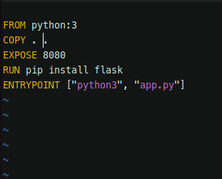

To build the image:

**docker build . -t flask2**

To run the container using created image:

**docker run -d -p 8087:8080 flask2**

Q3.. Deploy "jenkins/jenkins:lts" as container and deploy & publish UI [ User Interface / Dashboard ] on port 8000 and API on port 50000.

To run the container using jenkins image

**docker run -d -p 8000:8000 -p 50000:50000 jenkins/jenkins:lts**

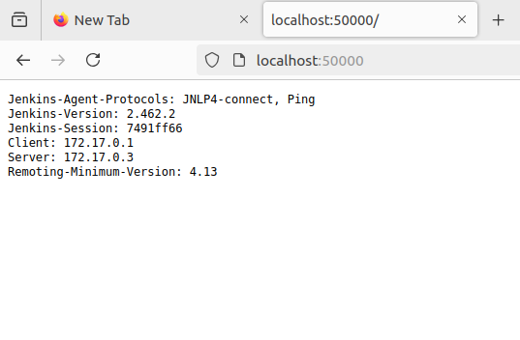

**All running containers:**

