**Assignment 4 Cloud Computing**

Q1. Deploy an app using python Flask server & create Dockerfile to build image as follwing:

- Install all required dependencies

- Install Flask

pip install flask

- The code "app.py":

import os

from flask import Flask

app = Flask(_name_)

@app.route("/")

def main():

return "Welcome!"

@app.route('/hackers')

def hello():

return 'Hey buddy, how are you?'

if _name_ == "_main_":

app.run(host="0.0.0.0", port=8080)

- Entrypoint to Start Web Server:

python3 app.py

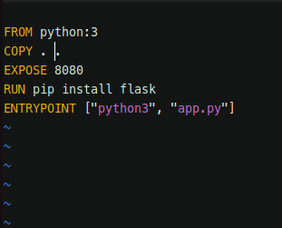

To build the image:

**docker build . -t flask2**

To run the container using created image:

**docker run -d -p 8087:8080 flask2**

Q2.. Deploy "jenkins/jenkins:lts" as container and deploy & publish UI [ User Interface / Dashboard ] on port 8000 and API on port 50000.

To run the container using jenkins image

**docker run -d -p 8000:8000 -p 50000:50000 jenkins/jenkins:lts**

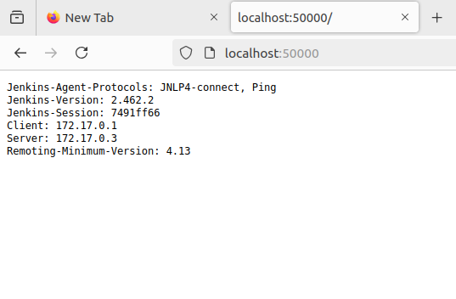

**All running containers:**

