**Exercise on GitHub and Git**

**Part 3:**

Answer the following questions.

What is GitHub? When was it created? Why? By who? What similar platforms exist? Why would you use such a platform? (Answer between 5 and 10 lines)

**ANS** :

* GitHub is a web-based Git or version control repository and Internet hosting service. It is mostly used for code.
* It was created on ‎February 8, 2008; 9 years ago.
* GitHub was created to provide a Web-based graphical interface. It also provides access control and several collaboration features, such as a wikis and basic task management tools for every project.
* It was created by Tom Preston-Werner
* Some similar platforms to GitHub are GitLab, Bitbucket, Beanstalk, SourceForce, Apache Allura, Cloud Source, AWS CodeCommit and GitKraken.
* GitHub helps in collaborating and track changes in your code across versions and tons of integration options are avaialable. GitHub is a reposoitory and you can Have your code reviewed by the community easily.

**Part 4:**

Go through the Git tutorial here: <https://try.github.io>. While doing the tutorial, save your work.

**ANS** :

Here are some screen shots of tutorial.

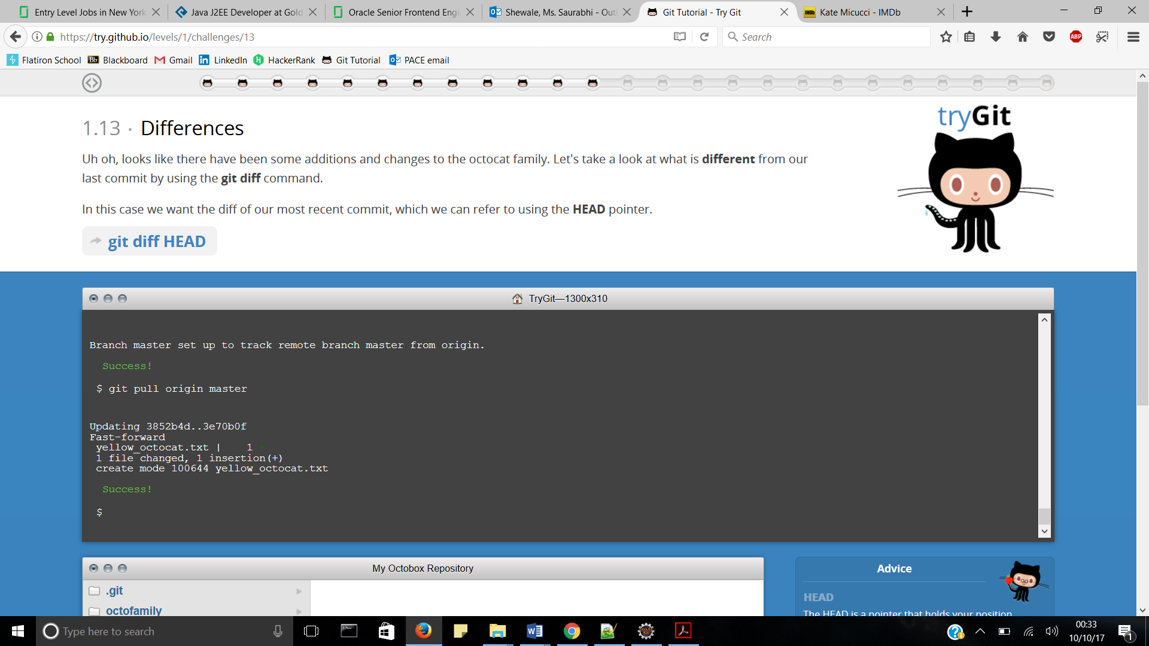

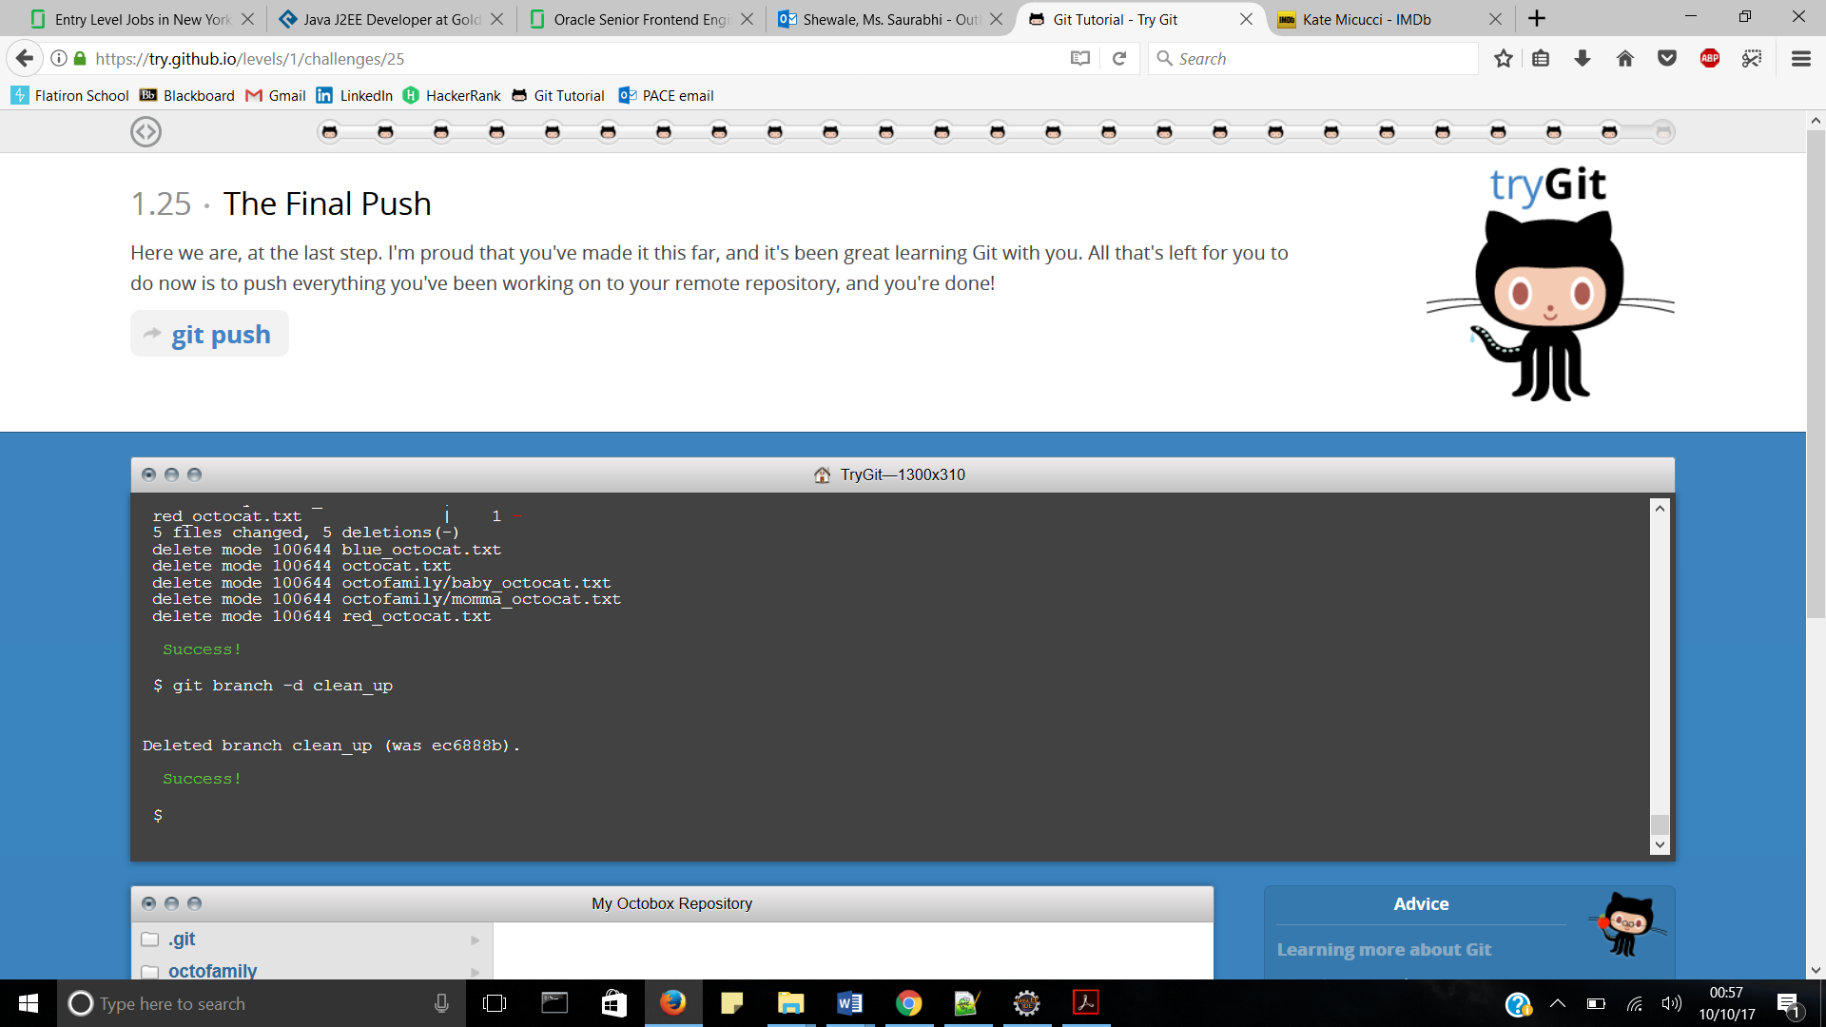

**Part 5:**

Define the following terms in the context of Git (2 lines maximum):

**ANS** :

* Repository – it is the version of something that is hosted on a server, most likely GitHub. It can be connected to local clones so that changes can be synced.
* Commit – A commit is an individual change to a file (or set of files). It's like when you save a file, except with Git, every time you save it creates a unique ID, that allows you to keep record of what changes were made when and by who.
* Push – It refers to sending your committed changes to a remote repository, such as a repository hosted on GitHub.
* Branch – A branch is a parallel version of a repository. It is contained within the repository, but does not affect the primary branch allowing you to work freely without disrupting the "live" version.
* Fork – A fork is a personal copy of another user's repository that lives on your account. Forks allow you to freely make changes to a project without affecting the original.
* Merge – Merging takes the changes from one branch (in the same repository or from a fork), and applies them into another.
* Clone – A clone is a copy of a repository that lives on your computer instead of on a website's server somewhere, or the act of making that copy. You can push your local changes to the remote to keep them synced when you're online.
* Pull – Pull refers to when you are fetching in changes and merging them.
* Pull request – Pull requests are proposed changes to a repository submitted by a user and accepted or rejected by a repository's collaborators.

**Part 7:**

Retrieve the README.md file at:

<https://github.com/paceuniversity/courses>

Add your name (lastname, firstname) in the file, **add a comment (date and time) (REQUIRED)**, and update the README.md file at: <https://github.com/paceuniversity/courses>. Your name should appear at the provided <https://github.com/paceuniversity/courses>. Please check the work of previous students.

List the commands and strategy you use to do this part of the exercise in the *LastnameFirstnameGitTutorial-mm-dd-yyyy.docx* file and push it to: [https://github.com/yourpseudo/CSXXX20XX](https://github.com/yourpseudo/CSXXX2016).

**ANS**:

Commands used are as follows :

Edit file and propose file change.