**Roll no:-192010045,192010051,192011063**

**KAIROSCOPE**

**Problem statement :**When it comes to celebration photographs becomes one of the important thing as it reminds us of the old memories.The memories we had share with our dear ones and now days it becomes hard find photography shop in each area as everyone has camera has a second option option in their phones so we come up with a website where customer can book a photographer just by completing few steps from their home.

* In current system, customers have to call or meet photographers and

book them.

* Photographers are booked only by their contact or limited peoples

who are known to them.

* Customer compares only knowing photographers and book one of

them.

* Current system is manual. Photographers keep track of their orders in

Register.

* Whenever new order comes, photographers check availability

manually and register new orders accordingly.

* Photographers maintain their photography albums and show to the

customers. They maintain their information about various functions

and their cost manually

* Customers have to meet or call photographers to book them.
* Checking availability in existing data for accepting new orders is tedious.
* Maintenance of all manual records is difficult.
* Photographers don’t get orders from other than contact o nearby

persons.

* Customers don't get many options to compare their cost and quality.
* The new system will provide a unified platform for Photographers.
* User friendly.
* The new system will save customer’s time and money.
* In this system finding best Photographers according to their quality

and cost is easy.

* Customers view many photographers on one website and book them.
* Photographers get more orders from unknown people also.
* Photographers get the opportunity to show their talent to more people.
* Photographers maintain their record on that website only.
* Customers get more options of Photographers to compare and book

them.

* Customers don’t have to go Photographers studio , they directly book

online.

**Abstract:**

This website will shortlist the available number of photographers according to requirements of the customer.This website is designed to provide better options of photographers as it is difficult to find a suitable photographer according to the event and affordable budget.Customer can book a photographer for various events like wedding,baby shower,pre-wedding ,cultural events,college fest etc.According to the requirements customer can select the suitable photographer and book the photographer if available.The request is send to the admin.Admin accept the deal and then a confirmation message send to both customer and photographer.

**Software requirement:**

-Operating system : Windows 10 and later.

-Server: Apache

-Application used : Atom

Node JS

Mysql Database

**Hardware requirement:**

-Minimum 512mb RAM

-Intel 2GHZ processor

-Minimum 1GB secondary storage

**USER INTERFACE**

**HomeScreen**

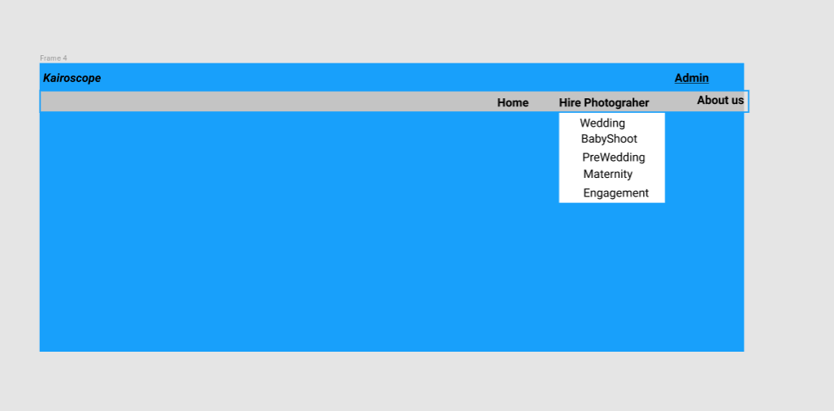

**Book Photographer**

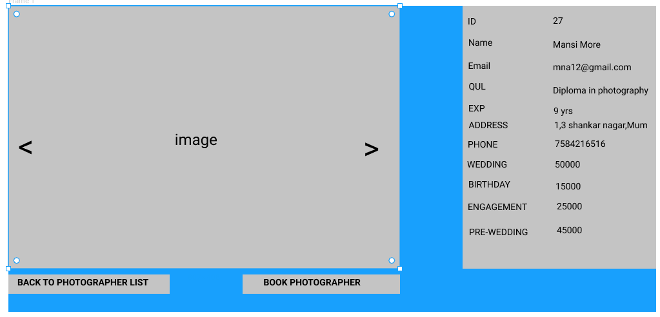

**Add Personal Details**

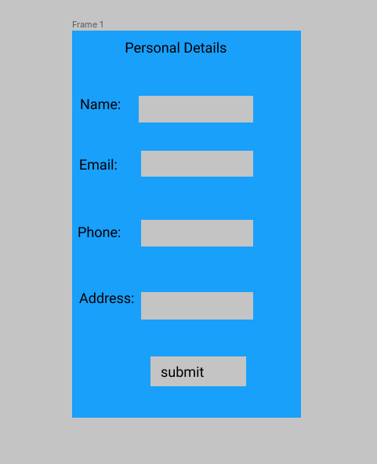

**Add Event Details**

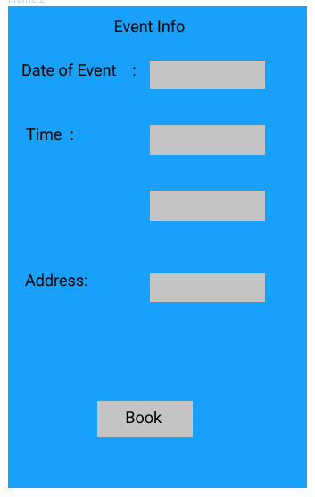

**Registered request Message**

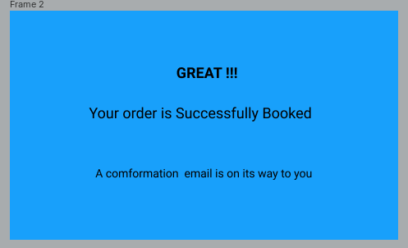

**About Us**

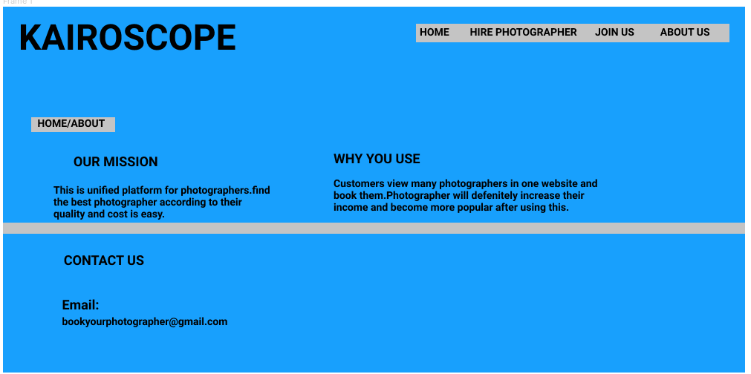

**Admin Panel**

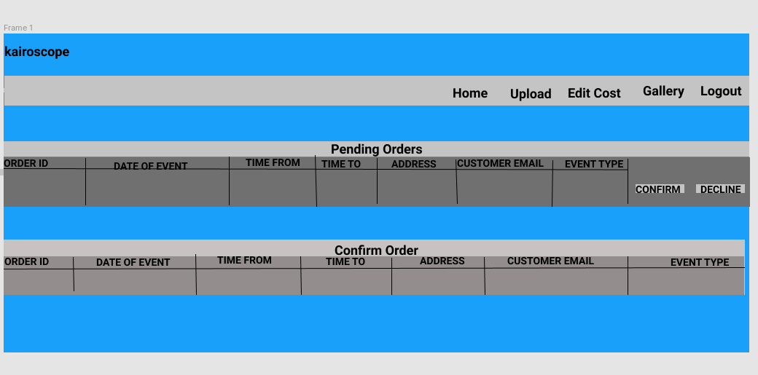

**Upload Pictures**

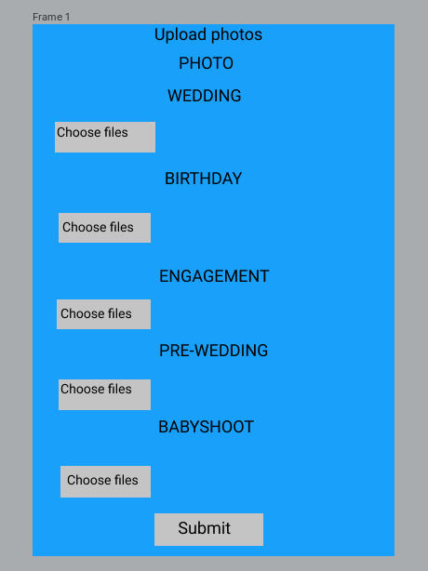

**Edit Cost**

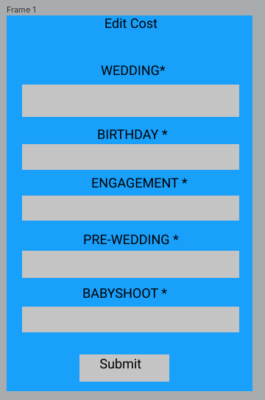

**Gallery**

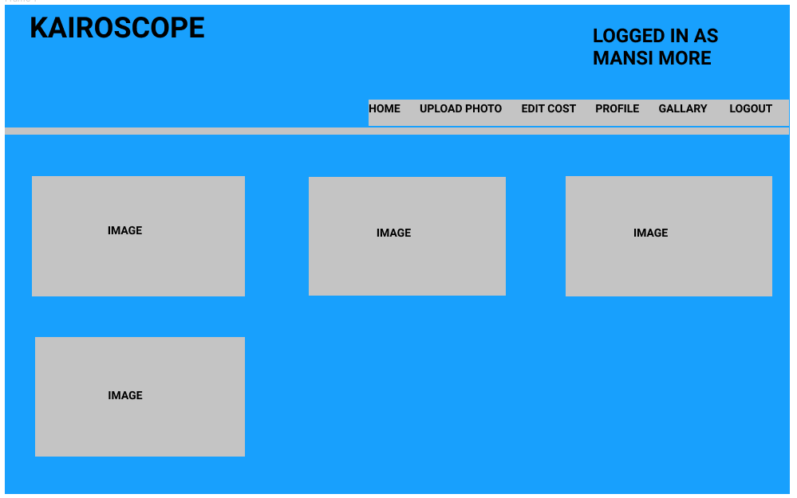

**Use Case Description**

**ACTORS**

**Admin**

* He will upload photos of newly handled events.
* Edit cost according to the events.
* He also views the gallery.
* He can confirm orders or decline the orders.
* If the order is confirm the admin will send a mail to the customer and same if he decline the order

**Customer**

* Customers will first view the admin’s work and decide whether to book or not,if he chooses a book then he will fill his personal details.After submitting personal details the customer will fill the event information for which he wants to book the photographer.

**USE CASES**

**Login**

* Description : Admin will login into the system.
* Input : Username & password.
* Output : Navigate to the home page of the admin panel.

**Upload Photos**

* Description : Here, Admin will upload the new photos which will be viewed by the client.
* Input : Choose jpeg file(images) which are to be uploaded.
* Output : Images uploaded successfully message.

**Edit Cost**

* Description : Admin will be uploading the cost.
* Input : Enter the cost which is to be changed of different types of events.
* Output : Cost updates successfully.

**Gallery**

* Description : Admin will be viewing the gallery.
* Output : Here, the uploaded photographs are viewed by admin to see whether they are uploaded correctly or not.

**Pending Orders**

* Description : Here, admin will be checking all the requests that came from the client.
* Input : The event details entered by the customer are displayed in admin.
* Output : The list of orders are displayed and the admin will decide to confirm the order or to decline the order.

**Accept Order**

* Description : Admin will confirm the requests of the client, if he is willing to.
* Input : If admin chooses confirm option, then a confirmation mail is sent to the customer.
* Output : The orders confirmed by the admin will be displayed in the confirmation order table.

**Decline Order**

* Description : Admin will decline the requests of the client, if he is willing to.
* Input : If admin chooses a decline option, then a rejected mail is sent to the customer.
* Output : The request which is rejected will be removed from the pending order table.

**Complete Order**

* Description : Admin will update the client through mail whenever their order will get completed.
* Input : Whenever admin completes the order,he will update the client.
* Output : Order completion mail will be sent from admin to client.

**View Photographer’s Work**

* Description : Here, the client will view the work of the photographer.
* Input : The pictures uploaded by the admin/photographer are being viewed.
* Output : These uploaded pictures are viewed by customers for reference.

**Book Photographer**

* Description : Client will book the photographer if he likes his work.
* Input : If the customer likes the photographer's work and is willing to hire the photographer, then he will click the book photographer option.
* Output : After clicking the book photographer option, the customer will be navigated to Add Personal Details Window.

**Add Personal Details**

* Description : Client will submit his personal details.
* Input : Here, the personal details are entered by the customer.
* Output : After inputting personal details the customer will be navigated to Add Event Details Window.

**Add Event Details**

* Description : Client will submit his event details.
* Input : The customer will click on the submit button of the Add Personal Details Window.
* Output : Here, the customer will enter the details of the event for which the photographer is being hired for.

**USE CASE DIAGRAM**

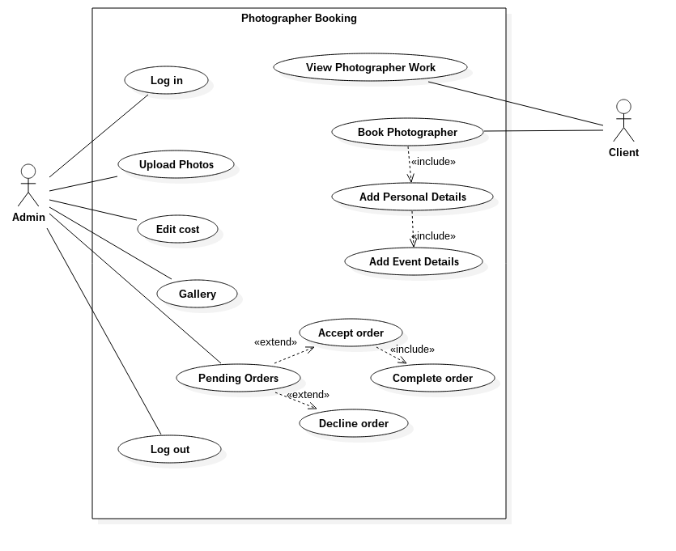

**ER DIAGRAM:**

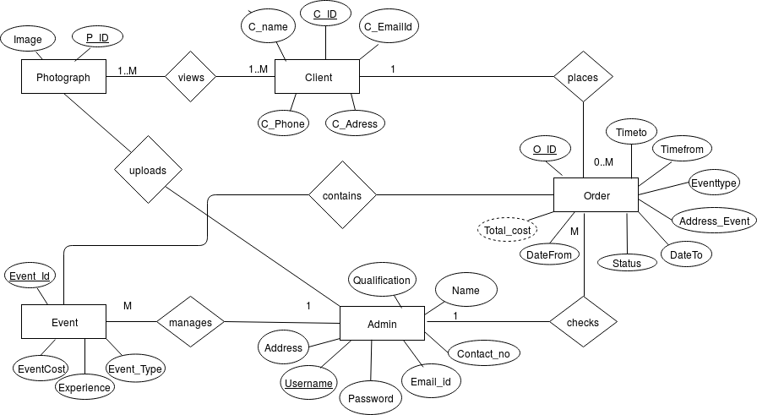

**CLASS DIAGRAM**

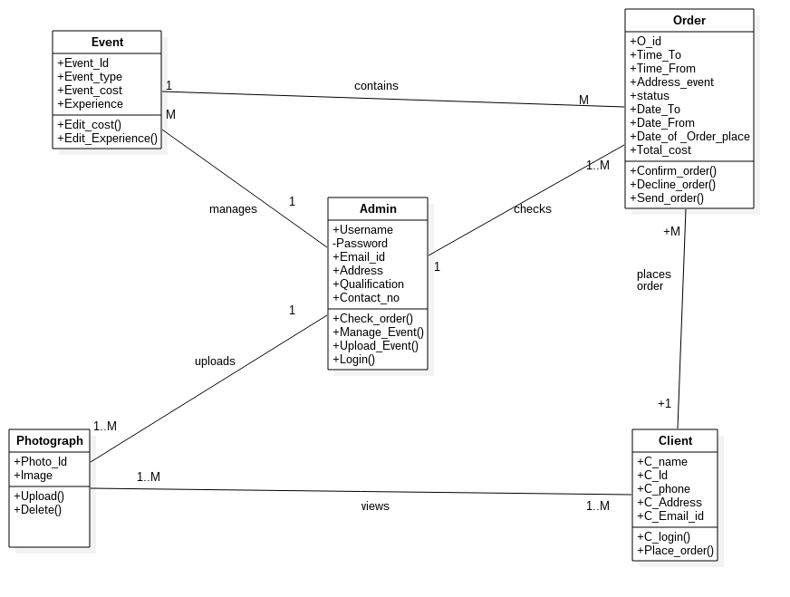

**DATABASE SCHEMA**

**Client**

|  |  |  |
| --- | --- | --- |
| C_Id | int | Primary Key |
| C_Name | varchar |  |
| C_Phone | int |  |
| C_Address | varchar |  |
| C_EmailID | varchar |  |

**Admin**

|  |  |  |
| --- | --- | --- |
| Username | varchar | Primary Key |
| Name | varchar |  |
| Password | varchar |  |
| Email_id | varchar |  |
| Address | varchar |  |
| Qualification | varchar |  |
| Contact_no | int |  |

**Event**

|  |  |  |
| --- | --- | --- |
| Event_Id | int | Primary Key |
| Event_type | varchar |  |
| Event_cost | int |  |
| Experience | int |  |

**Photograph**

|  |  |  |
| --- | --- | --- |
| Photo_Id | int | Primary Key |
| Image | varchar |  |
| Event_Id | int | Foreign Key |

**Order**

|  |  |  |
| --- | --- | --- |
| O_id | int | Primary Key |
| Date_of_Order_placed | datetime |  |
| Date_To | datetime |  |
| Date_From | datetime |  |
| Time_To | time |  |
| Time_From | time |  |
| Address_event | varchar |  |
| Event_Id | int | Foreign Key |
| status | varchar |  |
| C_Id | int | Foreign Key |
| Total_cost | int |  |

**Activity Diagram:**

**Admin Panel**

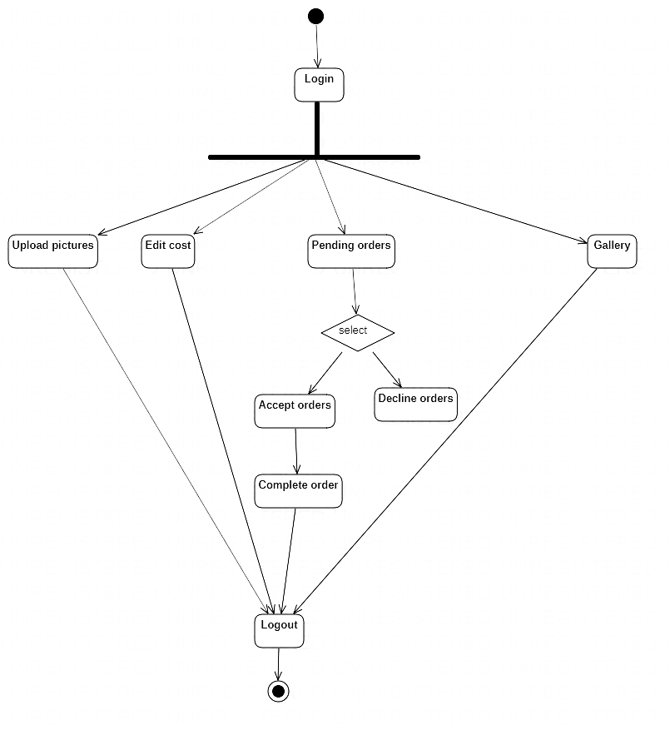

**Client Side**

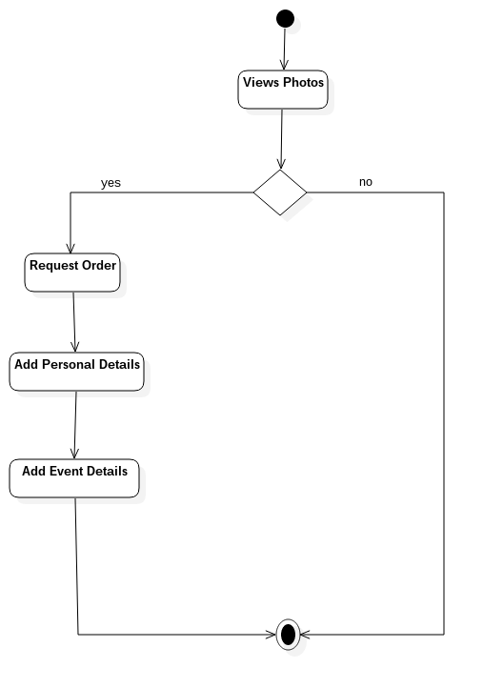

**Sequence Diagram**

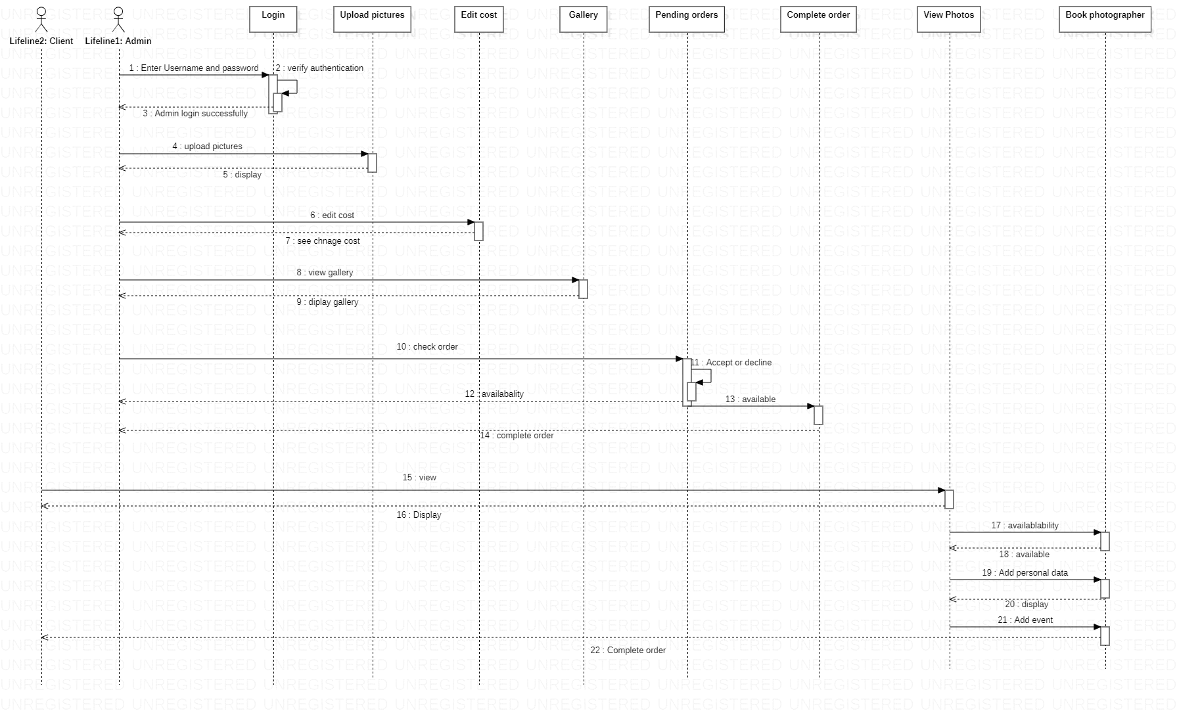

**Deployment Diagram**

