­­­­­

**RAJITH JAYADEVAN**

**SAURABH JAPE**

**ANANYA CHAKRABORTY**

**SUKHMEET SINGH**



IST 722- data warehousing

GROUP 5-PROJECT REPORT

July 1, 2016

ACKNOWLEDGEMENT

An endeavor over a period of time can be successful only with the advice and guidance of all the well-wishers, some directly through their technical assistance and some through their encouragement and help. We take this opportunity to owe our thanks and deep sense of gratitude to all who encouraged us and stood by our side in completing this project and making it a successful one. We are highly indebted to Prof. Michael Fudge, for his active help and guidance all throughout the course. We would also like to thank all our peers for their comments and feedbacks, which helped us improve on our flaws thus enhancing our work.

OVERVIEW

**Problem Statement**

There has been tremendous growth in the education structure at Syracuse University because of the fact that they provide classes on campus, distance learning programs and online classes. Hence a need arises for the assessment for course catalog. This assessment requires the university to conduct a trend analysis for the enrolment activity for the courses. This trend analysis involves the number of enrolments for courses and the number of students that drop the class.

**Background**

Students can drop classes due to many factors that can range from being obvious reasons to unknown/indeterminable reasons. The factors can be like manual errors, opting for substitute classes, time clashes, course-work, reputation of the faculty. Also students drop classes if get a chance to join the same course under a different faculty who is a generous grader.

**Project Objective**

The objective of our project is to have a rough idea of the trends for enrolment activity and provide a count of the number of enrollments and drops for a course to the University Staff. The end-product of this project is to provide valuable information to the University in order to make a business decision to improve course services, course technology, course modification, or even creating or developing a new course according to the industry requirement, dropping courses from the catalog or continuing with the same course offerings based on the assessment of the course catalog.

**Project Scope & Mission**

The scope of the project is to provide the University with facts and figures which will enable the University and staff to analyze data to provide Key Performance Indicators, KRI- Key Risk Indicators and provide trends and opportunities for Business intelligence, Business Development and Business Analyst Professionals. Since it is a trend analysis, there must be certain numbers or indicating factors like ratings or scorecards which will enable the professionals and University officials to make decisions regarding the courses.

## 

## **Team Member & Roles**



**Rajith Jayadevan**- ETL Architect and Data Architect

**Saurabh Jape**– Business Analyst and Data Architect

**Sukhmeet Singh**–BI Designer

**Ananya Chakraborty**– Decision Support Analyst

## **Stakeholders**

Business Owner- University

Business Managers – University Staff

Customer – Faculty and Students

University Provost

Business Analyst

Business Development Professionals

Program Manager

Project Manager

Project Group 5

Analysis

## **Business Process**

**Name:** **Student Registration Activity**

The business process that we have selected for our project is to determine the class registration activity in order to get information and trends about the number of enrollments and drops for a particular course and the class section during an academic semester.

## **Databases Used**

ist722_group5_dw

ist722_group5_stage

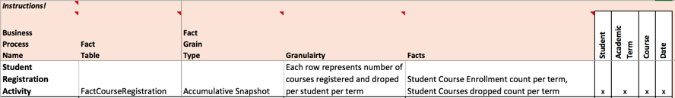**Bus Matrix**

The following is a screenshot for the bus matrix that we created for the project.

**Bubble Chart**

A bubble chart showcases the relationship between various fact and dimensions. Following is the bubble chart that we created for our project.

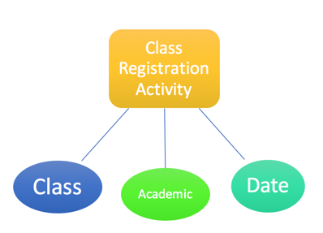

**Attribute List**

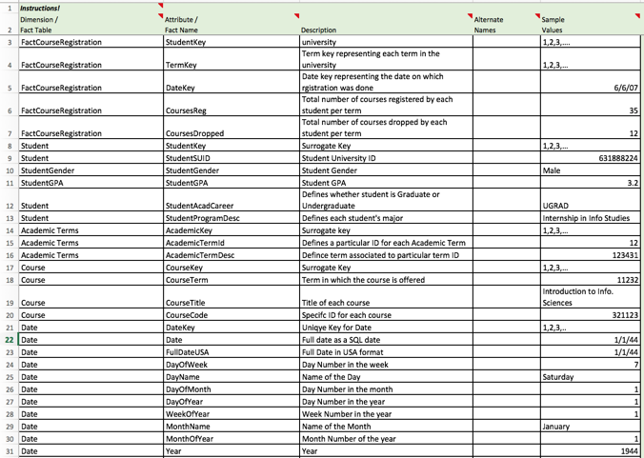 Following is the list which is called the Attribute List. The attribute list includes attributes for the various dimensions and facts.

## **Issue List**

Following is the list of issues that came up while working on the project. We were able

to solve all of the issues faced.

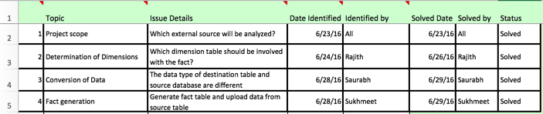

DESIGN

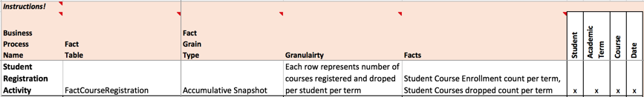**Detailed Bus Matrix**

**Fact/ Derived Fact Worksheets:**

### **FACT TABLE**

### FactCourseRegisteration- Description, Example Value, Display Folder

### 

### FactCourseRegisteration- Target, Source

### FactCourseRegisteration- ETL Rules, Comments

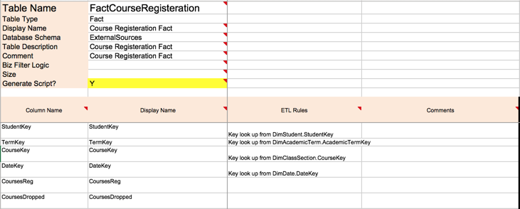

* **Detailed Dimensional Design Worksheet**

1. ***Dimension Tables:***

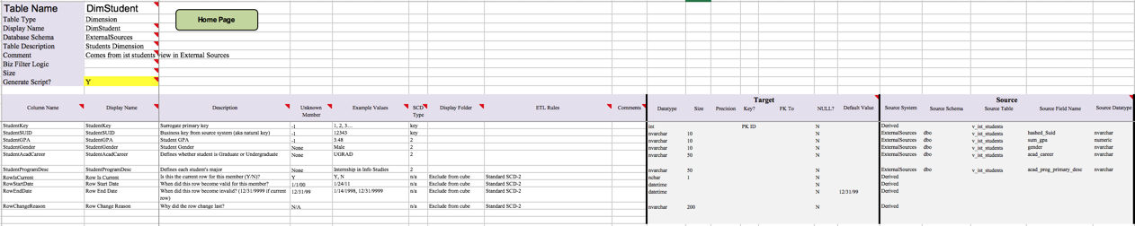**DimStudent**

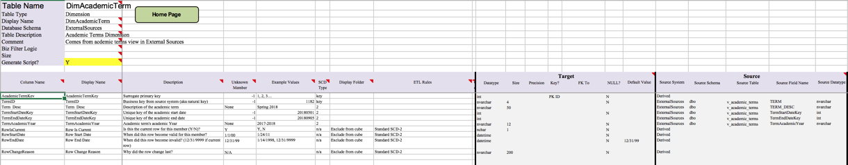**DimAcademicTerm**

**DimClassSection**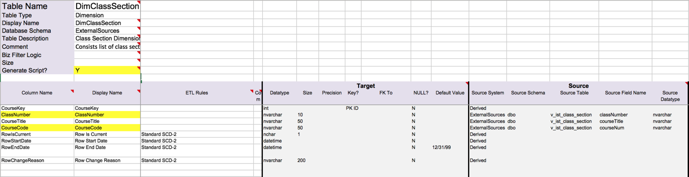

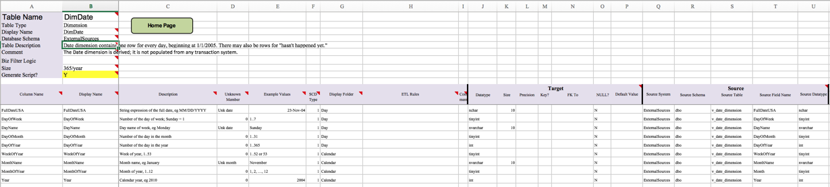**DimDate**

Dimensional Hierarchies

* Dimensional Hierarchy in DimAcademicTerm

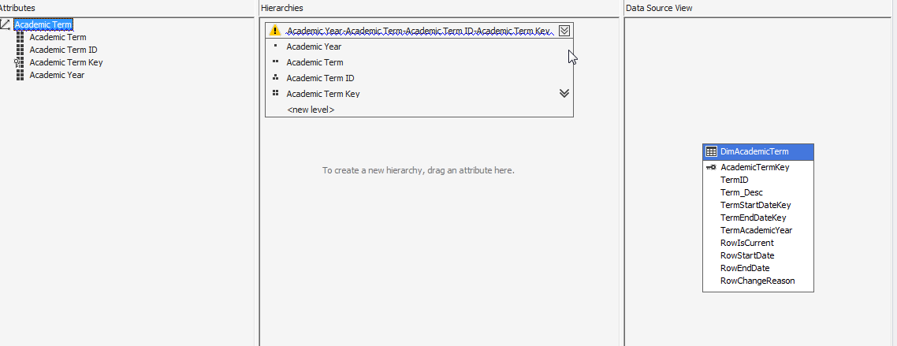

* Dimensional Hierarchy in DimClasssSection

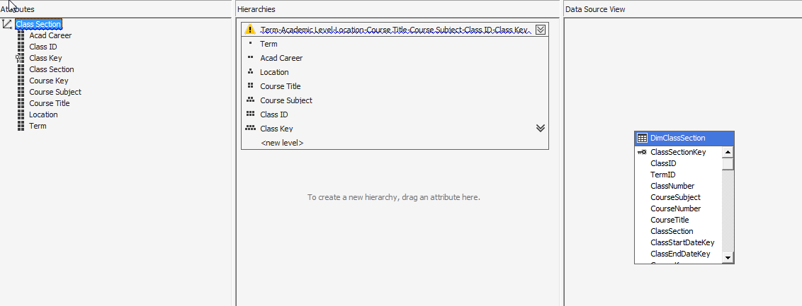

* Dimensional Hierarchy in DimDate

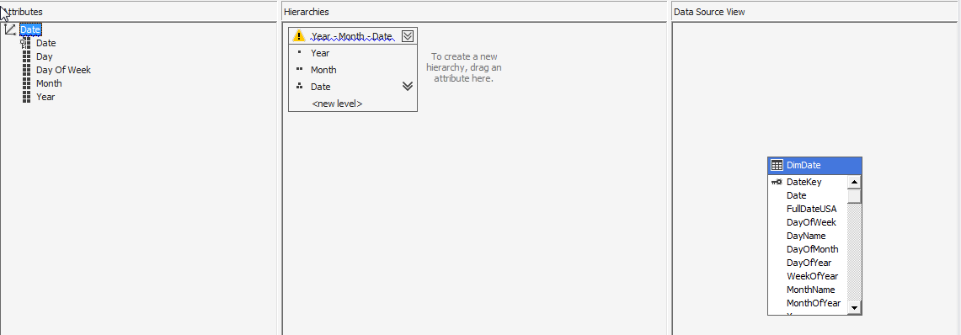

Star Schema Model Diagram

In this case, we have used the Star Schema model as each dimension is represented by a single table in the ROLAP schema.

DimStudent

DimAcademicTerm

DimDate

FACT COURSE REGISTRATION

DimClassSection

ETL Specifications

**High - Level Source to Target Map**

**STAGE**

stgAcademicTerms

stgCourses

stdDate

stgStudents

DimDate

DimAcademicTerms

DimClassSection

DimStudents

Date

AcademicTerms

ClassSection

Students

**DW**

**SOURCE**

**Peer Evaluation**

|  |  |  |  |  |
| --- | --- | --- | --- | --- |
| Task | Rajith Jayadevan | Saurabh Jape | Sukhmeet Singh | Ananya Chakraborty |
| Creating deliverables | 5 | 5 | 5 | 5 |
| Integrating deliverables | 3 | 3 | 5 | 5 |
| High Level Dimensional Model | 5 | 5 | 4 | 5 |
| Detailed Level Dimensional Model | 5 | 5 | 5 | 4 |
| Creating ROLAP Schema | 4 | 4 | 4 | 3 |
| ETL code Package | 4 | 5 | 3 | 4 |
| MOLAP Database | 5 | 4 | 5 | 5 |
| Final Review | 5 | 5 | 5 | 5 |

1- No Contribution 4- Good Contribution

2- Barely made a contribution 5- Excellent Contribution

3- Medium contribution

Implementation

* Rolap Schema In Sql Server

### **Fact Table**

* **Fact Registration Activity:**

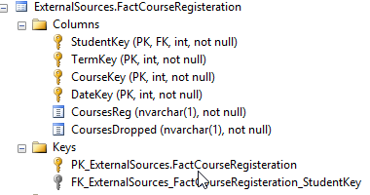

### **Dimension Tables**

**DimAcademicTerm:**

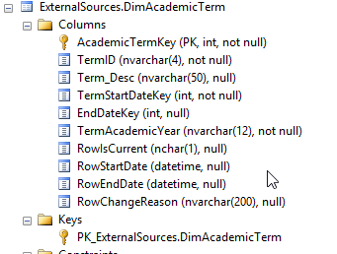

**DimClassSection:**

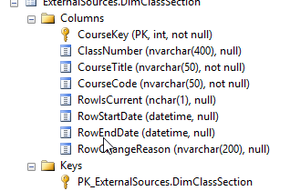

**DimDate:**

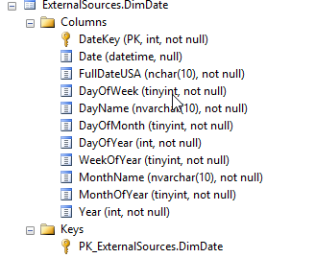

**DimStudent:**

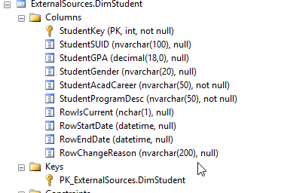

### 

### **Star Schema Diagram**

## 

## **SSIS ETL Code/Packages**

### **Populate ROLAP Schema from Sources**

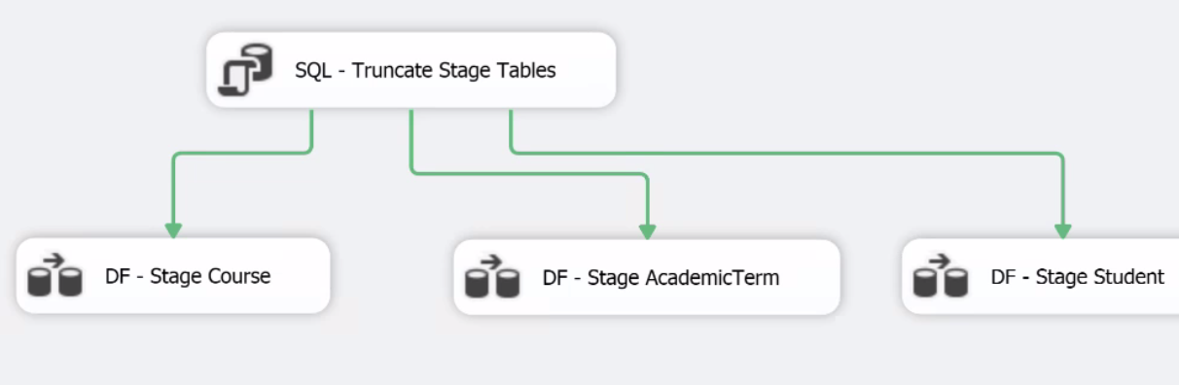

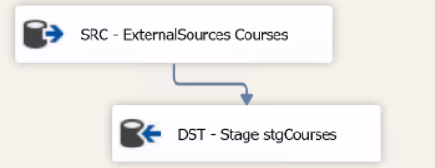 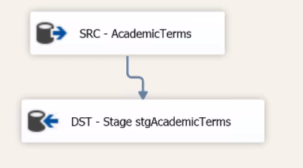 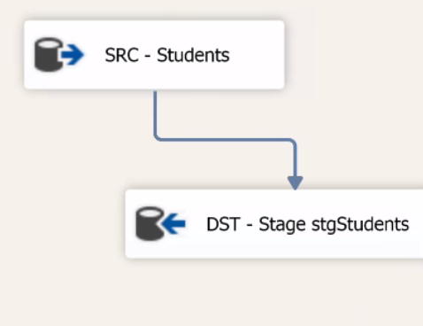

### **Load from Stage table to Target tables**

### 

**Analysis Service Molap Database**

## **Molap Cube Structure**

## 