**ANSWER 1:**

**OUTPUT:**

List of acceptable words:[Two, alike, fair, Verona, we, lay, scene, ancient, new, unclean, the, fatal, of, these, two, foes, pair, of, lovers, take, their, piteous, Do, their, their, strife, The, fearful, of, their, love, And, the, continuance, of, their, rage, but, their, end, now, the, two, of, The, if, you, patient, attend, here, shall, miss, shall, strive]

List organized by the length of words:[continuance, ancient, unclean, piteous, fearful, patient, Verona, lovers, strife, attend, strive, alike, scene, fatal, these, their, their, their, their, their, their, shall, shall, fair, foes, pair, take, love, rage, here, miss, Two, lay, new, the, two, The, And, the, but, end, now, the, two, The, you, we, of, of, Do, of, of, of, if]

Count of occurances of words:{but=1, lovers=1, attend=1, pair=1, rage=1, Two=1, love=1, of=5, The=2, patient=1, ancient=1, continuance=1, if=1, Verona=1, fearful=1, alike=1, end=1, these=1, piteous=1, lay=1, fatal=1, foes=1, here=1, you=1, the=3, fair=1, shall=2, Do=1, two=2, new=1, strive=1, now=1, take=1, scene=1, strife=1, their=6, unclean=1, And=1, miss=1, we=1}

Most common word: their

**SCREENSHOT:**

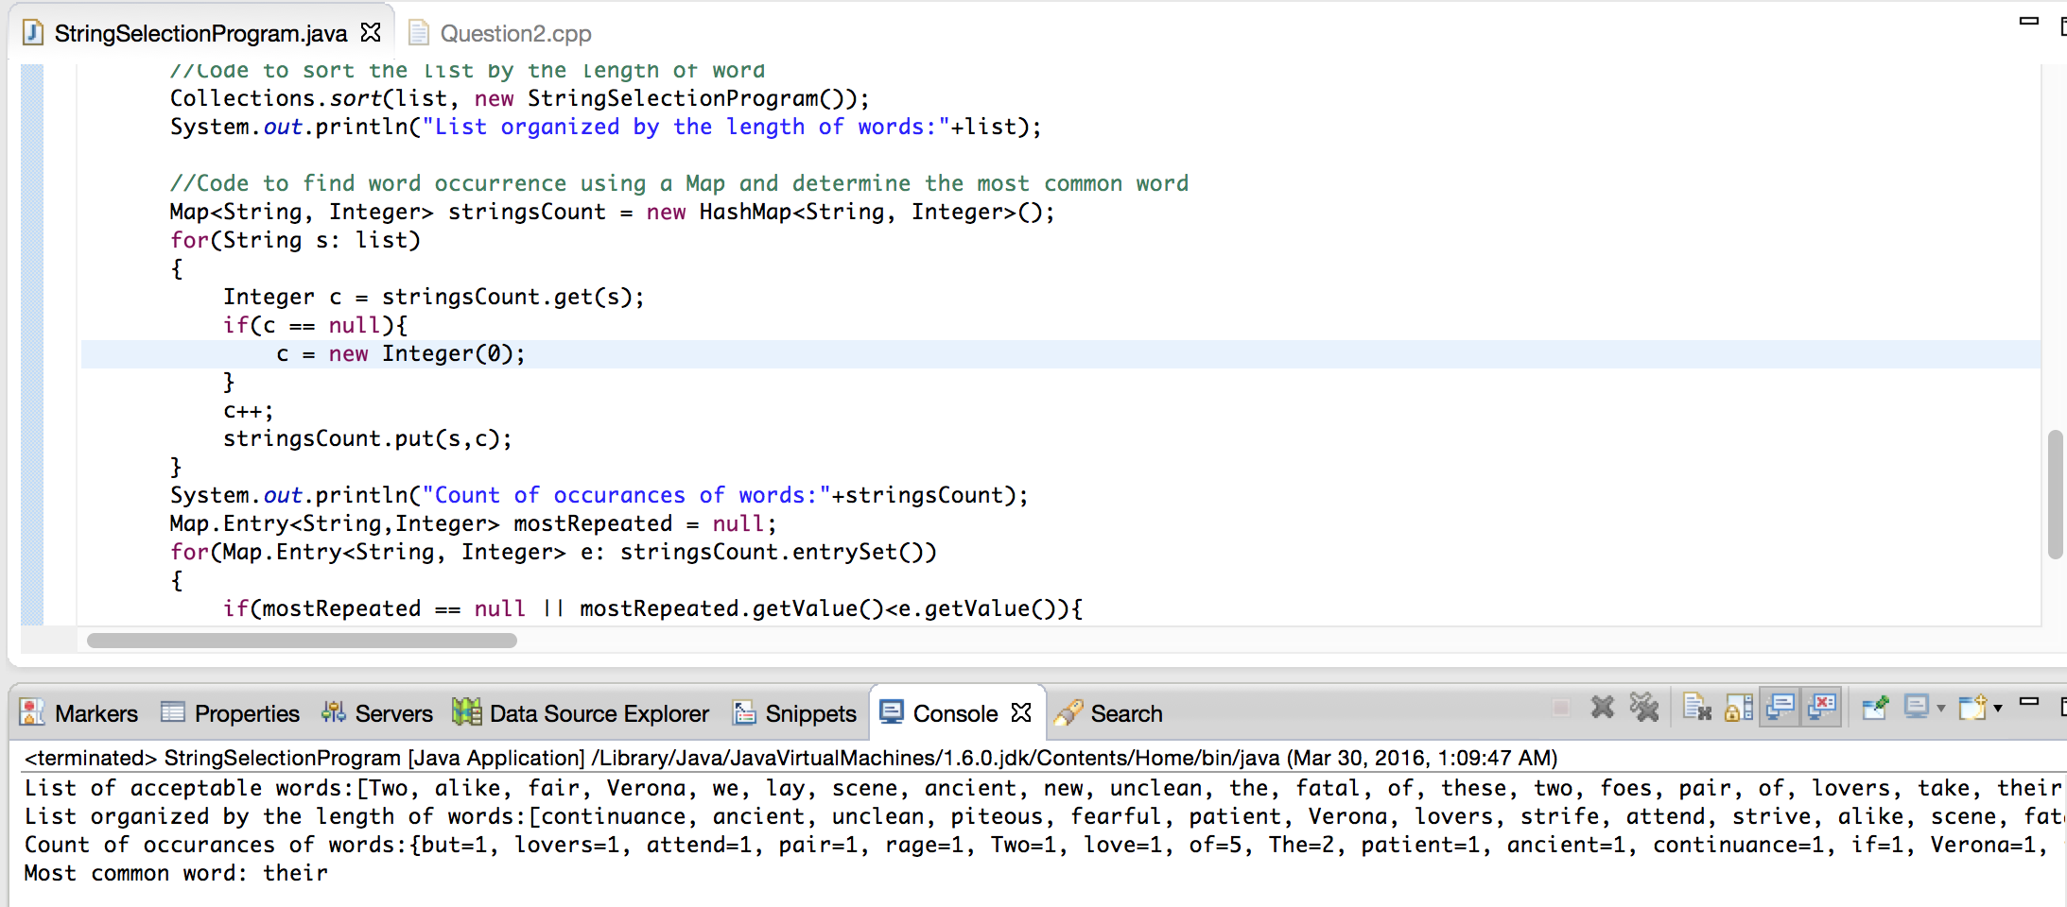

**ANSWER 2:**

**OUTPUT:**

Elements in Array1: 552,38,957,144,106,79,440,109,238,463,

Elements in Array2: 156,906,398,856,354,516,494,505,528,797,

Elements in Array3: 296,393,209,554,582,261,855,474,335,68,

Elements merged and stored in Array4: 552,38,957,144,106,79,440,109,238,463,156,906,398,856,354,516,494,505,528,797,296,393,209,554,582,261,855,474,335,68,

Array without duplicates and in descending order 957,906,856,855,797,582,554,552,528,516,505,494,474,463,440,398,393,354,335,296,261,238,209,156,144,109,106,79,68,38,

Updated Array1: 957,two,two,five,797,two,two,two,two,two,five,two,two,463,grapefruit,two,393,two,five,two,261,two,209,two,two,109,two,79,two,two,

Updated Array2: 957,grapefruit,grapefruit,five,797,grapefruit,grapefruit,grapefruit,grapefruit,grapefruit,five,grapefruit,grapefruit,463,2,grapefruit,393,grapefruit,five,grapefruit,261,grapefruit,209,grapefruit,grapefruit,109,grapefruit,79,grapefruit,grapefruit,

**SCREENSHOT**

