

**“Car Showroom Management”**

A

SRS Report submitted to the

Savitribai Phule Pune University, Pune

For the Degree of

**Bachelor of Engineering**

**In**

**Computer Engineering**

By

**Ms. Jagtap Neha Chandrashekhar [333]**

**Mr. Jha Saurabh Bhagwan[358]**

**Ms. Raskar Prajakta Sanjay[355]**

Under The Guidance of

**Prof. Varsha Mhaske.**



**Department of Computer Engineering,**

Shivnagar Vidya Prasarak Mandal’s

**College OF Engineering, Malegaon (Bk)**

Tal:-Baramati, Dist:- Pune 413115

**Year 2019-2020.**

**CERTIFICATE**

This is to certify that the report entitled,

**“Car Show Room Management”**

Submitted by

**Ms. Jagtap Neha Chandrashekhar [333]**

**Mr. Jha Saurabh Bhagwan [358]**

**Ms. Raskar Prajakta Sanjay [355]**

Is hereby approved in partial fulfilment of the Bachelor’s Degree in

Computer Engineering.

**Prof. H. R. Kumbhar Dr. S. M. Mukane**

**(H.O.D) (PRINCIPAL)**



**Department of Computer Engineering**

Shivnagar Vidya Prasarak Mandal’s

**College OF Engineering, Malegaon (Bk)**

Tal:-Baramati, Dist:- Pune 413115

**Year 2019-2020**

**Table of Contents :**

1. Introduction
2. Motivation
3. Problem Statement
4. Objectives
5. E-R diagram
6. Conclusion
7. Reference

**Introduction :**

* This project helps employee & owner of car showroom to maintain database of employee and Customers.
* This project mainly focus on making and maintaining database database of car showroom easily.

**Motivation :**

* The paper work for maintaining employee and customers can be a lot of work which requires lot of time.
* Creating a program which manages all this work by using database which saves time which can be used somewhere else.

**Problem Statement :**

* To create a python program for car showroom management using MYSQL.

**Objectives :**

* Understand database systems.
* Understand database connectivity with python.

**E-R Diagram :**

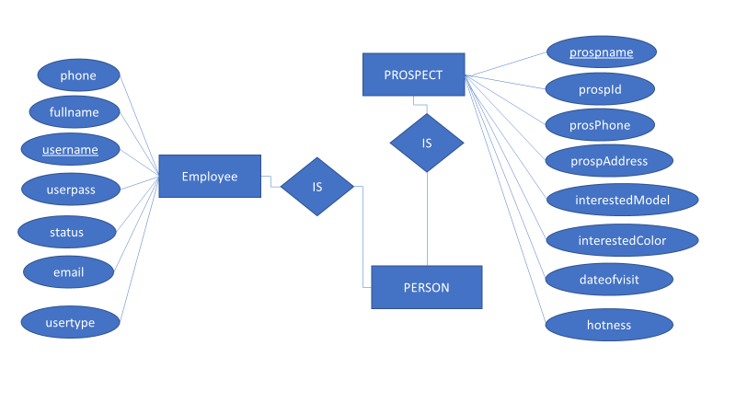

**Conclusion :**

* While performing this project we studied database system and database connectivity using MYSQL with python.

**Refrences :**

1. <http://www.tutorialspoint.com/py>
2. <https://www.youtube.com/watch>