**Synopsis**

**Title :- Shopkeeper (E-Commerse) WebApp**

1. **Introduction**
   1. Project Overview
      1. Aims and Objectives :
         * The primary objectives of this platform are to facilitate shopkeepers in setting up and maintaining their online presence, enhance the efficiency of inventory management and order fulfillment processes, and provide a user-friendly interface for both shopkeepers and customers.
         * Streamline the transition of local businesses to the online marketplace.
         * Enhance the visibility and accessibility of shopkeepers' products.
         * Provide a user-friendly platform for managing inventory and processing customer orders.
      2. Future Scope and Further Enhancement :
         * In the future, the platform aims to integrate advanced analytics for sales forecasting, implement AI-driven features for personalized product recommendations, expand to include support for multiple languages and currencies, and incorporate emerging technologies like AR for virtual product try-ons.
      3. Conclusion :
         * the Shopkeeper e-commerce website is a one-stop solution for shopkeepers looking to establish their online presence. It aims to provide a seamless experience for both shopkeepers and customers, and its future enhancements will further improve the efficiency and effectiveness of online business operations.
2. **Supporting Information**
   1. Resources :
      1. IDE : Visual Studio Code
      2. Language : Javascript, html and css
      3. Framework : Bootstrap,
      4. Design and Layout : Figma
      5. Web Hosting : Github, Gitlab
      6. Database : Postgresql, Mongodb
   2. Limitations :
3. **Technical Details**
   1. Process Description :
      1. **Website setup:** The first step is to set up the website. This involves selecting a domain name, choosing a hosting provider, and designing the website’s layout and user interface.
      2. **Product listing:** Once the website is set up, the next step is to list the products that the shopkeeper wants to sell. This involves creating product descriptions, uploading product images, and setting prices.
      3. **Inventory management:** After the products are listed, the shopkeeper needs to manage their inventory. This involves keeping track of stock levels, updating product availability, and managing orders.
      4. **Order fulfillment:** When a customer places an order, the shopkeeper needs to fulfill it. This involves packaging the product, shipping it to the customer, and updating the order status.
      5. **Customer support:** Finally, the shopkeeper needs to provide customer support. This involves answering customer queries, resolving complaints, and providing refunds or exchanges if necessary.
   2. 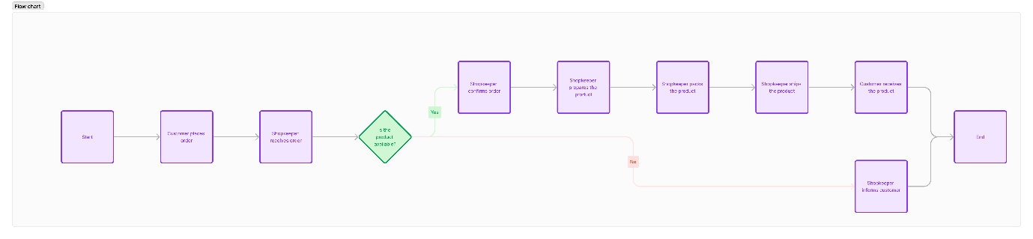Data Flow Diagrams (DFDs) :
   3. Entity-Relationship (ER) Diagram :
4. **Data Collection**
   1. Explanation of Data Collection Methods, Tools, or Strategies :
      1. Detail how user data, product information, and transactional data are collected and utilized within the web app.
5. **Citation and Documentation**
   1. References :

**Team Members:**

1. Arbaj Shafic Shaikh
2. Saurabh Gaurish Kope