**ComicCrafter AI**

By:

(2201321530051, Saurabh Kumar)

(2201321530065, Yash Mishra)

(2201321530039, Nishaant Singh)



**Greater Noida Institute of Technology (Engg. Institute), Greater Noida**

**Dr. A.P.J. Abdul Kalam Technical University, Lucknow**

February, 2025

**Introduction**

**ComicCrafter AI** is an innovative, generative AI-based platform designed to create visually engaging comic-style stories based on user prompts. By leveraging the power of **Large Language Models (LLMs)** for story generation and **Image generation models** like **Stable Diffusion**, the system seamlessly transforms textual input into a structured comic book format.

The primary objective of **ComicCrafter AI** is to automate and streamline the comic creation process while maintaining coherence between narrative and visuals. The system follows a structured workflow: first, a **user inputs a story prompt**, which is processed by an **LLM** to generate a four-part structured story, including an introduction, storyline, climax, and moral. Next, an **Image generation model** creates corresponding visuals that match the story’s tone and themes. Finally, the generated text and images are merged into a formatted digital comic, ensuring a compelling storytelling experience.

One of the standout features of **ComicCrafter AI** is its ability to run on **edge devices**, allowing users to create comics efficiently without requiring cloud-based infrastructure. This makes it a powerful tool for artists, writers, and comic enthusiasts who seek a **fast, automated, and AI-enhanced** approach to storytelling.

**Problem Statement**

Traditional comic creation is a time-intensive process requiring a combination of artistic skills, storytelling expertise, and digital tools. Writers and artists often spend significant time conceptualizing, illustrating, and formatting comics, which limits efficiency and accessibility. With the rapid advancement of **Artificial Intelligence (AI),** there is an opportunity to automate and enhance the comic creation process. However, existing AI-based tools primarily focus on **either text generation or image synthesis** separately, lacking an integrated solution that ensures coherence between narrative and visuals. The absence of a **unified AI-driven storytelling system** makes it difficult for users to generate high-quality, structured comic books in an efficient manner.

**Methodology**

**Phase 1: Story Generation using LLMs**

The system utilizes Large Language Models (LLMs) such as **Gemma2 2b instruct** to generate structured stories from user prompts. The model is tuned to produce coherent narratives divided into four key sections: introduction, storyline, climax, and moral of the story. To maintain consistency, prompt engineering is applied, ensuring that the generated content aligns with a comic book structure.

**Phase 2: AI-Based Image Generation**

The second phase involves using AI-powered image generation models like Stable Diffusion and tools such as **Comfy UI** to create illustrations that match the generated text. These images reflect the comic-style aesthetics, ensuring a visually appealing output. The AI model takes textual descriptions from the story and translates them into scene-specific illustrations, maintaining character consistency.

**Phase 3: Merging Story and Images**

By the help of web integration framework such as **Gradio** we are able to merge the LLM’s output with the Stable Diffusion output in a comic book layout.

**Phase 4: Deployment on Edge Devices**

To enhance accessibility and performance, ***ComicCrafter AI*** is optimized for deployment onedge devices. By leveraging **Comfy UI framework** and **LM studio framework**, the system runs locally without requiring cloud-based computation. This ensures low latency, privacy protection, and efficient processing. By integrating LLMs, Image generation, and edge computing, ***ComicCrafter AI*** offers a fast, automated, and user-friendly approach to comic book creation.

**Challenges Faced**

#### ****1. Image Relevance and Style Consistency****

Generating **visually accurate and contextually aligned** images for each story segment was a challenge. AI-generated images sometimes **failed to maintain character consistency**, leading to **visual discrepancies** in different comic panels. To address this, **Stable Diffusion fine-tuning** were implemented to **ensure stylistic uniformity across panels**.

#### ****2. Seamless Integration of Text and Images****

Combining the AI-generated **text and images** into a **cohesive comic book format** required an efficient **layout design mechanism**. This was resolved by implementing **web integration framework called Gradio**

#### ****3. Edge Device Deployment and Performance Optimization****

Running AI models on **edge devices** rather than cloud-based systems posed **computational limitations**. AI models for both **text and image generation** are typically resource-intensive, requiring **hardware acceleration** for smooth execution. Techniques like **model caching, and hardware-specific optimizations** were used to improve performance while maintaining output quality.

**Proposed Solution**

**DFD Diagram**

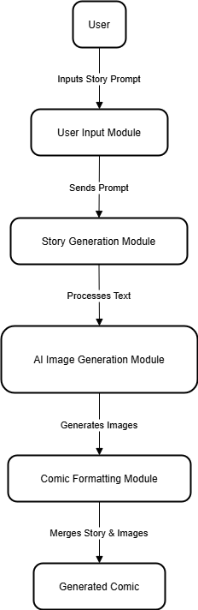Level 1 DFD:

**Source Code Link:** [**https://github.com/saurabhkumar9901/ComicCrafterAI.git**](https://github.com/saurabhkumar9901/ComicCrafterAI.git)

**Video of running code link:**

[**https://drive.google.com/file/d/1KB4B9kgda9i_WE9V9zUeiZrlZFjxF-Ux/view?usp=sharing**](https://drive.google.com/file/d/1KB4B9kgda9i_WE9V9zUeiZrlZFjxF-Ux/view?usp=sharing)