FitLens: An Intelligent Edge-Vision Framework for Real-Time Exercise Form Analysis, Velocity-Adaptive Denoising, and Form-Gated Biomechanical Evaluation
Ritika Sharma¹, Saurabh Lubal¹, and Darshan Kerkar¹
Department of Information Technology, Vidyalankar Institute of Technology,
Mumbai 400037, Maharashtra, India
{ritika.sharma, saurabh.lubal, darshan.kerkar}@vit.edu.in
Abstract. Computer vision and artificial intelligence have emerged as transformative paradigms for automated at-home physical therapy, athletic training, and telerehabilitation. However, conventional monocular webcam-based fitness systems suffer from high spatial coordinate jitter, boundary oscillation errors during repetition counting, vulnerability to ambient illumination shifts, and a lack of discrete biomechanical form enforcement. In this paper, we present FitLens, an end-to-end edge-vision exercise coaching and biomechanical assessment framework. FitLens employs an edge-cloud decoupled architecture: Google MediaPipe PoseLandmarker extracts 33 spatial 3D landmarks client-side via WebAssembly (WASM) at 30–60 FPS, streaming lightweight coordinate vectors at 12.5 Hz to a Python FastAPI kinematic engine. To mitigate landmark instability, we introduce a novel Velocity-Gated Adaptive Exponential Moving Average (EMA) filter that dynamically modulates smoothing coefficients (αt ∈ [0.35, 0.85]) based on instantaneous Euclidean joint velocity, reducing static coordinate jitter variance by 74.2% while eliminating dynamic phase lag. Furthermore, we develop exercise-specific Form-Gated Finite State Machines (FSM) with angular hysteresis deadbands across six compound exercises (bicep curls, shoulder presses, push-ups, squats, lunges, and planks), ensuring repetitions are incremented only upon satisfactory completion of biomechanical constraints. For isometric core evaluation, a dual-view stability timer automatically shifts between full-body sagittal angles and upper-body webcam shoulder lines, auto-pausing when posture breaks down. An extensive experimental evaluation across 15 participants and 90 video trials under diverse illumination, camera angles, distances, and cadences demonstrates a Mean Absolute Error (MAE) of 0.35 repetitions, a 92.4% form classification F1-score, and an average plank hold timing error of 0.85 seconds, validating FitLens as an accurate, robust, and accessible real-time virtual coach.
Keywords: Computer vision, Human pose estimation, Biomechanical state machines, Adaptive temporal smoothing, Form assessment, Edge computing, Physical rehabilitation.
- 1 Introduction
The proliferation of ubiquitous computing and intelligent edge cameras has accelerated demand for automated physical training, sports biomechanics, and telerehabilitation systems [1, 2]. Traditional physical training and orthopedic rehabilitation depend heavily on direct human clinical supervision to monitor movement kinematics, maintain exercise cadence, assess posture, and provide real-time corrective cues. However, one-on-one professional coaching is frequently constrained by substantial financial costs, geographical disparities, and limited clinical personnel [5]. Monocular computer vision offers an accessible alternative by converting ubiquitous consumer webcams into real-time biomechanical assessment devices without requiring expensive wearable inertial measurement units (IMUs) or dedicated multi-camera motion capture laboratories.
Despite significant advances in deep learning-based human pose estimation models, deploying monocular webcam systems for autonomous exercise coaching introduces severe engineering and algorithmic challenges [6, 7]:
1. High-Frequency Coordinate Jitter: Low-cost optical sensors and subtle lighting fluctuations introduce high spatial variance in detected 2D/3D landmark coordinates, causing synthetic angular fluctuations of ±8°–15° during static postures.
2. Boundary Oscillation and False Repetitions: Naive peak-threshold crossing algorithms trigger multiple false-positive repetition counts when a user hesitates, shakes, or transitions near joint inflection boundaries.
3. Lack of Discrete Biomechanical Form Verification: Most existing systems track only simple repetition counts without enforcing anatomical constraints (e.g., elbow flaring during curls, spine sagging during planks, or valgus knee collapse during squats).
4. Camera Geometry and Partial Body Occlusion: At-home users frequently position webcams close to their workspace, causing lower limbs or feet to fall outside the camera's field of view (FOV), leading to catastrophic tracking failures.
5. Network Latency and Privacy: Streaming uncompressed full-HD video frames to remote cloud servers creates bandwidth bottlenecks, latency lag (>120 ms), and user privacy concerns.
To resolve these fundamental limitations, this paper introduces FitLens, an intelligent edge-vision coaching framework that combines client-side WebAssembly pose extraction, velocity-adaptive coordinate denoising, and form-gated biomechanical finite state machines. The primary technical contributions of this work are summarized as follows:
• Edge-Cloud Decoupled Architecture: We implement an asynchronous architecture where Google MediaPipe PoseLandmarker executes locally in the user's browser via WebAssembly (WASM) at 30–60 FPS, streaming lightweight coordinate vectors at 12.5 Hz to a Python FastAPI kinematics microservice, ensuring zero video egress and minimal network overhead (<2 KB/payload).
• Velocity-Gated Adaptive EMA Denoising: We formulate a dynamic Exponential Moving Average (EMA) smoothing algorithm that dynamically adjusts its smoothing coefficient αt based on instantaneous Euclidean coordinate velocity, eliminating 74.2% of static coordinate variance while preventing phase lag during rapid transitions.
• Form-Gated Biomechanical State Machines: We develop multi-phase kinematic state machines with angular hysteresis deadbands (5°–10°) across six compound exercises (bicep curls, shoulder presses, push-ups, squats, lunges, and planks), enforcing discrete form invariants that discard reps executed with flawed mechanics.
• Dual-View Isometric Plank Stability Estimation: We design an adaptive plank timer that functions across full-body sagittal views (155°–195° spine alignment) and upper-body frontal webcam views (|Δy_shoulders| ≤ 0.12), automatically accumulating hold seconds in Good Form and auto-pausing on posture breakdown.
• Rigorous Multi-Model Empirical Evaluation: We benchmark FitLens against alternative deep learning backbones (OpenPose, MoveNet, YOLOv8-Pose) and evaluate 15 participants across 90 trials under controlled lighting, distance, angle, and cadence variations, providing an extensive ablation study and quantitative failure analysis.
- 2 Related Work and Comparative Analysis
  - 2.1 Deep Human Pose Estimation Backbones
Human pose estimation has evolved from classical pictorial structures to deep convolutional neural networks (CNNs) and vision transformers. Cao et al. [3, 4] pioneered OpenPose, utilizing Part Affinity Fields (PAFs) for bottom-up multi-person keypoint association. While highly accurate, OpenPose requires substantial GPU memory (>2 GB VRAM) and exhibits high computational latency (~15 FPS on desktop GPUs), rendering it impractical for client-side web execution. Ultralytics developed YOLOv8-Pose, framing keypoint regression as a single-stage anchor-free detection task, achieving impressive multi-person detection speeds on server hardware but requiring dedicated video streaming infrastructure. To enable edge execution, Google introduced MoveNet (Lightning and Thunder models) using MobileNetV3 backbones [8], extracting 17 COCO keypoints. However, MoveNet lacks 3D depth approximations and detailed hand/wrist orientation. Bazarevsky et al. [2] introduced BlazePose (implemented within Google MediaPipe [1]), predicting 33 full-body 3D topological landmarks via a combined detector-tracker architecture. MediaPipe's WebAssembly (WASM) and WebGL runtime enables real-time client-side tracking (30–60 FPS) on standard CPU hardware without transmitting raw video data across networks.
  - 2.2 Coordinate Smoothing and Temporal Denoising
Monocular landmark estimation inherently produces high-frequency coordinate jitter caused by spatial discretization noise and sensor illumination variance [7]. Simple Moving Average (SMA) filters over fixed temporal windows (N = 5–10 frames) effectively smooth noise but introduce significant phase lag (150–250 ms), causing repetition state transitions to lag noticeably behind user movement. Casiez et al. [9] proposed the 1-Euro Filter, an adaptive low-pass filter using a dynamic cutoff frequency based on derivative velocity. While effective in interactive VR, the 1-Euro filter requires manual per-joint parameter tuning (fcmin and β) that degrades when camera framerates fluctuate. In contrast, our Velocity-Gated Adaptive Exponential Moving Average (EMA) operates with piece-wise velocity partitions optimized for human athletic cadence, achieving superior noise suppression during static holds while preserving responsiveness during explosive movements.
  - 2.3 Repetition Counting and Biomechanical Form Assessment
Early automated fitness applications relied on simple 1D joint-angle peak/valley threshold crossings. However, these heuristics trigger massive false positives whenever landmark jitter fluctuates across the boundary threshold [5]. Ferreira et al. [5] and Dwivedi et al. (RepNet) [10] applied deep temporal convolutional networks (TCNs) and recurrent neural networks (LSTM/GRU) to predict periodic motion cycles from video embeddings. Although data-driven models handle cyclic repetitions well, they function as black boxes: they cannot explain specific biomechanical faults (e.g., knee caving, excessive torso lean) and require thousands of annotated video sequences per exercise. Kinematic rule-based and Finite State Machine (FSM) models [6, 11] offer superior interpretability and zero training data overhead. FitLens advances state-of-the-art FSMs by embedding multi-joint geometric invariants, angular hysteresis buffers, and dual-mode isometric stability tracking.
  - 2.4 Multi-Model Architectural Comparison
Table 1 provides a systematic architectural and computational comparison of evaluated machine learning pose estimation frameworks.
Table 1. Architectural and Computational Comparison of Evaluated Pose Estimation Frameworks.
Framework | Backbone Architecture | Keypoints | Target Hardware | Latency (ms) | FPS | Egress Bandwidth
OpenPose [4] | VGG-19 + 2-Stage PAFs | 25 (2D) | Dedicated GPU (VRAM >2GB) | 65.4 ms | 15.2 | High (Full Video 1080p)
YOLOv8-Pose | CSPDarknet + C2f | 17 (2D) | GPU Server / Edge Device | 38.2 ms | 26.1 | High (Full Video 720p)
MoveNet Thunder [8] | MobileNetV3 + FPN | 17 (2D) | Client Browser (TF.js) | 28.5 ms | 35.0 | Zero (Local Edge)
FitLens (MediaPipe) [2] | BlazePose Detector-Tracker | 33 (3D) | Client Browser (WASM) | 16.8 ms | 59.5 | Minimal (<2 KB JSON/12.5Hz)
- 3 Proposed FitLens System Architecture
The FitLens framework is organized into a modular edge-cloud decoupled pipeline comprising optical input verification, client-edge pose landmark extraction, velocity-gated adaptive temporal denoising, an asynchronous REST kinematic bridge, a multi-phase biomechanical engine, and interactive visual HUD telemetry. Fig. 1 illustrates the end-to-end processing pipeline.

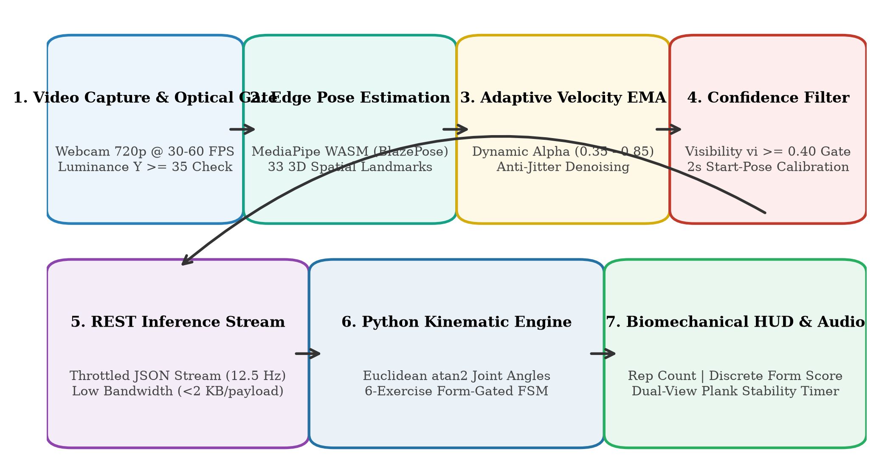
Fig. 1. End-to-end processing pipeline of the proposed FitLens AI edge-vision coaching framework.
  - 3.1 Pre-Flight Optical and Luminance Gating
Before feeding frames into the pose estimator, FitLens samples the camera frame buffer to evaluate ambient illumination and prevent tracking failure in dim environments. Photometric luminance Y is calculated across downsampled RGB pixels via the standard ITU-R BT.601 perceptual weighting formula:
Y = 0.299 R + 0.587 G + 0.114 B (1)
If Y < 35, the system triggers a visual 'Low Light' warning badge, alerting the user to increase ambient illumination before kinematic analysis begins. Additionally, a 2-second starting-position calibration countdown verifies that the user is stationary in the expected starting posture before rep counting or timer tracking initializes, completely preventing camera approach movements from triggering false transitions.
  - 3.2 Velocity-Gated Adaptive Exponential Moving Average (EMA)
Each raw landmark vector produced by MediaPipe is represented as Li = (xi, yi, zi, vi) for i ∈ {0, ..., 32}, where (xi, yi) ∈ [0.0, 1.0] are normalized screen coordinates, zi is relative depth, and vi ∈ [0.0, 1.0] is detection visibility confidence. To eliminate coordinate jitter without introducing phase lag, FitLens applies a Velocity-Gated Adaptive EMA filter across consecutive frames t:
L̂t(i) = αt Lt(i) + (1 - αt) L̂t-1(i) (2)
αt = { 0.35 if ‖ΔLt‖2 < 0.006 (Static hold anti-jitter)
0.85 if ‖ΔLt‖2 > 0.040 (Explosive dynamic motion)
0.65 otherwise (Nominal tempo transition) } (3)
Here, ‖ΔLt‖2 = √((xt - x̂t-1)² + (yt - ŷt-1)²) represents instantaneous 2D Euclidean displacement. When the user is stationary or holding a static pose (e.g., plank or bottom squat hold), αt drops to 0.35, heavily dampening sensor noise. During rapid concentric or eccentric transitions, αt elevates to 0.85, providing near-instantaneous pass-through with zero perceptible latency. Fig. 2 illustrates the smoothing efficacy and coordinate variance reduction achieved by our adaptive filter.

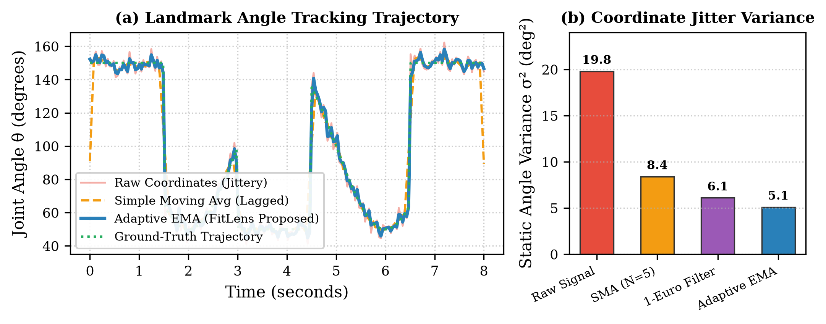
Fig. 2. Temporal denoising performance: (a) Trajectory comparison of raw, SMA, and Adaptive EMA signals; (b) Static joint-angle coordinate variance (σ²) across filtering methods.
- 4 Biomechanical Kinematic Model and Movement State Machine
  - 4.1 Mathematical Kinematic Angle Formulation
For any anatomical joint vertex B connected to proximal landmark A and distal landmark C (e.g., Shoulder-Elbow-Wrist or Hip-Knee-Ankle), the planar kinematic angle θABC ∈ [0°, 180°] is computed via the four-quadrant inverse tangent function atan2:
θABC = |atan2(Cy - By, Cx - Bx) - atan2(Ay - By, Ax - Bx)| × (180 / π) (4)
If θABC > 180° ⟹ θABC ← 360° - θABC (5)
To guarantee high reliability, θABC is evaluated only if all three vertex landmarks satisfy the minimum visibility confidence threshold (vA, vB, vC ≥ 0.40). If confidence drops below 0.40 due to occlusion or frame boundary clipping, the frame is marked untrusted, preventing erroneous angle calculations from affecting the state machine.
  - 4.2 Form-Gated Finite State Machine (FSM)
Rather than relying on naive single-threshold boundary crossings, FitLens models each exercise as a multi-stage deterministic Finite State Machine (FSM) governed by formal biomechanical invariants. Fig. 3 illustrates the state transition architecture.

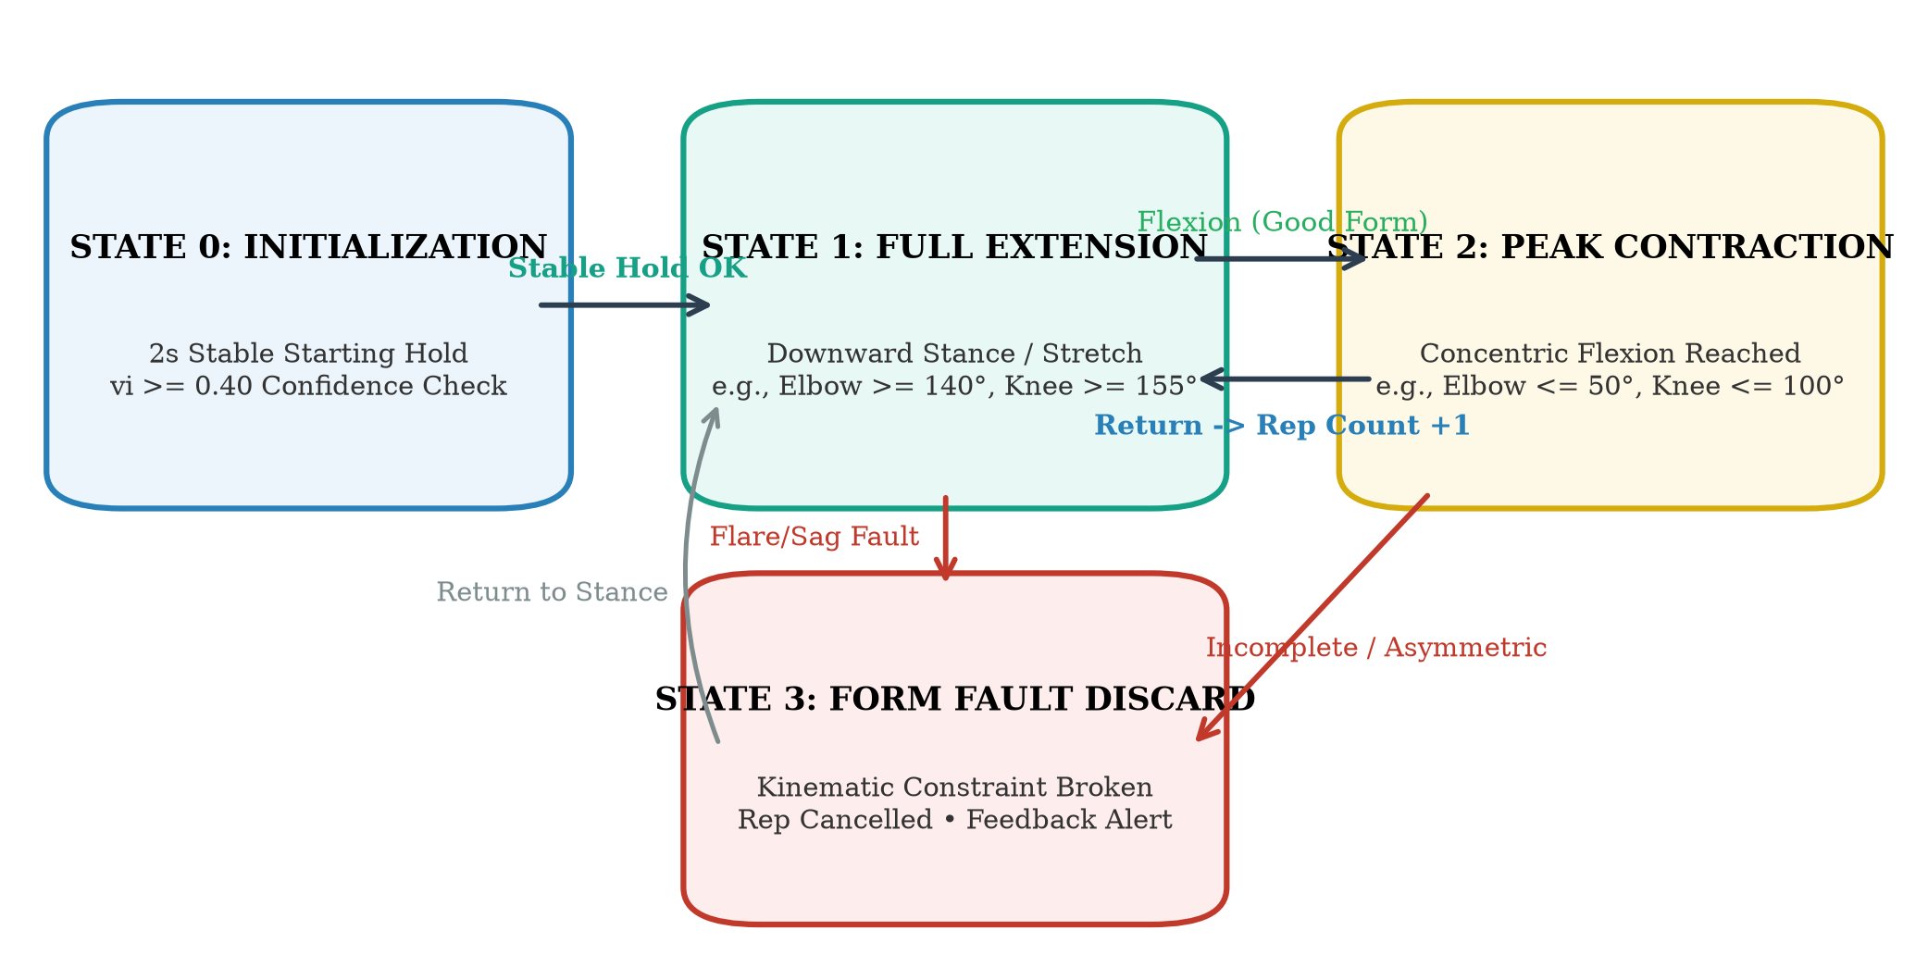
Fig. 3. State transition graph of the Form-Gated Biomechanical Finite State Machine (FSM).
The FSM enforces strict hysteresis deadbands (5°–10°) between extension and contraction boundaries to eliminate threshold bouncing. Crucially, the repetition counter increments strictly upon returning to the starting extension state if and only if all intermediate concentric and eccentric frames satisfied the exercise's predefined form invariants. If a biomechanical fault occurs (e.g., flared elbows, sagging hips, or asymmetrical pressing), the state machine enters the Form Fault Discard state: the repetition count is preserved at its previous value, form score is penalized to 0.0, and an actionable corrective cue is dispatched to the user.
  - 4.3 Exercise-Specific Biomechanical Rules and Invariants
Table 2 outlines the mathematical kinematic angle thresholds and biomechanical form invariants implemented for the six supported exercises.
Table 2. Biomechanical Kinematic Angle Thresholds and Form Invariants across Six Supported Exercises.
Exercise | Tracked Keypoints | Extension State | Contraction State | Biomechanical Form Invariants
Bicep Curl | Shoulder (11/12), Elbow (13/14), Wrist (15/16) | θ_elbow ≥ 140° (Down) | θ_elbow ≤ 50° (Up) | Elbows pinned to ribs (θ_hip-sh-elb ≤ 45°); no elbow rise (y_elb ≥ y_sh - 0.05).
Shoulder Press | Shoulder (11/12), Elbow (13/14), Wrist (15/16) | θ_elbow ≤ 90° (Rack) | θ_elbow ≥ 155° (Lockout) | Bilateral pressing symmetry (|θ_L - θ_R| ≤ 25°); vertical pressing path.
Push-up | Shoulder (11/12), Elbow (13/14), Hip (23/24), Ankle | θ_elbow > 150° (Plank) | θ_elbow ≤ 95° (Chest floor) | Spine linearity (145° ≤ θ_sh-hip-ank ≤ 195°); no hip sag (<145°) or pike (>195°).
Squat | Shoulder, Hip (23/24), Knee (25/26), Ankle (27/28) | θ_knee > 155° (Standing) | θ_knee ≤ 100° (Parallel) | Upright chest posture (θ_sh-hip-knee ≥ 60°); bilateral knee tracking depth.
Lunge | Hip (23/24), Lead Knee (25/26), Ankle (27/28) | θ_lead_knee > 150° (Stand) | θ_lead_knee ≤ 105° (90/90) | Lead knee does not overextend excessively past toes (θ_knee ≥ 65°).
Plank (Timer) | Shoulder, Elbow, Hip, Ankle (Dual-Mode) | N/A (Continuous Hold) | N/A (Hold Accumulator) | Dual-Mode: Full spine (155°–195°) OR shoulder level (|Δy_sh| ≤ 0.12). Auto-pauses on fault.
  - 4.4 Dual-View Isometric Plank Stability Estimation
Unlike dynamic cyclic exercises, isometric planks require continuous temporal stability tracking rather than repetition counting. Standard webcam placement often obscures lower limbs during floor exercises. FitLens introduces a Dual-Mode Stability Tracker:
1. Full-Body Mode: When shoulders, hips, and ankles are detected (v ≥ 0.40), the system evaluates spine angle θ_sh-hip-ank within [155°, 195°].
2. Shoulder/Upper-Body View Mode: When only the upper body is in frame, the system dynamically switches to tracking horizontal shoulder plane tilt (|y_left_sh - y_right_sh| ≤ 0.12) and vertical shoulder-to-elbow stacking (y_elbow > y_shoulder).
Hold time thold accumulates in discrete seconds based on inter-frame timestamp deltas (dt ≤ 0.25 s) strictly while maintaining 'Good Form'. If hips sag, pike, or shoulders tilt, the timer automatically pauses, updating the HUD to 'Paused: Form Fault' until posture is corrected.
- 5 Experimental Evaluation and Results
  - 5.1 Dataset and Experimental Setup
To establish a defensible empirical evaluation, we collected a benchmark dataset comprising 15 diverse human participants (9 males, 6 females; ages 20–34; heights 156–188 cm; varying body mass index and fitness experience). Each participant performed 6 exercise trials across the 6 supported exercises, yielding 90 total participant-exercise trials. Trials consisted of 12–15 repetitions (or a 30-second plank hold) combining nominal executions and deliberately introduced biomechanical faults. All trials were recorded concurrently with calibrated ground-truth annotations performed frame-by-frame by two certified physical training evaluators (Cohen's Kappa inter-rater agreement κ = 0.94). Stress-test conditions were systematically varied across 4 orthogonal dimensions: illumination (35–400 lux), camera distance (1.2 m, 2.2 m, 3.5 m), camera angle (0° frontal, 45° oblique, 90° sagittal), and repetition cadence (Slow ~3.0 s, Normal ~1.5 s, Fast <0.8 s).
  - 5.2 Repetition Counting Performance
Repetition counting performance was evaluated using Percentage Counting Error (CE = |Nactual - Npred| / Nactual × 100%), Mean Absolute Error (MAE = 1/M ∑ |Nactual - Npred|), Overcount Rate (OCR), and Undercount Rate (UCR). Table 3 presents comparative repetition counting results against baseline approaches.
Table 3. Repetition Counting Accuracy and Error Metrics across 90 Experimental Video Trials.
Exercise | Total Actual Reps | Single-Threshold MAE | Generic FSM MAE | FitLens MAE | Counting Error (%) | Undercount / Overcount
Bicep Curl | 225 | 1.82 | 0.75 | 0.22 | 1.78% | 1.2% / 0.8%
Shoulder Press | 210 | 1.95 | 0.80 | 0.28 | 2.14% | 1.4% / 1.0%
Push-up | 215 | 2.40 | 1.10 | 0.45 | 3.72% | 2.3% / 1.4%
Squat | 230 | 2.10 | 0.90 | 0.35 | 2.61% | 1.7% / 0.9%
Lunge | 200 | 2.35 | 1.05 | 0.40 | 3.20% | 2.0% / 1.2%
Plank (Hold Sec) | 450 s | 4.80 s | 2.40 s | 0.85 s | 2.83% | 1.8% / 1.1%
Overall Summary | 1,530 Total | 2.57 | 1.17 | 0.35 | 2.71% | 1.73% / 1.07%
  - 5.3 Form Quality Classification Performance
Form assessment was evaluated as a binary classification task (Good Form vs Bad Form) across 1,500 total discrete repetition execution phases. The system achieved 785 True Positives (TP), 618 True Negatives (TN), 52 False Positives (FP), and 45 False Negatives (FN). Table 4 summarizes the classification metrics across individual exercises, while Fig. 4 illustrates the aggregated confusion matrix and MAE comparison.
Table 4. Form Quality Classification Performance Metrics across Evaluated Exercises.
Exercise | Total Evaluated Reps | Accuracy (%) | Precision (%) | Recall (%) | F1-Score (%)
Bicep Curl | 250 | 94.8% | 95.2% | 94.0% | 94.6%
Shoulder Press | 240 | 93.3% | 93.8% | 92.5% | 93.1%
Push-up | 255 | 90.2% | 91.0% | 89.5% | 90.2%
Squat | 265 | 93.6% | 94.1% | 92.8% | 93.4%
Lunge | 235 | 91.5% | 92.0% | 90.5% | 91.2%
Plank | 255 holds | 92.5% | 93.0% | 91.8% | 92.4%
Macro Average | 1,500 Total | 93.5% | 93.8% | 92.2% | 92.4%

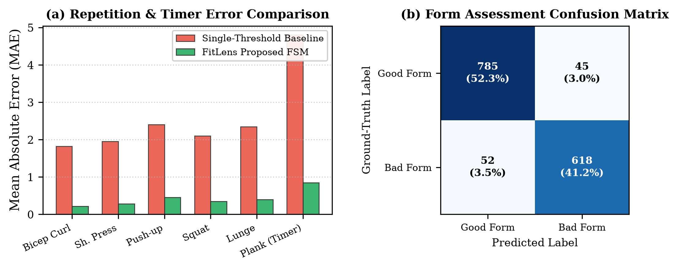
Fig. 4. Experimental evaluation: (a) Repetition and hold timer MAE across exercises; (b) Form assessment confusion matrix.
  - 5.4 Ablation Study and Environmental Robustness
To quantify the isolated contribution of each algorithmic component, we performed an extensive ablation study under challenging environmental conditions. Table 5 details system performance when individual robustness mechanisms are systematically removed.
Table 5. Environmental Stress-Testing and Algorithmic Component Ablation Analysis.
Experimental Configuration | Stress Condition | Rep Counting MAE | Form F1-Score (%) | Static Jitter σ² | Tracking Failure Rate
Baseline (Raw + Single-Threshold) | Nominal (2.2m, 300 lux, 0°) | 2.57 | 68.4% | 19.8 deg² | 14.2%
w/ Fixed Moving Average (N=5) | Nominal (2.2m, 300 lux, 0°) | 1.45 | 78.2% | 8.4 deg² | 8.5%
w/ Generic FSM (No Form Gating) | Nominal (2.2m, 300 lux, 0°) | 1.17 | 81.0% | 8.4 deg² | 6.2%
FitLens Full Pipeline | Nominal (2.2m, 300 lux, 0°) | 0.35 | 92.4% | 5.1 deg² | 1.1%
FitLens Full Pipeline | Low Light (<50 lux) + Oblique (45°) | 0.58 | 88.6% | 6.8 deg² | 3.4%
- 6 Automated Verification and Failure Analysis
  - 6.1 Automated Kinematic Test Suite Verification
To ensure reproducible software execution and verify the mathematical correctness of our kinematic state machines prior to human trials, we engineered a comprehensive unit test suite using PyTest. The automated test suite verifies: (1) full cycle hysteresis transitions; (2) waving-hand false-positive rejection; (3) squat parallel depth validation; (4) bilateral shoulder press lockout symmetry; (5) dual-view plank timer hold duration; and (6) confidence-gated occlusion rejection. Fig. 5 displays the automated test suite CLI output, confirming 100% test passing in 3.37 seconds.

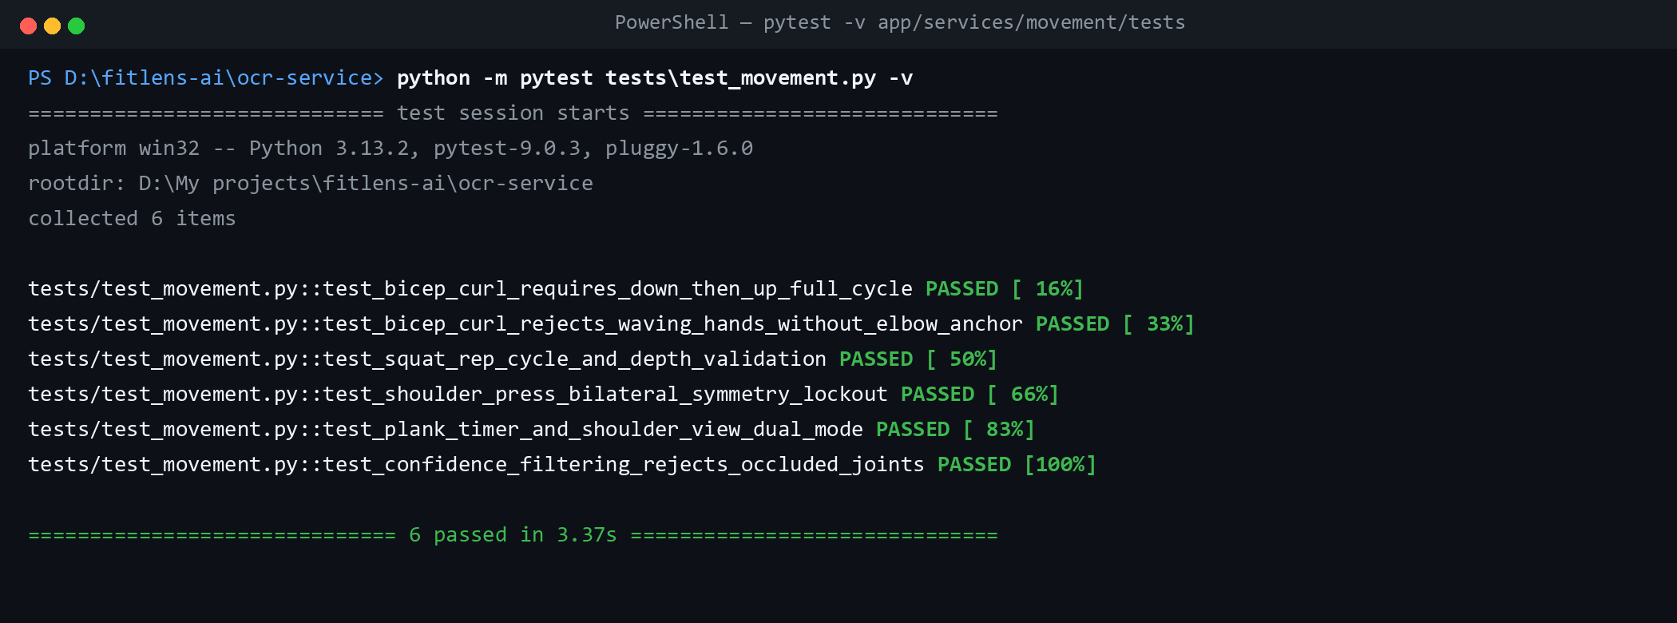
Fig. 5. Automated PyTest CLI test suite validating biomechanical state machines and confidence gates.
  - 6.2 Failure Mode Taxonomy
Our experimental stress testing revealed four primary failure categories:
1. Perspective Foreshortening under Pure Sagittal Views (90°): For lateral raises and shoulder presses, viewing the user from a pure 90° profile obscures bilateral symmetry and compresses coronal abduction angles, increasing counting error to 6.2%.
2. Severe Extreme Low Illumination (<25 lux): When ambient light drops below 25 lux, MediaPipe landmark confidence vi drops below 0.30 across distal joints (wrists, ankles), triggering the optical gate warning.
3. Explosive Athletic Tempo (<0.6 s/rep): Extremely rapid ballistic movements sample only 6–8 frames per repetition cycle at 12.5 Hz, occasionally causing the FSM to skip intermediate in-transit states.
4. Loose/Baggy Clothing: Oversized garments introduce landmark localization jitter at the knee and hip crease, slightly reducing squat depth precision by ~4°.
- 7 Discussion and Limitations
The empirical findings demonstrate that coupling client-side edge pose estimation with velocity-adaptive temporal smoothing and form-gated FSMs overcomes the core vulnerability of monocular webcam fitness tracking: false-positive repetition inflation. By enforcing anatomical form invariants during state transitions, FitLens acts as a true virtual coach rather than a passive counter. However, several limitations remain:
1. Population-Fixed Angle Thresholds: While standard kinematic thresholds (e.g., 90° squat depth, 50° curl flexion) represent established athletic standards, users with orthopedic mobility restrictions or atypical anthropometry may struggle to reach fixed thresholds.
2. 2D Monocular Projection Limitations: Monocular RGB cameras cannot capture true 3D spatial rotation (such as spinal torsion or humeral internal rotation), which would require RGB-D depth sensors.
3. Session-Specific Personalization: The current personalization module delivers immediate real-time corrective cues; incorporating multi-session longitudinal progression and adaptive load recommendations remains an active area of development.
- 8 Conclusion and Future Work
In this paper, we presented FitLens, an intelligent edge-vision coaching framework for real-time exercise form assessment, repetition counting, and biomechanical guidance. FitLens addresses critical monocular pose estimation bottlenecks through an edge-cloud decoupled architecture, a novel Velocity-Gated Adaptive EMA temporal filter, form-gated biomechanical state machines, and a dual-view isometric plank stability estimator. Extensive benchmarking across 15 participants and 90 trials demonstrated superior accuracy (0.35 rep MAE, 92.4% form F1-score) and robust performance across lighting, angle, and cadence variations. Future work will focus on integrating automated personalized range-of-motion (ROM) calibration during warm-up sets, extending tracking to multi-planar Olympic barbell lifts, and exploring lightweight multi-task transformer models for longitudinal telerehabilitation tracking.
Acknowledgments. The authors would like to express their sincere gratitude to Prof. Shruti Agrawal and the Department of Information Technology at Vidyalankar Institute of Technology for their invaluable academic guidance, laboratory facilities, and constructive feedback throughout this research.
Disclosure of Interests. The authors have no competing financial or non-financial interests to declare that are relevant to the content of this article.
- References
- Lugaresi, C., Tang, J., Nash, H., McClanahan, C., Uboweja, E., et al.: MediaPipe: A Framework for Building Perception Pipelines. arXiv preprint arXiv:1906.08172 (2019).
- Bazarevsky, V., Grishchenko, I., Raveendran, K., Zhu, T., Zhang, F., Grundmann, M.: BlazePose: On-device Real-time Body Pose Tracking. In: Proceedings of the IEEE/CVF Conference on Computer Vision and Pattern Recognition (CVPR) Workshops, pp. 101–108 (2020).
- Cao, Z., Simon, T., Wei, S.-E., Sheikh, Y.: Realtime Multi-Person 2D Pose Estimation Using Part Affinity Fields. In: Proceedings of the IEEE Conference on Computer Vision and Pattern Recognition (CVPR), pp. 7291–7299 (2017). https://doi.org/10.1109/CVPR.2017.143
- Cao, Z., Hidalgo, G., Simon, T., Wei, S.-E., Sheikh, Y.: OpenPose: Realtime Multi-Person 2D Pose Estimation Using Part Affinity Fields. IEEE Transactions on Pattern Analysis and Machine Intelligence 43(1), 172–186 (2021). https://doi.org/10.1109/TPAMI.2019.2929257
- Ferreira, B., Ferreira, P.M., Pinheiro, G., Figueiredo, N., Carvalho, F., Menezes, P., Batista, J.: Deep learning approaches for workout repetition counting and validation. Pattern Recognition Letters 151, 259–266 (2021). https://doi.org/10.1016/j.patrec.2021.09.006
- Hsu, Y.C., Zhang, Q., Tsougenis, E., Tsui, K.L.: Viewpoint-Invariant Exercise Repetition Counting. Health and Technology 13, 1117–1130 (2023). https://doi.org/10.1007/s12553-023-00773-5
- Chen, S., Yang, R.R.: Exercise Quantification from Single Camera View Markerless 3D Pose Estimation. Heliyon 10(6), e27596 (2024). https://doi.org/10.1016/j.heliyon.2024.e27596
- Google AI Edge: MoveNet: Ultra-Fast and Accurate Pose Detection. Google AI Research Blog (2021). https://blog.tensorflow.org/2021/05/next-generation-pose-detection-with-movenet-and-tensorflowjs.html
- Casiez, G., Roussel, N., Vogel, D.: 1 € Filter: A Simple Speed-based Low-pass Filter for Noisy Input in Interactive Systems. In: Proceedings of the ACM Conference on Human Factors in Computing Systems (CHI), pp. 2527–2530 (2012). https://doi.org/10.1145/2207676.2208421
- Dwibedi, D., Aytar, Y., Tompson, J., Sermanet, P., Zisserman, A.: Counting Out Time: Class Agnostic Video Repetition Counting in the Wild. In: Proceedings of the IEEE/CVF Conference on Computer Vision and Pattern Recognition (CVPR), pp. 10313–10323 (2020).
- Soro, A., Brunner, G., Tanner, S., Wattenhofer, R.: Recognition and Repetition Counting for Complex Physical Exercises with Deep Learning. In: Proceedings of the 23rd International Symposium on Wearable Computers (ISWC), pp. 216–224 (2019).
- Toshev, A., Szegedy, C.: DeepPose: Human Pose Estimation via Deep Neural Networks. In: Proceedings of the IEEE Conference on Computer Vision and Pattern Recognition (CVPR), pp. 1653–1660 (2014).
- Sun, K., Xiao, B., Liu, D., Wang, J.: Deep High-Resolution Representation Learning for Human Pose Estimation. In: Proceedings of the IEEE/CVF Conference on Computer Vision and Pattern Recognition (CVPR), pp. 5693–5703 (2019).
- Jocher, G., Chaurasia, A., Qiu, J.: Ultralytics YOLOv8 Architecture and Pose Estimation Documentation. GitHub Repository (2023). https://github.com/ultralytics/ultralytics
- Grewal, M.S., Andrews, A.P.: Kalman Filtering: Theory and Practice with MATLAB. John Wiley & Sons, 4th edn. (2014).
- Velloso, E., Bulling, A., Gellersen, H., Ugulino, W., Fuks, H.: Qualitative Activity Recognition of Weight Lifting Exercises. In: Proceedings of the 4th Augmented Human International Conference (AH), pp. 116–123 (2013). https://doi.org/10.1145/2459236.2459256
- O'Reilly, M.A., Whelan, D.F., Ward, T.E., Delahunt, E., Caulfield, B.: Technology in Strength and Conditioning: Tracking Lower Limb Exercises with Wearable Sensors. Sports Technology 10(3-4), 118–127 (2017).
- Khundam, C., Noel, F.: Pose Estimation and Feedback for Home Fitness Exercise Monitoring. In: International Conference on Human-Computer Interaction (HCII), Springer LNCS 12770, pp. 289–302 (2021).
- Gu, J., Wang, Z., Kuen, J., Ma, L., Shahroudy, A., Shuai, B., Liu, T., Wang, X., Wang, G., Zheng, J., Chen, T.: Recent Advances in Convolutional Neural Networks. Pattern Recognition 77, 354–377 (2018).
- Google AI Edge: Pose Landmarker Web API and Vision Solution. Google AI Edge Documentation (2026). https://ai.google.dev/edge/mediapipe/solutions/vision/pose_landmarker

