
Semester | F.E. Semester I
Subject | FLC Lab
Subject Professor In-charge | Prof. Vinita Bhandiwad
Assisting Teachers | Ajit Ghadage/Kiran Hemale/Nikita Gharat
Laboratory | M201/M414/Lab14

Student Name | Saurabh Lubal
Roll Number | 24101C0040
Grade and Subject Teacher’s Signature

Experiment Number | 5
Title | Implementation of Boolean Expressions using LogiSim.
Resources / Apparatus Required | Hardware: - | Software:  Logi Sim
Objectives  (Skill Set / Knowledge Tested / Imparted) | In this experiment, student should understand how to perform Boolean Expression using LogiSim software.
Theory: | In LogiSim, Boolean expressions are implemented by mapping logical operators (AND, OR, NOT) to corresponding gates. Each variable connects to input pins, and gates are linked according to the expression. The output pin displays results in real-time based on inputs, allowing for easy testing and verification. LogiSim’s interface provides a practical way to learn Boolean logic and digital circuit design.
Procedure | Expression 1: (AB)+(A′B′)  The Expression (AB)+(A′B′) is a form of the XOR function. It can be simplified as:  (AB)+(A’B’) = A⊕B  This is because A⊕B = (AB’) + (A’B) and is also equivalent to (AB) + (A’B’) by properties of Boolean algebra.  Simplified Form: A⊕B  Expression 2: (A+B) . (B’ + C’)  - Apply Distributive Property:  (A+B)(B’+C’) = AB’+ AC’ + BB’ + BC’  - Note that BB’ = 0 (since B and B’ are complements, their AND is always zero):  = AB’ + AC’ + 0 + BC’ = AB’ + AC’ +BC’  - No further simplification is possible for this expression.  Simplified Form: AB’ + AC’ + BC’
Observation & Output: | 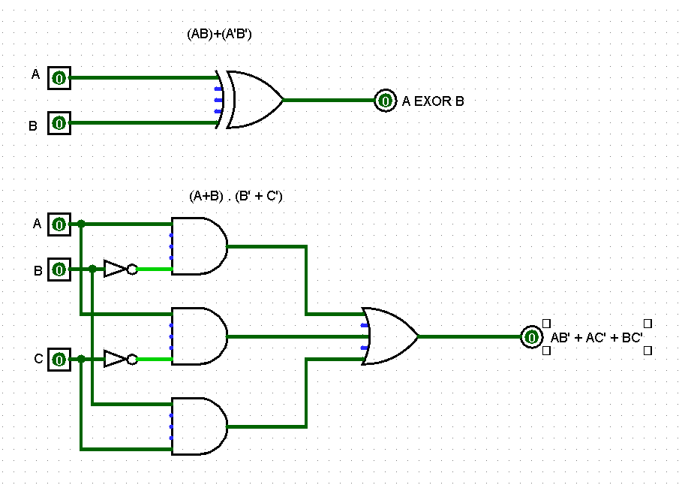
Conclusion | The Boolean expressions were simplified to their minimal forms. Expression (AB) + (A’B’) simplifies to A⊕B, indicating an XOR operation. Expression (A+B) . (B’+C’) simplifies to AB’ + AC’ +BC’, with no further reduction possible.

