NAME : SAURABH LUBAL
ROLL NO :24101C0040

QUESTION 1 :
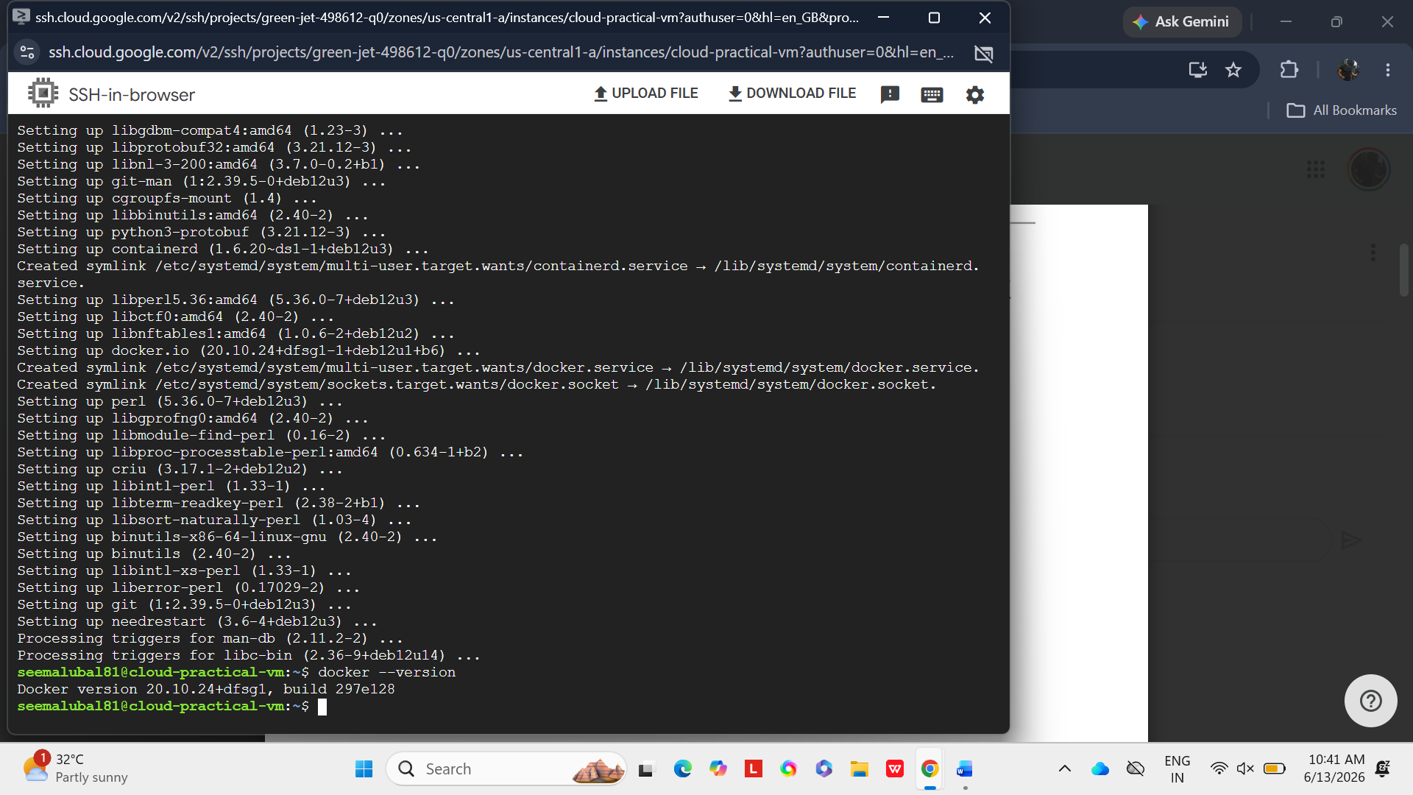
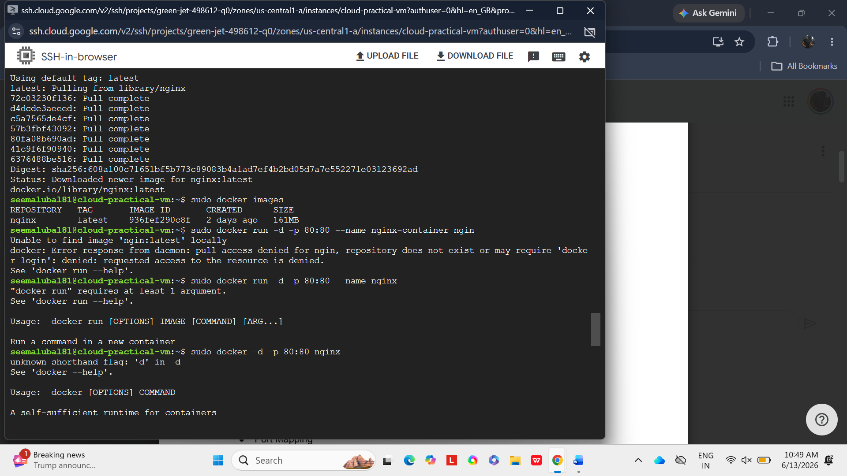
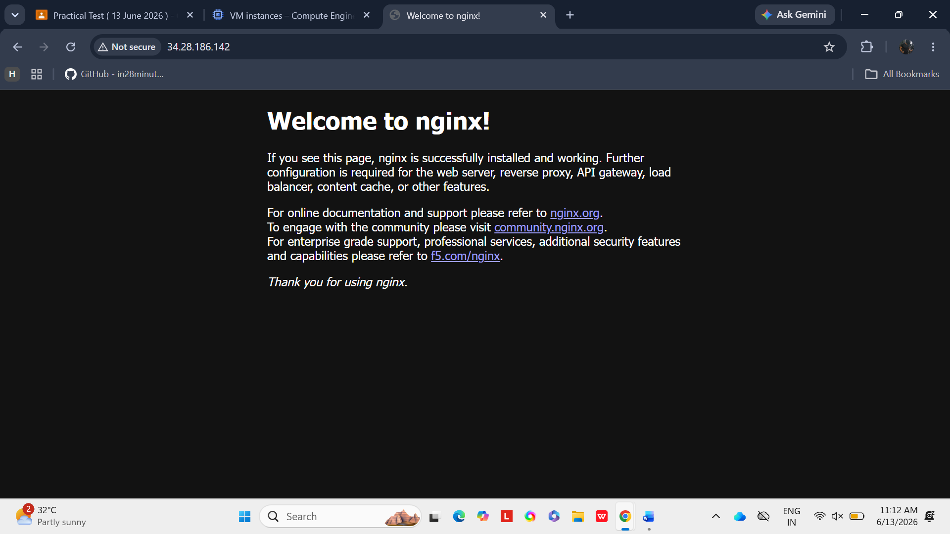
QUESTION 2:
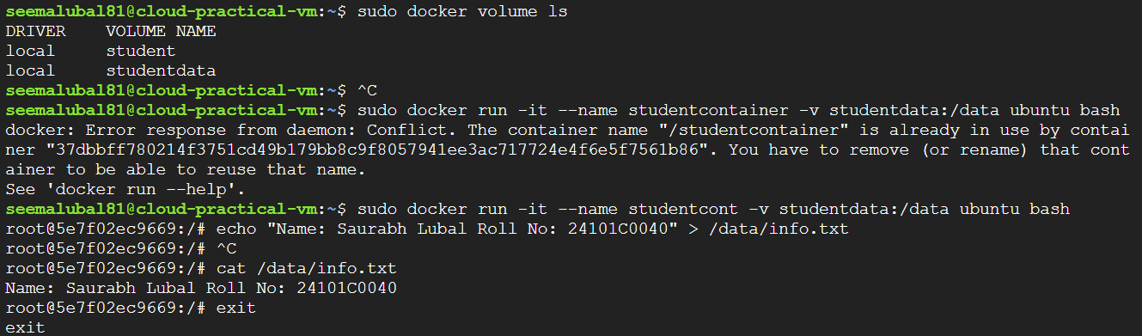
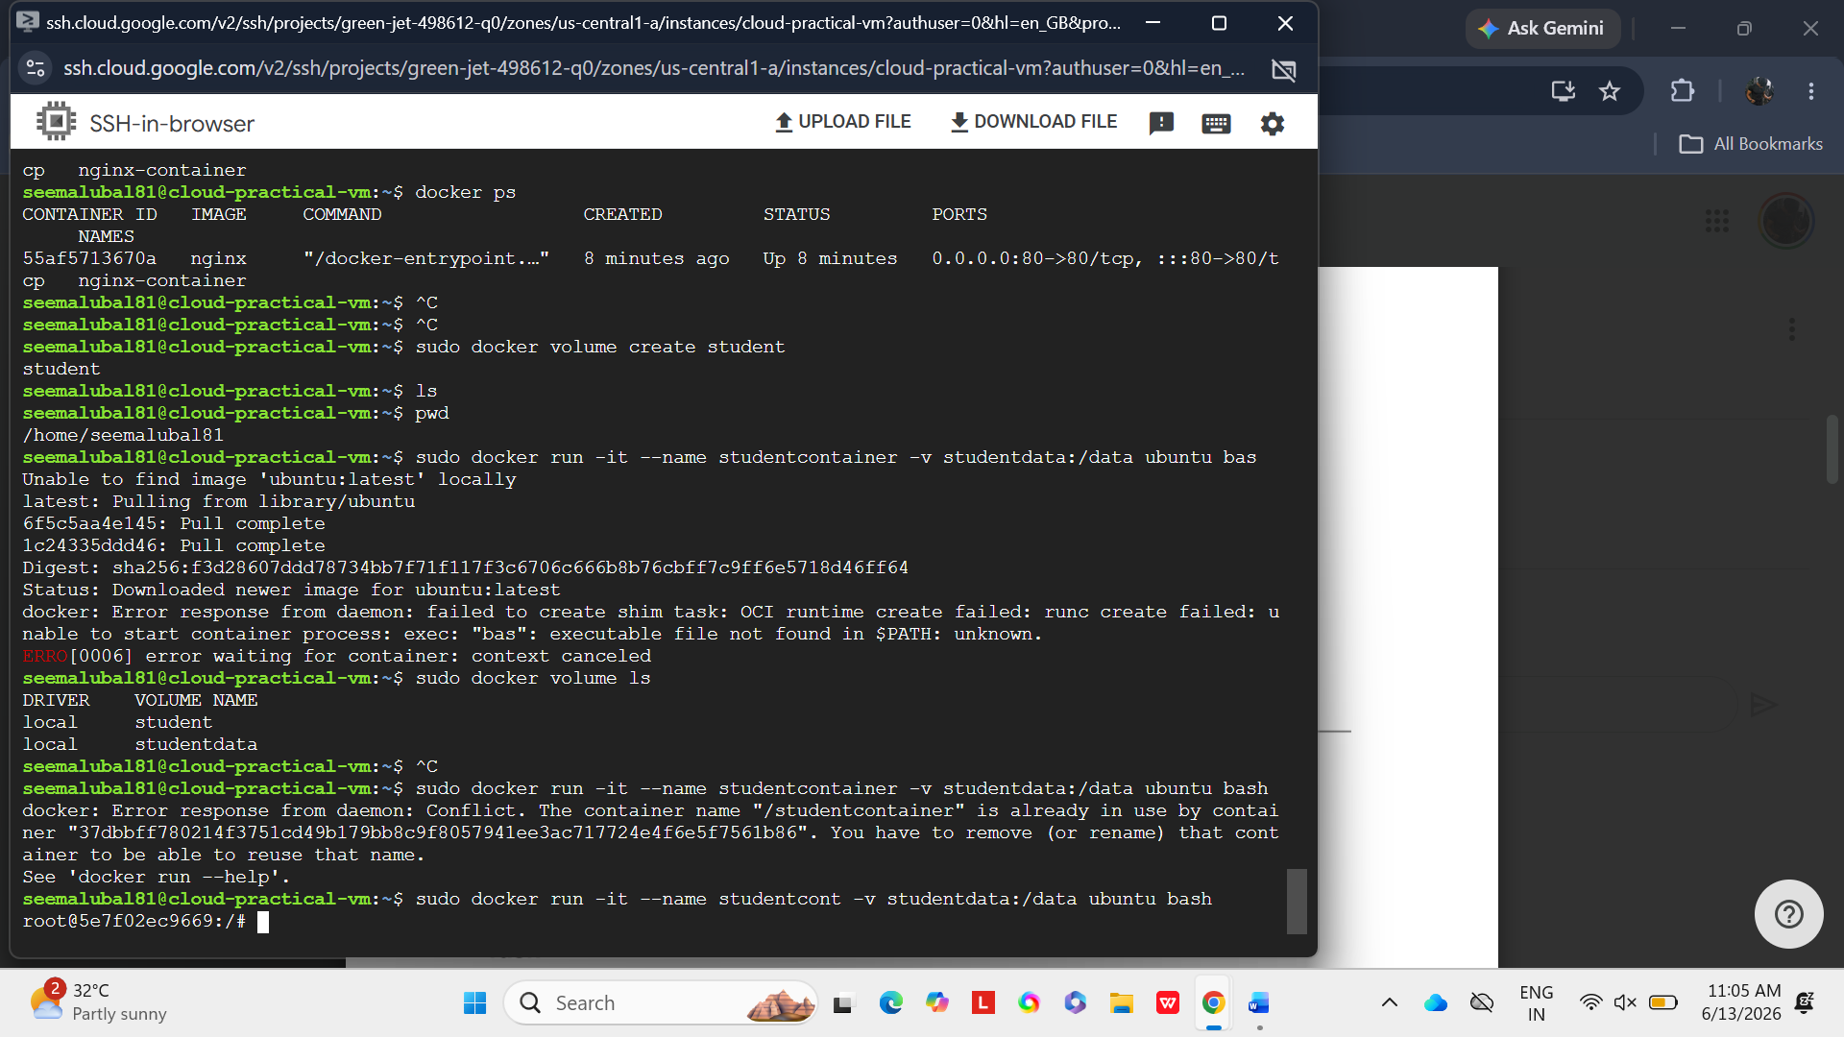
QUESTION3
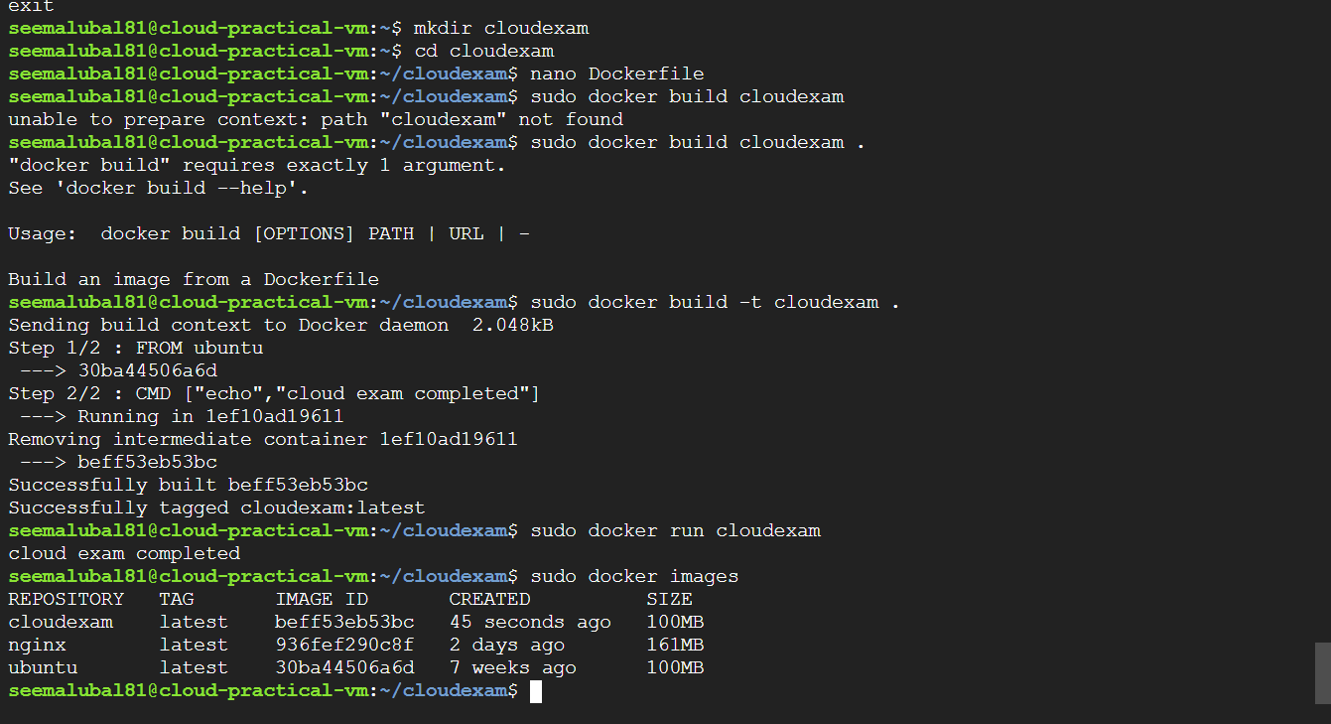
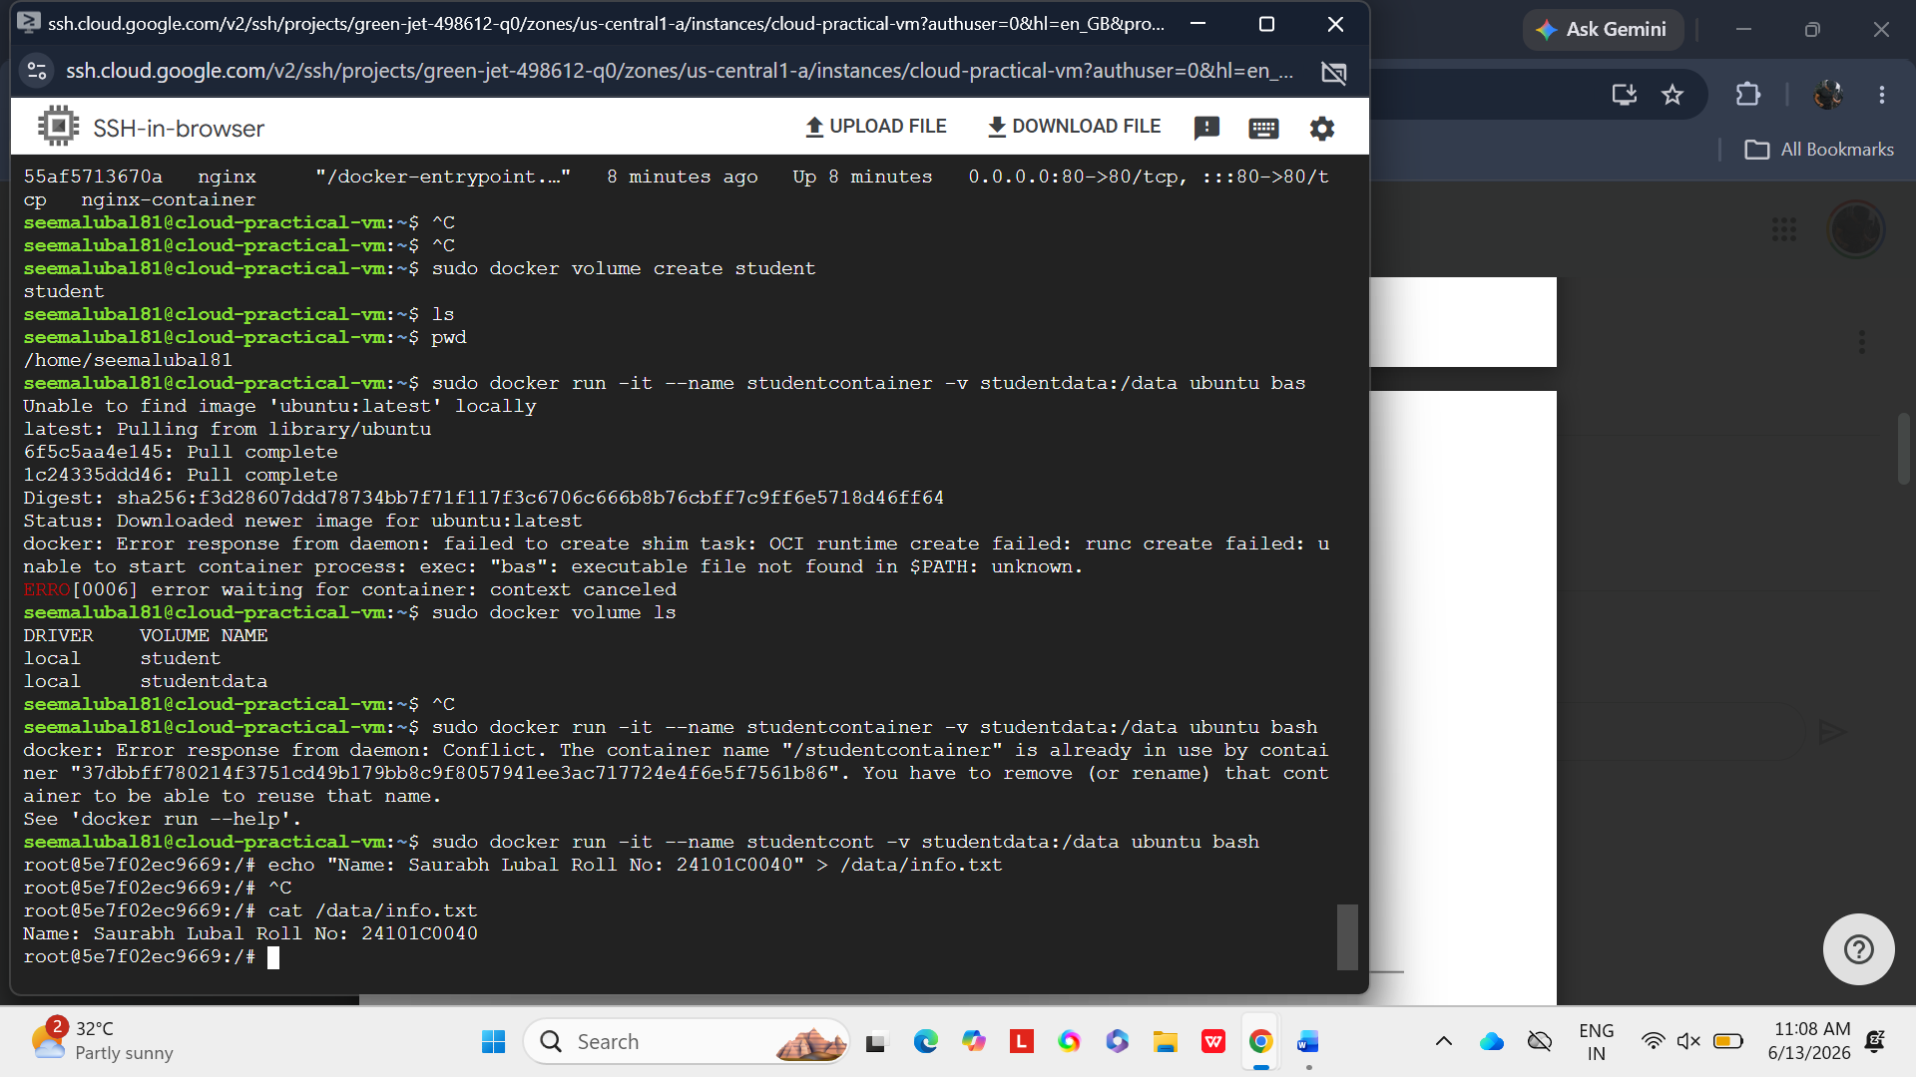
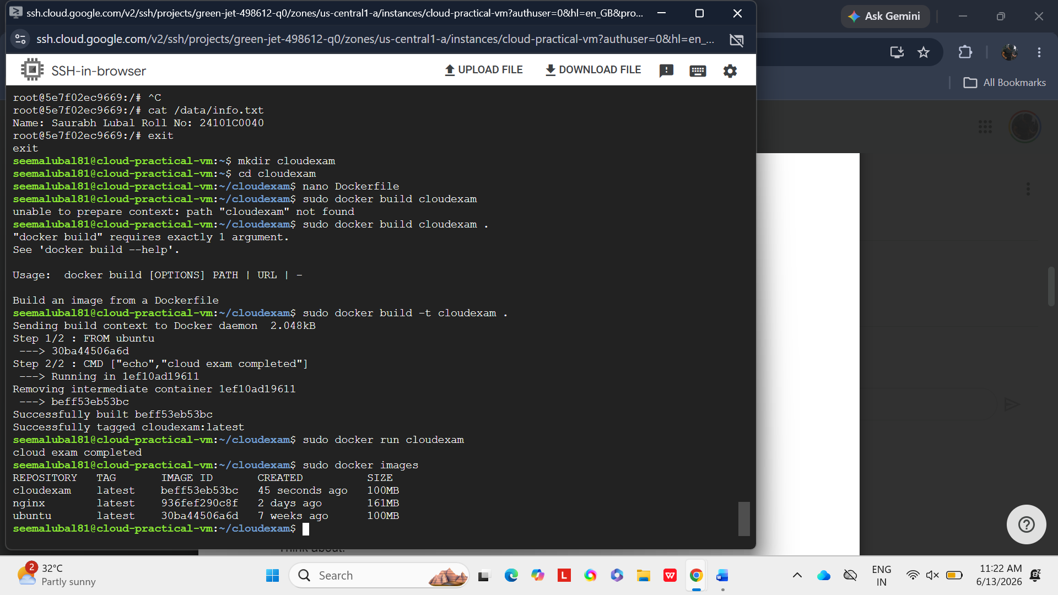
BONUS CHALLENGE:
- Difference between Docker Image and Docker Container:
A Docker Image is a package that contains the application and all required files.
A Docker Container is a running version of that image where the application works.
- Why are Docker Volumes used?
Docker Volumes are used to save data permanently even after deleting a container.
They help store and share data easily between containers.

