Project name

Banking Query Classification

* **Problem definition and solution approach**

This project is a study of banking related queries that how a ML model can help to a customer or to associates internally by answering the asked questions. It will be helpful that without human interaction the chatbot will reply the Frequently asked questions.

The customer’s facing too much problems such as related Debit and credit cards, how to open and close the account, how much interest will be paid by the bank in FD like many more questions.

We need a model which is highly accurate and faster in operation.

**1. Project Problem i.e. Why do we need this model.**

Like every organisation is approaching towards the less the operational cost higher the profit to the organisation. So, the chatbot would be perfect option for it, cause all the man power required to answer the customer would be reduced.

AI chatbots can help educate and simplify banking for consumers by providing necessary information and being available 24/7 to answer frequently asked customer queries. In this process, chatbots collect and update customer data that gets assorted and stored to personalise interactions, streamline processes, recommend and sell products, give financial advice and create a customer profile for further reference. This helps save time and money, increase company data, improve employee efficiency and retain customers.

But for the simpler queries the model can be used. For complicated queries the staff would be the best option.

**2. Solution approach i.e. How the model will help to reduce the banking problems.**

These conversational chatbots use Natural Language Processing (NLP) to understand customer queries using specific keywords and answer accordingly easily. By automating FAQs and replies via chatbots, banks can be available 24/7 and answer most customer queries in real-time, especially repetitive questions about the bank information or banking processes.

Chatbots can be used for a variety of banking processes, like collecting and processing data and documents, creating and managing customer accounts, providing account details and balance information, reducing the impending wait time and paperwork by using existing data to automate processes for clients, doing KYC processes, making and receiving payment transactions, etc. By automating these processes, the bank makes their work easier while simultaneously improving the overall banking experience.

Banking chatbots like any other can be used to reach out to customers and seamlessly collect their personal reviews and feedback in conversation. This information can then be used to improve service and help retain customers for life.

* **These are the following steps which we are going to follow in the Data Analysis**

Basic Data Pre-processing (Cleaning the Data, Null values & visualize)

Data Collection & Understanding the Problem Statement

Text Processing

Remove stop words & lemmatization

Convert text to lower case, Expand Contraction

Remove Punctuations & Special Characters

Analysing Pre-processed Data

EDA on Data

Model Training & Testing

* **Data Collection.**
* Bank FAQs Input Data

The dataset is of having the Banking Related FAQs consists of banking related questions and answers.

1. Loading the required libraries

Import pandas as pd

Import numpy as np

1. Load the dataset

Before jumping to the exploration stage, we need to perform basic data pre-processing steps like null value imputation and removal of unwanted data. So, let’s start by importing libraries and reading our dataset:

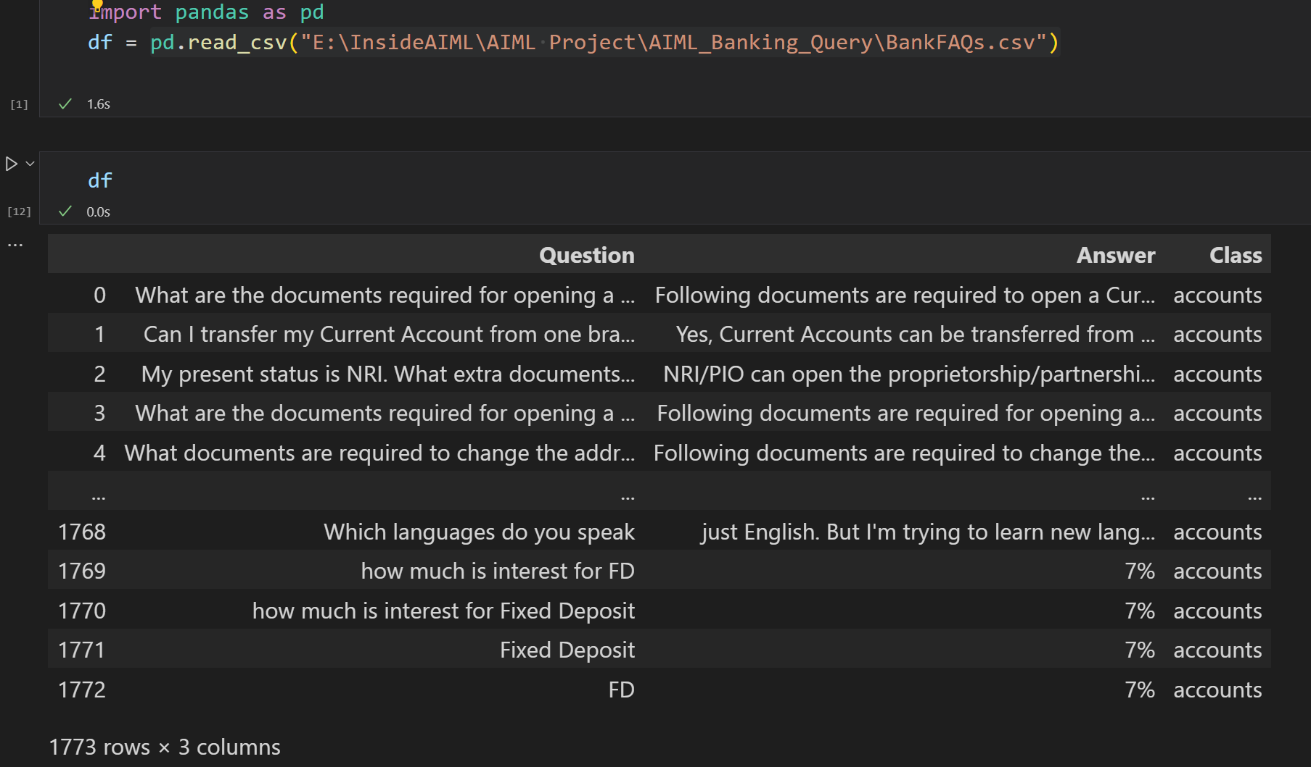

* The Datset is having 1773 rows x 3 columns
* The Dataset is having only three Features

1. Question

2. Answer

3. Class

* **Basic Data Pre-processing (Cleaning the Data, Null values & visualize)**

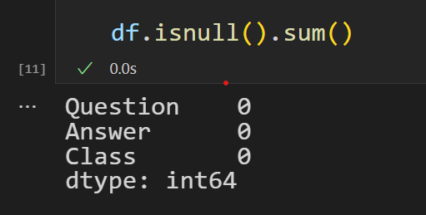

1. Check type of the data

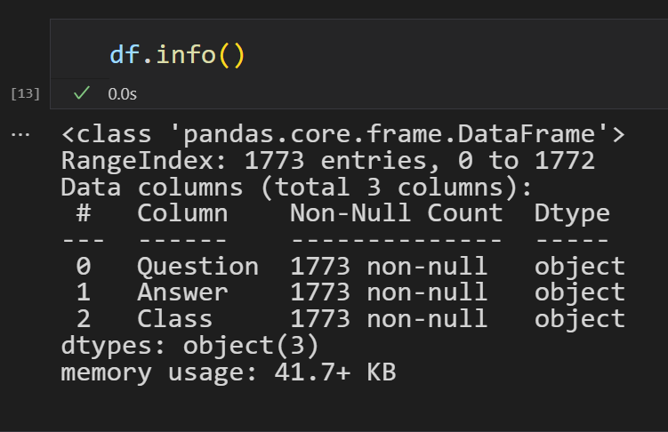

* Visualisation : In the **Class** Column weitage of the Class Insurance is higher which is more than 400 counts & the fundtransfer class is having minimum weightage which is less than 50 counts

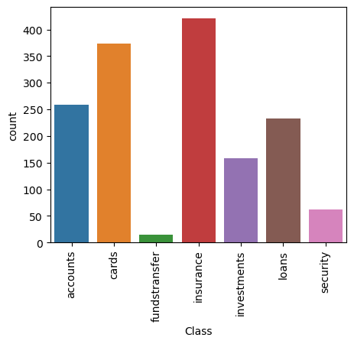

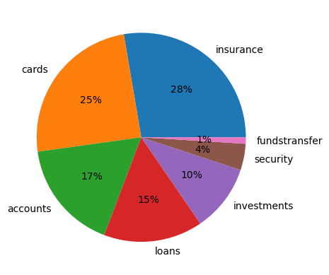

* Questions, Answers & their Classes

Q1. how nominee can claim money from bank after death

A1. After notifying the bank about the death, the bank will check for survivor/ nomination clauses. And if there is one, it will ask the nominee to settle the account, provided they have a death certificate and submitted a death claim application

C1. accounts

Q2. What should I do if an unusual activity in my bank account happens?

A2. Notify your bank immediately. For more details, give a missed call on 14440. If someone has fraudulently withdrawn money from your bank account, inform your bank immediately.

C2. security

Q3. how the CIBIL score is calculated?

A3. By Looking at your Payment History, Credit Exposure, Credit Type and Duration, You should avoid applying for multiple lines of credit at the same time.

C3. accounts

Q4. How to Remove my Name from CIBIL Defaulters’ List?

A4. You should note that CIBIL will not publish a defaulters list. however, if you are a defaulter, then this will be reflected on your CIBIL score and also your report. A low score means that you will be less likely to get a loan approved from the banks and NBFCs. If a payment default or delayed payment has been marked in your report, then, this will affect your chances of getting a loan.

C4. accounts

Q5. How to improve CIBIL score?

A5. Use credit responsibly, avoid late or missed payments, maintain a low credit utilisation ratio, make sure to close accounts, review your credit report, those things will increase your CIBIL score.

C5. accounts

Q6. Is my credit score and my CIBIL score one and the same thing?

A6. Yes, your credit score and your CIBIL score are the same. The Credit Information Bureau (India) Limited was the very first credit bureau in the country and so, CIBIL score was a term that was used synonymously with the term, credit score.

C6. accounts

Q7. Does our have its own CIBIL score?

A7. Our bank does not issue credit scores for our customers. The CIBIL is the credit bureau which collects information from and NBFCs about people and they then calculate the credit score.

C7. accounts

Q8. What is the best CIBIL score for me to get a loan?

A8. You should have a minimum CIBIL score between 650-700 to get a loan.

C8. accounts

Q9. Will a loan rejection affect my CIBIL score?

A9. Yes, a loan rejection will lower your CIBIL score.

C9. accounts

Q10. How to transfer money to international bank account?

* A10. Visit the SBI website and Login using the details or click on
* Select Payments/Transfer option
* Then select My Accounts & Profile
* Click on Add & Manage Beneficiary
* Provide your SBI profile password and click submit

Click on Foreign Outward Remittance Beneficiary or Outward Remittance Beneficiary NRE as your feel the need

Enter International Beneficiary details click on register

You will get an OTP and will need to provide it to approve the connection.

C10. accounts

Q11. Is trading account and bank account same?

A11. Like a savings account holds money, a Demat account allows investors to store financial instruments in a dematerialized or electronic form which are debited and credited accordingly. A trading account, on the other hand, functions more like your current bank account.

C11. accounts

Q12. Can I use saving account as trading account?

A12. Connecting both the savings account and the demat account permits you to buy shares and remove or add funds to your demat account without any hassle.

C12. accounts

Q13. what are the requirements to open a current bank account?

A13. Here is the list of documents to open a current account

* PAN Card.
* Driving Licence.
* Passport.
* ID cards issued central & state govt.
* Passbook scheduled commercial bank.
* Marriage certificate.
* Voters ID card.
* Aadhar Card.

C13. accounts

Q14. What are the different types of accounts our bank provides?

A14. Here are the types of the accounts that our bank provides.

* [Savings Account](https://byjus.com/#Savings-Account)
* [Current Account](https://byjus.com/#Current-Account)
* [Recurring Deposit Account](https://byjus.com/#Recurring-Deposit-Account)
* [Fixed Deposit Account](https://byjus.com/#Fixed-Deposit-Account)
* [DEMAT Account](https://byjus.com/#DEMAT-Account)
* [NRI Account](https://byjus.com/#NRI-Account)

C14. accounts

Q 15. What are the bank benefits for disabled person?

A15. NHFDC provides maximum loan up to 50.0 lakh to Persons with disabilities for self-employment activity at the rate of interest 5-9% p.a. (A rebate of 1% in interest will be allowed to women with disabilities/persons with disabilities other than OH in self-employment loans of up to Rs.50,000/-).

C15. accounts

Q16. Which saving account is best for girl child?

A16. Sukanya Samriddhi Yojana (SSY) is a government offered investment cum savings scheme targeted at the parents of a girl child.

C16. accounts

Q17. What are the benefits of opening of Sukanya Samriddhi Yojana account?

A17. Here are some benefits of Sukanya Samriddhi Yojana (SSY)

* Need a small amount of INR 250 for opening a Sukanya Samriddhi Yojana account.
* Helps save for your girl child's educational expenses.
* The Triple Tax Benefits you cannot ignore. ...
* Attractive interest rates
* You only need to deposit for 15 years. ...
* Premature withdrawal allowed under special circumstances.

Q18. what are business bank accounts?

A18. Common business accounts include a checking account, savings account, credit card account, and a merchant services account. Merchant services accounts allow you to accept credit and debit card transactions from your customers. You can open a business bank account once you've gotten your federal EIN.

C18. accounts

Q19. Which credit card can be used internationally?

A19. Worldwide however, not all merchants accept these same four networks. Visa and Mastercard are the most widely accepted throughout the world. If a business accepts credit cards, your Visa or Mastercard will likely work fine.

C19. Cards

Q20. What is Young stars saving account?

A20. Young Stars Account is aimed for children in the age group of 0-18 years. You can open and operate the account to plan your child's need, right from a young age. For this account, parent/ guardian needs to have a Bank Account and should be an Indian citizen.

You may also visit our website > Product > Accounts & Deposits > Savings Accounts > Types of Savings Account > Young Stars Account.

C20. accounts

* Text Processing

Generally, text data contains a lot of noise either in the form of symbols or in the form of punctuations and stop words. Therefore, it becomes necessary to clean the text, not just for making it more understandable but also for getting better insights

* **Expanding Contraction**

Contractions are the shortened versions of words like **don’t** for **do not** and **how’ll** for **how will**. These are used to reduce the speaking and writing time of words. We need to expand these contractions for a better analysis of the reviews.

In the **Question** & **Answer** column huge no of contraction were present so for the Training & testing of the data there is no importance of contraction data like **(" 's":" is", "aren't": "are not")** so we removed them by first storing all the contraction in the Dictionary then defining the Expression for finding the contraction then Defining the function for finding the contraction and in last removed them using Lambda (special function).

* **Lowercasing the words**

In NLP, models treat words like **Goat** and **goat** differently, even if they are the same. Therefore, to overcome this problem, we lowercase the words. Here, I am using the lower () function available in Python for converting text to lowercase

* **Removing Punctuation & special character Which found in the dataset**

The punctuation removal process will help to treat each text equally. For example, the word data and data! are treated equally after the process of removal of punctuations.

* **Removing the Extra space between two Words.**

Well, removing the extra space is good as it doesn't store extra memory and even we can see the data clearly. This how our data looks after cleaning

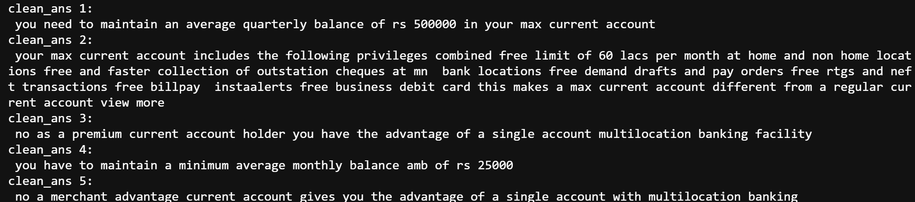

* **Lemmatization**

Lemmatization is one of the common text pre-processing tasks in NLP that reduces a given word to its root word. We have done Lemmatization Using en_core_web_sm cause it’s a small dataset. And en_core_web_sm is a small**English pipeline** trained on written web text (blogs, news, comments), that includes vocabulary, syntax and entities.

* **Label Encoding**

Label encoding refers to converting the labels into a numeric form so as to convert them into the machine-readable form. Machine learning algorithms can then decide in a better way how those labels must be operated. It is an important pre-processing step for the structured dataset in supervised learning.

There are 7 no of variables are present in the Class column we have applied the Label encoder to it.

* **Applying TF-IDF**

It is text vectorizer that transforms the text into a usable vector. It combines 2 concepts, Term Frequency (TF) and Document Frequency (DF). The term frequency is the number of occurrences of a specific term in a document. Term frequency indicates how important a specific term in a document.

* **Applying train_test_split**

After cleaning the Dataset we split the Dataset into training set and testing set then got that much of number of columns and the rows mentioned below.

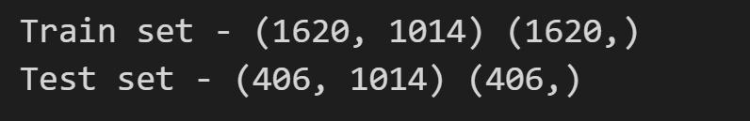

* **Training the Dataset**

Creating the model using SVC and storing in the variable ‘classifier’ with using ‘linear as the kernel and fitting the x_train and y_train using SVC and then predicting the x_test. **Saving Model:**

* **Saving the modelusing pickle**

We have saved the trained model to a file called model1.pkl using the pickle.dump() function. we open the model1.pkl file in read binary mode ('rb'). We can then use the loaded model to make predictions on new data by calling the predict() method.

* **Deployment Using Flask**

Machine learning is a process that is widely used for prediction. N number of algorithms are available in various libraries which can be used for prediction. In this article, we are going to build a prediction model on historical data using different machine learning algorithms and classifiers, plot the results, and calculate the accuracy of the model on the testing data. Building/Training a model using various algorithms on a large dataset is one part of the data. But using these models within the different applications is the second part of deploying machine learning in the real world. To put it to use in order to predict the new data, we have to deploy it over the internet so that the outside world can use it. In this article, we will talk about how we have trained a machine learning model and created a web application on it using Flask.

**1. Create a flask application which will accept the text and return the category of text :**

**2. Create flask api:**

**3.Deploy flask application to Streamlit:** check out the given link of deployment to get the output of our project.