HOMEWORK: Creating a Data Model

Using your Adventure Works report file, complete the following:

**1)** Navigate to the **RELATIONSHIPS**view, and perform the following actions *(00:14 mark)*:

* Right-click to delete each relationship between **AW_Sales**, **AW_Customer_Lookup** and **AW_Calendar_Lookup**(*including both date fields*) *(00:21 mark)*
* Use the **Manage Relationships** tool to delete *all* remaining relationships between all tables *(01:05 mark)*

|  |
| --- |
|  |

**2)** Recreate all table relationships (*using any method you prefer*), and confirm the following *(01:30 mark)*:

* Cardinality is **1-to-Many** for all relationships *- Yes*
* Filters are all **One-Way**(*no two-way filters*) *– Yes*
* Filter direction correctly flows "**downstream**" to data tables - *Yes*
* Data tables are **not connected** directly to one another *Yes and no many to many relationship*
* Both data tables are connected to **all valid lookup tables***Yes*
* Product-related tables follow a **snowflake schema***Yes*

|  |
| --- |
|  |

**3)** Return to the **REPORT**view, and complete the following :

* Edit (*or insert*) the  matrix visual to show **ReturnQuantity** (*values*) by **CategoryName** (*rows*) from the **AW_Product_Category_Lookup**table
  + *Which category saw the highest volume of returns? How many?*
    - *- Accessories, 1130*
* Replace **CategoryName** with **Year**from the **AW_Calendar_Lookup**table
  + 86 returns in 2015
  + 770 returns in 2016
  + *How many returns do you see in 2015 vs. 2016? (07:00 mark)*
* Replace **Year** with **FullName** from the **AW_Customer_Lookup**table *(07:12 mark)*
  + *What do you see, and why?*
    - *We see series of identical returning values, 1828, which is a grand total. We don’t have a relationship between customer look up and return table. So, it is not able to filter the data.*
  + 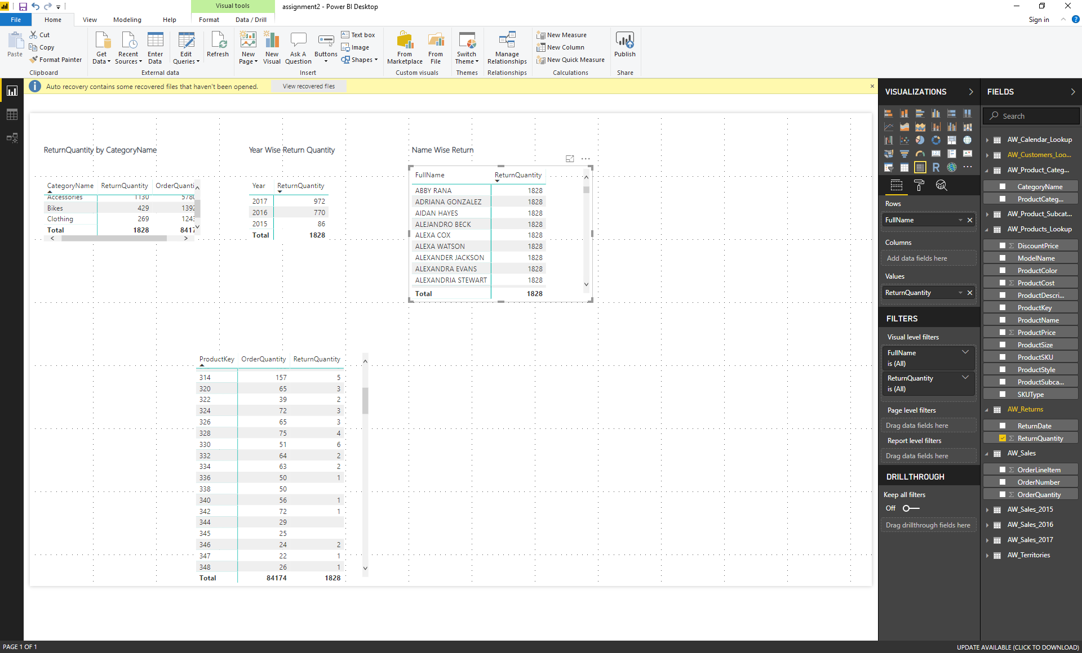
* Update the matrix to show both **OrderQuantity** and **ReturnQuantity** (*values*) by **ProductKey** (*rows*) from the **AW_Product_Lookup** table *(07:59 mark)*
  + *What was the total OrderQuantity for Product #338?*
  + *Total order quantity 50 for product 338*
  + 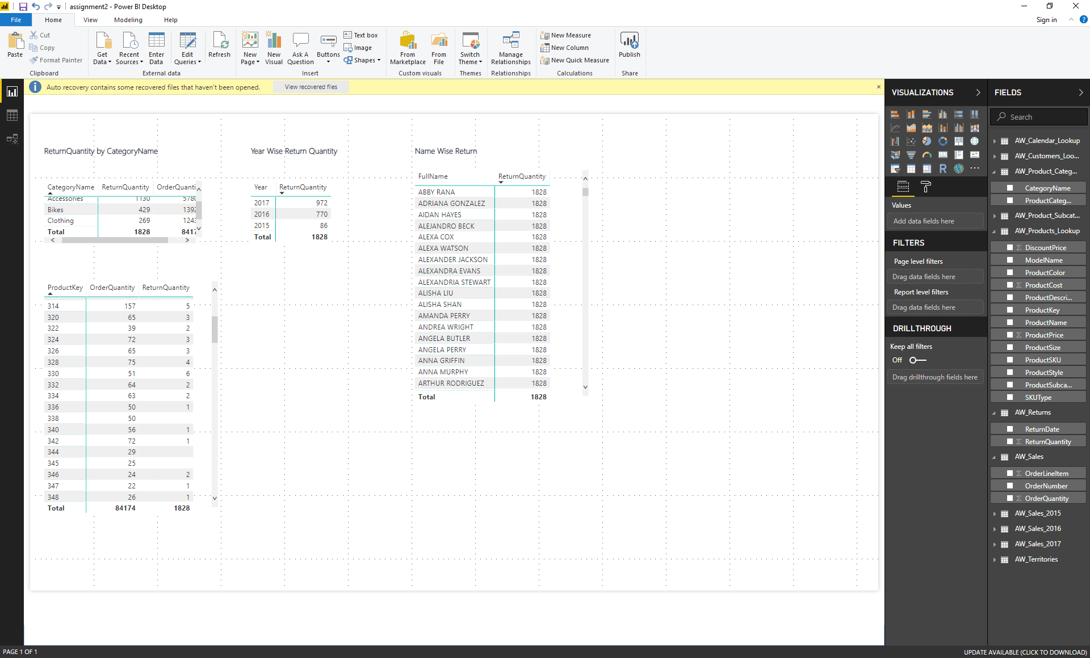

**4)**Unhide the **ProductKey** field from the **AW_Returns** tables (*using either the****DATA****or****RELATIONSHIPS****view*)

* In the matrix, replace **ProductKey** from **AW_Product_Lookup** with **ProductKey**from the **AW_Returns** table *(09:21 mark)*
* 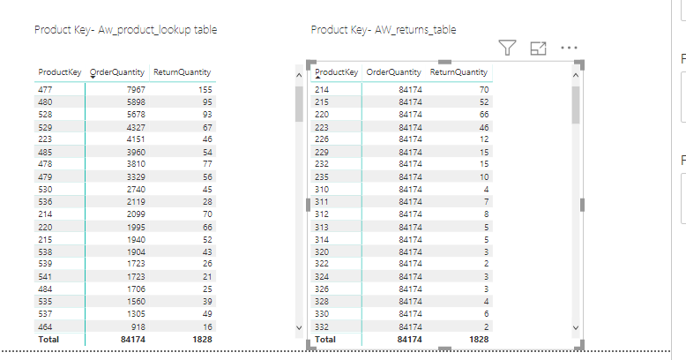
  + *Why do we the same repeating values for OrderQuantity? (09:44 mark)*
    - *Reason- AW Returns Product key cannot go upstream against the direction of the arrow it cannot transmit up to the product lookup table and has no possible way to go to the Sales table, since that is only possible path between sales and return table. So the sales table field Order Quantity has no idea that user has filtered anything in aw-returned. So it returns grand total.*
* Edit the relationship between **AW_Returns** and **AW_Product_Lookup** to change the cross filter direction from *Single* to *Both (10:29 mark)*
* 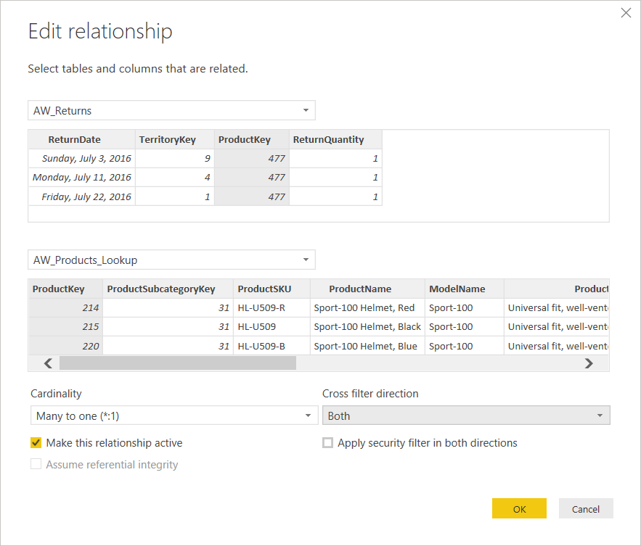
* 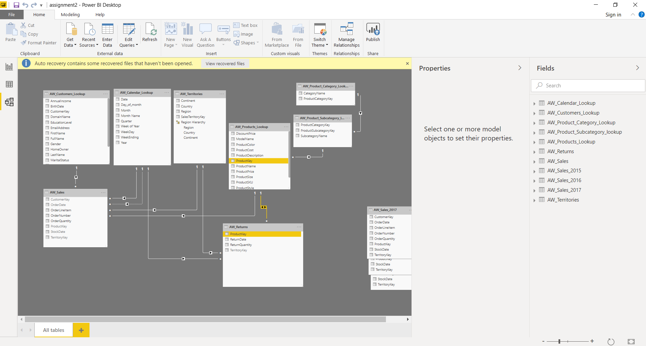
  + *Why does the visual now show OrderQuantity values by product, even though we are using****ProductKey****from****AW_Returns****?*
  + *How many orders do we see now for Product #338? What's going on here? (11:34 mark)*

We don’t see 338 product.

Cross join view is invalid

As we don’t have any returns on the 338, it is not showing up.

**5)** Complete the following *(13:05 mark)*:

* Change the cross filter direction between **AW_Returns** and **AW_Product_Lookup** back to *single* (*One-Way*) *(13:15 mark)*
* Hide the **ProductKey** field in the **AW_Returns** table from report view (*and any other foreign keys, if necessary*) *(13:29 mark)*
* Update the matrix to show **ProductKey** from the **AW_Product_Lookup**, rather than **AW_Returns***(13:38 mark)*
* 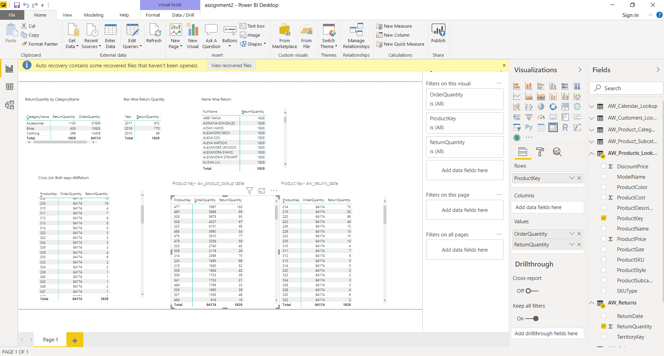
* **Recommendation:** Save a separate backup copy of the .pbix file (*i.e. "AdventureWorks_Report_Backup"*) *(13:57 mark)*