**COLLEGE PREDICTOR**

A

Mini Project Report submitted to Savitribai Phule Pune University, Pune



In partial Fulfillment for the awards of Degree of Engineering in Computer Engineering

**Submitted by**

|  |  |
| --- | --- |
| **Name of the Student** | **Seat Number** |
| Mr. Saurabh Mohite | S190084211 |
| Mr. Saurabh Bankar | S190084221 |
| Mr. Rohan Darandale | S190084348 |
| Mr. Dhananjay Sonune | S190084270 |

**Under the Guidance of**

**Mrs.Pooja Bhondve**

**Asst. Professor**



**May 2022-23**

**Department of Computer Engineering**

**D. Y. Patil College of Engineering,** **Akurdi, Pune-44.**

**D. Y. Patil College of Engineering,** **Akurdi, Pune-44**

**Department of Computer Engineering**

(2022-2023)

**Certificate**



This is to certify that, **PBL-10**

Mr. Saurabh Mohite S190084287

Mr. Saurabh Bankar S190084221

Mr. Rohan Darandale S190084232

Mr. Dhananjay Sonune S190084330

have successfully completed the Mini project entitled “ **College Predictor** ”under my guidance in partial fulfillment of the requirements for the Second Year of Engineering in Computer Engineering under the Savitribai Phule Pune University during the academic year 2022-2023

**Date :**

**Place:**

**Mrs. Pooja Bhondve Dr.Mrs.M.A.Potey**

**Project Guide HoD(Computer Enginnering)**

**Acknowledgements**

With deep sense of gratitude we would like to thank all the people who have lit our path with their kind guidance. We are very grateful to these intellectuals who did their best to help during our project work.

It is our proud privilege to express a deep sense of gratitude to **Dr.Mrs.P.Malathi ,** Principal of DYPCOE Akurdi,Pune-44 for his comments and kind permission to complete this project. We remain indebted to **Dr.Mrs.M.A.Potey,** H.O.D.Computer Engineering Department for his timely suggestion and valuable guidance.

The special gratitude goes to **Mrs.Pooja Bhondave** excellent and precious guidance in completion of this work .We thanks to all the colleagues for their appreciable help for our working project. With various industry owners or lab technicians to help, it has been our endeavor throughout our work to cover the entire project work.

We are also thankful to our parents who provided their wishful support for our project completion successfully .And lastly we thank our all friends and the people who are directly or indirectly related to our project work.

Mr. Saurabh mohite

Mr. Saurabh bankar

Mr. Rohan darandale

Mr. Dhananjay sonune

**Abstract**

The ease of making better choices and making better decisions in terms of selecting colleges is our aim. Our analysis on colleges for the students makes easier for them to make accurate decision about their preferred colleges. For such analysis, it requires future possibilities from the past record data from DTE which can potentially make the predictions and recommendation for students. Our analysis with the data mining methods would help giving probable accuracy and this requires analytical methods for predicting future recommendation. Today, most students make mistakes in their preference list due to lack of knowledge, improper and incorrect analysis of colleges and insecure predictions. Hence repent and regret after allotment. Our project will solve the general issue of the student community by using technology. This project aims to develop a predictive model for college admissions based on MHT-CET marks. The project collects data on MHT-CET marks and other relevant factors such as high school performance, extracurricular activities, and personal statements from students applying to engineering colleges in Maharashtra. The collected data is preprocessed, including cleaning, feature selection, feature engineering, and normalization. A predictive model is developed using machine learning algorithms, artificial neural networks, hybrid models, or fuzzy logic. The developed model is evaluated using appropriate metrics such as accuracy, precision, recall, and F1-score. The model is then deployed in a web-based application where students can enter their MHT-CET marks and other relevant factors to obtain personalized recommendations on which colleges they are likely to get admission to. The web-based application has an intuitive and user-friendly interface to ensure that students can easily enter their data and obtain accurate and relevant recommendations. Appropriate security measures are implemented to ensure that student data is protected and confidential. Regular maintenance and updates are carried out to ensure that the system remains accurate and relevant to current admissions criteria. In conclusion, the project provides an effective and efficient way for students to make informed decisions about their college admissions based on their MHT-CET marks and other relevant factors.

**Keywords*:*** DTE, Analysis, MHT-CET, Percentile, big data, Prediction

**Table of Contents**

**Abstract i**

**Table of Contents ii**

**List of Abbreviations iii**

**List of Figures iv**

**List of Tables v**

**1.** **Introduction 1**

1.1 Overview

1.2 Aim/Motivation

1.3 Objective

1.4 Organization of Report

**2.** **Literature Survey 2**

**3. Problem Statement 4**

**4. Software Requirements Specification 5**

4.1 Hardware Requirements

4.2 Software Requirements

**5. System Design 6**

5.1 Project Block Diagram 6

5.2 GUI of Working System 8

**6.Test Cases 11**

**7. Conclusion and Future Scope 14**

**References 15**

**List of Abbreviations**

Here is a list of abbreviations that be relevant to a college prediction project using MHT-CET marks:

1. MHT-CET: Maharashtra Common Entrance Test
2. HTTP: Hypertext Transfer Protocol
3. HTTPS: Hypertext Transfer Protocol Secure
4. SQL: Structured Query Language
5. JSON: JavaScript Object Notation
6. API: Application Programming Interface
7. URL: Uniform Resource Locator
8. HTML: Hypertext Markup Language
9. CSS: Cascading Style Sheets
10. JS: JavaScript
11. MongoDB: MongoDB database
12. Nodejs: JavaScript Framework

**List of Figures**

Fig 1 Data Flow Diagram 6

Fig 2 Home Page 8

Fig 3 Login Page 8

Fig 4 Signup Page 9

Fig 5 Percentile Page 9

Fig 6 Predicted College List-1 10

Fig 7 Predicted College List-2 10

**List of Tables**

Table 1: Literature Survey 3

Table 2: Test Cases for Login Module 11

Table 3: Test Cases for Signup Module 12

Table 4: Test Cases for Percentile Module 13

**Chapter 1**

**Introduction**

* 1. **Overview**

The Maharashtra Common Entrance Test (MHT CET) is conducted by the State Common Entrance Test Cell, Maharashtra for admissions to undergraduate courses in engineering, technology, pharmacy, and agricultural courses offered by colleges in the state. The MHT CET exam is a highly competitive exam, and students who perform well in this exam have a better chance of getting admission to top colleges in the state. In this project, we will build a college predictor based on MHT CET marks to help students predict their chances of getting admission to top colleges.

* 1. **Aim/Motivation**

We have collected the cut off details of all the colleges for creating the database. Using past previous year cut off marks we have calculated the range in which the college may fall. Accordingly, the comparison will be made between the marks entered by the user and the list of colleges will be displayed in which the user may get admission.

* 1. **Objective**

Using past previous year cut off marks we have calculated the range in which the college may fall. Accordingly, the comparison will be made between the marks entered by the user and the list of colleges will be displayed in which the user may get admission.

**1.4 Organization of Report**

The rest of this report is organized in following manner. In all chapters, related contents are described in detail.

**Chapter 2**

**Literature Survey**

College prediction project using MHT-CET marks is an interesting research topic. The project involves predicting the college that a student is likely to get admission to based on their MHT-CET marks. In this literature survey, we will look at the different approaches that have been used in similar projects.

|  |  |  |  |  |
| --- | --- | --- | --- | --- |
| Sr No | Title | Author | Publication Details | Methodology |
| 1 | Prediction and Analysis for Students' Marks Based on Decision Tree Algorithm | Zhiwu Liu and Xiuzhi Zhang | Intelligent Networks and Intelligent Systems, 2010 - ieeexplore.ieee.org | The effectiveness and correctness of analysis and forecasting model and classification for students' marks based on decision tree algorithm C4.5 has been examined by an example.This system only provided Students marks and the accuracy of forecasting model is less than 80%. |
| 2 | College Admission Predictor | Annam Mallikharjuna Roa | ICOSEC 2021  7-9, October 2021 | Proposed a web based application system in which students can register their marks along with their personal information. The main advantage of the project is the computerization of the entrance seat allotment process. Whatever may be their scores , this application helps to find the best colleges.The main objective of this system was to make the right choice of colleges.The proposed system only performed the seat allotment process. |
| 3 | StudieMe: College Recommendation System | Vidhish Sharma | **3rd International Conference on Recent Developments in Control, Automation & Power Engineering (RDCAPE)**  10-11 Oct. 2019 | Proposed a novel web platform for a college selection process. In this paper, they worked on designing a recommendation system that could understand the skill set and interest of a user through the data from the User's Profile to suggest recommended options of colleges for the users to select. This web platform which gives the result as top matched colleges for a particular user. In this paper, recommendation system is not based on cutoffs percentage. |
| 4 | HRSPCA: Hybrid recommender system for predicting college admission | Abdul Hamid M Ragab ,Abdul Fatah S. Mashat and Ahmed M Khedra | **12th International Conference on Intelligent Systems Design and Applications (ISDA)**  27-29 Nov. 2012 | Proposed a new college admission system using hybrid recommender. The proposed HRSPCA system consists of two cascaded hybrid recommenders working together with the help of college predictor, for achieving high performance.The first recommender assigns student's tracks for preparatory year students while the second recommender assigns the specialized college for students who passed the preparatory year exams successfully.The system analyzes student academic merits, background, student records, and the college admission criteria. Then, it predicts the likelihood of university college that a student may enter. In this paper, the recommendation system is not based on cutoffs percentage |

Table 1

**Chapter 3**

**Problem Statement**

There are more than 400 engineering colleges in Maharashtra, for which admission is governed by DTE (Directorate of Technical Education).

It's very difficult for the students to and out suitable colleges for them based on their MHCET Score, MHCET Rank, Category, Home University, etc. Various colleges provide degree in engineering in various branches (IT, Computer, Mechanical, Electrical, civil, etc)

It is very tedious job for a student to understand about the suitable colleges which provides preferred branch and to analyses it's last three years cut offs in order to predict whether that he can get one of those colleges in CAP.

Most of the students make mistakes in their preference list due to lack of knowledge, improper and incorrect analysis of colleges.

Hence those students regret after what they get the college after allotment. Our project will solve the issue of the student community by using a technology.

We are designing a web application college predictorfor predicting the college through an algorithm for students who aspires for taking admission in engineering through CAP

.

**Chapter 4**

**Software Requirements Specification**

4.1 Hardware Requirements

* Dual-Core 2 GHZ or higher
* 4 GB RAM
* 1 GB free disk space

4.2 Software Requirements

* Visual Studio Code -Text Editor
* Supported Operating System: Windows 11
* Supported Databases: MongoDB
* Languages: HTML, CSS, JavaScript.
* JavaScript extensions: NodeJS, express.
* Template Engine: Mustache extension- handlebars(hbs)
* MongoDB Compass, mongoose dependency

4.3Other Requirements :

* The data of cutoffs percentage of previous years and college details are the main requirement for proper working of our system.
* The college recommendation system requires data from the latest CAP round containing percentage, seat-type, college name, college location and course name, etc. for college listing, this data is extracted from pdf provided by the mahacet.org for every college and is stored into a database.
* The college details are extracted from College's and other educational websites.
* The cutoffs prediction system requires data from previous years cutoffs for proper prediction analysis which is hardly available on some websites over the internet, that is not in proper format

**Chapter 5**

**System Design**

**5.1Project Block Diagram**

Here is a high-level system design for a college prediction project using MHT-CET marks:

1. Data Collection: The system will collect data on MHT-CET marks and other relevant factors such as admission category of student from students applying to engineering colleges in Maharashtra.

2. Data Preprocessing: The collected data will be preprocessed, including data cleaning, data arranging in desired manner, etc.

3.Data flow diagram:

User Interaction

FrontEnd

Node.js API

MongoDB

Data Query

Response

FrontEnd

Display List

Fig 1

**Breakdown of the flow:**

1. **The user interacts with the website's frontend interface.**
2. **The frontend (HTML and CSS) collects the marks of the student and sends the data to the Node.js API.**
3. **The Node.js API receives the request and processes the data.**
4. **The API communicates with the MongoDB database to query the relevant college data based on the student's marks and category.**
5. **The API receives the data from the database.**
6. **The API sends a response back to the frontend.**
7. **The frontend receives the response from the API.**
8. **The frontend displays the list of possible colleges for admission based on the received data.**
9. **The user can view the list of colleges on the website.**

4. Model Development: The preprocessed data will be used to develop a predictive model using NodeJs, ExpressJs and MongoDB, etc.

5. Model Deployment: The model will be deployed in a web-based application where students can enter their MHT-CET marks and other relevant factors to obtain personalized recommendations on which colleges they are likely to get admission to.

6. User Interface: The web-based application will have an intuitive and user-friendly interface to ensure that students can easily enter their data and obtain accurate and relevant recommendations.

7. Security: The system will implement appropriate security measures to ensure that student data is protected and confidential.

8. Maintenance and Updates: The system will be regularly maintained and updated to ensure that it remains accurate and relevant to current admissions criteria.

In college prediction system using MHT-CET marks requires a comprehensive approach to data collection, preprocessing, model development, evaluation, deployment, user interface, security, maintenance, and updates.

**5.2GUI of Working System**

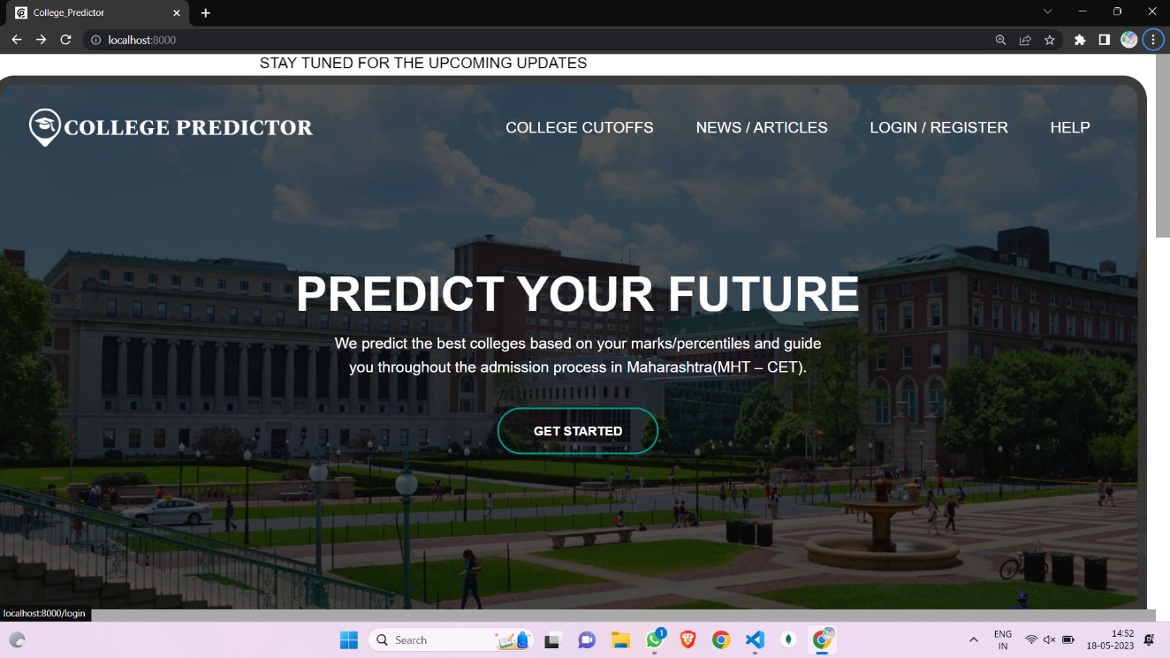

**Fig 2**

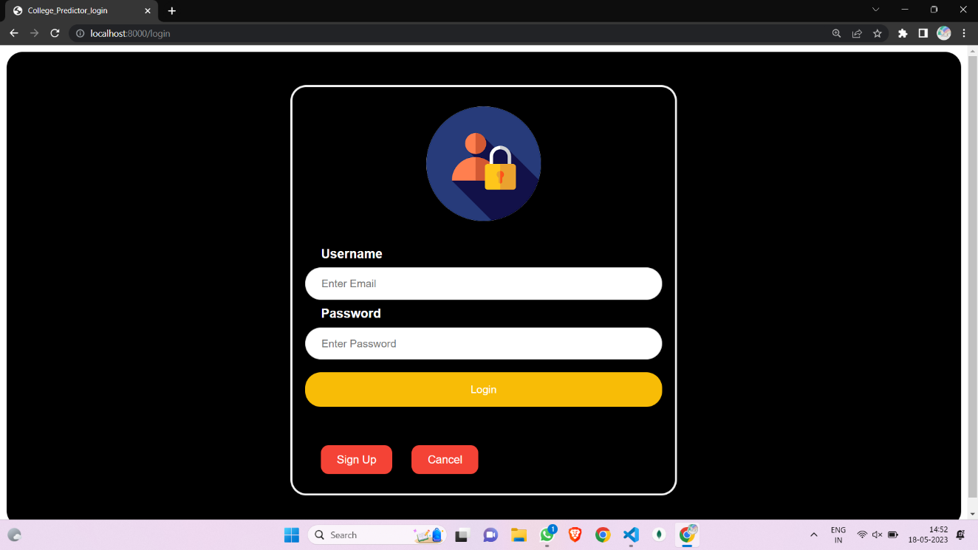

**Fig 3**

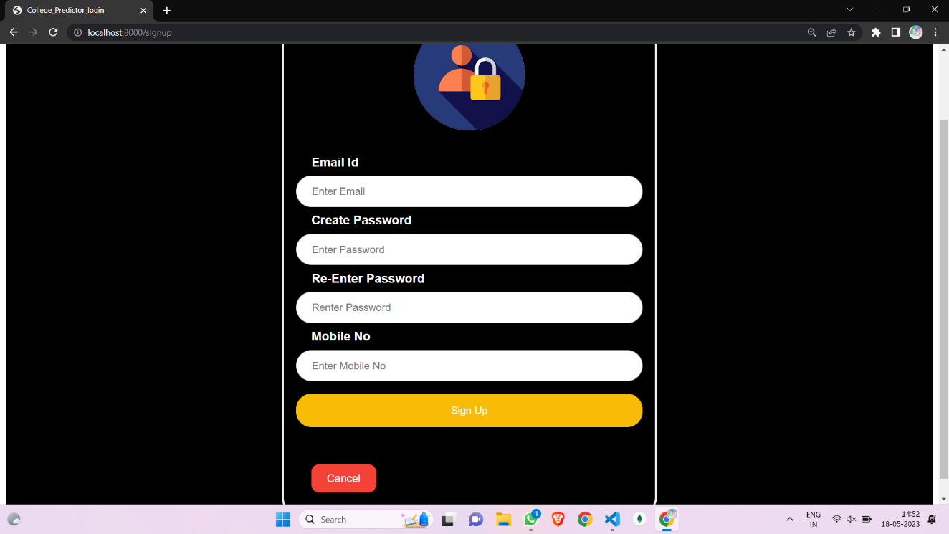

**Fig 4**

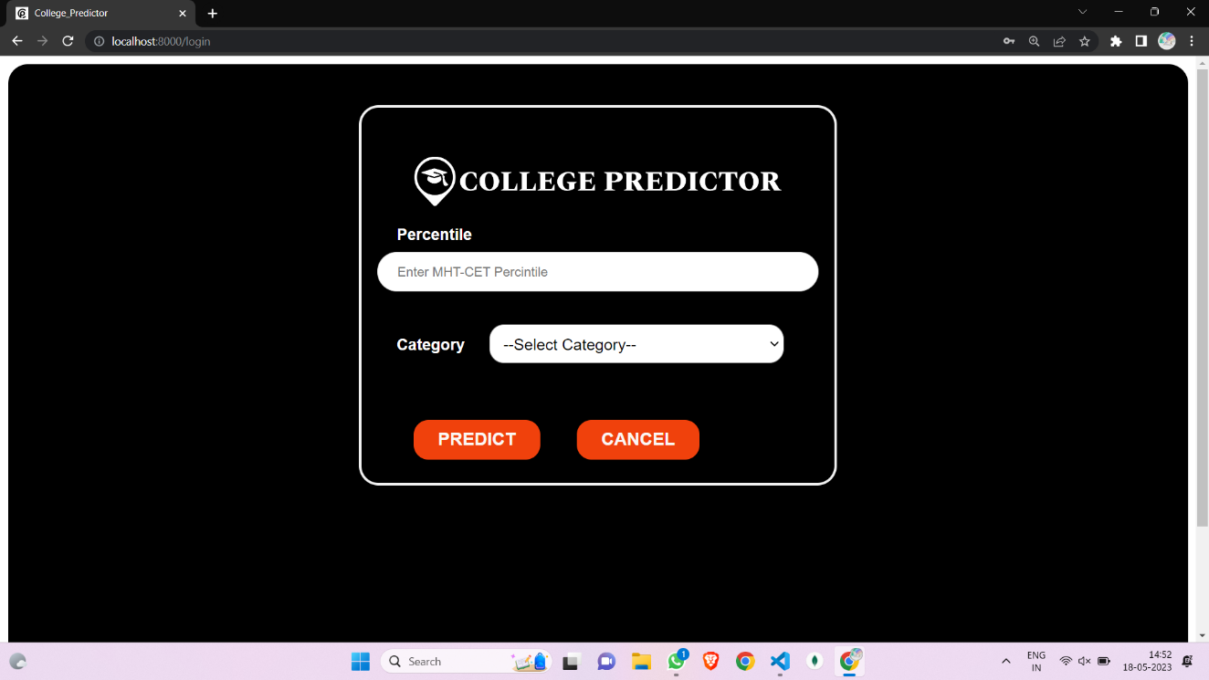

**Fig 5**

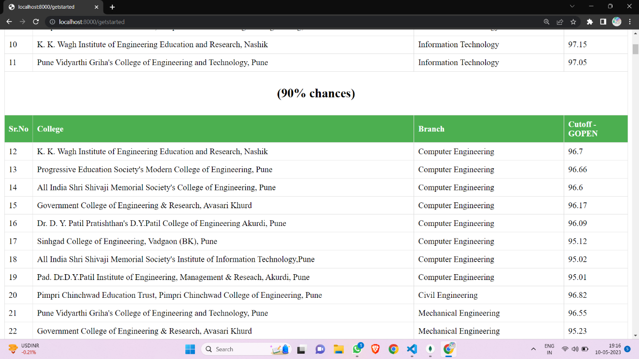

**Fig 6**

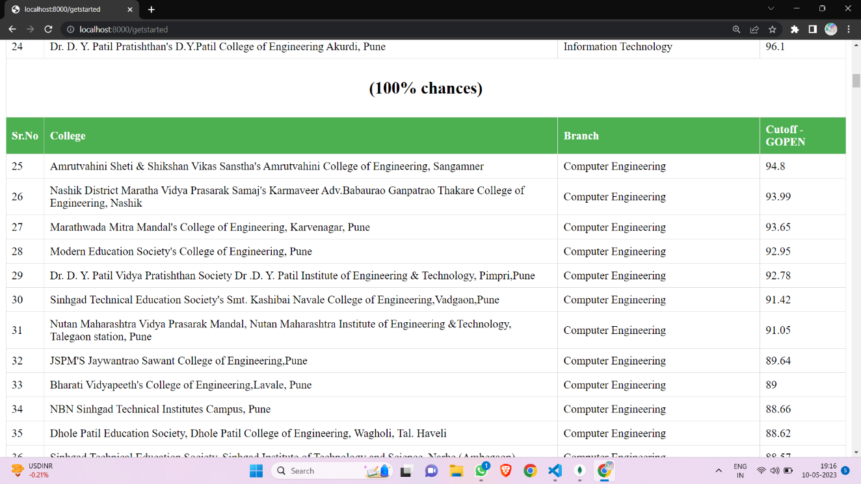

**Fig 7**

**Chapter 6**

**Test Cases**

1.Login Module

|  |  |  |  |  |  |
| --- | --- | --- | --- | --- | --- |
| Test ID | Test Case Name | Description | Expected Output | Actual Output | Status |
| 1 | Valid Credentials | Testing with valid email and password combination. | Successful login and redirection to the page. | Successful login and redirection to the page. | PASS |
| 2 | Empty Fields | Testing when email and password fields are left empty. | Display an error message for required fields. | Display an error message for required fields. | PASS |
| 3 | Empty Password | Testing when the password field is left empty. | Display an error message for required password. | Display an error message for required password. | PASS |
| 4 | Empty Email | Testing when the email field is left empty. | Display an error message for required email. | Display an error message for required email. | PASS |
| 5 | Invalid Email | Testing with an email format that is missing the "@" symbol. | Display an error message for invalid email. | Display an error message for invalid email. | PASS |
| 6 | Unregistered Email | Testing with a valid email format but an unregistered email address. | Display an error message for unregistered email. | Display an error message for unregistered email. | PASS |
| 7 | Incorrect Password | Testing with a valid email format but an incorrect password. | Display an error message for incorrect password. | Display an error message for incorrect password. | PASS |
| 8 | Maximum Length | Testing with email and password exceeding the maximum allowed length. | Display an error message for input length | Display an error message for input length | PASS |
| 9 | Sign Up Button | Clicking the "Sign Up" button should redirect to the signup page. | Redirect to the signup page. | Redirect to the signup page. | PASS |

Table 2

2.SignIn Module

|  |  |  |  |  |  |
| --- | --- | --- | --- | --- | --- |
| Test Id | Test Case Name | Description | Expected Output | Actual Output | Status |
| 1 | Empty Email Field | Test if the email field is left empty | Display error message "Email is required" | Display error message "Email is required" | PASS |
| 2 | Invalid Email Format | Test with an invalid email format | Display error message "Invalid email format" | Display error message "Invalid email format" | PASS |
| 3 | Empty Password Field | Test if the password field is left empty | Display error message "Password is required" | Display error message "Password is required" | PASS |
| 4 | Password Length | Test with a password shorter than 5 characters | Display error message "Password is too short" | Display error message "Password is too short" | PASS |
| 5 | Empty Confirm Password | Test if the confirm password field is left empty | Display error message "Confirm password is required" | Display error message "Confirm password is required" | PASS |
| 6 | Password Mismatch | Test with password and confirm password fields mismatch | Display error message "Passwords do not match" | Display error message "Passwords do not match" | PASS |
| 7 | Empty Phone Number | Test if the phone number field is left empty | Display error message "Phone number is required" | Display error message "Phone number is required" | PASS |
| 8 | Invalid Phone Number | Test with an invalid phone number format | Display error message "Invalid phone number format" | Display error message "Invalid phone number format" | PASS |
| 9 | Sign Up Button | Test for successful sign in | Redirect to “get started” page | Redirect to the “get started” page. | PASS |
| 10 | Cancel  Button | Test for unsuccessful sign in | Redirect to the home page. | Redirect to the home page. | PASS |

Table 3

3.Percentile Module

|  |  |  |  |  |  |
| --- | --- | --- | --- | --- | --- |
| Test Id | Test Case Name | Description | Expected Output | Actual Output | Status |
| 1 | Valid Input Category | Fill in valid percentile and select a category | Form submission is successful | Form submission is successful | PASS |
| 2 | Empty Percentile | Leave percentile field empty | Form submission fails (required field) | Form submission fails (required field) | PASS |
| 3 | Invalid Percentile | Enter invalid percentile (non-numeric value) | Form submission fails (required field) | Form submission fails (required field) | PASS |
| 4 | Missing Category | Fill in valid percentile and select "Select Category" | Form submission fails (required field) | Form submission fails (required field) | PASS |
| 5 | Missing Category | Fill in valid percentile and select a category | Form submission fails (required field) | Form submission fails (required field) | PASS |
| 6 | Valid Input Category and Invalid Percentile | Fill in valid percentile and select a category | Form submission is successful and redirect to college list page | Form submission is successful | PASS |
| 7 | Valid Input Category and Missing Category | Fill in valid percentile and select a category | Form submission is unsuccessful | Form submission is unsuccessful | PASS |
| 8 | Valid Input Category | Fill in valid percentile and select a category | Form submission is successful and redirect to college list page | Form submission is successful and redirect to college list page | PASS |
| 9 | Valid Input Category | Fill in valid percentile and select a category | Form submission is successful and redirect to college list page | Form submission is successful and redirect to college list page | PASS |
| 10 | Valid Input Category | Fill in valid percentile and select a category | Form submission is successful and redirect to college list page | Form submission is successful and redirect to college list page | PASS |

Table 4

**Chapter 7**

**Conclusion and Future Scope**

College prediction project using MHT-CET marks is an important research area that has gained significant attention in recent years. The project involves predicting the college that a student is likely to get admission to based on their MHT-CET marks. Different approaches, such as machine learning algorithms, artificial neural networks, hybrid models, and fuzzy logic, have been used in previous studies. However, the choice of the approach depends on the specific problem and the available data.

Future Scope:

Future research in college prediction using MHT-CET marks can focus on the following areas:

1. Exploring the use of deep learning algorithms in predicting college admissions based on MHT-CET marks.

2. Investigating the impact of additional factors, such as academic performance in high school, extracurricular activities, and personal statement, on college admissions.

3. Developing a more comprehensive model that incorporates multiple data sources and provides a more accurate prediction of college admissions.

4. Evaluating the performance of the proposed model on a larger dataset with diverse demographics to ensure the model's generalizability.

5. Integrating the proposed model into a web-based application that can provide personalized recommendations to students based on their MHT-CET marks and other relevant factors.

In conclusion, the college prediction project using MHT-CET marks has significant potential for future research and development, which can ultimately benefit students in making informed decisions about their college admissions.

**References**

1. W3 School “Introduction To The Web Development”. <https://www.w3schools.com/>
2. Frontend Languages: HTML, CSS link: <https://www.thapatechnical.com>/
3. Backend Languages: Node.js, Express.js link: <https://www.thapatechnical.com>/
4. Database: MongoDB: <https://www.thapatechnical.com>/
5. College Cutoff Data: <https://cetcell.mahacet.org/>, https://www.shiksha.com/