Seamless Person Integration with Shadow Detection and Edge Analysis

Author: Saurabh Nagayach

## Abstract

This project focuses on seamlessly integrating a foreground image (person/object) into a background image while maintaining photorealism. The pipeline involves background removal, blending, light direction estimation, shadow generation, and edge detection. The final output produces a visually realistic composite image with shadows aligned to estimated lighting conditions, as well as the detection of shadow edges for enhanced analysis.

# 1. Introduction

Image composition is the process of merging a foreground image with a background to create a single, realistic visual. To achieve photorealism, the foreground must not only be blended seamlessly but also match the lighting and shadow dynamics of the background.  
  
This project implements a step-by-step algorithm that:  
1. Extracts the foreground object.  
2. Places it into the background using alpha blending.  
3. Estimates light direction to generate natural shadows.  
4. Detects and highlights shadow edges using Canny edge detection.

# 2. Algorithms Used

2.1 Foreground Extraction:  
- Algorithm: U²-Net via rembg library.  
- Process: Automatically detects and removes the background of the foreground image, producing an alpha mask.  
- Result: A clean person/object image (fg_rgb) and its binary mask (mask_fg).  
  
2.2 Image Blending:  
- Algorithm: Alpha Blending.  
- Equation: I_result = α * I_fg + (1-α) * I_bg, where α is derived from the mask.  
- Purpose: Smoothly overlays the person onto the background.  
  
2.3 Light Direction Estimation:  
- Algorithm: Gradient-based method using Sobel filters.  
- Steps: Convert background to grayscale, compute gradients (Gx, Gy), and estimate dominant light direction using θ = arctan(Gy/Gx).  
  
2.4 Shadow Generation:  
- Algorithm: Mask Projection with Gaussian Blur.  
- Steps: Use the foreground mask, offset it based on light direction, blur to soften edges, and darken the region on the background.  
  
2.5 Shadow Edge Detection:  
- Algorithm: Canny Edge Detector.  
- Purpose: Identify and highlight the boundary of the shadow.

# 3. Implementation Steps

Step 1: Foreground and Background Input.  
Step 2: Background Removal.  
Step 3: Resize and Place Foreground.  
Step 4: Blending.  
Step 5: Light Direction Estimation and Visualization.  
Step 6: Shadow Generation.  
Step 7: Shadow Edge Detection.  
Step 8: Final Visualization.

# 4. Results

The pipeline successfully places the person into the scene with realistic blending. Shadows align with the estimated light direction, enhancing photorealism. The shadow edges are accurately detected using the Canny detector.

# 5. Conclusion

This project integrates computer vision techniques to solve a real-world problem of realistic image composition. By combining foreground extraction, gradient-based lighting estimation, alpha blending, Gaussian-blurred shadow projection, and edge detection, the system achieves high-quality outputs that are visually convincing.

6. OUTPUT:

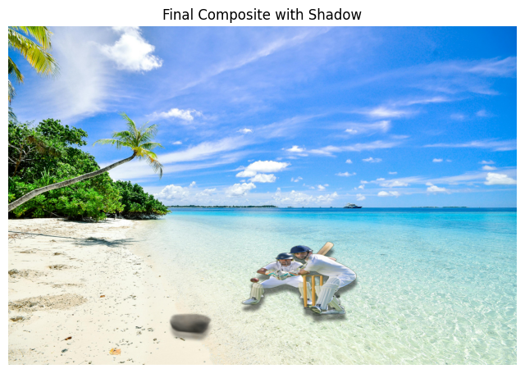FOREGROUND IMAGE: BACKGROUND IMAGE: FINAL OUTPUT:

