**Class:** Third Year (Computer Science and Engineering)

**Year:** 2020-21 **Semester:** 2

**Course:** Advanced Web and Mobile Application Development Lab (4CS381)

**LA4/ESE Exam**

**17/06/2021 01.00 PM – 04.00 PM**

**Exam Seat No:**

Name: Saurabh Makarand Narkhede

Exam Seat Number: 2018BTECS00071

**Problem Statement 1**

**Statement:**

Design and build a simple website for WLUG online event using Node.js, Express.js and any database.  
1. Use POST and GET method appropriately.  
2. Use different routes for redirection and multiple callback functions  
3. Use database connectivity for data storage and retrieval.  
4. Create a page for contact details.  
5. Select HTML, CSS, JavaScript and other frameworks as per need.

**Screenshot 1:**

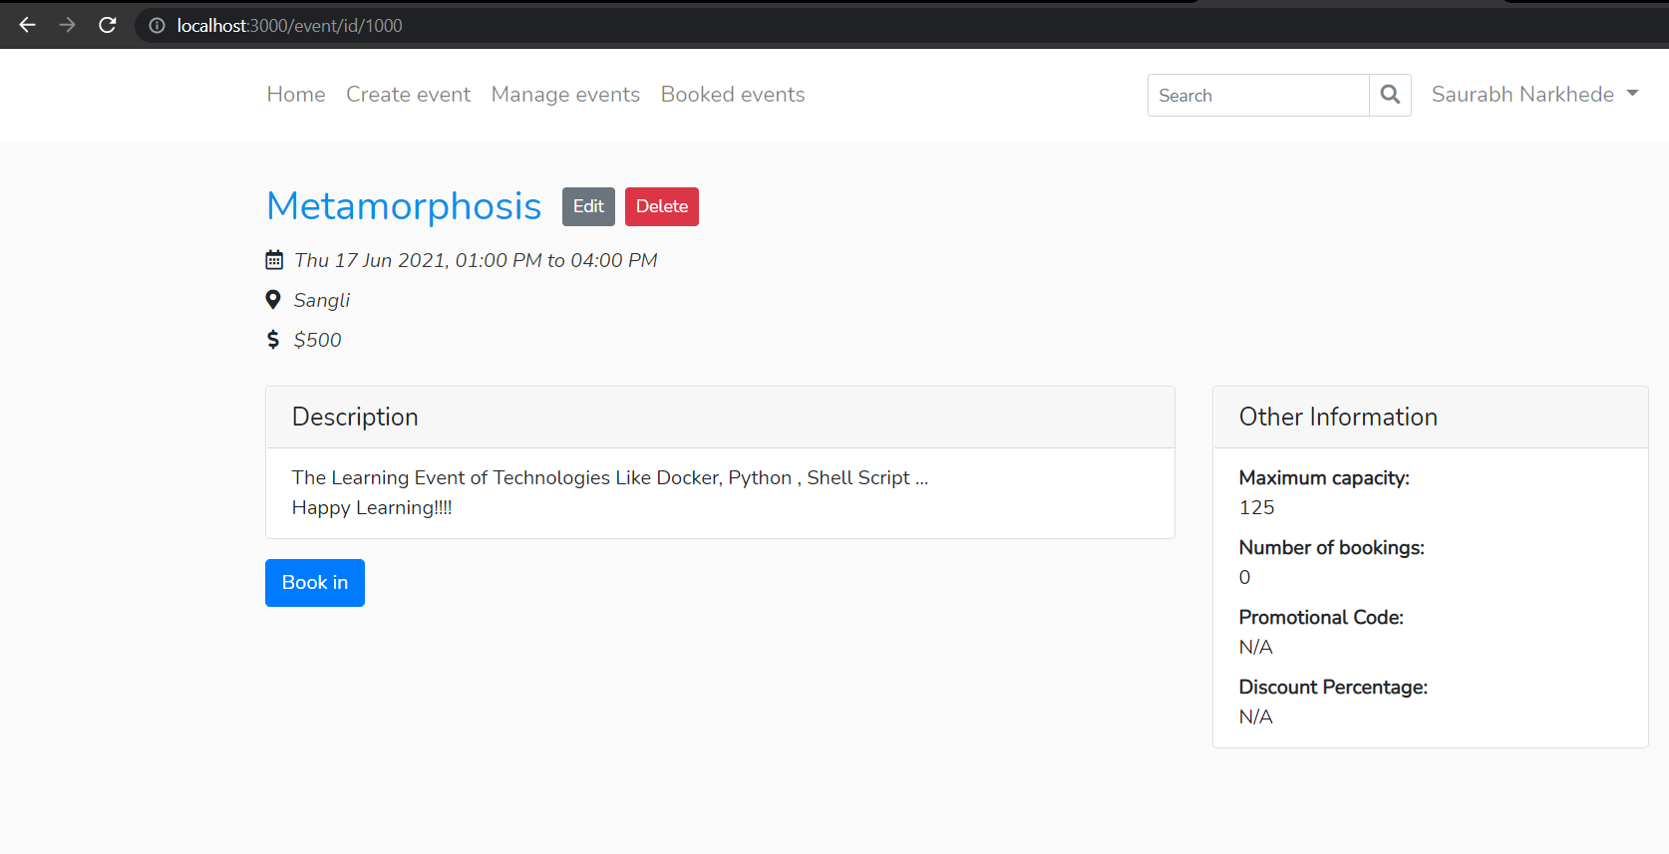

**Information 1:**

Event Named Metamorphosis Created on the Website.

**Screenshot 2:**

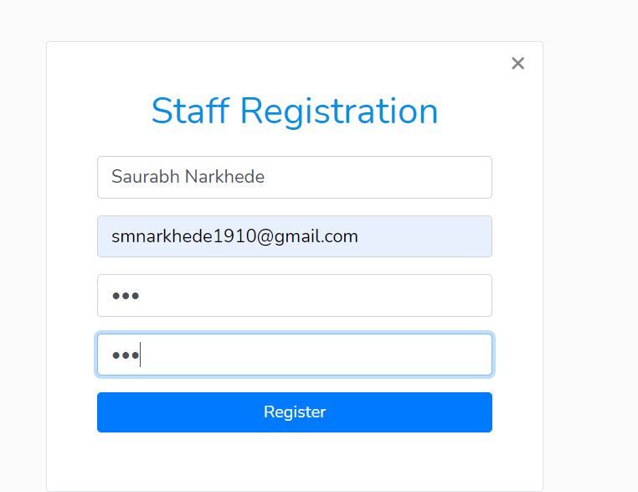

**Information 2:**

Staff Registeration.

**Screenshot 3:**

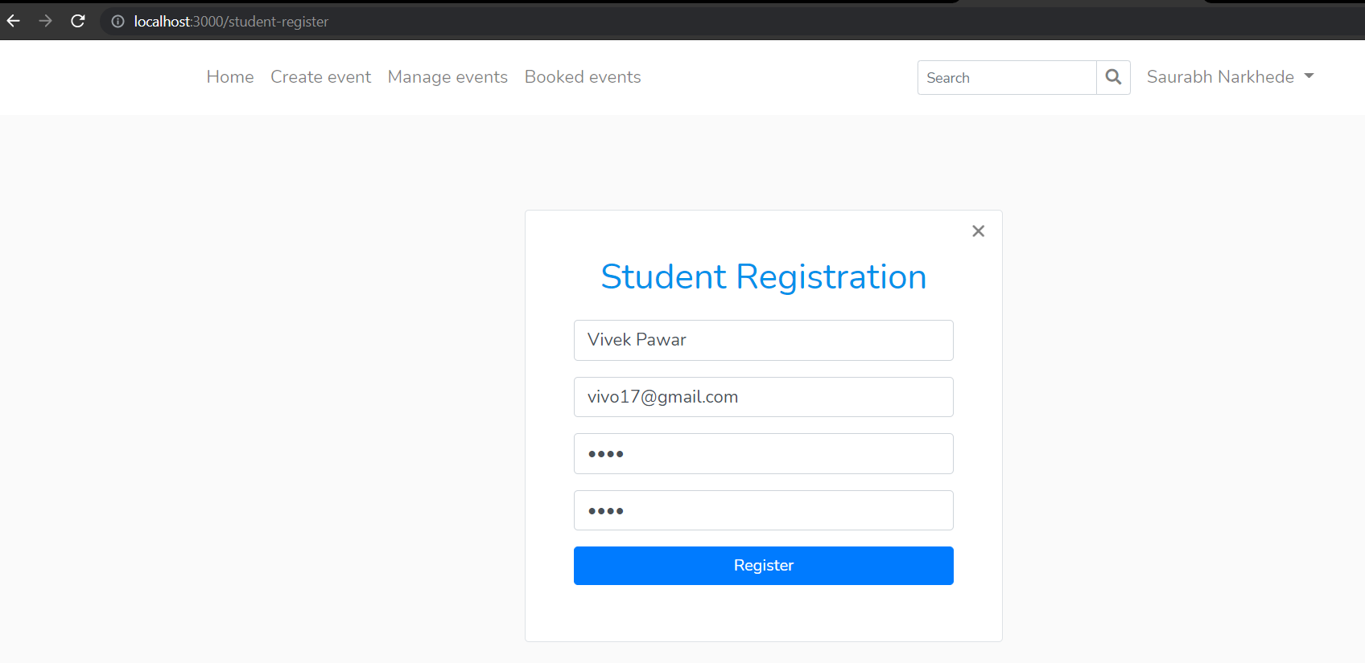

**Information 3:**

Student Can register for Event.

**Screenshot 4:**

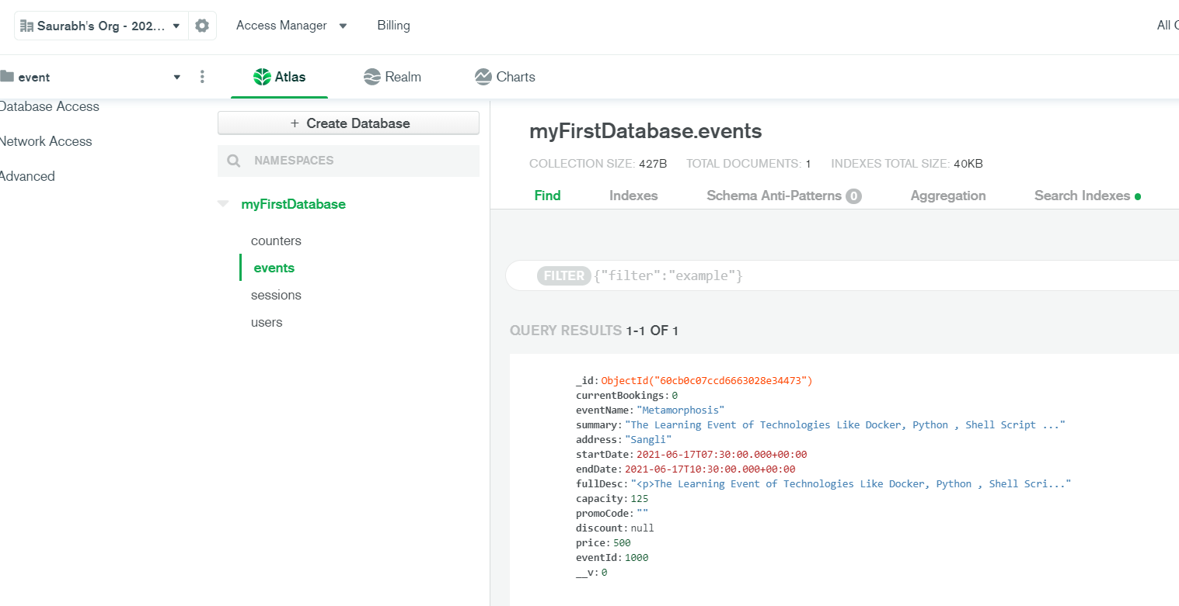

**Information 4:**

Database Connectivity Established.

**Screenshot 5:**

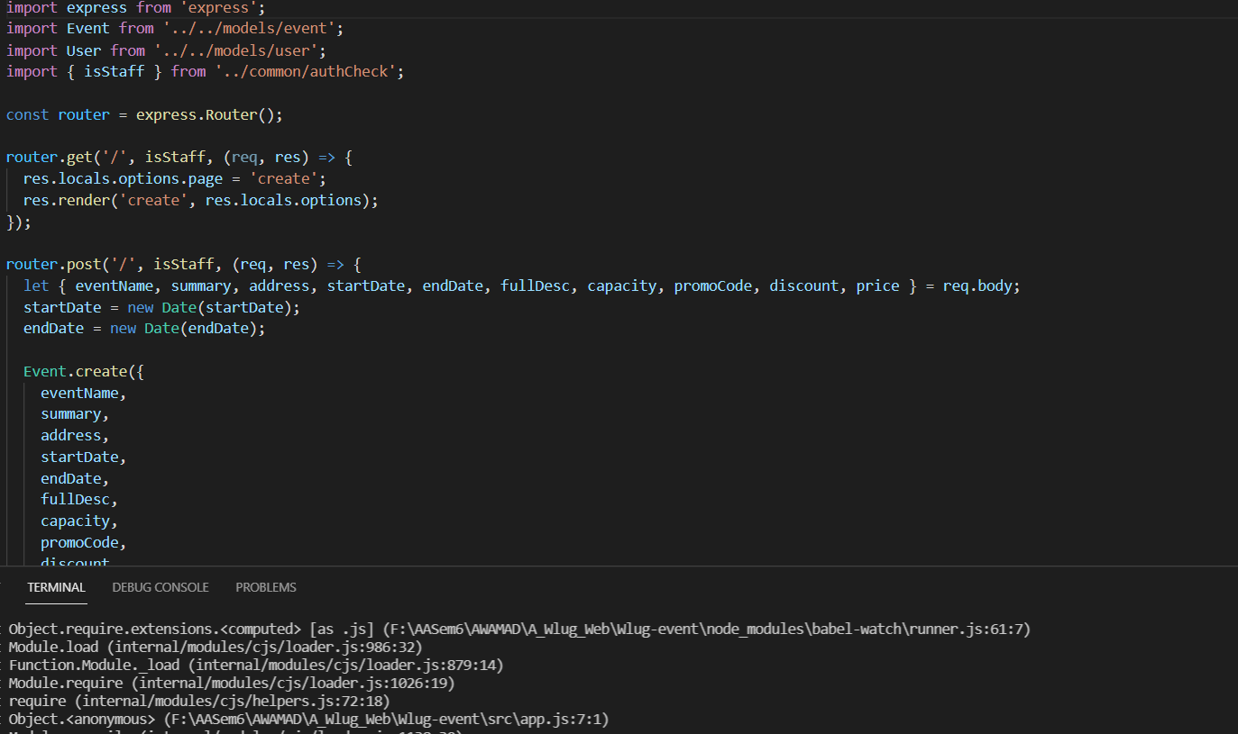

**Information 5:**

Both Get And Post Methods Are Added.

**Screenshot 6:**

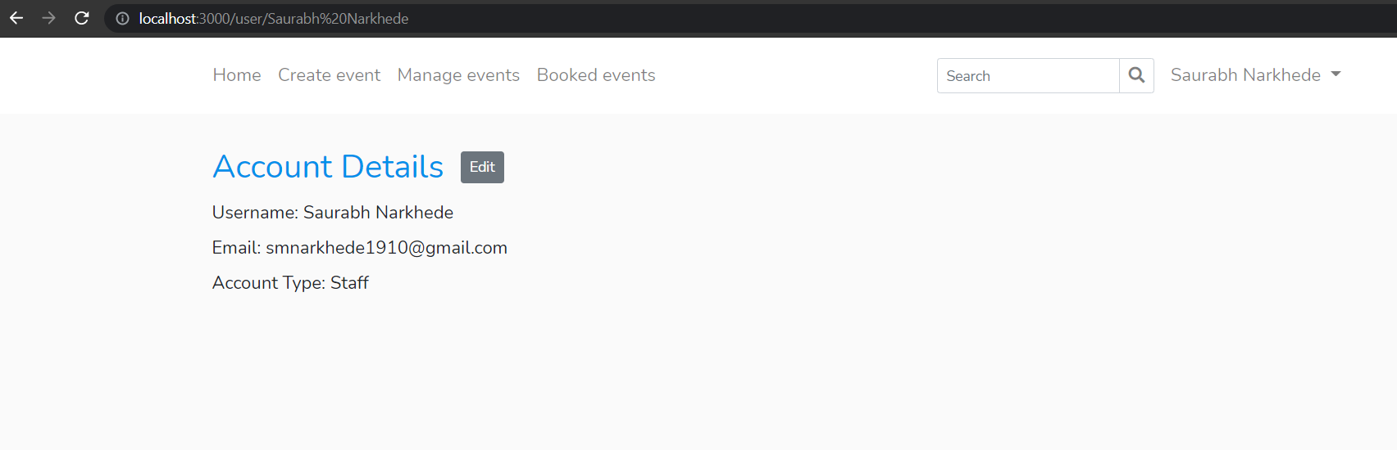

**Information 6:**

Contact Page Added.

**Screenshot 7:**

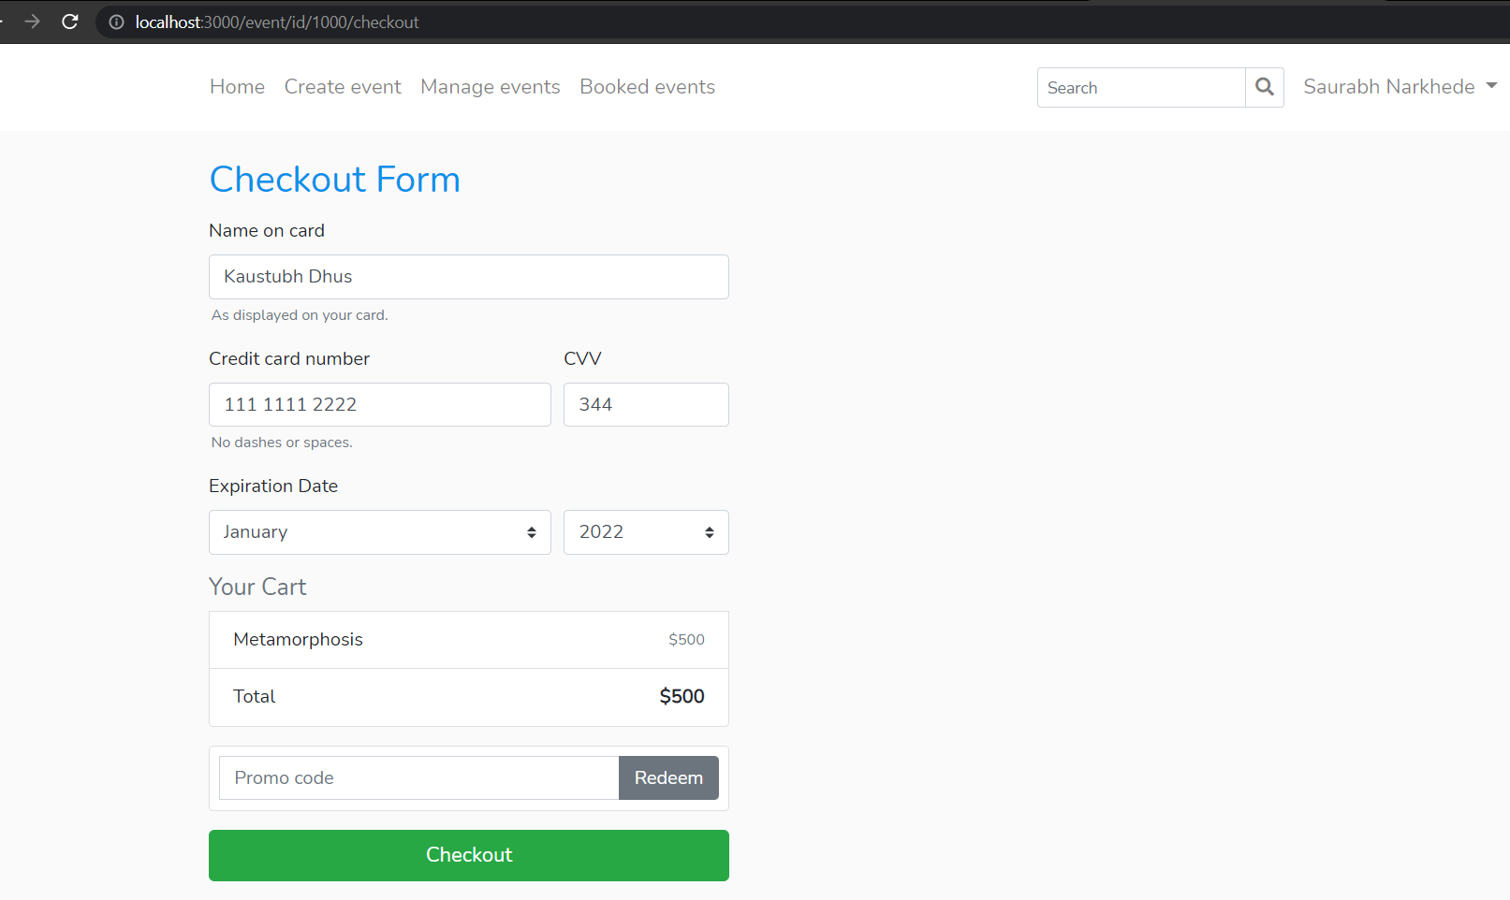

**Information 7:**

Page for New Booking Created.

**Problem Statement 2**

**Statement:**

Create and run React App for coordinating team details and event images using different components, props and user defined components.

**Screenshot 1:**

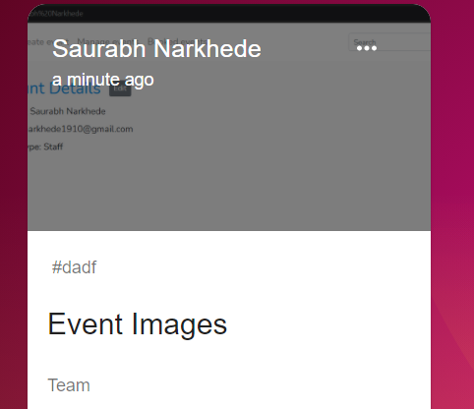

**Information 1:**

**Event Images Stored.**

**Screenshot 2:**

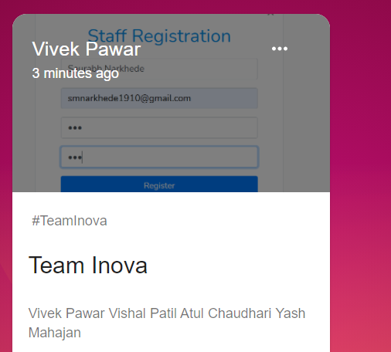

**Information 2:**

**Event Team Created.**

**Screenshot 3:**

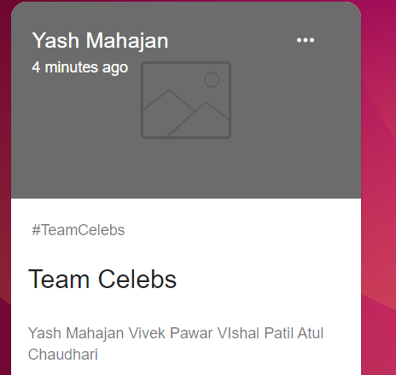

**Information 3:**

**Multiple Teams Created**

**Screenshot 4:**

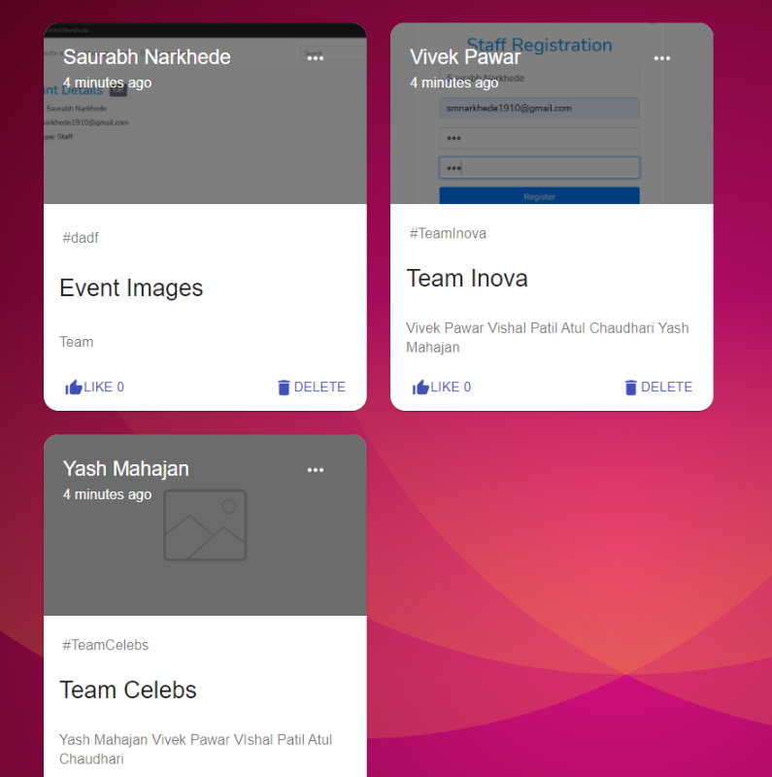

**Information 4:**

**Multiple Teams Created.**

**Technologies Used:** *HTML , CSS, Node JS, ExpressJS, Mongo DB, ReactJS.*

**GitHub Link:** [**https://github.com/saurabhnarkhede/AWAMAD_LA4**](https://github.com/saurabhnarkhede/AWAMAD_LA4)