DevOps Capstone Project # 1 Infra Optimization
Important points :

- All kubectl commands need to run from Control Plane node only and not from local VM or lab machine.
- Ansible-playbook commands need to run from local VM or lab machine only and not from Control Plane node.

Pre Requisite :
- Prepare Ansible setup with required plugins and python modules :
sudo apt update -y # Update packages on ubuntu lab-machine
# Install Python dependencies required by Ansible collections/modules
python3 -m pip install --user boto3 botocore kubernetes
# Install Ansible collections
ansible-galaxy collection install -r requirements.yml
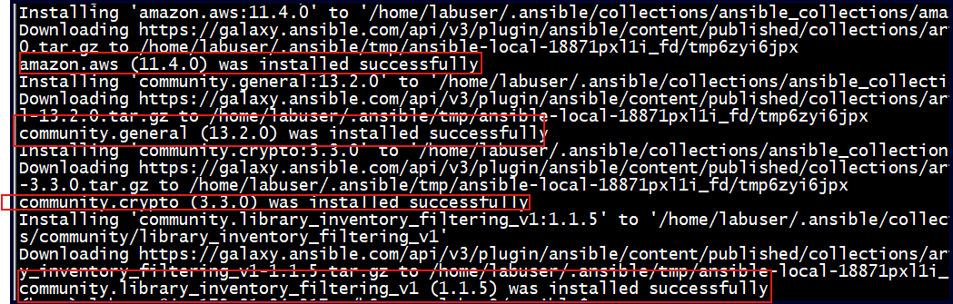
- Verify the installation :
ansible-galaxy collection list
python3 -c "import boto3; print(boto3.__version__)"
python3 -c "import kubernetes; print(kubernetes.__version__)"
ansible-galaxy collection list | egrep -i "amazon.aws|general|crypto|kubernetes"
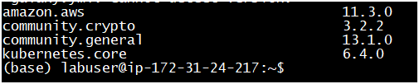

- Download the project config files to lab machine or local machine. You can use any FTP tool ( filezilla, winscp etc) or you can use SCP command from your windows/linux machine :
scp -r .\k8s-aws-lab-v2-new labuser@3.110.113.140:/home/labuser # This command will copy k8s-aws-lab-v2-new folder and its files to lab machine IP 3.110.113.140 ( change it with your lab machine IP ) under path /home/labuser.
- Below are files inside ansible directory and their purpose. We need to run these files in sequence :
├── ansible # Directory with ansible related config.
│ ├── 0.provision.yml # Used to create 3 subnets , Security groups, Route table etc.
│ ├── 1.prepare-nodes.yml # Install kubectl/kubelet/kubeadm on nodes. Also install helm/docker/containerd packages.
│ ├── 2.cluster-init-node-join.yml # Initializes Kubernets cluster from control plane node. Generates Join command
│ ├── 3.set-provider-ids.yml # Patches the Worker nodes Spec.ProviderID to allow LoadBalancers to work properly.
│ ├── 4.install-nlb-controller-metrics-server.yml # Install LoadBalancerController and metrics-server addon in k8s cluster.
│ ├── 5.etcdctl-install.yml # Install etcdctl utilities in control plane node, required for etcd backup task.

Configuration :
- Execute 0.provision.yml to provision the subnets and worker/master node.
$ ansible-playbook 0.provision.yml
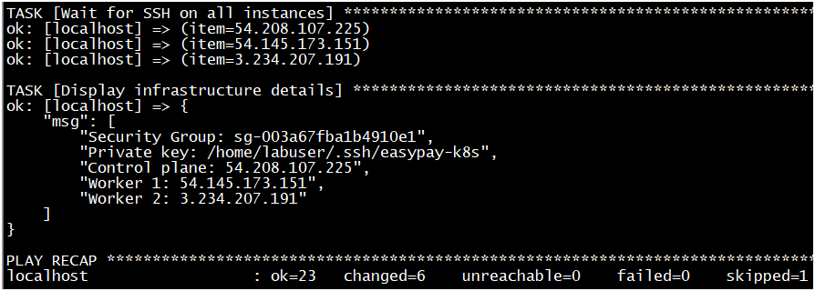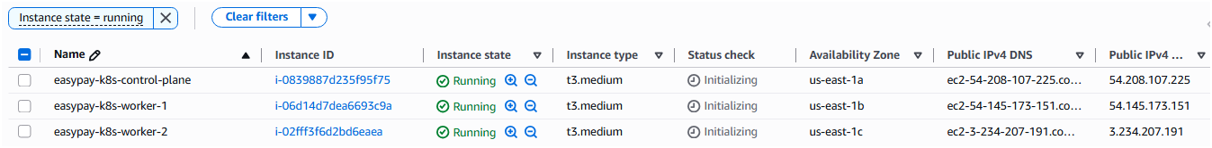
- # Test the connectivity of all hosts from local machine # $ ansible all -m ping
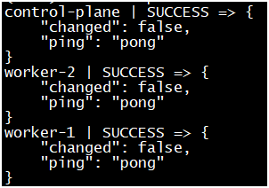
- $ ansible-playbook 1.prepare-nodes.yml # To serup nodes with required packages like docker, helm, kubeadm, kubectl etc.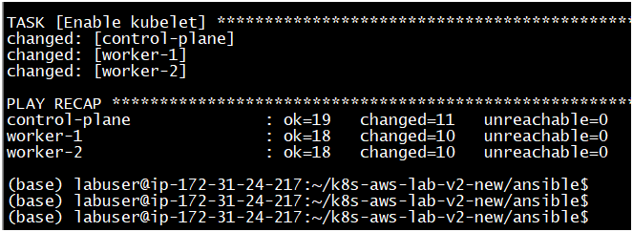

Note : Try connecting with control plane node from lab machine using :
$ ssh -i ~/.ssh/easypay-k8s ec2-user@<<PUBLIC_IP_CONTROL_PLANE>>
Exit from the control plane node and continue with the process.
- $ ansible-playbook 2.cluster-init-node-join.yml # To initialize the k8s cluster and make worker nodes join the cluster.

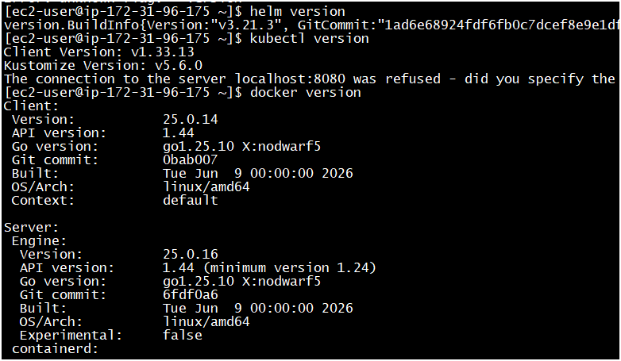
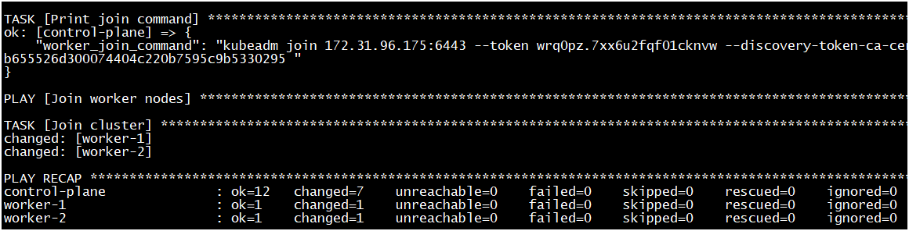

It will show join commands which gets executed on both worker nodes and those should join our Kubernetes cluster. We should have 3 nodes ready ( 1 Master, 2 worker ).
To confirm the status of the Kubernetes cluster, lets login to Control plane node : $ ssh -i ~/.ssh/easypay-k8s ec2-user@<<PUBLIC_IP_CONTROL_PLANE>>
kubectl get nodes -o wide
kubectl get pods -Ao wide
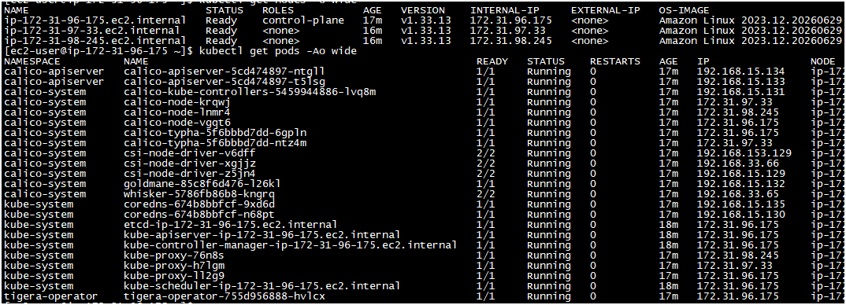

- Continue with the next step : Configure provider ID in worker nodes.
$ ansible-playbook 3.set-provider-ids.yml
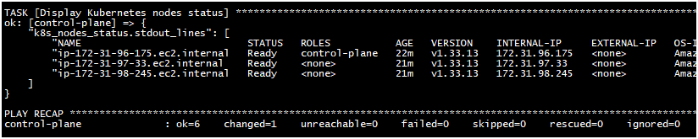

- $ kubectl describe node | egrep -i "^Name|provider" # Only worker nodes will have ProviderID now.
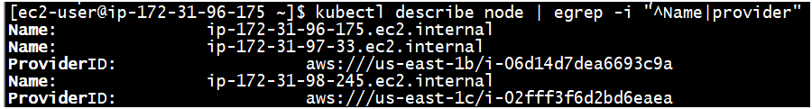

- $ ansible-playbook 4.install-nlb-controller-metrics-server.yml to install Network load balancer controller and metrics server on our Kubernetes cluster.
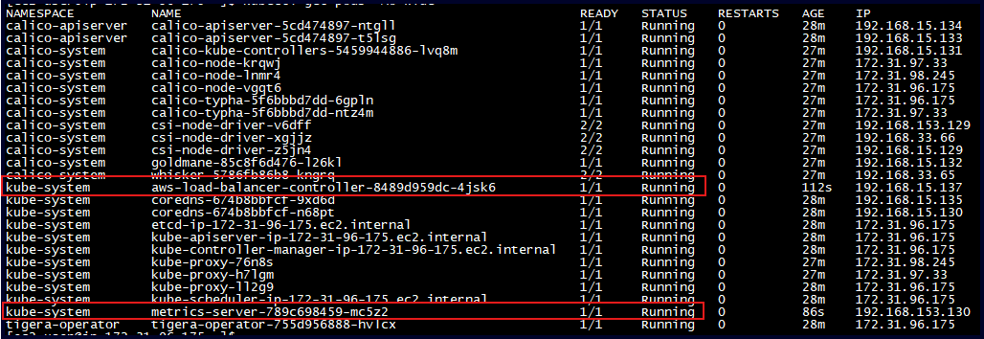
This playbook also has a task to copy Kubernetes deployment manifests from your local to inside Control plane nodes, because those manifests can be deployed from your control plane node only.
TASK [Copy kubernetes directory to control plane node]
- Verify by doing ls -latr and you should see these files inside control plane node as well.
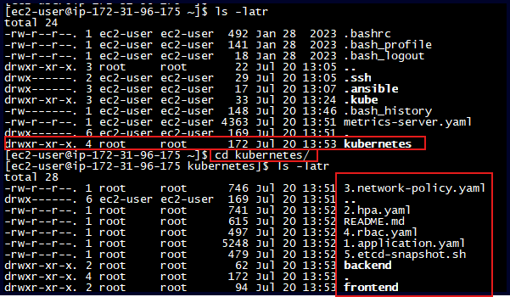

##############################################################################
### APPLICATION Building And Deployment In Kubernetes Cluster ###
##############################################################################
Note :
Note that if you have amd64 based worker nodes you will need docker images which are build on amd64 based VM terminal. Our Simplilearn Lab machine is not amd64 ( its ARM64 based architecture) so if you build docker images on your lab machine and then deploy on worker nodes created by AmazonLinux2023 ( which is amd64 based) your pods will not come up. So for this lab we can create docker images on Control plane node ( which is amd64 based ) so that when we deploy these images in our cluster, it will work fine on our amd64 nodes.

## Remember the sequence :
Docker Build -> Docker Tag ( with target Docker Repo Format) -> ( Docker Login) -> Docker Push

- You need to first login to remote repository where you are planning to push the docker image :

For Docker hub : you need username/repo-name and PAT ( PersonalAccessToken)
For Public AWS ECR Repo: aws ecr-public get-login-password --region us-east-1 | docker login --username AWS --password-stdin public.ecr.aws/<<ECR_UNIQUE_ID>>
For Private Repo : aws ecr get-login-password --region us-east-1 | docker login --username AWS --password-stdin <<AWS_ACCOUNT_ID>>.dkr.ecr.<<REGION>>>>.amazonaws.com

cd ~/kubernetes/backend
docker build -t easypay-backend:v1 . # Picks up application and Dockerfile from backend folder and builds a local image easypay-backend:v1.
docker tag easypay-backend:v1 saurabhnegi2306/easypay:backend-v1 # Tags/renames easypay-backend:v1 into saurabhnegi2306/easypay:backend-v1 as per docker Repo format.
docker push saurabhnegi2306/easypay:backend-v1 # Pushes newly tagged image to dockerHub account names "saurabhnegi2306" and inside repo "easypay" with tag "backend-v1".
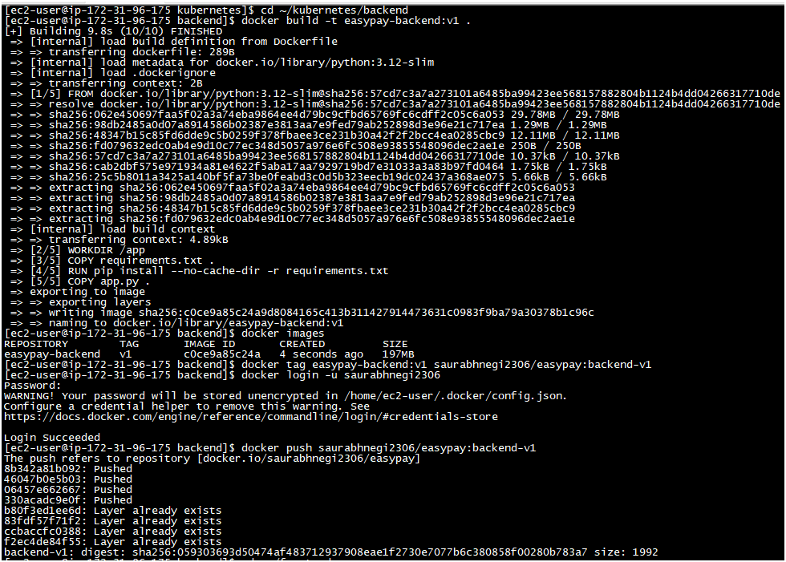
```
cd ../frontend
docker build -t easypay-frontend:v1 . # Picks up application and Dockerfile from frontend folder and builds a local image easypay-frontend:v1.
docker tag easypay-frontend:v1 saurabhnegi2306/easypay:frontend-v1 # Tags/renames easypay-frontend:v1 into saurabhnegi2306/easypay:frontend-v1 as per docker Repo format.
docker push saurabhnegi2306/easypay:frontend-v1 # Pushes newly tagged image to dockerHub account names "saurabhnegi2306" and inside repo "easypay" with tag "frontend-v1".
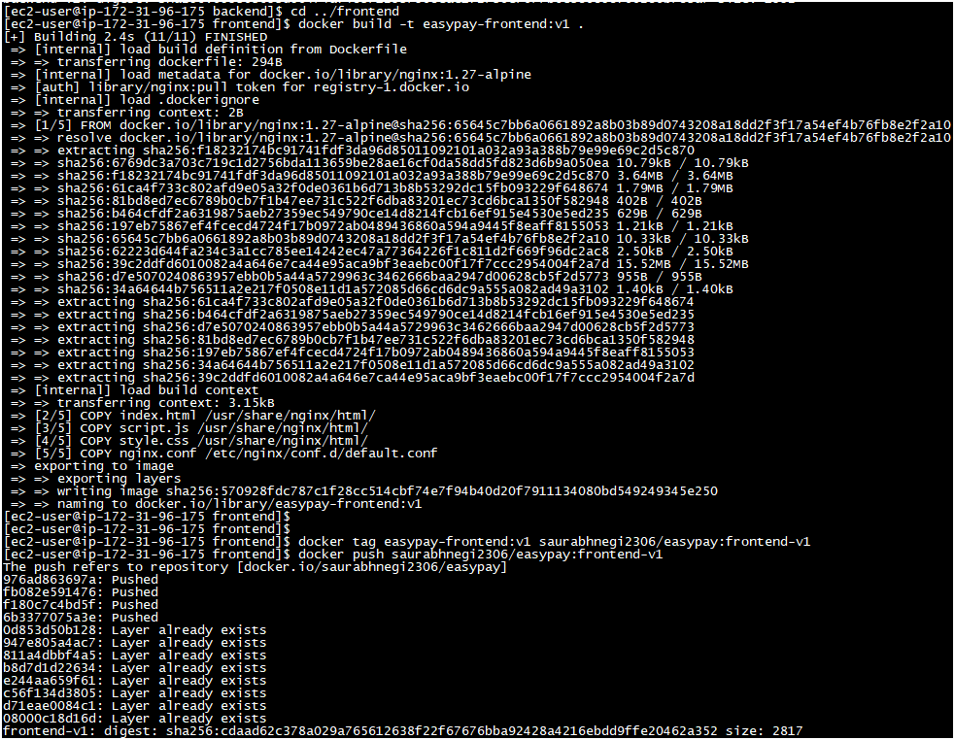

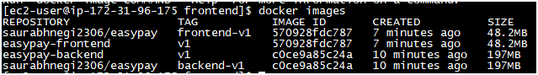
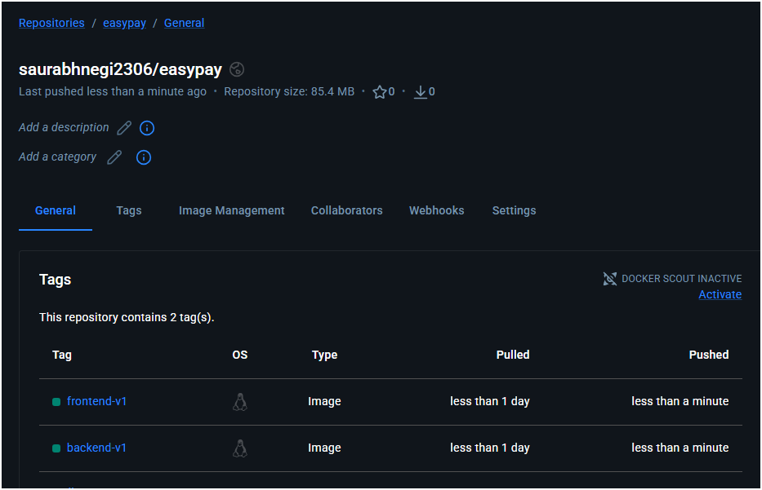

Now since images are ready we need to update these images in /Kubernetes/1.application.yaml
Leave these as it is or else update with your own images ( pushed in previous steps).
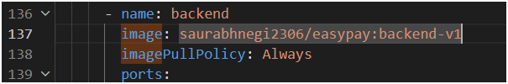
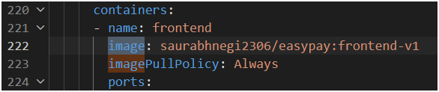

- Deploy the application : $ kubectl apply -f 1.application.yaml
This will install Deployment for front/backend, mysql statefulset,service, secret etc.
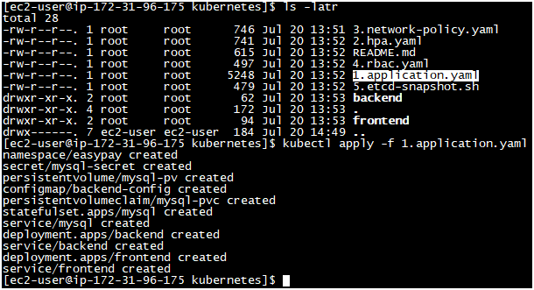

- Verify the resources in easypay namespace : $ kubectl get pods,svc -n easypay -o wide 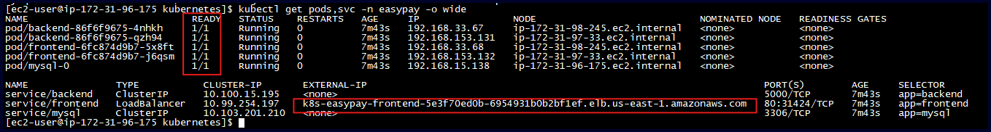
Load balancer will be visible in service output and also in EC2 Loadbalancer console in AWS.
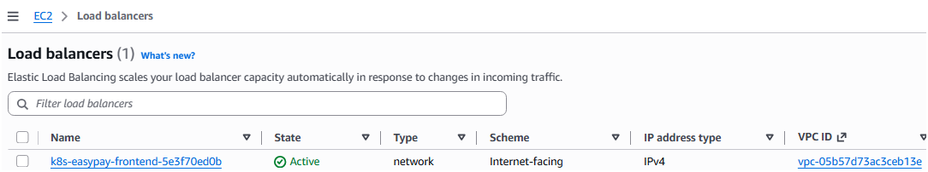

##############################################################################
################ Horizontal Pod Autocaler Demo ################
##############################################################################

- Apply HPA using : $ kubectl apply -f 2.hpa.yaml and verify $ kubectl get hpa -n easypay
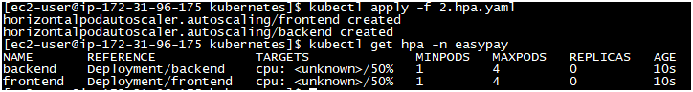
- Check utilization of Pods and Nodes : $ kubectl top pods -A $ kubectl top nodes
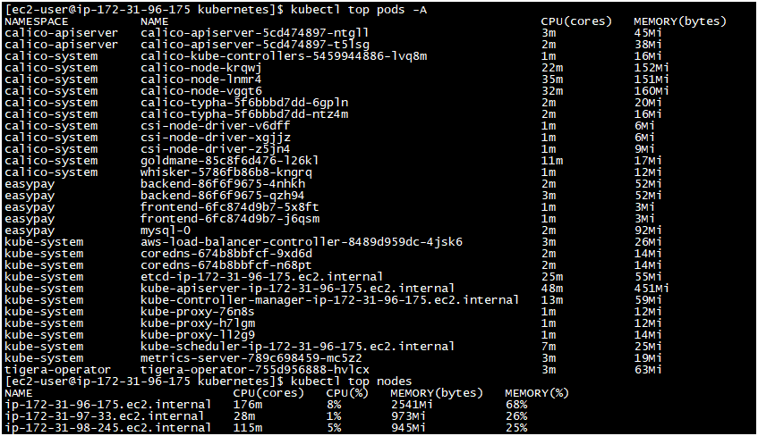
- Now to simulate higher traffic increase, we will install stress tool in one of the container and stress it to simulate actual load.
kubectl exec -it -n easypay $BACKEND_POD -- sh -c "apt update && apt install -y stress"
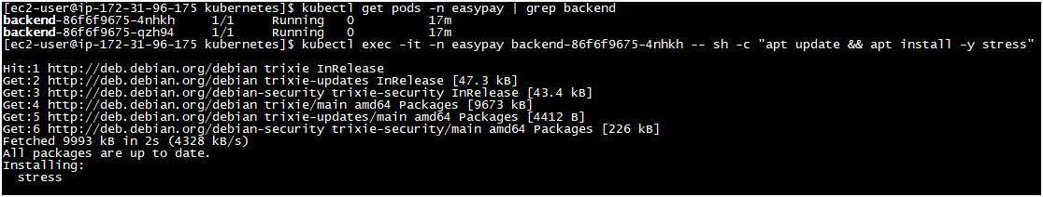
kubectl exec -n easypay $BACKEND_POD -- sh -c "stress --cpu 2 --timeout 300 >/dev/null 2>&1 &"
After stress testing starts in the backend, check the HPA :
kubectl get hpa -n easypay OR watch -d kubectl get hpa -n easypay
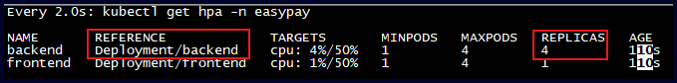
You will notice the REPLCIAS count increasing and after some time it will scale down to 1 when stress testing ends.
##############################################################################
#################### Network Policy Demo ####################
##############################################################################

- So till now we haven’t applied any explicit network policy. By default every pod in Kubernetes cluster can reach to every other pod. Lets launch 2 test pods in 2 different Namespaces to test this concept.
kubectl run unauthorized-client -n easypay --image=busybox:1.36 --restart=Never -- sleep 3600
kubectl run unauthorized-client2 -n default --image=busybox:1.36 --restart=Never -- sleep 3600
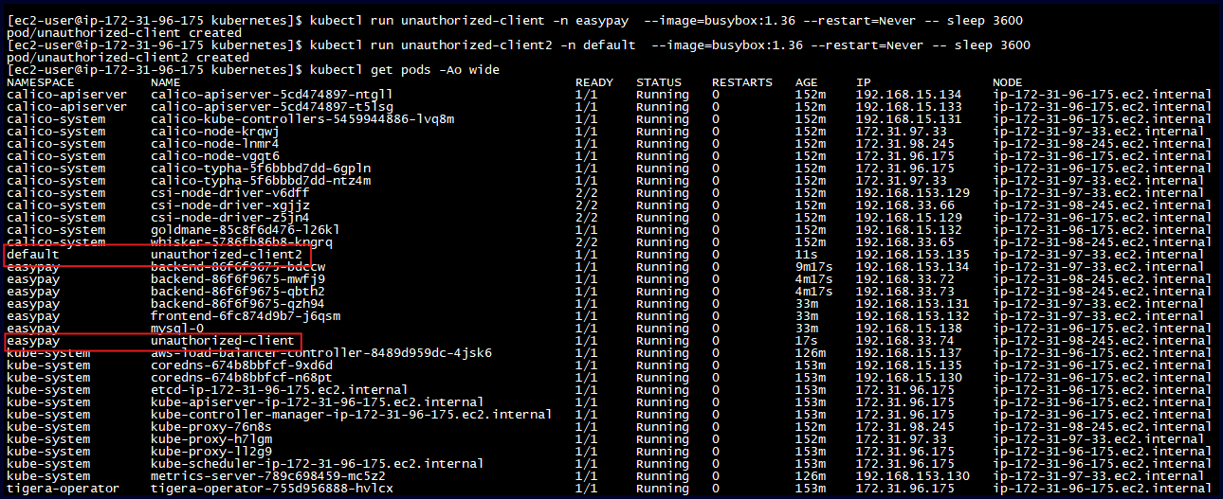
When these test pods are up we can try to connect DB pod from these pods using “nc” and “wget” :
kubectl exec -n easypay unauthorized-client -- nc -zv mysql 3306 -w 3
kubectl exec -n default unauthorized-client2 -- nc -zv mysql.easypay.svc.cluster.local 3306 -w 3
kubectl exec -n easypay unauthorized-client -- wget -qO- http://backend:5000/health
kubectl exec -n default unauthorized-client2 -- wget -qO- http://backend.easypay.svc.cluster.local:5000/health
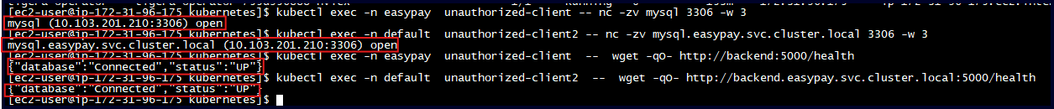
We will be able to connect as expected. Lets apply network policies and then retry the same tests.
- kubectl apply -f 3.network-policy.yaml
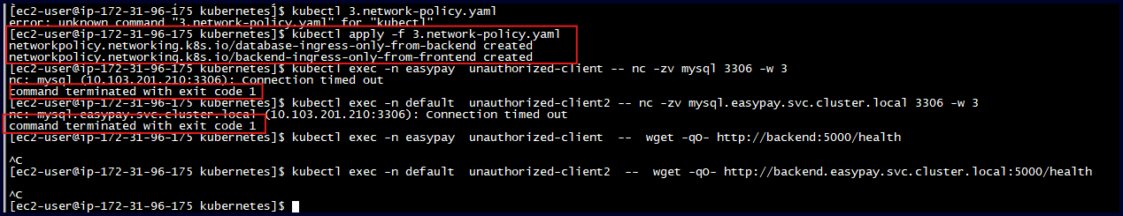
$ kubectl delete -f 3.network-policy.yaml # Delete network policy and again test , it should work again.
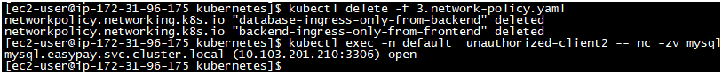

##############################################################################
############### Role Based Access Control RBAC ###############
##############################################################################
- Create the RBAC user : $ kubectl apply -f 4.rbac.yaml
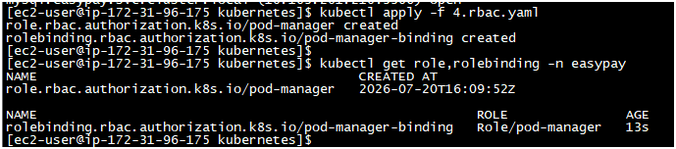
- Test the permissions using :
kubectl auth can-i list pods -n easypay --as=lab-user
kubectl auth can-i get pods -n easypay --as=lab-user
kubectl auth can-i update pods -n easypay --as=lab-user
kubectl auth can-i delete pods -n easypay --as=lab-user
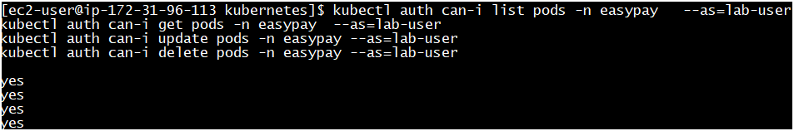
Since all these actions were allowed in yaml file, we should get YES as response.
- Test additional permissions which are not allowed in yaml :
kubectl auth can-i delete deployments -n easypay --as=lab-user
kubectl auth can-i get secrets -n easypay --as=lab-user
kubectl auth can-i get nodes --as=lab-user
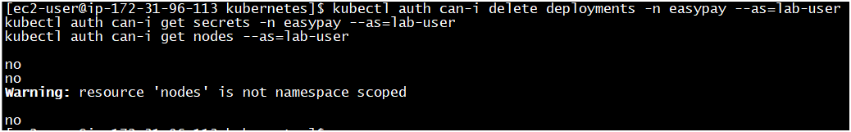
So this confirms any user/application with this role will have limited access on the pods

##############################################################################
############### Application UI And Testing The Flow ##############
##############################################################################
- Once the deployment is done via 1.application.yaml , we will have a Load balancer deployed which we can access from our browser since it’s a public Load Balancer ( Internet Facing)
kubectl get svc frontend -n easypay

You can add your name/email/balance and ADD CUSTOMER, this data will be forwarded to the backend flask application which will further store this information in mySql database.
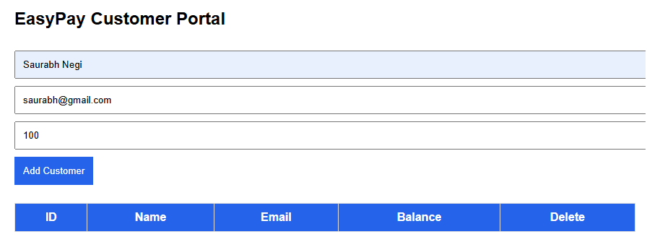

Browser
↓
AWS NLB
↓
Frontend Pod
↓ /database
Database Service
↓
Database Pod

##############################################################################
############### ETCD Snapshot ##############
##############################################################################

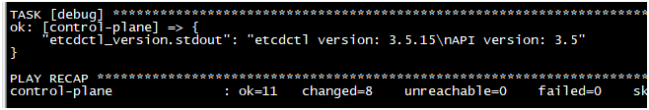
- To install ETCDCTL tool required for ETCD snapshot : $ ansible-playbook 5.etcdctl-install.yml
5. Take the etcd snapshot
- Commands to take the snapshot and verify the status are included in 5.etcd-snapshot.sh. You can this script in one go or command by command :
