PROJECT REPORT
Breast Cancer Diagnosis Classifier
A Machine Learning Approach to Tumor Classification Using the Wisconsin Diagnostic Breast Cancer Dataset
- Submitted by: SAURABH KUMAR PAL
- Institution / Course: CHANDIGARH GROUP OF COLLEGES JHANJERI,MOHALI,PUNJAB,140307
- Date: 24 September 2026

Table of Contents
1. Abstract 2
2. Introduction 2
3. Objectives 2
4. Dataset Description 3
5. Tools and Technologies 4
6. Methodology 4
7. Implementation 6
8. Results and Analysis 6
9. Discussion 8
10. Limitations 9
11. Future Work 9
12. Conclusion 9
13. References 10

1. Abstract
Early and accurate classification of breast tumors as malignant or benign is a central task in cancer screening. This project develops and evaluates a machine learning pipeline that predicts tumor malignancy from 30 numeric features computed from digitized images of fine needle aspirates, using the Wisconsin Diagnostic Breast Cancer (WDBC) dataset of 569 samples.
Four classifiers (Logistic Regression, Support Vector Machine, Random Forest, and Gradient Boosting) were compared using stratified 5-fold cross-validation with ROC-AUC as the selection metric. Preprocessing was placed inside a scikit-learn Pipeline to prevent data leakage. The best model, a tuned Logistic Regression, achieved 98.2% accuracy and a ROC-AUC of 0.995 on a held-out test set of 114 samples, misclassifying only two cases: one false negative and one false positive.
The report describes the dataset, methodology, implementation, results, and limitations, and discusses why results on this clean benchmark should not be interpreted as clinical performance.

2. Introduction

2.1 Background
Breast cancer is one of the most common cancers worldwide, and outcomes depend strongly on how early it is detected. Fine needle aspiration (FNA) is a minimally invasive procedure in which a small sample of cells is drawn from a breast mass and examined under a microscope. Measuring the size, shape, and texture of the cell nuclei in these images provides quantitative evidence that can help distinguish malignant from benign masses.
Machine learning can learn patterns in such measurements and provide a fast, consistent second opinion. Because the input is a small table of numeric features rather than raw images, the problem is well suited to classical supervised learning algorithms.

2.2 Problem Statement
Given 30 numeric measurements describing the cell nuclei of a breast mass, predict whether the mass is malignant or benign. This is a binary classification problem on tabular data.

2.3 Motivation
Beyond the medical setting, this problem is an ideal vehicle for demonstrating good machine learning practice: a small, clean dataset makes the effect of methodological choices (leakage prevention, validation strategy, metric selection, interpretability) easy to observe and explain.

3. Objectives
- Build an end-to-end, reproducible classification pipeline using scikit-learn.
- Compare several algorithms fairly using cross-validation on the training data only.
- Prevent data leakage by keeping all preprocessing inside the modeling pipeline.
- Tune the best-performing model and evaluate it once on an untouched test set.
- Interpret the model using permutation feature importance.
- Persist the trained pipeline so it can be reused for inference.

4. Dataset Description

4.1 Source
The project uses the Wisconsin Diagnostic Breast Cancer (WDBC) dataset from the UCI Machine Learning Repository, distributed with scikit-learn through the load_breast_cancer function. The features were computed from digitized images of fine needle aspirates of breast masses and describe characteristics of the visible cell nuclei (Street, Wolberg & Mangasarian, 1993).
Table 1: Dataset summary
Property | Value
Number of samples | 569
Number of features | 30 (all numeric)
Target variable | Binary: 0 = malignant, 1 = benign
Malignant samples | 212 (37.3%)
Benign samples | 357 (62.7%)
Missing values | None

4.2 Features
Ten base measurements were computed for each nucleus. For each, three statistics are provided: the mean, the standard error, and the worst value (the mean of the three largest values). This yields 10 x 3 = 30 features.
Table 2: Base measurements computed for each cell nucleus
Measurement | Description
Radius | Mean distance from the center to points on the perimeter
Texture | Standard deviation of gray-scale values
Perimeter | Length of the nucleus boundary
Area | Area of the nucleus
Smoothness | Local variation in radius lengths
Compactness | Perimeter squared divided by area, minus 1.0
Concavity | Severity of concave portions of the contour
Concave points | Number of concave portions of the contour
Symmetry | Symmetry of the nucleus shape
Fractal dimension | Coastline approximation minus 1

4.3 Data Characteristics
- Mild class imbalance: about 63% benign versus 37% malignant, so stratified splitting is used.
- Strong feature correlation: radius, perimeter, and area of the same nucleus are almost perfectly correlated.
- Different feature scales: area is in the hundreds or thousands while smoothness is near 0.1, so scale-sensitive models require standardization.
- No missing values: no imputation was needed.

5. Tools and Technologies
Table 3: Software used
Tool | Purpose
Python 3 | Programming language
scikit-learn | Models, pipelines, cross-validation, grid search, metrics, permutation importance
pandas | Data handling and summaries
Matplotlib | Confusion matrix, ROC curve, and importance plots
joblib | Saving and loading the trained pipeline

6. Methodology
The workflow follows the sequence shown below. The test set is used exactly once, at the end, so that the final metrics are an honest estimate of performance on unseen data.
- Load the data and inspect class balance and missing values.
- Split into training (80%) and test (20%) sets with stratification.
- Compare four models with 5-fold stratified cross-validation on the training set.
- Select the best model by mean ROC-AUC and tune it with grid search.
- Evaluate the tuned model once on the held-out test set.
- Compute permutation feature importance and save the model.

6.1 Train-Test Split
The data was split 80/20 using stratified sampling with a fixed random seed (42), producing 455 training samples and 114 test samples. Stratification keeps the malignant/benign ratio the same in both sets; the test set contains 42 malignant and 72 benign cases.

6.2 Preventing Data Leakage
Each model is wrapped in a scikit-learn Pipeline. If the whole training set were standardized before cross-validation, information from each validation fold would leak into the scaler's mean and variance, producing slightly optimistic scores. Placing the scaler inside the pipeline ensures it is re-fit on only the training portion of every fold.
Pipeline([
("scale", StandardScaler()),
("clf", LogisticRegression(max_iter=1000, random_state=42)),
])

6.3 Models Compared
Table 4: Candidate models and rationale
Model | Scaling | Rationale
Logistic Regression | Yes | Simple, fast, interpretable linear baseline
SVM (RBF kernel) | Yes | Strong on small, scaled tabular data; non-linear boundary
Random Forest | No | Bagged decision trees; robust with little tuning
Gradient Boosting | No | Sequential trees; often best on tabular data

6.4 Validation Strategy and Metric
Models were compared with 5-fold stratified cross-validation (with shuffling). The selection metric was ROC-AUC, which measures how well a model ranks malignant cases above benign ones across all decision thresholds. It is independent of the arbitrary 0.5 cutoff and is far less affected by class imbalance than accuracy (Fawcett, 2006).

6.5 Hyperparameter Tuning
The winning model was tuned with GridSearchCV using the same cross-validation folds. The search grid for each candidate is listed below; only the grid of the selected model was executed.
Table 5: Hyperparameter grids
Model | Parameters searched
Logistic Regression | C in {0.01, 0.1, 1, 10, 100}
SVM (RBF) | C in {0.1, 1, 10, 100}; gamma in {scale, 0.01, 0.001}
Random Forest | n_estimators in {100, 300}; max_depth in {None, 5, 10}; min_samples_leaf in {1, 3}
Gradient Boosting | n_estimators in {100, 200}; learning_rate in {0.05, 0.1}; max_depth in {2, 3}

6.6 Evaluation Metrics
On the test set, the model is assessed with precision, recall, and F1-score for each class, the confusion matrix, and the ROC curve with its AUC. In a screening context, a false negative (a malignant tumor predicted benign) is more costly than a false positive, so recall on the malignant class is especially important.

6.7 Interpretability
Permutation importance shuffles one feature at a time on the test set and measures the resulting drop in ROC-AUC. It is model-agnostic and reflects what the model relies on for generalization (Fisher, Rudin & Dominici, 2019). Because many features are highly correlated, importance is spread across correlated groups, so individual scores appear small.

7. Implementation
The complete solution is a single Python script, cancer_classifier.py, organized into small functions that mirror the methodology. All random processes use a fixed seed so that results are reproducible.
Table 6: Main functions in cancer_classifier.py
Function | Responsibility
load_data() | Loads the dataset and prints class balance and missing values
compare_models() | Cross-validates the four pipelines and returns the best
tune_model() | Runs grid search on the winning model
evaluate() | Prints the classification report; saves confusion matrix and ROC plots
feature_importance() | Computes permutation importance and saves the plot
save_and_predict() | Saves the pipeline with joblib and runs a sample prediction
main() | Orchestrates the full workflow

The script produces three artifacts: evaluation.png (confusion matrix and ROC curve), feature_importance.png (top ten features), and cancer_model.joblib (the trained pipeline containing both the scaler and the classifier, so new data can be passed in without manual preprocessing).

8. Results and Analysis

8.1 Model Comparison
Table 7 reports the mean and standard deviation of ROC-AUC across the five cross-validation folds for each candidate model.
Table 7: Cross-validated ROC-AUC on the training set
Model | Mean ROC-AUC | Std. Dev.
Logistic Regression | 0.9959 | 0.0050
SVM (RBF) | 0.9956 | 0.0048
Gradient Boosting | 0.9920 | 0.0052
Random Forest | 0.9894 | 0.0086

All four models perform very well. The gap between the top two models (0.0003) is far smaller than the fold-to-fold standard deviation, so they are effectively tied. Logistic Regression was selected because it had the highest mean score and is the simplest and most interpretable option.

8.2 Hyperparameter Tuning
Grid search over the regularization strength C selected C = 1 with a cross-validated ROC-AUC of 0.9959, identical to the untuned baseline. Tuning therefore provided no measurable gain, which is common when a well-scaled linear model is already close to the ceiling on a clean dataset.

8.3 Test Set Performance
The tuned model was evaluated once on the 114 held-out samples.
Table 8: Classification report on the test set
Class | Precision | Recall | F1-score | Support
Malignant | 0.976 | 0.976 | 0.976 | 42
Benign | 0.986 | 0.986 | 0.986 | 72
Accuracy |  |  | 0.982 | 114

The model reached an accuracy of 98.2% (112 of 114 correct) and a ROC-AUC of 0.9954. Using a 95% Wilson interval, the accuracy is estimated to lie between about 93.8% and 99.5%, which reflects the small size of the test set.
Table 9: Confusion matrix on the test set
 | Predicted malignant | Predicted benign
Actually malignant | 41 (true positive) | 1 (false negative)
Actually benign | 1 (false positive) | 71 (true negative)

The model missed one malignant tumor (recall of 41/42 = 97.6%, 95% interval roughly 87.7% to 99.6%) and raised one false alarm on a benign tumor.
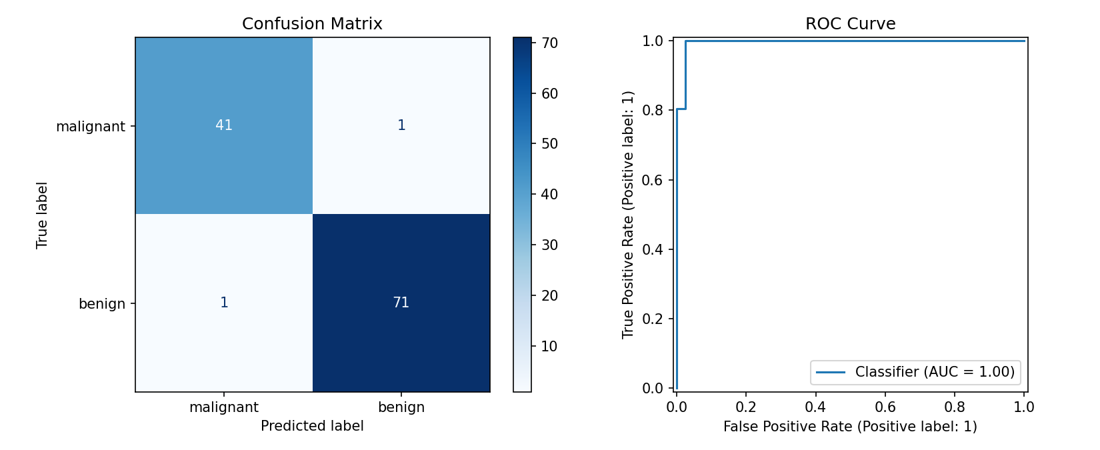
Figure 1: Confusion matrix (left) and ROC curve (right) on the held-out test set

8.4 Feature Importance
Table 10: Top 10 features by permutation importance (drop in ROC-AUC)
Rank | Feature | Importance
1 | worst smoothness | 0.0036
2 | worst concave points | 0.0033
3 | area error | 0.0033
4 | radius error | 0.0032
5 | worst area | 0.0029
6 | worst radius | 0.0028
7 | worst texture | 0.0026
8 | worst perimeter | 0.0020
9 | mean concave points | 0.0019
10 | worst concavity | 0.0018

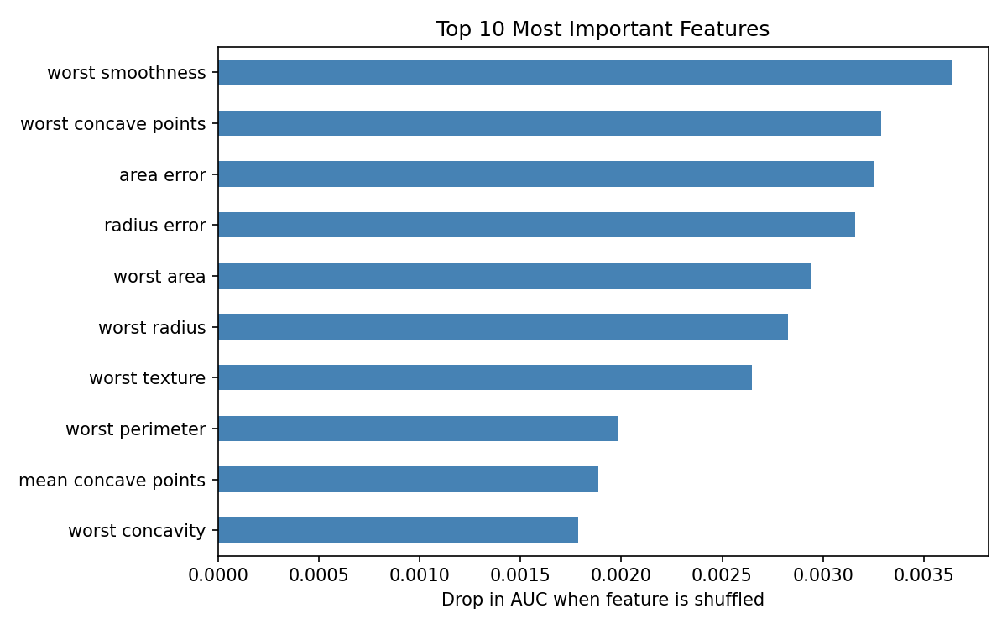
Figure 2: Top 10 features ranked by permutation importance
Seven of the top ten features are "worst" statistics, which describe the most extreme nuclei in a sample. This agrees with the intuition that the most abnormal cells are the most diagnostic. The importance values are small and close together because correlated features (for example radius, perimeter, and area) compensate for one another when one is shuffled.

9. Discussion
- Simple models are competitive. A regularized linear model matched or beat more complex ensembles, showing that a strong baseline should always come first.
- Methodology matters more than model choice. Stratified splitting, leakage-free pipelines, and a single final test evaluation account for the trustworthiness of the reported numbers.
- Error type matters more than accuracy. The single false negative is the costliest kind of mistake in screening. Lowering the decision threshold on malignant probability would trade a few extra false alarms for higher malignant recall.
- Importance scores need context. With correlated features, low individual importance does not imply low relevance; groups of related features carry the signal together.

10. Limitations
- Small test set: with 114 samples, one or two errors visibly change the metrics; the true accuracy could plausibly be anywhere from about 94% to 99.5%.
- Unusually clean dataset: real clinical data contains missing values, label noise, and distribution shift, so performance would likely be lower.
- Single split: the final result comes from one train-test split; repeating with multiple seeds or using nested cross-validation would give a more robust estimate.
- No external validation: the model was not tested on data from a different hospital, device, or population.
- No calibration or fairness analysis: predicted probabilities were not checked for calibration, and performance across patient subgroups was not assessed.
- Not a clinical tool: the system has not been clinically validated or approved and must not be used for real diagnosis.

11. Future Work
- Add SHAP values to explain individual predictions.
- Tune the decision threshold to prioritize malignant recall, selecting it via cross-validated predictions.
- Evaluate additional models such as XGBoost, LightGBM, or a small neural network.
- Assess probability calibration and add calibration curves.
- Deploy the model behind a FastAPI service or a Streamlit interface.
- Add unit tests and continuous integration with GitHub Actions.
- Test on a more challenging, imbalanced, real-world dataset.

12. Conclusion
This project built a complete, reproducible machine learning pipeline for classifying breast tumors as malignant or benign. Four algorithms were compared with stratified cross-validation, and a tuned Logistic Regression model reached 98.2% test accuracy and a ROC-AUC of 0.995, with only one false negative and one false positive on 114 unseen samples.
The main lessons are methodological: begin with a simple baseline, keep preprocessing inside the pipeline to avoid leakage, select models on training data only, touch the test set once, and interpret results with an awareness of sample size and data quality. While the scores are excellent, they come from a small and unusually clean benchmark, and the system is an educational demonstration rather than a diagnostic tool.

13. References
- Street, W. N., Wolberg, W. H., & Mangasarian, O. L. (1993). Nuclear feature extraction for breast tumor diagnosis. IS&T/SPIE International Symposium on Electronic Imaging: Science and Technology, 1905, 861-870.
- Dua, D., & Graff, C. (2019). UCI Machine Learning Repository. University of California, Irvine, School of Information and Computer Sciences. https://archive.ics.uci.edu/ml
- Pedregosa, F., et al. (2011). Scikit-learn: Machine learning in Python. Journal of Machine Learning Research, 12, 2825-2830.
- Fawcett, T. (2006). An introduction to ROC analysis. Pattern Recognition Letters, 27(8), 861-874.
- Fisher, A., Rudin, C., & Dominici, F. (2019). All models are wrong, but many are useful: Learning a variable's importance by studying an entire class of prediction models simultaneously. Journal of Machine Learning Research, 20(177), 1-81.
- Breiman, L. (2001). Random forests. Machine Learning, 45(1), 5-32.
- Friedman, J. H. (2001). Greedy function approximation: A gradient boosting machine. Annals of Statistics, 29(5), 1189-1232.
- Cortes, C., & Vapnik, V. (1995). Support-vector networks. Machine Learning, 20(3), 273-297.

