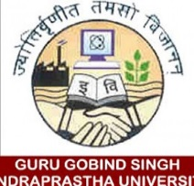

**GURU GOBIND SINGH INDRAPRASTHA UNIVERSITY**

**Sector - 16C Dwarka, Delhi – 110078**

DATE: 27-09-2013

This is to certify that Mr. SAURABH KUMAR is a student of UNIVERSITY SCHOOL OF INFORMATION AND COMMUNICATION TECHNOLOGY (Indraprashtha University, Delhi) pursuing 3 years post-graduation course of MASTER OF COMPUTER APPLICATION – SOFTWARE ENGINEERING (MCA-SE) for the session 2013 – 2016 with enrollment number – 06216404513.

REGISTRAR

GURU GOBIND SINGH INDRAPRASTHA UNIVERSITY, DELHI