**TRAINING SESSIONS**

Banks use our software ‘**REVAL TS’** to offer their corporate customers the following features:

* Cash management methods.
* Physical and Notional Pooling.
* Interest enhancements.
* Reports.

**Reval TS Customers:**

S:\mv\marketing\Marktforschung\Kunden\Kundenprofile\Commerzbank AG\Images\logo_neu_300dpi.jpg



C:\Users\moh\Desktop\logo_rbz.gif



C:\Users\moh\Desktop\helaba_logo.png







**Cash Pooling System Workflow:**

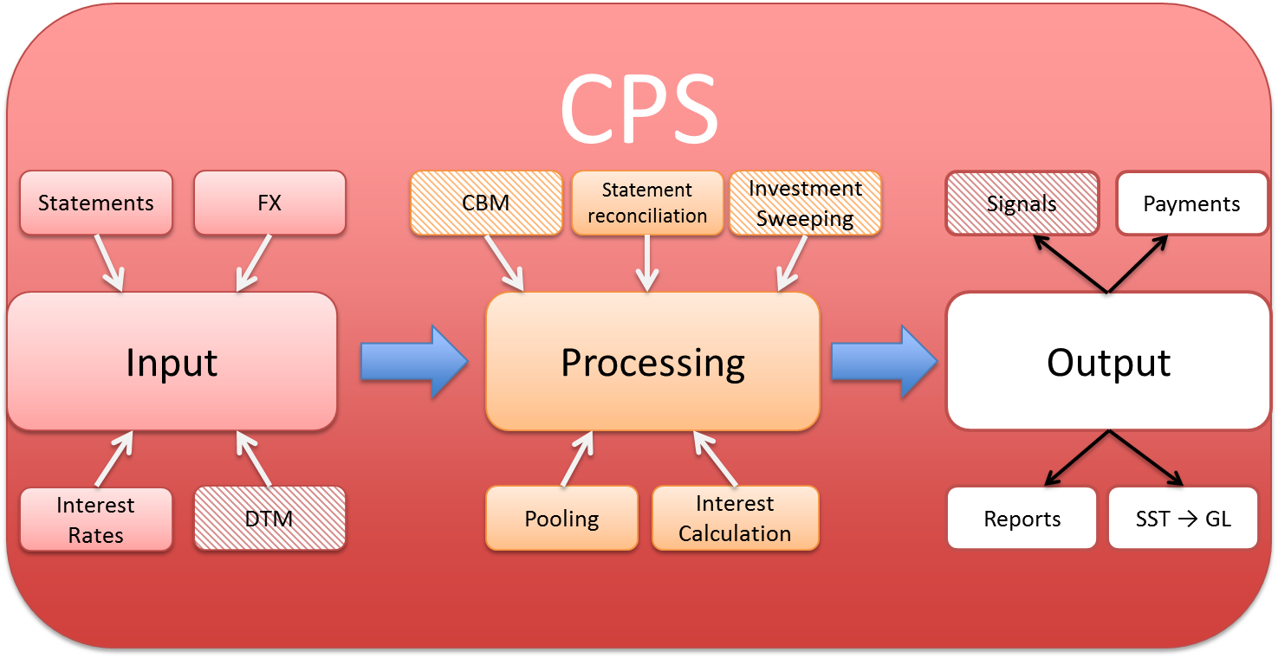

In Reval, the following terms mean the same and depends on the client.

Cash Pooling system => Treasury Services => Reval Inside => Cash Pooling Engine => Liquidity Centre (LQC) for Union Bank => For customer specific name, S2BL.

**Banking Basics:**

* IBAN = International Bank Account Number.
* BIC = Bank Identifier Code.
* SWIFT = Society for Worldwide Interbank Financial Telecommunication. (to get information into the system).

The Society for Worldwide Interbank Financial Telecommunication (SWIFT) provides a network that enables financial institutions worldwide to send and receive information about financial transactions in a secure, standardized and reliable environment. SWIFT also sells software and services to financial institutions, much of it for use on the SWIFTNet Network, and ISO 9362. Business Identifier Codes (BICs, previously Bank Identifier Codes) are popularly known as "SWIFT codes".

* ISO = International Standardization Organization.
* SEPA = Single Euro Payments Area.

The Single Euro Payments Area (SEPA) is a payment-integration initiative of the European Union for simplification of bank transfers denominated in euro.

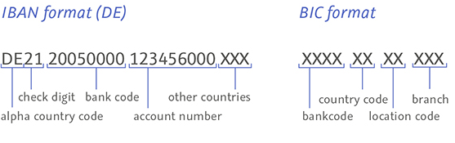

SWIFT Message Types:

ISO 15022MT (Message Type).

ISO 20022MX (Message XML).

**Banking Basics:**

Debtor

Definition: One who owes a debt or the performance of an obligation to another.

Creditor

Definition: An individual to whom an obligation is owed because he or she has given something of value in exchange.

**Commercial Bank**

* A Commercial Bank is a financial institution providing services (such as accepting deposits, giving business loans and auto loans) for businesses, organizations and individuals.
* Services include offering current, deposit and saving accounts, credit cards, ATMs, as well as giving out loans to corporate and private clients.
* A commercial bank is defined as a bank whose main business is deposit-taking and making loans.

**Investment Bank**

* An investment bank is a financial institution that assists individuals, corporations, and governments in raising financial capital by underwriting or acting as the client's agent in the issuance of securities.
* Main business is securities underwriting, M&A advisory (Mergers and Acquisitions), asset management and securities trading.
* Securities underwriting refers to the process by which investment banks raise investment capital from investors on behalf of corporations and governments that are issuing securities.

**Universal Banks**

* An Universal Bank covers both commercial and investment banking activities.
* Typical business model of banks in Europe.
* Example Deutsche.

**Central Bank**

* A central bank is a public institution that manages the currency of a country or group of countries and controls the money supply.
* One of the main tools of any central bank is setting interest rates.
* A central bank is not a commercial bank.
* It does act as a bank for the commercial banks.
* Commercial banks can turn to a central bank to borrow money, usually to cover very short-term needs.

**European System Of Central Banks**

* European Central Bank (ECB) and the national central banks (NCB) of the EU Member States whose currency is the euro constitute the Eurosystem, the central banking system of the € area.
* European System of Central Banks (ESCB) = ECB and the NCBs of all EU Member States whether the currency is € or not.
* Distinction between the Eurosystem and the ESCB:
  + European System of Central Banks

The ESCB comprises the ECB and the national central banks (NCBs) of all EU Member States whether they have adopted the euro or not.

* + Eurosystem

The Eurosystem comprises the ECB and the NCBs of those countries that have adopted the euro. The Eurosystem and the ESCB will co-exist as long as there are EU Member States outside the euro area.

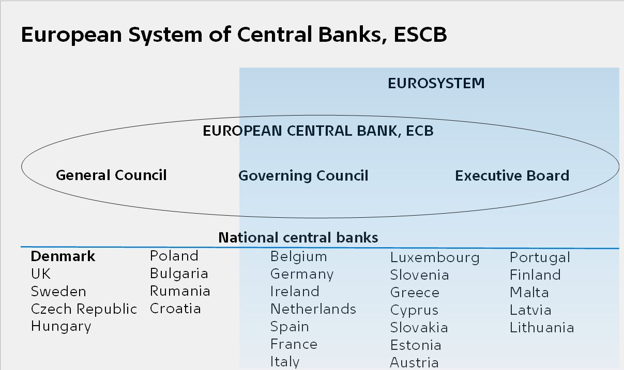

ECB is responsible for:

* Price stability of the Eurosystem - safeguarding the value of the €, Exchange rate stability responsibility.
* Safety and soundness of the banking system and the stability of the financial system within the EU and each participating Member State.
* ESCB shall support the general economic policies in the European Union with a view to contributing to the achievement of the objectives of the Union.

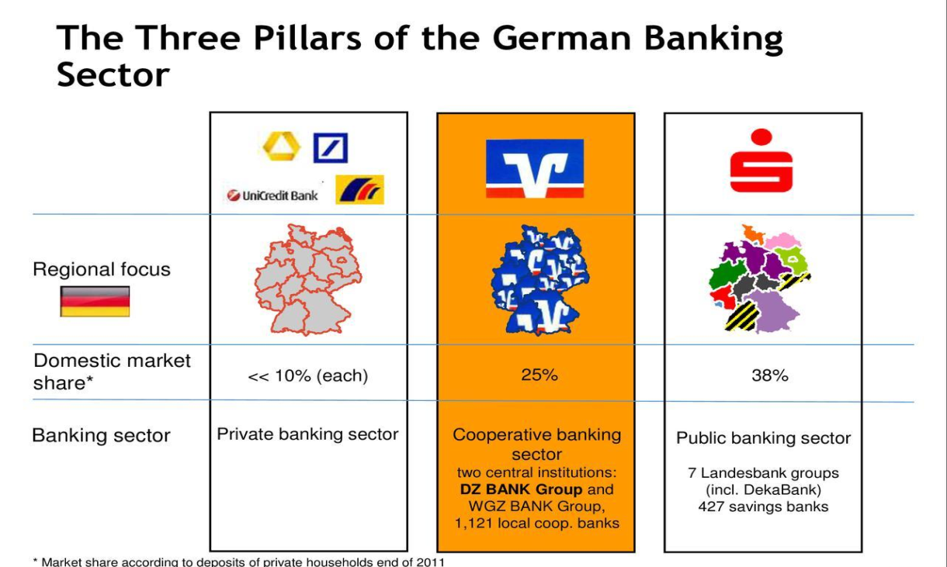

* **Public bank** is a bank, a financial institution, in which a state or public actors are the owners. It is a company under state control.
* **Cooperative banking** is retail and commercial banking organized on a cooperative basis. Cooperative banking institutions take deposits and lend money in most parts of the world.
* **Private banks** are banks owned by either an individual or a general partner(s) with limited partner(s). Private banks are not incorporated. In any such case, the creditors can look to both the "entirety of the bank's assets" as well as the entirety of the sole-proprietor's/general-partners' assets.

**INDIAN BANKS**

are categorised into five different groups according to their ownership and/or nature of operation:

* State Bank of India and its Associates
* Nationalised Banks
* Private Sector Banks
* Foreign Banks
* Regional Rural

The scheduled banks are those which are included under the 2nd Schedule of the Reserve Bank of India Act, 1934.

Commercial banks refer to both scheduled and non-scheduled commercial banks which are regulated under the Banking Regulation Act, 1949.

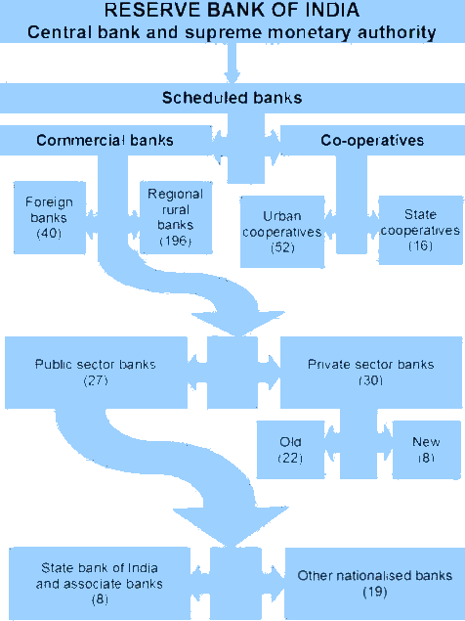

**Account Statements**

Definition: A record of transactions and their effect on account balances for a specific account over a specified period.

(Example)

* Opening balance.
* Debit and credit transactions.
* Closing balance.

**MT940 = End of day account statement**

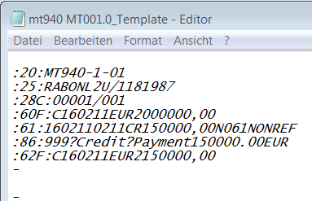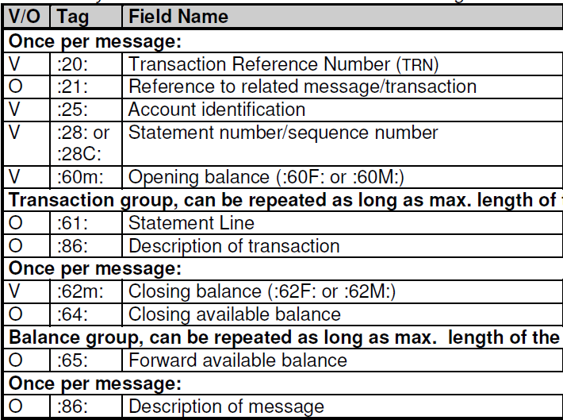

Field 61 - Important information for transaction

Format 6!n[4!n]2a[1!a]15d1!a3!c16x[//16x][34x]

* 6!n (Value Date)
* [4!n] (Entry Date)
* 2a (Debit/Credit Mark)
* [1!a] (Funds Code)
* 15d (Amount)
* 1!a3!c (Transaction Type)(Identification Code)
* 16x (Reference for the Account Owner)
* [//16x] (Reference of the Account Servicing Institution)
* [34x] (Supplementary Details)

**MT942 = Intraday account statement**

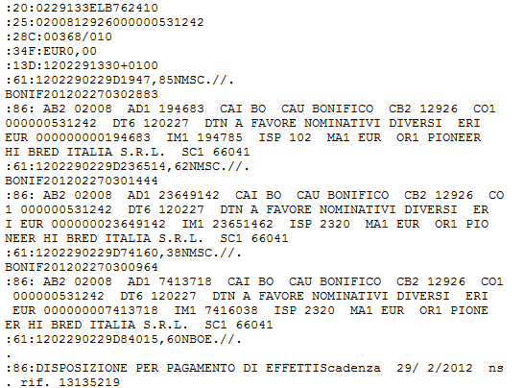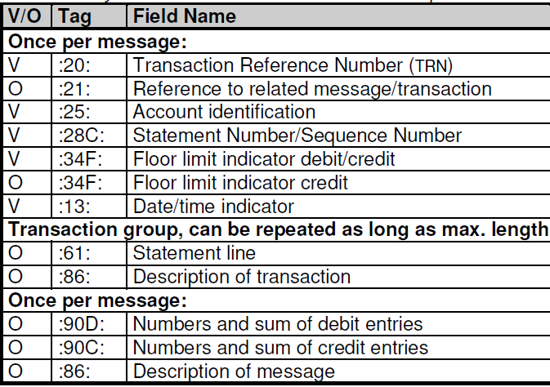

**Cash Pooling:**

Definition: A cash management technique aimed at improving liquidity management by pooling an organization's account balances.

* Holding – Subsidiary Structure
* Sweeping & Topping

Pooling methods: (Example Flip Chart)

* Target Balancing
* Settlement Pooling
* Zero Balancing

**Notional Pooling**

Definition: Notional pooling is a mechanism for calculating interest on the combined credit and debit balances of accounts between an Holding and their subsidiaries without effective transfers between the accounts.

Notional Pooling Details:

* Bonus on interest due to group of accounts.
* Interest settlement payments.

**Interest Rate**

Definition: Interest is the charge for the privilege of borrowing money, typically expressed as a percentage of principal (Interest Rate), by a lender to a borrower for the use of money.

* Key Interest Rates
* Interbank Rates

Key Interest Rates

Rate at which commercial banks can borrow money from the central banks.

Central banks announce Key Interest Rates:

* European Central Bank (ECB): Main Refinancing Rate 0%
* Bank of England: Repo Rate 0,5%
* Federal Reserve Bank (FED) USA: Federal Funds Rate 0,25-0,5%
* Reserve Bank of India (RBI): Policy Repo Rate 6,75%

Interbank Rates

The interbank rate is the rate of interest charged on short-term loans made between banks. Banks borrow and lend money in the interbank market.

Important Rates:

* London Interbank Offered Rate (LIBOR): -0,374% (1 week)
* European Interbank Offered Rate (EURIBOR): -0,354% (1 week)
* Euro OverNight Index Average (EONIA): -0,349%
* Mumbai Interbank Offered Rate (MIBOR):

**Foreign Exchange**

Foreign exchange is the exchange of one currency for another, or the conversion of one currency into another currency. Foreign exchange also refers to the global market where currencies are traded virtually around-the-clock.

The term foreign exchange is usually abbreviated as "forex" or "FX".

Quotation of foreign exchange rates:

* EUR/INR = 75,0980.
* INR/EUR = 0,0133.
* Value of 1 unit of foreign currency in domestic currency.
* EUR/INR = 75,0980 → 1€ is worth 75,0980 ₹ (€ = foreign currency, ₹ = domestic currency) .
* Bid Rate: Price to which an investor can sell the foreign currency, is always lower than the Ask Rate.
* Ask Rate: Price to which an investor can buy the foreign currency.

**Interest Calculation**

What is Interest?

Definition: Interest is the charge for the privilege of borrowing money, typically expressed as a percentage of principal (Interest rate), by a lender to a borrower for the use of money

**Payments**

* A payment is the transfer of one form of goods, service or financial asset in exchange for another form of good, service or financial asset in proportions that have been previously agreed upon by all parties involved. Payment can be made in the form of funds, assets or services.
* A delivery/transfer of money, or its equivalent in either specific property or services, by a debtor to a creditor.
* Payment formats
  + ISO20022
    - SEPA PAIN
  + SWIFT
    - MT101
    - MT103

**Business Intelligence**

BI is a technology-driven process for analyzing data and presenting actionable information to help corporate executives, managers and end users make more informed business decisions.

* collect data from internal systems and external sources.
* prepare it for analysis.
* develop and run queries against the data.
* create reports, dashboards and data visualizations.
* make the analytical results available to corporate decision makers as well as operational workers.

Reval Product is an example of BI.

**Reports**

A document containing information organized in a narrative, graphic, or tabular form, prepared on ad hoc, periodic, recurring, regular, or as required basis.

Reports may refer to specific periods, events, occurrences, or subjects.

Examples:

* Interest Reports
* Intercompany Account Reports
* Pooling Reports
* Management Reports
* Financial Reports

**User Interface**

Visual part of computer application or operating system through which a user interacts with a computer or a software. It determines how commands are given to the computer or the program and how information is displayed on the screen.

Reval TS = GUI Graphical User Interface.

**Login:**

Impossible to use administration to use a manual link. (Test Installation).

User Preferences can be found at Administration > Users & Authorizations > User Preferences.

Individual user settings:

* Set language
* Set separators
* Number of list entries
* Date format
* Change password

Screen Layout:

* Each list can be individualized by using filters and layouts
* Filters influence the number of rows
* Layouts define the displayed columns and the row order
* Data can be visualized by creating a diagram
* Save filter, layout and diagram templates
* Save multiple templates of each type
* Combine filter, layout and diagram to a favorite
* Lists are automatically split to multiple pages
* Easily navigate between pages
* Switch to next or previous page
* Directly jump to first or last page
* Type in desired page number directly
* Per default the system shows 50 lines per page
* Changeable in User Preferences

Filter:

Create a filter template by clicking on “Filter”

* Owner of the filter specifies who will be able to use it
* User: valid only for this user
* Group: valid for all users of this group
* Global: for ALL users
* Activate “Default” to set this filter as standard

Diagram:

* Select “diagram“ from column menu or choose  
  a template from the drop down list and click on  
  “Diagram” to open the diagram view.
* In order to create a diagram a list needs to have
* Grouped entries and
* Enabled calculation of any column
* Change diagram type
* Different variations of column,  
  line, pie, bars, area and ring  
  diagrams available
* Select a color template
* Edit diagram settings
* Various settings can be adjusted
* Change labeling, axis, scaling  
  and more general information
* Name the settings and save them as a template

Favorites:

* Combinations of filter, layout and diagram
* Click on „Favorites“
* Type a name and description

Print and Export:

* “Print“ opens the print option for the open data list

**Data Import & Export via DTM**

Data Transport Module:

* Transfer static data from Reval Instance A to Reval Instance B.
* Import static data from a CSV file to any Reval Instance.
* Import static data into a Template client and distribute them to a certain number of clients.

**File System**

**Containers and Services**

Container logic in Reval

* Principles
* Folder structure
* Container types
* Administration (ASP)
* Template (V01)
* Clients

Services

* Background
* Services
* Services in ASP
* Services in customer containers

What is a client/container?

* ASP:
* Template:
* Client:

Different client/container types

ASP: Central administration client

Template: Template of client container

Client: Represents for instance a SCB customer

Services:

Background Server is a scheduler to execute the jobs.

Each service or service chain runs within a specific unix process.

There are several unix processes running in parallel.

They do the entire work:

* Read files from interfaces or write files
* Read data from database or copy/write to database
* It processes and transform data
* Trigger other services to run

Services run as independent process.

* May be aborted manually from the GUI
* Record log files with detail level depending on log level
* Most services will generate an additional report (mailing list freely definable)

Services are executed by the background server.

Services are started at the following condition:

* Time triggered at a certain time
* Triggered by a previous service
* Started manually

**Service Configuration:**

* Each service uses a certain function
* Each function can execute a certain set of parameters
* Date formats need to be input like ccyy.mm.dd
* A service has a unique service number and is aligned to a client
* 10 parameter lines can be used for further configuration

**Function Types:**

* Permanent services running for the following functions:
* MON: Updates the monitors and triggers alerts
* POOL\_SRV: Triggers pooling calculation
* LOOP: a service with no immediate function; freely configurable. Mainly used to check for conditions ("start process if...")
* Special service functions
* DUMMY: test, whether background is active
* SYSTEM: start of external programs, scripts, etc…
* CHAIN: start of successive services in same container
* START, START\_SRV: start services in different containers
* Normal service functions
* CONVERT, BER, POOL, ZA, ZDZ, ZAVBS, BSS, BCS etc.
* Quick Overview Of Function Types
* CONVERT -> Transform Data
* START -> Starts other services
* BER -> Run Report and save result to database
* ZA -> Run Interest Calculation
* ZDZ -> Create Cash Transactions (CTAs) out of interest calc.
* ZAVBS -> Generate Payments
* BSS -> Read in bank statements, syntax check
* BCS -> Establish connection to the bank system
* TAX -> In end of day processing update balances, etc.
* K2S -> Create Interface File
* S2I -> Create Booking File for CORE bank system

Business processes like EOD or Prior Day processing are fulfilled by service chains

* Include all services required for the whole process
* One service subsequently triggers the next one
* Process chain ends after executing the last service in the chain

Use predefined global filters for better overview

**Overview service chains for ASP**

* US02000010 Starter for intra-day processing
* US02002010 Starter for post intra-day actions
* US03001000 Starter for CSL / DSR pre processing 3pm
* US03003000 Starter for CSL / DSR EOD processing 6pm
* US05000000 EOD processing
* US07000000 Prior day processing (BOFCUS)
* US06000000 Prior day processing (BOTKUS, TPBxxx)
* TPBXXX0000 Daily maintaining services (cleanups)

**Overview service chains for clients**

* TPBXXX0000 Daily maintaining services (cleanups)
* US02000000 Intra day processing
* US05000600 Daily end jobs
* US06000000 Prior day statement processing
* US07004000 Prior day interest calculation
* US07005000 Prior day book transfer and payment processing
* US07006000 Payment processing
* US05000000 EOD statement processing
* US05000200 EOD book transfer and payment processing

In “**Running Services**” check for

* Services that are active and running
* Services that have status “will be started”

In “**Completed Services**” check for all finished services

* Red Color: Aborted with Error
* Blue Color: Finished with Alerts
* Black: Finished without Errors
* Grey: Inactive

Error Handling and Analysis

* Check field “Result Info”
* Open Service (double-click) and check the  
  parameter that has been used
* Open “Log File” and search for terms
  + {ERROR }
  + {ALERT }

**DOUBTS**

* S2BL for which client and full form?
* Hotline feature?
* Book Date And Value Date?
* What parameters for calculating value date in a CTA?
* Modus parameter in service parameters?
* Report start and start-up?
* Favourites?
* Dashboard?
* Stress testing? Anything similar in india?
* CRR,SLR?
* EBA?
* IFRS?
* ICBS, SCB: Concept China?