Integrated Informatics
​The Integrated Informatics Hub works across the Analytics Organization to support improvement in clinical outcomes and care delivery by integrating datasets from health plan and delivery systems enabling a holistic view of health plan membership and the delivery system patient population. Working hand in hand with business and spoke analytics teams, Integrated Informatics utilizes advanced analytics such as natural language processing, artificial intelligence and machine learning to tackle key questions and resolve problems resulting in increased operational and financial efficiencies. This approach permits the proactive identification, stratification and segmentation of the Presbyterian Healthcare Services population which enables the development of appropriately targeted clinical programs.
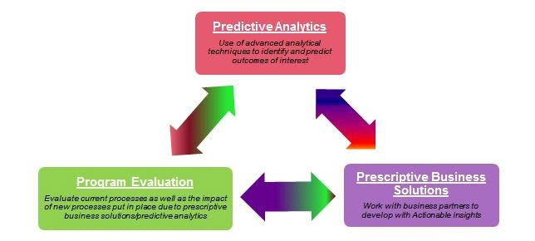
Integrated Informatics works with business partners to develop actionable insights effecting multifaceted aspects of the delivery system. Focused efforts have included the development of models demonstrating cost reduction, assessing provider performance, improving clinical conditions and prescriptive solutions for employer health programs. Programmatic evaluation allows monitoring the effectiveness of the predictive analytic approaches and is an integral component of the departments work.

Program Evaluation Dashboard:
Which is an Interactive application built using Streamlit, Pandas, and Plotly to enable data-driven insights from healthcare claims data. It allows users to explore key metrics such as cost, utilization, and product performance through predefined business prompts, along with dynamic filters, and respective visualizations.

Projects ongoing and pipeline:
  - AArete Automation - Automation of AArete Monthly reporting for Payment Integrity
  - Program Evaluation Automation - Program Evaluation of engaged and non-engaged members with match-scores
  - Outreach Dashboard - Centralized Outreach & Disease-Management, Engagement Rate
  - Mobile Health Dashboard - serves Health Plan Place and Population Health business users to understand membership, quality, and annual health wellness visit gaps and capture for the Health Plan Place defined catchment area.
  - Unite US Data Mapping - Mapping of various SDOH assessment questions for data mart
Key Project Delivered:
  - Member 360 – SAS Automation and Tableau dashboards to deliver the on-demand, comprehensive member-level view integrating claims, clinical, pharmacy, care management, SDOH, and predictive analytics data for intervention population identification and feasibility assessment.
  - Population Assessment - SAS Automation for population analytics and Tableau dashboard to provide high-level assessments by Line of Business, Group ID, and PMG/Non-PMG, enabling segmentation, cost/utilization profiling, and opportunity identification
  - PHP Health Equity Dashboard & PDS-PMG Health Equity Insights - SAS automation for equity analytics and Tableau dashboard to monitor priority quality and outcome measures, identifying demographic and SDOH disparities that inform equity-focused interventions
  - Outreach Dashboard - Automates outreach and disease-management tracking through SAS automation and Tableau dashboards, monitoring members identified, outreached, and engaged, as well as visit completion and pre/post utilization impacts
  - Healthy Solutions – Disease Management Outcomes - Automates the disease-management outcomes analytics using SAS automation and Tableau dashboard to evaluate engaged vs. not engaged members and pre- vs. post-intervention impacts across chronic condition programs ()
  - PHP Medicaid CISC Population - Automates the Medicaid population analytics, providing details into high-need members across demographics, cost, utilization, providers, SDOH, and care management to support prioritization and intervention planning
Value to PHP:
  - Automation that scales across LOB, Group ID, PMG/Non-PMG and multiple program dashboards without rebuilding logic each time.

