AZURE ENVIRONMENT ASSESSMENT
Contoso
Inventory, Well-Architected findings and remediation roadmap

Report date: 29 September 2026
Inventory export date: 2026-09-20
Inventory source: sample-inventory.csv
Subscriptions in scope: 3
Resources assessed: 152

Contents
Right-click and choose 'Update Field' to build the table of contents.

1. Executive summary
Overall posture score: 76/100 (Fair)
152  Resources | 3  Subscriptions | 23  Resource groups | 5  Regions
17  High findings | 73  Medium findings | 16  Low findings | 78%  Tag coverage

Contoso's Azure environment, comprising 152 resources across three subscriptions and five regions, has been assessed with a current overall posture score of 76/100, which is rated as Fair. This assessment reveals that while the estate demonstrates some robust practices in governance, it faces significant challenges in areas such as security, reliability, and cost optimization.
The most critical risks identified include storage accounts permitting HTTP access, allowing anonymous blob access, VMs being stopped but not deallocated, and web apps failing to enforce HTTPS. These issues pose a high risk of data exposure and unauthorized access, potentially compromising the integrity and confidentiality of sensitive information. Additionally, network security groups (NSGs) exposing management ports to the Internet and the presence of classic resources in use are also significant vulnerabilities that could be exploited by attackers.
On a more positive note, governance practices appear to be well-established, with 86% of the estate rated as Good. The tagging coverage is at 78%, ensuring that most resources have necessary metadata for effective management and compliance. Furthermore, the identified architecture patterns such as multi-region hub-and-spoke network topology, hybrid connectivity via Site-to-Site VPNs, and a federated logging approach with one workspace per subscription demonstrate a solid foundational structure.
The recommended priorities for remediation are structured according to the severity and impact of each issue. The first 30 days should focus on addressing high-risk items such as storage accounts permitting HTTP access, VMs not being deallocated properly, and web apps failing HTTPS enforcement. These actions will mitigate immediate security risks and reduce potential data breaches. Over the next 60 days, efforts should be directed towards resolving governance issues like missing required tags and ensuring that all resources are within approved regions. Finally, over the following 90 days, attention can turn to optimizing costs through measures such as managing unattached managed disks and upgrading storage replication methods.
By prioritizing these remediation steps, Contoso can significantly enhance its Azure environment's security posture, reliability, and cost efficiency, thereby protecting critical business assets and ensuring long-term operational resilience.
AI-drafted narrative, grounded in the assessment facts (see 2. Scope and methodology).

Key observations
- 152 resources were assessed across 3 subscription(s), 23 resource groups and 5 region(s).
- Architecture at a glance: network topology is multi-region hub-and-spoke with exceptions; hybrid connectivity is site-to-site VPN to on-premises; subscription model is landing-zone style: platform and workload subscriptions, split by environment.
- 106 finding(s) were raised: 17 high, 73 medium and 16 low severity, affecting 78 resources.
- Security is the weakest area (score 68/100); Governance is the strongest (86/100).
- 78% of resources carry all required tags (environment, owner, costCenter).
- Priority high-severity issues: Storage account permits HTTP (4); Storage account allows anonymous blob access (4); VM stopped but not deallocated (4).

Scorecard
Pillar | Score | Rating | Checks | Findings | High | Medium | Low
Security | 68 | Fair | 51 | 16 | 12 | 4 | 0
Reliability | 75 | Fair | 64 | 21 | 0 | 15 | 6
Cost Optimization | 78 | Fair | 92 | 19 | 4 | 12 | 3
Operational Excellence | 73 | Fair | 26 | 7 | 0 | 0 | 7
Governance | 86 | Good | 305 | 43 | 1 | 42 | 0

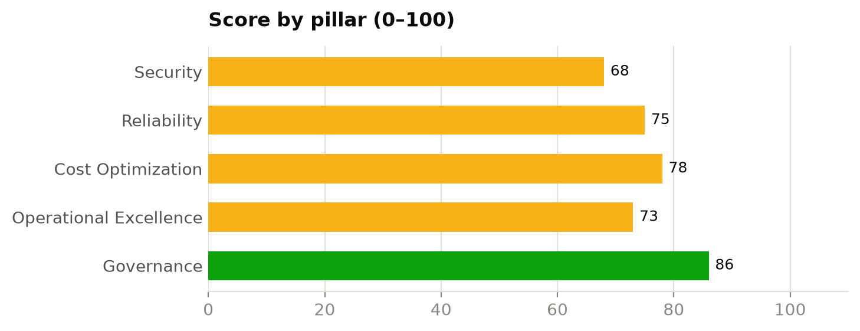

2. Scope and methodology
The assessment is based on the resource inventory export supplied by Contoso (sample-inventory.csv). No access to the Azure environment was required. Each resource was evaluated against a rule set aligned to the Microsoft Azure Well-Architected Framework pillars (Security, Reliability, Cost Optimization, Operational Excellence) plus a Governance pillar covering tagging, regions and deployment model.
Pillar scores are the severity-weighted pass rate of all rule evaluations in that pillar (High = 5, Medium = 3, Low = 1). 80+ is rated Good, 60–79 Fair, and below 60 Poor.
Subscription | Subscription ID | Resources
Contoso-Production | 11111111-1111-1111-1111-111111111111 | 77
Contoso-NonProduction | 22222222-2222-2222-2222-222222222222 | 54
Contoso-Connectivity | 33333333-3333-3333-3333-333333333333 | 21

Use of AI in this report
Narrative marked as AI-drafted was written by the open-source language model qwen2.5:7b-instruct from the verified facts produced by the assessment engine; the model was given those facts only, not the inventory itself. Every figure and rule ID in the drafted text was checked against those facts, and any passage that failed the check uses the standard wording. Scores, findings and tables are not AI-generated.

3. Architecture assessment
This section identifies the architecture patterns the environment follows, such as its network topology, hybrid connectivity and subscription model, and compares them with Microsoft's reference architectures (the Cloud Adoption Framework Azure landing zone and the Well-Architected Framework). Each area states the pattern identified, the evidence for it in the inventory, and considerations.
Confidence shows how firmly the inventory supports each conclusion: High means direct configuration evidence, Medium means inferred from resource types and naming, Low means the export lacked the data. Identity (Microsoft Entra ID), role assignments, Azure Policy and management groups are not part of a resource inventory and are outside the scope of this section.
Architecture at a glance
Area | Pattern identified | Confidence
3.1 Network topology | Multi-region hub-and-spoke with exceptions | High
3.2 Hybrid connectivity | Site-to-site VPN to on-premises | High
3.3 Traffic flow and perimeter security | Defence in depth (central firewall, WAF-protected ingress, private endpoints for PaaS, Bastion for admin access) | High
3.4 Subscription and landing zone model | Landing-zone style: platform and workload subscriptions, split by environment | Medium
3.5 Application hosting architecture | Hybrid IaaS/PaaS, three-tier (web, application, data) | Medium
3.6 Resilience and disaster recovery | Multi-region, but not in Azure region pairs; no DR replication evidence | Medium
3.7 Operations and monitoring | Federated logging (one workspace per subscription) | Medium

3.1 Network topology
Pattern identified: Multi-region hub-and-spoke with exceptions (confidence: High)
The network topology at Contoso follows a multi-region hub-and-spoke pattern, with high confidence in the evidence provided. This design centralises shared services such as Azure Bastion, Firewall, and VPN gateway within regional hubs (vnet-hub-eastus and vnet-hub-westeurope), facilitating centralized management and security inspection. However, there are notable deviations from the Microsoft Cloud Adoption Framework's landing zone and Well-Architected Framework recommendations.
Direct peerings between spokes, such as those between vnet-prd-eastus and vnet-dev-eastus, bypass the central firewall, allowing un-inspected outbound traffic. Additionally, vnet-dev-sandbox is not peered to any network, creating an isolated environment that may expose it to unnecessary public access. These gaps could potentially undermine the security benefits of a hub-and-spoke architecture by allowing workloads in different regions and environments to communicate without central inspection or management.
To align with best practices, direct spoke-to-spoke peerings should be removed, routing all traffic through the hubs for consistent inspection. Furthermore, ensuring that vnet-dev-eastus routes 0.0.0.0/0 to the hub firewall will enforce comprehensive security measures on all outbound traffic. Lastly, a decision must be made regarding whether to integrate vnet-dev-sandbox into the main network or decommission it, as unmanaged networks can introduce additional risk and complexity.
AI-drafted narrative, grounded in the assessment facts (see 2. Scope and methodology).
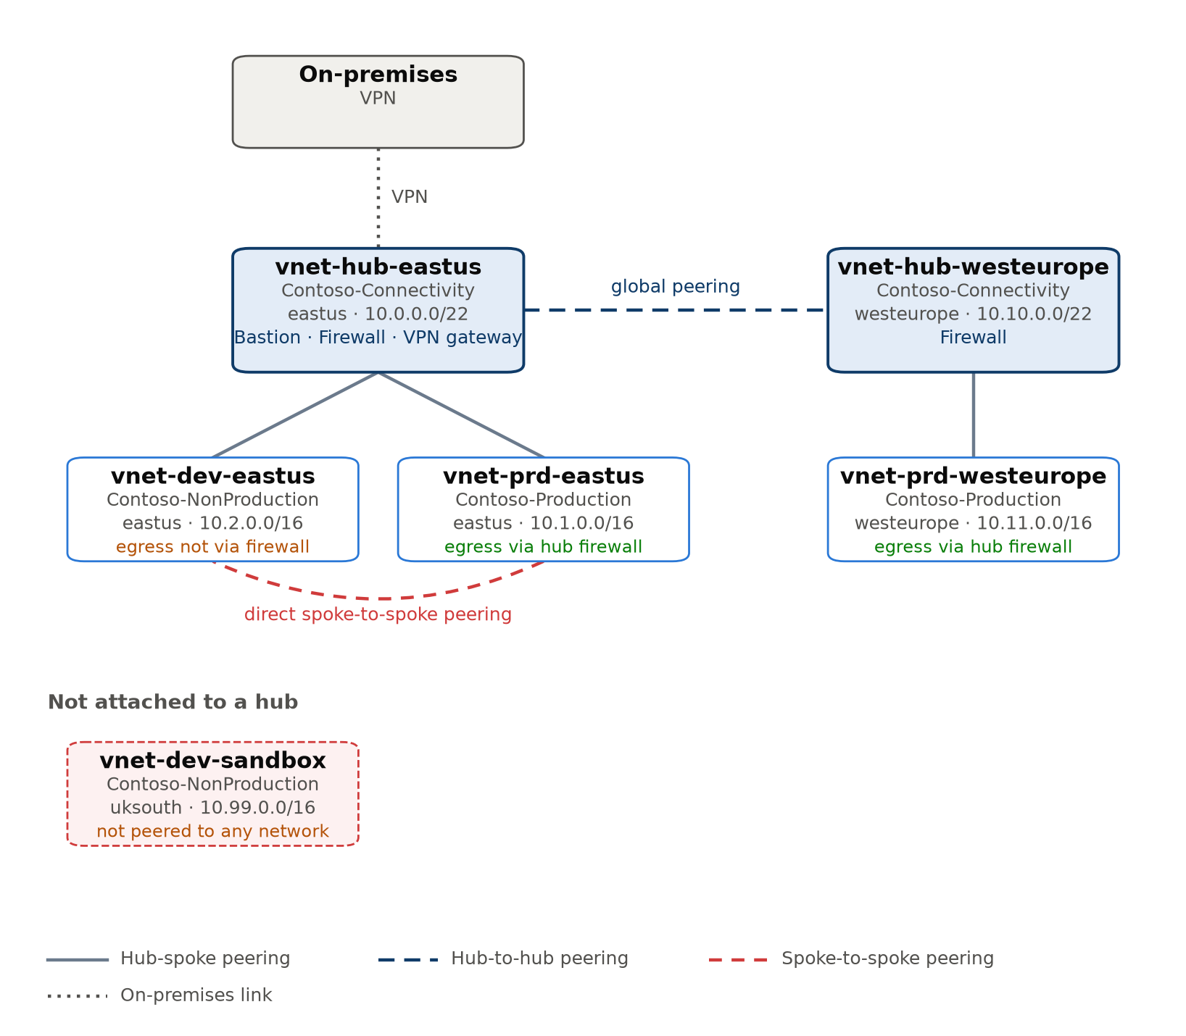
Figure: network topology derived from VNet peerings (Multi-region hub-and-spoke with exceptions).
Evidence from the inventory
- Hub vnet-hub-eastus (eastus, Contoso-Connectivity): address space 10.0.0.0/22; services: Azure Bastion, Azure Firewall and VPN gateway; spokes: vnet-prd-eastus and vnet-dev-eastus.
- Hub vnet-hub-westeurope (westeurope, Contoso-Connectivity): address space 10.10.0.0/22; services: Azure Firewall; spokes: vnet-prd-westeurope.
- Spokes vnet-prd-eastus and vnet-prd-westeurope send Internet-bound traffic to the hub firewall through a 0.0.0.0/0 route. vnet-dev-eastus has no such route, so its outbound traffic bypasses central inspection.
- vnet-prd-eastus (Contoso-Production) is peered directly with vnet-dev-eastus (Contoso-NonProduction), bypassing the hub.
- vnet-dev-sandbox (uksouth, Contoso-NonProduction) is not peered to any network.
Virtual networks
VNet | Role | Subscription | Region | Address space | Peered with | Default route via firewall
vnet-hub-eastus | Hub | Contoso-Connectivity | eastus | 10.0.0.0/22 | vnet-dev-eastus, vnet-hub-westeurope, vnet-prd-eastus | -
vnet-hub-westeurope | Hub | Contoso-Connectivity | westeurope | 10.10.0.0/22 | vnet-hub-eastus, vnet-prd-westeurope | -
vnet-dev-eastus | Spoke | Contoso-NonProduction | eastus | 10.2.0.0/16 | vnet-hub-eastus, vnet-prd-eastus | No
vnet-prd-eastus | Spoke | Contoso-Production | eastus | 10.1.0.0/16 | vnet-dev-eastus, vnet-hub-eastus | Yes
vnet-prd-westeurope | Spoke | Contoso-Production | westeurope | 10.11.0.0/16 | vnet-hub-westeurope | Yes
vnet-dev-sandbox | Isolated | Contoso-NonProduction | uksouth | 10.99.0.0/16 | - | No

Considerations against the reference architecture
- Remove direct spoke-to-spoke peerings and route that traffic through the hub firewall, particularly between production and non-production (Contoso-NonProduction and Contoso-Production).
- Add a user-defined route (0.0.0.0/0 to the hub firewall) to vnet-dev-eastus so all egress is inspected.
- Decide whether vnet-dev-sandbox should join the hub or be removed; unmanaged islands tend to accumulate public exposure.
Related findings
- SEC-007 NSG exposes management ports to the Internet: High, 2 resources (see 6.1 Security)

3.2 Hybrid connectivity
Pattern identified: Site-to-site VPN to on-premises (confidence: High)
The current architecture employs a site-to-site VPN to connect on-premises infrastructure, adhering to the recommended shared-gateway design. The evidence is high, as indicated by the presence of vgw-hub-eastus, which is configured with a VpnGw2AZ SKU and operates in an active-standby mode within vnet-hub-eastus. This setup ensures redundancy and reliability for the connection.
However, there are gaps when compared to the Microsoft reference architecture. The current design only includes a gateway in the eastus region, while spokes in westeurope rely on cross-region connectivity through the hub gateway. If the eastus region becomes unavailable, this could disrupt on-premises connectivity. To mitigate this risk, it is recommended to deploy additional gateways in each regional hub, ensuring that all regions can independently establish a connection to on-premises sites.
Additionally, the current setup relies solely on IPsec tunnels over the Internet for production workloads, which may introduce latency and bandwidth limitations. For critical applications, leveraging ExpressRoute with a VPN as a backup could provide more robust connectivity options, enhancing both performance and reliability. Configuring the gateways in an active-active mode would also reduce the risk of single points of failure by ensuring that two on-premises devices can maintain the connection simultaneously.
In practice, these gaps imply potential vulnerabilities to regional outages and limitations in network performance for mission-critical workloads. Addressing these issues through additional gateway deployments and enhanced connectivity options will strengthen the overall hybrid environment's resilience and efficiency.
AI-drafted narrative, grounded in the assessment facts (see 2. Scope and methodology).
Evidence from the inventory
- vgw-hub-eastus: Vpn gateway, SKU VpnGw2AZ, zone-redundant, active-standby, deployed in vnet-hub-eastus.
- lng-onprem-dc1: on-premises site at 203.0.113.10 advertising 192.168.0.0/16.
- cn-hub-eastus-to-dc1: IPsec connection, status Connected.
Considerations against the reference architecture
- Only eastus has a gateway; spokes in westeurope reach on-premises across regions, and lose on-premises connectivity if that region is unavailable. Add a gateway in each regional hub.
- A single VPN tunnel runs over the Internet; for production workloads with latency or bandwidth needs, consider ExpressRoute with VPN as backup.
- Configure VPN gateways as active-active with two on-premises devices to remove a single point of failure.

3.3 Traffic flow and perimeter security
Pattern identified: Defence in depth (central firewall, WAF-protected ingress, private endpoints for PaaS, Bastion for admin access) (confidence: High)
The identified pattern of Defence in Depth for traffic flow and perimeter security at Contoso closely aligns with the principles outlined in both the Cloud Adoption Framework (CAF) Landing Zone and the Well-Architected Framework. The central firewall, WAF-protected ingress, private endpoints for PaaS services, and Bastion for administrative access demonstrate a robust approach to securing network traffic.
However, there are notable gaps that indicate areas for improvement. Specifically, some Network Security Groups (NSGs) still allow RDP or SSH from the Internet, which contradicts the use of Azure Bastion. This leaves potential vulnerabilities in place, as Internet-sourced connections bypass the intended security measures. Additionally, while 15 PaaS services accept public network traffic, only two currently utilise private endpoints, indicating a need for broader implementation.
To align more closely with best practices, it is recommended to remove any existing Internet-sourced RDP/SSH rules and extend private endpoint usage across all relevant services. Implementing DDoS Network Protection where appropriate will further enhance the security posture of internet-facing workloads. These actions are critical to ensuring a comprehensive Defence in Depth strategy that minimises exposure to potential threats, thereby protecting both data integrity and system availability.
AI-drafted narrative, grounded in the assessment facts (see 2. Scope and methodology).
Evidence from the inventory
- Web application firewall: agw-prd-eastus.
- DDoS Network Protection plan: none.
Considerations against the reference architecture
- Remove Internet-sourced RDP/SSH rules now that Bastion is available.
- Extend private endpoints to the remaining PaaS services and disable their public network access (stprddata00, stprddata01, stprddata02, stprddata03, stprddata04 and kv-prd-00 …).
- Consider DDoS Network Protection for virtual networks with Internet-facing workloads.
Related findings
- SEC-007 NSG exposes management ports to the Internet: High, 2 resources (see 6.1 Security)
- SEC-005 SQL server reachable from public networks: Medium, 1 resource (see 6.1 Security)
- SEC-002 Storage account allows anonymous blob access: High, 4 resources (see 6.1 Security)
- SEC-006 Web app does not enforce HTTPS: High, 2 resources (see 6.1 Security)

3.4 Subscription and landing zone model
Pattern identified: Landing-zone style: platform and workload subscriptions, split by environment (confidence: Medium)
The identified subscription and landing zone model follows a platform and workload separation, with three distinct subscriptions: Contoso-Connectivity (platform), Contoso-NonProduction (workload), and Contoso-Production (workload). This pattern is consistent with the Cloud Adoption Framework's recommendation for separating shared services from application workloads. However, there are notable gaps compared to the Microsoft reference architecture.
Firstly, the absence of a dedicated management subscription means that central logging, automation, and backup functionalities are dispersed across multiple subscriptions—specifically, Log Analytics workspaces reside in both non-production and production environments. This could lead to inconsistencies in monitoring and governance practices, as these functions should ideally be centralized for easier management and compliance.
Secondly, there is no identified identity subscription, which suggests that domain controllers or other identity services may not be properly isolated. According to the reference architecture, isolating such critical components in a dedicated subscription enhances security and simplifies administrative tasks.
Lastly, while the subscriptions are structured according to the landing zone model, management groups, Azure Policy assignments, and role-based access controls (RBAC) are not documented within this inventory. This oversight means that governance and compliance checks need to be conducted separately to ensure alignment with best practices outlined in the Well-Architected Framework.
These gaps imply potential challenges in maintaining a cohesive and secure environment, particularly around centralized management and identity services. Addressing these areas will help Contoso achieve a more robust and compliant Azure architecture.
AI-drafted narrative, grounded in the assessment facts (see 2. Scope and methodology).
Subscription roles
Subscription | Inferred role | Resources | Main resource types
Contoso-Connectivity | Platform: connectivity | 21 | Public IP addresses (6), Network security groups (4), Virtual networks (2)
Contoso-NonProduction | Workload: non-production | 54 | Managed disks (14), Virtual machines (10), Network interfaces (10)
Contoso-Production | Workload: production | 77 | Managed disks (20), Virtual machines (14), Network interfaces (14)

Considerations against the reference architecture
- There is no dedicated management subscription; Log Analytics workspaces sit in Contoso-NonProduction and Contoso-Production. The landing zone model places central logging, automation and backup in a management subscription.
- No identity subscription was found. If domain controllers or identity services run in Azure, isolate them in a dedicated identity subscription.
- Management groups, Azure Policy assignments and RBAC are not part of a resource inventory; review them separately to confirm the landing zone governance.

3.5 Application hosting architecture
Pattern identified: Hybrid IaaS/PaaS, three-tier (web, application, data) (confidence: Medium)
The application hosting architecture at Contoso employs a hybrid Infrastructure as a Service (IaaS) and Platform as a Service (PaaS) model, with a three-tier design comprising the presentation, application, and data tiers. This pattern is identified with medium confidence based on the inventory evidence provided.
Comparing this to Microsoft’s Cloud Adoption Framework landing zone and Well-Architected Framework, we observe that while the current architecture effectively separates concerns into distinct tiers, there are opportunities for improvement. Specifically, the absence of VM scale sets means that stateless components such as web apps do not benefit from automatic scaling capabilities, which could lead to underutilization or over-provisioning during peak loads. Additionally, several workloads hosted on IaaS virtual machines present operational overhead in terms of patch management and availability maintenance. Reevaluating these components for potential replatforming to PaaS services like App Service, Azure SQL Database, or Kubernetes (AKS) could streamline operations and reduce the burden on IT staff.
In practice, failing to leverage scale sets and other managed services may result in suboptimal resource utilization and increased operational costs. For instance, the identified gaps in VM sizing, deallocation of stopped instances, and consolidation of App Service plans highlight areas where automation and optimization can be further enhanced. Addressing these issues will not only improve cost efficiency but also align more closely with Microsoft’s best practices for a robust and scalable cloud architecture.
AI-drafted narrative, grounded in the assessment facts (see 2. Scope and methodology).
Evidence from the inventory
- Virtual machines: 24; scale sets: 0; AKS clusters: 0; web apps: 8; function apps: 0; databases and caches: 8.
Considerations against the reference architecture
- No VM scale sets are used, so VM capacity does not scale automatically. Stateless tiers are good candidates for scale sets or App Service.
- Review VM-hosted components for replatforming to PaaS (App Service, Azure SQL, AKS) to reduce operational overhead.
Related findings
- OPS-001 Previous-generation VM size: Low, 5 resources (see 6.4 Operational Excellence)
- COST-003 VM stopped but not deallocated: High, 4 resources (see 6.3 Cost Optimization)
- COST-005 Empty App Service plan: Medium, 2 resources (see 6.3 Cost Optimization)

3.6 Resilience and disaster recovery
Pattern identified: Multi-region, but not in Azure region pairs; no DR replication evidence (confidence: Medium)
The resilience and disaster recovery (RDR) pattern identified in the environment is multi-region, but not within Azure region pairs. This configuration provides a basic level of redundancy across four regions—eastus, westeurope, uksouth, and centralindia—but lacks data replication mechanisms necessary for effective disaster recovery. The confidence in this assessment is medium based on the available evidence.
Compared to the Microsoft reference architecture outlined by the Cloud Adoption Framework (CAF) landing zone and Well-Architected Framework, several gaps are evident. Firstly, there is no deployment of Recovery Services vaults or Azure Backup solutions, which would be critical for protecting VMs and databases. Secondly, while some workloads use availability zones, this is not consistently applied across all resources, and there is no defined disaster recovery strategy or tested failover plans.
In practice, these gaps mean that the environment's ability to recover from regional outages or disasters is limited. Without proper data replication and backup strategies, significant downtime could occur if a region fails. The absence of Recovery Services vaults also leaves critical workloads unprotected against data loss. Implementing these recommendations would enhance the overall resilience and ensure business continuity in the event of unforeseen disruptions.
AI-drafted narrative, grounded in the assessment facts (see 2. Scope and methodology).
Considerations against the reference architecture
- Deploy Recovery Services vaults and back up VMs and databases; define RPO/RTO per workload.
- Decide the DR strategy per workload (active/active, active/passive or backup-and-restore), then replicate data and test failover.
- Place production VMs across availability zones (or use zone-redundant scale sets) to survive a datacenter failure.
Related findings
- REL-001 VM has no zone or availability set: Medium, 15 resources (see 6.2 Reliability)
- REL-003 Storage account uses locally redundant replication: Low, 3 resources (see 6.2 Reliability)
- REL-004 SQL database not zone redundant: Low, 3 resources (see 6.2 Reliability)

3.7 Operations and monitoring
Pattern identified: Federated logging (one workspace per subscription) (confidence: Medium)
The identified pattern of federated logging, with one workspace per subscription (log-prd-01 in Contoso-Production and log-dev-01 in Contoso-NonProduction), simplifies access control by environment but complicates cross-environment monitoring. This approach aligns partially with the Cloud Adoption Framework's landing zone model, which recommends a central workspace in the management subscription for centralized visibility. However, it diverges from this recommendation as each workload environment maintains its own workspace. The absence of a dedicated workspace for Contoso-Connectivity further exacerbates this gap.
The current setup makes it challenging to achieve a unified security view and cross-environment analytics, which are critical for comprehensive operational monitoring and incident response. This could lead to fragmented insights and increased complexity in managing security and compliance across environments. The low severity of the OPS-002 finding related to Log Analytics retention underscores the importance of addressing these gaps to ensure that all resources meet audit and investigative requirements effectively.
AI-drafted narrative, grounded in the assessment facts (see 2. Scope and methodology).
Considerations against the reference architecture
- The landing zone model recommends a central workspace in the management subscription, with resource-context access for workload teams.
Related findings
- OPS-002 Log Analytics retention below target: Low, 2 resources (see 6.4 Operational Excellence)

4. Infrastructure overview
This section describes the environment as understood from the inventory export: what it contains, how it is organised and how each area is configured. Each part ends with the findings that relate to it, so the description can be read alongside the findings in section 6 and the roadmap in section 7.

4.1 Estate at a glance
The estate comprises 152 Azure resources distributed across three subscriptions and 23 resource groups, with deployments in five regions. The primary region, eastus, hosts 49% of the total resources, followed by westeurope (27%), uksouth (18%), and a smaller presence in centralindia (5%). This regional distribution suggests a balanced approach to ensure geographical redundancy and local compliance requirements.
From a functional perspective, compute and networking dominate at 38% each, indicating a focus on scalable infrastructure. The significant number of managed disks (34) and virtual machines (24) supports this, highlighting the use of IaaS for core operations. However, the presence of classic resources (1%) and legacy application services (8%) could pose maintenance challenges and security risks, as these are generally less secure and harder to manage compared to modern Azure services.
The high proportion of managed disks and virtual machines also implies a robust infrastructure capable of handling significant workloads, which is beneficial for operational resilience. However, the mixed hosting model, with both IaaS and some classic resources, may introduce complexity in management and could benefit from consolidation into more modern, secure services to streamline operations and enhance security posture.
AI-drafted narrative, grounded in the assessment facts (see 2. Scope and methodology).
Resources by functional area
Area | Resources | % of estate | Main resource types
Compute | 58 | 38% | Managed disks (34), Virtual machines (24)
Networking | 57 | 38% | Network interfaces (24), Network security groups (7), Virtual networks (6)
Application hosting | 12 | 8% | App Services (8), App Service plans (4)
Storage | 10 | 7% | Storage accounts (10)
Databases | 8 | 5% | SQL databases (6), SQL servers (2)
Security services | 4 | 3% | Key vaults (4)
Monitoring and management | 2 | 1% | Log Analytics workspaces (2)
Classic (legacy) resources | 1 | 1% | Classic cloud services (1)

4.2 Subscriptions and resource organisation
The infrastructure is organised into three distinct Azure subscriptions: Contoso-Production, Contoso-NonProduction, and Contoso-Connectivity. This separation helps in managing different environments—production, development, and connectivity-related resources—separately. On average, each resource group contains 6.6 resources, with the largest groups being rg-prd-app01 (19), rg-dev-app01 (13), and rg-prd-app02 (12).
The Contoso-Production subscription houses 77 resources across nine resource groups in four regions, primarily focusing on managed disks, virtual machines, and network interfaces. This setup ensures that critical production workloads are well-segregated from development environments, enhancing security and operational resilience. Similarly, the Contoso-NonProduction environment contains 54 resources, mainly comprising similar types of infrastructure but tagged for development purposes.
The Contoso-Connectivity subscription, with its 21 resources across four resource groups in three regions, manages network-related services such as public IP addresses, network security groups, and virtual networks. This separation is crucial for maintaining a clear distinction between application and connectivity resources, which can improve overall network security and management efficiency.
This structured organisation supports better governance, easier compliance checks, and improved operational visibility, ensuring that the business can manage costs more effectively while maintaining robust security and resilience across its environments.
AI-drafted narrative, grounded in the assessment facts (see 2. Scope and methodology).
- Contoso-Production: 77 resources in 9 resource groups across 4 regions (centralindia, eastus, uksouth and westeurope). It mainly contains managed disks (20), virtual machines (14) and network interfaces (14). Resources are tagged as environment 'prod'.
- Contoso-NonProduction: 54 resources in 10 resource groups across 4 regions (centralindia, eastus, uksouth and westeurope). It mainly contains managed disks (14), virtual machines (10) and network interfaces (10). Resources are tagged as environment 'dev'.
- Contoso-Connectivity: 21 resources in 4 resource groups across 3 regions (eastus, global and westeurope). It mainly contains public IP addresses (6), network security groups (4) and virtual networks (2). Resources are tagged as environment 'shared'.
Subscription summary
Subscription | Resources | Resource groups | Regions | Main resource types
Contoso-Production | 77 | 9 | centralindia, eastus, uksouth, westeurope | Managed disks (20), Virtual machines (14), Network interfaces (14)
Contoso-NonProduction | 54 | 10 | centralindia, eastus, uksouth, westeurope | Managed disks (14), Virtual machines (10), Network interfaces (10)
Contoso-Connectivity | 21 | 4 | eastus, global, westeurope | Public IP addresses (6), Network security groups (4), Virtual networks (2)

4.3 Regional footprint
The regional footprint of the environment spans five regions: eastus, westeurope, uksouth, centralindia, and a global region. While deploying resources across multiple regions provides an opportunity for regional resilience, only three of these—eastus, westeurope, and uksouth—are officially approved. The remaining 8 out-of-policy resources are located in the centralindia region.
This configuration introduces both benefits and challenges. From a security perspective, having resources distributed across different geopolitical boundaries can enhance compliance with local data sovereignty regulations. However, it also increases complexity in managing and securing these resources independently. For resilience, deploying workloads only in approved regions means that regional failures could impact operations if not properly failover-capable.
The presence of 8 out-of-policy resources (GOV-002) highlights a potential risk to governance and operational efficiency. These resources may be subject to additional regulatory scrutiny or compliance issues, which could affect the overall security posture. Additionally, maintaining these non-compliant regions incurs unnecessary costs and complicates management efforts.
To mitigate these risks, it is recommended to apply the 'Allowed locations' policy as per GOV-002 and plan for the migration of out-of-policy resources into approved regions. This will streamline governance, enhance security, and potentially reduce operational overhead.
AI-drafted narrative, grounded in the assessment facts (see 2. Scope and methodology).
Resources by region
Region | Resources | % of estate | Main areas
eastus | 74 | 49% | Networking (32), Compute (25), Application hosting (7)
westeurope | 41 | 27% | Compute (14), Networking (14), Storage (5)
uksouth | 27 | 18% | Compute (15), Networking (8), Databases (2)
centralindia | 8 | 5% | Compute (4), Storage (2), Networking (1)
global | 2 | 1% | Networking (2)

Related findings
- GOV-002 Resource outside approved regions: Medium, 8 resources (see 6.5 Governance)

4.4 Compute
The compute environment consists of 24 virtual machines (VMs) distributed across two Azure subscriptions and four regions, with a mix of Linux (20 VMs) and Windows (4 VMs). The majority of the VM sizes are D-series v5 (13), E-series v5 (4), and A-series v2 (3), with specific common sizes including Standard_D2s_v5 (9), Standard_E8s_v5 (4), and Standard_D4s_v5 (4).
From a security and resilience perspective, 79% of the VMs are currently running, while one is deallocated and four are stopped but still allocated. This means that these stopped VMs continue to incur costs, which could be optimized by deallocating them or scheduling an auto-shutdown as per COST-003 and COST-004 recommendations.
Resilience is another critical aspect; 9 VMs are pinned to availability zones, providing a level of fault tolerance. However, the remaining 15 VMs lack both zone and availability-set protection, meaning they depend on a single host or datacenter for redundancy. This configuration could pose a risk in case of regional outages (REL-001). Deploying these VMs across multiple zones or into an availability set would enhance resilience.
Cost optimization is also a key area; 15 VMs are not utilizing the latest generation SKUs, which may offer better price-performance (OPS-001). Additionally, there are 10 unattached managed disks that are still billed but unused, suggesting potential savings through deletion or snapshotting and subsequent removal as recommended by COST-001.
Overall, while the current setup meets basic operational needs, improvements in resilience, cost management, and VM sizing can significantly enhance both security and efficiency.
AI-drafted narrative, grounded in the assessment facts (see 2. Scope and methodology).
Virtual machines by size
VM size | Series | Count
Standard_D2s_v5 | D-series v5 | 9
Standard_E8s_v5 | E-series v5 | 4
Standard_D4s_v5 | D-series v5 | 4
Standard_A2_v2 | A-series v2 | 3
Standard_DS2_v2 | DS-series v2 | 2
Standard_B2ms | B-series | 2

Related findings
- REL-001 VM has no zone or availability set: Medium, 15 resources (see 6.2 Reliability)
- COST-003 VM stopped but not deallocated: High, 4 resources (see 6.3 Cost Optimization)
- COST-004 Deallocated VM: Low, 1 resource (see 6.3 Cost Optimization)
- COST-001 Unattached managed disk: Medium, 10 resources (see 6.3 Cost Optimization)
- OPS-001 Previous-generation VM size: Low, 5 resources (see 6.4 Operational Excellence)

4.5 Networking
The networking infrastructure at Contoso comprises 57 resources, including network interfaces, security groups, virtual networks, and load balancers. This setup supports a distributed environment with six virtual networks across regions such as eastus, uksouth, and westeurope, bolstered by two Azure Firewalls for enhanced security. Traffic filtering is managed through seven Network Security Groups (NSGs) that collectively apply 9 custom rules, though some NSGs inadvertently expose management ports to the Internet, posing a significant security risk (SEC-007). Additionally, six public IP addresses are allocated, with two remaining unassociated and thus unused, indicating potential cost inefficiencies (COST-002).
From a security perspective, exposing management ports to the Internet can lead to unauthorized access attempts. Implementing Azure Bastion or Just-in-Time VM access would mitigate this risk by restricting direct internet access to critical services. Regarding resilience, while the current setup is robust, ensuring proper network topology and connectivity between virtual networks will be crucial for maintaining service availability across regions.
Cost-wise, releasing unassociated public IP addresses can help Contoso reduce unnecessary expenses without impacting operational needs. Overall, optimizing these networking elements will enhance both security and cost efficiency, aligning with broader IT strategy goals.
AI-drafted narrative, grounded in the assessment facts (see 2. Scope and methodology).
Network resources
Resource type | Count | Regions
Network interfaces | 24 | centralindia, eastus, uksouth, westeurope
Network security groups | 7 | eastus, westeurope
Virtual networks | 6 | eastus, uksouth, westeurope
Public IP addresses | 6 | eastus, westeurope
Azure Firewalls | 2 | eastus, westeurope
routetables | 2 | eastus, westeurope
privateendpoints | 2 | eastus
privatednszones | 2 | global
virtualnetworkgateways | 1 | eastus
localnetworkgateways | 1 | eastus
connections | 1 | eastus
bastionhosts | 1 | eastus
Application gateways | 1 | eastus
Load balancers | 1 | eastus

Related findings
- SEC-007 NSG exposes management ports to the Internet: High, 2 resources (see 6.1 Security)
- COST-002 Unassociated public IP address: Low, 2 resources (see 6.3 Cost Optimization)

4.6 Storage
The infrastructure comprises 10 storage accounts, all of the StorageV2 type. Replication strategies vary: four use GRS (Geo-redundant replication), three employ LRS (Locally redundant replication), and another three utilise ZRS (Zone-redundant replication). This setup ensures that data is replicated within a single region for local redundancy, while also providing an additional copy in a paired region with GRS. ZRS offers enhanced resilience by replicating data across availability zones.
From a security perspective, four accounts permit HTTP traffic, which could expose sensitive data to potential threats (SEC-001). Enforcing HTTPS is recommended to ensure secure data transfer. Additionally, four storage accounts allow anonymous blob access, potentially compromising data integrity and confidentiality (SEC-002), and two accept TLS versions lower than 1.2, leaving them vulnerable to certain types of cyberattacks (SEC-003). Implementing TLS 1.2 or higher is advised.
Regarding reliability, three out of ten storage accounts use LRS, which offers minimal resilience within a single datacenter (REL-003). For critical production data that requires regional redundancy and availability, switching to ZRS or GZRS would be beneficial. This change aligns with the need for enhanced disaster recovery capabilities and reduced risk of data loss due to localized outages.
AI-drafted narrative, grounded in the assessment facts (see 2. Scope and methodology).
Storage accounts
Account | Subscription | Replication | HTTPS only | Min TLS | Anonymous blob access
stdevdata00 | Contoso-NonProduction | Standard_GRS | Yes | TLS1_2 | Allowed
stdevdata01 | Contoso-NonProduction | Standard_GRS | No | TLS1_2 | Allowed
stdevdata02 | Contoso-NonProduction | Standard_LRS | Yes | TLS1_0 | Blocked
stdevdata03 | Contoso-NonProduction | Standard_ZRS | No | TLS1_2 | Blocked
stdevdata04 | Contoso-NonProduction | Standard_GRS | Yes | TLS1_0 | Blocked
stprddata00 | Contoso-Production | Standard_LRS | Yes | TLS1_2 | Blocked
stprddata01 | Contoso-Production | Standard_GRS | Yes | TLS1_2 | Blocked
stprddata02 | Contoso-Production | Standard_ZRS | Yes | TLS1_2 | Allowed
stprddata03 | Contoso-Production | Standard_ZRS | No | TLS1_2 | Blocked
stprddata04 | Contoso-Production | Standard_LRS | No | TLS1_2 | Allowed

Related findings
- SEC-001 Storage account permits HTTP: High, 4 resources (see 6.1 Security)
- SEC-002 Storage account allows anonymous blob access: High, 4 resources (see 6.1 Security)
- SEC-003 Storage account accepts TLS < 1.2: Medium, 2 resources (see 6.1 Security)
- REL-003 Storage account uses locally redundant replication: Low, 3 resources (see 6.2 Reliability)

4.7 Databases
The database environment at Contoso currently employs Azure SQL, with 2 logical servers hosting a total of six databases across different service tiers: S1 (3), Basic (2), and GP_Gen5_2 (1). This setup indicates a mix of performance levels, where the S1 tier is likely used for more transactional workloads, while the Basic tier may be allocated to less demanding tasks. The single database on the GP_Gen5_2 tier suggests it might handle higher-performance requirements.
From a security perspective, one logical server (sql-dev-01) allows public network access, which poses a medium-severity risk as identified by SEC-005. This configuration could expose these databases to potential unauthorized access or attacks from the internet. The recommendation is to disable public network access and connect through Private Endpoints for enhanced security.
In terms of resilience, only one out of six databases (REL-004) benefits from zone redundancy, indicating a low-severity risk. Zone redundancy ensures that if an Azure region fails, data can still be accessed from another zone within the same region. Given this finding, it is advisable to enable zone redundancy on all business-critical databases to improve overall reliability and avoid potential downtime.
AI-drafted narrative, grounded in the assessment facts (see 2. Scope and methodology).
Related findings
- SEC-005 SQL server reachable from public networks: Medium, 1 resource (see 6.1 Security)
- REL-004 SQL database not zone redundant: Low, 3 resources (see 6.2 Reliability)

4.8 Application hosting
Application hosting in the environment is configured to use Azure App Service, with eight web applications distributed across four different pricing tiers: two P1v3 plans, one S1 plan, and one B1 plan. Six of these apps enforce HTTPS-only access, enhancing security by preventing data interception over HTTP connections.
However, there are implications for both security and cost management. The enforcement of HTTPS on six out of eight applications indicates a proactive stance towards securing web traffic, which is crucial to protect sensitive information from eavesdropping. Nonetheless, two App Service plans (asp-dev-00 and asp-dev-01) host no active apps but still incur charges, highlighting inefficiencies in resource utilization.
According to the findings, SEC-006 identifies that two of eight evaluated resources do not enforce HTTPS-only access, suggesting a potential vulnerability. COST-005 points out that these empty App Service plans are unnecessary and should be deleted or consolidated with active plans (Rule ID: COST-005), which could lead to significant cost savings without compromising functionality.
AI-drafted narrative, grounded in the assessment facts (see 2. Scope and methodology).
Related findings
- SEC-006 Web app does not enforce HTTPS: High, 2 resources (see 6.1 Security)
- COST-005 Empty App Service plan: Medium, 2 resources (see 6.3 Cost Optimization)

4.9 Security services
The security services in the environment are managed through four Key Vaults: kv-dev-00, kv-dev-01, kv-prd-00 and kv-prd-01. Three out of these four vaults have purge protection enabled, which ensures that deleted secrets cannot be permanently removed during a specified retention period. This setup enhances the security posture by providing an additional safeguard against both malicious and accidental deletions.
While this configuration is effective for three of the Key Vaults, one remains unprotected as per SEC-004 (Security, Medium severity). The lack of purge protection in kv-dev-01 poses a risk, as it could lead to irreversible data loss if secrets are mistakenly or intentionally deleted. Enabling purge protection across all vaults would mitigate this risk and align with best security practices.
The use of two Azure Firewalls—one each in the eastus and westeurope regions—provides robust network perimeter protection. This dual-region deployment ensures that even if one firewall is compromised, the other can still protect the environment, thereby enhancing resilience. However, it's important to ensure continuous monitoring and maintenance of both firewalls to maintain this level of security and resilience.
AI-drafted narrative, grounded in the assessment facts (see 2. Scope and methodology).
Related findings
- SEC-004 Key Vault purge protection disabled: Medium, 1 resource (see 6.1 Security)

4.10 Monitoring and management
The monitoring and management setup in the environment involves collecting logs across two Log Analytics workspaces, log-dev-01 and log-prd-01, with a 30-day retention period. This configuration ensures that operational data is retained for a sufficient duration to facilitate troubleshooting and compliance checks. However, the absence of an Azure Recovery Services vault indicates no current backup strategy for virtual machines or databases, which could pose risks in case of data loss or system failures.
The short log retention period (30 days) identified in OPS-002 highlights that while operational excellence is being maintained to some extent, it may not fully meet the organization's audit and investigative requirements. This could lead to potential gaps in forensic analysis during security incidents or regulatory compliance checks. To mitigate this risk, increasing log retention or implementing a more comprehensive archiving strategy would be advisable.
In summary, while the current setup supports basic monitoring needs, enhancing both the logging duration and backup strategies is crucial for improving overall resilience and ensuring data integrity.
AI-drafted narrative, grounded in the assessment facts (see 2. Scope and methodology).
Related findings
- OPS-002 Log Analytics retention below target: Low, 2 resources (see 6.4 Operational Excellence)

4.11 Governance and tagging
In the governance and tagging section, 89% of resources are tagged with at least one tag, and 78% carry all required tags—environment, owner, and costCenter. The use of three distinct keys (costCenter, environment, and owner) ensures a structured approach to resource management. However, there is room for improvement; GOV-001 indicates that 34 resources are missing at least one required tag, suggesting potential gaps in accountability and visibility. Additionally, the presence of a single classic deployment model (legacy-cloudservice) poses a high-risk issue as it uses the retired Azure Service Manager model, which needs to be migrated to Azure Resource Manager before platform retirement.
These findings imply that while tagging is largely compliant, there are critical areas for enhancement. Enforcing tagging standards through Azure Policy will help mitigate risks associated with missing or incomplete tags. The classic resource also highlights a need for proactive migration strategies to ensure ongoing system resilience and compliance.
AI-drafted narrative, grounded in the assessment facts (see 2. Scope and methodology).
Required tag coverage
Tag | Resources tagged | Coverage | Most common values
environment | 125 | 82% | prod (63), dev (44), shared (18)
owner | 125 | 82% | app-team (44), platform (44), data-team (37)
costCenter | 126 | 83% | CC300 (43), CC200 (42), CC100 (41)

Related findings
- GOV-001 Required tags missing: Medium, 34 resources (see 6.5 Governance)
- GOV-002 Resource outside approved regions: Medium, 8 resources (see 6.5 Governance)
- GOV-003 Classic (ASM) resource in use: High, 1 resource (see 6.5 Governance)

5. Inventory charts and statistics
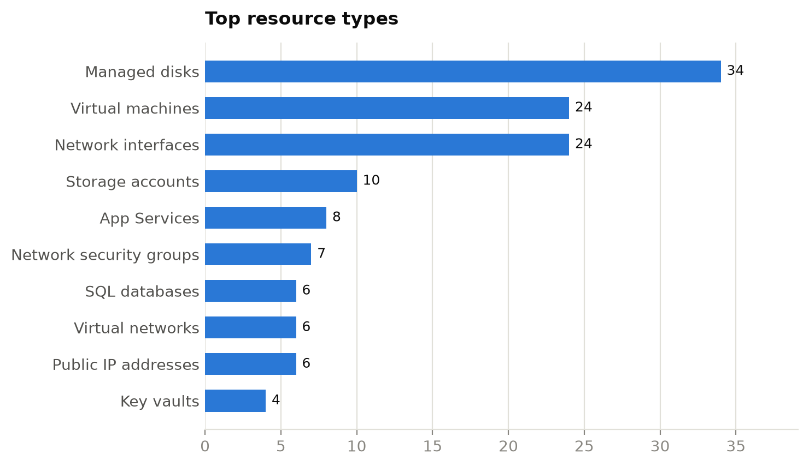
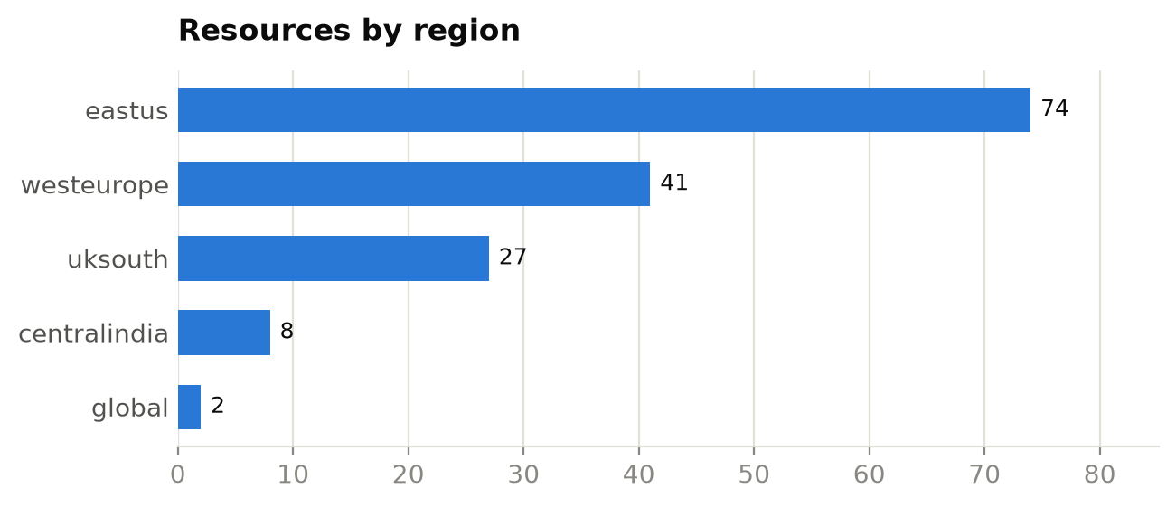
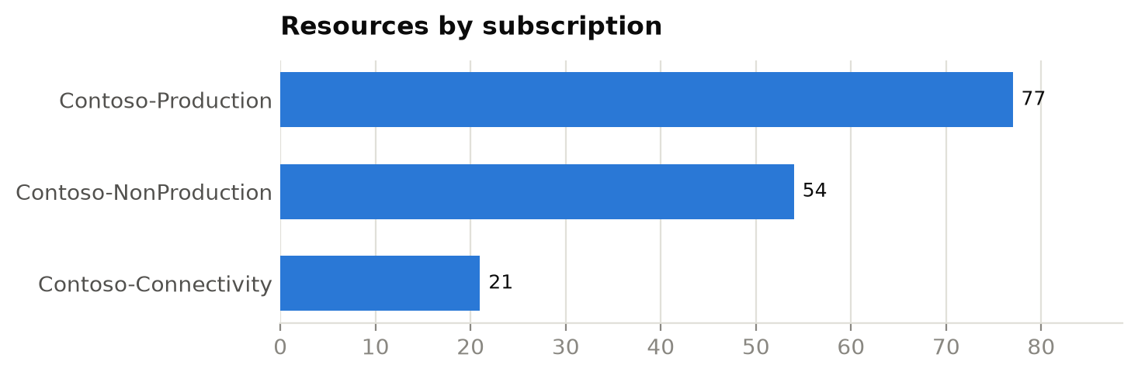

Resource types
Resource type | Count | % of estate
Managed disks | 34 | 22.4%
Virtual machines | 24 | 15.8%
Network interfaces | 24 | 15.8%
Storage accounts | 10 | 6.6%
App Services | 8 | 5.3%
Network security groups | 7 | 4.6%
SQL databases | 6 | 3.9%
Virtual networks | 6 | 3.9%
Public IP addresses | 6 | 3.9%
Key vaults | 4 | 2.6%
App Service plans | 4 | 2.6%
SQL servers | 2 | 1.3%
Log Analytics workspaces | 2 | 1.3%
Azure Firewalls | 2 | 1.3%
routetables | 2 | 1.3%
privateendpoints | 2 | 1.3%
privatednszones | 2 | 1.3%
Classic cloud services | 1 | 0.7%
virtualnetworkgateways | 1 | 0.7%
localnetworkgateways | 1 | 0.7%
connections | 1 | 0.7%
bastionhosts | 1 | 0.7%
Application gateways | 1 | 0.7%
Load balancers | 1 | 0.7%

6. Assessment findings
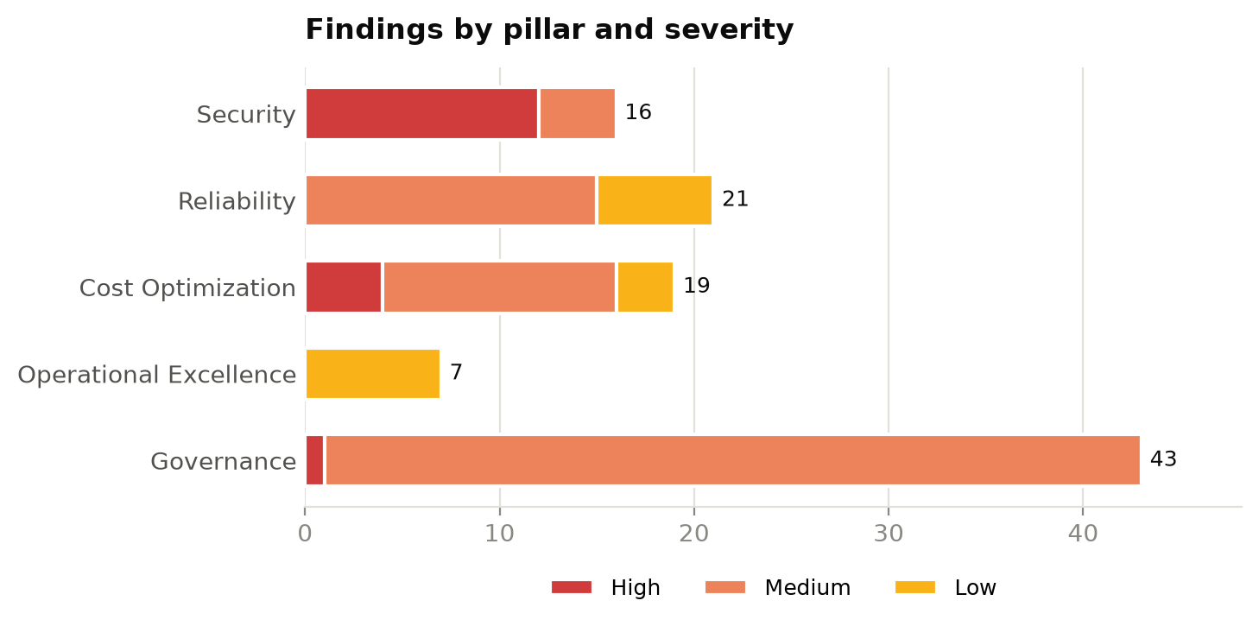

6.1 Security — 68/100 (Fair)

SEC-001: Storage account permits HTTP
Severity: High Affected: 4 of 10 evaluated resources
Recommendation: Enable 'Secure transfer required' on the storage account.
Examples: stdevdata01, stdevdata03, stprddata03, stprddata04
Context: see 4.6 Storage in the infrastructure overview.

SEC-002: Storage account allows anonymous blob access
Severity: High Affected: 4 of 10 evaluated resources
Recommendation: Set allowBlobPublicAccess to false and use SAS or Entra ID for access.
Examples: stdevdata00, stdevdata01, stprddata02, stprddata04
Context: see 4.6 Storage in the infrastructure overview.

SEC-006: Web app does not enforce HTTPS
Severity: High Affected: 2 of 8 evaluated resources
Recommendation: Enable 'HTTPS Only' on the App Service.
Examples: app-dev-01, app-dev-02
Context: see 4.8 Application hosting in the infrastructure overview.

SEC-007: NSG exposes management ports to the Internet
Severity: High Affected: 2 of 7 evaluated resources
Recommendation: Remove Internet-sourced RDP/SSH rules; use Azure Bastion or Just-in-Time VM access.
Examples: nsg-mgmt-eastus, nsg-mgmt-westeurope
Context: see 4.5 Networking in the infrastructure overview.

SEC-003: Storage account accepts TLS < 1.2
Severity: Medium Affected: 2 of 10 evaluated resources
Recommendation: Set minimum TLS version to 1.2.
Examples: stdevdata02, stdevdata04
Context: see 4.6 Storage in the infrastructure overview.

SEC-004: Key Vault purge protection disabled
Severity: Medium Affected: 1 of 4 evaluated resources
Recommendation: Enable purge protection to guard secrets and keys against malicious or accidental deletion.
Examples: kv-dev-00
Context: see 4.9 Security services in the infrastructure overview.

SEC-005: SQL server reachable from public networks
Severity: Medium Affected: 1 of 2 evaluated resources
Recommendation: Disable public network access and connect through Private Endpoints.
Examples: sql-dev-01
Context: see 4.7 Databases in the infrastructure overview.

6.2 Reliability — 75/100 (Fair)

REL-001: VM has no zone or availability set
Severity: Medium Affected: 15 of 24 evaluated resources
Recommendation: Deploy production VMs across availability zones or in a scale set / availability set.
Examples: vm-dev-000, vm-dev-001, vm-dev-002, vm-dev-003, vm-dev-004 …
Context: see 4.4 Compute in the infrastructure overview.

REL-003: Storage account uses locally redundant replication
Severity: Low Affected: 3 of 10 evaluated resources
Recommendation: Use ZRS/GZRS for production data that needs zone or regional resilience.
Examples: stdevdata02, stprddata00, stprddata04
Context: see 4.6 Storage in the infrastructure overview.

REL-004: SQL database not zone redundant
Severity: Low Affected: 3 of 6 evaluated resources
Recommendation: Enable zone redundancy on business-critical databases.
Examples: sql-dev-01/db1, sql-dev-01/db2, sql-prd-01/db1
Context: see 4.7 Databases in the infrastructure overview.

6.3 Cost Optimization — 78/100 (Fair)

COST-003: VM stopped but not deallocated
Severity: High Affected: 4 of 24 evaluated resources
Recommendation: Deallocate stopped VMs (Stop from the portal/CLI) or schedule auto-shutdown.
Examples: vm-dev-006, vm-dev-009, vm-prd-000, vm-prd-001
Context: see 4.4 Compute in the infrastructure overview.

COST-001: Unattached managed disk
Severity: Medium Affected: 10 of 34 evaluated resources
Recommendation: Snapshot if required, then delete orphaned disks.
Examples: disk-dev-orphan-0, disk-dev-orphan-1, disk-dev-orphan-2, disk-dev-orphan-3, disk-prd-orphan-0 …
Context: see 4.4 Compute in the infrastructure overview.

COST-005: Empty App Service plan
Severity: Medium Affected: 2 of 4 evaluated resources
Recommendation: Delete or consolidate App Service plans with no apps.
Examples: asp-dev-00, asp-dev-01
Context: see 4.8 Application hosting in the infrastructure overview.

COST-002: Unassociated public IP address
Severity: Low Affected: 2 of 6 evaluated resources
Recommendation: Release public IPs that are not attached to any resource.
Examples: pip-eastus-0, pip-westeurope-0
Context: see 4.5 Networking in the infrastructure overview.

COST-004: Deallocated VM
Severity: Low Affected: 1 of 24 evaluated resources
Recommendation: Confirm the VM is still needed; delete it and its disks if not.
Examples: vm-prd-008
Context: see 4.4 Compute in the infrastructure overview.

6.4 Operational Excellence — 73/100 (Fair)

OPS-001: Previous-generation VM size
Severity: Low Affected: 5 of 24 evaluated resources
Recommendation: Resize to current generation (v5/v6) SKUs for better price-performance.
Examples: vm-dev-006, vm-prd-001, vm-prd-002, vm-prd-004, vm-prd-008
Context: see 4.4 Compute in the infrastructure overview.

OPS-002: Log Analytics retention below target
Severity: Low Affected: 2 of 2 evaluated resources
Recommendation: Increase retention or archive to meet audit and investigation requirements.
Examples: log-dev-01, log-prd-01
Context: see 4.10 Monitoring and management in the infrastructure overview.

6.5 Governance — 86/100 (Good)

GOV-003: Classic (ASM) resource in use
Severity: High Affected: 1 of 1 evaluated resources
Recommendation: Migrate classic resources to Azure Resource Manager before platform retirement.
Examples: legacy-cloudservice
Context: see 4.11 Governance and tagging in the infrastructure overview.

GOV-001: Required tags missing
Severity: Medium Affected: 34 of 152 evaluated resources
Recommendation: Enforce the tagging standard with Azure Policy (Require/Inherit a tag) and back-fill existing resources.
Examples: app-prd-01, asp-dev-00, asp-dev-01, disk-dev-orphan-0, disk-prd-orphan-3 …
Context: see 4.11 Governance and tagging in the infrastructure overview.

GOV-002: Resource outside approved regions
Severity: Medium Affected: 8 of 152 evaluated resources
Recommendation: Apply the 'Allowed locations' policy and plan migration of out-of-policy resources.
Examples: disk-dev-orphan-2, disk-prd-orphan-3, nic-prd-012, sql-prd-01, stprddata00 …
Context: see 4.3 Regional footprint in the infrastructure overview.

7. Remediation roadmap

0-30 days (quick wins & critical risk)
ID | Action | Severity | Pillar | Resources
SEC-001 | Enable 'Secure transfer required' on the storage account. | High | Security | 4
SEC-002 | Set allowBlobPublicAccess to false and use SAS or Entra ID for access. | High | Security | 4
COST-003 | Deallocate stopped VMs (Stop from the portal/CLI) or schedule auto-shutdown. | High | Cost Optimization | 4
SEC-006 | Enable 'HTTPS Only' on the App Service. | High | Security | 2
SEC-007 | Remove Internet-sourced RDP/SSH rules; use Azure Bastion or Just-in-Time VM access. | High | Security | 2
GOV-003 | Migrate classic resources to Azure Resource Manager before platform retirement. | High | Governance | 1
COST-001 | Snapshot if required, then delete orphaned disks. | Medium | Cost Optimization | 10
COST-005 | Delete or consolidate App Service plans with no apps. | Medium | Cost Optimization | 2
COST-002 | Release public IPs that are not attached to any resource. | Low | Cost Optimization | 2
COST-004 | Confirm the VM is still needed; delete it and its disks if not. | Low | Cost Optimization | 1

30-60 days
ID | Action | Severity | Pillar | Resources
GOV-001 | Enforce the tagging standard with Azure Policy (Require/Inherit a tag) and back-fill existing resources. | Medium | Governance | 34
REL-001 | Deploy production VMs across availability zones or in a scale set / availability set. | Medium | Reliability | 15
GOV-002 | Apply the 'Allowed locations' policy and plan migration of out-of-policy resources. | Medium | Governance | 8
SEC-003 | Set minimum TLS version to 1.2. | Medium | Security | 2
SEC-004 | Enable purge protection to guard secrets and keys against malicious or accidental deletion. | Medium | Security | 1
SEC-005 | Disable public network access and connect through Private Endpoints. | Medium | Security | 1

60-90 days
ID | Action | Severity | Pillar | Resources
OPS-001 | Resize to current generation (v5/v6) SKUs for better price-performance. | Low | Operational Excellence | 5
REL-003 | Use ZRS/GZRS for production data that needs zone or regional resilience. | Low | Reliability | 3
REL-004 | Enable zone redundancy on business-critical databases. | Low | Reliability | 3
OPS-002 | Increase retention or archive to meet audit and investigation requirements. | Low | Operational Excellence | 2

Appendix A. Detailed findings
Rule | Severity | Resource | Type | Resource group | Subscription | Detail
COST-003 | High | vm-dev-006 | Virtual machines | rg-dev-app03 | Contoso-NonProduction | VM is stopped but still allocated (compute is billed)
COST-003 | High | vm-dev-009 | Virtual machines | rg-dev-app02 | Contoso-NonProduction | VM is stopped but still allocated (compute is billed)
COST-003 | High | vm-prd-000 | Virtual machines | rg-prd-app01 | Contoso-Production | VM is stopped but still allocated (compute is billed)
COST-003 | High | vm-prd-001 | Virtual machines | rg-prd-app02 | Contoso-Production | VM is stopped but still allocated (compute is billed)
GOV-003 | High | legacy-cloudservice | Classic cloud services | rg-legacy | Contoso-Connectivity | Classic (ASM) deployment model resource
SEC-001 | High | stdevdata01 | Storage accounts | rg-dev-data | Contoso-NonProduction | HTTP traffic is permitted
SEC-001 | High | stdevdata03 | Storage accounts | rg-dev-data | Contoso-NonProduction | HTTP traffic is permitted
SEC-001 | High | stprddata03 | Storage accounts | rg-prd-data | Contoso-Production | HTTP traffic is permitted
SEC-001 | High | stprddata04 | Storage accounts | rg-prd-data | Contoso-Production | HTTP traffic is permitted
SEC-002 | High | stdevdata00 | Storage accounts | rg-dev-data | Contoso-NonProduction | Anonymous blob access is allowed
SEC-002 | High | stdevdata01 | Storage accounts | rg-dev-data | Contoso-NonProduction | Anonymous blob access is allowed
SEC-002 | High | stprddata02 | Storage accounts | rg-prd-data | Contoso-Production | Anonymous blob access is allowed
SEC-002 | High | stprddata04 | Storage accounts | rg-prd-data | Contoso-Production | Anonymous blob access is allowed
SEC-006 | High | app-dev-01 | App Services | rg-dev-web | Contoso-NonProduction | HTTPS-only is not enforced
SEC-006 | High | app-dev-02 | App Services | rg-dev-web | Contoso-NonProduction | HTTPS-only is not enforced
SEC-007 | High | nsg-mgmt-eastus | Network security groups | rg-hub-eastus | Contoso-Connectivity | Internet-exposed management ports: allow-rdp (3389)
SEC-007 | High | nsg-mgmt-westeurope | Network security groups | rg-hub-westeurope | Contoso-Connectivity | Internet-exposed management ports: allow-rdp (3389)
COST-001 | Medium | disk-dev-orphan-0 | Managed disks | rg-dev-app01 | Contoso-NonProduction | Unattached Premium_LRS disk, 128 GB
COST-001 | Medium | disk-dev-orphan-1 | Managed disks | rg-dev-app01 | Contoso-NonProduction | Unattached Premium_LRS disk, 64 GB
COST-001 | Medium | disk-dev-orphan-2 | Managed disks | rg-dev-app01 | Contoso-NonProduction | Unattached StandardSSD_LRS disk, 64 GB
COST-001 | Medium | disk-dev-orphan-3 | Managed disks | rg-dev-app01 | Contoso-NonProduction | Unattached Premium_LRS disk, 64 GB
COST-001 | Medium | disk-prd-orphan-0 | Managed disks | rg-prd-app01 | Contoso-Production | Unattached StandardSSD_LRS disk, 64 GB
COST-001 | Medium | disk-prd-orphan-1 | Managed disks | rg-prd-app01 | Contoso-Production | Unattached Premium_LRS disk, 512 GB
COST-001 | Medium | disk-prd-orphan-2 | Managed disks | rg-prd-app01 | Contoso-Production | Unattached Premium_LRS disk, 512 GB
COST-001 | Medium | disk-prd-orphan-3 | Managed disks | rg-prd-app01 | Contoso-Production | Unattached Premium_LRS disk, 128 GB
COST-001 | Medium | disk-prd-orphan-4 | Managed disks | rg-prd-app01 | Contoso-Production | Unattached StandardSSD_LRS disk, 256 GB
COST-001 | Medium | disk-prd-orphan-5 | Managed disks | rg-prd-app01 | Contoso-Production | Unattached Premium_LRS disk, 64 GB
COST-005 | Medium | asp-dev-00 | App Service plans | rg-dev-web | Contoso-NonProduction | App Service plan hosts no apps
COST-005 | Medium | asp-dev-01 | App Service plans | rg-dev-web | Contoso-NonProduction | App Service plan hosts no apps
GOV-001 | Medium | app-prd-01 | App Services | rg-prd-web | Contoso-Production | Missing tag(s): environment, owner
GOV-001 | Medium | asp-dev-00 | App Service plans | rg-dev-web | Contoso-NonProduction | Missing tag(s): environment, owner
GOV-001 | Medium | asp-dev-01 | App Service plans | rg-dev-web | Contoso-NonProduction | Missing tag(s): environment, owner
GOV-001 | Medium | disk-dev-orphan-0 | Managed disks | rg-dev-app01 | Contoso-NonProduction | Missing tag(s): costCenter
GOV-001 | Medium | disk-prd-orphan-3 | Managed disks | rg-prd-app01 | Contoso-Production | Missing tag(s): costCenter
GOV-001 | Medium | kv-prd-00 | Key vaults | rg-prd-sec | Contoso-Production | Missing tag(s): environment, owner, costCenter
GOV-001 | Medium | kv-prd-01 | Key vaults | rg-prd-sec | Contoso-Production | Missing tag(s): costCenter
GOV-001 | Medium | nic-dev-002 | Network interfaces | rg-dev-app03 | Contoso-NonProduction | Missing tag(s): environment, owner, costCenter
GOV-001 | Medium | nic-dev-004 | Network interfaces | rg-dev-app01 | Contoso-NonProduction | Missing tag(s): environment, owner, costCenter
GOV-001 | Medium | nic-dev-005 | Network interfaces | rg-dev-app02 | Contoso-NonProduction | Missing tag(s): environment
GOV-001 | Medium | nic-dev-006 | Network interfaces | rg-dev-app03 | Contoso-NonProduction | Missing tag(s): owner, costCenter
GOV-001 | Medium | nic-prd-003 | Network interfaces | rg-prd-app04 | Contoso-Production | Missing tag(s): environment, costCenter
GOV-001 | Medium | nic-prd-006 | Network interfaces | rg-prd-app03 | Contoso-Production | Missing tag(s): environment, owner
GOV-001 | Medium | nsg-app-westeurope | Network security groups | rg-hub-westeurope | Contoso-Connectivity | Missing tag(s): environment, owner, costCenter
GOV-001 | Medium | pip-eastus-0 | Public IP addresses | rg-hub-eastus | Contoso-Connectivity | Missing tag(s): environment, owner, costCenter
GOV-001 | Medium | pip-eastus-1 | Public IP addresses | rg-hub-eastus | Contoso-Connectivity | Missing tag(s): owner, costCenter
GOV-001 | Medium | pip-eastus-2 | Public IP addresses | rg-hub-eastus | Contoso-Connectivity | Missing tag(s): environment, owner
GOV-001 | Medium | sql-dev-01 | SQL servers | rg-dev-data | Contoso-NonProduction | Missing tag(s): environment, costCenter
GOV-001 | Medium | stdevdata02 | Storage accounts | rg-dev-data | Contoso-NonProduction | Missing tag(s): environment, owner, costCenter
GOV-001 | Medium | stprddata04 | Storage accounts | rg-prd-data | Contoso-Production | Missing tag(s): environment, owner
GOV-001 | Medium | vm-dev-003 | Virtual machines | rg-dev-app04 | Contoso-NonProduction | Missing tag(s): owner, costCenter
GOV-001 | Medium | vm-dev-003_OsDisk | Managed disks | rg-dev-app04 | Contoso-NonProduction | Missing tag(s): environment, owner, costCenter
GOV-001 | Medium | vm-dev-006 | Virtual machines | rg-dev-app03 | Contoso-NonProduction | Missing tag(s): environment, owner, costCenter
GOV-001 | Medium | vm-dev-008 | Virtual machines | rg-dev-app01 | Contoso-NonProduction | Missing tag(s): environment, owner, costCenter
GOV-001 | Medium | vm-prd-000_OsDisk | Managed disks | rg-prd-app01 | Contoso-Production | Missing tag(s): environment, owner, costCenter
GOV-001 | Medium | vm-prd-001 | Virtual machines | rg-prd-app02 | Contoso-Production | Missing tag(s): environment, owner, costCenter
GOV-001 | Medium | vm-prd-003_OsDisk | Managed disks | rg-prd-app04 | Contoso-Production | Missing tag(s): environment, owner, costCenter
GOV-001 | Medium | vm-prd-004 | Virtual machines | rg-prd-app01 | Contoso-Production | Missing tag(s): environment, owner
GOV-001 | Medium | vm-prd-005_OsDisk | Managed disks | rg-prd-app02 | Contoso-Production | Missing tag(s): environment, owner, costCenter
GOV-001 | Medium | vm-prd-007_OsDisk | Managed disks | rg-prd-app04 | Contoso-Production | Missing tag(s): environment, owner, costCenter
GOV-001 | Medium | vm-prd-009 | Virtual machines | rg-prd-app02 | Contoso-Production | Missing tag(s): environment, owner, costCenter
GOV-001 | Medium | vm-prd-009_OsDisk | Managed disks | rg-prd-app02 | Contoso-Production | Missing tag(s): costCenter
GOV-001 | Medium | vm-prd-010 | Virtual machines | rg-prd-app03 | Contoso-Production | Missing tag(s): environment, owner, costCenter
GOV-001 | Medium | vm-prd-013_OsDisk | Managed disks | rg-prd-app02 | Contoso-Production | Missing tag(s): environment, owner, costCenter
GOV-002 | Medium | disk-dev-orphan-2 | Managed disks | rg-dev-app01 | Contoso-NonProduction | Deployed in 'centralindia', outside approved regions
GOV-002 | Medium | disk-prd-orphan-3 | Managed disks | rg-prd-app01 | Contoso-Production | Deployed in 'centralindia', outside approved regions
GOV-002 | Medium | nic-prd-012 | Network interfaces | rg-prd-app01 | Contoso-Production | Deployed in 'centralindia', outside approved regions
GOV-002 | Medium | sql-prd-01 | SQL servers | rg-prd-data | Contoso-Production | Deployed in 'centralindia', outside approved regions
GOV-002 | Medium | stprddata00 | Storage accounts | rg-prd-data | Contoso-Production | Deployed in 'centralindia', outside approved regions
GOV-002 | Medium | stprddata02 | Storage accounts | rg-prd-data | Contoso-Production | Deployed in 'centralindia', outside approved regions
GOV-002 | Medium | vm-prd-012 | Virtual machines | rg-prd-app01 | Contoso-Production | Deployed in 'centralindia', outside approved regions
GOV-002 | Medium | vm-prd-012_OsDisk | Managed disks | rg-prd-app01 | Contoso-Production | Deployed in 'centralindia', outside approved regions
REL-001 | Medium | vm-dev-000 | Virtual machines | rg-dev-app01 | Contoso-NonProduction | Not deployed to an availability zone, availability set or scale set
REL-001 | Medium | vm-dev-001 | Virtual machines | rg-dev-app02 | Contoso-NonProduction | Not deployed to an availability zone, availability set or scale set
REL-001 | Medium | vm-dev-002 | Virtual machines | rg-dev-app03 | Contoso-NonProduction | Not deployed to an availability zone, availability set or scale set
REL-001 | Medium | vm-dev-003 | Virtual machines | rg-dev-app04 | Contoso-NonProduction | Not deployed to an availability zone, availability set or scale set
REL-001 | Medium | vm-dev-004 | Virtual machines | rg-dev-app01 | Contoso-NonProduction | Not deployed to an availability zone, availability set or scale set
REL-001 | Medium | vm-dev-005 | Virtual machines | rg-dev-app02 | Contoso-NonProduction | Not deployed to an availability zone, availability set or scale set
REL-001 | Medium | vm-dev-006 | Virtual machines | rg-dev-app03 | Contoso-NonProduction | Not deployed to an availability zone, availability set or scale set
REL-001 | Medium | vm-dev-007 | Virtual machines | rg-dev-app04 | Contoso-NonProduction | Not deployed to an availability zone, availability set or scale set
REL-001 | Medium | vm-dev-008 | Virtual machines | rg-dev-app01 | Contoso-NonProduction | Not deployed to an availability zone, availability set or scale set
REL-001 | Medium | vm-dev-009 | Virtual machines | rg-dev-app02 | Contoso-NonProduction | Not deployed to an availability zone, availability set or scale set
REL-001 | Medium | vm-prd-003 | Virtual machines | rg-prd-app04 | Contoso-Production | Not deployed to an availability zone, availability set or scale set
REL-001 | Medium | vm-prd-004 | Virtual machines | rg-prd-app01 | Contoso-Production | Not deployed to an availability zone, availability set or scale set
REL-001 | Medium | vm-prd-006 | Virtual machines | rg-prd-app03 | Contoso-Production | Not deployed to an availability zone, availability set or scale set
REL-001 | Medium | vm-prd-007 | Virtual machines | rg-prd-app04 | Contoso-Production | Not deployed to an availability zone, availability set or scale set
REL-001 | Medium | vm-prd-009 | Virtual machines | rg-prd-app02 | Contoso-Production | Not deployed to an availability zone, availability set or scale set
SEC-003 | Medium | stdevdata02 | Storage accounts | rg-dev-data | Contoso-NonProduction | Minimum TLS version is TLS1_0
SEC-003 | Medium | stdevdata04 | Storage accounts | rg-dev-data | Contoso-NonProduction | Minimum TLS version is TLS1_0
SEC-004 | Medium | kv-dev-00 | Key vaults | rg-dev-sec | Contoso-NonProduction | Purge protection is disabled
SEC-005 | Medium | sql-dev-01 | SQL servers | rg-dev-data | Contoso-NonProduction | Public network access is enabled
COST-002 | Low | pip-eastus-0 | Public IP addresses | rg-hub-eastus | Contoso-Connectivity | Public IP is not associated with any resource
COST-002 | Low | pip-westeurope-0 | Public IP addresses | rg-hub-westeurope | Contoso-Connectivity | Public IP is not associated with any resource
COST-004 | Low | vm-prd-008 | Virtual machines | rg-prd-app01 | Contoso-Production | VM is deallocated; disks and IPs still incur cost
OPS-001 | Low | vm-dev-006 | Virtual machines | rg-dev-app03 | Contoso-NonProduction | Previous-generation size Standard_A2_v2
OPS-001 | Low | vm-prd-001 | Virtual machines | rg-prd-app02 | Contoso-Production | Previous-generation size Standard_DS2_v2
OPS-001 | Low | vm-prd-002 | Virtual machines | rg-prd-app03 | Contoso-Production | Previous-generation size Standard_A2_v2
OPS-001 | Low | vm-prd-004 | Virtual machines | rg-prd-app01 | Contoso-Production | Previous-generation size Standard_DS2_v2
OPS-001 | Low | vm-prd-008 | Virtual machines | rg-prd-app01 | Contoso-Production | Previous-generation size Standard_A2_v2
OPS-002 | Low | log-dev-01 | Log Analytics workspaces | rg-dev-mon | Contoso-NonProduction | Retention is 30 days (target ≥ 90)
OPS-002 | Low | log-prd-01 | Log Analytics workspaces | rg-prd-mon | Contoso-Production | Retention is 30 days (target ≥ 90)
REL-003 | Low | stdevdata02 | Storage accounts | rg-dev-data | Contoso-NonProduction | Replication is Standard_LRS (single datacenter)
REL-003 | Low | stprddata00 | Storage accounts | rg-prd-data | Contoso-Production | Replication is Standard_LRS (single datacenter)
REL-003 | Low | stprddata04 | Storage accounts | rg-prd-data | Contoso-Production | Replication is Standard_LRS (single datacenter)
REL-004 | Low | sql-dev-01/db1 | SQL databases | rg-dev-data | Contoso-NonProduction | Database is not zone redundant
REL-004 | Low | sql-dev-01/db2 | SQL databases | rg-dev-data | Contoso-NonProduction | Database is not zone redundant
REL-004 | Low | sql-prd-01/db1 | SQL databases | rg-prd-data | Contoso-Production | Database is not zone redundant

Appendix B. Resource inventory
Name | Type | Resource group | Location | Subscription | SKU
privatelink.blob.core.windows.net | privatednszones | rg-dns | global | Contoso-Connectivity
privatelink.database.windows.net | privatednszones | rg-dns | global | Contoso-Connectivity
afw-hub-eastus | Azure Firewalls | rg-hub-eastus | eastus | Contoso-Connectivity | AZFW_VNet
bas-hub-eastus | bastionhosts | rg-hub-eastus | eastus | Contoso-Connectivity | Standard
cn-hub-eastus-to-dc1 | connections | rg-hub-eastus | eastus | Contoso-Connectivity
lng-onprem-dc1 | localnetworkgateways | rg-hub-eastus | eastus | Contoso-Connectivity
nsg-app-eastus | Network security groups | rg-hub-eastus | eastus | Contoso-Connectivity
nsg-mgmt-eastus | Network security groups | rg-hub-eastus | eastus | Contoso-Connectivity
pip-eastus-0 | Public IP addresses | rg-hub-eastus | eastus | Contoso-Connectivity | Standard
pip-eastus-1 | Public IP addresses | rg-hub-eastus | eastus | Contoso-Connectivity | Standard
pip-eastus-2 | Public IP addresses | rg-hub-eastus | eastus | Contoso-Connectivity | Standard
vgw-hub-eastus | virtualnetworkgateways | rg-hub-eastus | eastus | Contoso-Connectivity | VpnGw2AZ
vnet-hub-eastus | Virtual networks | rg-hub-eastus | eastus | Contoso-Connectivity
afw-hub-westeurope | Azure Firewalls | rg-hub-westeurope | westeurope | Contoso-Connectivity | AZFW_VNet
nsg-app-westeurope | Network security groups | rg-hub-westeurope | westeurope | Contoso-Connectivity
nsg-mgmt-westeurope | Network security groups | rg-hub-westeurope | westeurope | Contoso-Connectivity
pip-westeurope-0 | Public IP addresses | rg-hub-westeurope | westeurope | Contoso-Connectivity | Standard
pip-westeurope-1 | Public IP addresses | rg-hub-westeurope | westeurope | Contoso-Connectivity | Standard
pip-westeurope-2 | Public IP addresses | rg-hub-westeurope | westeurope | Contoso-Connectivity | Standard
vnet-hub-westeurope | Virtual networks | rg-hub-westeurope | westeurope | Contoso-Connectivity
legacy-cloudservice | Classic cloud services | rg-legacy | eastus | Contoso-Connectivity
disk-dev-orphan-0 | Managed disks | rg-dev-app01 | westeurope | Contoso-NonProduction | Premium_LRS
disk-dev-orphan-1 | Managed disks | rg-dev-app01 | westeurope | Contoso-NonProduction | Premium_LRS
disk-dev-orphan-2 | Managed disks | rg-dev-app01 | centralindia | Contoso-NonProduction | StandardSSD_LRS
disk-dev-orphan-3 | Managed disks | rg-dev-app01 | eastus | Contoso-NonProduction | Premium_LRS
vm-dev-000_OsDisk | Managed disks | rg-dev-app01 | eastus | Contoso-NonProduction | Premium_LRS
vm-dev-004_OsDisk | Managed disks | rg-dev-app01 | eastus | Contoso-NonProduction | Premium_LRS
vm-dev-008_OsDisk | Managed disks | rg-dev-app01 | eastus | Contoso-NonProduction | Premium_LRS
vm-dev-000 | Virtual machines | rg-dev-app01 | eastus | Contoso-NonProduction
vm-dev-004 | Virtual machines | rg-dev-app01 | eastus | Contoso-NonProduction
vm-dev-008 | Virtual machines | rg-dev-app01 | eastus | Contoso-NonProduction
nic-dev-000 | Network interfaces | rg-dev-app01 | eastus | Contoso-NonProduction
nic-dev-004 | Network interfaces | rg-dev-app01 | eastus | Contoso-NonProduction
nic-dev-008 | Network interfaces | rg-dev-app01 | eastus | Contoso-NonProduction
vm-dev-001_OsDisk | Managed disks | rg-dev-app02 | uksouth | Contoso-NonProduction | Premium_LRS
vm-dev-005_OsDisk | Managed disks | rg-dev-app02 | uksouth | Contoso-NonProduction | Premium_LRS
vm-dev-009_OsDisk | Managed disks | rg-dev-app02 | uksouth | Contoso-NonProduction | Premium_LRS
vm-dev-001 | Virtual machines | rg-dev-app02 | uksouth | Contoso-NonProduction
vm-dev-005 | Virtual machines | rg-dev-app02 | uksouth | Contoso-NonProduction
vm-dev-009 | Virtual machines | rg-dev-app02 | uksouth | Contoso-NonProduction
nic-dev-001 | Network interfaces | rg-dev-app02 | uksouth | Contoso-NonProduction
nic-dev-005 | Network interfaces | rg-dev-app02 | uksouth | Contoso-NonProduction
nic-dev-009 | Network interfaces | rg-dev-app02 | uksouth | Contoso-NonProduction
vm-dev-002_OsDisk | Managed disks | rg-dev-app03 | eastus | Contoso-NonProduction | Premium_LRS
vm-dev-006_OsDisk | Managed disks | rg-dev-app03 | uksouth | Contoso-NonProduction | Premium_LRS
vm-dev-002 | Virtual machines | rg-dev-app03 | eastus | Contoso-NonProduction
vm-dev-006 | Virtual machines | rg-dev-app03 | uksouth | Contoso-NonProduction
nic-dev-002 | Network interfaces | rg-dev-app03 | eastus | Contoso-NonProduction
nic-dev-006 | Network interfaces | rg-dev-app03 | uksouth | Contoso-NonProduction
vm-dev-003_OsDisk | Managed disks | rg-dev-app04 | eastus | Contoso-NonProduction | Premium_LRS
vm-dev-007_OsDisk | Managed disks | rg-dev-app04 | eastus | Contoso-NonProduction | Premium_LRS
vm-dev-003 | Virtual machines | rg-dev-app04 | eastus | Contoso-NonProduction
vm-dev-007 | Virtual machines | rg-dev-app04 | eastus | Contoso-NonProduction
nic-dev-003 | Network interfaces | rg-dev-app04 | eastus | Contoso-NonProduction
nic-dev-007 | Network interfaces | rg-dev-app04 | eastus | Contoso-NonProduction
sql-dev-01 | SQL servers | rg-dev-data | uksouth | Contoso-NonProduction
sql-dev-01/db0 | SQL databases | rg-dev-data | westeurope | Contoso-NonProduction | Basic
sql-dev-01/db1 | SQL databases | rg-dev-data | uksouth | Contoso-NonProduction | S1
sql-dev-01/db2 | SQL databases | rg-dev-data | westeurope | Contoso-NonProduction | S1
stdevdata00 | Storage accounts | rg-dev-data | westeurope | Contoso-NonProduction | Standard_GRS
stdevdata01 | Storage accounts | rg-dev-data | eastus | Contoso-NonProduction | Standard_GRS
stdevdata02 | Storage accounts | rg-dev-data | westeurope | Contoso-NonProduction | Standard_LRS
stdevdata03 | Storage accounts | rg-dev-data | westeurope | Contoso-NonProduction | Standard_ZRS
stdevdata04 | Storage accounts | rg-dev-data | westeurope | Contoso-NonProduction | Standard_GRS
log-dev-01 | Log Analytics workspaces | rg-dev-mon | uksouth | Contoso-NonProduction
vnet-dev-eastus | Virtual networks | rg-dev-network | eastus | Contoso-NonProduction
vnet-dev-sandbox | Virtual networks | rg-dev-sandbox | uksouth | Contoso-NonProduction
kv-dev-00 | Key vaults | rg-dev-sec | westeurope | Contoso-NonProduction
kv-dev-01 | Key vaults | rg-dev-sec | eastus | Contoso-NonProduction
asp-dev-00 | App Service plans | rg-dev-web | eastus | Contoso-NonProduction | S1
asp-dev-01 | App Service plans | rg-dev-web | eastus | Contoso-NonProduction | B1
app-dev-00 | App Services | rg-dev-web | westeurope | Contoso-NonProduction
app-dev-01 | App Services | rg-dev-web | eastus | Contoso-NonProduction
app-dev-02 | App Services | rg-dev-web | eastus | Contoso-NonProduction
app-dev-03 | App Services | rg-dev-web | uksouth | Contoso-NonProduction
disk-prd-orphan-0 | Managed disks | rg-prd-app01 | uksouth | Contoso-Production | StandardSSD_LRS
disk-prd-orphan-1 | Managed disks | rg-prd-app01 | westeurope | Contoso-Production | Premium_LRS
disk-prd-orphan-2 | Managed disks | rg-prd-app01 | eastus | Contoso-Production | Premium_LRS
disk-prd-orphan-3 | Managed disks | rg-prd-app01 | centralindia | Contoso-Production | Premium_LRS
disk-prd-orphan-4 | Managed disks | rg-prd-app01 | eastus | Contoso-Production | StandardSSD_LRS
disk-prd-orphan-5 | Managed disks | rg-prd-app01 | westeurope | Contoso-Production | Premium_LRS
vm-prd-000_OsDisk | Managed disks | rg-prd-app01 | westeurope | Contoso-Production | Premium_LRS
vm-prd-004_OsDisk | Managed disks | rg-prd-app01 | westeurope | Contoso-Production | Premium_LRS
vm-prd-008_OsDisk | Managed disks | rg-prd-app01 | uksouth | Contoso-Production | Premium_LRS
vm-prd-012_OsDisk | Managed disks | rg-prd-app01 | centralindia | Contoso-Production | Premium_LRS
vm-prd-000 | Virtual machines | rg-prd-app01 | westeurope | Contoso-Production
vm-prd-004 | Virtual machines | rg-prd-app01 | westeurope | Contoso-Production
vm-prd-008 | Virtual machines | rg-prd-app01 | uksouth | Contoso-Production
vm-prd-012 | Virtual machines | rg-prd-app01 | centralindia | Contoso-Production
lbi-prd-app | Load balancers | rg-prd-app01 | eastus | Contoso-Production | Standard
nic-prd-000 | Network interfaces | rg-prd-app01 | westeurope | Contoso-Production
nic-prd-004 | Network interfaces | rg-prd-app01 | westeurope | Contoso-Production
nic-prd-008 | Network interfaces | rg-prd-app01 | uksouth | Contoso-Production
nic-prd-012 | Network interfaces | rg-prd-app01 | centralindia | Contoso-Production
vm-prd-001_OsDisk | Managed disks | rg-prd-app02 | eastus | Contoso-Production | Premium_LRS
vm-prd-005_OsDisk | Managed disks | rg-prd-app02 | eastus | Contoso-Production | Premium_LRS
vm-prd-009_OsDisk | Managed disks | rg-prd-app02 | eastus | Contoso-Production | Premium_LRS
vm-prd-013_OsDisk | Managed disks | rg-prd-app02 | westeurope | Contoso-Production | Premium_LRS
vm-prd-001 | Virtual machines | rg-prd-app02 | eastus | Contoso-Production
vm-prd-005 | Virtual machines | rg-prd-app02 | eastus | Contoso-Production
vm-prd-009 | Virtual machines | rg-prd-app02 | eastus | Contoso-Production
vm-prd-013 | Virtual machines | rg-prd-app02 | westeurope | Contoso-Production
nic-prd-001 | Network interfaces | rg-prd-app02 | eastus | Contoso-Production
nic-prd-005 | Network interfaces | rg-prd-app02 | eastus | Contoso-Production
nic-prd-009 | Network interfaces | rg-prd-app02 | eastus | Contoso-Production
nic-prd-013 | Network interfaces | rg-prd-app02 | westeurope | Contoso-Production
vm-prd-002_OsDisk | Managed disks | rg-prd-app03 | uksouth | Contoso-Production | Premium_LRS
vm-prd-006_OsDisk | Managed disks | rg-prd-app03 | eastus | Contoso-Production | Premium_LRS
vm-prd-010_OsDisk | Managed disks | rg-prd-app03 | westeurope | Contoso-Production | Premium_LRS
vm-prd-002 | Virtual machines | rg-prd-app03 | uksouth | Contoso-Production
vm-prd-006 | Virtual machines | rg-prd-app03 | eastus | Contoso-Production
vm-prd-010 | Virtual machines | rg-prd-app03 | westeurope | Contoso-Production
nic-prd-002 | Network interfaces | rg-prd-app03 | uksouth | Contoso-Production
nic-prd-006 | Network interfaces | rg-prd-app03 | eastus | Contoso-Production
nic-prd-010 | Network interfaces | rg-prd-app03 | westeurope | Contoso-Production
vm-prd-003_OsDisk | Managed disks | rg-prd-app04 | westeurope | Contoso-Production | Premium_LRS
vm-prd-007_OsDisk | Managed disks | rg-prd-app04 | eastus | Contoso-Production | Premium_LRS
vm-prd-011_OsDisk | Managed disks | rg-prd-app04 | uksouth | Contoso-Production | Premium_LRS
vm-prd-003 | Virtual machines | rg-prd-app04 | westeurope | Contoso-Production
vm-prd-007 | Virtual machines | rg-prd-app04 | eastus | Contoso-Production
vm-prd-011 | Virtual machines | rg-prd-app04 | uksouth | Contoso-Production
nic-prd-003 | Network interfaces | rg-prd-app04 | westeurope | Contoso-Production
nic-prd-007 | Network interfaces | rg-prd-app04 | eastus | Contoso-Production
nic-prd-011 | Network interfaces | rg-prd-app04 | uksouth | Contoso-Production
sql-prd-01 | SQL servers | rg-prd-data | centralindia | Contoso-Production
sql-prd-01/db0 | SQL databases | rg-prd-data | eastus | Contoso-Production | GP_Gen5_2
sql-prd-01/db1 | SQL databases | rg-prd-data | eastus | Contoso-Production | S1
sql-prd-01/db2 | SQL databases | rg-prd-data | eastus | Contoso-Production | Basic
stprddata00 | Storage accounts | rg-prd-data | centralindia | Contoso-Production | Standard_LRS
stprddata01 | Storage accounts | rg-prd-data | westeurope | Contoso-Production | Standard_GRS
stprddata02 | Storage accounts | rg-prd-data | centralindia | Contoso-Production | Standard_ZRS
stprddata03 | Storage accounts | rg-prd-data | eastus | Contoso-Production | Standard_ZRS
stprddata04 | Storage accounts | rg-prd-data | eastus | Contoso-Production | Standard_LRS
log-prd-01 | Log Analytics workspaces | rg-prd-mon | eastus | Contoso-Production
nsg-prd-app | Network security groups | rg-prd-network | eastus | Contoso-Production
nsg-prd-data | Network security groups | rg-prd-network | eastus | Contoso-Production
nsg-prd-web | Network security groups | rg-prd-network | eastus | Contoso-Production
pe-sql-prd-01 | privateendpoints | rg-prd-network | eastus | Contoso-Production
pe-stprddata00-blob | privateendpoints | rg-prd-network | eastus | Contoso-Production
rt-prd-eastus | routetables | rg-prd-network | eastus | Contoso-Production
rt-prd-weu | routetables | rg-prd-network | westeurope | Contoso-Production
vnet-prd-eastus | Virtual networks | rg-prd-network | eastus | Contoso-Production
vnet-prd-westeurope | Virtual networks | rg-prd-network | westeurope | Contoso-Production
kv-prd-00 | Key vaults | rg-prd-sec | eastus | Contoso-Production
kv-prd-01 | Key vaults | rg-prd-sec | westeurope | Contoso-Production
agw-prd-eastus | Application gateways | rg-prd-web | eastus | Contoso-Production
asp-prd-00 | App Service plans | rg-prd-web | westeurope | Contoso-Production | P1v3
asp-prd-01 | App Service plans | rg-prd-web | westeurope | Contoso-Production | P1v3
app-prd-00 | App Services | rg-prd-web | eastus | Contoso-Production
app-prd-01 | App Services | rg-prd-web | eastus | Contoso-Production
app-prd-02 | App Services | rg-prd-web | westeurope | Contoso-Production
app-prd-03 | App Services | rg-prd-web | eastus | Contoso-Production

