AZURE ENVIRONMENT ASSESSMENT
Contoso
Inventory, Well-Architected findings and remediation roadmap

Report date: 27 September 2026
Inventory export date: 2026-09-20
Inventory source: sample-inventory.csv
Subscriptions in scope: 3
Resources assessed: 152

Contents
Right-click and choose 'Update Field' to build the table of contents.

1. Executive summary
Overall posture score: 76/100 (Fair)
152  Resources | 3  Subscriptions | 23  Resource groups | 5  Regions
17  High findings | 73  Medium findings | 16  Low findings | 78%  Tag coverage

Key observations
- 152 resources were assessed across 3 subscription(s), 23 resource groups and 5 region(s).
- Architecture at a glance: network topology is multi-region hub-and-spoke with exceptions; hybrid connectivity is site-to-site VPN to on-premises; subscription model is landing-zone style: platform and workload subscriptions, split by environment.
- 106 finding(s) were raised: 17 high, 73 medium and 16 low severity, affecting 78 resources.
- Security is the weakest area (score 68/100); Governance is the strongest (86/100).
- 78% of resources carry all required tags (environment, owner, costCenter).
- Priority high-severity issues: Storage account permits HTTP (4); Storage account allows anonymous blob access (4); VM stopped but not deallocated (4).

Scorecard
Pillar | Score | Rating | Checks | Findings | High | Medium | Low
Security | 68 | Fair | 51 | 16 | 12 | 4 | 0
Reliability | 75 | Fair | 64 | 21 | 0 | 15 | 6
Cost Optimization | 78 | Fair | 92 | 19 | 4 | 12 | 3
Operational Excellence | 73 | Fair | 26 | 7 | 0 | 0 | 7
Governance | 86 | Good | 305 | 43 | 1 | 42 | 0

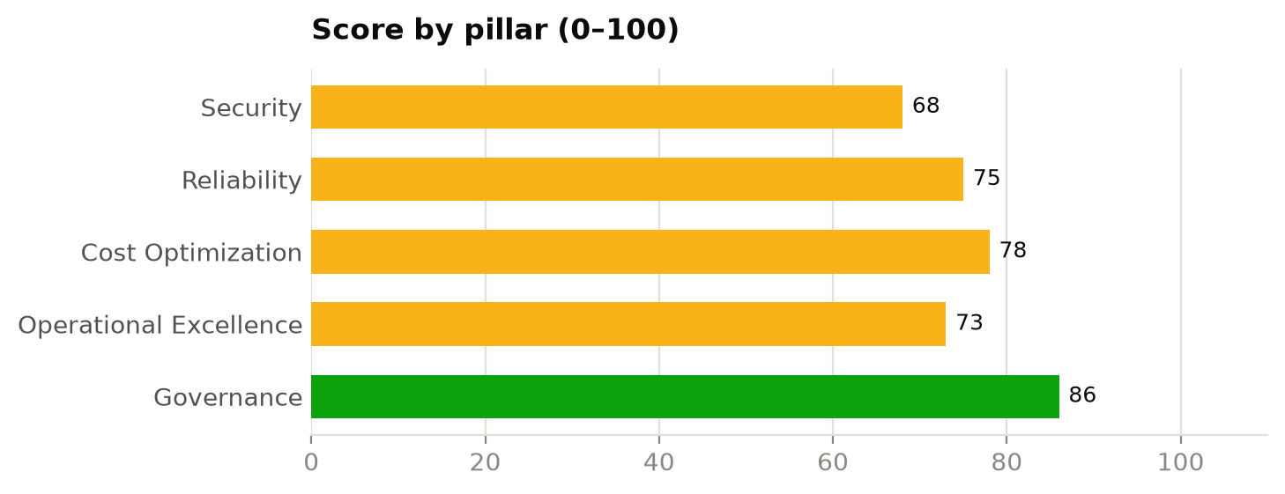

2. Scope and methodology
The assessment is based on the resource inventory export supplied by Contoso (sample-inventory.csv). No access to the Azure environment was required. Each resource was evaluated against a rule set aligned to the Microsoft Azure Well-Architected Framework pillars (Security, Reliability, Cost Optimization, Operational Excellence) plus a Governance pillar covering tagging, regions and deployment model.
Pillar scores are the severity-weighted pass rate of all rule evaluations in that pillar (High = 5, Medium = 3, Low = 1). 80+ is rated Good, 60–79 Fair, and below 60 Poor.
Subscription | Subscription ID | Resources
Contoso-Production | 11111111-1111-1111-1111-111111111111 | 77
Contoso-NonProduction | 22222222-2222-2222-2222-222222222222 | 54
Contoso-Connectivity | 33333333-3333-3333-3333-333333333333 | 21

3. Architecture assessment
This section identifies the architecture patterns the environment follows, such as its network topology, hybrid connectivity and subscription model, and compares them with Microsoft's reference architectures (the Cloud Adoption Framework Azure landing zone and the Well-Architected Framework). Each area states the pattern identified, the evidence for it in the inventory, and considerations.
Confidence shows how firmly the inventory supports each conclusion: High means direct configuration evidence, Medium means inferred from resource types and naming, Low means the export lacked the data. Identity (Microsoft Entra ID), role assignments, Azure Policy and management groups are not part of a resource inventory and are outside the scope of this section.
Architecture at a glance
Area | Pattern identified | Confidence
3.1 Network topology | Multi-region hub-and-spoke with exceptions | High
3.2 Hybrid connectivity | Site-to-site VPN to on-premises | High
3.3 Traffic flow and perimeter security | Defence in depth (central firewall, WAF-protected ingress, private endpoints for PaaS, Bastion for admin access) | High
3.4 Subscription and landing zone model | Landing-zone style: platform and workload subscriptions, split by environment | Medium
3.5 Application hosting architecture | Hybrid IaaS/PaaS, three-tier (web, application, data) | Medium
3.6 Resilience and disaster recovery | Multi-region, but not in Azure region pairs; no DR replication evidence | Medium
3.7 Operations and monitoring | Federated logging (one workspace per subscription) | Medium

3.1 Network topology
Pattern identified: Multi-region hub-and-spoke with exceptions (confidence: High)
The network is built around 2 hub virtual networks (vnet-hub-eastus in eastus and vnet-hub-westeurope in westeurope), which host shared services: Azure Bastion, Azure Firewall and VPN gateway. 3 spoke networks peer to the hubs and carry the workloads. This is the hub-and-spoke pattern recommended in the Azure landing zone reference architecture: shared connectivity, inspection and management access are centralised in the hub, and workloads are isolated in spokes.
The regional hubs are peered with each other (global VNet peering), giving cross-region connectivity between spokes through their hubs.
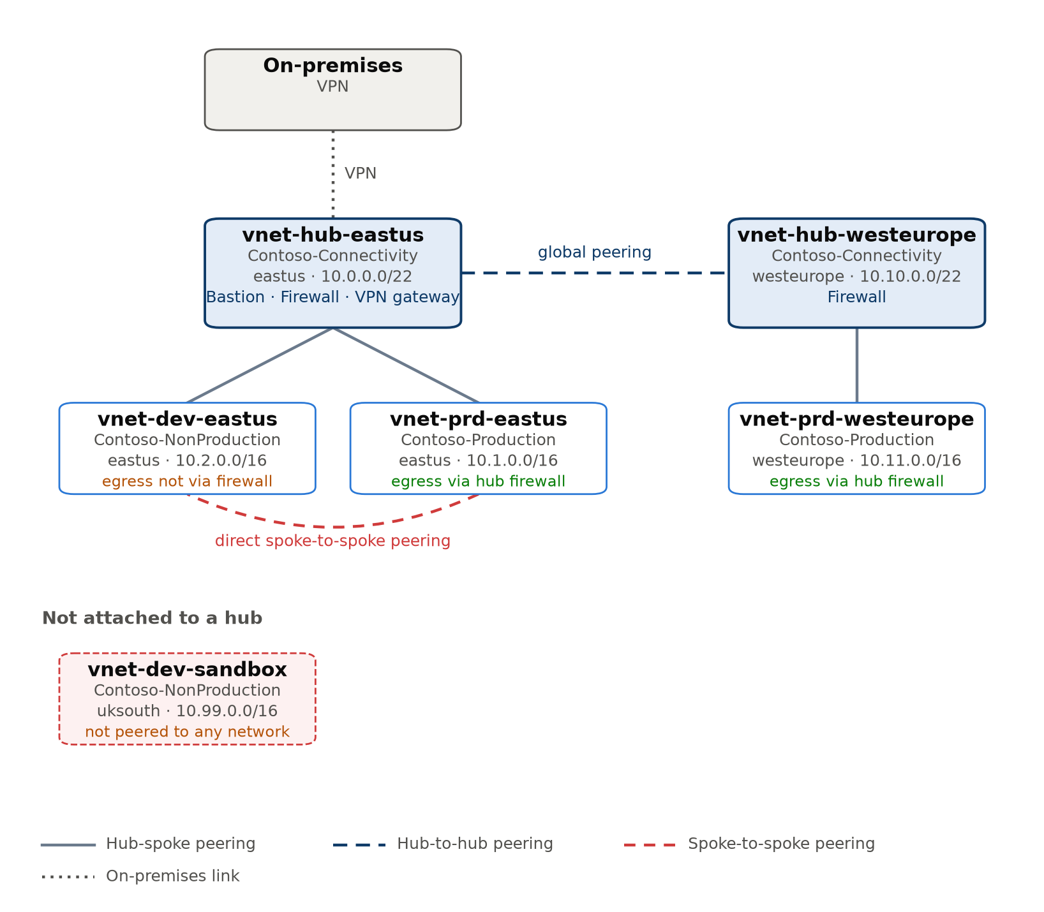
Figure: network topology derived from VNet peerings (Multi-region hub-and-spoke with exceptions).
Evidence from the inventory
- Hub vnet-hub-eastus (eastus, Contoso-Connectivity): address space 10.0.0.0/22; services: Azure Bastion, Azure Firewall and VPN gateway; spokes: vnet-prd-eastus and vnet-dev-eastus.
- Hub vnet-hub-westeurope (westeurope, Contoso-Connectivity): address space 10.10.0.0/22; services: Azure Firewall; spokes: vnet-prd-westeurope.
- Spokes vnet-prd-eastus and vnet-prd-westeurope send Internet-bound traffic to the hub firewall through a 0.0.0.0/0 route. vnet-dev-eastus has no such route, so its outbound traffic bypasses central inspection.
- vnet-prd-eastus (Contoso-Production) is peered directly with vnet-dev-eastus (Contoso-NonProduction), bypassing the hub.
- vnet-dev-sandbox (uksouth, Contoso-NonProduction) is not peered to any network.
Virtual networks
VNet | Role | Subscription | Region | Address space | Peered with | Default route via firewall
vnet-hub-eastus | Hub | Contoso-Connectivity | eastus | 10.0.0.0/22 | vnet-dev-eastus, vnet-hub-westeurope, vnet-prd-eastus | -
vnet-hub-westeurope | Hub | Contoso-Connectivity | westeurope | 10.10.0.0/22 | vnet-hub-eastus, vnet-prd-westeurope | -
vnet-dev-eastus | Spoke | Contoso-NonProduction | eastus | 10.2.0.0/16 | vnet-hub-eastus, vnet-prd-eastus | No
vnet-prd-eastus | Spoke | Contoso-Production | eastus | 10.1.0.0/16 | vnet-dev-eastus, vnet-hub-eastus | Yes
vnet-prd-westeurope | Spoke | Contoso-Production | westeurope | 10.11.0.0/16 | vnet-hub-westeurope | Yes
vnet-dev-sandbox | Isolated | Contoso-NonProduction | uksouth | 10.99.0.0/16 | - | No

Considerations against the reference architecture
- Remove direct spoke-to-spoke peerings and route that traffic through the hub firewall, particularly between production and non-production (Contoso-NonProduction and Contoso-Production).
- Add a user-defined route (0.0.0.0/0 to the hub firewall) to vnet-dev-eastus so all egress is inspected.
- Decide whether vnet-dev-sandbox should join the hub or be removed; unmanaged islands tend to accumulate public exposure.
Related findings
- SEC-007 NSG exposes management ports to the Internet: High, 2 resources (see 6.1 Security)

3.2 Hybrid connectivity
Pattern identified: Site-to-site VPN to on-premises (confidence: High)
The environment connects to on-premises through a site-to-site VPN, terminated in the hub network vnet-hub-eastus. Spokes use the hub gateway through gateway transit, which is the recommended shared-gateway design.
Evidence from the inventory
- vgw-hub-eastus: Vpn gateway, SKU VpnGw2AZ, zone-redundant, active-standby, deployed in vnet-hub-eastus.
- lng-onprem-dc1: on-premises site at 203.0.113.10 advertising 192.168.0.0/16.
- cn-hub-eastus-to-dc1: IPsec connection, status Connected.
Considerations against the reference architecture
- Only eastus has a gateway; spokes in westeurope reach on-premises across regions, and lose on-premises connectivity if that region is unavailable. Add a gateway in each regional hub.
- A single VPN tunnel runs over the Internet; for production workloads with latency or bandwidth needs, consider ExpressRoute with VPN as backup.
- Configure VPN gateways as active-active with two on-premises devices to remove a single point of failure.

3.3 Traffic flow and perimeter security
Pattern identified: Defence in depth (central firewall, WAF-protected ingress, private endpoints for PaaS, Bastion for admin access) (confidence: High)
Inbound: traffic enters through 1 Application Gateway (agw-prd-eastus; WAF enabled) and 1 load balancer.
Outbound and east-west: 2 Azure Firewalls (afw-hub-eastus and afw-hub-westeurope) inspect traffic; 2 spokes force Internet-bound traffic through them.
Administration: Azure Bastion (bas-hub-eastus) provides browser-based RDP/SSH without public IPs on VMs. However, some network security groups still allow RDP or SSH from the Internet.
PaaS access: 2 private endpoints connect PaaS services privately (sql-prd-01 and stprddata00). 15 services still accept public network traffic.
Evidence from the inventory
- Web application firewall: agw-prd-eastus.
- DDoS Network Protection plan: none.
Considerations against the reference architecture
- Remove Internet-sourced RDP/SSH rules now that Bastion is available.
- Extend private endpoints to the remaining PaaS services and disable their public network access (stprddata00, stprddata01, stprddata02, stprddata03, stprddata04 and kv-prd-00 …).
- Consider DDoS Network Protection for virtual networks with Internet-facing workloads.
Related findings
- SEC-007 NSG exposes management ports to the Internet: High, 2 resources (see 6.1 Security)
- SEC-005 SQL server reachable from public networks: Medium, 1 resource (see 6.1 Security)
- SEC-002 Storage account allows anonymous blob access: High, 4 resources (see 6.1 Security)
- SEC-006 Web app does not enforce HTTPS: High, 2 resources (see 6.1 Security)

3.4 Subscription and landing zone model
Pattern identified: Landing-zone style: platform and workload subscriptions, split by environment (confidence: Medium)
The 3 subscriptions in scope appear to play these roles: Contoso-Connectivity (platform: connectivity), Contoso-NonProduction (workload: non-production) and Contoso-Production (workload: production). Roles are inferred from subscription names, environment tags and the resources each contains.
Separating shared platform services (connectivity, management) from application workloads follows the Azure landing zone model in the Cloud Adoption Framework, where platform teams own the hub and workload teams own their subscriptions.
Subscription roles
Subscription | Inferred role | Resources | Main resource types
Contoso-Connectivity | Platform: connectivity | 21 | Public IP addresses (6), Network security groups (4), Virtual networks (2)
Contoso-NonProduction | Workload: non-production | 54 | Managed disks (14), Virtual machines (10), Network interfaces (10)
Contoso-Production | Workload: production | 77 | Managed disks (20), Virtual machines (14), Network interfaces (14)

Considerations against the reference architecture
- There is no dedicated management subscription; Log Analytics workspaces sit in Contoso-NonProduction and Contoso-Production. The landing zone model places central logging, automation and backup in a management subscription.
- No identity subscription was found. If domain controllers or identity services run in Azure, isolate them in a dedicated identity subscription.
- Management groups, Azure Policy assignments and RBAC are not part of a resource inventory; review them separately to confirm the landing zone governance.

3.5 Application hosting architecture
Pattern identified: Hybrid IaaS/PaaS, three-tier (web, application, data) (confidence: Medium)
Workloads run on IaaS virtual machines and App Service web apps: 24 VM-based resources and 16 managed (PaaS) services. VMs make up the majority, so the estate is primarily IaaS; much of the operating system patching, scaling and availability work remains with the customer.
Tiers identified: presentation (Application Gateway and App Service), application (VMs and App Service) and data (SQL databases and SQL servers).
Evidence from the inventory
- Virtual machines: 24; scale sets: 0; AKS clusters: 0; web apps: 8; function apps: 0; databases and caches: 8.
Considerations against the reference architecture
- No VM scale sets are used, so VM capacity does not scale automatically. Stateless tiers are good candidates for scale sets or App Service.
- Review VM-hosted components for replatforming to PaaS (App Service, Azure SQL, AKS) to reduce operational overhead.
Related findings
- OPS-001 Previous-generation VM size: Low, 5 resources (see 6.4 Operational Excellence)
- COST-003 VM stopped but not deallocated: High, 4 resources (see 6.3 Cost Optimization)
- COST-005 Empty App Service plan: Medium, 2 resources (see 6.3 Cost Optimization)

3.6 Resilience and disaster recovery
Pattern identified: Multi-region, but not in Azure region pairs; no DR replication evidence (confidence: Medium)
Production runs in 4 regions (eastus: 36, westeurope: 24, uksouth: 10, centralindia: 7 resources). None of these regions are paired with each other. Running in several regions only provides disaster recovery if data is replicated and workloads can fail over; the inventory shows the building blocks, not a tested failover plan.
Within regions: 9 of 24 VMs use availability zones, 3 of 10 storage accounts replicate across zones and 4 replicate to a paired region, and 1 of 6 SQL databases is zone redundant.
Backup and site recovery: 0 vaults found, so there is no evidence of Azure Backup or Azure Site Recovery protecting these workloads.
Considerations against the reference architecture
- Deploy Recovery Services vaults and back up VMs and databases; define RPO/RTO per workload.
- Decide the DR strategy per workload (active/active, active/passive or backup-and-restore), then replicate data and test failover.
- Place production VMs across availability zones (or use zone-redundant scale sets) to survive a datacenter failure.
Related findings
- REL-001 VM has no zone or availability set: Medium, 15 resources (see 6.2 Reliability)
- REL-003 Storage account uses locally redundant replication: Low, 3 resources (see 6.2 Reliability)
- REL-004 SQL database not zone redundant: Low, 3 resources (see 6.2 Reliability)

3.7 Operations and monitoring
Pattern identified: Federated logging (one workspace per subscription) (confidence: Medium)
Logs go to 2 Log Analytics workspaces (log-prd-01 in Contoso-Production and log-dev-01 in Contoso-NonProduction). Each subscription keeps its own workspace, which simplifies access control per environment but makes cross-environment queries and a single security view (Microsoft Sentinel) harder.
Contoso-Connectivity has no workspace of its own and must send logs elsewhere.
Automation accounts: 0. Diagnostic settings, alert rules and Azure Monitor agent coverage are not part of a resource inventory and need a separate review.
Considerations against the reference architecture
- The landing zone model recommends a central workspace in the management subscription, with resource-context access for workload teams.
Related findings
- OPS-002 Log Analytics retention below target: Low, 2 resources (see 6.4 Operational Excellence)

4. Infrastructure overview
This section describes the environment as understood from the inventory export: what it contains, how it is organised and how each area is configured. Each part ends with the findings that relate to it, so the description can be read alongside the findings in section 6 and the roadmap in section 7.

4.1 Estate at a glance
The environment described by sample-inventory.csv contains 152 Azure resources organised into 3 subscriptions and 23 resource groups, deployed across 5 regions. eastus is the primary region, hosting 49% of all resources, followed by westeurope (27%), uksouth (18%) and centralindia (5%).
By function, the estate is made up of compute (38%), networking (38%), application hosting (8%), storage (7%), databases (5%), security services (3%), monitoring and management (1%) and classic (legacy) resources (1%). The most common resource types are managed disks (34), virtual machines (24), network interfaces (24), storage accounts (10) and App Services (8).
The hosting model is predominantly infrastructure-as-a-service (IaaS), built around virtual machines: there are 24 virtual machines alongside 20 managed application or database services.
Resources by functional area
Area | Resources | % of estate | Main resource types
Compute | 58 | 38% | Managed disks (34), Virtual machines (24)
Networking | 57 | 38% | Network interfaces (24), Network security groups (7), Virtual networks (6)
Application hosting | 12 | 8% | App Services (8), App Service plans (4)
Storage | 10 | 7% | Storage accounts (10)
Databases | 8 | 5% | SQL databases (6), SQL servers (2)
Security services | 4 | 3% | Key vaults (4)
Monitoring and management | 2 | 1% | Log Analytics workspaces (2)
Classic (legacy) resources | 1 | 1% | Classic cloud services (1)

4.2 Subscriptions and resource organisation
Resources are spread across 3 subscriptions. The breakdown below describes what each subscription contains, which helps show how workloads and environments are separated.
On average a resource group holds 6.6 resources. The largest are rg-prd-app01 in Contoso-Production (19), rg-dev-app01 in Contoso-NonProduction (13) and rg-prd-app02 in Contoso-Production (12).
- Contoso-Production: 77 resources in 9 resource groups across 4 regions (centralindia, eastus, uksouth and westeurope). It mainly contains managed disks (20), virtual machines (14) and network interfaces (14). Resources are tagged as environment 'prod'.
- Contoso-NonProduction: 54 resources in 10 resource groups across 4 regions (centralindia, eastus, uksouth and westeurope). It mainly contains managed disks (14), virtual machines (10) and network interfaces (10). Resources are tagged as environment 'dev'.
- Contoso-Connectivity: 21 resources in 4 resource groups across 3 regions (eastus, global and westeurope). It mainly contains public IP addresses (6), network security groups (4) and virtual networks (2). Resources are tagged as environment 'shared'.
Subscription summary
Subscription | Resources | Resource groups | Regions | Main resource types
Contoso-Production | 77 | 9 | centralindia, eastus, uksouth, westeurope | Managed disks (20), Virtual machines (14), Network interfaces (14)
Contoso-NonProduction | 54 | 10 | centralindia, eastus, uksouth, westeurope | Managed disks (14), Virtual machines (10), Network interfaces (10)
Contoso-Connectivity | 21 | 4 | eastus, global, westeurope | Public IP addresses (6), Network security groups (4), Virtual networks (2)

4.3 Regional footprint
Resources are deployed in 5 regions: eastus (74), westeurope (41), uksouth (27), centralindia (8) and global (2). Running in several regions gives the option of regional resilience, but only if workloads are actually designed to fail over between them.
The approved regions are eastus, westeurope and uksouth. 8 resources sit outside them, in centralindia (8).
Resources by region
Region | Resources | % of estate | Main areas
eastus | 74 | 49% | Networking (32), Compute (25), Application hosting (7)
westeurope | 41 | 27% | Compute (14), Networking (14), Storage (5)
uksouth | 27 | 18% | Compute (15), Networking (8), Databases (2)
centralindia | 8 | 5% | Compute (4), Storage (2), Networking (1)
global | 2 | 1% | Networking (2)

Related findings
- GOV-002 Resource outside approved regions: Medium, 8 resources (see 6.5 Governance)

4.4 Compute
There are 24 virtual machines across 2 subscriptions and 4 regions.
By operating system, the fleet is Linux (20) and Windows (4). It uses 6 VM sizes, mostly D-series v5 (13), E-series v5 (4) and A-series v2 (3); the most common sizes are Standard_D2s_v5 (9), Standard_E8s_v5 (4) and Standard_D4s_v5 (4).
At the time of export 19 of 24 VMs (79%) were running, 1 was deallocated and 4 were stopped but still allocated, which means their compute is still being billed.
For resilience, 9 VMs are pinned to availability zones and 0 sit in availability sets; the remaining 15 have no zone or availability-set protection and depend on a single host or datacenter.
Storage for these machines is provided by 34 managed disks totalling 4,928 GB, on Premium_LRS (31) and StandardSSD_LRS (3) tiers. Disk states are Attached (24) and Unattached (10). The 10 unattached disks (1,856 GB) are not used by any VM but are still billed.
Virtual machines by size
VM size | Series | Count
Standard_D2s_v5 | D-series v5 | 9
Standard_E8s_v5 | E-series v5 | 4
Standard_D4s_v5 | D-series v5 | 4
Standard_A2_v2 | A-series v2 | 3
Standard_DS2_v2 | DS-series v2 | 2
Standard_B2ms | B-series | 2

Related findings
- REL-001 VM has no zone or availability set: Medium, 15 resources (see 6.2 Reliability)
- COST-003 VM stopped but not deallocated: High, 4 resources (see 6.3 Cost Optimization)
- COST-004 Deallocated VM: Low, 1 resource (see 6.3 Cost Optimization)
- COST-001 Unattached managed disk: Medium, 10 resources (see 6.3 Cost Optimization)
- OPS-001 Previous-generation VM size: Low, 5 resources (see 6.4 Operational Excellence)

4.5 Networking
The network layer consists of 57 resources: Network interfaces (24), Network security groups (7), Virtual networks (6), Public IP addresses (6), Azure Firewalls (2), routetables (2), privateendpoints (2), privatednszones (2), virtualnetworkgateways (1), localnetworkgateways (1), connections (1), bastionhosts (1), Application gateways (1) and Load balancers (1).
There are 6 virtual networks in eastus, uksouth and westeurope, with 2 Azure Firewalls deployed. How these networks connect to each other (the topology) is assessed in the Architecture assessment section.
Traffic filtering uses 7 network security groups with 9 custom rules between them. Some NSGs allow RDP or SSH from the Internet (see related findings).
6 public IP addresses are allocated; 2 of them are not associated with any resource.
Network resources
Resource type | Count | Regions
Network interfaces | 24 | centralindia, eastus, uksouth, westeurope
Network security groups | 7 | eastus, westeurope
Virtual networks | 6 | eastus, uksouth, westeurope
Public IP addresses | 6 | eastus, westeurope
Azure Firewalls | 2 | eastus, westeurope
routetables | 2 | eastus, westeurope
privateendpoints | 2 | eastus
privatednszones | 2 | global
virtualnetworkgateways | 1 | eastus
localnetworkgateways | 1 | eastus
connections | 1 | eastus
bastionhosts | 1 | eastus
Application gateways | 1 | eastus
Load balancers | 1 | eastus

Related findings
- SEC-007 NSG exposes management ports to the Internet: High, 2 resources (see 6.1 Security)
- COST-002 Unassociated public IP address: Low, 2 resources (see 6.3 Cost Optimization)

4.6 Storage
There are 10 storage accounts, all of kind StorageV2. Replication is GRS for 4, LRS for 3 and ZRS for 3. LRS keeps copies within one datacenter only; ZRS spreads them across zones and GRS/GZRS add a copy in a paired region.
On security settings, 6 of 10 accounts require HTTPS, 8 enforce TLS 1.2 or later, 4 allow anonymous blob access, and 10 accept traffic from public networks.
Storage accounts
Account | Subscription | Replication | HTTPS only | Min TLS | Anonymous blob access
stdevdata00 | Contoso-NonProduction | Standard_GRS | Yes | TLS1_2 | Allowed
stdevdata01 | Contoso-NonProduction | Standard_GRS | No | TLS1_2 | Allowed
stdevdata02 | Contoso-NonProduction | Standard_LRS | Yes | TLS1_0 | Blocked
stdevdata03 | Contoso-NonProduction | Standard_ZRS | No | TLS1_2 | Blocked
stdevdata04 | Contoso-NonProduction | Standard_GRS | Yes | TLS1_0 | Blocked
stprddata00 | Contoso-Production | Standard_LRS | Yes | TLS1_2 | Blocked
stprddata01 | Contoso-Production | Standard_GRS | Yes | TLS1_2 | Blocked
stprddata02 | Contoso-Production | Standard_ZRS | Yes | TLS1_2 | Allowed
stprddata03 | Contoso-Production | Standard_ZRS | No | TLS1_2 | Blocked
stprddata04 | Contoso-Production | Standard_LRS | No | TLS1_2 | Allowed

Related findings
- SEC-001 Storage account permits HTTP: High, 4 resources (see 6.1 Security)
- SEC-002 Storage account allows anonymous blob access: High, 4 resources (see 6.1 Security)
- SEC-003 Storage account accepts TLS < 1.2: Medium, 2 resources (see 6.1 Security)
- REL-003 Storage account uses locally redundant replication: Low, 3 resources (see 6.2 Reliability)

4.7 Databases
Azure SQL is used with 2 logical servers hosting 6 databases on the S1 (3), Basic (2) and GP_Gen5_2 (1) service tiers.
Public network access is enabled on sql-dev-01; 1 of 6 databases is zone redundant.
Related findings
- SEC-005 SQL server reachable from public networks: Medium, 1 resource (see 6.1 Security)
- REL-004 SQL database not zone redundant: Low, 3 resources (see 6.2 Reliability)

4.8 Application hosting
Web workloads run on Azure App Service: 8 apps hosted on 4 App Service plans (P1v3 (2), S1 (1) and B1 (1) pricing tiers).
6 of 8 apps enforce HTTPS-only access. The plan(s) asp-dev-00 and asp-dev-01 host no apps but still incur charges.
Related findings
- SEC-006 Web app does not enforce HTTPS: High, 2 resources (see 6.1 Security)
- COST-005 Empty App Service plan: Medium, 2 resources (see 6.3 Cost Optimization)

4.9 Security services
Secrets, keys and certificates are held in 4 Key Vaults (kv-dev-00, kv-dev-01, kv-prd-00 and kv-prd-01).
3 of 4 vaults have purge protection enabled, which prevents deleted secrets from being permanently removed during the retention period.
Network perimeter protection is provided by 2 Azure Firewalls in eastus and westeurope.
Related findings
- SEC-004 Key Vault purge protection disabled: Medium, 1 resource (see 6.1 Security)

4.10 Monitoring and management
Logs are collected in 2 Log Analytics workspaces (log-dev-01 and log-prd-01).
Log retention is 30 days on 2 workspaces.
No Recovery Services vault was found, so there is no evidence of Azure Backup protecting the virtual machines or databases.
Related findings
- OPS-002 Log Analytics retention below target: Low, 2 resources (see 6.4 Operational Excellence)

4.11 Governance and tagging
135 of 152 resources (89%) carry at least one tag, and 78% carry all of the required tags (environment, owner and costCenter).
In total 3 distinct tag keys are in use, most often costCenter (126), environment (125) and owner (125).
1 resource still uses the classic (Azure Service Manager) deployment model (legacy-cloudservice). This model is retired, so it needs migrating to Azure Resource Manager.
Required tag coverage
Tag | Resources tagged | Coverage | Most common values
environment | 125 | 82% | prod (63), dev (44), shared (18)
owner | 125 | 82% | app-team (44), platform (44), data-team (37)
costCenter | 126 | 83% | CC300 (43), CC200 (42), CC100 (41)

Related findings
- GOV-001 Required tags missing: Medium, 34 resources (see 6.5 Governance)
- GOV-002 Resource outside approved regions: Medium, 8 resources (see 6.5 Governance)
- GOV-003 Classic (ASM) resource in use: High, 1 resource (see 6.5 Governance)

5. Inventory charts and statistics
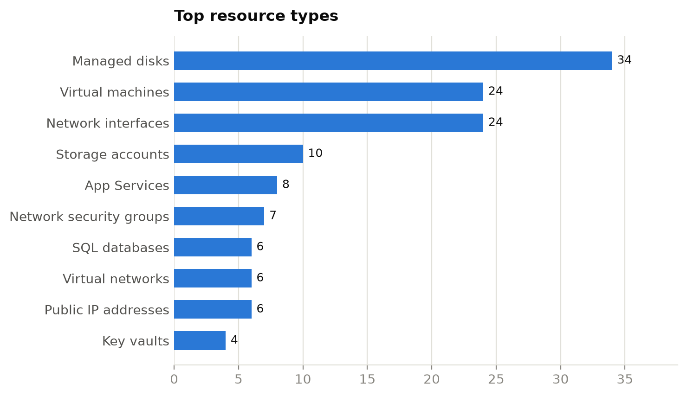
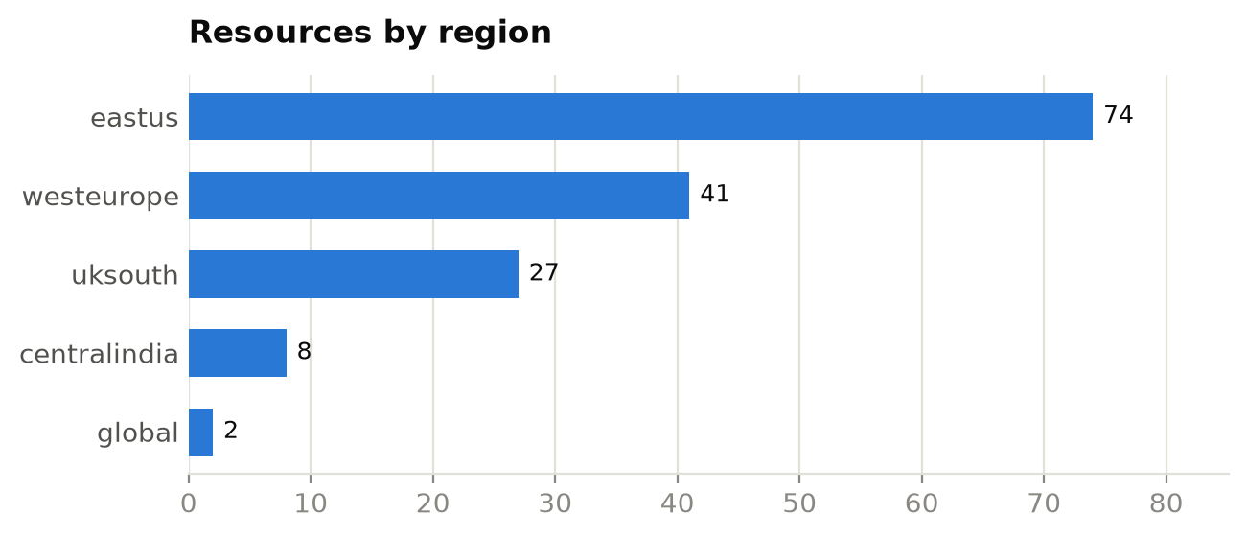
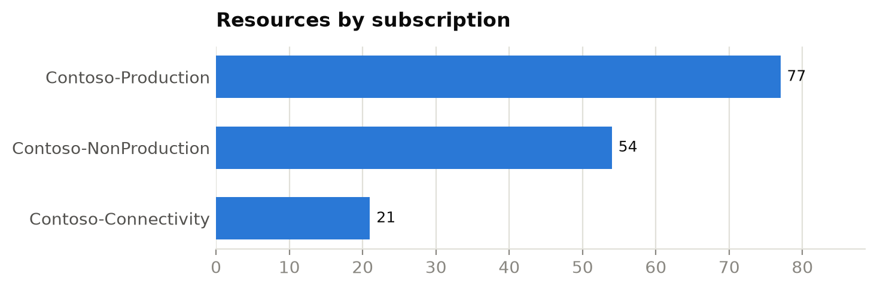

Resource types
Resource type | Count | % of estate
Managed disks | 34 | 22.4%
Virtual machines | 24 | 15.8%
Network interfaces | 24 | 15.8%
Storage accounts | 10 | 6.6%
App Services | 8 | 5.3%
Network security groups | 7 | 4.6%
SQL databases | 6 | 3.9%
Virtual networks | 6 | 3.9%
Public IP addresses | 6 | 3.9%
Key vaults | 4 | 2.6%
App Service plans | 4 | 2.6%
SQL servers | 2 | 1.3%
Log Analytics workspaces | 2 | 1.3%
Azure Firewalls | 2 | 1.3%
routetables | 2 | 1.3%
privateendpoints | 2 | 1.3%
privatednszones | 2 | 1.3%
Classic cloud services | 1 | 0.7%
virtualnetworkgateways | 1 | 0.7%
localnetworkgateways | 1 | 0.7%
connections | 1 | 0.7%
bastionhosts | 1 | 0.7%
Application gateways | 1 | 0.7%
Load balancers | 1 | 0.7%

6. Assessment findings
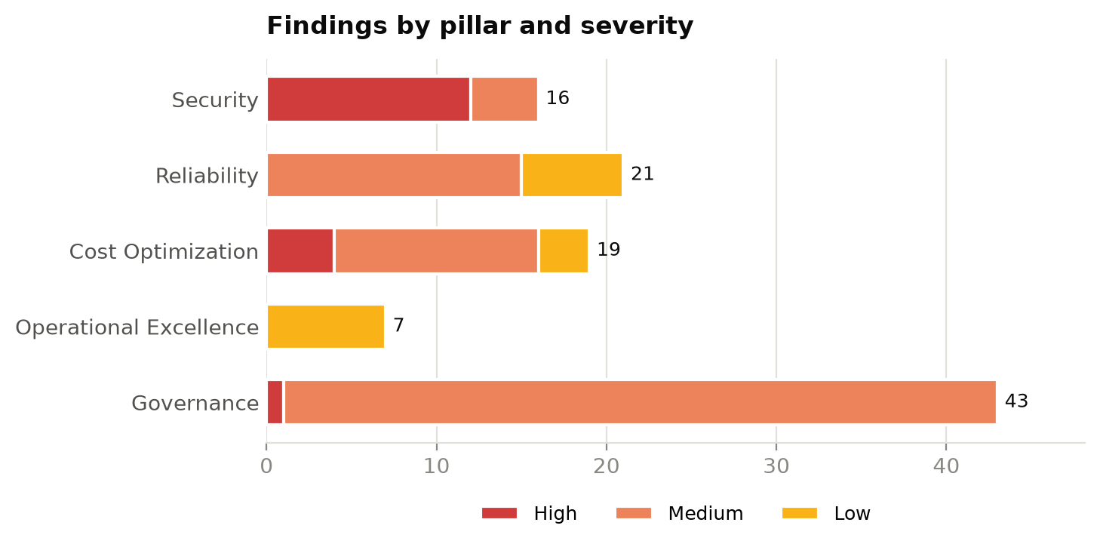

6.1 Security — 68/100 (Fair)

SEC-001: Storage account permits HTTP
Severity: High Affected: 4 of 10 evaluated resources
Recommendation: Enable 'Secure transfer required' on the storage account.
Examples: stdevdata01, stdevdata03, stprddata03, stprddata04
Context: see 4.6 Storage in the infrastructure overview.

SEC-002: Storage account allows anonymous blob access
Severity: High Affected: 4 of 10 evaluated resources
Recommendation: Set allowBlobPublicAccess to false and use SAS or Entra ID for access.
Examples: stdevdata00, stdevdata01, stprddata02, stprddata04
Context: see 4.6 Storage in the infrastructure overview.

SEC-006: Web app does not enforce HTTPS
Severity: High Affected: 2 of 8 evaluated resources
Recommendation: Enable 'HTTPS Only' on the App Service.
Examples: app-dev-01, app-dev-02
Context: see 4.8 Application hosting in the infrastructure overview.

SEC-007: NSG exposes management ports to the Internet
Severity: High Affected: 2 of 7 evaluated resources
Recommendation: Remove Internet-sourced RDP/SSH rules; use Azure Bastion or Just-in-Time VM access.
Examples: nsg-mgmt-eastus, nsg-mgmt-westeurope
Context: see 4.5 Networking in the infrastructure overview.

SEC-003: Storage account accepts TLS < 1.2
Severity: Medium Affected: 2 of 10 evaluated resources
Recommendation: Set minimum TLS version to 1.2.
Examples: stdevdata02, stdevdata04
Context: see 4.6 Storage in the infrastructure overview.

SEC-004: Key Vault purge protection disabled
Severity: Medium Affected: 1 of 4 evaluated resources
Recommendation: Enable purge protection to guard secrets and keys against malicious or accidental deletion.
Examples: kv-dev-00
Context: see 4.9 Security services in the infrastructure overview.

SEC-005: SQL server reachable from public networks
Severity: Medium Affected: 1 of 2 evaluated resources
Recommendation: Disable public network access and connect through Private Endpoints.
Examples: sql-dev-01
Context: see 4.7 Databases in the infrastructure overview.

6.2 Reliability — 75/100 (Fair)

REL-001: VM has no zone or availability set
Severity: Medium Affected: 15 of 24 evaluated resources
Recommendation: Deploy production VMs across availability zones or in a scale set / availability set.
Examples: vm-dev-000, vm-dev-001, vm-dev-002, vm-dev-003, vm-dev-004 …
Context: see 4.4 Compute in the infrastructure overview.

REL-003: Storage account uses locally redundant replication
Severity: Low Affected: 3 of 10 evaluated resources
Recommendation: Use ZRS/GZRS for production data that needs zone or regional resilience.
Examples: stdevdata02, stprddata00, stprddata04
Context: see 4.6 Storage in the infrastructure overview.

REL-004: SQL database not zone redundant
Severity: Low Affected: 3 of 6 evaluated resources
Recommendation: Enable zone redundancy on business-critical databases.
Examples: sql-dev-01/db1, sql-dev-01/db2, sql-prd-01/db1
Context: see 4.7 Databases in the infrastructure overview.

6.3 Cost Optimization — 78/100 (Fair)

COST-003: VM stopped but not deallocated
Severity: High Affected: 4 of 24 evaluated resources
Recommendation: Deallocate stopped VMs (Stop from the portal/CLI) or schedule auto-shutdown.
Examples: vm-dev-006, vm-dev-009, vm-prd-000, vm-prd-001
Context: see 4.4 Compute in the infrastructure overview.

COST-001: Unattached managed disk
Severity: Medium Affected: 10 of 34 evaluated resources
Recommendation: Snapshot if required, then delete orphaned disks.
Examples: disk-dev-orphan-0, disk-dev-orphan-1, disk-dev-orphan-2, disk-dev-orphan-3, disk-prd-orphan-0 …
Context: see 4.4 Compute in the infrastructure overview.

COST-005: Empty App Service plan
Severity: Medium Affected: 2 of 4 evaluated resources
Recommendation: Delete or consolidate App Service plans with no apps.
Examples: asp-dev-00, asp-dev-01
Context: see 4.8 Application hosting in the infrastructure overview.

COST-002: Unassociated public IP address
Severity: Low Affected: 2 of 6 evaluated resources
Recommendation: Release public IPs that are not attached to any resource.
Examples: pip-eastus-0, pip-westeurope-0
Context: see 4.5 Networking in the infrastructure overview.

COST-004: Deallocated VM
Severity: Low Affected: 1 of 24 evaluated resources
Recommendation: Confirm the VM is still needed; delete it and its disks if not.
Examples: vm-prd-008
Context: see 4.4 Compute in the infrastructure overview.

6.4 Operational Excellence — 73/100 (Fair)

OPS-001: Previous-generation VM size
Severity: Low Affected: 5 of 24 evaluated resources
Recommendation: Resize to current generation (v5/v6) SKUs for better price-performance.
Examples: vm-dev-006, vm-prd-001, vm-prd-002, vm-prd-004, vm-prd-008
Context: see 4.4 Compute in the infrastructure overview.

OPS-002: Log Analytics retention below target
Severity: Low Affected: 2 of 2 evaluated resources
Recommendation: Increase retention or archive to meet audit and investigation requirements.
Examples: log-dev-01, log-prd-01
Context: see 4.10 Monitoring and management in the infrastructure overview.

6.5 Governance — 86/100 (Good)

GOV-003: Classic (ASM) resource in use
Severity: High Affected: 1 of 1 evaluated resources
Recommendation: Migrate classic resources to Azure Resource Manager before platform retirement.
Examples: legacy-cloudservice
Context: see 4.11 Governance and tagging in the infrastructure overview.

GOV-001: Required tags missing
Severity: Medium Affected: 34 of 152 evaluated resources
Recommendation: Enforce the tagging standard with Azure Policy (Require/Inherit a tag) and back-fill existing resources.
Examples: app-prd-01, asp-dev-00, asp-dev-01, disk-dev-orphan-0, disk-prd-orphan-3 …
Context: see 4.11 Governance and tagging in the infrastructure overview.

GOV-002: Resource outside approved regions
Severity: Medium Affected: 8 of 152 evaluated resources
Recommendation: Apply the 'Allowed locations' policy and plan migration of out-of-policy resources.
Examples: disk-dev-orphan-2, disk-prd-orphan-3, nic-prd-012, sql-prd-01, stprddata00 …
Context: see 4.3 Regional footprint in the infrastructure overview.

7. Remediation roadmap

0-30 days (quick wins & critical risk)
ID | Action | Severity | Pillar | Resources
SEC-001 | Enable 'Secure transfer required' on the storage account. | High | Security | 4
SEC-002 | Set allowBlobPublicAccess to false and use SAS or Entra ID for access. | High | Security | 4
COST-003 | Deallocate stopped VMs (Stop from the portal/CLI) or schedule auto-shutdown. | High | Cost Optimization | 4
SEC-006 | Enable 'HTTPS Only' on the App Service. | High | Security | 2
SEC-007 | Remove Internet-sourced RDP/SSH rules; use Azure Bastion or Just-in-Time VM access. | High | Security | 2
GOV-003 | Migrate classic resources to Azure Resource Manager before platform retirement. | High | Governance | 1
COST-001 | Snapshot if required, then delete orphaned disks. | Medium | Cost Optimization | 10
COST-005 | Delete or consolidate App Service plans with no apps. | Medium | Cost Optimization | 2
COST-002 | Release public IPs that are not attached to any resource. | Low | Cost Optimization | 2
COST-004 | Confirm the VM is still needed; delete it and its disks if not. | Low | Cost Optimization | 1

30-60 days
ID | Action | Severity | Pillar | Resources
GOV-001 | Enforce the tagging standard with Azure Policy (Require/Inherit a tag) and back-fill existing resources. | Medium | Governance | 34
REL-001 | Deploy production VMs across availability zones or in a scale set / availability set. | Medium | Reliability | 15
GOV-002 | Apply the 'Allowed locations' policy and plan migration of out-of-policy resources. | Medium | Governance | 8
SEC-003 | Set minimum TLS version to 1.2. | Medium | Security | 2
SEC-004 | Enable purge protection to guard secrets and keys against malicious or accidental deletion. | Medium | Security | 1
SEC-005 | Disable public network access and connect through Private Endpoints. | Medium | Security | 1

60-90 days
ID | Action | Severity | Pillar | Resources
OPS-001 | Resize to current generation (v5/v6) SKUs for better price-performance. | Low | Operational Excellence | 5
REL-003 | Use ZRS/GZRS for production data that needs zone or regional resilience. | Low | Reliability | 3
REL-004 | Enable zone redundancy on business-critical databases. | Low | Reliability | 3
OPS-002 | Increase retention or archive to meet audit and investigation requirements. | Low | Operational Excellence | 2

Appendix A. Detailed findings
Rule | Severity | Resource | Type | Resource group | Subscription | Detail
COST-003 | High | vm-dev-006 | Virtual machines | rg-dev-app03 | Contoso-NonProduction | VM is stopped but still allocated (compute is billed)
COST-003 | High | vm-dev-009 | Virtual machines | rg-dev-app02 | Contoso-NonProduction | VM is stopped but still allocated (compute is billed)
COST-003 | High | vm-prd-000 | Virtual machines | rg-prd-app01 | Contoso-Production | VM is stopped but still allocated (compute is billed)
COST-003 | High | vm-prd-001 | Virtual machines | rg-prd-app02 | Contoso-Production | VM is stopped but still allocated (compute is billed)
GOV-003 | High | legacy-cloudservice | Classic cloud services | rg-legacy | Contoso-Connectivity | Classic (ASM) deployment model resource
SEC-001 | High | stdevdata01 | Storage accounts | rg-dev-data | Contoso-NonProduction | HTTP traffic is permitted
SEC-001 | High | stdevdata03 | Storage accounts | rg-dev-data | Contoso-NonProduction | HTTP traffic is permitted
SEC-001 | High | stprddata03 | Storage accounts | rg-prd-data | Contoso-Production | HTTP traffic is permitted
SEC-001 | High | stprddata04 | Storage accounts | rg-prd-data | Contoso-Production | HTTP traffic is permitted
SEC-002 | High | stdevdata00 | Storage accounts | rg-dev-data | Contoso-NonProduction | Anonymous blob access is allowed
SEC-002 | High | stdevdata01 | Storage accounts | rg-dev-data | Contoso-NonProduction | Anonymous blob access is allowed
SEC-002 | High | stprddata02 | Storage accounts | rg-prd-data | Contoso-Production | Anonymous blob access is allowed
SEC-002 | High | stprddata04 | Storage accounts | rg-prd-data | Contoso-Production | Anonymous blob access is allowed
SEC-006 | High | app-dev-01 | App Services | rg-dev-web | Contoso-NonProduction | HTTPS-only is not enforced
SEC-006 | High | app-dev-02 | App Services | rg-dev-web | Contoso-NonProduction | HTTPS-only is not enforced
SEC-007 | High | nsg-mgmt-eastus | Network security groups | rg-hub-eastus | Contoso-Connectivity | Internet-exposed management ports: allow-rdp (3389)
SEC-007 | High | nsg-mgmt-westeurope | Network security groups | rg-hub-westeurope | Contoso-Connectivity | Internet-exposed management ports: allow-rdp (3389)
COST-001 | Medium | disk-dev-orphan-0 | Managed disks | rg-dev-app01 | Contoso-NonProduction | Unattached Premium_LRS disk, 128 GB
COST-001 | Medium | disk-dev-orphan-1 | Managed disks | rg-dev-app01 | Contoso-NonProduction | Unattached Premium_LRS disk, 64 GB
COST-001 | Medium | disk-dev-orphan-2 | Managed disks | rg-dev-app01 | Contoso-NonProduction | Unattached StandardSSD_LRS disk, 64 GB
COST-001 | Medium | disk-dev-orphan-3 | Managed disks | rg-dev-app01 | Contoso-NonProduction | Unattached Premium_LRS disk, 64 GB
COST-001 | Medium | disk-prd-orphan-0 | Managed disks | rg-prd-app01 | Contoso-Production | Unattached StandardSSD_LRS disk, 64 GB
COST-001 | Medium | disk-prd-orphan-1 | Managed disks | rg-prd-app01 | Contoso-Production | Unattached Premium_LRS disk, 512 GB
COST-001 | Medium | disk-prd-orphan-2 | Managed disks | rg-prd-app01 | Contoso-Production | Unattached Premium_LRS disk, 512 GB
COST-001 | Medium | disk-prd-orphan-3 | Managed disks | rg-prd-app01 | Contoso-Production | Unattached Premium_LRS disk, 128 GB
COST-001 | Medium | disk-prd-orphan-4 | Managed disks | rg-prd-app01 | Contoso-Production | Unattached StandardSSD_LRS disk, 256 GB
COST-001 | Medium | disk-prd-orphan-5 | Managed disks | rg-prd-app01 | Contoso-Production | Unattached Premium_LRS disk, 64 GB
COST-005 | Medium | asp-dev-00 | App Service plans | rg-dev-web | Contoso-NonProduction | App Service plan hosts no apps
COST-005 | Medium | asp-dev-01 | App Service plans | rg-dev-web | Contoso-NonProduction | App Service plan hosts no apps
GOV-001 | Medium | app-prd-01 | App Services | rg-prd-web | Contoso-Production | Missing tag(s): environment, owner
GOV-001 | Medium | asp-dev-00 | App Service plans | rg-dev-web | Contoso-NonProduction | Missing tag(s): environment, owner
GOV-001 | Medium | asp-dev-01 | App Service plans | rg-dev-web | Contoso-NonProduction | Missing tag(s): environment, owner
GOV-001 | Medium | disk-dev-orphan-0 | Managed disks | rg-dev-app01 | Contoso-NonProduction | Missing tag(s): costCenter
GOV-001 | Medium | disk-prd-orphan-3 | Managed disks | rg-prd-app01 | Contoso-Production | Missing tag(s): costCenter
GOV-001 | Medium | kv-prd-00 | Key vaults | rg-prd-sec | Contoso-Production | Missing tag(s): environment, owner, costCenter
GOV-001 | Medium | kv-prd-01 | Key vaults | rg-prd-sec | Contoso-Production | Missing tag(s): costCenter
GOV-001 | Medium | nic-dev-002 | Network interfaces | rg-dev-app03 | Contoso-NonProduction | Missing tag(s): environment, owner, costCenter
GOV-001 | Medium | nic-dev-004 | Network interfaces | rg-dev-app01 | Contoso-NonProduction | Missing tag(s): environment, owner, costCenter
GOV-001 | Medium | nic-dev-005 | Network interfaces | rg-dev-app02 | Contoso-NonProduction | Missing tag(s): environment
GOV-001 | Medium | nic-dev-006 | Network interfaces | rg-dev-app03 | Contoso-NonProduction | Missing tag(s): owner, costCenter
GOV-001 | Medium | nic-prd-003 | Network interfaces | rg-prd-app04 | Contoso-Production | Missing tag(s): environment, costCenter
GOV-001 | Medium | nic-prd-006 | Network interfaces | rg-prd-app03 | Contoso-Production | Missing tag(s): environment, owner
GOV-001 | Medium | nsg-app-westeurope | Network security groups | rg-hub-westeurope | Contoso-Connectivity | Missing tag(s): environment, owner, costCenter
GOV-001 | Medium | pip-eastus-0 | Public IP addresses | rg-hub-eastus | Contoso-Connectivity | Missing tag(s): environment, owner, costCenter
GOV-001 | Medium | pip-eastus-1 | Public IP addresses | rg-hub-eastus | Contoso-Connectivity | Missing tag(s): owner, costCenter
GOV-001 | Medium | pip-eastus-2 | Public IP addresses | rg-hub-eastus | Contoso-Connectivity | Missing tag(s): environment, owner
GOV-001 | Medium | sql-dev-01 | SQL servers | rg-dev-data | Contoso-NonProduction | Missing tag(s): environment, costCenter
GOV-001 | Medium | stdevdata02 | Storage accounts | rg-dev-data | Contoso-NonProduction | Missing tag(s): environment, owner, costCenter
GOV-001 | Medium | stprddata04 | Storage accounts | rg-prd-data | Contoso-Production | Missing tag(s): environment, owner
GOV-001 | Medium | vm-dev-003 | Virtual machines | rg-dev-app04 | Contoso-NonProduction | Missing tag(s): owner, costCenter
GOV-001 | Medium | vm-dev-003_OsDisk | Managed disks | rg-dev-app04 | Contoso-NonProduction | Missing tag(s): environment, owner, costCenter
GOV-001 | Medium | vm-dev-006 | Virtual machines | rg-dev-app03 | Contoso-NonProduction | Missing tag(s): environment, owner, costCenter
GOV-001 | Medium | vm-dev-008 | Virtual machines | rg-dev-app01 | Contoso-NonProduction | Missing tag(s): environment, owner, costCenter
GOV-001 | Medium | vm-prd-000_OsDisk | Managed disks | rg-prd-app01 | Contoso-Production | Missing tag(s): environment, owner, costCenter
GOV-001 | Medium | vm-prd-001 | Virtual machines | rg-prd-app02 | Contoso-Production | Missing tag(s): environment, owner, costCenter
GOV-001 | Medium | vm-prd-003_OsDisk | Managed disks | rg-prd-app04 | Contoso-Production | Missing tag(s): environment, owner, costCenter
GOV-001 | Medium | vm-prd-004 | Virtual machines | rg-prd-app01 | Contoso-Production | Missing tag(s): environment, owner
GOV-001 | Medium | vm-prd-005_OsDisk | Managed disks | rg-prd-app02 | Contoso-Production | Missing tag(s): environment, owner, costCenter
GOV-001 | Medium | vm-prd-007_OsDisk | Managed disks | rg-prd-app04 | Contoso-Production | Missing tag(s): environment, owner, costCenter
GOV-001 | Medium | vm-prd-009 | Virtual machines | rg-prd-app02 | Contoso-Production | Missing tag(s): environment, owner, costCenter
GOV-001 | Medium | vm-prd-009_OsDisk | Managed disks | rg-prd-app02 | Contoso-Production | Missing tag(s): costCenter
GOV-001 | Medium | vm-prd-010 | Virtual machines | rg-prd-app03 | Contoso-Production | Missing tag(s): environment, owner, costCenter
GOV-001 | Medium | vm-prd-013_OsDisk | Managed disks | rg-prd-app02 | Contoso-Production | Missing tag(s): environment, owner, costCenter
GOV-002 | Medium | disk-dev-orphan-2 | Managed disks | rg-dev-app01 | Contoso-NonProduction | Deployed in 'centralindia', outside approved regions
GOV-002 | Medium | disk-prd-orphan-3 | Managed disks | rg-prd-app01 | Contoso-Production | Deployed in 'centralindia', outside approved regions
GOV-002 | Medium | nic-prd-012 | Network interfaces | rg-prd-app01 | Contoso-Production | Deployed in 'centralindia', outside approved regions
GOV-002 | Medium | sql-prd-01 | SQL servers | rg-prd-data | Contoso-Production | Deployed in 'centralindia', outside approved regions
GOV-002 | Medium | stprddata00 | Storage accounts | rg-prd-data | Contoso-Production | Deployed in 'centralindia', outside approved regions
GOV-002 | Medium | stprddata02 | Storage accounts | rg-prd-data | Contoso-Production | Deployed in 'centralindia', outside approved regions
GOV-002 | Medium | vm-prd-012 | Virtual machines | rg-prd-app01 | Contoso-Production | Deployed in 'centralindia', outside approved regions
GOV-002 | Medium | vm-prd-012_OsDisk | Managed disks | rg-prd-app01 | Contoso-Production | Deployed in 'centralindia', outside approved regions
REL-001 | Medium | vm-dev-000 | Virtual machines | rg-dev-app01 | Contoso-NonProduction | Not deployed to an availability zone, availability set or scale set
REL-001 | Medium | vm-dev-001 | Virtual machines | rg-dev-app02 | Contoso-NonProduction | Not deployed to an availability zone, availability set or scale set
REL-001 | Medium | vm-dev-002 | Virtual machines | rg-dev-app03 | Contoso-NonProduction | Not deployed to an availability zone, availability set or scale set
REL-001 | Medium | vm-dev-003 | Virtual machines | rg-dev-app04 | Contoso-NonProduction | Not deployed to an availability zone, availability set or scale set
REL-001 | Medium | vm-dev-004 | Virtual machines | rg-dev-app01 | Contoso-NonProduction | Not deployed to an availability zone, availability set or scale set
REL-001 | Medium | vm-dev-005 | Virtual machines | rg-dev-app02 | Contoso-NonProduction | Not deployed to an availability zone, availability set or scale set
REL-001 | Medium | vm-dev-006 | Virtual machines | rg-dev-app03 | Contoso-NonProduction | Not deployed to an availability zone, availability set or scale set
REL-001 | Medium | vm-dev-007 | Virtual machines | rg-dev-app04 | Contoso-NonProduction | Not deployed to an availability zone, availability set or scale set
REL-001 | Medium | vm-dev-008 | Virtual machines | rg-dev-app01 | Contoso-NonProduction | Not deployed to an availability zone, availability set or scale set
REL-001 | Medium | vm-dev-009 | Virtual machines | rg-dev-app02 | Contoso-NonProduction | Not deployed to an availability zone, availability set or scale set
REL-001 | Medium | vm-prd-003 | Virtual machines | rg-prd-app04 | Contoso-Production | Not deployed to an availability zone, availability set or scale set
REL-001 | Medium | vm-prd-004 | Virtual machines | rg-prd-app01 | Contoso-Production | Not deployed to an availability zone, availability set or scale set
REL-001 | Medium | vm-prd-006 | Virtual machines | rg-prd-app03 | Contoso-Production | Not deployed to an availability zone, availability set or scale set
REL-001 | Medium | vm-prd-007 | Virtual machines | rg-prd-app04 | Contoso-Production | Not deployed to an availability zone, availability set or scale set
REL-001 | Medium | vm-prd-009 | Virtual machines | rg-prd-app02 | Contoso-Production | Not deployed to an availability zone, availability set or scale set
SEC-003 | Medium | stdevdata02 | Storage accounts | rg-dev-data | Contoso-NonProduction | Minimum TLS version is TLS1_0
SEC-003 | Medium | stdevdata04 | Storage accounts | rg-dev-data | Contoso-NonProduction | Minimum TLS version is TLS1_0
SEC-004 | Medium | kv-dev-00 | Key vaults | rg-dev-sec | Contoso-NonProduction | Purge protection is disabled
SEC-005 | Medium | sql-dev-01 | SQL servers | rg-dev-data | Contoso-NonProduction | Public network access is enabled
COST-002 | Low | pip-eastus-0 | Public IP addresses | rg-hub-eastus | Contoso-Connectivity | Public IP is not associated with any resource
COST-002 | Low | pip-westeurope-0 | Public IP addresses | rg-hub-westeurope | Contoso-Connectivity | Public IP is not associated with any resource
COST-004 | Low | vm-prd-008 | Virtual machines | rg-prd-app01 | Contoso-Production | VM is deallocated; disks and IPs still incur cost
OPS-001 | Low | vm-dev-006 | Virtual machines | rg-dev-app03 | Contoso-NonProduction | Previous-generation size Standard_A2_v2
OPS-001 | Low | vm-prd-001 | Virtual machines | rg-prd-app02 | Contoso-Production | Previous-generation size Standard_DS2_v2
OPS-001 | Low | vm-prd-002 | Virtual machines | rg-prd-app03 | Contoso-Production | Previous-generation size Standard_A2_v2
OPS-001 | Low | vm-prd-004 | Virtual machines | rg-prd-app01 | Contoso-Production | Previous-generation size Standard_DS2_v2
OPS-001 | Low | vm-prd-008 | Virtual machines | rg-prd-app01 | Contoso-Production | Previous-generation size Standard_A2_v2
OPS-002 | Low | log-dev-01 | Log Analytics workspaces | rg-dev-mon | Contoso-NonProduction | Retention is 30 days (target ≥ 90)
OPS-002 | Low | log-prd-01 | Log Analytics workspaces | rg-prd-mon | Contoso-Production | Retention is 30 days (target ≥ 90)
REL-003 | Low | stdevdata02 | Storage accounts | rg-dev-data | Contoso-NonProduction | Replication is Standard_LRS (single datacenter)
REL-003 | Low | stprddata00 | Storage accounts | rg-prd-data | Contoso-Production | Replication is Standard_LRS (single datacenter)
REL-003 | Low | stprddata04 | Storage accounts | rg-prd-data | Contoso-Production | Replication is Standard_LRS (single datacenter)
REL-004 | Low | sql-dev-01/db1 | SQL databases | rg-dev-data | Contoso-NonProduction | Database is not zone redundant
REL-004 | Low | sql-dev-01/db2 | SQL databases | rg-dev-data | Contoso-NonProduction | Database is not zone redundant
REL-004 | Low | sql-prd-01/db1 | SQL databases | rg-prd-data | Contoso-Production | Database is not zone redundant

Appendix B. Resource inventory
Name | Type | Resource group | Location | Subscription | SKU
privatelink.blob.core.windows.net | privatednszones | rg-dns | global | Contoso-Connectivity
privatelink.database.windows.net | privatednszones | rg-dns | global | Contoso-Connectivity
afw-hub-eastus | Azure Firewalls | rg-hub-eastus | eastus | Contoso-Connectivity | AZFW_VNet
bas-hub-eastus | bastionhosts | rg-hub-eastus | eastus | Contoso-Connectivity | Standard
cn-hub-eastus-to-dc1 | connections | rg-hub-eastus | eastus | Contoso-Connectivity
lng-onprem-dc1 | localnetworkgateways | rg-hub-eastus | eastus | Contoso-Connectivity
nsg-app-eastus | Network security groups | rg-hub-eastus | eastus | Contoso-Connectivity
nsg-mgmt-eastus | Network security groups | rg-hub-eastus | eastus | Contoso-Connectivity
pip-eastus-0 | Public IP addresses | rg-hub-eastus | eastus | Contoso-Connectivity | Standard
pip-eastus-1 | Public IP addresses | rg-hub-eastus | eastus | Contoso-Connectivity | Standard
pip-eastus-2 | Public IP addresses | rg-hub-eastus | eastus | Contoso-Connectivity | Standard
vgw-hub-eastus | virtualnetworkgateways | rg-hub-eastus | eastus | Contoso-Connectivity | VpnGw2AZ
vnet-hub-eastus | Virtual networks | rg-hub-eastus | eastus | Contoso-Connectivity
afw-hub-westeurope | Azure Firewalls | rg-hub-westeurope | westeurope | Contoso-Connectivity | AZFW_VNet
nsg-app-westeurope | Network security groups | rg-hub-westeurope | westeurope | Contoso-Connectivity
nsg-mgmt-westeurope | Network security groups | rg-hub-westeurope | westeurope | Contoso-Connectivity
pip-westeurope-0 | Public IP addresses | rg-hub-westeurope | westeurope | Contoso-Connectivity | Standard
pip-westeurope-1 | Public IP addresses | rg-hub-westeurope | westeurope | Contoso-Connectivity | Standard
pip-westeurope-2 | Public IP addresses | rg-hub-westeurope | westeurope | Contoso-Connectivity | Standard
vnet-hub-westeurope | Virtual networks | rg-hub-westeurope | westeurope | Contoso-Connectivity
legacy-cloudservice | Classic cloud services | rg-legacy | eastus | Contoso-Connectivity
disk-dev-orphan-0 | Managed disks | rg-dev-app01 | westeurope | Contoso-NonProduction | Premium_LRS
disk-dev-orphan-1 | Managed disks | rg-dev-app01 | westeurope | Contoso-NonProduction | Premium_LRS
disk-dev-orphan-2 | Managed disks | rg-dev-app01 | centralindia | Contoso-NonProduction | StandardSSD_LRS
disk-dev-orphan-3 | Managed disks | rg-dev-app01 | eastus | Contoso-NonProduction | Premium_LRS
vm-dev-000_OsDisk | Managed disks | rg-dev-app01 | eastus | Contoso-NonProduction | Premium_LRS
vm-dev-004_OsDisk | Managed disks | rg-dev-app01 | eastus | Contoso-NonProduction | Premium_LRS
vm-dev-008_OsDisk | Managed disks | rg-dev-app01 | eastus | Contoso-NonProduction | Premium_LRS
vm-dev-000 | Virtual machines | rg-dev-app01 | eastus | Contoso-NonProduction
vm-dev-004 | Virtual machines | rg-dev-app01 | eastus | Contoso-NonProduction
vm-dev-008 | Virtual machines | rg-dev-app01 | eastus | Contoso-NonProduction
nic-dev-000 | Network interfaces | rg-dev-app01 | eastus | Contoso-NonProduction
nic-dev-004 | Network interfaces | rg-dev-app01 | eastus | Contoso-NonProduction
nic-dev-008 | Network interfaces | rg-dev-app01 | eastus | Contoso-NonProduction
vm-dev-001_OsDisk | Managed disks | rg-dev-app02 | uksouth | Contoso-NonProduction | Premium_LRS
vm-dev-005_OsDisk | Managed disks | rg-dev-app02 | uksouth | Contoso-NonProduction | Premium_LRS
vm-dev-009_OsDisk | Managed disks | rg-dev-app02 | uksouth | Contoso-NonProduction | Premium_LRS
vm-dev-001 | Virtual machines | rg-dev-app02 | uksouth | Contoso-NonProduction
vm-dev-005 | Virtual machines | rg-dev-app02 | uksouth | Contoso-NonProduction
vm-dev-009 | Virtual machines | rg-dev-app02 | uksouth | Contoso-NonProduction
nic-dev-001 | Network interfaces | rg-dev-app02 | uksouth | Contoso-NonProduction
nic-dev-005 | Network interfaces | rg-dev-app02 | uksouth | Contoso-NonProduction
nic-dev-009 | Network interfaces | rg-dev-app02 | uksouth | Contoso-NonProduction
vm-dev-002_OsDisk | Managed disks | rg-dev-app03 | eastus | Contoso-NonProduction | Premium_LRS
vm-dev-006_OsDisk | Managed disks | rg-dev-app03 | uksouth | Contoso-NonProduction | Premium_LRS
vm-dev-002 | Virtual machines | rg-dev-app03 | eastus | Contoso-NonProduction
vm-dev-006 | Virtual machines | rg-dev-app03 | uksouth | Contoso-NonProduction
nic-dev-002 | Network interfaces | rg-dev-app03 | eastus | Contoso-NonProduction
nic-dev-006 | Network interfaces | rg-dev-app03 | uksouth | Contoso-NonProduction
vm-dev-003_OsDisk | Managed disks | rg-dev-app04 | eastus | Contoso-NonProduction | Premium_LRS
vm-dev-007_OsDisk | Managed disks | rg-dev-app04 | eastus | Contoso-NonProduction | Premium_LRS
vm-dev-003 | Virtual machines | rg-dev-app04 | eastus | Contoso-NonProduction
vm-dev-007 | Virtual machines | rg-dev-app04 | eastus | Contoso-NonProduction
nic-dev-003 | Network interfaces | rg-dev-app04 | eastus | Contoso-NonProduction
nic-dev-007 | Network interfaces | rg-dev-app04 | eastus | Contoso-NonProduction
sql-dev-01 | SQL servers | rg-dev-data | uksouth | Contoso-NonProduction
sql-dev-01/db0 | SQL databases | rg-dev-data | westeurope | Contoso-NonProduction | Basic
sql-dev-01/db1 | SQL databases | rg-dev-data | uksouth | Contoso-NonProduction | S1
sql-dev-01/db2 | SQL databases | rg-dev-data | westeurope | Contoso-NonProduction | S1
stdevdata00 | Storage accounts | rg-dev-data | westeurope | Contoso-NonProduction | Standard_GRS
stdevdata01 | Storage accounts | rg-dev-data | eastus | Contoso-NonProduction | Standard_GRS
stdevdata02 | Storage accounts | rg-dev-data | westeurope | Contoso-NonProduction | Standard_LRS
stdevdata03 | Storage accounts | rg-dev-data | westeurope | Contoso-NonProduction | Standard_ZRS
stdevdata04 | Storage accounts | rg-dev-data | westeurope | Contoso-NonProduction | Standard_GRS
log-dev-01 | Log Analytics workspaces | rg-dev-mon | uksouth | Contoso-NonProduction
vnet-dev-eastus | Virtual networks | rg-dev-network | eastus | Contoso-NonProduction
vnet-dev-sandbox | Virtual networks | rg-dev-sandbox | uksouth | Contoso-NonProduction
kv-dev-00 | Key vaults | rg-dev-sec | westeurope | Contoso-NonProduction
kv-dev-01 | Key vaults | rg-dev-sec | eastus | Contoso-NonProduction
asp-dev-00 | App Service plans | rg-dev-web | eastus | Contoso-NonProduction | S1
asp-dev-01 | App Service plans | rg-dev-web | eastus | Contoso-NonProduction | B1
app-dev-00 | App Services | rg-dev-web | westeurope | Contoso-NonProduction
app-dev-01 | App Services | rg-dev-web | eastus | Contoso-NonProduction
app-dev-02 | App Services | rg-dev-web | eastus | Contoso-NonProduction
app-dev-03 | App Services | rg-dev-web | uksouth | Contoso-NonProduction
disk-prd-orphan-0 | Managed disks | rg-prd-app01 | uksouth | Contoso-Production | StandardSSD_LRS
disk-prd-orphan-1 | Managed disks | rg-prd-app01 | westeurope | Contoso-Production | Premium_LRS
disk-prd-orphan-2 | Managed disks | rg-prd-app01 | eastus | Contoso-Production | Premium_LRS
disk-prd-orphan-3 | Managed disks | rg-prd-app01 | centralindia | Contoso-Production | Premium_LRS
disk-prd-orphan-4 | Managed disks | rg-prd-app01 | eastus | Contoso-Production | StandardSSD_LRS
disk-prd-orphan-5 | Managed disks | rg-prd-app01 | westeurope | Contoso-Production | Premium_LRS
vm-prd-000_OsDisk | Managed disks | rg-prd-app01 | westeurope | Contoso-Production | Premium_LRS
vm-prd-004_OsDisk | Managed disks | rg-prd-app01 | westeurope | Contoso-Production | Premium_LRS
vm-prd-008_OsDisk | Managed disks | rg-prd-app01 | uksouth | Contoso-Production | Premium_LRS
vm-prd-012_OsDisk | Managed disks | rg-prd-app01 | centralindia | Contoso-Production | Premium_LRS
vm-prd-000 | Virtual machines | rg-prd-app01 | westeurope | Contoso-Production
vm-prd-004 | Virtual machines | rg-prd-app01 | westeurope | Contoso-Production
vm-prd-008 | Virtual machines | rg-prd-app01 | uksouth | Contoso-Production
vm-prd-012 | Virtual machines | rg-prd-app01 | centralindia | Contoso-Production
lbi-prd-app | Load balancers | rg-prd-app01 | eastus | Contoso-Production | Standard
nic-prd-000 | Network interfaces | rg-prd-app01 | westeurope | Contoso-Production
nic-prd-004 | Network interfaces | rg-prd-app01 | westeurope | Contoso-Production
nic-prd-008 | Network interfaces | rg-prd-app01 | uksouth | Contoso-Production
nic-prd-012 | Network interfaces | rg-prd-app01 | centralindia | Contoso-Production
vm-prd-001_OsDisk | Managed disks | rg-prd-app02 | eastus | Contoso-Production | Premium_LRS
vm-prd-005_OsDisk | Managed disks | rg-prd-app02 | eastus | Contoso-Production | Premium_LRS
vm-prd-009_OsDisk | Managed disks | rg-prd-app02 | eastus | Contoso-Production | Premium_LRS
vm-prd-013_OsDisk | Managed disks | rg-prd-app02 | westeurope | Contoso-Production | Premium_LRS
vm-prd-001 | Virtual machines | rg-prd-app02 | eastus | Contoso-Production
vm-prd-005 | Virtual machines | rg-prd-app02 | eastus | Contoso-Production
vm-prd-009 | Virtual machines | rg-prd-app02 | eastus | Contoso-Production
vm-prd-013 | Virtual machines | rg-prd-app02 | westeurope | Contoso-Production
nic-prd-001 | Network interfaces | rg-prd-app02 | eastus | Contoso-Production
nic-prd-005 | Network interfaces | rg-prd-app02 | eastus | Contoso-Production
nic-prd-009 | Network interfaces | rg-prd-app02 | eastus | Contoso-Production
nic-prd-013 | Network interfaces | rg-prd-app02 | westeurope | Contoso-Production
vm-prd-002_OsDisk | Managed disks | rg-prd-app03 | uksouth | Contoso-Production | Premium_LRS
vm-prd-006_OsDisk | Managed disks | rg-prd-app03 | eastus | Contoso-Production | Premium_LRS
vm-prd-010_OsDisk | Managed disks | rg-prd-app03 | westeurope | Contoso-Production | Premium_LRS
vm-prd-002 | Virtual machines | rg-prd-app03 | uksouth | Contoso-Production
vm-prd-006 | Virtual machines | rg-prd-app03 | eastus | Contoso-Production
vm-prd-010 | Virtual machines | rg-prd-app03 | westeurope | Contoso-Production
nic-prd-002 | Network interfaces | rg-prd-app03 | uksouth | Contoso-Production
nic-prd-006 | Network interfaces | rg-prd-app03 | eastus | Contoso-Production
nic-prd-010 | Network interfaces | rg-prd-app03 | westeurope | Contoso-Production
vm-prd-003_OsDisk | Managed disks | rg-prd-app04 | westeurope | Contoso-Production | Premium_LRS
vm-prd-007_OsDisk | Managed disks | rg-prd-app04 | eastus | Contoso-Production | Premium_LRS
vm-prd-011_OsDisk | Managed disks | rg-prd-app04 | uksouth | Contoso-Production | Premium_LRS
vm-prd-003 | Virtual machines | rg-prd-app04 | westeurope | Contoso-Production
vm-prd-007 | Virtual machines | rg-prd-app04 | eastus | Contoso-Production
vm-prd-011 | Virtual machines | rg-prd-app04 | uksouth | Contoso-Production
nic-prd-003 | Network interfaces | rg-prd-app04 | westeurope | Contoso-Production
nic-prd-007 | Network interfaces | rg-prd-app04 | eastus | Contoso-Production
nic-prd-011 | Network interfaces | rg-prd-app04 | uksouth | Contoso-Production
sql-prd-01 | SQL servers | rg-prd-data | centralindia | Contoso-Production
sql-prd-01/db0 | SQL databases | rg-prd-data | eastus | Contoso-Production | GP_Gen5_2
sql-prd-01/db1 | SQL databases | rg-prd-data | eastus | Contoso-Production | S1
sql-prd-01/db2 | SQL databases | rg-prd-data | eastus | Contoso-Production | Basic
stprddata00 | Storage accounts | rg-prd-data | centralindia | Contoso-Production | Standard_LRS
stprddata01 | Storage accounts | rg-prd-data | westeurope | Contoso-Production | Standard_GRS
stprddata02 | Storage accounts | rg-prd-data | centralindia | Contoso-Production | Standard_ZRS
stprddata03 | Storage accounts | rg-prd-data | eastus | Contoso-Production | Standard_ZRS
stprddata04 | Storage accounts | rg-prd-data | eastus | Contoso-Production | Standard_LRS
log-prd-01 | Log Analytics workspaces | rg-prd-mon | eastus | Contoso-Production
nsg-prd-app | Network security groups | rg-prd-network | eastus | Contoso-Production
nsg-prd-data | Network security groups | rg-prd-network | eastus | Contoso-Production
nsg-prd-web | Network security groups | rg-prd-network | eastus | Contoso-Production
pe-sql-prd-01 | privateendpoints | rg-prd-network | eastus | Contoso-Production
pe-stprddata00-blob | privateendpoints | rg-prd-network | eastus | Contoso-Production
rt-prd-eastus | routetables | rg-prd-network | eastus | Contoso-Production
rt-prd-weu | routetables | rg-prd-network | westeurope | Contoso-Production
vnet-prd-eastus | Virtual networks | rg-prd-network | eastus | Contoso-Production
vnet-prd-westeurope | Virtual networks | rg-prd-network | westeurope | Contoso-Production
kv-prd-00 | Key vaults | rg-prd-sec | eastus | Contoso-Production
kv-prd-01 | Key vaults | rg-prd-sec | westeurope | Contoso-Production
agw-prd-eastus | Application gateways | rg-prd-web | eastus | Contoso-Production
asp-prd-00 | App Service plans | rg-prd-web | westeurope | Contoso-Production | P1v3
asp-prd-01 | App Service plans | rg-prd-web | westeurope | Contoso-Production | P1v3
app-prd-00 | App Services | rg-prd-web | eastus | Contoso-Production
app-prd-01 | App Services | rg-prd-web | eastus | Contoso-Production
app-prd-02 | App Services | rg-prd-web | westeurope | Contoso-Production
app-prd-03 | App Services | rg-prd-web | eastus | Contoso-Production

