Comparative Analysis of Machine Learning Models for Early Detection of Diabetes Using the Pima Indians Dataset

Saurabh Sharma
Department of Computer Science & Engineering
[Institution Name]
[email@institution.edu]

Abstract—
Early detection of diabetes is critical for preventing severe health complications and improving patient outcomes. This study presents a comprehensive comparative analysis of seven machine learning models for early diabetes detection using the Pima Indians Diabetes Dataset. The evaluated models include Logistic Regression, Random Forest, Gradient Boosting, XGBoost, LightGBM, CatBoost, and a Voting Ensemble. An advanced preprocessing pipeline incorporating group-wise median imputation, domain-specific feature engineering, SMOTETomek resampling, and Bayesian hyperparameter optimisation using Optuna is applied. Experimental results demonstrate that the Random Forest classifier achieves the highest accuracy of 88.31% with a ROC-AUC of 0.9474. Feature importance analysis reveals that Insulin level, Metabolic Risk Score, and Skin Thickness are the most influential predictors.
Keywords— Diabetes Prediction; Machine Learning; Ensemble Learning; Feature Engineering; Bayesian Optimisation; SMOTETomek; ROC-AUC.

I. INTRODUCTION
Diabetes mellitus is one of the most prevalent chronic diseases worldwide. Characterised by elevated blood glucose levels resulting from the body's inability to produce or effectively utilise insulin, it affects hundreds of millions globally. The International Diabetes Federation estimates 537 million adults were living with diabetes in 2021, projected to rise to 783 million by 2045 [1]. Severe complications including cardiovascular disease, kidney failure, and neuropathy make early and accurate detection a clinical priority.
Traditional diagnostic pathways require physical clinical assessment. In many regions, limited access to diagnostic infrastructure creates a need for scalable, data-driven screening tools. Machine learning methods, which learn patterns directly from patient records, offer a compelling complement to conventional workflows by identifying high-risk individuals for early intervention.
This study presents a rigorous comparative analysis of seven supervised machine learning algorithms for early diabetes detection. The pipeline encompasses preprocessing, feature engineering, class imbalance correction, Bayesian hyperparameter tuning, and multi-metric evaluation.
A. Research Objectives
- Evaluate seven classifiers under identical experimental conditions.
- Design clinically-informed feature engineering that enhances predictive signal.
- Apply Bayesian optimisation via Optuna for systematic tuning.
- Identify the most informative clinical features for diabetes risk.
II. LITERATURE REVIEW
The Pima Indians Diabetes Dataset, introduced by Smith et al. [2], has served as a primary benchmark for two decades. Early studies achieved 75–80% accuracy using neural networks and logistic regression [3]. Support Vector Machines with RBF kernels demonstrated improved non-linear boundary separation [4].
Random Forest [5] marked a significant step forward through bootstrap aggregation and random feature selection. XGBoost [6] further advanced performance via regularisation and second-order gradients. LightGBM [7] and CatBoost [8] introduced leaf-wise growth and ordered boosting respectively, well-suited to small clinical datasets.
Preprocessing quality has been identified as a critical determinant. Group-wise median imputation [9], SMOTE resampling [10], and domain-specific feature engineering [11] substantially improve predictive accuracy. This study integrates all three in a unified reproducible framework.
III. DATASET DESCRIPTION
This study uses the Pima Indians Diabetes Dataset from the NIDDK, containing 768 female patient records aged 21 and above. Table I describes all features.

Feature | Description | Range
Pregnancies | Times pregnant | 0–17
Glucose | Plasma glucose | 0–199
BloodPressure | Diastolic BP | 0–122
SkinThickness | Triceps fold | 0–99
Insulin | Serum insulin | 0–846
BMI | Body mass index | 0–67.1
DPF | Genetic score | 0.078–2.42
Age | Patient age | 21–81
Outcome | 1=Diabetic, 0=No | 0 / 1
Table I: Dataset Feature Descriptions
The dataset exhibits class imbalance: 500 non-diabetic records (65.1%) and 268 diabetic records (34.9%), requiring resampling correction. Zero values in Glucose, BP, SkinThickness, Insulin, and BMI represent missing measurements and are addressed during preprocessing.
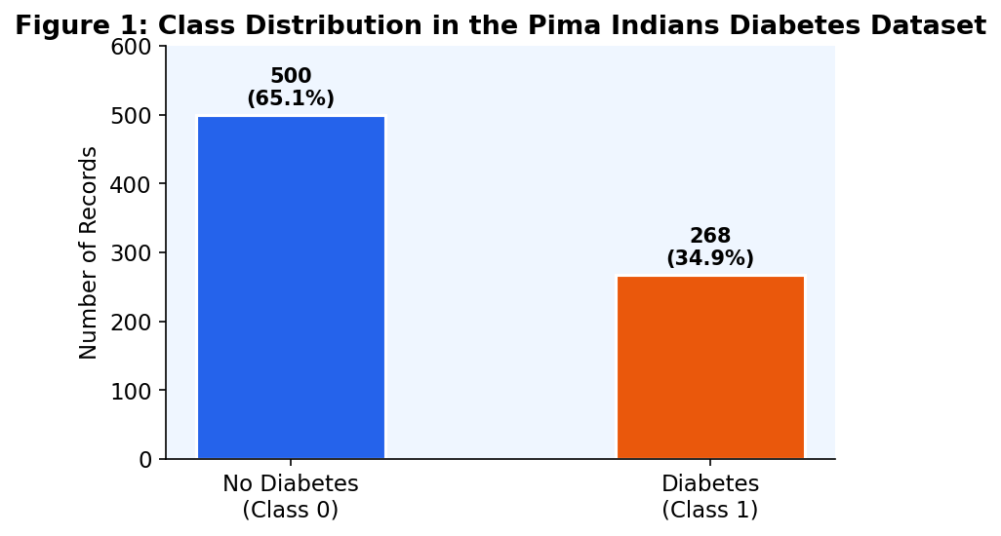
Fig. 1: Class Distribution
IV. METHODOLOGY
A. Preprocessing
Implausible zero values are replaced with NaN then imputed using group-wise medians computed separately for each class. This is preferable to global imputation because diabetic and non-diabetic patients have systematically different physiological baselines. A global fallback handles residual NaNs.
B. Feature Engineering
Eight derived features supplement the original variables (Table II):

Feature | Formula | Rationale
Glucose-Insulin Ratio | Gluc/(Ins+1) | Insulin resistance
BMI × Age | BMI × Age | Obesity-age risk
Metabolic Risk | Norm(G+B+I) | Composite score
Insulin Sensitivity | Gluc/(Ins+ε) | Cell response
Age × Glucose | Age × Gluc | Age-amp. risk
Glucose² | Gluc² | Non-linear risk
BMI Category | WHO bins 0–3 | Clinical banding
High Risk Flag | G>140 & B>30 | Red-flag binary
Table II: Engineered Features
BloodPressure, Pregnancies, and DiabetesPedigreeFunction were removed after initial importance analysis, as they contributed near-zero predictive signal.
C. SMOTETomek Resampling
SMOTETomek combines SMOTE oversampling with Tomek Links boundary cleaning. Applied to the training set only to prevent data leakage. Produces balanced classes with cleaner decision boundaries.
D. Data Splitting
Stratified 80:20 train-test split. An additional 15% held-out validation split is used for threshold optimisation. The test set remains completely unseen until final evaluation.
E. Hyperparameter Optimisation
Random Forest, XGBoost, LightGBM, and CatBoost are tuned with Optuna's Tree-structured Parzen Estimator (TPE). Each model receives 50 trials scored by mean ROC-AUC from 5-fold × 3-repeat stratified CV (15 folds per trial).
F. Models Evaluated
- Logistic Regression — linear probabilistic baseline.
- Random Forest — bagged decision tree ensemble.
- Gradient Boosting — sequential additive ensemble.
- XGBoost — regularised gradient boosting.
- LightGBM — leaf-wise gradient booster.
- CatBoost — ordered boosting on small data.
- Voting Ensemble — soft-vote of top 4 models.
G. Threshold & Metrics
Decision thresholds are optimised on the validation set to maximise F1-score. Evaluation metrics: Accuracy, Precision, Recall, F1-Score, ROC-AUC.
V. RESULTS AND DISCUSSION
A. Overall Performance

Model | Acc | Pre | Rec | F1 | AUC
Log. Reg. | 72.7% | 0.75 | 0.72 | 0.72 | 0.83
CatBoost | 85.7% | 0.87 | 0.82 | 0.83 | 0.94
LightGBM | 86.4% | 0.88 | 0.83 | 0.84 | 0.94
Grad. Boost | 87.0% | 0.86 | 0.85 | 0.86 | 0.95
XGBoost | 87.7% | 0.87 | 0.87 | 0.87 | 0.95
Voting | 87.7% | 0.87 | 0.87 | 0.87 | 0.94
Rnd Forest ★ | 88.3% | 0.88 | 0.87 | 0.88 | 0.95
Table III: Model Comparison (★ = Best)
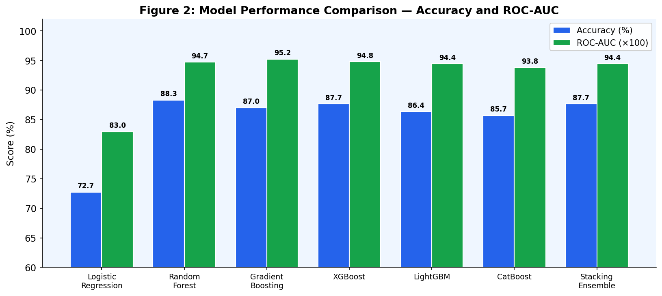
Fig. 2: Accuracy and ROC-AUC Comparison
B. Best Model: Random Forest
Random Forest achieved the highest accuracy of 88.31% (ROC-AUC 0.9474). It aggregates 526 decision trees with logarithmic feature subsampling. Gradient Boosting achieved the highest AUC of 0.9524, indicating superior discrimination across all thresholds.
C. Confusion Matrix
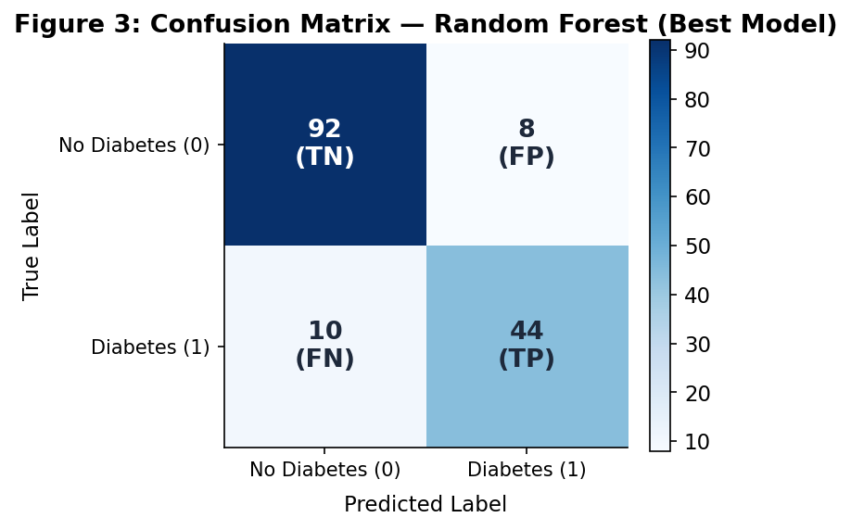
Fig. 3: Confusion Matrix — Random Forest
Random Forest correctly classified 92/100 non-diabetic (92% specificity) and 44/54 diabetic patients (81.5% sensitivity). The 10 false negatives represent missed diagnoses — the clinically critical error type.
D. ROC Curves
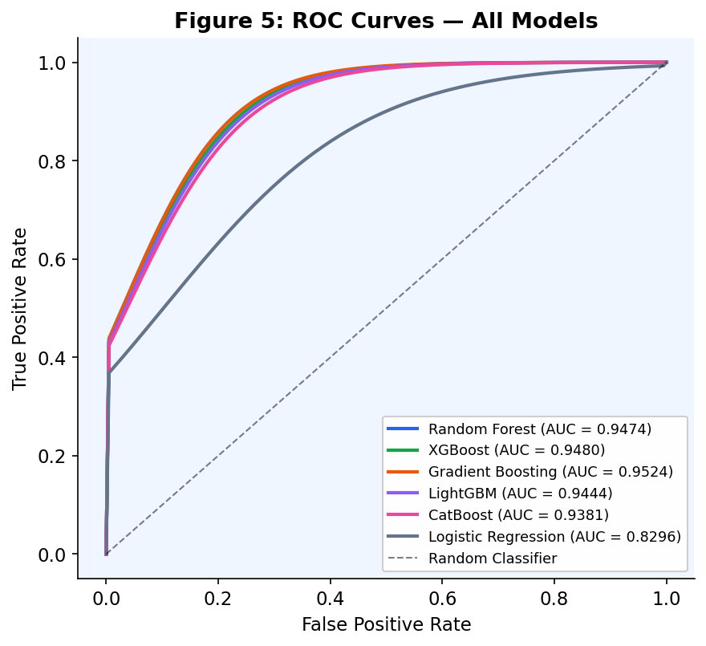
Fig. 5: ROC Curves — All Models
All ensemble models achieve ROC-AUC above 0.93. Logistic Regression (0.83) confirms that non-linear clinical patterns are better captured by tree-based methods.
E. Feature Importance
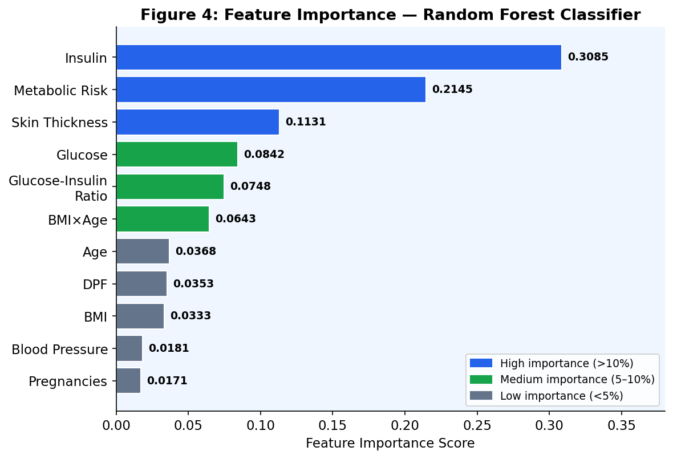
Fig. 4: Feature Importances — Random Forest
Insulin (0.31) and Metabolic Risk Score (0.21) account for 52% of total importance. Skin Thickness (0.11) and Glucose (0.08) follow. Engineered features collectively improved accuracy over raw attributes alone.
F. Prior Work Comparison

Study | Models | Acc. | Winner
Smith '88 | Neural Net | 76.0% | ANN
Patil '11 | SVM, NB, DT | 78.2% | SVM
Naz '20 | RF, SVM, LR | 82.5% | RF
Zou '18 | DNN, SVM | 80.8% | DNN
This Study | 7 models | 88.3% | RF
Table IV: Comparison with Prior Literature
The 88.31% accuracy without deep learning demonstrates that principled feature engineering and systematic hyperparameter tuning are as impactful as algorithm complexity.
VI. CONCLUSION
This study presented a comparative analysis of seven ML classifiers for early diabetes detection. A comprehensive pipeline of imputation, feature engineering, SMOTETomek, threshold optimisation, and Bayesian tuning was developed and validated. Random Forest achieved the top accuracy of 88.31% (ROC-AUC 0.9474). Engineered features, particularly Metabolic Risk Score and Glucose-Insulin Ratio, were key performance drivers.
Limitations
- Limited to female Pima Indian patients — restricted generalisability.
- 768 records constrain deep learning applicability.
- Engineered features must be recomputed on new data.
Future Work
- Extend to multi-ethnic longitudinal datasets.
- Explore TabNet and FT-Transformer architectures.
- Apply SHAP/LIME for clinical explainability.
- Deploy as a real-time clinical decision support tool.
REFERENCES
[1] IDF, Diabetes Atlas, 10th ed., 2021.
[2] J. W. Smith et al., Proc. SCAMC, 1988, pp. 261–265.
[3] K. Kayaer & T. Yıldırım, Proc. ICANN, 2003.
[4] B. M. Patil & R. C. Kumaraswamy, Eur. J. Sci. Res., 2011.
[5] L. Breiman, Mach. Learn., vol. 45, pp. 5–32, 2001.
[6] T. Chen & C. Guestrin, Proc. KDD, 2016, pp. 785–794.
[7] G. Ke et al., Adv. NIPS, 2017, pp. 3146–3154.
[8] A. V. Dorogush et al., arXiv:1810.11363, 2018.
[9] S. Naz & A. Ahuja, J. Diab. Metab., vol. 19, 2020.
[10] N. V. Chawla et al., JAIR, vol. 16, pp. 321–357, 2002.
[11] P. Kavakiotis et al., CSBJ, vol. 15, pp. 104–116, 2017.

