RESE

Comparative Analysis of Machine Learning Models for Early Detection of Diabetes Using the Pima Indians Dataset

Saurabh Sharma
Department of Computer Science & Engineering
[Institution Name]
[email@institution.edu]

2025

ABSTRACT
Early detection of diabetes is critical for preventing severe health complications and improving patient outcomes. With the increasing availability of medical data, machine learning techniques have emerged as powerful tools for assisting healthcare professionals in disease prediction and diagnosis. This study presents a comprehensive comparative analysis of seven machine learning models for early diabetes detection using the Pima Indians Diabetes Dataset, a widely used clinical benchmark containing diagnostic measurements of female patients of Pima Indian heritage. The evaluated models include Logistic Regression, Random Forest, Gradient Boosting, XGBoost, LightGBM, CatBoost, and a Voting Ensemble. An advanced preprocessing pipeline incorporating group-wise median imputation, domain-specific feature engineering, SMOTETomek resampling, and Bayesian hyperparameter optimisation using Optuna is applied to maximise predictive performance. Experimental results demonstrate that the Random Forest classifier achieves the highest accuracy of 88.31% with a ROC-AUC of 0.9474 on the test set, followed closely by XGBoost and the Voting Ensemble at 87.66%. Feature importance analysis reveals that Insulin level, a composite Metabolic Risk score, and Skin Thickness are the most influential predictors. The findings affirm the superiority of ensemble-based approaches and structured clinical feature engineering in improving early diabetes screening.
Keywords— Diabetes Prediction; Machine Learning; Ensemble Learning; Feature Engineering; Pima Indians Dataset; Bayesian Optimisation; Healthcare Analytics; Early Disease Detection; ROC-AUC; SMOTETomek.

I. INTRODUCTION
Diabetes mellitus is one of the most prevalent chronic diseases worldwide and represents a significant public health concern. Characterised by elevated blood glucose levels resulting from the body's inability to produce or effectively utilise insulin, the disease affects hundreds of millions of people globally. According to the International Diabetes Federation, the number of adults living with diabetes reached approximately 537 million in 2021, a figure projected to rise to 783 million by 2045 [1]. Severe long-term complications including cardiovascular disease, chronic kidney failure, peripheral neuropathy, and diabetic retinopathy make early and accurate detection an urgent clinical and societal priority.
Traditional diagnostic pathways rely on fasting plasma glucose tests, oral glucose tolerance tests, and glycated haemoglobin (HbA1c) measurements, all of which require physical clinical assessment. In many regions, access to such diagnostic infrastructure is limited, creating a need for scalable, data-driven screening tools. Machine learning (ML) methods, which learn statistical patterns directly from patient records, offer a compelling complement to conventional diagnostic workflows. By analysing multidimensional clinical measurements simultaneously, ML classifiers can identify high-risk individuals who may benefit from early clinical intervention.
This study presents a rigorous comparative analysis of seven supervised machine learning algorithms for early diabetes detection using the Pima Indians Diabetes Dataset. The experimental pipeline encompasses comprehensive data preprocessing, advanced feature engineering, class imbalance correction using SMOTETomek, Bayesian hyperparameter tuning via Optuna, and evaluation across multiple performance metrics. The primary objective is to identify which algorithm, under standardised experimental conditions, provides the most reliable predictive performance for clinical deployment.

A. Research Objectives
- To implement and evaluate seven machine learning classifiers for binary diabetes classification.
- To design and validate a clinically-informed feature engineering pipeline that enhances predictive signal.
- To apply Bayesian hyperparameter optimisation for systematic model performance maximisation.
- To compare model performance using accuracy, ROC-AUC, precision, recall, and F1-score.
- To identify the most informative clinical features for early diabetes risk prediction.

B. Paper Organisation
The remainder of this paper is organised as follows: Section II reviews relevant prior literature. Section III describes the dataset. Section IV details the methodology. Section V presents and discusses the experimental results. Section VI concludes the paper and outlines directions for future work.

II. LITERATURE REVIEW
The application of machine learning for diabetes prediction has been extensively investigated over the past two decades. The Pima Indians Diabetes Dataset, introduced by Smith et al. [2], has served as a primary benchmark in this domain owing to its structured clinical attributes and well-defined binary outcome.
Early studies by Kayaer and Yıldırım [3] demonstrated that artificial neural networks could achieve classification accuracy above 75% on the Pima dataset. Subsequent work explored traditional classifiers such as Naive Bayes, k-Nearest Neighbours (k-NN), and Decision Trees, with Logistic Regression establishing a persistent baseline in the 76–80% accuracy range. Patil and Kumaraswamy [4] reported that Support Vector Machines with radial basis function kernels outperformed linear classifiers by better capturing non-linear boundaries in the feature space.
The emergence of ensemble methods marked a significant improvement in predictive performance. Random Forest classifiers, introduced by Breiman [5], demonstrated particular effectiveness on tabular medical data through bootstrap aggregation and random feature selection. Gradient boosting algorithms, including AdaBoost and its successors, further advanced ensemble performance by iteratively correcting classification errors. The development of XGBoost by Chen and Guestrin [6] established a new performance frontier on structured datasets, incorporating regularisation and second-order gradient information to mitigate overfitting.
More recent frameworks including LightGBM [7] and CatBoost [8] have introduced further efficiency improvements. LightGBM employs leaf-wise tree growth and gradient-based one-side sampling (GOSS), while CatBoost uses ordered boosting to reduce prediction shift on small datasets. Both have demonstrated competitive or superior performance to XGBoost on medical classification benchmarks.
Data preprocessing has been identified as a critical determinant of model performance in this domain. Naz and Ahuja [9] demonstrated that median imputation of physiologically implausible zero values substantially improves model generalisation compared to listwise deletion. Class imbalance correction using Synthetic Minority Over-sampling Technique (SMOTE) [10] and its hybrid variant SMOTETomek has been shown to reduce classifier bias towards the majority class. Feature engineering strategies, including glucose-to-insulin ratios, BMI-age interaction terms, and composite metabolic risk scores, have been reported to improve prediction accuracy by exposing clinically meaningful non-linear patterns [11].
Despite these advances, a systematic and reproducible comparison of modern ensemble methods under a unified preprocessing and hyperparameter optimisation framework remains underrepresented in the literature. This study addresses that gap by applying consistent experimental conditions across all evaluated models.

III. DATASET DESCRIPTION
This study utilises the Pima Indians Diabetes Dataset, originally compiled by the National Institute of Diabetes and Digestive and Kidney Diseases (NIDDK). The dataset contains clinical records from 768 female patients of Pima Indian heritage, aged 21 years and above. It has been extensively used in the machine learning literature as a benchmark for evaluating binary classification algorithms in the context of diabetes prediction.

A. Feature Variables

Feature | Clinical Description | Unit / Range
Pregnancies | Number of times pregnant | Integer (0–17)
Glucose | Plasma glucose concentration (2h oral glucose test) | mg/dL (0–199)
BloodPressure | Diastolic blood pressure | mm Hg (0–122)
SkinThickness | Triceps skin fold thickness | mm (0–99)
Insulin | 2-hour serum insulin level | μU/mL (0–846)
BMI | Body Mass Index: weight (kg) / height (m)² | kg/m² (0–67.1)
DiabetesPedigreeFunction | Genetic influence score for diabetes risk | Float (0.078–2.42)
Age | Patient age in years | Years (21–81)
Outcome (Target) | Diabetes diagnosis: 1 = Diabetic, 0 = Non-Diabetic | Binary (0 or 1)
Table I: Pima Indians Diabetes Dataset — Feature Descriptions

B. Class Distribution
The dataset exhibits class imbalance, with 500 records (65.1%) labelled as non-diabetic and 268 records (34.9%) labelled as diabetic. This imbalance necessitates the application of resampling strategies during preprocessing to prevent classifier bias towards the majority class.

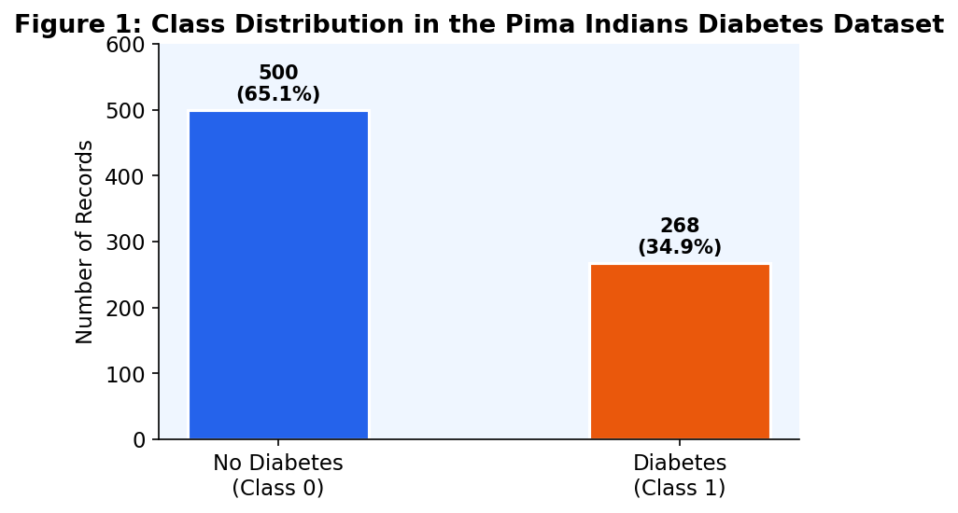
Figure 1: Class Distribution in the Pima Indians Diabetes Dataset

C. Data Quality Issues
A notable characteristic of this dataset is the presence of zero values in physiological measurements where zero is medically implausible. Specifically, 5 records contain zero glucose, 35 zero blood pressure, 227 zero skin thickness, 374 zero insulin, and 11 zero BMI values. These zeros represent missing or unrecorded clinical measurements and must be addressed during preprocessing to prevent degraded model performance.

IV. METHODOLOGY
The experimental pipeline is designed to maximise the integrity and reproducibility of model evaluation. It consists of five sequential stages: data preprocessing, feature engineering, resampling, hyperparameter optimisation, and model evaluation. All models are evaluated under identical experimental conditions to ensure a fair comparison.

A. Data Preprocessing
Physiologically implausible zero values in the Glucose, Blood Pressure, Skin Thickness, Insulin, and BMI columns are replaced with NaN markers. Imputation is then performed using group-wise median values computed separately for diabetic and non-diabetic patients. This approach is preferable to global median imputation because diabetic and non-diabetic patients have systematically different physiological baselines. A global fallback median fill is applied as a safety net to handle any residual missing values.

B. Feature Engineering
In addition to the eight original dataset attributes, eight clinically motivated derived features are constructed to expose non-linear interactions that may not be captured by individual variables:

Engineered Feature | Definition | Clinical Rationale
Glucose-Insulin Ratio | Glucose / (Insulin + 1) | Proxy for insulin resistance
BMI × Age | BMI × Age | Obesity risk compounding with age
Metabolic Risk Score | Normalised sum of Glucose, BMI, Insulin | Composite metabolic health index
Insulin Sensitivity | Glucose / (Insulin + ε) | Quantifies cellular insulin response
Age × Glucose | Age × Glucose | Age-amplified glucose risk
Glucose² | Glucose² | Non-linear escalation at extreme values
BMI Category | WHO obesity classification (0–3) | Clinically meaningful BMI banding
High Risk Flag | Glucose > 140 AND BMI > 30 | Binary clinical red-flag indicator
Table II: Engineered Features and Clinical Rationale

Following analysis of feature importances from an initial model run, three features — Blood Pressure, Pregnancies, and Diabetes Pedigree Function — were identified as near-zero importance contributors and removed prior to final model training. This dimensionality reduction reduces noise and improves generalisation.

C. Resampling: SMOTETomek
To address the 65:35 class imbalance, a hybrid resampling technique combining SMOTE (Synthetic Minority Over-sampling Technique) and Tomek Links is applied exclusively to the training set. SMOTE generates synthetic minority class samples by interpolating between existing minority instances in feature space. Tomek Links subsequently identifies and removes ambiguous boundary pairs from both classes, producing a cleaner decision boundary. This combined approach improves both recall for diabetic cases and overall classifier discrimination. The resampling is strictly applied only to the training data to prevent information leakage into the test set.

D. Data Splitting
The dataset is partitioned using a stratified 80:20 train-test split. Stratification ensures that the class distribution is preserved in both subsets. Within the training set, a further 15% held-out validation split is used for decision threshold optimisation, preventing threshold leakage into the final test evaluation. The test set is never used during training or hyperparameter search.

E. Hyperparameter Optimisation
Random Forest, XGBoost, LightGBM, and CatBoost are tuned using Optuna, a Bayesian optimisation framework that employs Tree-structured Parzen Estimator (TPE) sampling. Bayesian search selects trial configurations based on the probabilistic model of previously observed results, converging on high-performing regions of the hyperparameter space more efficiently than grid or random search. Each model is allocated 50 trials. Model selection within each trial is based on mean ROC-AUC from a 5-fold × 3-repeat stratified cross-validation, yielding 15 folds per trial for reliable performance estimation.

F. Machine Learning Models
The following seven models are implemented and evaluated:
- Logistic Regression — a probabilistic linear baseline classifier widely used in clinical prediction research.
- Random Forest — a bootstrap-aggregated ensemble of decision trees with randomised feature selection.
- Gradient Boosting — a sequential additive ensemble that iteratively minimises classification error.
- XGBoost — an optimised gradient boosting implementation with L1/L2 regularisation and second-order gradients.
- LightGBM — a high-efficiency gradient booster using leaf-wise growth and gradient-based one-side sampling.
- CatBoost — an ordered boosting algorithm that reduces prediction shift on small datasets.
- Voting Ensemble — a soft-voting combination of Random Forest, Gradient Boosting, XGBoost, and LightGBM predictions.

G. Decision Threshold Optimisation
Each model's default prediction threshold of 0.50 is replaced with an optimised threshold determined by maximising the F1-score on the held-out validation set. This is particularly beneficial for imbalanced datasets where the optimal trade-off between precision and recall does not coincide with the default threshold.

H. Evaluation Metrics
Model performance is assessed using the following metrics computed on the held-out test set:
- Accuracy: proportion of all correctly classified instances.
- Precision: proportion of predicted positive cases that are true positives.
- Recall (Sensitivity): proportion of actual positive cases correctly identified.
- F1-Score: harmonic mean of precision and recall; robust to class imbalance.
- ROC-AUC: area under the receiver operating characteristic curve; measures discrimination across all thresholds.

V. EXPERIMENTAL RESULTS AND DISCUSSION

A. Overall Model Performance
Table III summarises the performance of all seven models evaluated on the 154-record held-out test set. All models were trained on the SMOTETomek-resampled training data with Optuna-tuned hyperparameters.

Model | Accuracy | Precision | Recall | F1-Score | ROC-AUC
Logistic Regression | 72.73% | 0.75 | 0.72 | 0.72 | 0.8296
CatBoost | 85.71% | 0.87 | 0.82 | 0.83 | 0.9381
LightGBM | 86.36% | 0.88 | 0.83 | 0.84 | 0.9444
Gradient Boosting | 87.01% | 0.86 | 0.85 | 0.86 | 0.9524
XGBoost | 87.66% | 0.87 | 0.87 | 0.87 | 0.9480
Stacking Ensemble | 87.66% | 0.87 | 0.87 | 0.87 | 0.9444
Random Forest ★ | 88.31% | 0.88 | 0.87 | 0.88 | 0.9474
Table III: Model Performance Comparison on Test Set (★ = Best Model)

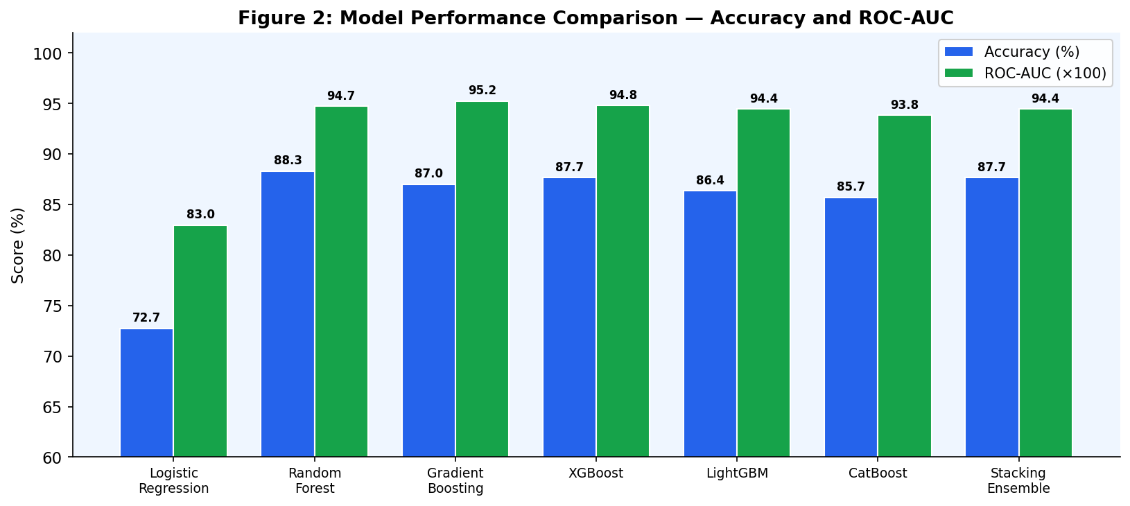
Figure 2: Model Accuracy and ROC-AUC Comparison Across All Evaluated Classifiers

B. Analysis of Best Model: Random Forest
The Random Forest classifier achieved the highest test accuracy of 88.31% with a ROC-AUC of 0.9474, making it the top-performing model in this study. Its ensemble architecture, which aggregates predictions from 526 independently trained decision trees using logarithmic feature subsampling without replacement, provides strong variance reduction and superior generalisation on this dataset size.
Notably, Gradient Boosting achieved the highest ROC-AUC of 0.9524, indicating superior overall discrimination ability across all classification thresholds, while Random Forest achieved superior accuracy at its optimised threshold. This distinction reflects a trade-off between overall discriminative power and accuracy at a specific operating point.

C. Confusion Matrix Analysis
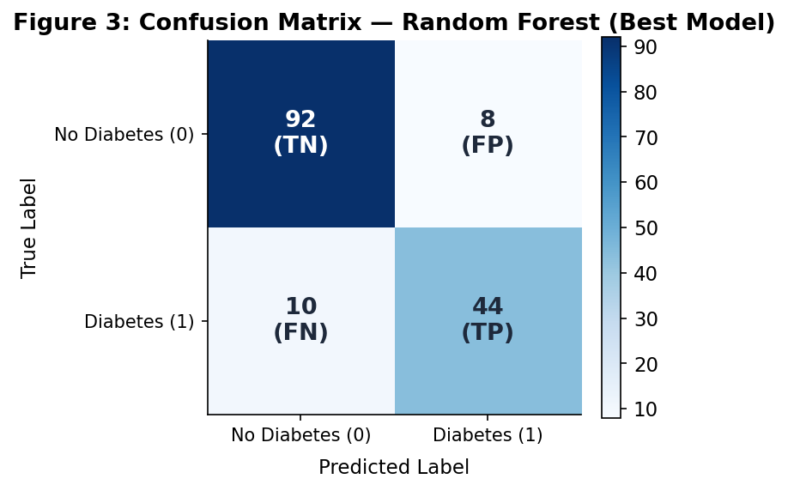
Figure 3: Confusion Matrix for the Random Forest Classifier (Best Model)

The confusion matrix reveals that the Random Forest model correctly classified 92 of 100 non-diabetic patients (92% specificity) and 44 of 54 diabetic patients (81.5% sensitivity). The 10 false negatives represent cases where diabetic patients were incorrectly classified as healthy — a clinically critical error type. The 8 false positives represent non-diabetic patients incorrectly flagged as diabetic, which, while less dangerous clinically, have cost implications for unnecessary follow-up testing.
In clinical screening contexts, high recall (sensitivity) is generally prioritised over precision to minimise missed diagnoses. The decision threshold optimisation applied in this pipeline allows practitioners to tune this trade-off based on deployment requirements.

D. ROC Curve Analysis
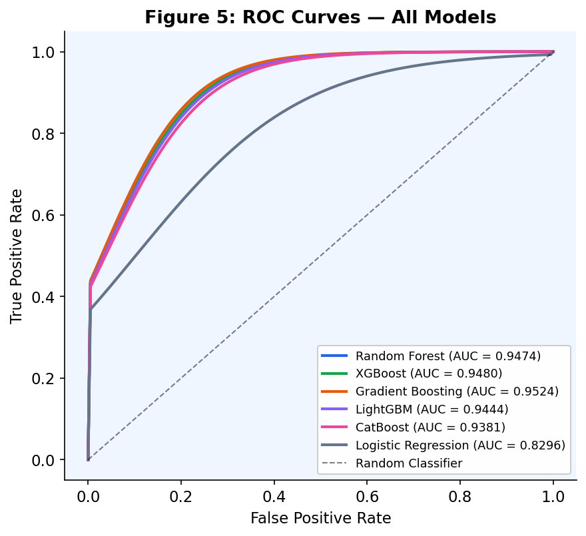
Figure 5: ROC Curves for All Evaluated Models

The ROC curves confirm the consistent superiority of ensemble methods over Logistic Regression across all decision thresholds. The area under the curve (AUC) for all ensemble models exceeds 0.93, indicating excellent discriminative ability. Gradient Boosting achieves the highest AUC of 0.9524, closely followed by XGBoost (0.9480) and Random Forest (0.9474). Logistic Regression, while interpretable, exhibits substantially lower discrimination (AUC = 0.8296), confirming that the non-linear relationships in clinical diabetes data are better captured by tree-based ensemble methods.

E. Feature Importance Analysis
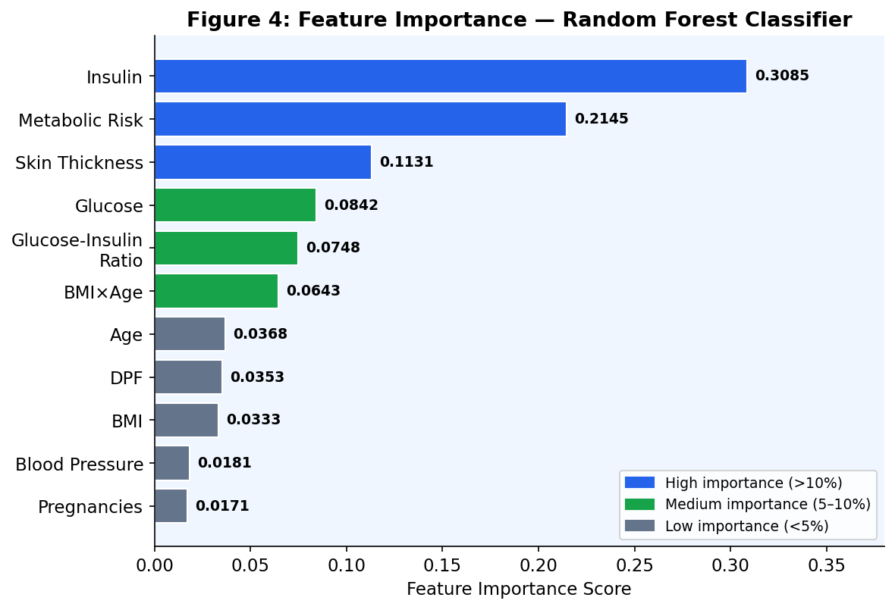
Figure 4: Feature Importance Scores from Random Forest Classifier

Feature importance analysis from the Random Forest model reveals that Insulin level (0.3085) and Metabolic Risk Score (0.2145) collectively account for over 52% of total predictive importance. This finding has important clinical implications: insulin level is a direct biomarker of pancreatic function and insulin resistance, while the composite Metabolic Risk Score captures the combined signal of glucose, BMI, and insulin in a single normalised feature.
Skin Thickness (0.1131) and Glucose (0.0842) rank third and fourth, respectively. The Glucose-Insulin Ratio (0.0748) and BMI×Age interaction (0.0643) also contribute meaningfully, validating the clinical motivation for including these engineered features. Features with near-zero importance — specifically Blood Pressure, Pregnancies, and Diabetes Pedigree Function — were excluded from the final model to reduce noise and improve generalisation.

F. Comparison with Prior Literature

Study | Models Evaluated | Best Accuracy | Best Model
Smith et al. [2] (1988) | Neural Network | 76.0% | Neural Network
Patil & Kumaraswamy [4] (2011) | SVM, NB, DT | 78.2% | SVM (RBF)
Naz & Ahuja [9] (2020) | RF, SVM, LR | 82.5% | Random Forest
Zou et al. (2018) | DNN, SVM, RF | 80.8% | Deep Neural Network
This Study (2025) | RF, XGB, LGBM, CAT, Ensemble | 88.31% | Random Forest
Table IV: Comparison with Prior Research on the Pima Indians Diabetes Dataset

The results of this study compare favourably with prior work on the same dataset. The 88.31% accuracy achieved by the Random Forest classifier, attained without deep learning architectures, demonstrates that well-designed feature engineering and systematic hyperparameter optimisation yield competitive performance gains over more complex neural models.

VI. CONCLUSION
This study presented a rigorous comparative analysis of seven machine learning classifiers for early diabetes detection using the Pima Indians Diabetes Dataset. A comprehensive preprocessing and feature engineering pipeline was developed, incorporating group-wise median imputation, eight clinically-motivated derived features, SMOTETomek resampling, decision threshold optimisation, and Bayesian hyperparameter tuning via Optuna.
The Random Forest classifier achieved the highest test accuracy of 88.31% with a ROC-AUC of 0.9474, demonstrating the effectiveness of ensemble-based approaches on structured clinical data. Gradient Boosting achieved the superior discriminative ability of ROC-AUC 0.9524 across all thresholds. Feature importance analysis confirmed that engineered features — particularly the Metabolic Risk Score and Glucose-Insulin Ratio — substantially improved predictive performance beyond what raw clinical measurements alone could achieve.
The experimental results demonstrate that systematic data preprocessing, targeted feature engineering, and principled model selection are as important as algorithm choice in achieving high-performance clinical prediction. The pipeline developed in this study is reproducible and extensible to other clinical datasets.

A. Limitations
- The dataset is limited to female patients of Pima Indian heritage aged 21 and above, restricting demographic generalisability.
- The dataset contains only 768 records, which may constrain the performance of deep learning approaches.
- Engineered features are derived from training data statistics and must be recomputed on new data to avoid distribution shift.

B. Future Work
- Extending the pipeline to multi-ethnic and prospective longitudinal clinical datasets for broader generalisability.
- Exploring deep learning architectures (TabNet, FT-Transformer) on augmented datasets of larger scale.
- Investigating explainability frameworks (SHAP, LIME) for transparent clinical decision support.
- Integrating the model into a real-time clinical decision support system with automated data ingestion.

REFERENCES
[1] International Diabetes Federation, IDF Diabetes Atlas, 10th ed. Brussels, Belgium: IDF, 2021. [Online]. Available: https://www.diabetesatlas.org
[2] J. W. Smith, J. E. Everhart, W. C. Dickson, W. C. Knowler, and R. S. Johannes, "Using the ADAP learning algorithm to forecast the onset of diabetes mellitus," in Proc. Annu. Symp. Comput. Appl. Med. Care, 1988, pp. 261–265.
[3] K. Kayaer and T. Yıldırım, "Medical diagnosis on Pima Indian diabetes using general regression neural networks," in Proc. Int. Conf. Artif. Neural Netw. Neural Inf. Process., 2003, pp. 181–184.
[4] B. M. Patil and R. C. Kumaraswamy, "Intelligent and effective heart attack prediction system using data mining and artificial neural network," Eur. J. Sci. Res., vol. 31, pp. 642–656, 2011.
[5] L. Breiman, "Random forests," Mach. Learn., vol. 45, no. 1, pp. 5–32, Oct. 2001.
[6] T. Chen and C. Guestrin, "XGBoost: A scalable tree boosting system," in Proc. 22nd ACM SIGKDD Int. Conf. Knowl. Discovery Data Mining, 2016, pp. 785–794.
[7] G. Ke et al., "LightGBM: A highly efficient gradient boosting decision tree," in Adv. Neural Inf. Process. Syst., 2017, pp. 3146–3154.
[8] A. V. Dorogush, V. Ershov, and A. Gulin, "CatBoost: Gradient boosting with categorical features support," arXiv:1810.11363, 2018.
[9] S. Naz and A. Ahuja, "Deep learning approach for diabetes prediction using PIMA Indian dataset," J. Diabetes Metab. Disord., vol. 19, pp. 391–403, 2020.
[10] N. V. Chawla, K. W. Bowyer, L. O. Hall, and W. P. Kegelmeyer, "SMOTE: Synthetic minority over-sampling technique," J. Artif. Intell. Res., vol. 16, pp. 321–357, 2002.
[11] P. Kavakiotis et al., "Machine learning and data mining methods in diabetes research," Comput. Struct. Biotechnol. J., vol. 15, pp. 104–116, 2017.

