DHRUV PATEL

15070121112

C-1

**ADBMS LAB ASSIGNMENT-1**

1. **Write and Implement PL/SQL code to swap two numbers.**

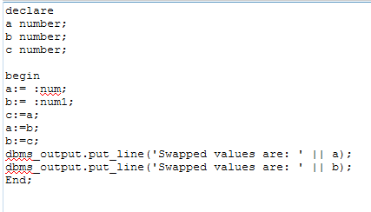

**INPUT OUTPUT**

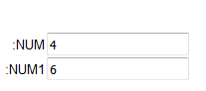 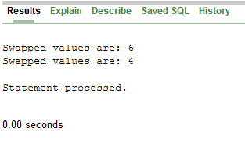

1. **Write and implement PL/SQL code to find student’s first name and last name from student table and print it on the screen.**

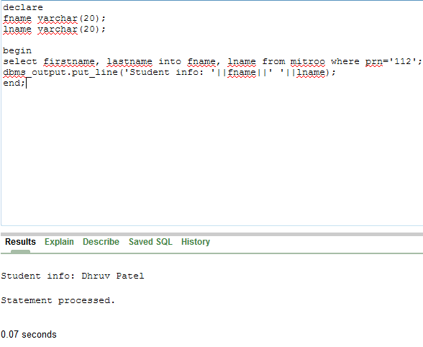

**3. Write and implement PL/SQL code to calculate power of the number.**

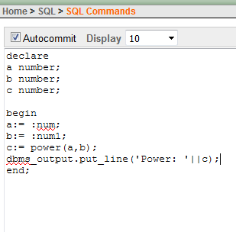

**INPUT OUTPUT**

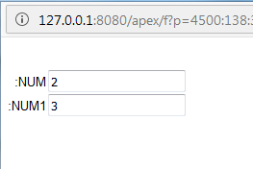 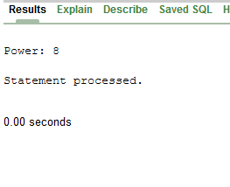

**4. Write and implement PL/SQL code to determine day of week based on today's date.**

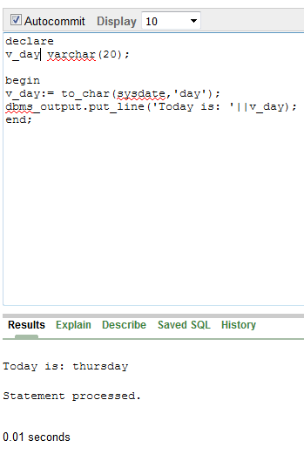

**5. Write and Implement PL/SQL code to print number 10 to 5 using while loop and for loop.**

**While Loop**

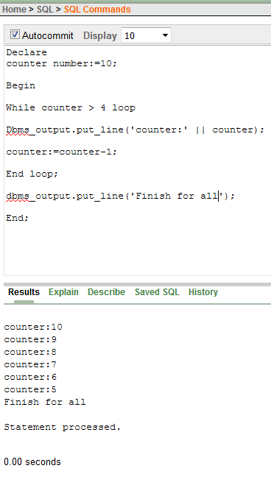

**For Loop**

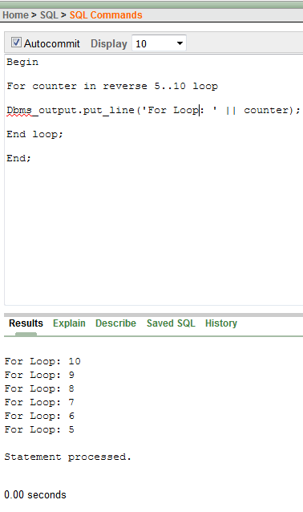

**6. Write and Implement PL/SQL code to print the given number is even or odd.**

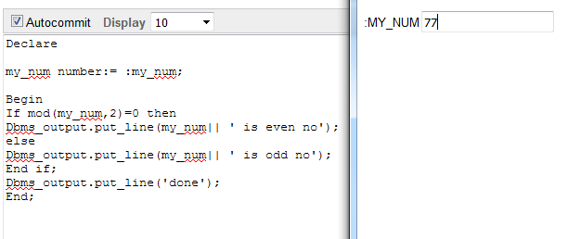

**OUTPUT**

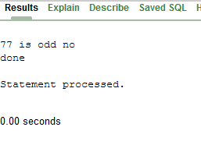

**7. Write and Implement PL/SQL code to find factorial of the number.**

