DHRUV PATEL

15070121112

C-1

**ADBMS LAB ASSIGNMENT-2**

1. **Write and Implement PL/SQL code to display customer name and address of a given customer from customer table. If the customer Id is not present in the table, it should throw an exception (‘no such customer’).**

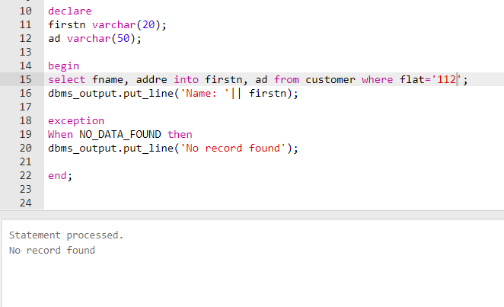

1. **Write and Implement PL/SQL code to display customer name and address of a given customer from customer table. When customer id is less than or equal to zero, it should throw user defined exception (‘Id must be greater than 0’).**

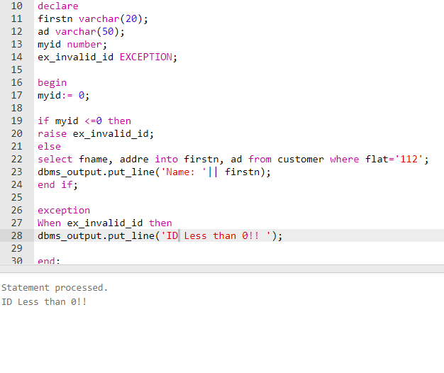

1. **Write and Implement PL/SQL code to find Length when Area and breadth of a Rectangle is given. If breadth is zero, it should throw an exception (zero_divide).**

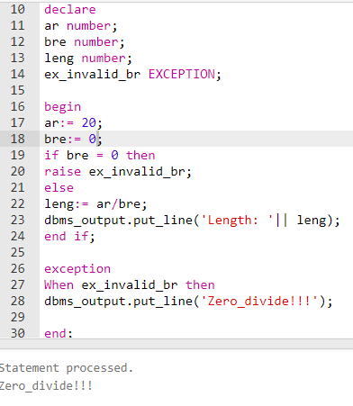

1. **Write and Implement PL/SQL code to display first name and last name of student whose marks are greater than 100. When multiple records are selected, it should throw an exception (TOO_MANY_ROWS).**

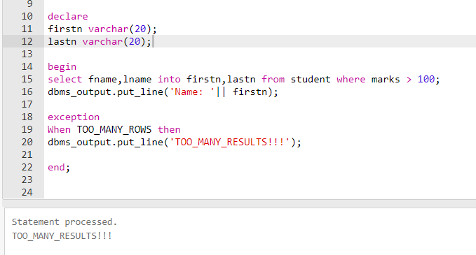

1. **Write and Implement PL/SQL code to raise the salary of a given employee (empid) by 10 %.If no data found it should throw exception (NO_Data_found). If the salary is null , it will raise_application_error(- 20101, 'Salary is missing').**

