DHRUV PATEL

15070121112

C-1

**ADBMS LAB ASSIGNMENT-3**

1. **Write a PL/SQL function to find the sum of the 1st 100 even numbers.**

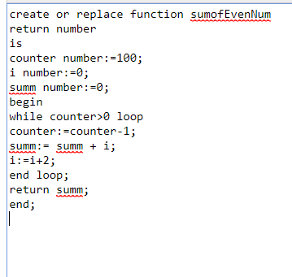

**OUTPUT**

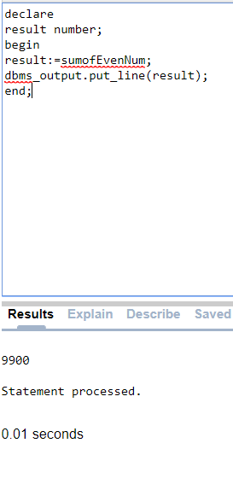

**2. Write a PL/SQL function to check if a number is prime or not.**

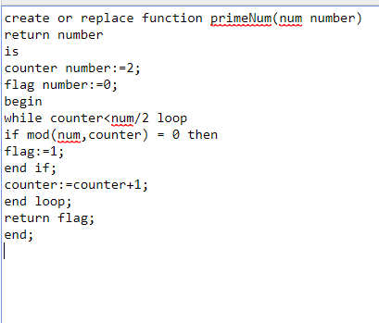

**OUTPUT**

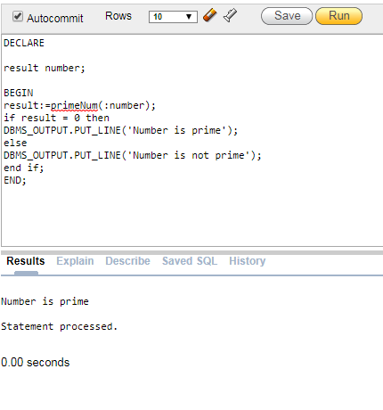

**3. Write PL/SQL function to find all the managers. Consider the schema Emp(Emp_no, Company, DOJ, Designation, Salary, Dep_No)**

create table empdata

(

empid number,

com varchar(50),

doj number,

desg varchar(50),

sal number,

depno number

);

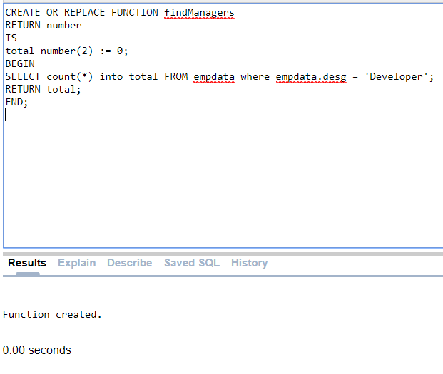

**OUTPUT**

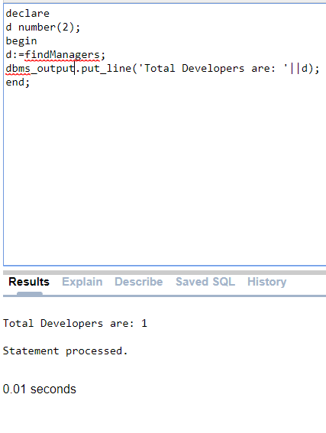

**4. Create a function to find number of employees earning salary more than 10000 Rs.**

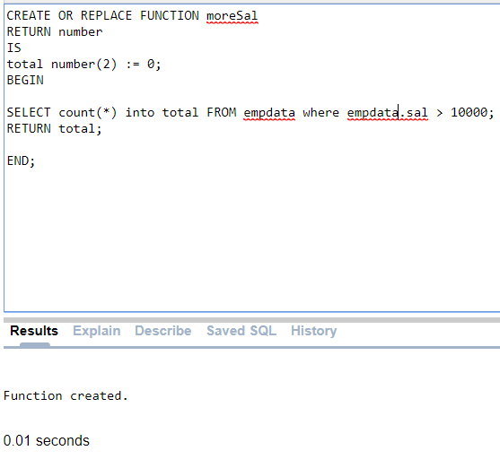

**OUTPUT**

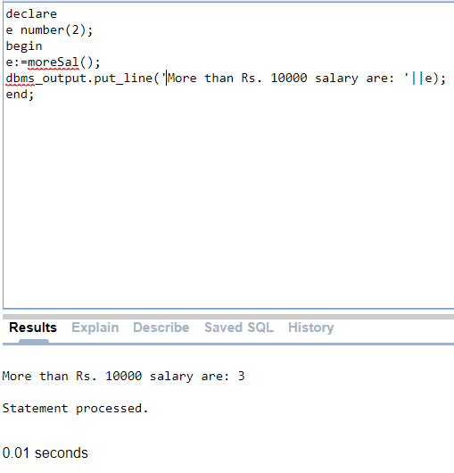

**5. Write a PL/SQL function to display highest paid employee name.**

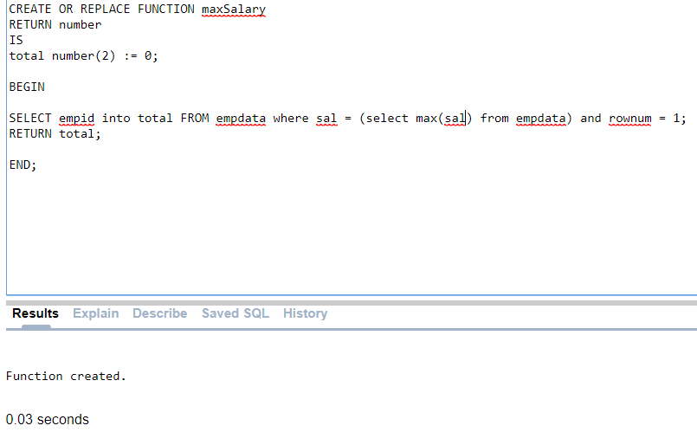

**OUTPUT**

