DHRUV PATEL

15070121112

C-1

**ADBMS LAB ASSIGNMENT-4**

**Q1. Write and Implement PL/SQL procedure to display student’s first name and last name of a given student from student table.**

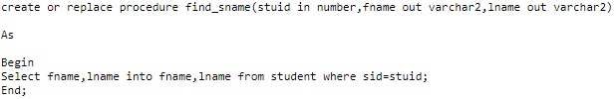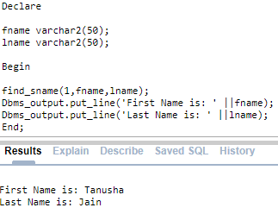

**Q2. Write and Implement PL/SQL procedure to compute the square**

**of a passed value.**

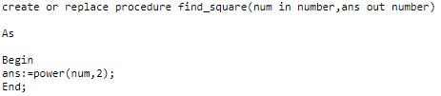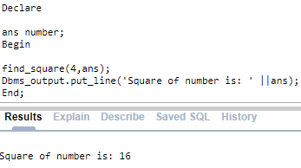

**Q3. Write and Implement PL/SQL procedure to find minimum**

**number from two values.**

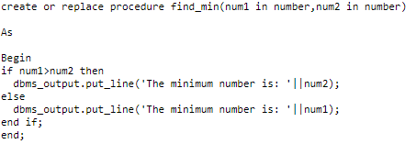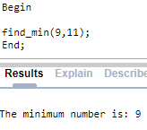

**4. Write and Implement PL/SQL procedure remove_emp which**

**removes a specified employee record from employee table. It**

**should also display total no of records before and after removal.**

