DHRUV PATEL

15070121112

C-1

**ADBMS LAB ASSIGNMENT-5**

**Q1. Write and Implement PL/SQL trigger audit_sal on employee**

**table. It should insert new record in another table emp_audit**

**when salary of an employee is updated. emp_audit table consist of**

**attributes empid, old salary, new salary and the date when salary**

**is updated.**

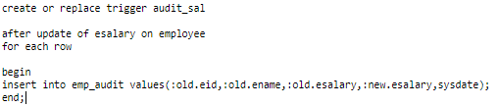

update employee set esalary=8000 where eid=1;

select * from emp_audit;



**Q2. Write and Implement PL/SQL trigger to raise an application**

**error if user tries to insert, update or delete data on employee**

**table on Saturday or Sunday or before 10 AM and after 5 pm.**

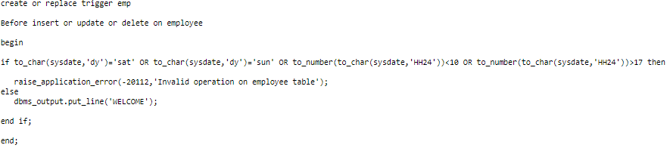

insert into employee values (7,'Meghraj',9000);

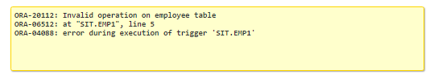

**Q3. Write and Implement PL/SQL trigger display_mark_changes on**

**student table. The trigger will be automatically fired before any**

**student’s marks updated in the table. It should also display old**

**and new marks.**

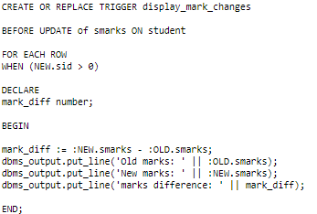

update student set smarks= 92 where sid=5;



**4. Write and Implement PL/SQL trigger on employee table that**

**automatically calculates the commission amount based on the**

**salary and the job. If job is salesman or analyst, comm will be**

**increased by 20% of the new salary. Additional condition is that,**

**if the commission amount was less than 1000, then the additional**

**commission is 1000; otherwise the additional commission is 2000.**

**This trigger will be automaticity fired before updating salary of**

**an employee.**

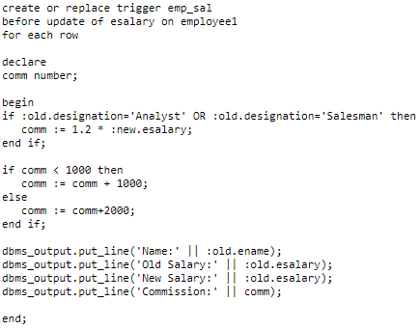

update employee set esalary= 5680 where eid=1;

