STQA Lab Assignment 4

Question: Design boundary value test conditions for determination of roots of a quadratic equation.

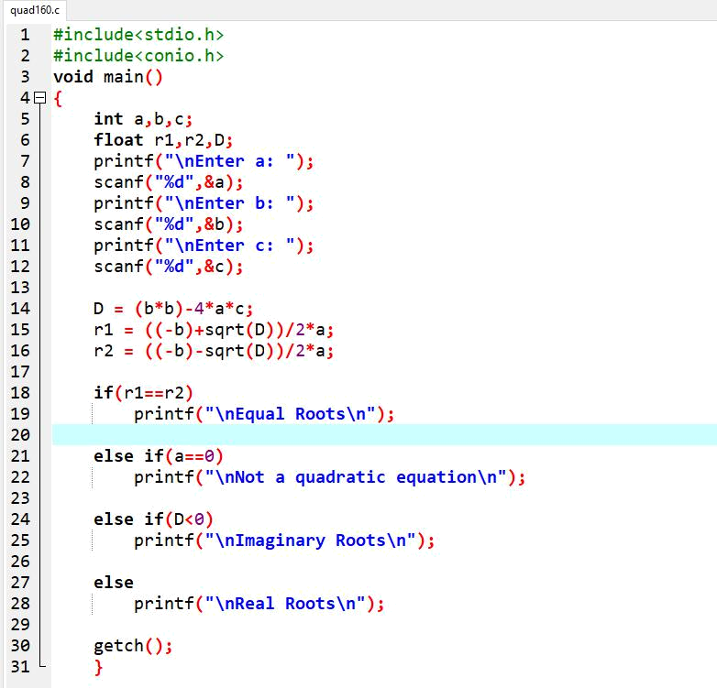

Saurabh Shingte Page 1

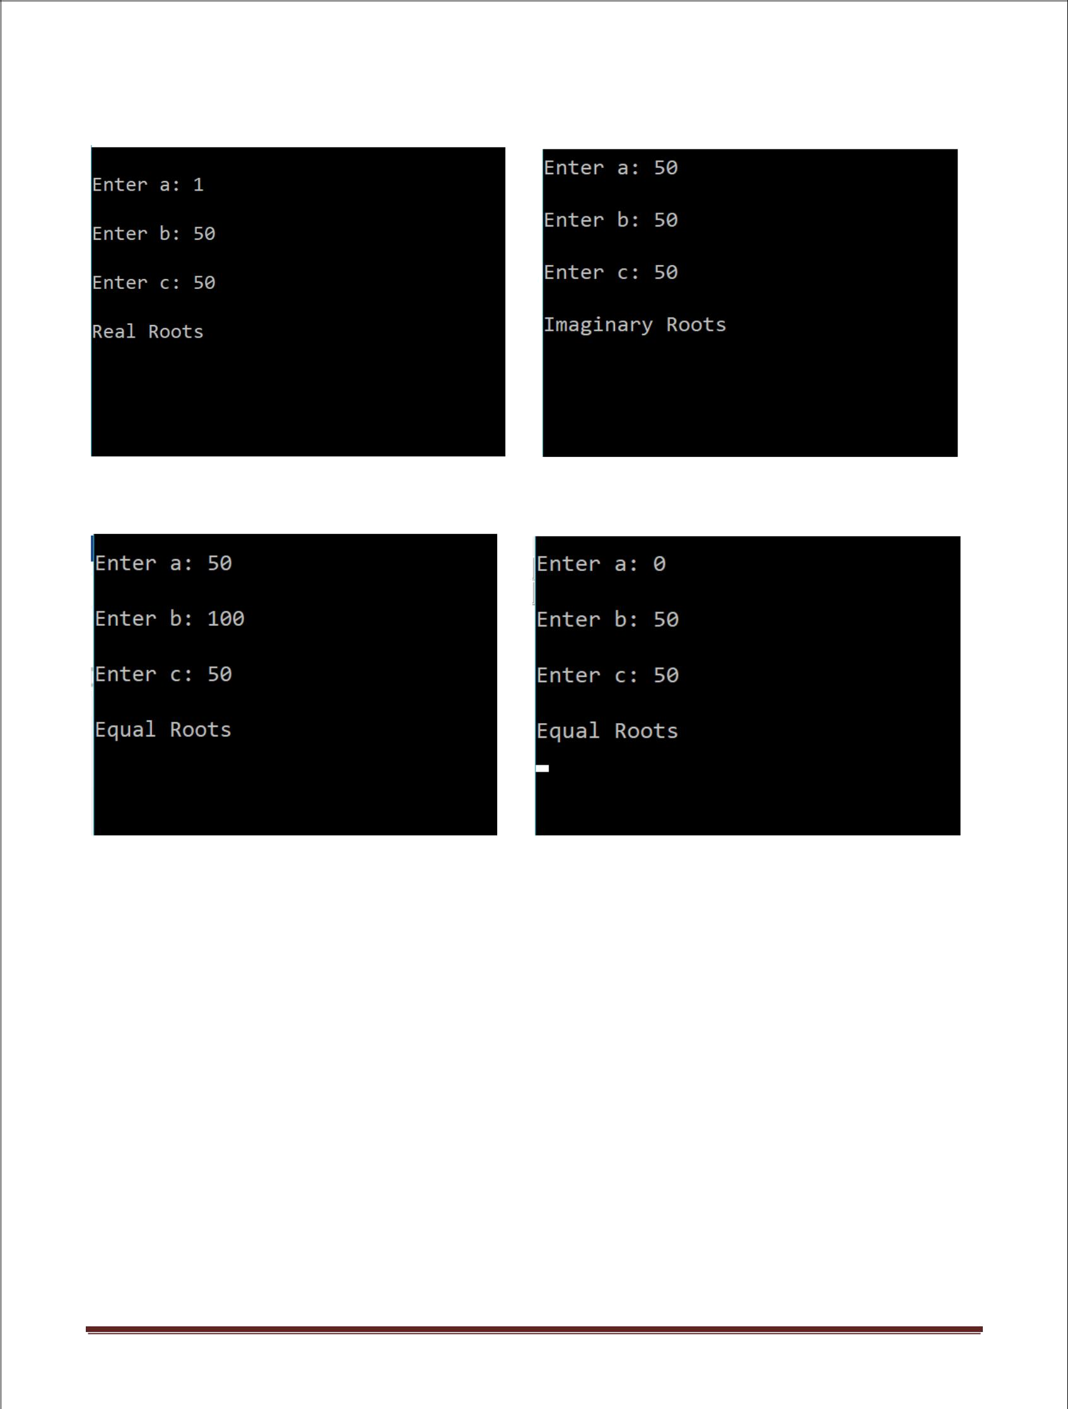

Saurabh Shingte Page 2

Sr. No. | a | b | c | Expected | Actual | Status
 |  |  |  | Output | Output
1. | 0 | 50 | 50 | Not a | Equal | FAIL
 |  |  |  | quadratic | Roots
 |  |  |  | equation
2. | 1 | 50 | 50 | Real | Real | PASS
 |  |  |  | Roots | Roots
3. | 50 | 50 | 50 | Imaginary | Imaginary | PASS
 |  |  |  | Roots | Roots
4. | 99 | 50 | 50 | Imaginary | Imaginary | PASS
 |  |  |  | Roots | Roots
5. | 100 | 50 | 50 | Imaginary | Imaginary | PASS
 |  |  |  | Roots | Roots
6. | 50 | 0 | 50 | Imaginary | Imaginary | PASS
 |  |  |  | Roots | Roots
7. | 50 | 1 | 50 | Imaginary | Imaginary | PASS
 |  |  |  | Roots | Roots
8. | 50 | 99 | 50 | Imaginary | Imaginary | PASS
 |  |  |  | Roots | Roots
9. | 50 | 100 | 50 | Equal | Equal | PASS
 |  |  |  | Roots | Roots
10. | 50 | 50 | 0 | Real | Real | PASS
 |  |  |  | Roots | Roots
11. | 50 | 50 | 1 | Real | Real | PASS
 |  |  |  | Roots | Roots
12. | 50 | 50 | 99 | Imaginary | Imaginary | PASS
 |  |  |  | Roots | Roots
13. | 50 | 50 | 100 | Imaginary | Imaginary | PASS
 |  |  |  | Roots | Roots

Saurabh Shingte Page 3

