STQA Lab Assignment 3

**Question:** Write a program in any language to find the factorial of a given number. Write different test cases, expected output and compare it with actual output.

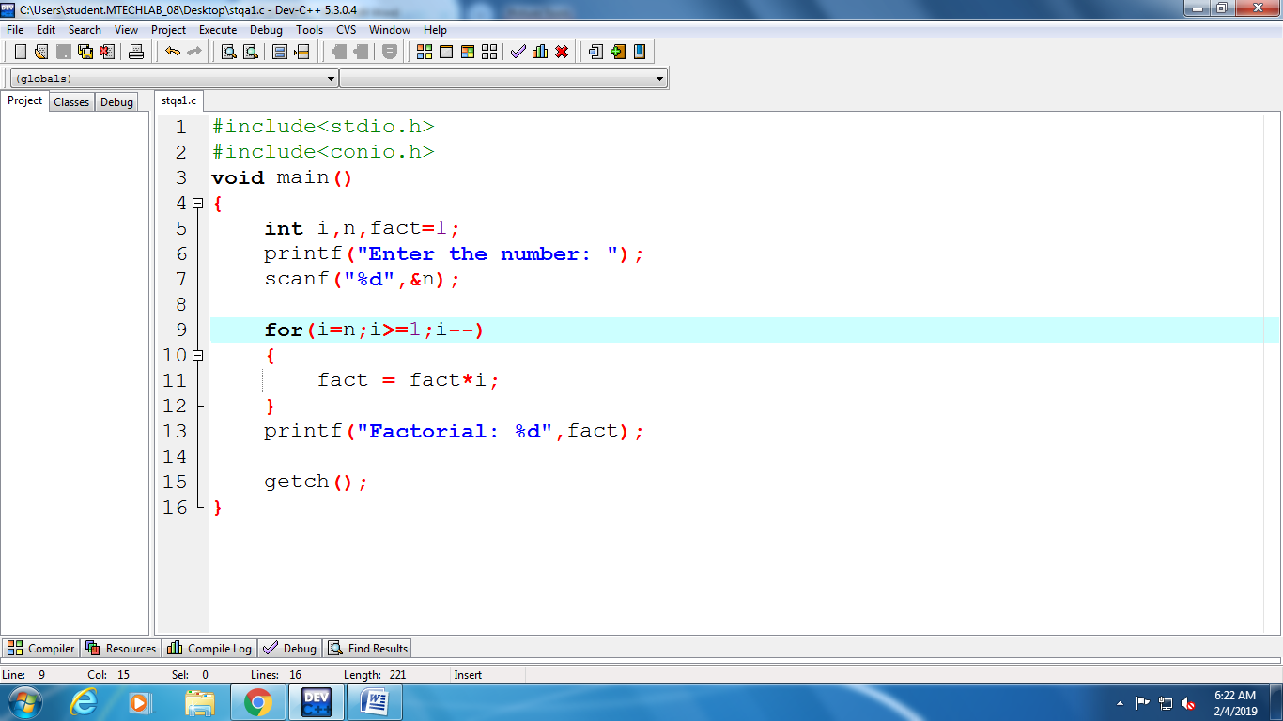

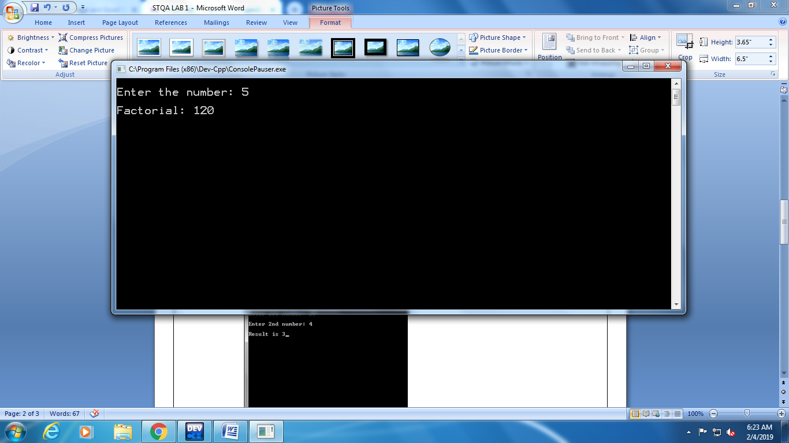 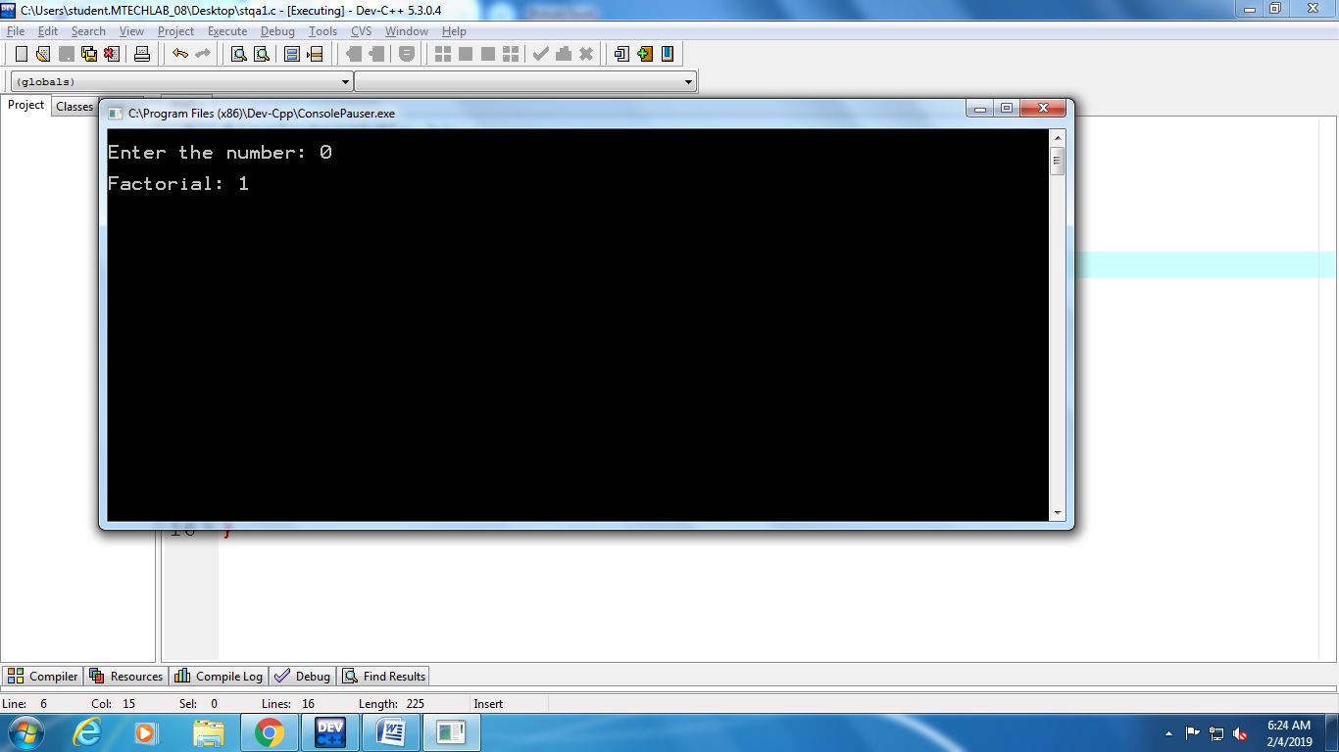

|  |  |  |  |  |  |
| --- | --- | --- | --- | --- | --- |
| Sr. No. | Size | Input | Actual Output | Expected Output | Status |
| 1. | 1 | 3 | 6 | 6 | PASS |
| 2. | 1 | 5 | 120 | 2 | PASS |
| 3. | 1 | 1 | 1 | 1 | PASS |
| 4. | 1 | 0 | 1 | 1 | PASS |
| 5. | 1 | -2 | 1 | Not Defined | FAIL |
| 6. | 1 | -1 | 1 | Not Defined | FAIL |