**STQA Lab Assignment – 7**

**Ouestion**: Consider a program for the determination of previous date. Its input is a triple of day, month, year, with the values in the range month (1-12), date (1-31), year (1900-2025). The possible outputs are previous date, and invalid date. Design the decision table and test cases for the problem.

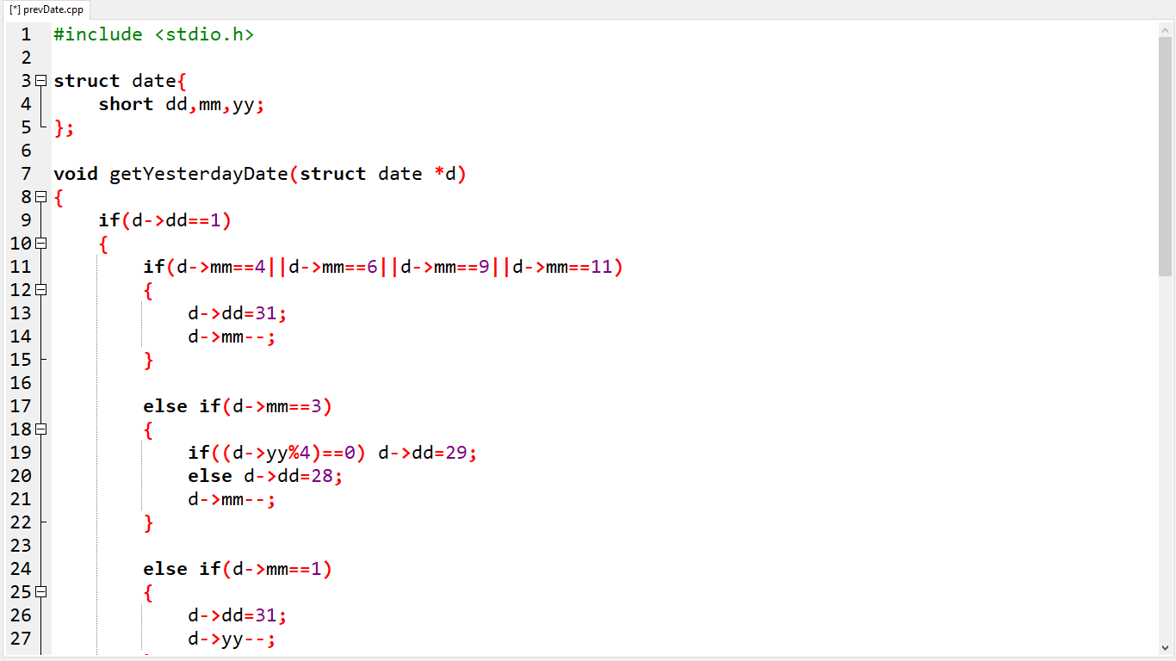

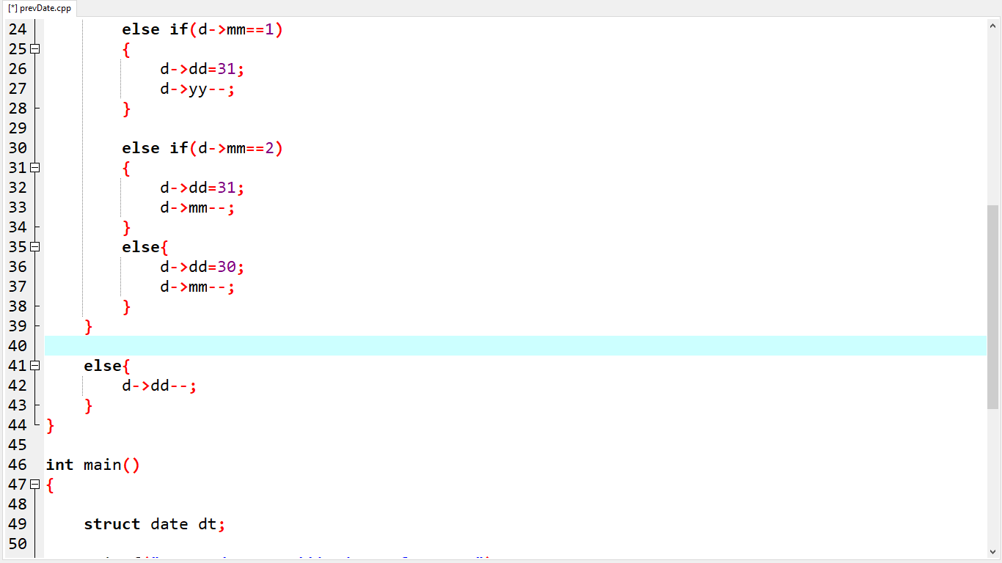

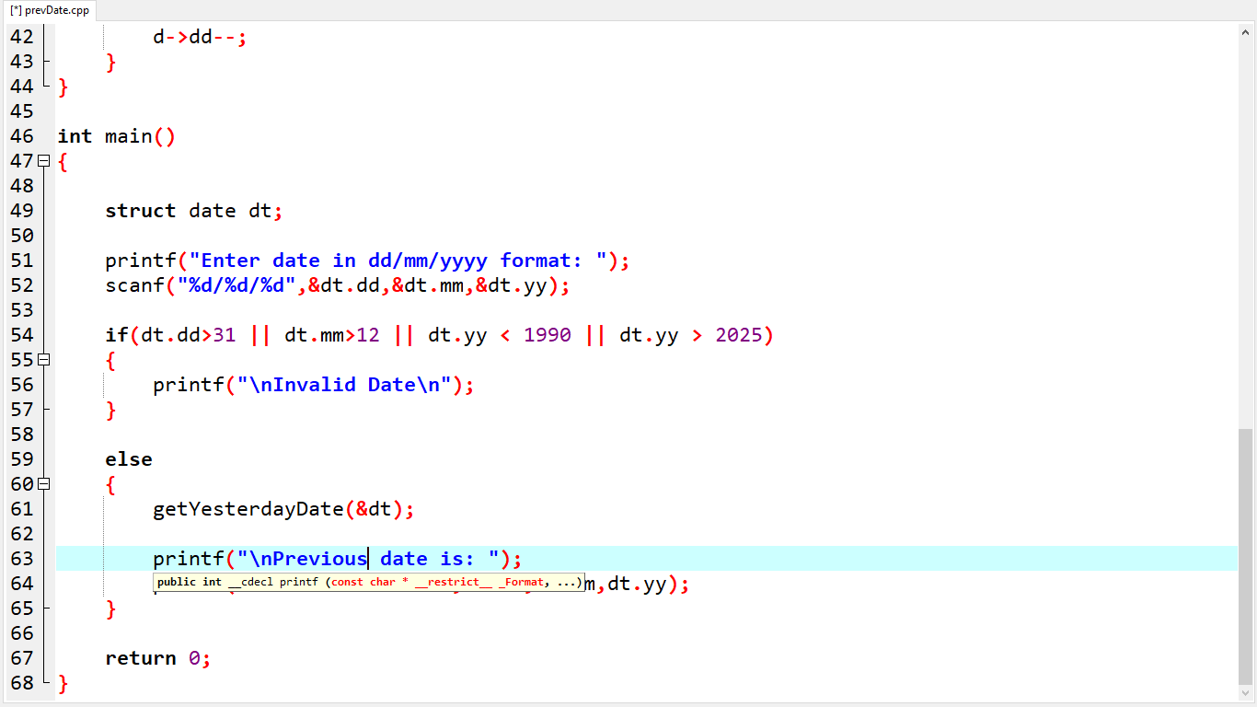

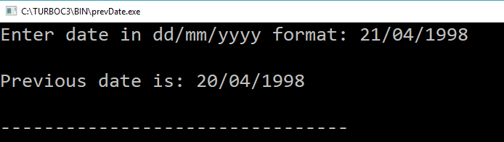

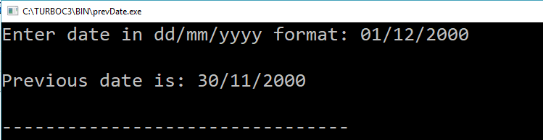

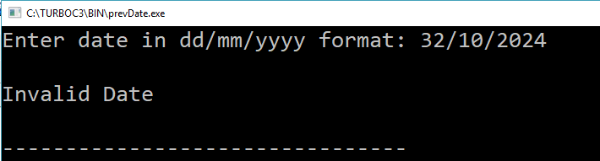

**DECISION TABLE:**

M1: Month has 30 days

M2: Month has 31 days except January, March and August

M3: Month is March

M4: Month is August

M5: Month is January

M6: Month is February

D1: day = 1

D2: 2 <= day <=28

D3: day = 29

D4: day = 30

D5: day = 31

Y1: Year is a leap year

Y2: Year is not a leap year

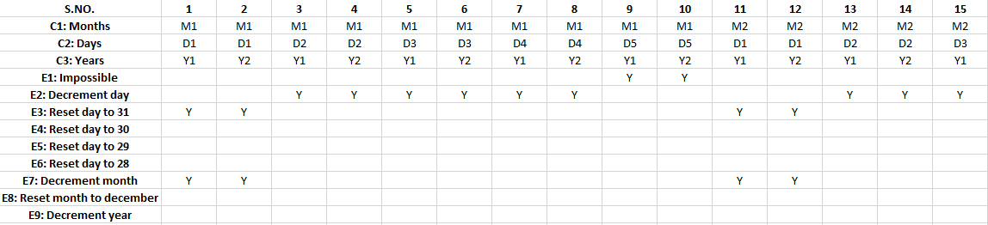

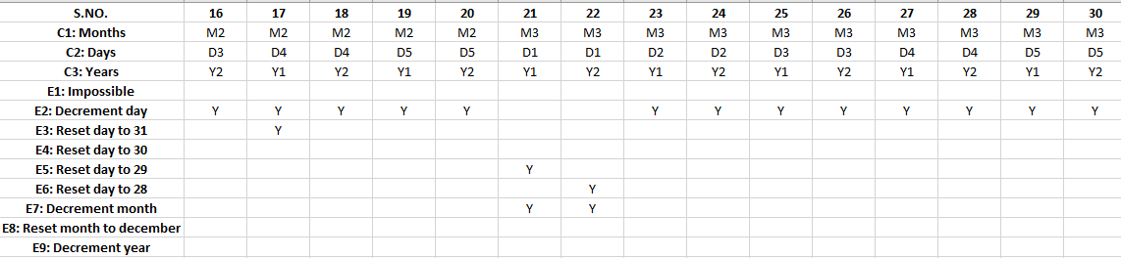

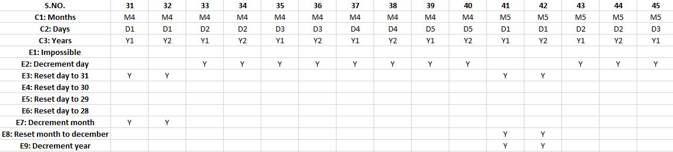

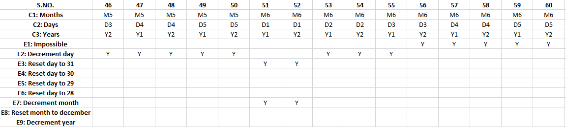

**TEST CASES:**

|  |  |  |  |  |
| --- | --- | --- | --- | --- |
| **TEST CASE ID** | **MONTH** | **DAY** | **YEAR** | **EXPECTED OUTPUT** |
| 1 | April | 1 | 2000 | 31 March 2000 |
| 2 | April | 1 | 2001 | 31 March 2001 |
| 3 | April | 15 | 2000 | 14 April 2000 |
| 4 | April | 15 | 2001 | 14 April 2001 |
| 5 | April | 29 | 2000 | 28 April 2000 |
| 6 | April | 29 | 2001 | 28 April 2001 |
| 7 | April | 30 | 2000 | 29 April 2001 |
| 8 | April | 30 | 2001 | 29 April 2001 |
| 9 | April | 31 | 2001 | Invalid |
| 10 | April | 31 | 2000 | Invalid |
| 11 | May | 1 | 2000 | 30 April 2000 |
| 12 | May | 1 | 2001 | 30 April 2001 |
| 13 | May | 15 | 2000 | 14 May 2000 |
| 14 | May | 15 | 2001 | 14 May 2001 |
| 15 | May | 29 | 2000 | 28 May 2000 |
| 16 | May | 29 | 2001 | 28 May 2001 |
| 17 | May | 30 | 2000 | 29 May 2000 |
| 18 | May | 30 | 2001 | 29 May 2001 |
| 19 | May | 31 | 2000 | 30 May 2000 |
| 20 | May | 31 | 2001 | 30 May 2001 |
| 21 | March | 1 | 2000 | 29 February 2000 |
| 22 | March | 1 | 2001 | 28 February 2001 |
| 23 | March | 15 | 2000 | 14 March 2000 |
| 24 | March | 15 | 2001 | 14 March 2001 |
| 25 | March | 29 | 2000 | 28 March 2000 |
| 26 | March | 29 | 2001 | 28 March 2001 |
| 27 | March | 30 | 2000 | 29 March 2000 |
| 28 | March | 30 | 2001 | 29 March 2001 |
| 29 | March | 31 | 2000 | 30 March 2000 |
| 30 | March | 31 | 2001 | 30 March 2001 |
| 31 | August | 1 | 2000 | 31 July 2000 |
| 32 | August | 1 | 2001 | 31 July 2001 |
| 33 | August | 15 | 2000 | 14 August 2000 |
| 34 | August | 15 | 2001 | 14 August 2001 |
| 35 | August | 29 | 2000 | 28 August 2000 |
| 36 | August | 29 | 2001 | 28 August 2001 |
| 37 | August | 30 | 2000 | 29 August 2000 |
| 38 | August | 30 | 2001 | 29 August 2001 |
| 39 | August | 31 | 2000 | 30 August 2000 |
| 40 | August | 31 | 2001 | 30 August 2001 |
| 41 | January | 1 | 2000 | 31 December 2000 |
| 42 | January | 1 | 2001 | 31 December 2001 |
| 43 | January | 15 | 2000 | 14 January 2000 |
| 44 | January | 15 | 2001 | 14 January 2001 |
| 45 | January | 29 | 2000 | 28 January 2000 |
| 46 | January | 29 | 2001 | 28 January 2001 |
| 47 | January | 30 | 2000 | 29 January 2000 |
| 48 | January | 30 | 2001 | 29 January 2001 |
| 49 | January | 31 | 2000 | 30 January 2000 |
| 50 | January | 31 | 2001 | 30 January 2001 |
| 51 | February | 1 | 2000 | 31 January 2000 |
| 52 | February | 1 | 2001 | 31 January 2001 |
| 53 | February | 15 | 2000 | 14 February 2000 |
| 54 | February | 15 | 2001 | 14 February 2001 |
| 55 | February | 29 | 2000 | 28 February 2000 |
| 56 | February | 29 | 2001 | Invalid |
| 57 | February | 30 | 2000 | Invalid |
| 58 | February | 30 | 2001 | Invalid |
| 59 | February | 31 | 2000 | Invalid |
| 60 | February | 31 | 2001 | Invalid |