**STQA Lab Assignment – 8**

**Question:** Write a program in C for the determination of the nature roots of a quadratic equation; its input is a triple of positive integers say a, b, and c and value from the interval 0 to 100. Also, the output may have one of the following word: not a quadratic equation, real roots, imaginary roots, equal roots. Do the following:

1. Draw the flow graph and DD graph.
2. Find independent paths from DD graph.
3. Calculate cyclomatic complexity.

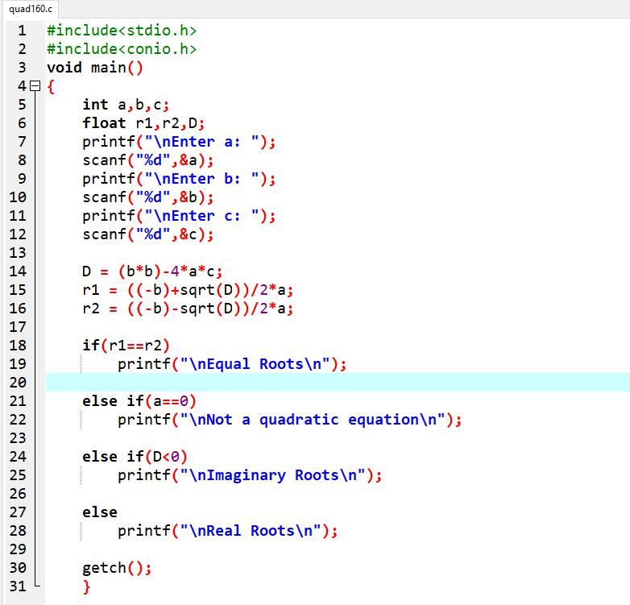

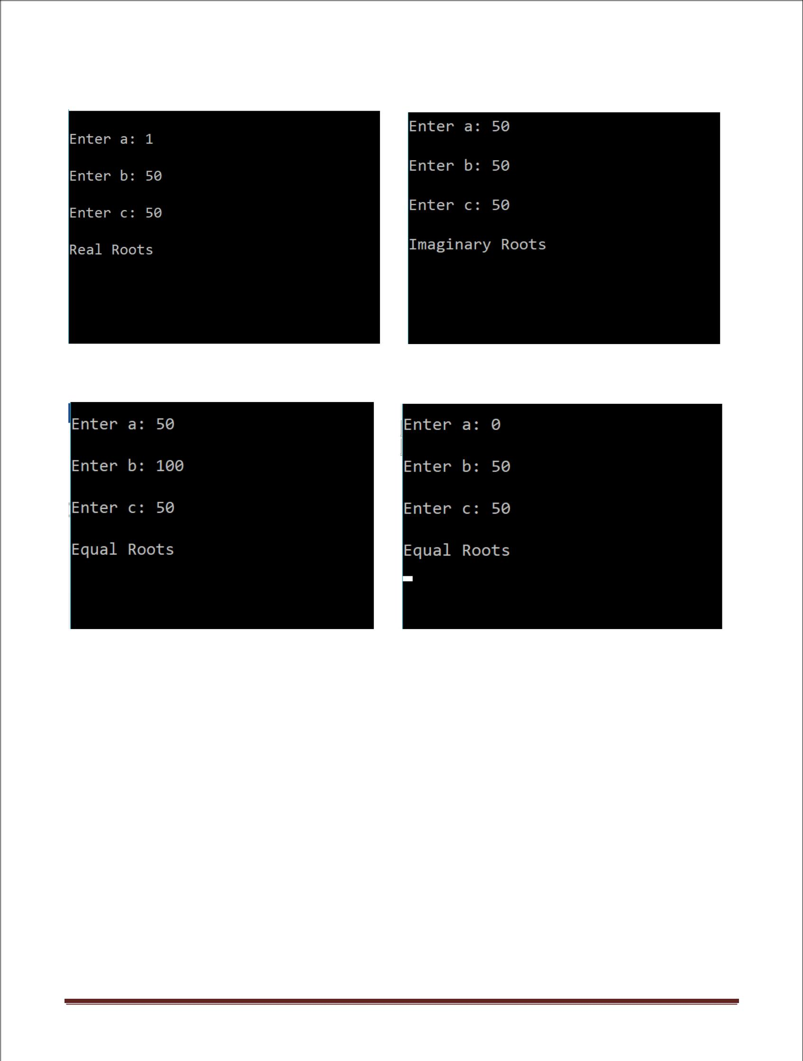

|  |  |  |  |  |  |  |
| --- | --- | --- | --- | --- | --- | --- |
| **Sr No.** | **a** | **b** | **c** | **Expected Output** | **Actual Output** | **Status** |
| 1. | 0 | 50 | 50 | Not a Quadratic Equation | Equal roots | FAIL |
| 2. | 1 | 50 | 50 | Real Roots | Real Roots | PASS |
| 3. | 50 | 50 | 50 | Imaginary Roots | Imaginary Roots | PASS |
| 4. | 99 | 50 | 50 | Imaginary Roots | Imaginary Roots | PASS |
| 5. | 100 | 50 | 50 | Imaginary Roots | Imaginary Roots | PASS |
| 6. | 50 | 0 | 50 | Imaginary Roots | Imaginary Roots | PASS |
| 7. | 50 | 1 | 50 | Imaginary Roots | Imaginary Roots | PASS |
| 8. | 50 | 99 | 50 | Imaginary Roots | Imaginary Roots | PASS |
| 9. | 50 | 100 | 50 | Equal Roots | Equal Roots | PASS |
| 10. | 50 | 50 | 0 | Real Roots | Real Roots | PASS |
| 11. | 50 | 50 | 1 | Real Roots | Real Roots | PASS |
| 12. | 50 | 50 | 99 | Imaginary Roots | Imaginary Roots | PASS |
| 13. | 50 | 50 | 100 | Imaginary Roots | Imaginary Roots | PASS |

**FLOW GRAPH**

**DD GRAPH**

**CYCLOMETRIC COMPLEXITY**

C(VC) = Regions + 1 = 3 + 1 = 4

**INDEPENDENT PATHS**

A – B – C – G

A – B – D – G

A – B – E – G

A – B – F – G