STQA Lab Assignment 2

**Question:** Write a program in any language to find the smallest integer from a set of integers. Write different test cases, expected output and compare it with actual output.

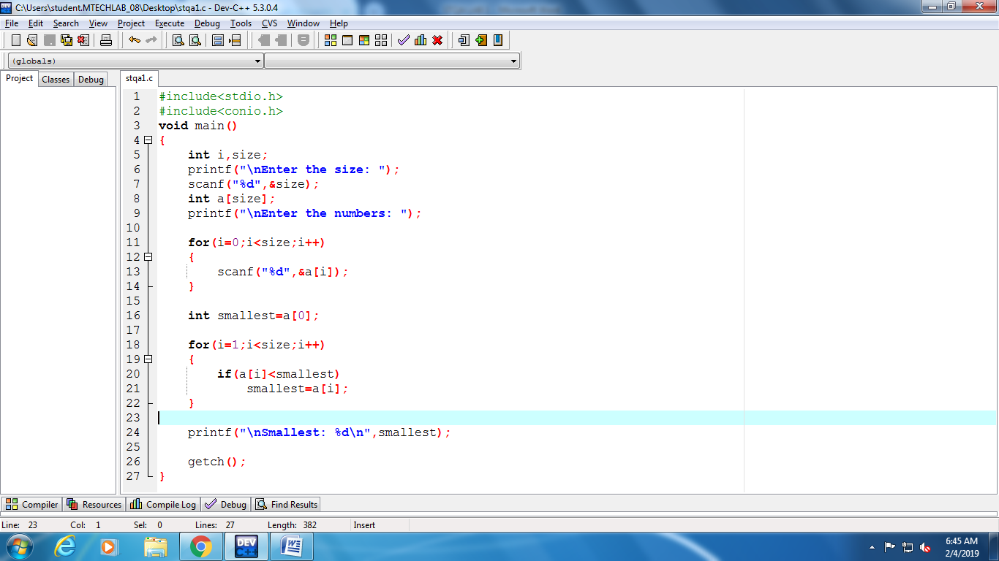

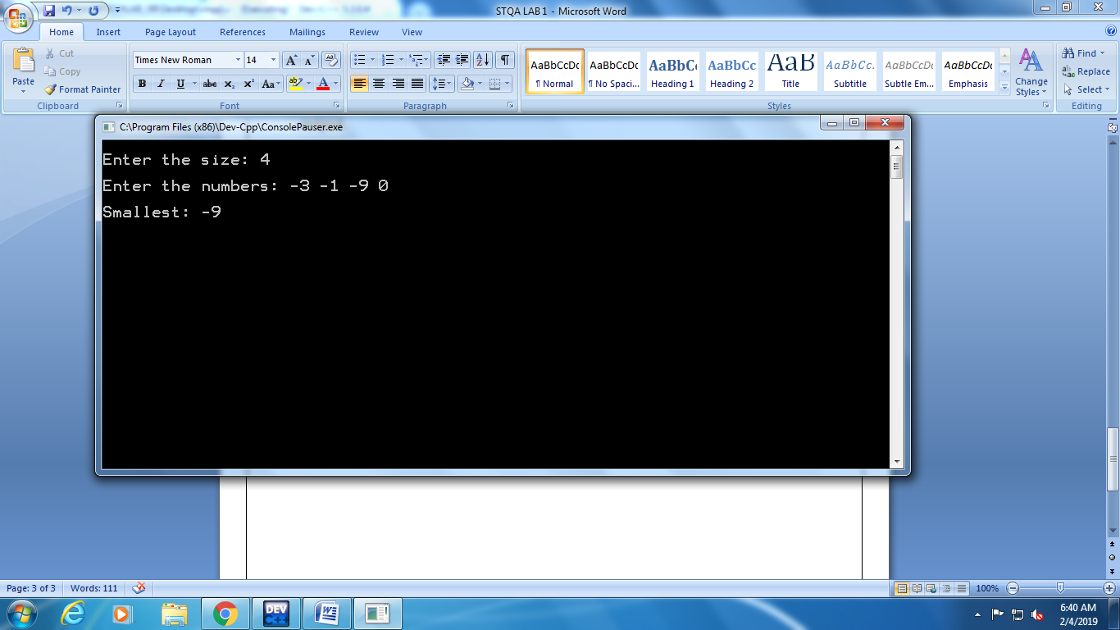 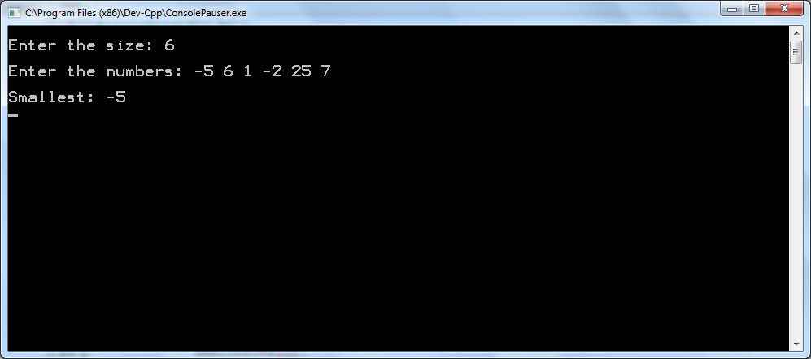

|  |  |  |  |  |  |
| --- | --- | --- | --- | --- | --- |
| Sr. No. | Size | Input | Actual Output | Expected Output | Status |
| 1. | 4 | -3, -1, -9, 0 | 0 | 0 | PASS |
| 2. | 3 | 5, 7, 9 | 5 | 5 | PASS |
| 3. | 2 | -1, -2 | -2 | -2 | PASS |
| 4. | 1 | 17 | 17 | 17 | PASS |
| 5. | 6 | 1, 2, 3, 4, 5 | 1 | 1 | PASS |