**STQA Lab Assignment 6**

**Question:** Write a program that accepts marks of 20 students of 5 subjects and outputs the average and pass/fail message.

Compute the following:

1. Draw flow graph.
2. Draw DD graph and connection matrix.
3. Compute cyclomatic complexity.
4. Identify independent paths.

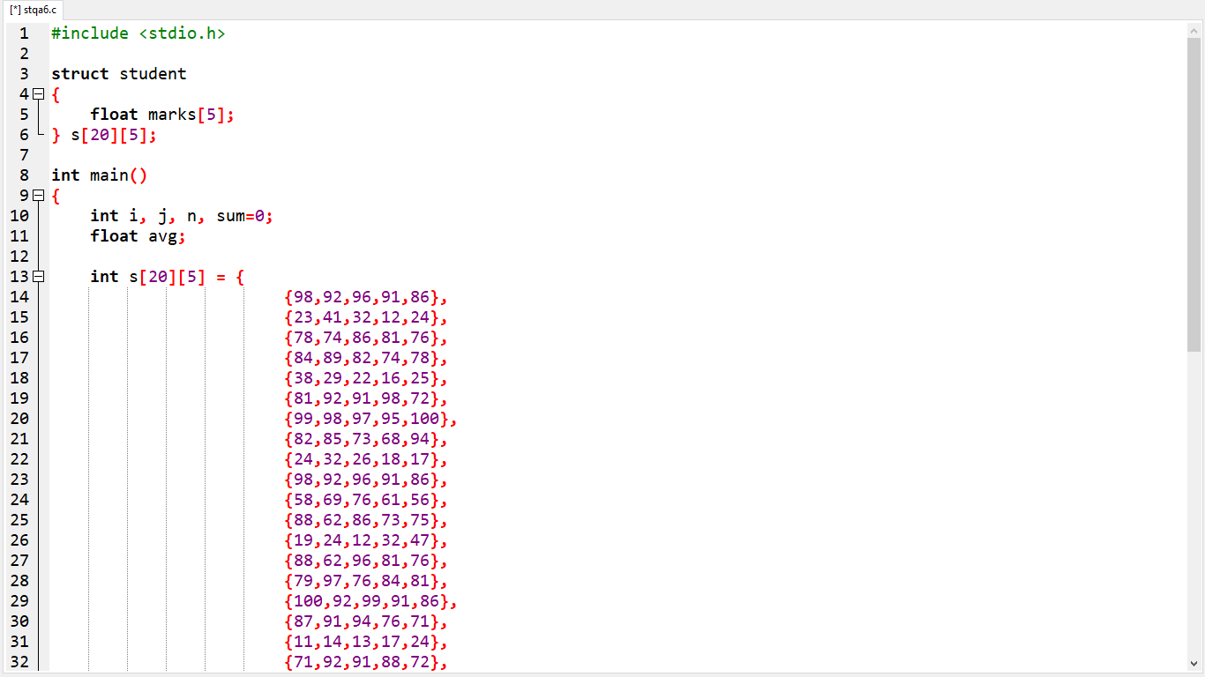

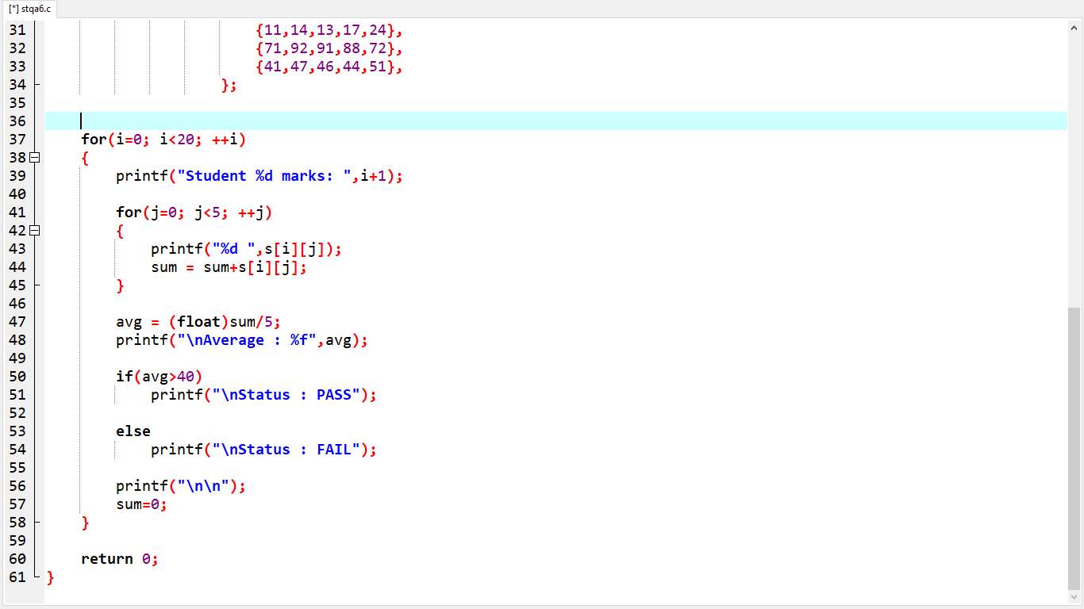

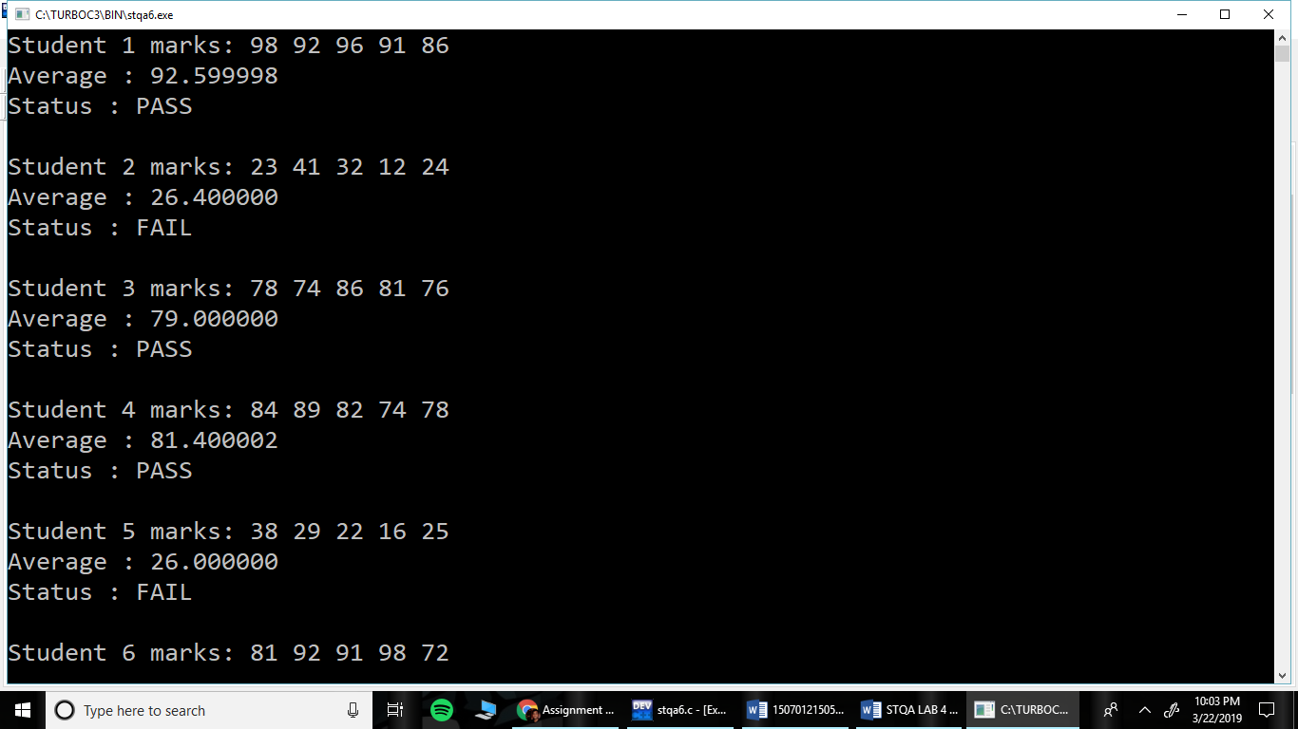

|  |  |  |  |  |  |
| --- | --- | --- | --- | --- | --- |
| **Sr. No.** | **Input** | **Average** | **Actual Output** | **Expected Output** | **Status** |
| 1. | 98  92  96  91  86 | 92.59 | PASS | PASS | PASS |
| 2. | 23  41  32  12  24 | 26.40 | FAIL | FAIL | PASS |
| 3. | 78  74  86  81  76 | 79.00 | PASS | PASS | PASS |
| 4. | 84  89  82  74  78 | 81.40 | PASS | PASS | PASS |
| 5. | 38  29  22  16  25 | 26.00 | FAIL | FAIL | PASS |

1. **FLOW GRAPH**

1. **DD GRAPH**
2. **CYCLOMATIC COMPLEXITY**

C(VC) = Regions + 1 = 2 + 1 = 3

C(VC) = E – N + 2 = 9 – 8 + 2 = 3

C(VC) **=** No. of Decision Nodes + 1 = 2 + 1 = 3

1. **INDEPENDENT PATHS**

**Path 1:** A-B-C-D-E-G

**Path 2:** A-B-C-D-F-G

**Path 3:** A-B-H

|  |  |  |  |  |  |  |  |  |
| --- | --- | --- | --- | --- | --- | --- | --- | --- |
| **Nodes** | **A** | **B** | **C** | **D** | **E** | **F** | **G** | **H** |
| **A** |  | 1 |  |  |  |  |  |  |
| **B** |  |  | 1 |  |  |  |  | 1 |
| **C** |  |  |  | 1 |  |  |  |  |
| **D** |  |  |  |  | 1 | 1 |  |  |
| **E** |  |  |  |  |  |  | 1 |  |
| **F** |  |  |  |  |  |  | 1 |  |
| **G** |  | 1 |  |  |  |  |  |  |
| **H** |  |  |  |  |  |  |  |  |