**STQA Lab Assignment 5**

**Question:** Consider a program to classify the triangle. Its input is a triple of positive integers x, y and z and the data type of input parameters ensures that these will be integers greater than 0 and less than or equal to 100. The program output can be one of the following: Scalene, isosceles, equilateral or not a triangle. Generate robust and worst test cases for this problem.

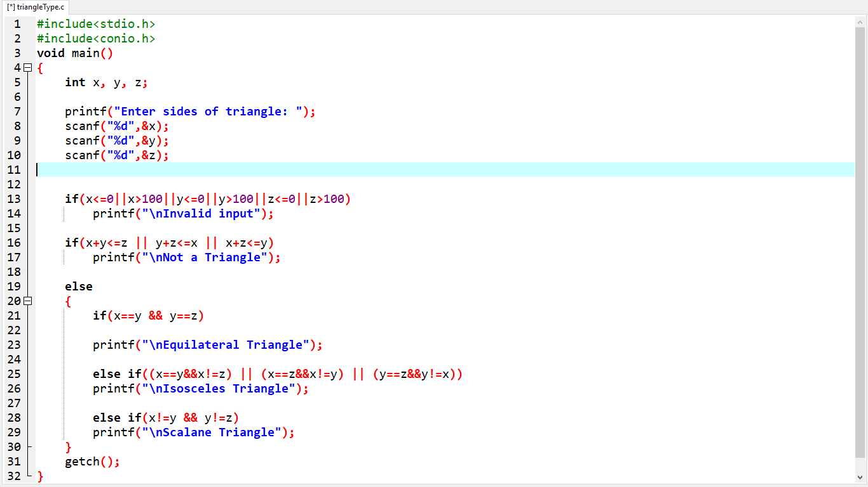

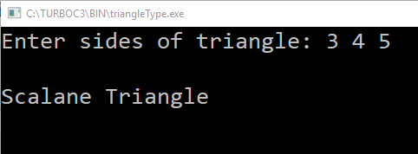

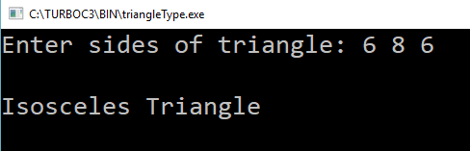

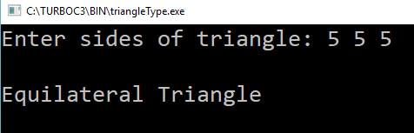

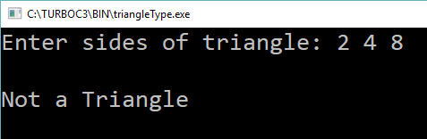

**Robust Test Cases**

|  |  |  |  |  |  |  |
| --- | --- | --- | --- | --- | --- | --- |
| **Sr. No.** | **x** | **y** | **z** | **Expected Output** | **Actual Output** | **Status** |
| 1. | -1 | 50 | 50 | Invalid Input | Invalid Input | PASS |
| 2. | 0 | 50 | 50 | Invalid Input | Invalid Input | PASS |
| 3. | 1 | 50 | 50 | Isosceles Triangle | Isosceles Triangle | PASS |
| 4. | 50 | 50 | 50 | Equilateral Triangle | Equilateral Triangle | PASS |
| 5. | 99 | 50 | 50 | Isosceles Triangle | Isosceles Triangle | PASS |
| 6. | 100 | 50 | 50 | Not a Triangle | Not a Triangle | PASS |
| 7. | 101 | 50 | 50 | Invalid Input | Invalid Input | PASS |
| 8. | 50 | -1 | 50 | Invalid Input | Invalid Input | PASS |
| 9. | 50 | 0 | 50 | Invalid Input | Invalid Input | PASS |
| 10. | 50 | 1 | 50 | Isosceles Triangle | Isosceles Triangle | PASS |
| 11. | 50 | 99 | 50 | Isosceles Triangle | Isosceles Triangle | PASS |
| 12. | 50 | 100 | 50 | Not a Triangle | Not a Triangle | PASS |
| 13. | 50 | 101 | 50 | Invalid Input | Invalid Input | PASS |
| 14. | 50 | 50 | -1 | Invalid Input | Invalid Input | PASS |
| 15. | 50 | 50 | 0 | Invalid Input | Invalid Input | PASS |
| 16. | 50 | 50 | 1 | Isosceles Triangle | Isosceles Triangle | PASS |
| 17. | 50 | 50 | 99 | Isosceles Triangle | Isosceles Triangle | PASS |
| 18. | 50 | 50 | 100 | Not a Triangle | Not a Triangle | PASS |
| 19. | 50 | 50 | 101 | Invalid Input | Invalid Input | PASS |

**Worst Test Cases**

|  |  |  |  |  |  |  |
| --- | --- | --- | --- | --- | --- | --- |
| **Sr. No.** | **x** | **y** | **z** | **Expected Output** | **Actual Output** | **Status** |
| 1. | 0 | 0 | 0 | Invalid Input | Invalid Input | PASS |
| 2. | 0 | 0 | 1 | Invalid Input | Invalid Input | PASS |
| 3. | 0 | 0 | 50 | Invalid Input | Invalid Input | PASS |
| 4. | 0 | 0 | 99 | Invalid Input | Invalid Input | PASS |
| 5. | 0 | 0 | 100 | Invalid Input | Invalid Input | PASS |
| 6. | 0 | 1 | 0 | Invalid Input | Invalid Input | PASS |
| 7. | 0 | 1 | 1 | Invalid Input | Invalid Input | PASS |
| 8. | 0 | 1 | 50 | Invalid Input | Invalid Input | PASS |
| 9. | 0 | 1 | 99 | Invalid Input | Invalid Input | PASS |
| 10. | 0 | 1 | 100 | Invalid Input | Invalid Input | PASS |
| 11. | 0 | 50 | 0 | Invalid Input | Invalid Input | PASS |
| 12. | 0 | 50 | 1 | Invalid Input | Invalid Input | PASS |
| 13. | 0 | 50 | 50 | Invalid Input | Invalid Input | PASS |
| 14. | 0 | 50 | 99 | Invalid Input | Invalid Input | PASS |
| 15. | 0 | 50 | 100 | Invalid Input | Invalid Input | PASS |
| 16. | 0 | 99 | 0 | Invalid Input | Invalid Input | PASS |
| 17. | 0 | 99 | 1 | Invalid Input | Invalid Input | PASS |
| 18. | 0 | 99 | 50 | Invalid Input | Invalid Input | PASS |
| 19. | 0 | 99 | 99 | Invalid Input | Invalid Input | PASS |
| 20. | 0 | 99 | 100 | Invalid Input | Invalid Input | PASS |
| 21. | 0 | 100 | 0 | Invalid Input | Invalid Input | PASS |
| 22. | 0 | 100 | 1 | Invalid Input | Invalid Input | PASS |
| 23. | 0 | 100 | 50 | Invalid Input | Invalid Input | PASS |
| 24. | 0 | 100 | 99 | Invalid Input | Invalid Input | PASS |
| 25. | 0 | 100 | 100 | Invalid Input | Invalid Input | PASS |
| 26. | 1 | 0 | 0 | Invalid Input | Invalid Input | PASS |
| 27. | 1 | 0 | 1 | Invalid Input | Invalid Input | PASS |
| 28. | 1 | 0 | 50 | Invalid Input | Invalid Input | PASS |
| 29. | 1 | 0 | 99 | Invalid Input | Invalid Input | PASS |
| 30. | 1 | 0 | 100 | Invalid Input | Invalid Input | PASS |
| 31. | 1 | 1 | 0 | Invalid Input | Invalid Input | PASS |
| 32. | 1 | 1 | 1 | Equilateral Triangle | Equilateral Triangle | PASS |
| 33. | 1 | 1 | 50 | Not a Triangle | Not a Triangle | PASS |
| 34. | 1 | 1 | 99 | Not a Triangle | Not a Triangle | PASS |
| 35. | 1 | 1 | 100 | Not a Triangle | Not a Triangle | PASS |
| 36. | 1 | 50 | 0 | Invalid Input | Invalid Input | PASS |
| 37. | 1 | 50 | 1 | Equilateral Triangle | Equilateral Triangle | PASS |
| 38. | 1 | 50 | 50 | Isosceles Triangle | Isosceles Triangle | PASS |
| 39. | 1 | 50 | 99 | Not a Triangle | Not a Triangle | PASS |
| 40. | 1 | 50 | 100 | Not a Triangle | Not a Triangle | PASS |
| 41. | 1 | 99 | 0 | Invalid Input | Invalid Input | PASS |
| 42. | 1 | 99 | 1 | Not a Triangle | Not a Triangle | PASS |
| 43. | 1 | 99 | 50 | Not a Triangle | Not a Triangle | PASS |
| 44. | 1 | 99 | 99 | Isosceles Triangle | Isosceles Triangle | PASS |
| 45. | 1 | 99 | 100 | Not a Triangle | Not a Triangle | PASS |
| 46. | 1 | 100 | 0 | Invalid Input | Invalid Input | PASS |
| 47. | 1 | 100 | 1 | Not a Triangle | Not a Triangle | PASS |
| 48. | 1 | 100 | 50 | Not a Triangle | Not a Triangle | PASS |
| 49. | 1 | 100 | 99 | Not a Triangle | Not a Triangle | PASS |
| 50. | 1 | 100 | 100 | Isosceles Triangle | Isosceles Triangle | PASS |
| 51. | 50 | 0 | 0 | Invalid Input | Invalid Input | PASS |
| 52. | 50 | 0 | 1 | Invalid Input | Invalid Input | PASS |
| 53. | 50 | 0 | 50 | Invalid Input | Invalid Input | PASS |
| 54. | 50 | 0 | 99 | Invalid Input | Invalid Input | PASS |
| 55. | 50 | 0 | 100 | Invalid Input | Invalid Input | PASS |
| 56. | 50 | 1 | 0 | Invalid Input | Invalid Input | PASS |
| 57. | 50 | 1 | 1 | Not a Triangle | Not a Triangle | PASS |
| 58. | 50 | 1 | 50 | Isosceles Triangle | Isosceles Triangle | PASS |
| 59. | 50 | 1 | 99 | Not a Triangle | Not a Triangle | PASS |
| 60. | 50 | 1 | 100 | Not a Triangle | Not a Triangle | PASS |
| 61. | 50 | 50 | 0 | Invalid Input | Invalid Input | PASS |
| 62. | 50 | 50 | 1 | Isosceles Triangle | Isosceles Triangle | PASS |
| 63. | 50 | 50 | 50 | Equilateral Triangle | Equilateral Triangle | PASS |
| 64. | 50 | 50 | 99 | Isosceles Triangle | Isosceles Triangle | PASS |
| 65. | 50 | 50 | 100 | Not a Triangle | Not a Triangle | PASS |
| 66. | 50 | 99 | 0 | Invalid Input | Invalid Input | PASS |
| 67. | 50 | 99 | 1 | Not a Triangle | Not a Triangle | PASS |
| 68. | 50 | 99 | 50 | Isosceles Triangle | Isosceles Triangle | PASS |
| 69. | 50 | 99 | 99 | Isosceles Triangle | Isosceles Triangle | PASS |
| 70. | 50 | 99 | 100 | Scalene Triangle | Scalene Triangle | PASS |
| 71. | 50 | 100 | 0 | Invalid Input | Invalid Input | PASS |
| 72. | 50 | 100 | 1 | Not a Triangle | Not a Triangle | PASS |
| 73. | 50 | 100 | 50 | Not a Triangle | Not a Triangle | PASS |
| 74. | 50 | 100 | 99 | Scalene Triangle | Scalene Triangle | PASS |
| 75. | 50 | 100 | 100 | Isosceles Triangle | Isosceles Triangle | PASS |
| 76. | 99 | 0 | 0 | Invalid Input | Invalid Input | PASS |
| 77. | 99 | 0 | 1 | Invalid Input | Invalid Input | PASS |
| 78. | 99 | 0 | 50 | Invalid Input | Invalid Input | PASS |
| 79. | 99 | 0 | 99 | Invalid Input | Invalid Input | PASS |
| 80. | 99 | 0 | 100 | Invalid Input | Invalid Input | PASS |
| 81. | 99 | 1 | 0 | Invalid Input | Invalid Input | PASS |
| 82. | 99 | 1 | 1 | Not a Triangle | Not a Triangle | PASS |
| 83. | 99 | 1 | 50 | Not a Triangle | Not a Triangle | PASS |
| 84. | 99 | 1 | 99 | Isosceles Triangle | Isosceles Triangle | PASS |
| 85. | 99 | 1 | 100 | Not a Triangle | Not a Triangle | PASS |
| 86. | 99 | 50 | 0 | Invalid Input | Invalid Input | PASS |
| 87. | 99 | 50 | 1 | Not a Triangle | Not a Triangle | PASS |
| 88. | 99 | 50 | 50 | Isosceles Triangle | Isosceles Triangle | PASS |
| 89. | 99 | 50 | 99 | Isosceles Triangle | Isosceles Triangle | PASS |
| 90. | 99 | 50 | 100 | Scalene Triangle | Scalene Triangle | PASS |
| 91. | 99 | 99 | 0 | Invalid Input | Invalid Input | PASS |
| 92. | 99 | 99 | 1 | Isosceles Triangle | Isosceles Triangle | PASS |
| 93. | 99 | 99 | 50 | Isosceles Triangle | Isosceles Triangle | PASS |
| 94. | 99 | 99 | 99 | Equilateral Triangle | Equilateral Triangle | PASS |
| 95. | 99 | 99 | 100 | Isosceles Triangle | Isosceles Triangle | PASS |
| 96. | 99 | 100 | 0 | Invalid Input | Invalid Input | PASS |
| 97. | 99 | 100 | 1 | Not a Triangle | Not a Triangle | PASS |
| 98. | 99 | 100 | 50 | Scalene Triangle | Scalene Triangle | PASS |
| 99. | 99 | 100 | 99 | Isosceles Triangle | Isosceles Triangle | PASS |
| 100. | 99 | 100 | 100 | Isosceles Triangle | Isosceles Triangle | PASS |
| 101. | 100 | 0 | 0 | Invalid Input | Invalid Input | PASS |
| 102. | 100 | 0 | 1 | Invalid Input | Invalid Input | PASS |
| 103. | 100 | 0 | 50 | Invalid Input | Invalid Input | PASS |
| 104. | 100 | 0 | 99 | Invalid Input | Invalid Input | PASS |
| 105. | 100 | 0 | 100 | Invalid Input | Invalid Input | PASS |
| 106. | 100 | 1 | 0 | Invalid Input | Invalid Input | PASS |
| 107. | 100 | 1 | 1 | Not a Triangle | Not a Triangle | PASS |
| 108. | 100 | 1 | 50 | Not a Triangle | Not a Triangle | PASS |
| 109. | 100 | 1 | 99 | Not a Triangle | Not a Triangle | PASS |
| 110. | 100 | 1 | 100 | Isosceles Triangle | Isosceles Triangle | PASS |
| 111. | 100 | 50 | 0 | Invalid Input | Invalid Input | PASS |
| 112. | 100 | 50 | 1 | Not a Triangle | Not a Triangle | PASS |
| 113. | 100 | 50 | 50 | Not a Triangle | Not a Triangle | PASS |
| 114. | 100 | 50 | 99 | Scalene Triangle | Scalene Triangle | PASS |
| 115. | 100 | 50 | 100 | Isosceles Triangle | Isosceles Triangle | PASS |
| 116. | 100 | 99 | 0 | Invalid Input | Invalid Input | PASS |
| 117. | 100 | 99 | 1 | Not a Triangle | Not a Triangle | PASS |
| 118. | 100 | 99 | 50 | Scalene Triangle | Scalene Triangle | PASS |
| 119. | 100 | 99 | 99 | Isosceles Triangle | Isosceles Triangle | PASS |
| 120. | 100 | 99 | 100 | Isosceles Triangle | Isosceles Triangle | PASS |
| 121. | 100 | 100 | 0 | Invalid Input | Invalid Input | PASS |
| 122. | 100 | 100 | 1 | Isosceles Triangle | Isosceles Triangle | PASS |
| 123. | 100 | 100 | 50 | Isosceles Triangle | Isosceles Triangle | PASS |
| 124. | 100 | 100 | 99 | Isosceles Triangle | Isosceles Triangle | PASS |
| 125. | 100 | 100 | 100 | Equilateral Triangle | Equilateral Triangle | PASS |