 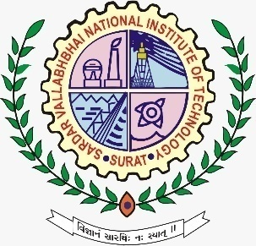

Mock placement

**Objective** :

Our purpose of having a mock placement is to provide a vivid idea and surroundings to the participants of an actual interview which they will be facing in the near future. This will give you a clear idea of your strengths, weaknesses and will greatly reduce your interview anxiety and the butterflies in your stomach.

This will include 3 rounds:

1. **APTITUDE TEST**
2. **GROUP DISCUSSION**
3. **PERSONAL INTERVIEW**

**Event flow:**

The first round will test your aptitude abilities in which the participants are required to solve 20 questions in 30 minutes.

Judging criteria:

After shortlisting, a group discussion round will take place consisting of 5 participants. The topic will be given on the spot and a discussion is to be held for 10 minutes. The participants are required to reach a consensus at the end of time limit.

After further shortlisting, the final round, i.e., the personal interview will be held where the interviewer will ask questions regarding your career goals, hobbies and most importantly about yourself.

Event coordinators

Akshita : +919079052802

Anshul : +918700274872