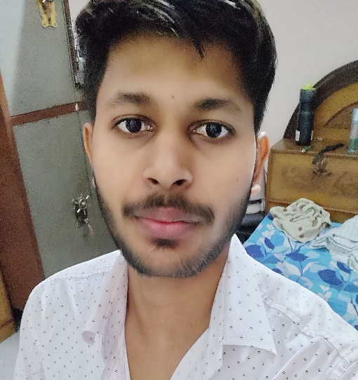 ***SUMMARY***

* English
* Hindi

**LANGUAGES**

* Web designing
* C++
* C

**SKILLS**

 [**saurabhsingh742003@gmail.com**](mailto:saurabhsingh742003@gmail.com)

** 6387010855**

 **Basti, UP**

**Saurabh Singh**

|  |
| --- |
| *Coding, problem-solving, web-designing Computer Science Engineer.* |

|  |
| --- |
| ***Central Academy, Basti, UP***  *Intermediate (Grade: 89.4%)*  ***Kapil Ganga Public School***  *High School (Grade: 88%)* |

***EDUCATION***

* *Reading*
* *Traveling*

***HOBBIES***