1. What are the keywords in python? Using the keywords library, print all the python keywords.

**Answer: -** 

1. What are the rules to create variables in python?

**Answer: - A variable name must start with a letter or the underscore character**

**A variable name cannot start with a number**

**A variable name can only contain alpha-numeric characters and underscores (A-z, 0-9, and _)**

**Variable names are case-sensitive (age, Age and AGE are three different variables)**

1. What are the standards and conventions followed for the nomenclature of variables in python to improve code readability and maintainability?

**Answer: - Variable names in Python can be any length and can consist of uppercase and lowercase letters ( A-Z , a-z ), digits ( 0-9 ), and the underscore character ( _ ). Use a lowercase single letter, word, or words. Separate words with underscores to improve readability.**

1. What will happen if a keyword is used as a variable name?

**Answer: - Keywords define the language’s syntax rules and structure, and they cannot be used as variable names. Programmers generally choose names for their variables that are meaningful to the human readers of the program to remember what the variable is used for.**

1. For what purpose def keyword is used?

**Answer: - The def keyword is used to create, (or define) a function.**

1. What is the operation of this special character ‘\’?

**Answer: - Backslash (\), Separates locations in a file or network path.**

1. Give an example of the following conditions:
2. Homogeneous list
3. Heterogeneous set
4. Homogeneous tuple

**Answer: - (i) Homogeneous list – Data elements will be of same data types.**

**(ii) Heterogeneous set – Data elements may not be of same data types. The items stored can be of any type numeric, string, boolean, objects, etc which makes it heterogeneous. This means that a list can have any type of data and we can iterate over this list using any type of loop.**

**(iii) Homogeneous tuple - Tuples are immutable, and usually contain a heterogeneous sequence of elements that are accessed via unpacking or indexing. Lists are mutable, and their elements are usually homogeneous and are accessed by iterating over the list.**

1. Explain the mutable and immutable data types with proper explanation & examples.

**Answer: - Mutable - A mutable object can be changed after it is created. Example - List, Set, Dictionary.**

**Immutable - An immutable object cannot be changed after it is created. Example - tuples, int, float, bool, frozenset.**

1. Write a code to create the given structure using only for loop.

*

***

*****

*******

*********

**Answer: -** 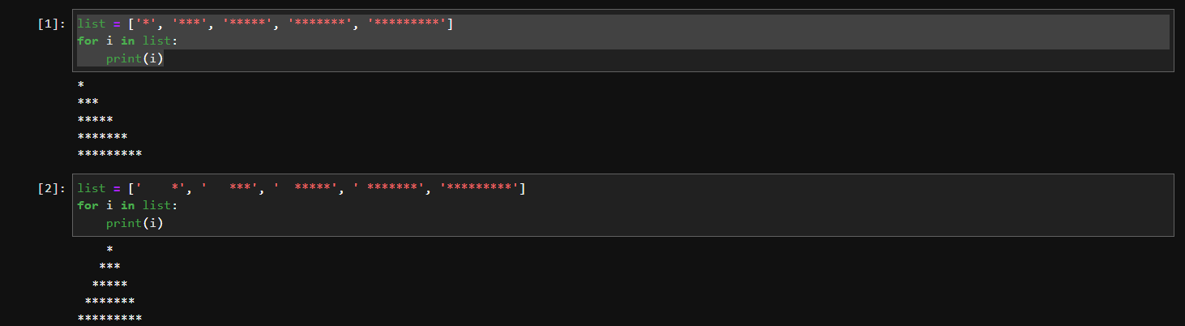

1. Write a code to create the given structure using while loop.

|||||||||

|||||||

|||||

|||

|

**Answer: -**

