1.What are the two values of the Boolean data type? How do you write them?

**Answer: - It has two possible values: True and False, which are special versions of 1 and 0 respectively and behave as such in arithmetic contexts.**

2. What are the three different types of Boolean operators?

**Answer: - AND/OR/NOT**

3. Make a list of each Boolean operator's truth tables (i.e., every possible combination of Boolean values for the operator and what it evaluates).

**Answer: - AND gate**

|  |  |  |
| --- | --- | --- |
| **X** | **Y** | **Output** |
| **0 (False)** | **0 (False)** | **0 (False)** |
| **1 (True)** | **0 (False)** | **0 (False)** |
| **0 (False)** | **1 (True)** | **0 (False)** |
| **1 (True)** | **1 (True)** | **1 (True)** |

**OR Gate**

|  |  |  |
| --- | --- | --- |
| **X** | **Y** | **Output** |
| **0 (False)** | **0 (False)** | **0 (False)** |
| **1 (True)** | **0 (False)** | **1 (True)** |
| **0 (False)** | **1 (True)** | **1 (True)** |
| **1 (True)** | **1 (True)** | **1 (True)** |

**NOT Gate**

|  |  |
| --- | --- |
| **Input** | **Output** |
| **0 (False)** | **1 (True)** |
| **1 (True)** | **0 (False)** |

4. What are the values of the following expressions?

(5 > 4) and (3 == 5)

not (5 > 4)

(5 > 4) or (3 == 5)

not ((5 > 4) or (3 == 5))

(True and True) and (True == False)

(not False) or (not True)

**Answer:- (5 > 4) and (3 == 5) - False  
not (5 > 4) - False  
(5 > 4) or (3 == 5) - True  
not ((5 > 4) or (3 == 5)) - False  
(True and True) and (True == False) - False  
(True and True) and (True == False) - True**

5. What are the six comparison operators?

**Answer: -**

|  |  |
| --- | --- |
| **=** | **equal** |
| **!=** | **not equal** |
| **>** | **Greater than** |
| **<** | **Less than** |
| **>=** | **Greater than or equal to** |
| **<=** | **Less than or equal to** |

6. How do you tell the difference between the equal to and assignment operators? Describe a condition and when you would use one.

**Answer: - In mathematics and algebra, = is an equal to operator. In programming = is an assignment operator, which means that it assigns a value to a variable.**

7. Identify the three blocks in this code:

spam = 0

if spam == 10:

print('eggs')

if spam > 5:

print('bacon')

else:

print('ham')

print('spam')

print('spam')

**Answer: - The three blocks are everything inside the if statement and the lines print('bacon') and print('ham').  
print('eggs')  
if spam > 5:  
print('bacon')  
else:  
print('ham')  
print('spam')**

8. Write code that prints Hello if 1 is stored in spam, prints Howdy if 2 is stored in spam, and prints Greetings! if anything else is stored in spam.

**Answer: - spam = 1**

**If spam == 1:**

**Print (‘Hello’)**

**If spam == 2:**

**Print(‘Howdy’)**

**else:**

**Print(‘Greetings!)**

9.If your programme is stuck in an endless loop, what keys you’ll press?

**Answer: - CTRL+C**

10. How can you tell the difference between break and continue?

**Answer: - Break: A break statement in Python alters the flow of a loop by terminating it once a specified condition is met.**

**Continue: The continue statement in Python is used to skip the remaining code inside a loop for the current iteration only**

11. In a for loop, what is the difference between range(10), range(0, 10), and range(0, 10, 1)?

**Answer: - Range (10) = one argument, will get a series of numbers that starts at 0 and includes every whole number up to 10**

**Range (0,10) = with two arguments, gets to decide not only where the series of numbers stops but also where it starts.**

**Range (0, 10, 1) = with three arguments, the user can choose not only where the series of numbers will start and stop, but also how big the difference will be between one number and the next. If the user doesn’t provide a step, then range() will automatically behave**

12. Write a short program that prints the numbers 1 to 10 using a for loop. Then write an equivalent program that prints the numbers 1 to 10 using a while loop.

**Answer: -** 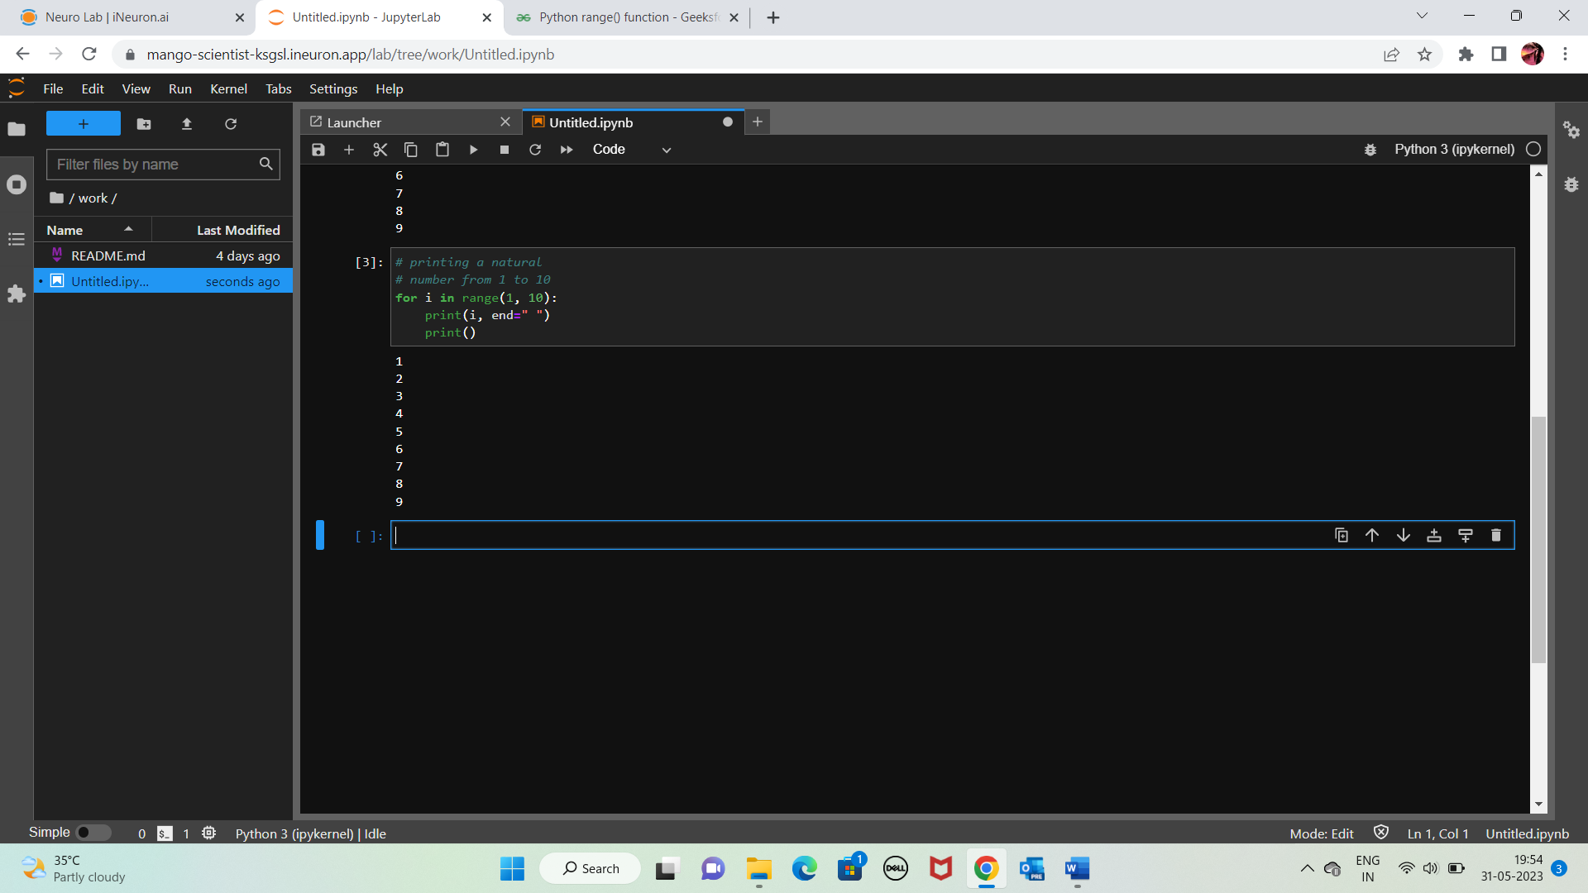

13. If you had a function named bacon() inside a module named spam, how would you call it after importing spam?

**Answer: - This function can be called with spam.bacon().**